**Carbon Sequestration in Imphal West District: A Mitigation to Climate Change**

Abdulla Azarudeen A1*, Thiyam Tamphasana Devi2

*1M.Tech. Student, Department of Civil Engineering, National Institute of Technology, Manipur, Langol-795004.*

*2Assistant Professor, Department of Civil Engineering, National Institute of Technology, Manipur.*

*\* e-mail:*[*azarcivilian@gmail.com*](mailto:azarcivilian@gmail.com) , <thiyam85@gmail.com>

**Introduction**

Carbon sequestration is the long-term carbon storage in plants, soils, geologic formations and the oceans. The IPCC estimated that 1.86 billion tons of carbon is released into the atmosphere annually due to LULC & climate change. The Imphal west district which possesses the large forest area is chosen for the present study since forests enhance carbon sequestration. The land use and the land cover map of Imphal west district is obtained from the maximum livelihood supervised classification. Imphal West district (Manipur state) was classified with six major divisions like; Dense forest, Sparse forest, Scrub/Grass, Cropland, Built-up & Water bodies. The remotely-sensed spectral bands can reveal valuable information such as vegetation structure, state of vegetation cover, photosynthetic capacity, leaf density and distribution, water content in leaves, mineral deficiencies and evidence of parasitic shocks or attacks (Jensen et al., 2007).The InVEST Carbon Storage and Sequestration model is implemented in the study which aggregates the amount of carbon stored in the carbon pools according to the land use maps and classifications and future prediction by using GeoSOS FLUS. This study compared the LULC and the total carbon sequestrated in year 2026 and stored in 1996 and 2016 in Manipur.

# Materials and Methods

The preparatory phase of fieldwork has been done before going to the field for study the carbon stocking. During this period the basic information and data were collected related to the literature searching for carbon stocking.

* Satellite imagery: Landsat 8 OLI (Dated 17/01/2016), Landsat 5 TM (11/021996) were downloaded.
* Geological map from Geological Survey of India (GSI).
* Default carbon value from Intergovernmental panel for climate change (IPCC).

Soil map prepared by National Bureau of Soil Survey & Land Use Planning (NBSS&LUP) on 1:500000 scale was used for extraction of physical and chemical properties of soil *viz*. soil depth, soil texture, soil drainage and soil erosion. Default carbon value is prepared by Intergovernmental panel for climate change based upon that holding capacity in different pools like Above ground biomass, Below ground biomass, Soil carbon, Dead wood, Harvest wood products. In this study ESRI ArcGIS 10.2. Software is used for mapping and to predict LULC GeoSOS-FLUS software is used. For calculation and mapping of carbon sequestration InVEST model and Google Earth Pro software are used.

*Figure 1. Amount of Carbon Stock (in Kg)*

**Result and Conclusion**

The carbon stocking of the year 1996 for Imphal west district (24.7828° N, 93.8859° E) were observed as 4.48 kg of carbon spread through Imphal west district as Dense forest (12.18%), Sparse forest (14.37%), Crop land (35.16%), Scrub/Grass (25.68%), Built up (12.61%) and Water bodies (0%). Likewise, for the year 2016, it is 3.78 kg of carbon in which Dense forest (10.55%), sparse forest (11.3%), Crop land (39.11%), Scrub/Grass (29.29%), Built up (9.75%) and Water bodies (0%). The Carbon stock is shown in Fig.1.The predicted carbon sequestration for the year 2026 has been calculated as 0.39 kg. It is spread through district with the concentration of minimum -1.8504 mg of C to maximum 0 mg of C at water bodies.

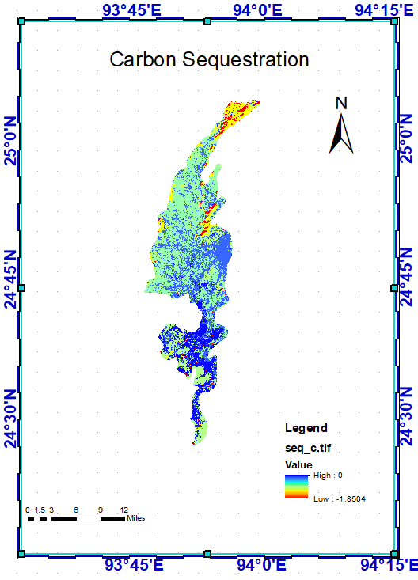

*Figure 2. Carbon Sequestration Map*

**References**

Xun Liang, Xiaoping Liu, Li Dan, Zhao Hui, Chen Guangzhao (2018). Urban growth simulation by incorporating planning policies into a CA-based future land-use simulation model. International Journal of Geographical Information Science, 32(11): 2294–2316

LU, D. (2001). Estimation of forest stand parameters and application in classification and change detection of forest cover types in the Brazilian Amazon basin. PhD dissertation, Indiana State University, Terre Haute, Indiana, USA

Kuldeep Pareta and Upasana Pareta (2011). Forest carbon management using satellite remote sensing techniques a case study of Sagar district (M.P.), E-International Scientific Research Journal. 3(4):ISSN 2094-1749.