**A STUDY ON BEHAVIOUR OF PHOTOCATALYTIC CONCRETE BLENDED WITH M-SAND**

**D.Satyanarayana1,** Department of Civil Engineering /Research Schloer, Sathyabama Institutte of Science & Technology(Deemed to be University)/Tamilanadu, India.

**Dr. R. PadmaPriya2**Department of Civil Engineering /Head of the Department, Sathyabama Institutte of Science & Technology(Deemed to be University)/Tamilanadu, India.  
* e-mail: [hodce@sasi.ac.in1](mailto:hodce@sasi.ac.in1) [padmapriyar_77@yahoo.com2](mailto:padmapriyar_77@yahoo.com2)

**Introduction**

Concrete is a matrix material prepared by mixing of larger boulders as course total, natural sand as fine aggregate and cement as binding material to suitable proportions with sufficient water as per water-cement ratio to form gel. Designing projects with photocatalytic concrete also helps to increase aesthetic endurance and make the structure looking like new over long time. Normally Natural Sand is not present in river up to required quantity. Digging sand, from river bed in excess quantity is hazardous to environment. The deep pits dug in the river bed, affects the ground water level. Erosion of nearby land is also due to excessive sand lifting. Manufactured sand is familiar as robo sand in construction world prepared by crushing of larger stone boulders into fine particles which will have cubical shape and can play similar role of natural sand in concrete.

The partial replacement of the titanium dioxide improves the strength of concrete and helps in depollution of polluted air and, creates a charge separation of electrons which disperses on the photocatalytic surface and reacts with external substances, decomposing organic compounds.[1-4]. Usage of manufactured sand not only fills the voids also improve the strength of the concrete by forming strong bonding for long period [5-6].

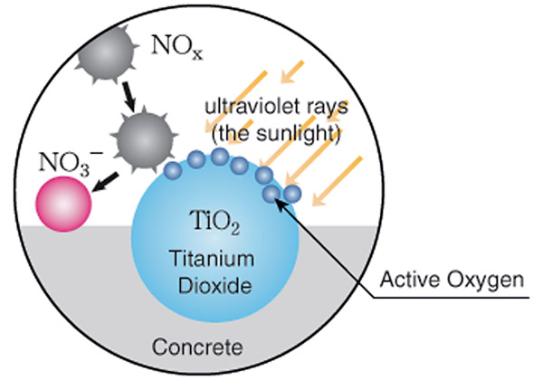 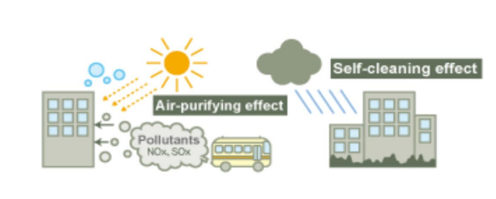

**Figure 1 & 2**

**Materials and Methods**

**Biding Material**

The binding material used in this study majorly consists of OPC 53 Grade and TiO2 at suitable proportions. When activated by the energy in light, the white pigment creates a charge that disperses on the surface of the photocatalyst, and reacts with external substances to decompose organic compound.

**Fine Aggregate**

Manufactured fine aggregate is furnish from crumble of rock material having size less than 4.75 mm size pre-owned in construction of structures. It is a high constitution material. Basalt material is a very fine-grained with visible mineral grains. The average density of basalt material is 3.0 gm/cm3.

**Results and Concluding remarks**

1. It is found that mechanical properties such as strength characteristics of the concrete being improved by partial replacement of M-sand for fine aggregate.
2. The ideal percentage of successor of natural fine aggregate by Manufactured fine aggregate is 80%
3. Due to scarcity of natural fine aggregate and its lofty cost could revitalize the adoption of manufactured fine aggregate by 100% successor instead of natural fine aggregate.
4. It is observed that the compressive strength and flexure strength of concrete can be improved by partial replacement of TiO2 as Binding Material
5. From the above experimental results it is proved that, TiO2 can be used as partial replacement as Cementenious Material and the compressive, flexure strengths are increased as the percentage of TiO2 is increased up to optimum level. The optimum percentage of replacement of TiO2 by Cement is 10%
6. The optimum percentage of TiO2 is 10% for getting maximum compressive strength and it is obtained as 33.32 N/mm2.
7. The percentage of increase in the compressive strength is 26.65% and the flexure strength is 10.48% at the age of 28 days with the replacement of M-Sand and TiO2 at 80%, & 10% respectively

**References:**

1. Hashimoto, K. Fujishima, A. “TiO 2  photocatalysis: A historical overview and future prospects” Japanese Journal of Applied Physics, Part 1: Regular Papers and Short Notes and Review Papers Volume 44, Issue 12, 8 December 2005, Pages 8269-828
2. Riahi, S. Nazari, A. “The effects of TiO2 nanoparticles on physical, thermal and mechanical properties of concrete using ground granulated blast furnace slag as binder”
3. Ali Nazari, Shadi Riahi, Shirin Riahi, Seyedeh Fatemeh Shamekhi “Improvement the mechanical properties of the cementitious composite by using TiO2 nanoparticles”, Journal of American Science 2010 volume -6
4. Mark Garger, Mandala , Evan Marohn “THE USE OF TITANIUM DIOXIDE IN CONCRETE MATERIALS TO FILTER SMOG POLLUTION FROM AIR” Conference Session B9, University of Pittsburgh Swanson School of Engineering.
5. M. Adams Joe, P. Brightson, M. Prem Anand, A. Maria Rajesh“Experimental investigation on the effect of m-sand in high performance concrete” American J.Engg.Res.,Vol.2, issue 12,2013.
6. Manjunatha M"Durability Studies on Concrete by Replacing Natural Sand with M-Sand A Review“, International Journal of Emerging Technology and Advanced Engineering VOL.6, ISSN 2250-2459. Issue 3, March 2016.