**CROSS SECTION OPTIMIZATION OF A TRUSS SUBJECTED TO VARIOUS GROUND MOTIONS USING SALP SWARM ALGORITHM**

Sistla Saiteja1*, Kalyana Rama J. S2,

1 Graduate students, Department of Civil Engineering, BITS Pilani Hyderabad Campus

2 Assistant professor, Department of Civil Engineering, BITS Pilani Hyderabad Campus  
* Sistla Saiteja1*,* E*-*Mail: h20181430050@hyderabad.bits-pilani.ac.in

**Abstract** Since the Earthquake forces are very random in nature, the need of the hour is proper analysis of structures by both static and dynamic methods. The important inputs for the dynamic method are spectral displacement, velocity and acceleration. The fundamental objective of this study is to determine the site-specific response spectrum for seven locations in India. The site-specific response spectrum has already been built by many researchers as mentioned in [5],[6],[7],[8]. New mark’s β [1],[3],[4] method was applied for computing the spectral quantities. Using STAAD pro mode shapes and natural frequencies of the chosen 52-bar truss which along with obtained spectral values for various ground motions will be used as an input for equivalent static method to find the base shear, which will be distributed along the height of the 52-bar truss. The distributed loads are the inputs for the 52-bar truss weight optimization using the SALP SWARM ALGORITHM [9]. The obtained weights of the 52-bar truss for different site-specific spectrum will be compared with that of the design spectrum of IS:1893 2016 [2]. This comparison will provide us an idea regarding the variation between site-specific, design spectrum of IS 1893 2016 [2] and the best tool for a possible spectral value.

**Keywords:** SALP SWARM ALGORITHM , Equivalent static method, New mark’s β method, MATLAB.

# INTRODUCTION

In the modern era accuracy is one of the most important factors in the field of design. As we witnessed a lot of earthquakes in the recent times, the need of the hour is to update the spectral quantities which are vital for estimating the dynamic response of any given structure. This current study involves 7 places namely ***Bhuj (2001), Uttarkashi (1991), Chamoli (1999), Chamba (1995), India-Burma border (1997), Nepal (2015), Ummulong(1986)*** respectively. Previously many researchers have generated their own site-specific spectrum for nuclear power plant design, capital city of Agartala etc. [5] [6] [7] The ground acceleration data of these 7 locations was obtained from ww.strongmotion.org. These locations were specifically chosen since they all fall under the category of zone-5 according to the seismic micro zonation as per IS:1893 part 1 2016 [2].With the help of Newmark’s β method the respective spectral quantities were estimated and effectively utilized to estimate the Lateral loading on the truss, which is further used as an input for the SALP SWARM ALGORITHM . Liu, Q., Paavola, J., & Zhang, J. (2016) [10] have optimized the shape and cross-section of plane trusses under various earthquake excitations using hessian matrix calculations. Their study hasn’t spoken about the design spectrum and its comparison with the site-specific spectrum. The site-specific curve is then compared with design spectrum of IS:1893 2016[2] in terms of the weight of the truss. The pseudo code and the understanding of the SALP SWARM ALGORITHM can be obtained from [9].

# PROBLEM DETAILS

The locations chosen for building the site-specific response spectrum and the 52-bar truss are shown below

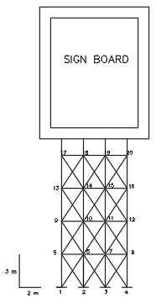 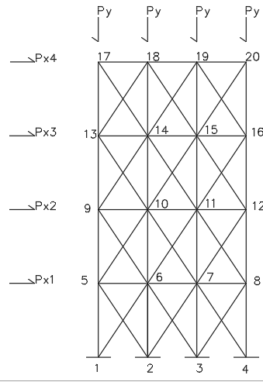

**Fig 1: 52 bar truss problem Fig 2: 52-bar truss loading diagram**

Table 1 - Truss properties

|  |  |  |
| --- | --- | --- |
| S.NO | QUANTITY | VALUE |
| 1 | Vertical truss member diameter (d) | 43.70110-3m |
| 2 | Moment of inertia | $$\frac{π×{\left(d\right)}^{3}}{64}=1.79*10-7m^{4}$$ |
| 3 | Length | 3 m |
| 4 | Steel density | 7850 kg/m3 |
| 5 | Mass at each floor (D.L) | 450 Kgs (Top floors)  600 Kgs (remaining floors) |
| 6 | Youngs modulus | $E=2.07*{10}^{9}\frac{N}{m^{2}}$ |
| 7 | Stiffness at each floor (vertical) | $\frac{12EI*4}{L^{3}}=4.7×{10}^{3}\frac{N}{m}$ |
| 8 | Stiffness at each floor (Diagonal) | $\frac{AE*\cos^{2}θ*4}{L}=76602×{10}^{3}\frac{N}{m}$ |
| 10 | Stiffness at each floor | $\frac{12EI*3}{L^{3}}=9.92×{10}^{5}\frac{N}{m}$ |
| 11 | Size of the sign board | 12x10x0.15 |
| 12 | Weight of the sign board (L.L) | 12x10x0.15x7850x10x10-3=1413KN |
| 13 | Fundamental freq. and time period | 6.384 sec -1, 0.984 seconds |

1. Figure 3 which shows the loading diagram consists of 2 loads i.e. 1) Px 2) Py respectively. Px is the lateral loading acting at the nodes which a result of earthquake excitation. Py is the weight of the sign board divided by four which is 353.25 KN
2. The free vibration analysis has been carried out to find out the natural frequency and the fundamental time period of the truss by using STAAD pro, which will be used as an input in the equivalent static method.
3. The importance factor I=1.5, Response reduction factor=3
4. The rest of the specifications are mentioned below

Table 2 – SALP SWARM ALGORITHM inputs

|  |  |  |
| --- | --- | --- |
| S.NO | **QUANTITY** | **VALUE** |
| 1 | Material density | 7850 $\frac{kg}{m^{3}}$ |
| 2 | Modulus of elasticity | 2.07*105 $Mpa$ |
| 3 | Load (Py) | 353.25 KN |
| 4 | Stress limitation | $∓180 Mpa$ |
| 5 | Area (lower bound) | 71.62x10-6 m2 |
| 6 | Area (upper bound) | 21620x10-6 m2 |

1. RESULTS AND DISCUSSION

# 1.1 Salp swarm algorithm [9]

1. The whole Salp population is split in to two groups
2. Leader
3. Follower
4. The leader is the one who locates the food source and intimates the followers. The followers then, based on the movement of the leader align themselves and move towards the food source in an optimized way i.e. by utilizing the least resources and adopting a very short route.
5. The position of the Salps is basically defined in an n dimensional search space where n being the number variables in the equation.
6. The food source is denoted by a letter F.

The position of the leader (Equation)

$p_{k}^{1}= O_{k}+C_{1}\left(\left({UB}_{k}-{LB}_{k}\right)C_{2}+{LB}_{k}\right) C_{3}≥0$ (1a)

$p_{k}^{1}= O_{k}-C_{1}\left(\left({UB}_{k}-{LB}_{k}\right)C_{2}+{LB}_{k}\right) C_{3}<0$ (1b)

$p_{k}^{1}$ indicates the position of the leader (iter=1)

$O_{k}$ is the position of the food source in the dimension j

${UB}_{k}$ indicates the upper bound of kth dimension

${LB}_{k}$ indicates the lower bound of the kth dimension

C1, C2, and C3 are random numbers

C1 = 2 $e^{-( {4 iter}/M)^2 }$, this is an important parameter which balances exploration and exploitation.

iter is the current iteration

M is the maximum number of iterations.

The position of the follower (equation)

$p_{k}^{iter}=\frac{1}{2}(x_{j}^{iter}+x_{j}^{iter-1}) when iter≥2$ (2)

Pseudo code

Initialize the Salps $p_{k}(k=1,2,..n)$ considering ${UB}_{k}$& ${LB}_{k}$

**While**  compute the fitness of the Salp

O = The best Salp

Update C1 by equation above

for every Salp $p_{k}^{iter}$

**if** inter==1

the position shall be updated by (1a) or (1b)

**else**

the position shall be updated by (2)

**end**

**end**

Make the necessary changes based on ${UB}_{k}$& ${LB}_{k}$

**end**



**Fig 3: Salp chain**

* 1. **Site Specific Response Spectrum**

The ground acceleration data of the 7 stations mentioned in the introduction was plugged into the Newmark’s β method and the respective spectral quantities i.e. Spectral Displacement, Pseudo Spectral velocity and Pseudo Spectral acceleration were determined. The obtained results are important to determine the Base shear which is in turn used to compute the lateral load distribution along the height of the truss. The Earthquake with the highest magnitude is chosen as the Maximum considered earthquake (M.C.E) for the respective site. The design earthquake is 1/2 times the Maximum considered earthquake. By obtaining the design ground acceleration, plug in the value into the formula mentioned in IS:1893 Part-1 2016 for obtaining the design spectrum. Medium type of site is chosen for the truss weight optimization using.

The Pseudo-Spectral acceleration vs Natural graphs for the chosen 7 different locations and the design spectra are shown below: -

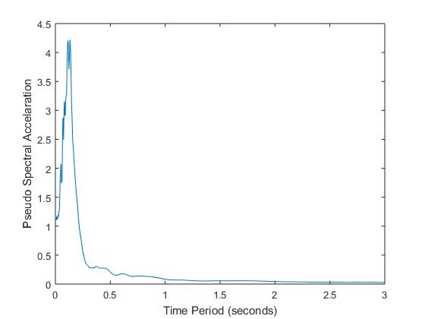 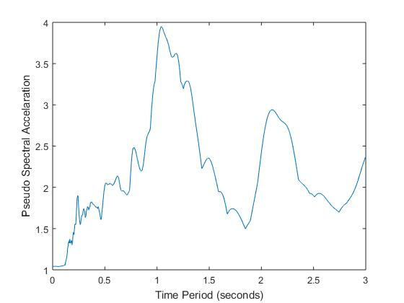

**Fig 4 – Ummulong (1986)** **Fig 5 – Uttarkashi (1991)**

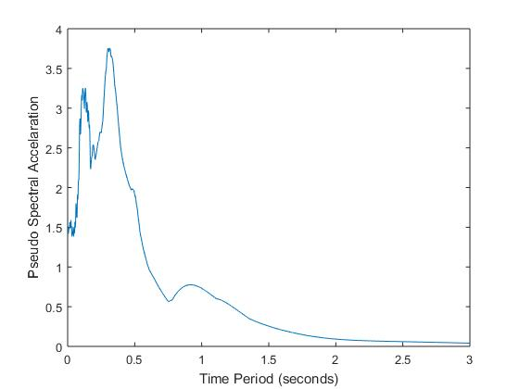 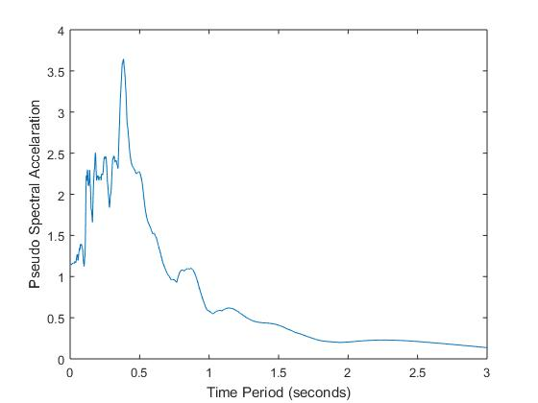

**Fig 6- Chamba (1995) Fig 7 – India Burma (1997)**

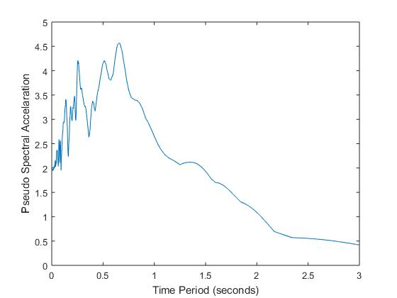 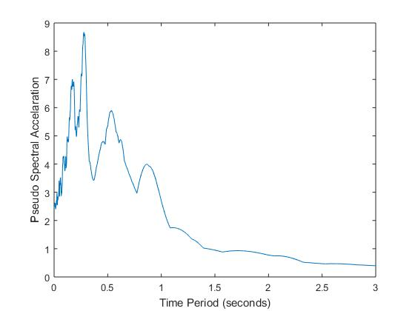

**Fig 8 – Chamoli (1999) Fig 9- Bhuj (2001)**

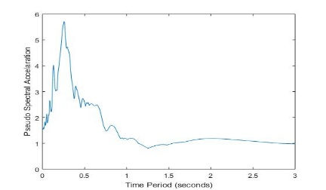

**Fig 10 – Nepal (2015)**

**1.3 Equivalent Static method**

The equivalent static method is now applied to the obtained site-specific response spectra. These spectra along with the time period determined by STAAD will be used to determine the horizontal seismic coefficient (Ah), which in turn will be used to compute the base shear. The obtained base shear will be distributed along the height of the building by the procedure mentioned in IS 1893 Part 1 2016 [2]

In all the following table the numbers 1-7 denote the earthquakes in the following manner: -

Table 3 – Locations chosen

|  |
| --- |
| S.NO Location Year |
| 1 Ummulong (1986) |
| 2 Uttarkashi (1991) |
| 3 Chamba (1995) |
| 4 India-Burma borders(1997) |
| 5 Chamoli (1999) |
| 6 Bhuj (2001) |
| 7 Nepal (2015)  8 Design Spectrum (2016) |

Table 4 – Lateral loads (KN) from equivalent static method

|  |  |  |  |  |  |  |  |  |
| --- | --- | --- | --- | --- | --- | --- | --- | --- |
| **Height** | **1** | **2** | **3** | **4** | **5** | **6** | **7** | 8 |
| 12 m | 6.92 | 219.2 | 55.5 | 44.7 | 203.7 | 248 | 198.4 | 217 |
| 9 m | 0.67 | 21.4 | 5.4 | 4.35 | 20 | 24 | 19.31 | 21.2 |
| 6 m | 0.22 | 7.11 | 1.8 | 1.45 | 6.6 | 8 | 6.5 | 7.08 |
| 3 m | 0.05 | 1.77 | 0.5 | 0.36 | 1.7 | 2 | 1.6 | 1.8 |
| Base shear (KN) | 7.87 | 249.5 | 63.2 | 50.86 | 232 | 282 | 225.8 | 206 |

* 1. **Truss optimization**

SALP SWARM ALGORITHM is a nature inspired algorithm which has been used for optimization in this current study. The 52-bar element has been grouped accordingly to reduce the computational time. The elements have been grouped in the following way :-

A1-A4 , A5-A10 , A11-A13 , A14-A17 , A18-A23 , A24-A26 , A27-A30 , A31-A36 , A37-A39 , A40-A43 , A44-A49 , A50-A52

After optimizing the truss with respect to the weight of the sign board and the lateral load exerted by the ground excitation the obtained cross-sectional areas of the member groups and the total weight of the truss in Kgs is shown in the table below

Table 5 – Optimized truss weight

|  |  |  |  |  |  |  |  |  |
| --- | --- | --- | --- | --- | --- | --- | --- | --- |
|  | 1 | 2 | 3 | 4 | 5 | 6 | 7 | 8 |
| A1 | 2000 | 3861 | 2417 | 2326 | 3631 | 4100 | 3623 | 3686 |
| A2 | 71.6 | 858 | 307 | 262 | 812 | 951 | 795 | 810 |
| A3 | 71.6 | 258 | 133 | 87 | 295 | 267 | 258 | 226 |
| A4 | 1975 | 3197 | 2227 | 2186 | 3023 | 266 | 3041 | 3106 |
| A5 | 71.6 | 624 | 220 | 180 | 697 | 3373 | 600 | 611 |
| A6 | 71.6 | 245 | 96 | 71 | 497 | 693 | 361 | 334 |
| A7 | 1955 | 2548 | 2071 | 2071 | 2466 | 251 | 2452 | 2474 |
| A8 | 71.6 | 664 | 253 | 163 | 664 | 744 | 624 | 655 |
| A9 | 71.6 | 322 | 141 | 103 | 505 | 373 | 374 | 377 |
| A10 | 1940 | 2020 | 1933 | 1955 | 2002 | 2032 | 1959 | 1963 |
| A11 | 71.6 | 677 | 222 | 182 | 632 | 759 | 661 | 661 |
| A12 | 76.7 | 1219 | 455 | 281 | 1149 | 1357 | 1321 | 1445 |
| W(Kg) | 805 | 1674 | 1025 | 965 | 1641 | 1786 | 1609 | 1637 |

# CONCLUSIONS

With the main agenda to observe the trend of the latest earthquakes and their implication on the existing buildings and its comparison with existing design spectrum IS:1893 part 1 the following conclusions can be drawn

# Robust classification of soil is mandatory. There is no variation in the peak response for different types of soils and hence the criteria for the existing design spectrum of IS:1893 2016 should be altered to make the responses more precise and accurate like that of EURO code 8.

# The building response has drastic variations for different ground acceleration time histories. Hence the base shear and the total truss weight have significant variation for all the site-specific spectrums as shown in the figures below

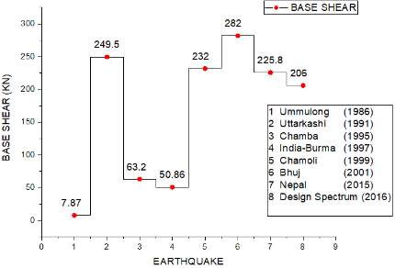 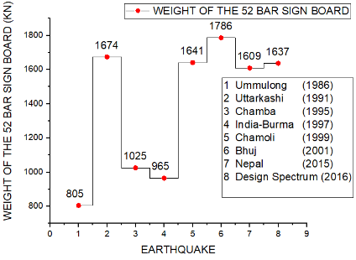

**Fig 11: Variation in Base shear Fig 12: Variation in truss weight**

1. It is seen that some earthquakes fall below the design base shear and some above. This clearly shows the uncertainty involved with the current code and this would have a drastic effect on life and property.
2. The zone factor i.e. peak ground acceleration has some specific values, but nothing has been mentioned about the P.G.A which falls in between.
3. It is better to use Site-specific response spectrum for a site since it yields better and accurate values for design and in case of the absence of the Site-specific spectrum, the design spectrum maybe used.

# REFERENCES

1. Katona, M. C., & Zienkiewicz, O. C. (1985). A unified set of single step algorithms part 3: The beta‐m method, a generalization of the Newmark scheme. *International Journal for Numerical Methods in Engineering*, *21*(7), 1345-1359.
2. IS-1893 Part-1 2016 Criteria for earthquake resistant design of structures.
3. Chopra AK. Dynamics of structures: theory and applications to earthquake engineering. Prentice-Hall; 2001.
4. Jain AK. Dynamics of structures with MATLAB® applications. Pearson Education India; 2017.
5. Boominathan A, Vikshalakshie MG, Subramanian RM. Site specific seismic study for a power plant site at Samalkot, Godavari rift basin in Peninsular India. 2012
6. Poggi V, Edwards B, Fäh D. A comparative analysis of site-specific response spectral amplification models. Physics and Chemistry of the Earth, Parts A/B/C. 2017 Apr 1;98:16-26.
7. Sil A, Sitharam TG. Site specific design response spectrum proposed for the capital city of Agartala, Tripura. Geomatics, Natural Hazards and Risk. 2016 Sep 2;7(5):1610-30.
8. ABHIJIT MOLAWADE RC, Ramancharla VK. Generation of Site-Specific Response Spectrum near Nuclear Power Plants: A Preliminary Case Study at Rawatbhata Station. 2015
9. Mirjalili, S., Gandomi, A. H., Mirjalili, S. Z., Saremi, S., Faris, H., & Mirjalili, S. M. (2017). Salp Swarm Algorithm: A bio-inspired optimizer for engineering design problems. *Advances in Engineering Software*, *114*, 163-191.
10. Rajeev, S., & Krishnamoorthy, C. S. (1992). Discrete optimization of structures using genetic algorithms. Journal of structural engineering, 118(5), 1233-1250.
11. Liu, Q., Paavola, J., & Zhang, J. (2016). Shape and cross-section optimization of plane trusses subjected to earthquake excitation using gradient and Hessian matrix calculations. Mechanics of Advanced Materials and Structures, 23(2), 156-169.