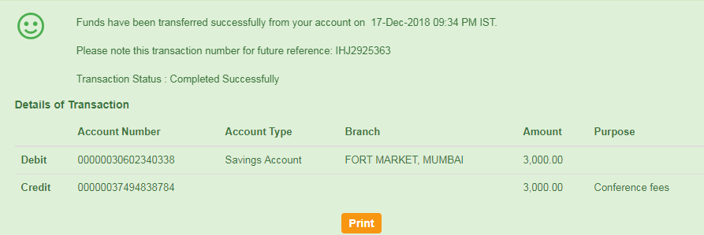

Payment slip for conference NIT Warangal