**Improvement of Boiler’s Efficiency by Auto Combustion Control using Ratio Control**

Samuel Morris 1*, Dr. K.Sudha Rani 2, Lalit Rout 3

*1VNR Vignana Jyothi Institute of Engineering and Technology, Pragthi Nagar, Hyderabad, 500090*

*2VNR Vignana Jyothi Institute of Engineering and Technology, Pragthi Nagar, Hyderabad, 500090*

*3 Essar Steel India Ltd., Hazira, Gujarat, 394270*

*\* samuelvrs@yahoo.co.in*

ABSTRACT

Efficiency, Safety and Eco friendliness are of paramount importance in any combustion process. Especially in large scale combustion units like boilers they are of utmost importance. This research is conducted to improve the efficiency of a water tube boilers, enhance the safety of Boilers and to reduce the emission of SOx, NOx and COx gases there by making them eco-friendly in nature. We have employed a ratio controller to control the Air-Fuel Ratio based on the oxygen content in the flue gases in the stack. Air-to-fuel ratio defines the amount of air needed to burn a specific fuel. For any combustion process there is a balance sought between losing energy from using too much air, and wasting energy from running too richly. The optimum Air- Fuel Ratio for Natural gas is identified as 9.53m3 Air to 1m3 Fuel. The best combustion efficiency occurs by continually choosing the right air-to-fuel ratio based on the current combustion parameters. In most scenarios, a liquid and gas fuel burner achieves this desired balance by operating at 105% to 120% of the optimal theoretical air. This results in an excess oxygen level of 2%. In the combustion zone, it is difficult to measure excess air. In the stack, however, it can be easily measured using Oxygen analysers.  When operating with 5%-20% excess air, it would correspond to a 1% to 3% oxygen measurement in the stack. We have employed a Zirconium Oxygen Analyser for this purpose which will adjust the Air Ratio with respect to the Oxygen content in the Stack. Simulation of this project is done using SIEMENS TIA software and resulted in an increased efficiency of 3.2%.

**Keywords:** Combustion Control, Ratio Control, Boiler, Oxygen Analyser, Air-Fuel Ratio, Load factor

# **1. INTRODUCTION**

A water tube boiler is used to heat feed water in tubes of the boiler order to produce steam.  Fuel is burned inside the [furnace](https://en.wikipedia.org/wiki/Furnace#Industrial_furnaces), creating hot gas which heats water in the steam-generating tubes. The energy released by the burning fuel in the boiler furnace is stored (as temperature and pressure) in the steam produced. This high temperature and pressure steam is then passed through one or several stages of super heaters before it is fed to the Steam Turbines.

The essential requirement for a combustion control system is to correctly proportion the quantities of air and fuel being burnt. This will ensure complete combustion, a minimum of excess air and acceptable exhaust gases. The control system must therefore measure and control the flow rates of fuel and air in order to correctly regulate their proportions.

When there are more than one Boiler and their capacity of operation is decided by ‘Load Factor’ which decides the Fuel Ratio to the burners. The Boilers can be operated in a combination of operating Loads to meet the end steam requirement.

The combustion process in Boilers can operated in both Manual and Auto modes. It is inferred from previous papers that Auto Mode provides better stability and combustion efficiency over Manual Mode. Even in combustion process employing PID controller we observe a rapid fluctuating in Output Steam Pressure which is undesired for downstream process. To avoid this fluctuation in Output Steam pressure and to increase Combustion efficiency we propose a fine tuning mechanism of Air-Fuel Ratio by tweaking the Air-Fuel Ratio with respect to the excess oxygen content in the boiler stack.

# **2. BOILER DESCRIPTION**

A water tube Boiler is simulated for this research using Siemens TIA software. Here a single Boiler with a single burner is employed and Air Fuel Ratio is adjusted automatically by a Ratio Controller w.r.t the Oxygen Content in the Stack. In case of several boilers, boilers are operated on partial loads or some operate on full load and some on standby. In such cases boilers are operated on partial load by the operator by feeding appropriate ‘Load factor’ to the automation system. Load factor is in the units of percentage of load.

# **3. EXPERMIENTAL DESIGN AND SET-UP**

Schematic of Combustion control using a Ration controller employing Oxygen Analyser is shown below.

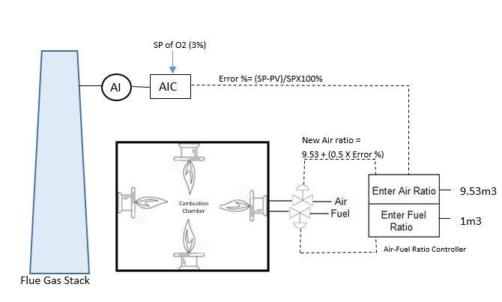

Fig. 1. Auto Combustion Control using Ratio Control employing Oxygen Analyser in Stack

Efficiency in combustion control is achieved by maintaining appropriate level of oxygen in the furnace to enable complete combustion of fuel which is given into furnace through burners. All unburnt fuel and air leaves the boiler through chimney (stack). Therefore, the percentage of oxygen in chimney is direct measure of left out oxygen in the Boiler furnace. It is learnt from previous papers that the percentage of left out oxygen after combustion will be between 3% - 7% and anything above this level is indicated excess presence of oxygen in the furnace and the combustion process is inefficient. In a vice-versa scenario, if the Oxygen percentage is less than 3% indicated that there is no sufficient oxygen for combustion which results inefficient combustion process and black smoke can be seen at the exhaust of the stack. To monitor the oxygen content in the stack a Zirconia Oxygen Analyser of Teledyne make and model SM425 is employed. Desired oxygen levels in the stack will be the Set point (SP) and Oxygen content in stack ready by Zirconia Oxygen Analyser will be the process value. Error is calculated by the Analyser Indicator and Controller and gives the Error % to Air-Fuel Ration Controller. Air fuel ratio controller initially gets input from the Boiler Load factor for giving proportionate steam output desired by the operator. The percentage of Air proportionate to Fuel ratio is set by Air-Fuel ration controller and fine-tuned by the input f Analyser Indicator controller (AIC) output.

Error % (from AIC) = (SP of O2- PV from Oz Analyser) / SP X 100%

It is learnt from previous papers that for every 1m3 of Fuel efficient Air ration will be 9.53m3 and to fine tune this Air Ratio Error signal from Analyser Indicator and controller is utilised .

New Air Ratio = 9.53 + (0.5 X Error %)

# **4. RESULT AND DISCUSSION**

Following is the trend of Output Pressure in Manual Combustion process without Oxygen Analyser feedback.

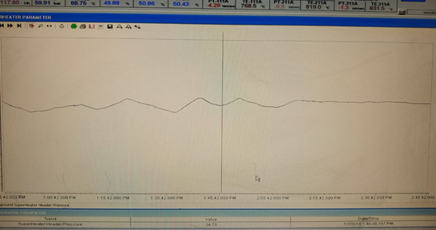

Fig. 2. Fluctuations in Output Pressure in Manual Operation

We observed that the Output pressure of Boiler is stable in Auto Combustion with Oxygen Analyser feedback with Ratio Control.

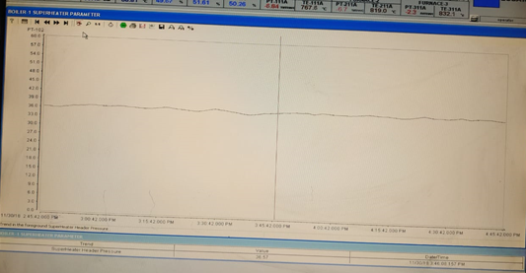

Fig. 3. Less or negligible fluctuations in Output Pressure in Auto Combustion mode using Ratio Controller with an Oxygen Analyser feedback

Thus by maintaining Air-Fuel Ratio we could achive efficient combustionin Boiler Furnace which resulted in

* steady output pressure from the boilers
* enhanced Boiler Safety by reducing fluctuations in combustion process
* less SOx, NOx and Cox gases in stack
* Lesser Fuel consumption which measured to efficiency increase of 3% - 4%in Boilers
* Earned carbon credits

# **5. CONCLUSION**

Improvement of Boiler efficiency was achieved between 3% - 4% by Auto Combustion process using Ratio Control employing Oxygen Analyser in stack. This work can be further applied to Boilers in Combined cycle power plants and in Industrial applications where boilers are used.

## **ACKNOWLEDGEMENTS**

The authors acknowledge the support from the management of VNR Vignan Jyothi Institute of Engineering and Technology for their support of this research.

REFERENCES

**[1]** Ratchaphon Suntivarakorn and Wasakorn Treedet ‘Improvement of Boiler's Efficiency Using Heat Recovery and Automatic Combustion Control System’ 3rd International Conference on Power and Energy Systems Engineering, Elsevier, CPESE 2016, 8-12 September 2016, Kitakyushu, Japan, Pages 3-4

**[2]** G. Conte, Senior Member, IEEE, M. Cesaretti, D. Scaradozzi ‘Combustion control in domestic boilers using an oxygen sensor’ 14th Mediterranean Conference on Control and Automation 2006, IEEE, 12 March 2007, Pages 1-4

**[3]** Book - Boiler Efficiency Guide, [Available from <http://cleaverbrooks.com/reference>center/insights/Boiler%20Efficiency%20Guide.pdf]

**[4]** Shizhe Li, Yinsong Wang and Zheng Zhao, ‘Performance Evaluation of the Boiler Combustion Control System Based on Data-Driven’ IEEE, International Conference on Information and Automation Lijiang, China, August 2015

**[5]** Book‘Energy Efficiency & Industrial Boiler Efficiency’ An Industry Perspective by Council of Industrial Boiler Owners

**[6]** Sunil P U, Jayesh Barve,P.S.V. Nataraj ‘Boiler model and simulation for control design and validation’ Third International Conference on Advances in Control and Optimization of Dynamical Systems, March 13-15, 2014. Kanpur [2] Kumar PR, Raju VR, Kumar NR, Krishna Ch V. Investigation of Improvement in Boiler Efficiency through Incorporation of Additional

**[7]** Bank of Tubes in the Economiser for Supercritical Steam Power Cycles. International Journal of Engineering Research and Development 2012; **4**: 94-100.Gibbs BM. Boiler Fuel Savings by Heat Recovery and Reduced Standby Losses. Heat Recovery Systems and CHP 1987; 7: 151-157.

**[8]** Blanco JM, Pena F. Increase in the Boiler’s Performance in Terms of the Acid Dew Point Temperature: Environmental Advantages of Replacing Fuels. Applied Thermal Engineering 2008; **28**: 777-784.