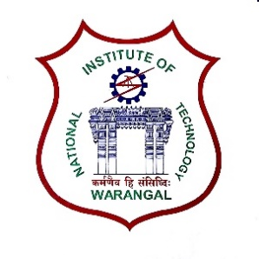**International Conference on**

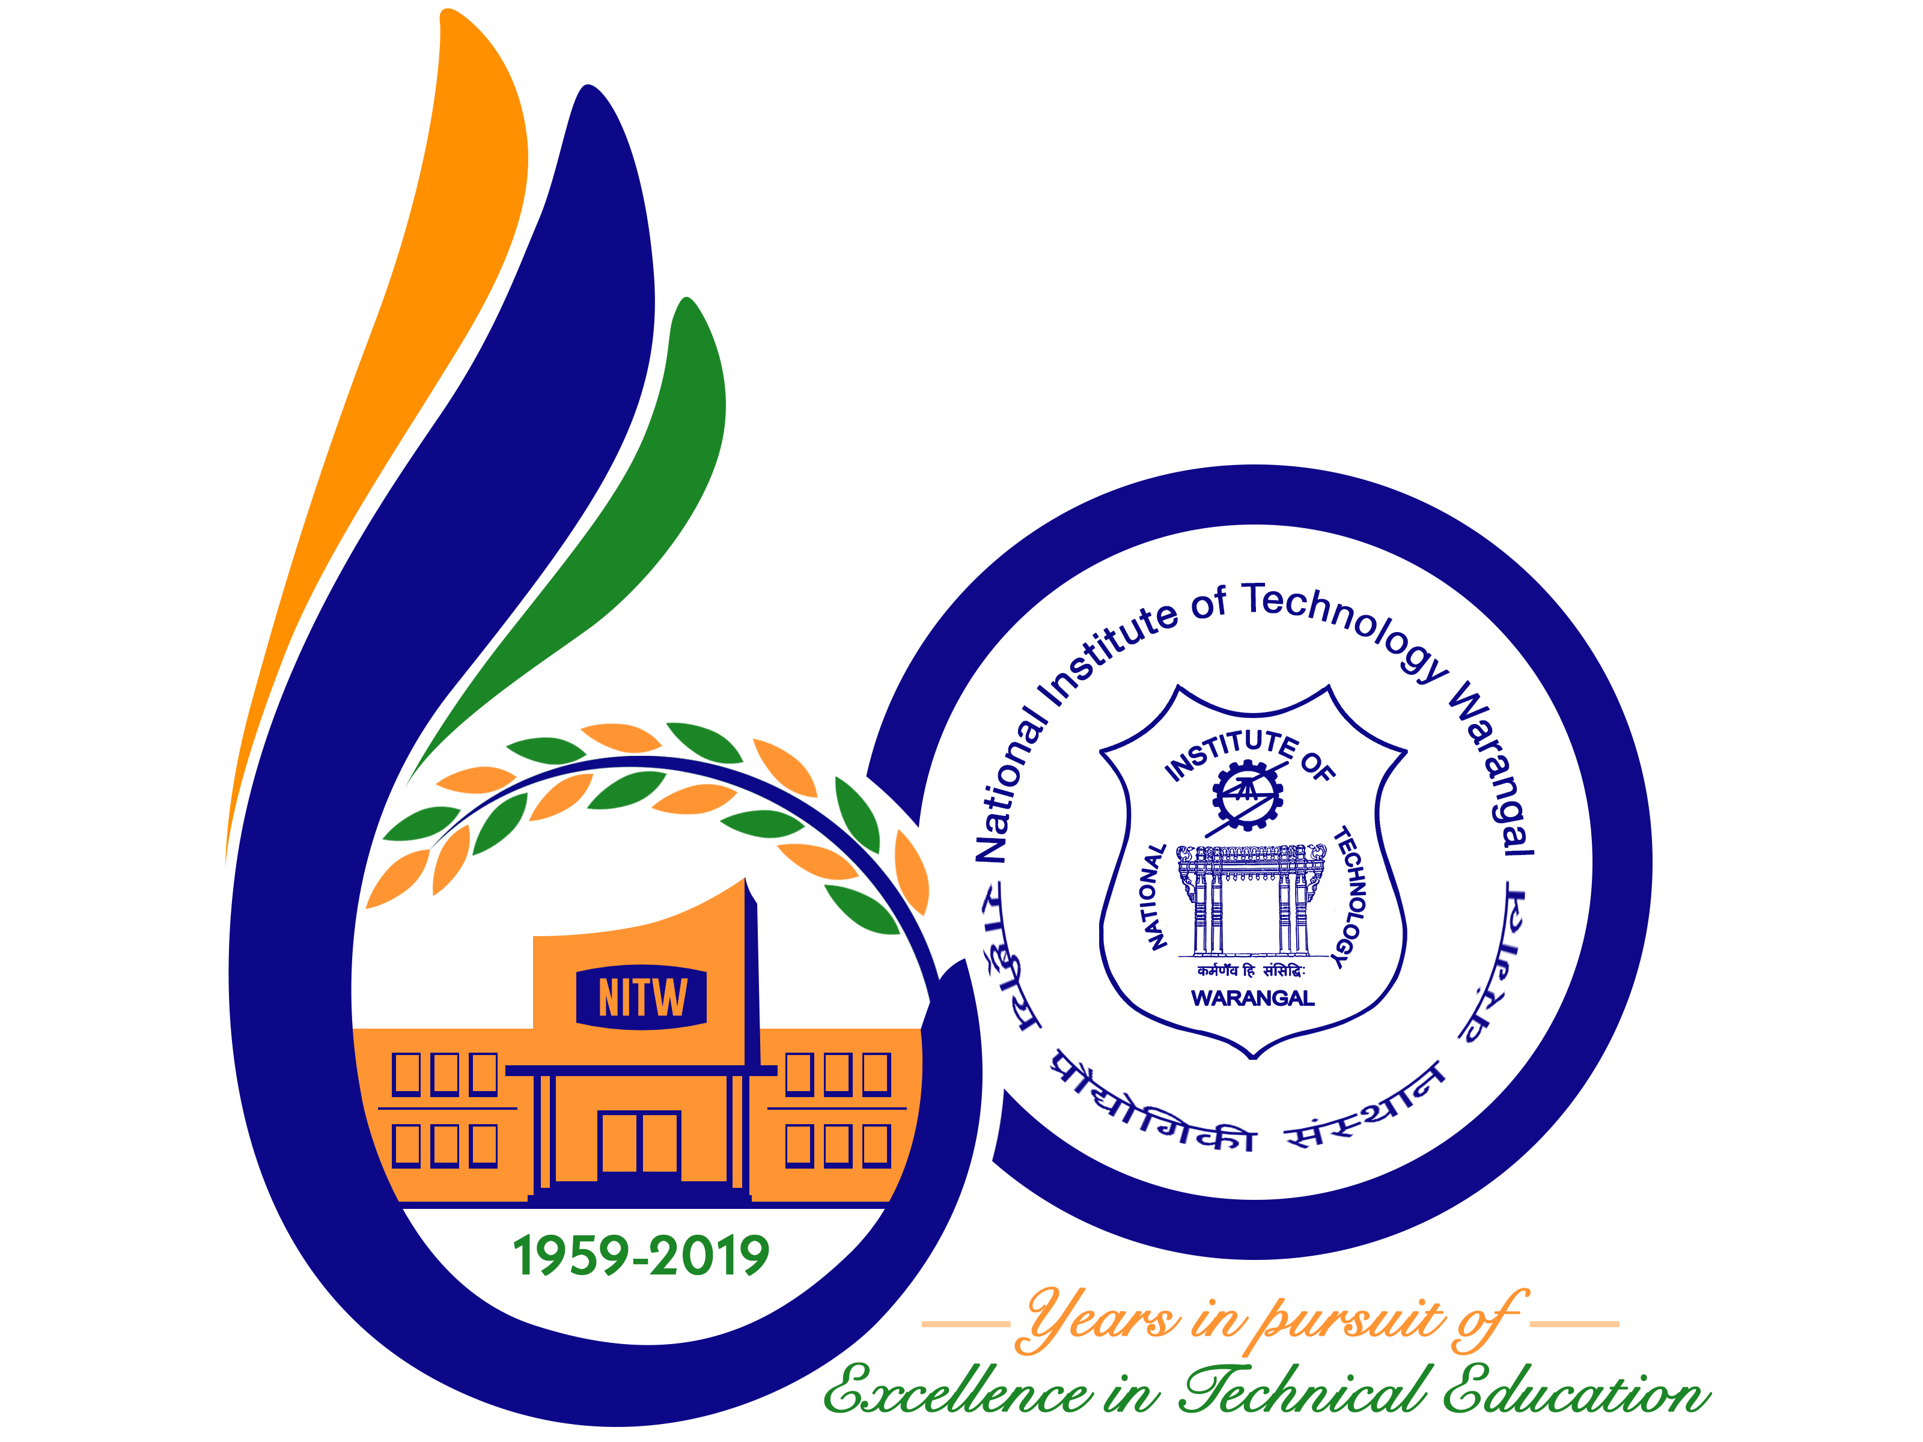

**New Frontiers in Chemical, Energy and Environmental Engineering (INCEEE – 2019)**

**15 – 16, February 2019**

**Organized by**

**Department of Chemical Engineering**

**National Institute of Technology Warangal, 506004, India**

**REGISTRATION FORM**

Name: Hari Kumar Andem

Designation: Research Scholar

Qualification: M.E. (Ph.D) Gender: Male

Organization: University College of Engineering (A), Osmania University, Hyderabad

Address for Correspondence: Department of Mechanical Engineering, Kakatiya Institute of Technology and Science, Hasanparthy, Warangal, Telangana – 506015

Mobile No.: (+91) 9618329820 Email: [ahk.me@kitsw.org](mailto:ahk.me@kitsw.org)

Category (Oral / Poster / Non-presenting): Oral

Title of Paper: AN EXPERIMENTAL STUDY ON ALUMINIUM METAL MATRIX COMPOSITE REINFORCED WITH BORON CARBIDE

Paper ID No.: **M083**

Payment Details (DD / Online transfer): Online transfer

Amount: 1500 Transaction ID No.: IHJ3927821 Date: 01JAN2019

Bank: State Bank of India

Date: 01–01–2019

Place: Warangal Signature of the Applicant

Forwarded through the Head of the Department / Institution