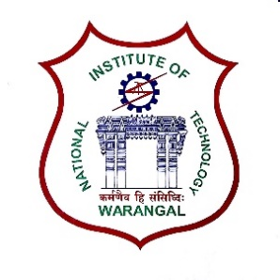**International Conference on**

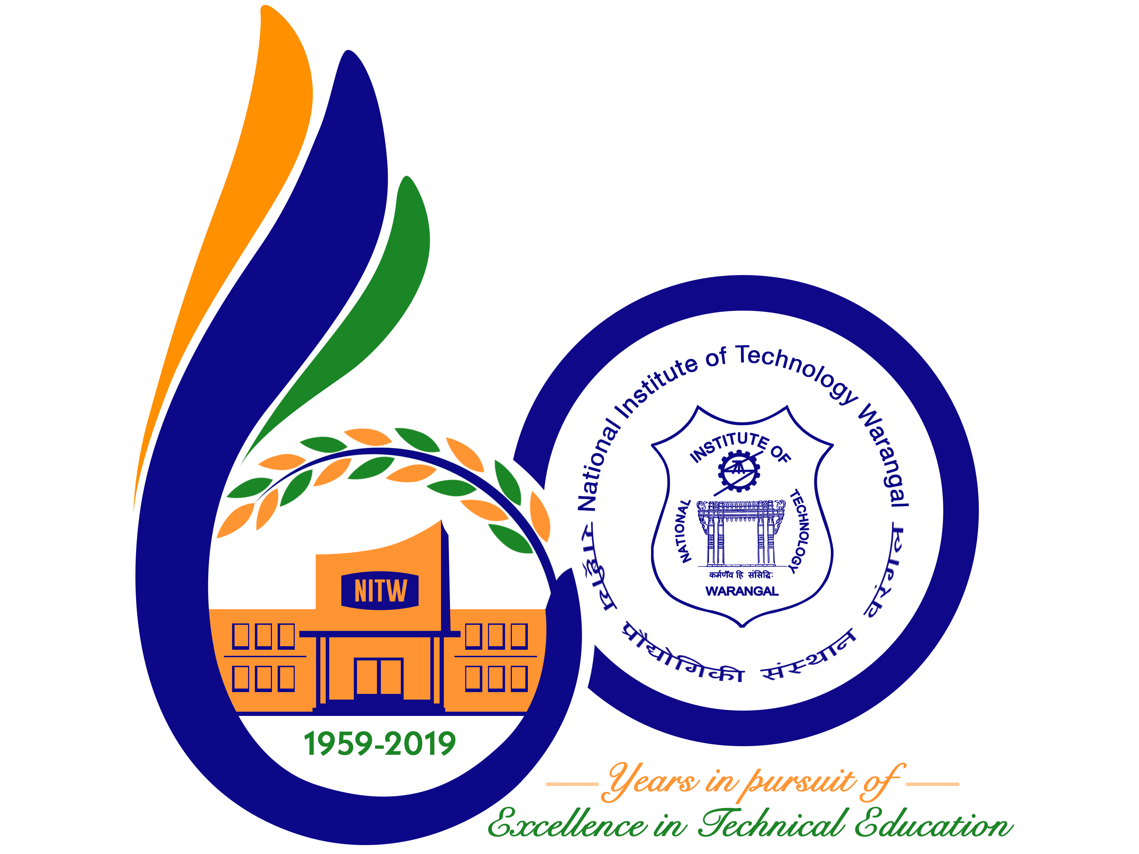

**New Frontiers in Chemical, Energy and Environmental Engineering (INCEEE – 2019)**

**15 – 16, February 2019**

**Organized by**

**Department of Chemical Engineering**

**National Institute of Technology Warangal, 506004, India**

**REGISTRATION FORM**

Name: Muralikrishna boni

Designation: Research scholar

Qualification: M.tech Gender: Male…

Organization: NIT warangal

Address for Correspondence: 14 th block, NIT Warangal hostel

Mobile No.: 8885223271 Email: muraliboni4@gmail.com

Category (Oral / Poster / Non-presenting): ……Oral…

Title of Paper: **Performance evaluation of an Air Breathing –Direct methanol fuel cell with different cathode current collector**

Paper ID No.: **18120102**

Payment Details (DD / Online transfer): …………… Online transfer ………………………………….

Amount: …………1500/-………DD/ Transaction ID No.:… IHJ3903057. Date:……01-01-2019…

Bank:……SBI…………………..

Date: 01-01-2019 D:\Journals-20-8-18\Chemical conference\mur sig.jpg

Place: NIT Warangal Signature of the Applicant

Forwarded through the Head of the Department / Institution