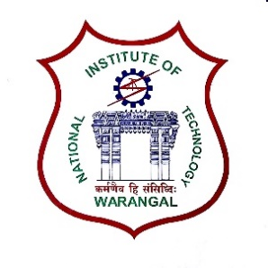**International Conference on**

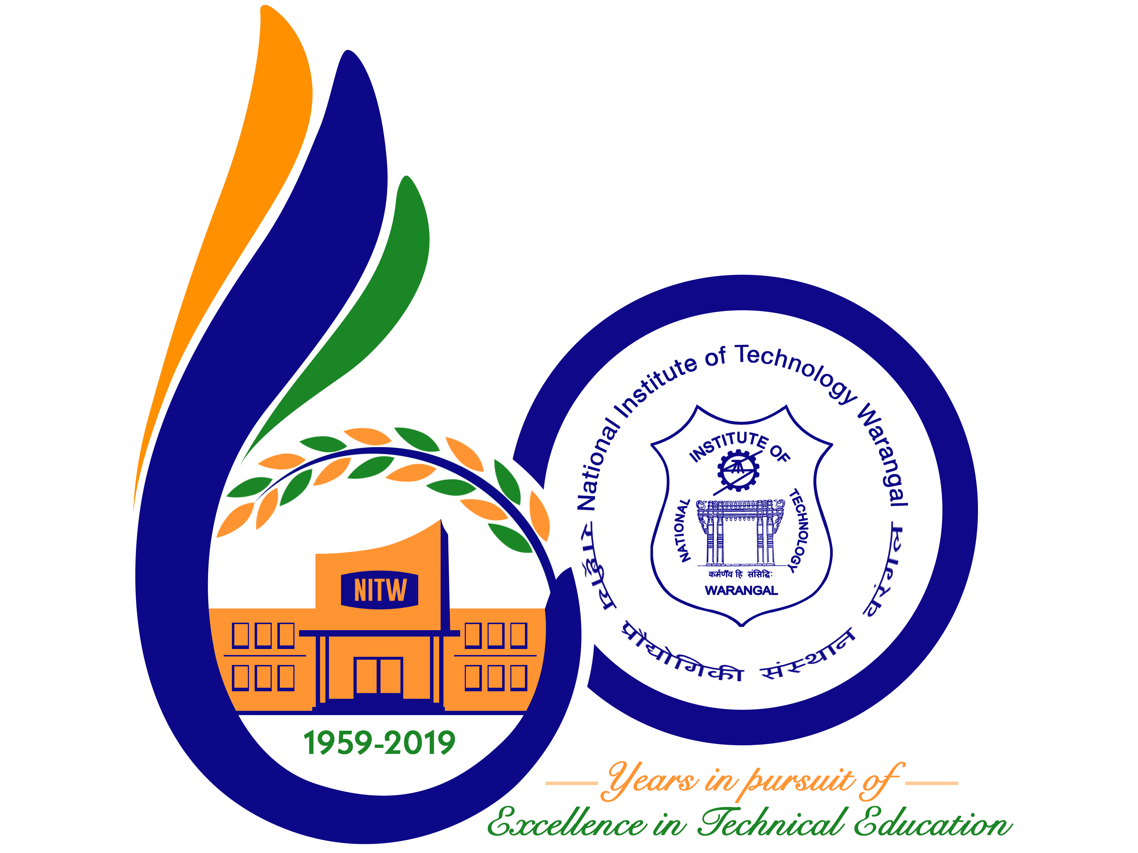

**New Frontiers in Chemical, Energy and Environmental Engineering (INCEEE – 2019)**

**15 – 16, February 2019**

**Organized by**

**Department of Chemical Engineering**

**National Institute of Technology Warangal, 506004, India**

**REGISTRATION FORM**

Name: **TAMILMANI J**

Designation: Research Scholar

Qualification: M.Tech., Ph.D.(Pursuing) Gender: Male

Organization: National Institute of Technology, Tiruchirappalli

Address for Correspondence: Tamilmani J, Research Scholar, Department of Chemical Engg,

National Institute of Technology, Tiruchirappalli,

Tamilnadu PIN-620015

Mobile No.: 09688894345 Email: tamilsiyaan@gmail.com

Category (Oral / ~~Poster / Non-presenting~~): **ORAL**

Title of Paper: Enhancing biohydrogen production from sugar industry effluent by metal oxide coatings on nickel foam cathode in Microbial Electrolysis Cell

Paper ID No.: **18111401**

Payment Details (~~DD /~~ Online transfer): **Online transfer**

Amount: **₨.1500** ~~DD/~~ Transaction ID No.: **IHJ3703322**  Date: **29-Dec-2018**

Bank: **SBI R E C TIRUCHIRAPALLI**

Date:

Place: NIT Trichy Signature of the Applicant

Forwarded through the Head of the Department / Institution