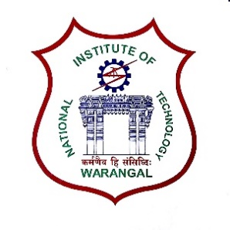**International Conference on**

**New Frontiers in Chemical, Energy and Environmental Engineering (INCEEE – 2019)**

**15 – 16, February 2019**

**Organized by**

**Department of Chemical Engineering**

**National Institute of Technology Warangal, 506004, India**

**REGISTRATION FORM**

Name: Kattela Siva Prasad

Designation: PhD Scholar

Qualification: M.Tech, Gender: Male

Organization: National Institute of Technology Warangal, 506004, India

Address for Correspondence: Fathima Nagar, Kazipet, Telenagana-506004

Mobile No.: 7674991614 Email: ksivaprasad286@gmail.com

Category (Oral / Poster / Non-presenting): Oral

Title of Paper:  Effect of n-butanol/diesel blends on performance and emissions characteristics of DI CI engine

Paper ID No.: 18112902

Payment Details (DD / Online transfer):

Amount: 1500 DD/ Transaction ID No.: IHJ3952468 Date: 01-01-2019

Bank: SBI

Date: 01-01-2019

Place: NIT WARANGAL Signature of the Applicant

Forwarded through the Head of the Department / Institution