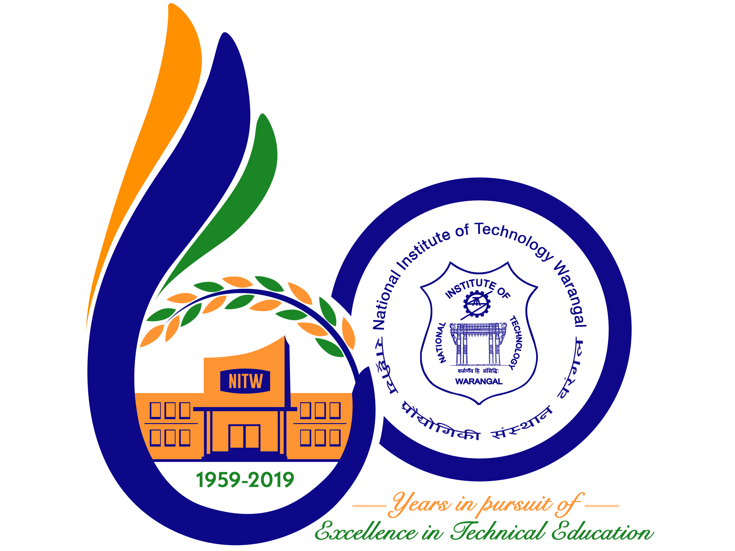**International Conference on**

**New Frontiers in Chemical, Energy and Environmental Engineering (INCEEE – 2019)**

**15 – 16, February 2019**

**Organized by**

**Department of Chemical Engineering**

**National Institute of Technology Warangal, 506004, India**

**REGISTRATION FORM**

Name: B.Sai Rohith …………………………………………………………………………………………….……………………..

Designation: Student …………………………………………………………………………………………………………………..

Qualification: B-Tech

…………………………………………………… Gender: Male ………………………………………

Organization: Chaitanya Bharathi Institute of Technology ………………………………………………………………………………………………………..…….…..

Address for Correspondence: flat no 402, meenakshi residency, bandari layout, nizampet, hyderabad ……… …………………………………………………………..…………………..…..

………………………………………………………………………………………….….

………………………………………………………………………………………….….

Mobile No.: 7093680860… ...………………………………………… Email: bairysairohith@gmail.com ……………………………………………..……

Category (Oral / Poster / Non-presenting): oral……………………………..

Title of Paper: Kinetic studies of CitrullusLanatus(Watermelon) peel using thermo gravimetric analysis

……….. ……………………………………………………………………………………………………..….

………………………………………………………………………………………………………………..….

………………………………………………………………………………………..………………………….

Paper ID No.: M097 ………………………………………..

Payment Details (DD / Online transfer): online transfer ……………………………………………….

Amount: 1500 …………………DD/ Transaction ID No.: UT38505927………………………………………. Date: 1-1-2019………………….

Bank: SBI………………………..

Date: 1-1-2019

Place: Hyderabad

Signature of the Applicant

Forwarded through the Head of the Department / Institution