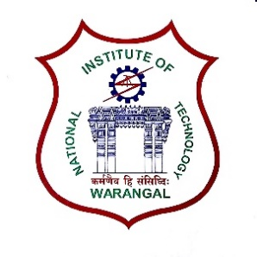**International Conference on**

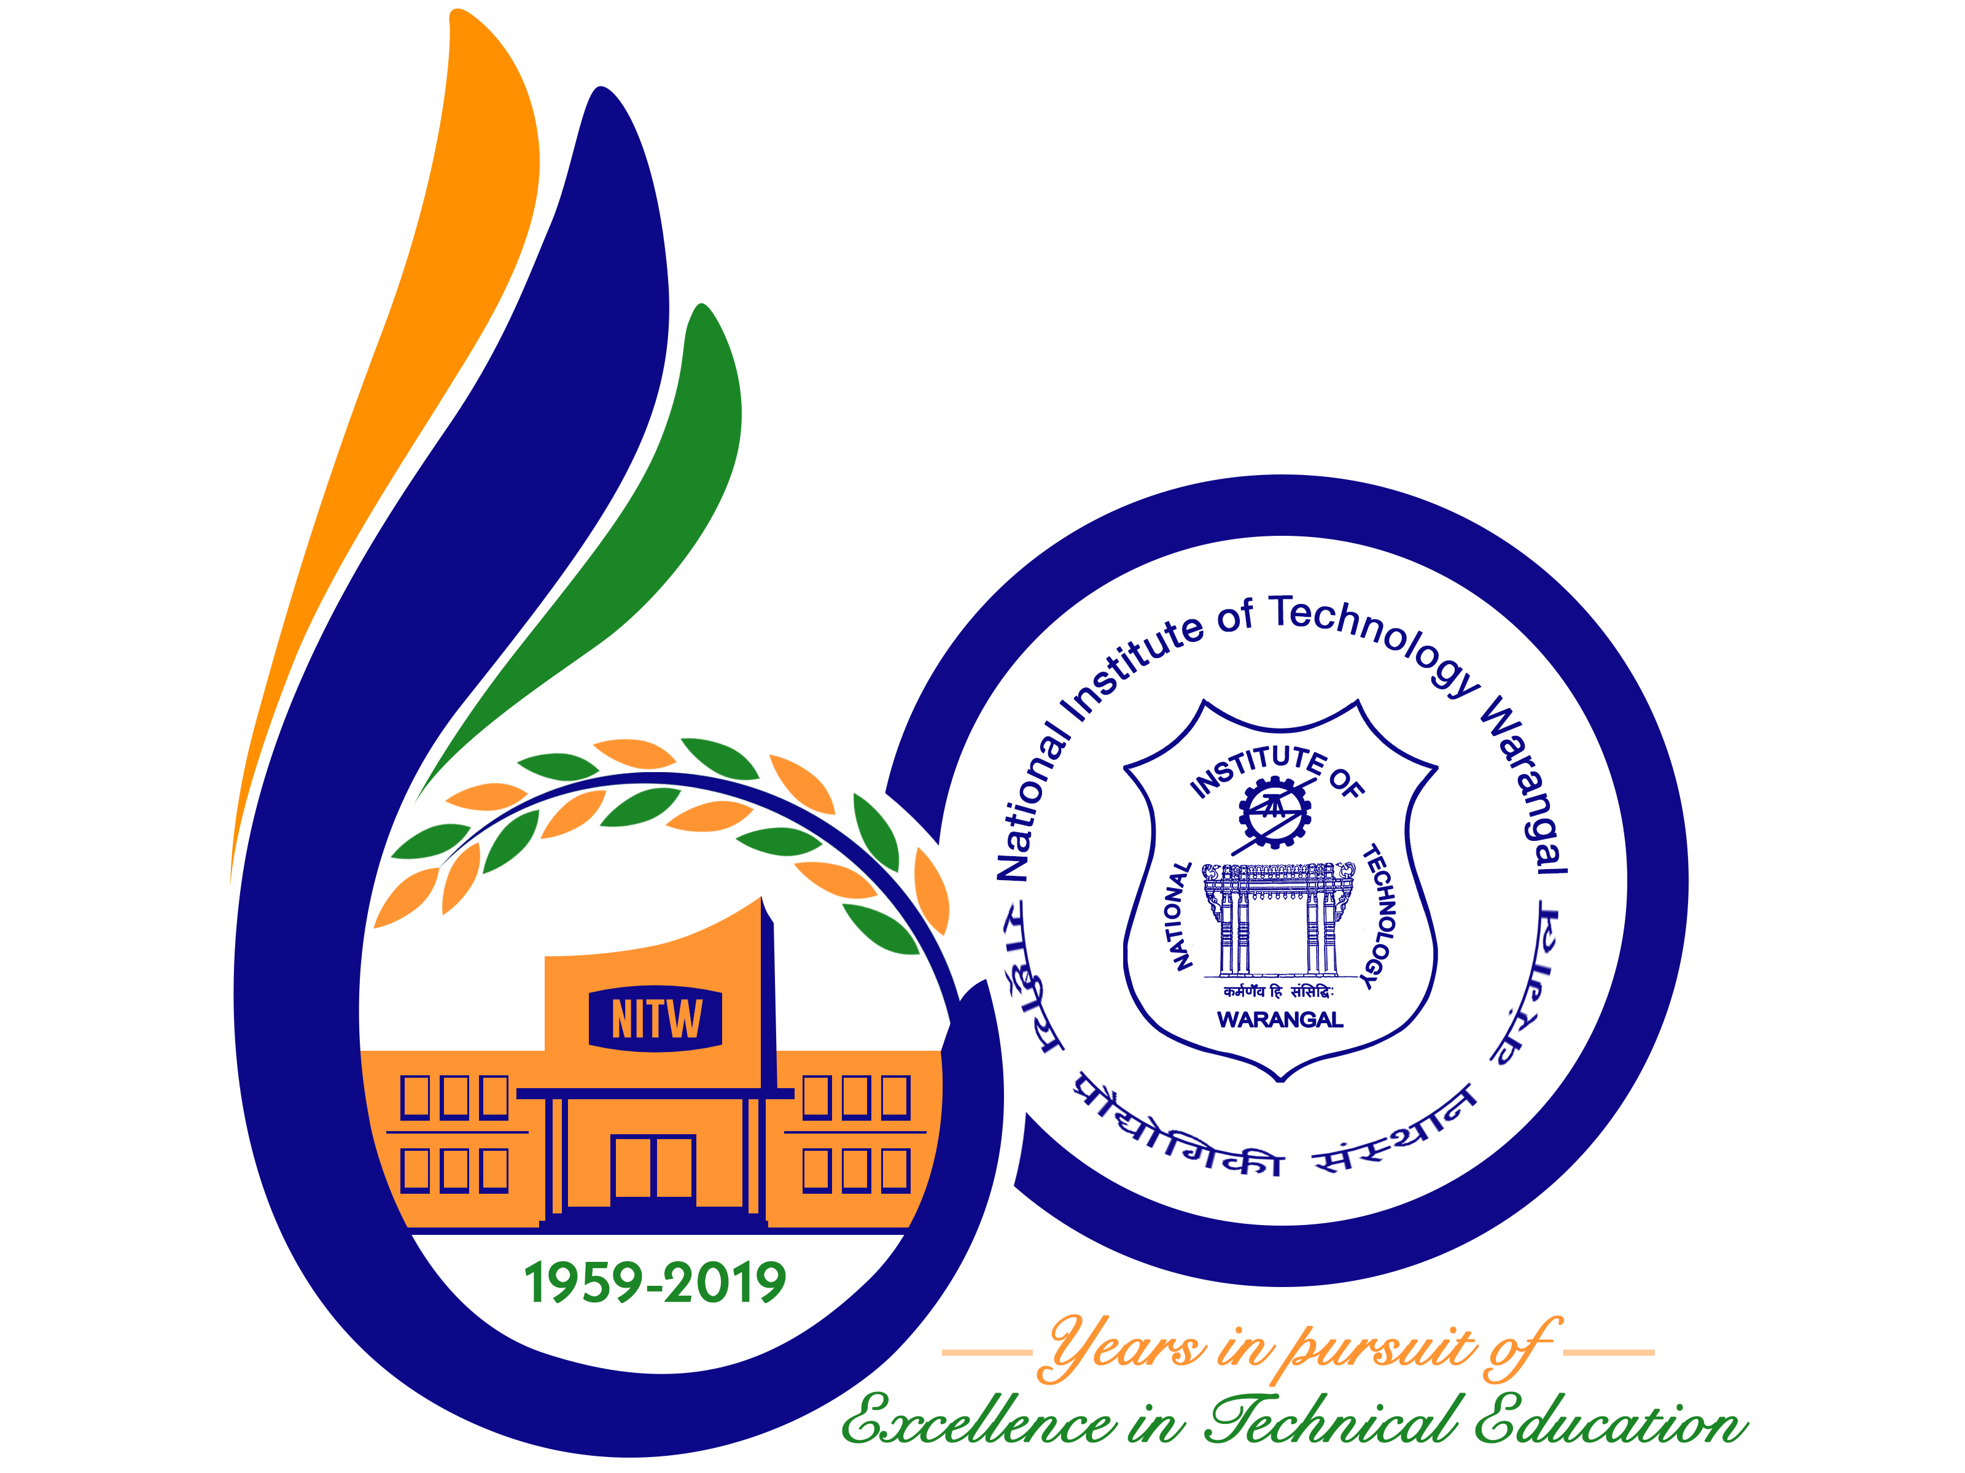

**New Frontiers in Chemical, Energy and Environmental Engineering (INCEEE – 2019)**

**15 – 16, February 2019**

**Organized by**

**Department of Chemical Engineering**

**National Institute of Technology Warangal, 506004, India**

**REGISTRATION FORM**

Name: ABHISHEK N SRIVASTAVA

Designation: Research Scholar

Qualification: M.Tech Gender: Male

Organization: Indian Institute of Technology (IIT) Delhi

Address for Correspondence: Simulation Laboratory Block V-312

Department of Civil Engineering, IIT Delhi

Hauz Khas, New Delhi- INDIA, PIN: 110016

Mobile No.: +91-7002728686 Email: abhishekiitdelhi17@gmail.com

Category (Oral / Poster / Non-presenting): Oral

Title of Paper: **Quantification of Landfill gas generation and Energy Potential estimation for Municipal Solid Waste in Delhi**

Paper ID No.: M076

Payment Details (DD / Online transfer): Online transfer

Amount: INR 1500 Transaction ID No.: **272880751** Date31/12/2018

Bank: Canara Bank, IIT Hauz Khas, New Delhi

Date: 31/12/2018

Place: New Delhi

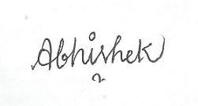

Signature of the Applicant