**International Conference on** 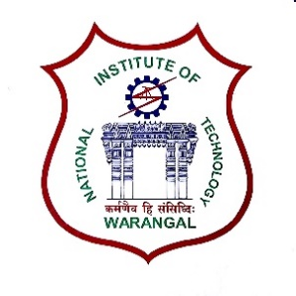

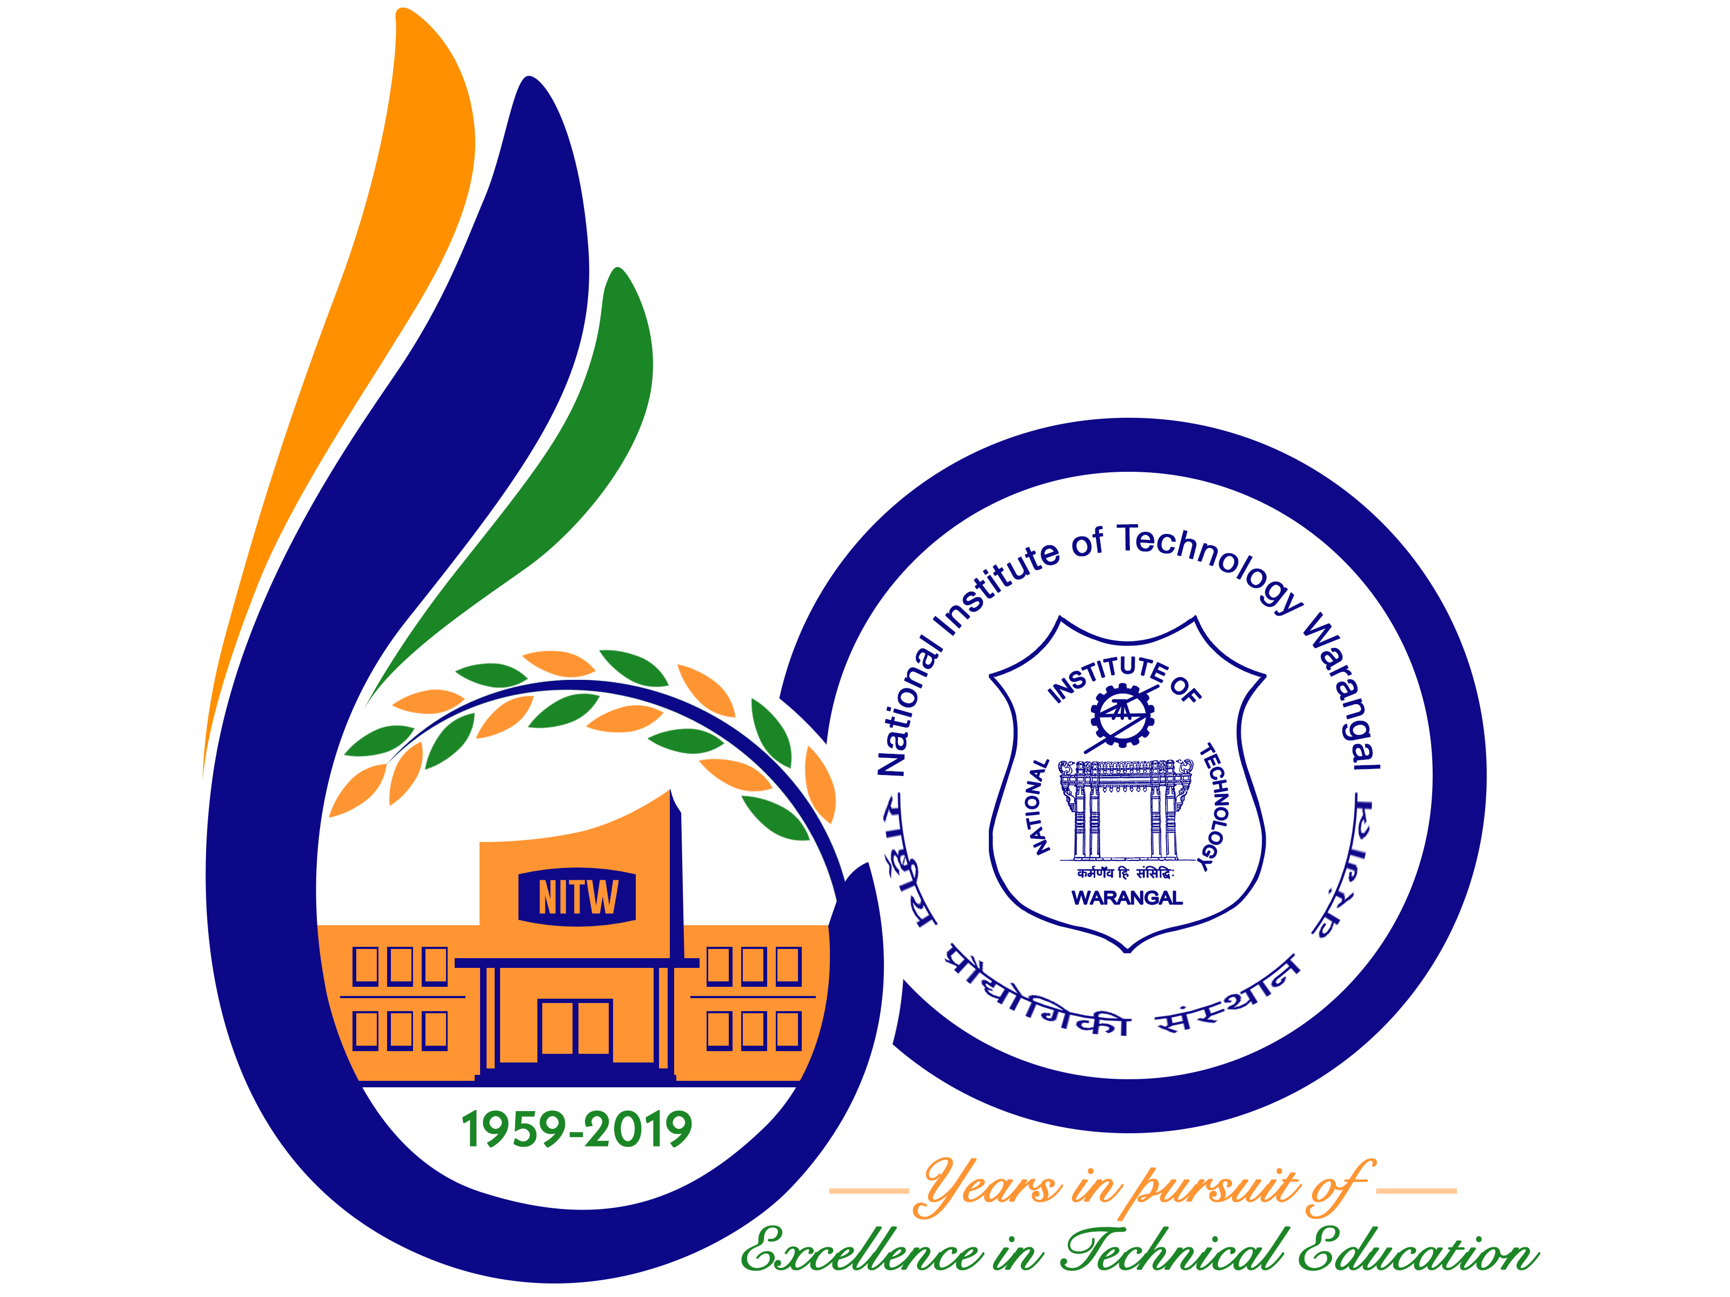

**New Frontiers in Chemical, Energy and Environmental Engineering (INCEEE – 2019)**

**15 – 16, February 2019**

**Organized by**

**Department of Chemical Engineering**

**National Institute of Technology Warangal, 506004, India**

**REGISTRATION FORM**

Name: Ramya Reddy pamulapati

Designation: student.

Qualification: b.tech. Gender: female

Organization: B.V.Raju institute of technology

Address for Correspondence: G2, tejeswi residency, nagarjuna homes,

Nizampet road,kukatpally, Hyderabad

500085

Mobile No.: 9100303922. Email: pamulapatiramya26@gmail.com

Category (Oral / Poster / Non-presenting): poster

Title of Paper: sorption studies of methelene blue on risk husk ash

.

Paper ID No.: M093

Payment Details (DD / Online transfer):online transfer.

Amount: 1500 DD/ Transaction ID No.:900909727864

Bank:Andhra Bank

Date: 9 Jan 2019

Place: Hyderabad Signature of the Applicant: Ramya

Forwarded through the Head of the Department / Institution