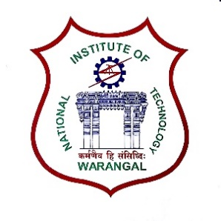**International Conference on**

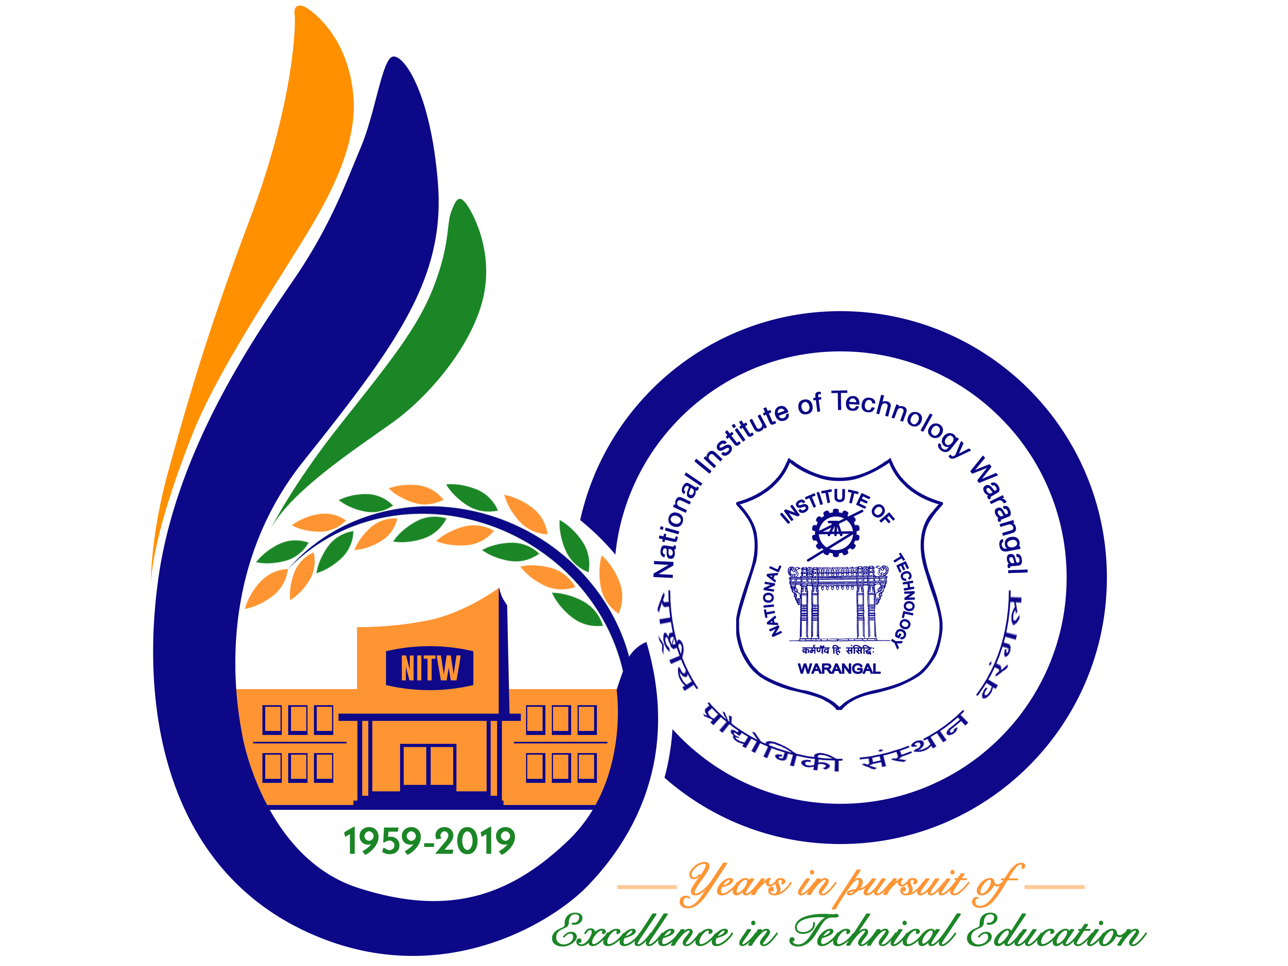

**New Frontiers in Chemical, Energy and Environmental Engineering (INCEEE – 2019)**

**15 – 16, February 2019**

**Organized by**

**Department of Chemical Engineering**

**National Institute of Technology Warangal, 506004, India**

**REGISTRATION FORM**

Name: D.SRINU

Designation: Asst. Prof.

Qualification: M.Tech (PhD) Gender: Male

Organization: TKR College of Engineering and Technology

Address for Correspondence: TKR College of Engineering and Technology, Medbowli, Meer pet, Hyd-500097

Mobile No.: 9494855488 Email: srinudaravath@gmail.com

Category (Oral / Poster / Non-presenting): Oral

Title of Paper: PARAMETRIC STUDIES ON COMBINED CONDUCTION AND CONVECTION HEAT TRANSFER IN PERFORATED FINS

Paper ID No.: 18121002

Payment Details (DD / Online transfer): Online transfer

Amount: 1500 DD/ Transaction ID No.: IMPS Ref no: 836517175532 Date: 31-12-2018

Bank: Karur Vysya Bank (KVB)

Date: 15-01-2019

Place: Hyderabad Signature of the Applicant

Forwarded through the Head of the Department / Institution