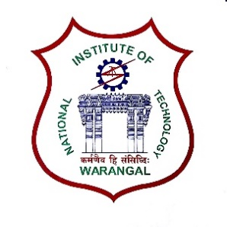**International Conference on**

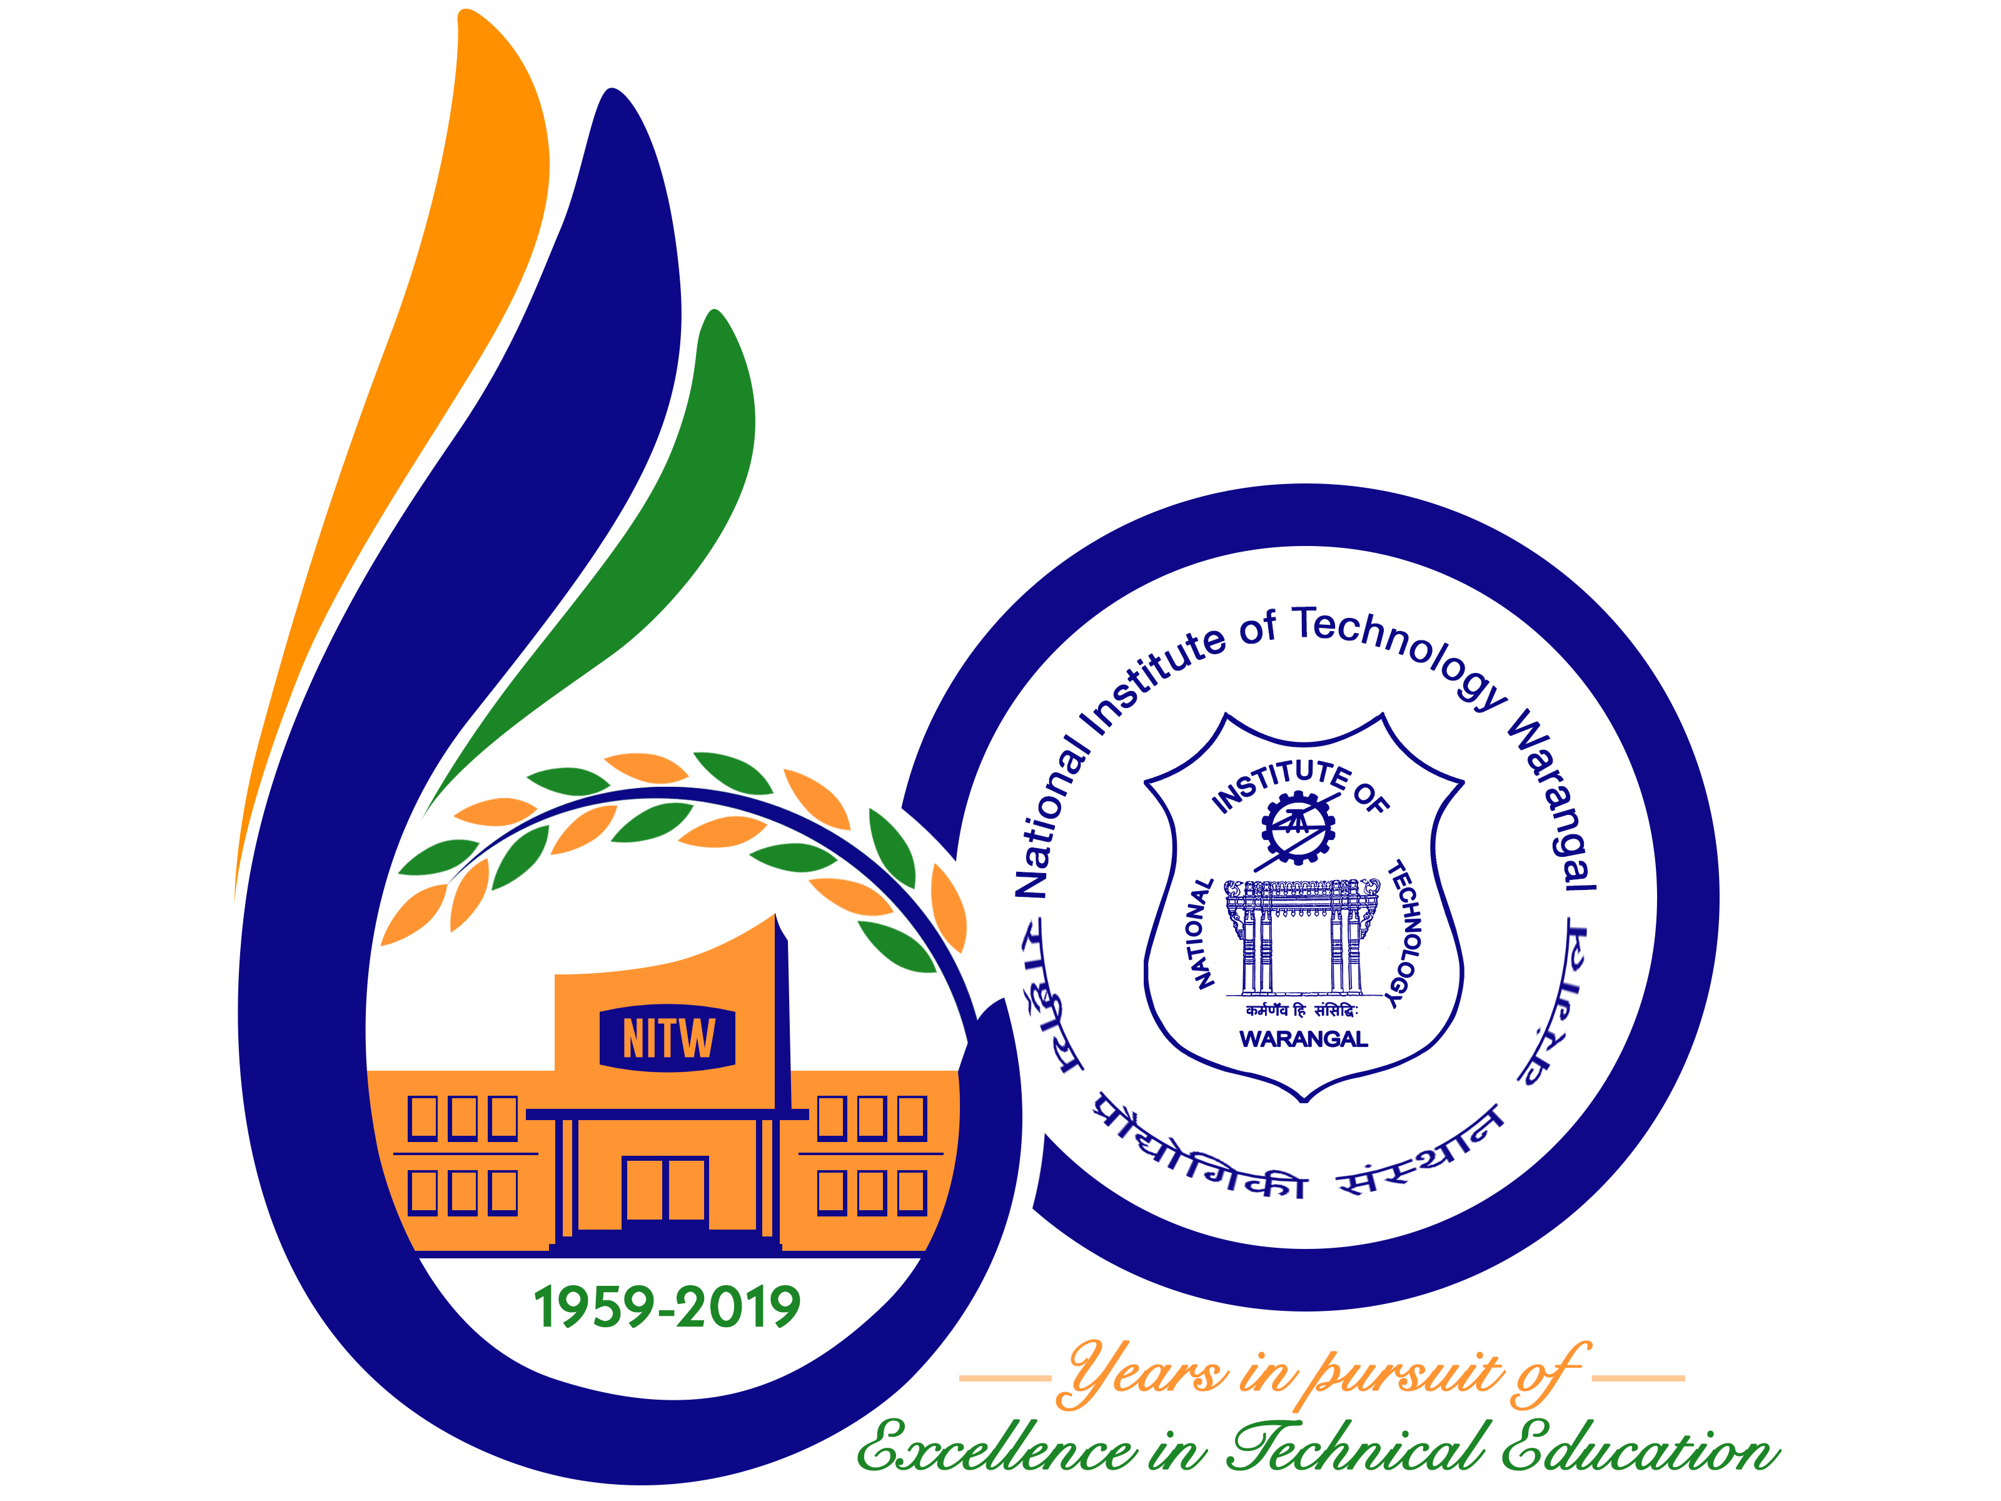

**New Frontiers in Chemical, Energy and Environmental Engineering (INCEEE – 2019)**

**15 – 16, February 2019**

**Organized by**

**Department of Chemical Engineering**

**National Institute of Technology Warangal, 506004, India**

**REGISTRATION FORM**

Name : S VENKATA SAI SUDHEER

Designation : RESEARCH SCHOLAR

Qualification : M.TECH (PhD) Gender: MALE

Organization : NATIONAL INSTITUTE OF TECHNOLGY WARANGAL

Address for Correspondence: ROOM NO: 14-1-22,

VIKRAM SARABHAI HOSTEL,

NIT WARANGAL

Mobile No.: 09642938100 Email: [svsaisudheernitw@gmail.com](mailto:svsaisudheernitw@gmail.com)

Category (Oral / Poster / Non-presenting): Oral.

Title of Paper: “Experimental investigation on flow boiling heat transfer characteristics

through vertical tube”

Paper ID No.: M059

Payment Details (DD / Online transfer): ONLINE TRANSFER.

Amount: Rs.1500/- DD/ Transaction ID No.: IHJ3891433 Date: 31/12/2018.

Bank: STATE BANK OF INDIA

Date: 31/12/2018 

Place: WARANGAL Signature of the Applicant

Forwarded through the Head of the Department / Institution