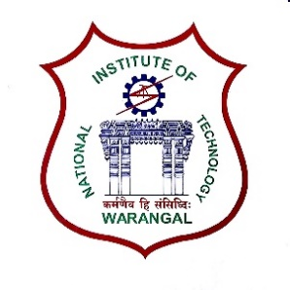**International Conference on**

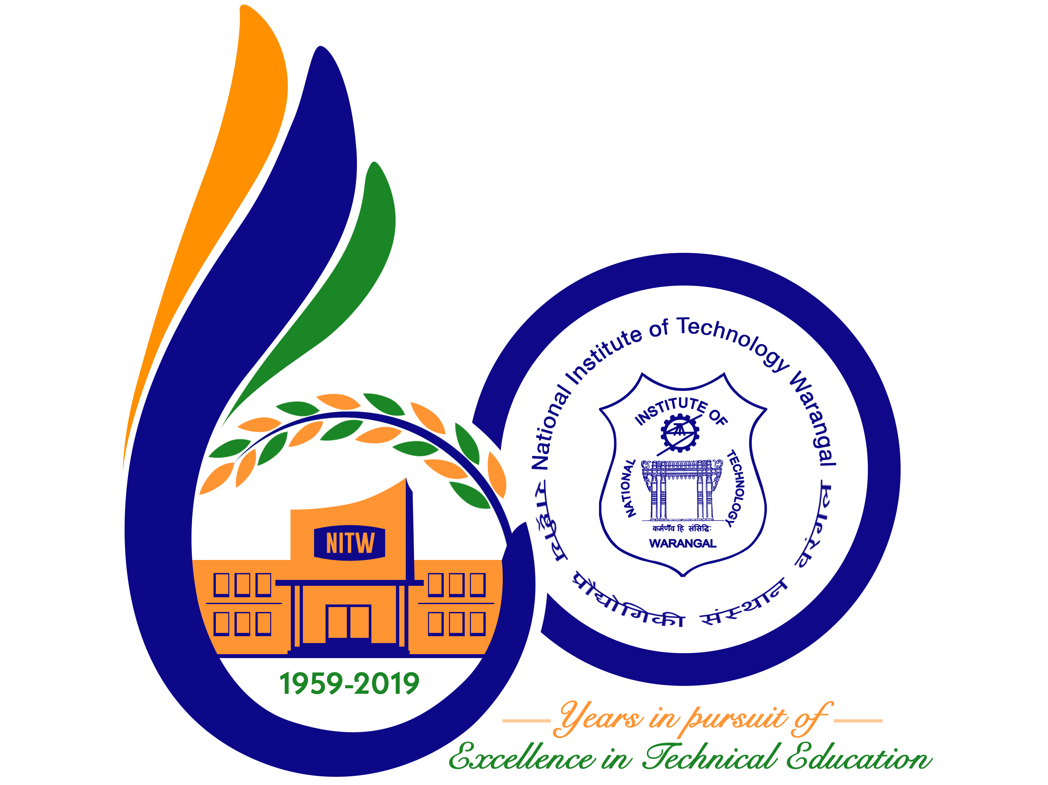

**New Frontiers in Chemical, Energy and Environmental Engineering (INCEEE – 2019)**

**15 – 16, February 2019**

**Organized by**

**Department of Chemical Engineering**

**National Institute of Technology Warangal, 506004, India**

**REGISTRATION FORM**

Name: Shubham Mohindru

Designation: Student

Qualification: B.Tech Gender Male

Organization: KLEF (Deemed to be University)

Address for Correspondence: Koneru Lakshmaiah Education Foundation, Greenfields, Guntur, 522502, Andhra Pradesh, India

Mobile No 7995642167 Email:160070392@kluniversity.in

Category (Oral / Poster / Non-presenting): **Oral Presentation**

Title of Paper: **Influence of wire fin on performance of coiled tube heat exchanger in a small J-T refrigerator**

Paper ID No.: **18120501**

Payment Details (DD / Online transfer): **Online transfer**

Amount: 1500 / Transaction ID No.:………………………………………. Date:………………….

Bank: SBI Date: 15-1-2019

Place: Mylavaram Signature of the Applicant Shubham Mohindru

Forwarded through the Head of the Department / Institution