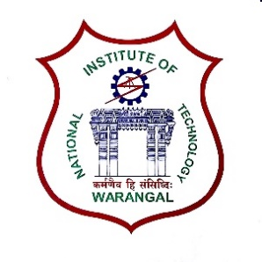**International Conference on**

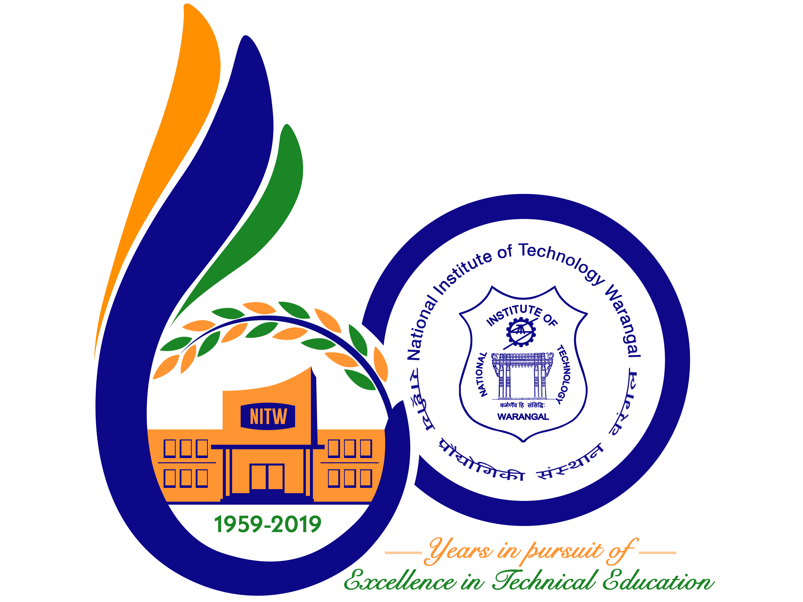

**New Frontiers in Chemical, Energy and Environmental Engineering (INCEEE – 2019)**

**15 – 16, February 2019**

**Organized by**

**Department of Chemical Engineering**

**National Institute of Technology Warangal, 506004, India**

**REGISTRATION FORM**

Name: VALAPARLA RANJITH KUMAR

Designation: RESEARCH SCHOLAR

Qualification: M.Tech Gender: Male

Organization: NIT--Warangal

Address for Correspondence: …RESARCH SCHOLAR,MED, NIT--WARANGAL

Mobile No.: 9985347176, 7386006827: Email:valaparlaranjith@gmail.com

Category (Oral / Poster / Non-presenting): ORAL

Title of Paper: [Numerical investigation of heat transfer and fluid flow characteristics in circular wavy microchannels with sidewall ribs](http://cms.nitw.ac.in/conference/downloadpaper/562).

Paper ID No.: 18121005

Payment Details (DD / Online transfer): Online transfer

Amount: 1500 DD/ Transaction ID No.: IHJ3873486 Date:31/12/2018

Bank:NET BANKING –QUICK TRANSFER—SBI—NITW--BRANCH

Date: 31/12/2018

Place: NIT--WARANGAL Signature of the Applicant:

Forwarded through the Head of the Department / Institution