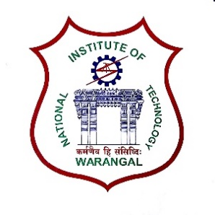**International Conference on**

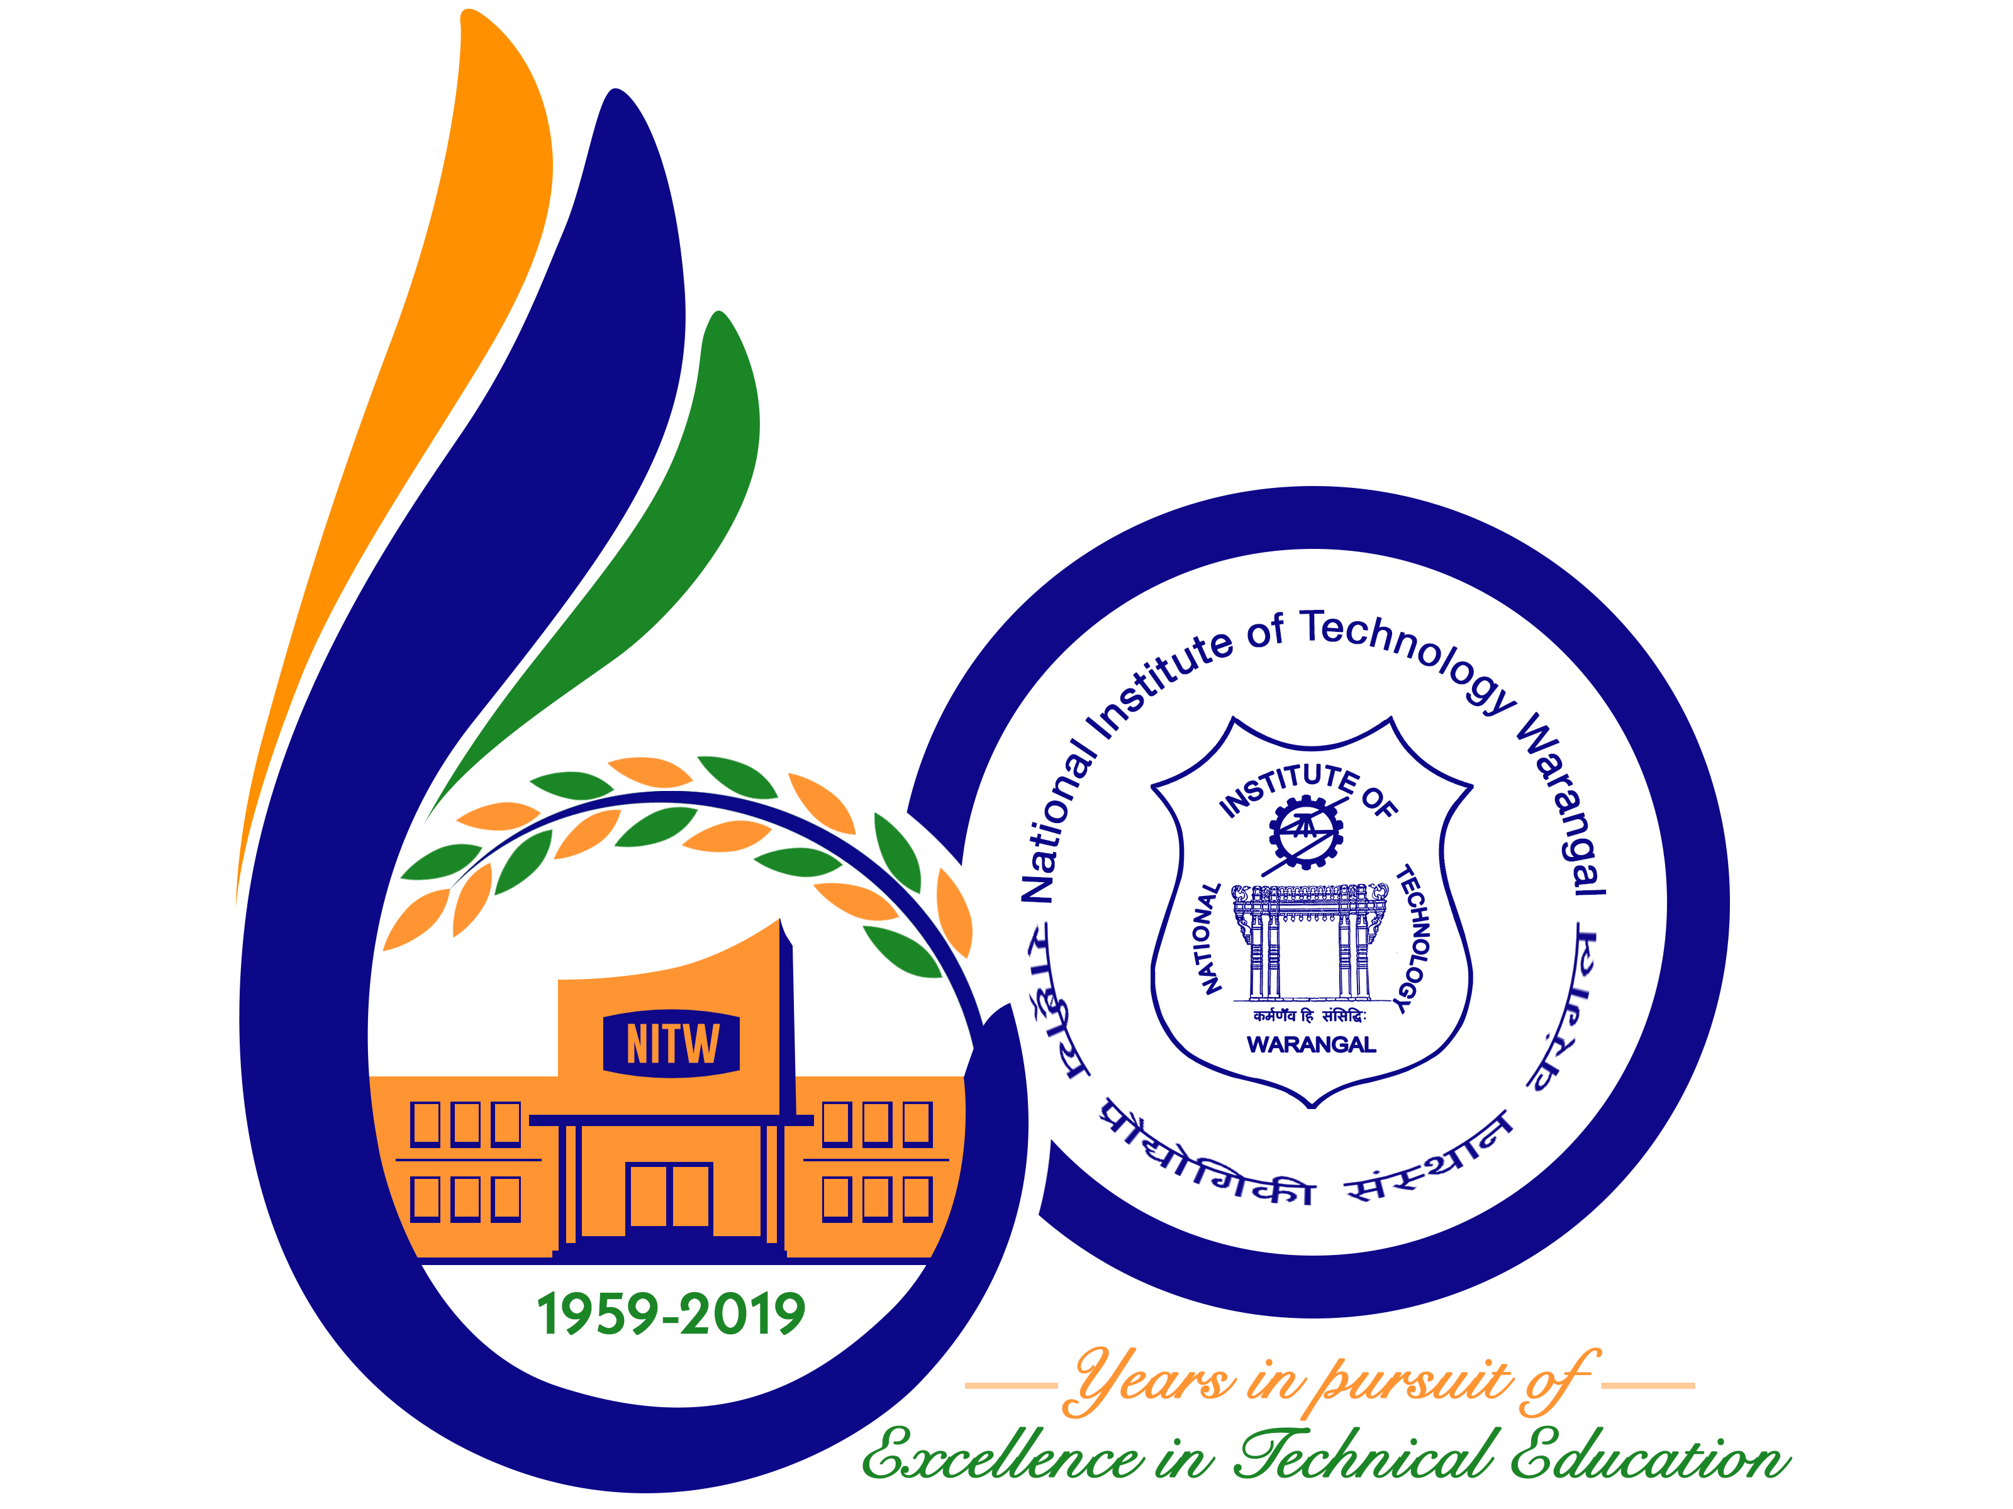

**New Frontiers in Chemical, Energy and Environmental Engineering (INCEEE – 2019)**

**15 – 16, February 2019**

**Organized by**

**Department of Chemical Engineering**

**National Institute of Technology Warangal, 506004, India**

**REGISTRATION FORM**

Name: P.Shirisha

Designation: Student

Qualification: B.Tech Gender: Female

Organization: Anurag Group of Institutions.

Address for Correspondence:

Department of chemical engineering

Anurag Group of Institutions.

Venkatapur RR(D) 500038

Mobile No.: 9160489856 Email: shirishapetchetty@gmail.com

Category (Oral / Poster / Non-presenting): Poster

Title of Paper: C4 PROJECT-THE MIRACLE RICE

Paper ID No 18113015

Payment Details (DD / Online transfer): Online transfer

Amount: 1500 DD/ Transaction ID No. IHJ3947094 Date:1/1/19

Bank: SBI –IICT hyd

Date: 1/1/19

Place: HYD