

**NATIONAL SYMPOSIUM ON**

**TRENDS IN ELECTRONICS & TELECOM (TREAT17)**

***Organized by***

***Department of ELECTRONICS AND***

***COMMUNICATION ENGINEERING,* NIT Warangal**

**17TH - 18TH FEBRUARY2017**

**REGISTRATION FORM**

Name: ………………………………………………...……………………

Designation: ……………………..…………………...………………….

Organization: …………………………………………...………………

Address for Correspondence:

………………...……...….……...................................................................

………………………………………………………...….…..........................

.......................................................................................…………………..

Tel/mobile no.…………………….. E-mail: ………………………..

Category: Oral/Poster presentation

Title of Paper:…………………………………………………………….

……..…………………………………………………………………………..

DD Particulars:

Amount …………………………….No..................................................

Date ………………………………….Bank ……………………..……….

Accommodation Required: Yes / No

Date:

Place:

Signature of the Applicant

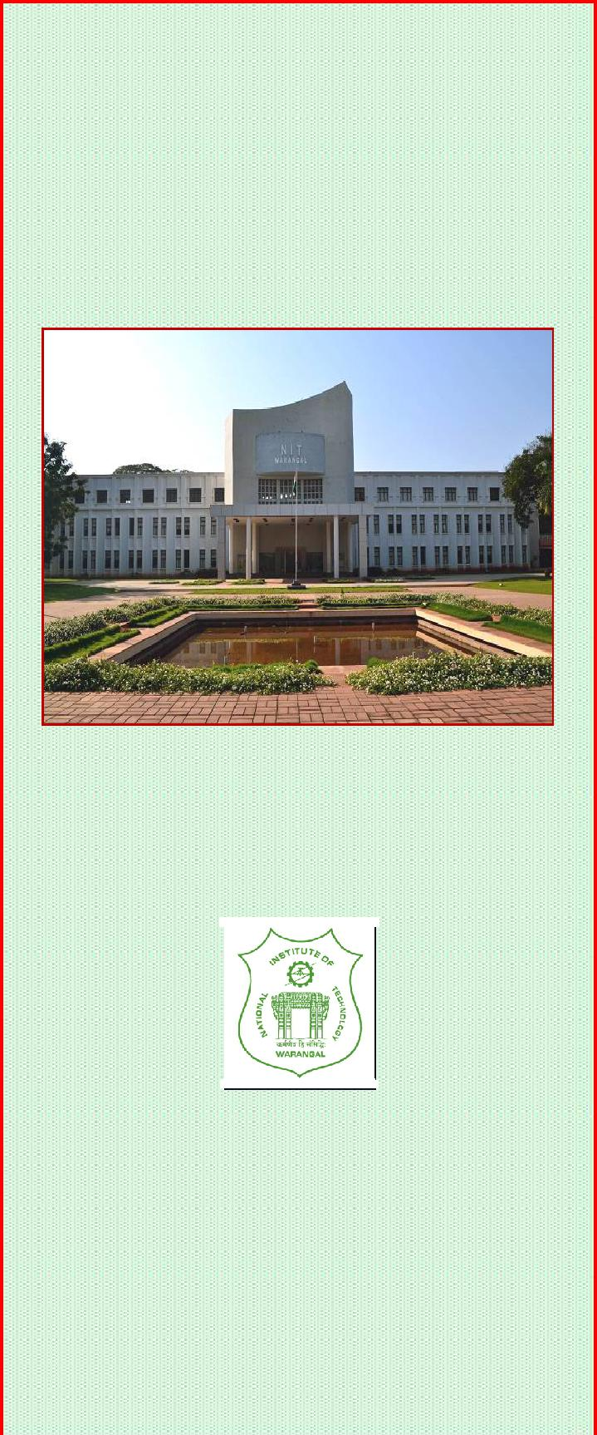**CHIEF PATRON**

Prof. G.R.C. Reddy, I/C Director, NIT Warangal

**ADVISORY COMMITTEE**

**National**

Prof. R.V. RAJA KUMAR, IIT, Bhubaneswar

Prof. AJAY CHAKRABARTY, IIT Kharagpur

Prof. SHANKAR P., IIT DELHI

Prof. RAMA SUBBA REDDY, IIT, Madras

Prof. D. JALIHAL, IIT Madras

Dr. D. R. JAHAGIRDAR , RCI Hyderabad

Prof. M.V. Karthikeyan, IIT ROORKEE

Prof. Ratnajit Bhattacharjee IIT Guwahati

Prof. Dr. Elizabeth Elias NIT **Calicut**

Prof. Muralidhar Kulakarni NITK, Suratkal

Prof. B. Venkataramani NIT Trichy

Dr. Lava Bhargava NIT Jaipur

**Departmental Organizing Committee**

**Prof. Krishna Prasad K S R**

**Sri Raghunath M. V**

**Dr. C.B. Rama Rao**

**Sri K.Ravi Kishore**

**Sri S.K.L.V.Sai Prakash**

**Sri P.Harikrishna Prasad**

**Dr. B. Lakshmi**

**Dr. N.Bheema Rao**

**Dr.L.Anjaneyulu**

**Sri K.V.Sridhar**

**Dr.T.V.K.Hanumantha Rao**

**Dr. P.Sreehari Rao**

**Sri A.Prakasa Rao**

**Sri P.Muralidhar**

**Smt.P.Prithvi**

**Smt.V.Rama**

**Dr.J.Ravi Kumar**

**Dr.D.Vakula**

**Sri K. Sarangam**

**Dr.S.Anuradha**

**Dr.V.V.Mani**

**ORGANISING SECRETARY**

**Dr. T. Kishore Kumar**

**NATIONAL SYMPOSIUM ON**

**TRENDS IN ELECTRONICS & COMMUNICATION (TREAT17)**

**17th – 18th FEBRUARY, 2017**

**ORGANISING SECRETARY**

**Dr. T. Kishore Kumar**

**Head of the Department**

**Convenor**

**PROF. N.V.S.N. SARMA**

**Sponsored by TEQIP-II, E&ICT Academy, NITW**

***Organized by***

**DEPARTMENT OF ELECTRONICS & COMMUNICATION ENGINEERING**

**NATIONAL INSTITUTE OF TECHNOLOGY**

**Warangal-506 004, T.S., India.**

**http://www.cms.nitw.ac.in/treat2017/**

**OBJECTIVE**

The objective of this symposium is to bring awareness and exposure to research scholars in various topics of current research interest so that they can actively pursue or incorporate the novel methods in other areas in their area of work. Also this symposium gives a forum for the researchers to have long discussions on future trends. The symposium is open to professionals, academics, and individuals from government agencies and other institutions registered for Ph.D. to exchange information and ideas on the advancement of Communications and Electronics technology.

The conference will feature a comprehensive technical program offering numerous technical sessions with papers showcasing the latest technologies, applications

and services. In addition, the conference program includes keynote talks from industrial leaders and renowned academicians,

**TOPICS OF INTEREST**

Topics on recent advances Electronics Engineering will include but are not limited to

**Wireless Communication**

**Wireless Sensor Networks**

**Microwave and Antennas**

**Optical Communication**

**Signal processing**

**Internet of Things**

**Embedded systems**

**Advances in Digital Design Analog / RF Design VLSI system Design with SDR Architectures**

**CALL FOR PAPERS**

Authors are invited to **submit the Full Papers,** not exceeding 6-pages in MS word format (soft copy) and neatly typed on A-4 size paper. Each manuscript will undergo a peer review process. To upload papers, please visit our website.

The contributed papers must be original and should not have published/ accepted in journals/proceedings. Upon the notification of acceptance, the author will have to submit final copy of the manuscript of the paper, copyright transfer agreement and registration fee and registration form on or before the last date.



**TREAT-2017 is planning to bring out Proceedings in the form of a DVD.**

**IMPORTANT DATES**

|  |  |  |
| --- | --- | --- |
| Submission of Full Paper | 30th Jan, 2017 |  |
| Acceptance of Paper | 6th Feb, 2017 |  |
| Receipt of full length | 13th Feb, 2017 |  |
| paper |  |  |
| Last Date of Registration | 14th Feb, 2017 |  |
|  |  |  |
| **BEST PAPER AWARD** |  |  |

A "Best Paper Award" will be conferred to the author(s) of a full paper presented at the conference

**REGISTRATION FEE**

|  |  |
| --- | --- |
| Delegates from Academic , R &D | Rs. 2000/- |
| Institutions |  |
| Delegates from Industry | Rs. 6000/- |
| Students | Rs. 1000/- |
|  |  |

**Mode of Payment:**

Account Name Director, (TEQIP-II), NITW

Account Number 62182612968

Bank State Bank of Hyderabad

Branch REC Warangal (NIT Campus)

Branch Code 20149

IFSC SBHY0020149

The registration fee can be paid through Demand Draft

1. drawn in favor of “Director, (TEQIP), NIT WARANGAL” or Online/NEFT. The filled in registration form along with the DD/Payment receipt should be sent by post or email to:

**Organising Secreatary,Treat-2017,** Department of ECE,

National Institute of Technology, Warangal-506 004, Telangana State, India.

Ph: 0870-2462412

**E-mail:** [**treat2017.nitw@gmail.com;**](mailto:treat2017.nitw@gmail.com;)

**ACCOMMODATION**



Limited accommodation may be provided on payment basis in the institute Visitors Block depending on availability and on first come first served basis. Participants who require accommodation in hotels will be arranged on PAYMENT basis. Warangal city covers a wide range of hotels and other accommodation facilities to suit every budget. Participants are advised to contact the hotels directly and book their accommodation. However, in case of difficulty, we will assist on your prior request.

**ABOUT THE DEPARTMENT & INSTITUTE**

National Institute of Technology (formerly Regional Engineering College), Warangal is the first among 17 RECs setup as joint venture of the Government of India and the state government. Over the years the college has established itself as a premier Institution imparting technical education of a very high standard leading to the B.Tech degrees in various branches of engineering and M.Tech. and Ph.D programs in various specializations.

The Department of Electronics and Communication Engineering offers an Undergraduate program in Electronics and communication Engineering and three Postgraduate programs in EI, VLSI, and ACS Specializations. The Department has experienced faculty and well-established laboratories to meet the requirement of UG, PG and Phd students. The Department has liaison with reputed industries and R&D organizations like DRDO, ISRO ECIL, Analog Devices Bangalore and C-DAC. Department conducts various sponsored programs throughout the year. At present, more than 30 Research Scholars are working for their Ph.D program.