**Two Week FDP on Blockchain Technology – The Future of Cyber Security (BCTFCS-2019)**

**(2nd December 2019 – 14th December 2019)**

**(Sponsored by ICPS Division of DST, Govt. of India)**

**Department of Computer Science and Engineering, National Institute of Technology, Warangal, Telangana State, India.**

Department of Computer Science and Engineering

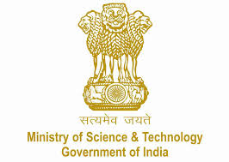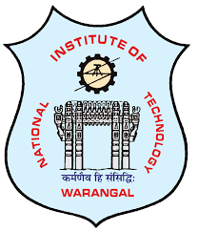

**Course Overview**

**About the FDP**

This course designed with the state-of-the-art concepts of Blockchain technology that comprises of theory as well as hands-on sessions in the area of Cyber Security and Blockchain System. Half of the course is designed for theory, use–case demonstrations, and research oriented discussions, which will be helpful in understanding the process; and the remaining 50% course for practical implementation(hands-on). In brief this FDP covers Introduction to Blockchain Theory-Distributed Ledger Technologies (DLT), Permissioned and Permissionless Blockchains, Model, framework, Blockchain network and architecture design, Blockchain consensus and fault tolerance mechanisms, Blockchain test-beds, platforms and simulations, Applications using or built on top of blockchains, Cryptographic algorithms and protocols, Security and reliability in Blockchain, Privacy and trust in blockchain, Blockchain applications in areas such as Internet of Things(IoT), Internet of things and blockchains.

The Department of Computer Science and Engineering, National Institute of Technology Warangal is organizing two weeks National level Faculty Development Programme (FDP) on Blockchain Technology- The Future of Cyber Security (BCTFCS-2019) sponsored by the Interdisciplinary Cyber Physical System (ICPS) Division, Department of Science & Technology (DST), Govt. of India. Distinguished Aacademicians, faculty members, research scholars, under-graduate, and graduate students are invited to attend this programme.

**Objective**

The objective of this programme is to unite practitioners, researchers and people from industry to discuss the progress on state-of-the-art research and the practical usage of blockchain technologies, focusing on the application and the technologies relying on it. Specifically, this FDP is to promote discussion on theory, progress, development, deployment and the practical usage of blockchain technologies with respect to cyber security.

|  |
| --- |
| **Topics to be Covered**  ( but not limited to) |
| Blockchain Theory-Distributed Ledger Technologies (DLT) |
| Permissioned and Permissionless Blockchains |
| Model, framework, and mechanism in designing blockchain |
| Blockchain network and architecture design |
| Consensus protocols for blockchains |
| Peer-to-Peer Networks, Peer-to-Peer communication protocols |
| Cyber-attacks to blockchain |
| Insider Threats- Case studies (e.g., of adoption, attacks, forks, scams etc.) |
| Cryptographic algorithms and protocols |
| Security and reliability in Blockchain |
| Privacy and trust in blockchain |
| Security related issues in blockchain |
| Internet of things (IoT) and blockchains |

**Outcome**

This FDP aims to unite interested scholars as well as industrial members from all relevant disciplines. The Outcome of this FDP is to promote, establish and speed up block chain technology related research, and identify future research challenges.

* **Application Notification : Oct 10, 2019**
* **Last Date for Application : Oct 30, 2019**
* **Acceptance Notification : Nov 5, 2019**
* **Start of the Programme : Dec 2, 2019**
* **End of the Programme : Dec 14, 2019**



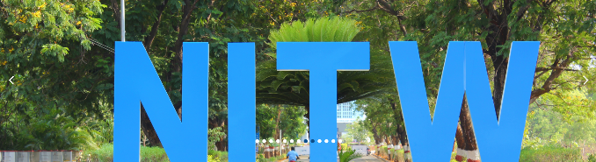

**Important Dates**

**Organised By**

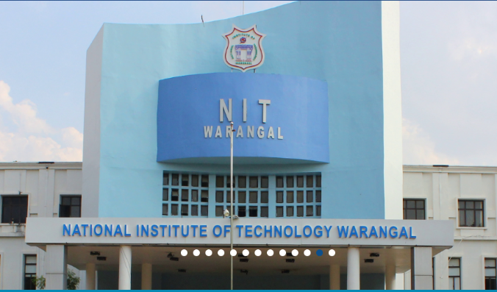

**Coordinators & Contact Information**

* **Dr. E.Suresh Babu,**

Assistant Professor,

Dept. of Computer Science & Engineering,

National Institute of Technology, Warangal.

(Email: [esbabu@nitw.ac.in](mailto:esbabu@nitw.ac.in)), Phone: +91 9440959713.

* **Dr. Y.Sreenivasa Rao**

Assistant Professor,

Dept. of Mathematcis,

National Institute of Technology, Warangal.

(Email: [ysr@nitw.ac.in](mailto:ysr@nitw.ac.in)), Phone: +91 9494776866.

|  |
| --- |
| **Who Can Attend?** |
| Course is open to Faculty Members/Research Scholars/PG Students From Colleges/Universities working in the relevant/allied disciplines. |

|  |
| --- |
| **How to Apply?** |
| * Applicants are requested to download the registration form from https://nitw.ac.in/.................................. * Send the Scanned copy of filled application to **esbabu@nitw.ac.in** and Hard copy to the following Address:   **Dr. E.Suresh Babu,**  Assistant Professor,  Dept. of Computer Science & Engineering,  National Institute of Technology, Warangal.  Warangal, Telangana(state), India. Pin-506004  Phone: +91 9440959713   * Mention on top of the cover "Application for Two Week FDP on Blockchain Technology – The Future of Cyber Security (BCTFCS-2019)” |

|  |
| --- |
| **Registration Form** |
| 1. **Name of the participant :………………………………………………………………** 2. **Organisation/Institute Name : …………………………………………….……… ………………………………………………………………………………………………………** 3. **Department Name : ………………………………………………………………………** 4. **Designation: …………………………………………………………………………………** 5. **Gender : (Male/Female) :………………………………………………………………** 6. **Address : ……………………………………………………………………………………… ………………………………………………………………………………………………………………………………………………………………………………………………………………** 7. **Caterogy : (GEN/OBC/SC/ST) : …………………………………..…………………..** 8. **Area of Interest : …………………………………………………………………………...** 9. **E-Mail ID : ………………………………………………………………………………………** 10. **Moible: …………………………………………………………………**   **Declaration of Applicant**  **I hereby declare that I have read all the terms and conditions mentioned in the FDP Brochure and agree to them. Also, all the information furnished here are true to the best of my knowledge, if found false/ incomplete/ incorrect, my application/ admission is liable to be rejected/cancelled at any time.**  **Place: …………………………..**  **Date: …………………………… (Signature of the Applicant)**  **Endorsement by Authority:**  **I recommend that Prof/Dr./Mr./MS./Mrs.w……………………………… ……………………………………Designation:..…………………………………………… (Institution)…………………………………………..……………., to attend the Two Week FDP from 2nd Dec 19" to 14th Dec 2019 and he/she will be relieved during this time to attend the FDP at NITW, if selected. This is also to certify that the details mentioned in this application form by him/her are checked and found to be correct.**  **Place: …………………………..**  **Date: …………………………… Signature**  **Head of the Instituion With Seal** |

* **Khurana Seminar Hall**, Seminar Complex, Near NITW Auditorium, National Institute of Technology, Warangal
* Speakers from IITs, NITs, Research Labs, Startups and Industries

**Venue**

* **Maximum Number of participants** is allowed: **30**
* **Registration Fee:** **No**
* **Free shared accommodation** will be provided on prior intimation
* **Working lunch, snacks & dinner** will be provided
* Participants are advised to bring their **own Laptops for experiments**
* Selection of Participants is based on **First Come First Serve Basis**

**General Information**

**Speakers**

**About the Department**

Department of Computer Science & Engineering is the most sought by students in India and abroad for admissions in to all its programmes. Popularity is gained for its innovative teaching of courses in ever updated curriculum so that top software industries prefer our students. Alumni have spread over the world across MNCs enjoying their positions in top brass and running their own industries. Department was established in 1991 and currently offering B.Tech.(CSE), M.Tech.(CSE), M.Tech.(CSIS), MCA and Ph.D by following pedagogical and technological methods to address the ever advancing courses.

**About the Institute**

National Institute of Technology, Warangal (Deemed University) , formerly known as Regional Engineering College, was established in 1959. Pandit Jawaharlal Nehru laid the foundation stone for this institute on October 10, 1959, the first in the chain of 30 NITs (formerly known as RECs) in the country. The Institute is well known for its dedicated faculty, staff and the state-of-the art infrastructure conducive to a healthy academic environment. The Institute is constantly striving to achieve higher levels of technical excellence. Evolving a socially relevant and yet internationally acceptable curriculum, implementing innovative and effective teaching methodologies and focusing on the wholesome development of the students are our concerns. Through the years, it has carved its niche for its teaching, research processes that assure the quality students to the world and hence Govt. of India listed NIT Warangal as An Institute of National Importance and is fully funded by Ministry of HRD, GoI, New Delhi with President of India as its Visitor.

**Two Week FDP on Blockchain Technology – The Future of Cyber Security (BCTFCS-2019)**

**(2nd December 2019 – 14th December 2019)**

**(Sponsored by ICPS Division of DST, Govt. of India)**

**Department of Computer Science and Engineering, National Institute of Technology, Warangal, Telangana State, India.**

Department of Computer Science and Engineering

