Organizing committee

Patron

Prof. N. V. Ramana Rao, Director, NITW

Chairman

Dr. C. Vanitha, Head, MMED

Conveners

Prof. G. V. S. Nageswara Rao

Prof. N. Narasaiah

Members

Dr. Asit Kumar Khanra

Dr. Mahesh Kumar Talari

Dr. Nagumouthu Kishore Babu

Dr. G. Brahma Raju

Dr. B. Srinivasa Rao

Dr. Ajoy Kumar Pandey

Dr. R. Arockia Kumar

Dr. V. Rangadhara Chary

Dr. Mithipati Siva Bhaskar

Dr. Varam Sreedevi

Dr. Avishkar Bhaurao Rathod

Dr. Uma Maheswara Rao Seelam

Contact

The Convener

ICAM5

Metallurgical and Materials Engineering Department

National Institute of Technology, Warangal

Warangal- 506 004, Telangana State, India

Phone 0870-2462521 (off)

Mobile 08332969385 (Chairman)

08332969382 (Convener)

08332969384 (Co-convener)

Fax 0870-2459547

E-mail icam5nitw@gmail.com

gvsnr@nitw.ac.in

nn@nitw.ac.in

Web

**About the Institute**

The National Institute of Technology Warangal, an institute of national importance (formerly known as the Regional Engineering College Warangal) established in the year 1959, is the first among the 31 NITs in the country setup as joint venture of the Government of India and the State Government. The institute offers 8 undergraduate programmes in engineering and 29 postgraduate programmes leading to M.Tech., M.Sc. (Tech.), MCA and MBA degrees. All the departments of the institute conduct research programmes leading to Ph.D. degrees. NIT Warangal is consistently ranked among top 10 technical institutes in country. It is located on the Hyderabad- Warangal national highway at a distance of 3km from Kazipet railway station and 12km from Warangal railway station. It is spread over 250acres and is totally residential campus. Participant are advised to alight either at Kazipet or Warangal depending upon their train of travel.

**About the Department**

The Department of Metallurgical and Materials Engineering (MME) was established in the year 1965 and presently offers an undergraduate program in MME and two postgraduate programs with specialization in Industrial Metallurgy and Materials Technology. The department is consistently receiving accreditation by NBA since past several years for its excellent academic and research activities. The department has experienced faculty and well established laboratories with state-of-the-art facilities in various areas of research. The department also offers PhD programme in MME and presently about 37 scholars are working in key areas of research. The department is also in collaborative research with organizations such as DMRL, ARCI, IGCAR, BARC, BHEL etc. Presently the department is engaged with research projects received from DAE-BRNS, DRDO-NRB, ERIPR, ARDB, AUSC Mission Directorate, etc.

**About Warangal**

Warangal is about 135km from Hyderabad, the capital of Telangana. It is well connected by rail and road. It is well known as an educational centre. Once, the capital of the great Kakatiya Kingdom and earlier known as Orugallu or Ekasilanagaram, Warangal still retains its importance as the cultural centre of the Telangana. It finds an important place in the tourist map of Telangana with sites of archaeological significance like the Warangal fort, Thousand Pillars temple, Bhadrakali templeand Ramappa temple. The three lakes namely Ramappa, Pakhal and Laknavaram and the wild life sanctuaries at Tadwai and Pakhal are famous for sightseeing.

**International Conference on**

**Advances in Minerals, Metals, Materials, Manufacturing and Modelling**

**(ICAM5)**

**25-27 September 2019**

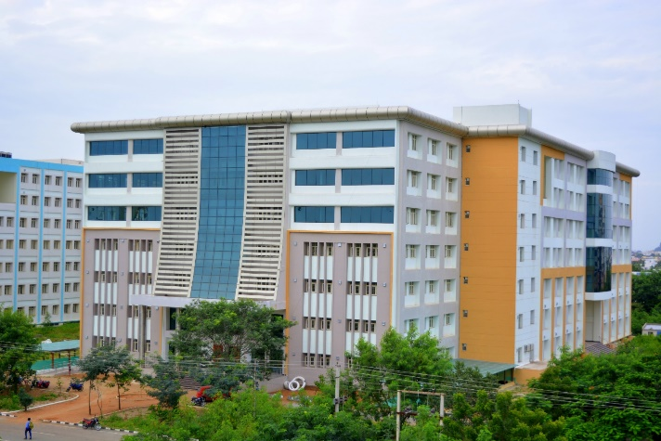On the occasion of Diamond Jubilee Celebrations of NIT Warangal

Sponsored by

**TEQIP III**

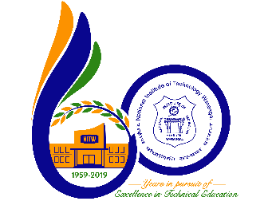

Organized by

Metallurgical and Materials Engineering Department

National Institute of Technology Warangal

(An Institute of National Importance)

Warangal-506 004, Telangana State, India

**About the conference**

The conference is being organized by the department as a part of institute’s diamond jubilee celebrations. The very purpose of the conference is to provide a platform for the academicians, scholars, researchers and industries to discuss and disseminate the knowledge created in minerals processing, new materials development, materials degradation and computational materials modelling. Further to discuss the advances and challenges in thematic areas.

**Thematic areas**

ICAM5 welcomes research papers on the following topics but not limited to:

Advances in mineral processing

Advances in iron and steel making

Special steels and alloys

High-temperature materials

Nanomaterials and nanostructured materials

Corrosion and oxidation

Creep, fatigue and creep-fatigue interaction

Surface engineering

Powder metallurgy

Advances in manufacturing

Advances in aerospace materials

Thermomechanical processing

Welding/ joining

Advanced ceramics/composites/polymers

Additive manufacturing

Energy materials/ bio-materials

Computational materials science/ process modelling

**Advisory committee**

Dr. Vikas Kumar Director, DRDO-DMRL

Dr. N. Eswara Prasad, Director, DMSRDE

Dr. G. Padmanabhan, Director, ARCI

Dr. Dinesh Srivatsava, CoE, NFC

Dr. T. Jayakumar, DRDO-DMRL

Dr. G. Amarendra, IGCAR

Prof. C. Surayanarayana UCF, USA

Prof. Ramana G Reddy

Sri. Rout, Vizag Steel

Prof. K. Hono, NIMS, Japan

Prof. G. V. S. Sastry, IIT-BHU

**Call for abstracts**

Authors should submit an abstract of their original, unpublished work in not exceeding 300 words in the attached format. The abstract must be mailed to icam5nitw@gmail.com

**Publication of proceedings**

Efforts are being made to publish the peer-reviewed papers in SCI/Scopus indexed/ reputed journals. Please check the website regularly for the updates.

**Awards**

Best paper presentation award will be conferred on the selected author(s) of papers presented at the conference.

**Sponsorship**

Various opportunities of sponsorship are available in ICAM5. The tariffs of each category of sponsorship and the benefits are displayed in website. The prospective sponsors are requested to contact the organizers.

**Metallography contest**

Metallography contest is organized for students/ scholars where black& white/ color micrographs displaying interesting microstructures obtained using optical/ electron microscopes. The selected micrographs will be awarded cash prize. However, participant should be a registered delegate of the conference.

**Accommodation**

The delegates will be provided boarding and lodging. In view of limited availability of rooms, accommodation will be provided on first come first serve basis. Delegates will not be entitled for payment of any TA/DA.

**How to reach?**

Nearby airport:

Hyderabad International airport (3hrs journey from Warangal)

Nearby railway station:

Kazipet (KZJ) 3km from NIT, Warangal

Warangal (WL) 13km from NIT, Warangal

**Tourist attraction nearby**

Lakhnavaram lake 70km from Warangal

Ramappa Temple 70km from Warangal

Siva Temple 120km from Warangal

**Confirmed speakers list**

Prof. C. Suryanarayana

Prof. Rama G Reddy

Dr. Vikas Kumar Director, DRDO-DMRL

Dr. N. Eswara Prasad, Director, DMSRDE

Dr. G. Padmanabhan, Director, ARCI

**Registration charges**

|  |  |  |  |  |
| --- | --- | --- | --- | --- |
| Category | Early bird | | Regular | |
| Indian  (INR) | Others  (USD) | Indian  (INR) | Others  (USD) |
| Academia &  R&D | 2500 | 200 | 3000 | 250 |
| Industry  participants | 5000 | 300 | 6000 | 350 |
| Research scholars | 1500 | 100 | 2000 | 150 |
| Accompanying person | 1500 | 100 | 2000 | 150 |

Registration fee along the registration form (attached herewith) may be sent to in the form of DD in favor of Convener- ICAM5 payable at Warangal or remitted through online / NEFT to the below mentioned bank account

|  |  |
| --- | --- |
| Account name | Convener- ICAM5 |
| Account No. |  |
| Bank | State Bank of India |
| Branch | REC Warangal (NITW) |
| Branch code | 20149 |
| IFSC | SBIN0020149 |
| MICR code | 506002030 |
| SWIFT code | SBININBBH14 |

**Important dates**

Abstract submission 10 Jun 2019

Notification of acceptance 30 Jun 2019

Full paper submission 15 Jul 2019

Early bird registration 15 Aug 2019

Registration deadline 15 Sep 2019