DATABASE DESIGN

**4. Database Design**

**4.1 Introduction**

Database is a collection of related data. Relational database stores data in a table or relations. The data stored in a relation are arranged in records. Each record consists of set of attributes. Fields can be referred to characteristics of records. This document describes the table that is used to design software, its attributes, data types, constraints and relationship among those tables.

**The design process consists of the following steps:**

* Determine the purpose of your database.
* Find and organize the information required.
* Divide the information into tables.
* Turn information items into columns.
* Specify primary keys.
* Set up the table relationships.
* Refine your design.
* Apply the normalization rules.

**4.2. Purpose and scope**

**Purpose**

* **Avoid Redundant Data**

The table in the database should be constructed following standards and with utmost dedication. It should have different fields and minimize redundant data. The table should always have a Primary Key that would be a unique id.

* **Faultless Information**

The database should follow the standards and conventions and provide meaningful information useful to the organization.(Constraint)

* **Data Integrity**

Integrity assists in guaranteeing that the values are valid and faultless. Data Integrity is set to tables, relationships, etc.

* **Modify**

The database developed should be worked upon with the conventions and standards, so that it can be easily modified whenever the need arise.

**Scope**

* Normalization of Database.
* Imposing Integrity Constraint.
* Establishing the Relation between the tables.
* Accessing the data from multiple tables. (Usage of join and sub query….)

**4.3. Database Identification**

The identification of database by unique name given to the various database objects. The identifier is the name of database object. The following are the various database objects.

* Tables
* Columns

**4.4. Schema information**

The database schema is its structure described in a [formal language](https://en.wikipedia.org/wiki/Formal_language) supported by the [database management system](https://en.wikipedia.org/wiki/Database_management_system) (DBMS). The term "[schema](https://en.wiktionary.org/wiki/schema)" refers to the organization of data as a blueprint of how the database is constructed (divided into database tables in the case of [relational databases](https://en.wikipedia.org/wiki/Relational_databases))

In a relational database, the scheme defines the table, fields, relationship, views, indexes, packages, procedure, functions, queues, triggers, types, sequences, materialized views.

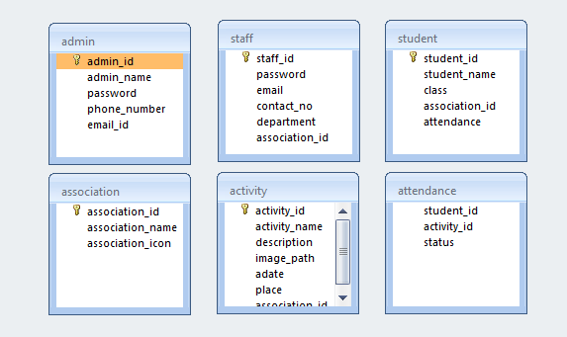

Fig(4.1)

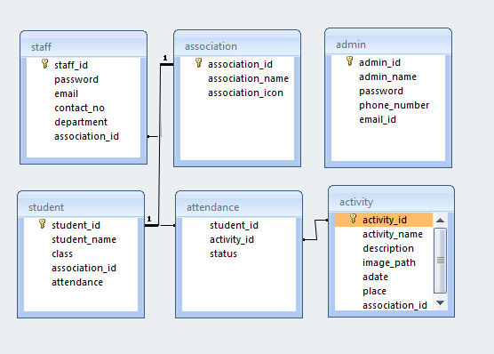

Fig(4.2)

**4.5. Table Definition**

* **admin**

|  |  |  |  |  |
| --- | --- | --- | --- | --- |
| Column Name | Data Type | Size | Constraint | Description |
| admin_id | varchar | 50 | Primary key | Admin id |
| admin_name | varchar | 50 | Not null | Admin name |
| password | varchar | 50 | Not null | password |
| phone_number | varchar | 50 | Not null | Phone number |
| email_id | varchar | 50 | Not null | Email id |

**Table 4.1**

|  |  |  |  |  |
| --- | --- | --- | --- | --- |
| Column Name | Data Type | Size | Constraint | Description |
| staff_id | varchar | 50 | Not null | Staff id |
| password | varchar | 50 | Not null | password |
| email | varchar | 50 | Not null | Email |
| contact_no | varchar | 50 | Not null | Contact no |
| department | varchar | 50 | Not null | department |
| association_id | varchar | 50 | Not null | Association id |

* **staff**

**Table 4.2**

* **activity**

|  |  |  |  |  |
| --- | --- | --- | --- | --- |
| Column Name | Data Type | Size | Constraint | Description |
| activity_id | varchar | 50 | Primary key | Activity id |
| activity_name | varchar | 50 | Not null | Activity name |
| description | mediumtext | 50 | Not null | description |
| image_path | varchar | 100 | Not null | Image path |
| date | date | 50 | Not null | Date |
| place | varchar | 50 | Not null | Place |
| association_id | varchar | 50 | Foreign key | Association id |

**Table 4.3**

* **association**

|  |  |  |  |  |
| --- | --- | --- | --- | --- |
| Column Name | Data Type | Size | Constraint | Description |
| association_id | varchar | 50 | Primary key | Association id |
| association_name | varchar | 50 | Not null | Association name |
| Association_icon | varchar | 100 | Not null | Association icon |

**Table 4.4**

* **attendance**

|  |  |  |  |  |
| --- | --- | --- | --- | --- |
| Column Name | Data Type | Size | Constraint | Description |
| student_id | varchar | 50 | Foreign key | Student id |
| activity_id | varchar | 50 | Foreign key | Activity id |
| status | tinyint | 1 | Not null | status |

**Table 4.5**

* **student**

|  |  |  |  |  |
| --- | --- | --- | --- | --- |
| Column Name | Data Type | Size | Constraint | Description |
| student_id | varchar | 50 | Primary key | Student id |
| student_name | varchar | 50 | Not null | Student name |
| class | varchar | 10 | Not null | Class |
| association_id | varchar | 50 | Foreign key | Association id |
| attendance | int | 10 | Not null | Attendance |

**Table 4.6**

**4.6. Physical design**

**The physical design is where you translate schemas into actual database structures.**

* Entity to Table
* Tuples to rows
* Attribute to Column
* Primary Key and Alternate Key to Unique Index
* Domain into Constraints

**4.7. Data Dictionary**

A data dictionary is a file or a set of files that includes a database's metadata. The data dictionary hold records about other objects in the database, such as data ownership, data relationships to other objects, and other data.

The data dictionary, in general, includes information about the following:

* Name of the data item
* Aliases
* Description/purpose
* Related data items
* Range of values
* Data structure definition

**4.8. ER diagram**

ER-modeling is a data modeling method used in software engineering to produce a conceptual data model of an information system. Diagrams created using this ER-modeling method are called Entity-Relationship Diagrams or ER diagrams or ERDs.

|  |  |
| --- | --- |
| Symbols | Conversion |
|  | Entity |
|  | Weak entity |
|  | Relation |
|  | Identity Relation |
|  | Attribute |
|  | Derived Attribute |
| R  E  E  1 R | Cardinality ratio 1:N from E1:E2 in R. |

**Components of an ER Diagrams**

### **1. Entity**

An entity can be a real-world object, either animate or inanimate, that can be merely identifiable.

An entity is denoted as a rectangle in an ER diagram. For example, in a school database, students, teachers, classes, and courses offered can be treated as entities. All these entities have some attributes or properties that give them their identity.

**Entity Set**

An entity set is a collection of related types of entities.

**Strong Entity**

An entity with uniquely identified by its attribute.

**Weak Entity**

In a relational database, a week entity is an entity that cannot be uniquely identified by its attributes alone.

**2. Attributes**

Entities are denoted utilizing their properties, known as attributes. All attributes have values. For example, a student entity may have name, class, and age as attributes.

There exists a domain or range of values that can be assigned to attributes. For example, a student's name cannot be a numeric value. It has to be alphabetic. A student's age cannot be negative, etc.

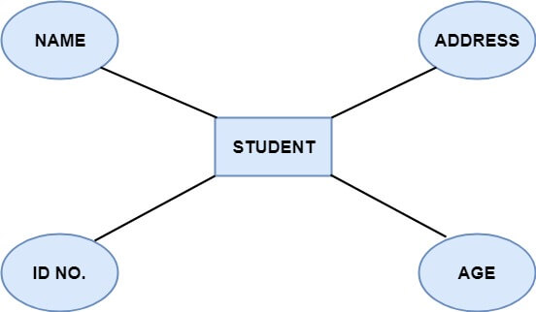

**There are four types of Attributes:**

1. Key attribute
2. Composite attribute
3. Single-valued attribute
4. Multi-valued attribute
5. Derived attribute

**1. Key attribute:** Key is an attribute or collection of attributes that uniquely identifies an entity among the entity set. For example, the roll number of a student makes him identifiable among students.

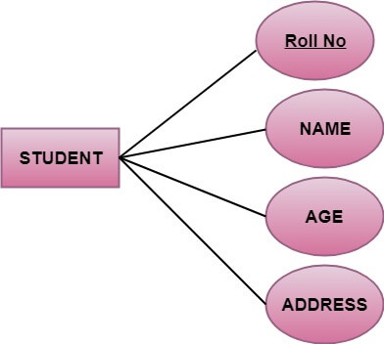

**2. Composite attribute:** An attribute that is a combination of other attributes is called a composite attribute. For example, In student entity, the student address is a composite attribute as an address is composed of other characteristics such as pin code, state, country.

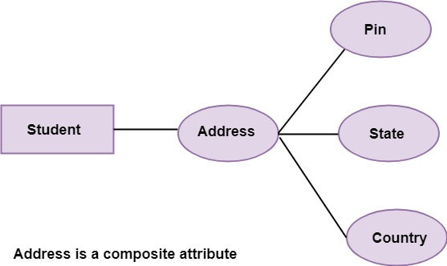

**3. Single-valued attribute:** Single-valued attribute contain a single value. For example, Social_Security_Number.

**4. Multi-valued Attribute:** If an attribute can have more than one value, it is known as a multi-valued attribute. Multi-valued attributes are depicted by the double ellipse. For example, a person can have more than one phone number, email-address, etc.

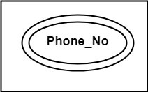

**5. Derived attribute:** Derived attributes are the attribute that does not exist in the physical database, but their values are derived from other attributes present in the database. For example, age can be derived from date_of_birth. In the ER diagram, Derived attributes are depicted by the dashed ellipse.

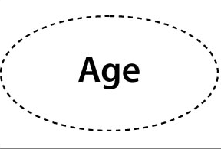

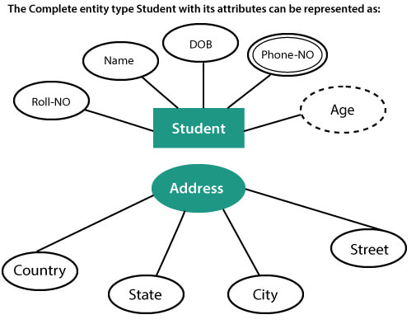

**3. Relationships**

The association among entities is known as relationship. Relationships are represented by the diamond-shaped box. For example, an employee works at a department, a student enrolls in a course. Here, Works at and Enrolls are called relationships.

**Degree of a relationship set**

The number of participating entities in a relationship describes the degree of the relationship. The three most common relationships in E-R models are:

1. Unary (degree1)
2. Binary (degree2)
3. Ternary (degree3)

**1. Unary relationship:** This is also called recursive relationships. It is a relationship between the instances of one entity type. For example, one person is married to only one person.

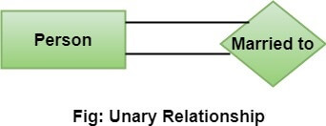

**2. Binary relationship:** It is a relationship between the instances of two entity types. For example, the Teacher teaches the subject.

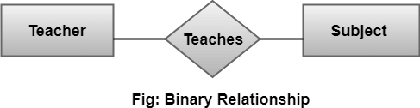

**3. Ternary relationship:** It is a relationship amongst instances of three entity types. In fig, the relationships "**may have**" provide the association of three entities, i.e., TEACHER, STUDENT, and SUBJECT. All three entities are many-to-many participants. There may be one or many participants in a ternary relationship.

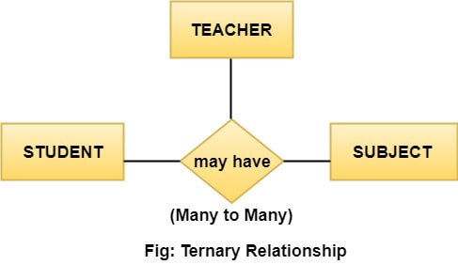

**Cardinality Ratio**

Cardinality describes the number of entities in one entity set, which can be associated with the number of entities of other sets via relationship set.

**Types of Cardinalities**

**1. One to One:** One entity from entity set A can be contained with at most one entity of entity set B and vice versa. Let us assume that each student has only one student ID, and each student ID is assigned to only one person. So, the relationship will be one to one. 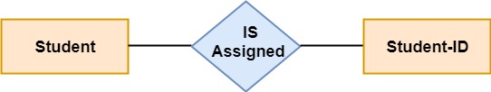

**2. One to many:** When a single instance of an entity is associated with more than one instances of another entity then it is called one to many relationships. For example, a client can place many orders; a order cannot be placed by many customers.

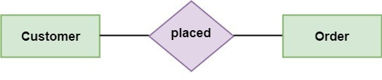

**3. Many to One:** More than one entity from entity set A can be associated with at most one entity of entity set B, however an entity from entity set B can be associated with more than one entity from entity set A. For example - many students can study in a single college, but a student cannot study in many colleges at the same time.

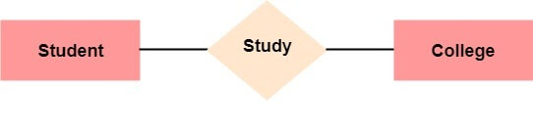

**4. Many to Many:** One entity from A can be associated with more than one entity from B and vice-versa. For example, the student can be assigned to many projects, and a project can be assigned to many students.

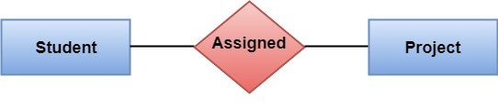

**Identifying relationship**

An identiffying relationship is a relationship between two entities in which an instance of a child entity is identified through its association with a parent entity, which means the child entity is dependent on the parent entity for its identity and cannot exits without it.

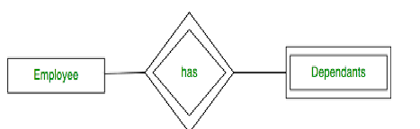

**Participation Contraints**

The participation constraint specifies the number of instance of an entity can participate in a relationship set.

**Total participation** – Each entity is involved in the relatioship. Total participation is represented by double lines.

**Partial participation** – Not all entities are involved in the relatioship. Partial participation is represented by single lines.

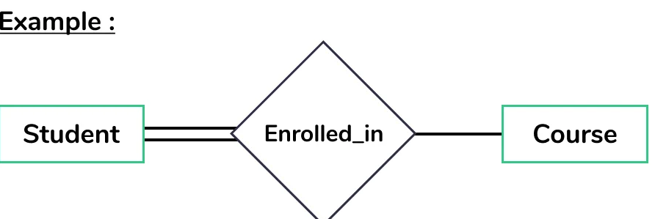

admin

staff

view

activity

view

view

association

attendance

has

student

has

Fig(4.3)

**4. 9. Database Administration**

**4.9.1. DBMS System information**

A database is an organized collection of structured information, or data typically stored electronically in a computer system. A data base is usually controlled by a database management system(DBMS).

(Specify the DBMS)

**4.9.2. DBMS configuration**

(Steps for configuration of DBMS)

Steps for configure apache and mysql in XAMPP

1. In phpmyadmin, click the Users tab at the top.
2. Find the row that has User root and Host 127.0.0.1.
3. Click Edit Privileges.
4. Click Change password.
5. Enter the password twice (write it down somewhere if you're not

sure you can remember it)

1. Click the Go button

**4.9.3. Support software required**

Mysql Required XAMPP

(Specify any support Software Required)

## Software Requirements

The following operating systems are officially supported:

* Windows 7 (64-bit, Professional level or higher)
* Mac OS X 10.6.1+
* Ubuntu 9.10 (64bit)
* Ubuntu 8.04 (32bit/64bit)

**4.9.4. Hardware (Storage) requirements**

(Specify the Disk place Required)

The minimum hardware requirements are:

* Hard Disk:1 GB Required 500GB(Recommended)
  + - CPU: Intel Core or Xeon 3GHz (or Dual Core 2GHz) or equal AMD CPU
* Cores: Single (Dual/Quad Core is recommended)
* RAM: 4 GB (6 GB recommended)
  + - Graphic Accelerators: nVidia or ATI with support of OpenGL 1.5 or higher
    - Display Resolution: 1280×1024 is recommended, 1024×768 is minimum.

**4.9.5. Backup and recover**

Recovery is **the process of restoring a database to the correct state in the event of a failure**

Database backup is **a way to protect and restore a database**. It is performed through database replication and can be done for a database or a database server.

**Using phpMyAdmin to Back Up or Restore MySQL**

If you’re running phpMyAdmin backing up and **restoring your MySQL database**is simple.

The **export**function is used as a backup, and the **import**function is used to restore.

**Step 1: Create a MySQL Database Backup**

1. Open phpMyAdmin. On the directory tree on the left, click the database you want to back up.

This should open the directory structure in the right-hand window. You’ll also notice that, in the directory tree on the left, all the assets under the main database are highlighted.

2. Click **Export**on the menu across the top of the display.

You’ll see a section called “Export Method.” Use **Quick**to save a copy of the whole database. Choose **Custom**to select individual tables or other special options.

Leave the **Format**field set to **SQL,**unless you have a good reason to change it.

3. Click **Go.** If you select **Quick,**your web browser will download a copy of the database into your specified downloads folder. You can copy that to a safe location.

**Step 2: Clear the Old Database Information**

It’s important to clear out old data before restoring a backup. If there’s any old data, it isn’t overwritten when you restore. This can create duplicate tables, causing errors and conflicts.

1. Open phpMyAdmin, on the navigation pane on the left, choose the database you want to restore.

2. Click the **check all**box near the bottom. Then, use the drop-down menu labeled **With selected**to select **Drop.**

3. The tool should prompt you to confirm that you want to go forward. Click **yes.**

This will get rid of all the existing data, clearing the way for your restoration.

**Step 3: Restore Your Backed up MySQL Database**

In phpMyAdmin, the **Import**tool is used to restore a database.

1. On the menu across the top, click **Import**.

2. The first section is labeled **File to import.** A couple of lines down, there’s a line that starts with “Browse your computer,” with a button labeled **Choose File.**Click that button.

3. Use the dialog box to navigate to the location where you’ve saved the export file that you want to restore. Leave all the options set to default. (If you created your backup with different options, you can select those here.)

4. Click **Go.**