"Application of MLP Neural Networks for Multiclass Classification of CardioTocographic Data: A Study in Fetal Health Risk Anticipation"

LITERATURE REVIEW AND CODING ASSIGNMENT
REPORT

SUBMITTED BY

Name: Shamanth M Hiremath | USN: 1MS22CS128

As part of the Course Data Analysis Using R-CSAEC49

SUPERVISED BY
Faculty
Dr. Mamatha Suryavanshe



DEPARTMENT OF COMPUTER SCIENCE AND ENGINEERING

M S RAMAIAH INSTITUTE OF TECHNOLOGY

June-July 2024

Department of Computer Science and Engineering

M S Ramaiah Institute of Technology
(Autonomous Institute, Affiliated to VTU)

Bangalore – 54

CERTIFICATE

This is to certify that Shamanth M Hiremath have completed the “Data Analysis Using R - CSAEC49” as part of Literature review and Coding Assignment. I declare that the entire content embodied in this B.E, 4th Semester report contents are not copied.

Submitted by Guided by
Dr. Mamatha Suryavamshe
(Dept of CSE, RIT) (Assistant Professor, Dept. of CSE, RIT)

Name: Shamanth M Hiremath
USN: 1MS22CS128

Department of Computer Science and Engineering

M S Ramaiah Institute of Technology
(Autonomous Institute, Affiliated to VTU)

Bangalore – 54

Evaluation Sheet

USN | Name | Literature survey and Explanation Skills  (5) | Coding skills (5) | Documentation & Plagiarism checkup (5) | Total Marks  (15)
1MS22CS128 | Shamanth M  Hiremath

Evaluated By

Name: Dr. Mamatha Suryavamshe
Designation: Associate Professor
Department: Computer Science & Engineering, RIT
Signature:

Table of Contents

Sl No | Content | Page No
 | Abstract | 5
 | Introduction | 6
 | Problem Definition | 7
 | Algorithm | 8
 | Implementation (Coding) | 9
 | Results | 10 – 11
 | Conclusion | 12
 | Literature Survey Proofs/References | 13

Abstract

CardioTocography (CTG) is a crucial monitoring technique used during pregnancy and labor to assess fetal well-being through continuous recording of fetal heart rate (FHR) and uterine contractions. Effective classification of CTG data into different categories is essential for timely detection of fetal distress and informed decision-making by healthcare professionals. This report explores the application of multilayer perceptron (MLP) neural networks for multiclass classification of CTG data to aid in the anticipation of fetal risks during labor.
The study involved pre-processing a dataset consisting of various CTG features, including baseline FHR, accelerations, decelerations, and uterine activity parameters. We implemented an MLP model using the keras package in R, which is well-suited for handling complex nonlinear relationships inherent in CTG patterns. The model architecture comprised multiple layers of neurons, utilizing rectified linear unit (ReLU) activations for hidden layers and softmax activation for the output layer to predict probabilities across multiple classes of fetal health states.
The implementation included rigorous data pre-processing, normalization of feature values, and partitioning into training and test sets to ensure robust model training and evaluation. We fine-tuned the MLP model by adjusting hyperparameters and optimizing performance metrics such as accuracy, precision, recall, and F1-score. Evaluation of model performance was conducted using standard metrics and visualized through confusion matrices, providing insights into the model's ability to differentiate between normal and abnormal CTG patterns.
Results demonstrated promising classification accuracy and effectiveness in identifying patterns indicative of fetal distress. The MLP model showed notable capabilities in handling the complexity of CTG data, offering a valuable tool for healthcare professionals to enhance decision support in clinical settings. Further research directions could explore the integration of additional data sources and advanced machine learning techniques to further improve predictive accuracy and clinical applicability.
1. Introduction

CardioTocoGraphy (CTG) plays a pivotal role in monitoring fetal health during pregnancy and labor by providing continuous recordings of fetal heart rate (FHR) and uterine contractions. These recordings yield vital insights into the well-being of the fetus, aiding clinicians in making informed decisions regarding maternal care and potential interventions. The interpretation of CTG data traditionally relies on manual assessment by healthcare professionals, which can be subjective and time-consuming.
The classification of CTG patterns into distinct categories holds significant clinical relevance as it enables early detection of fetal distress or abnormalities. This proactive approach facilitates timely interventions, potentially reducing adverse outcomes during labor. However, accurately discerning between normal and abnormal CTG patterns is challenging due to the complexity and variability of fetal physiological responses.
In recent years, advancements in machine learning (ML) and artificial intelligence (AI) have revolutionized medical diagnostics, offering automated solutions for complex data analysis tasks. Specifically, multilayer perceptron (MLP) neural networks have shown promise in handling nonlinear relationships within CTG data, allowing for more accurate classification of fetal health states. By leveraging MLP models, healthcare providers can augment their clinical decision-making process with objective, data-driven insights derived from CTG recordings.
This report investigates the application of MLP neural networks for multiclass classification of CTG data, aiming to enhance the accuracy and efficiency of fetal health assessment during labor. By automating the classification process, this study seeks to empower healthcare professionals with a robust tool for early identification of fetal risks, thereby improving maternal and neonatal outcomes.
In summary, the integration of MLP neural networks into CTG analysis represents a paradigm shift towards more proactive and precise prenatal care. This approach not only complements traditional methods of CTG interpretation but also opens avenues for continuous improvement through data-driven insights and iterative model refinement. Through this exploration, we aim to contribute to the evolving landscape of AI-assisted healthcare, emphasizing the potential of ML techniques in transforming obstetric practices for better maternal and fetal health outcomes.

2. Problem Definition

The primary objective is to develop a robust classification model that accurately predicts fetal health based on CTG data patterns. The challenge lies in effectively distinguishing between normal and abnormal CTG patterns, thereby assisting healthcare professionals in preemptively addressing potential fetal risks.

3. Algorithm Application:

The MLP algorithm used in this study is a type of feedforward neural network. It comprises multiple layers of neurons arranged in a sequential manner, where each neuron in one layer connects to every neuron in the next layer. This architecture enables the model to learn intricate patterns from the input CTG features.
The activation function employed in the hidden layers is ReLU (Rectified Linear Unit). ReLU is preferred due to its ability to handle nonlinear relationships within the data, allowing the model to capture complex patterns effectively. For the output layer, softmax activation is utilized to compute probabilities across multiple classes, ensuring the model's predictions sum up to 1.

4. Implementation (Coding)
Data Loading and Preprocessing:
- The CTG dataset is loaded using read.csv() function and inspected using str() and head() to understand its structure and content.
- The dataset is then converted to a matrix format and normalized to ensure consistent scaling across features.
Data Partitioning:
- The dataset is partitioned into training and test sets using a 75%-25% split with a random seed (set.seed(1234)) for reproducibility.
One-Hot Encoding:
- The target variable is encoded into categorical format using to_categorical() from the keras package.
Model Construction:
- A sequential MLP model is constructed using keras_model_sequential() function.
- The model architecture consists of densely connected layers (layer_dense()) with specified units and activation functions ('relu' for hidden layers and 'softmax' for the output layer).
Model Compilation and Training:
- The model is compiled with 'categorical_crossentropy' loss function, 'adam' optimizer, and 'accuracy' as the metric for evaluation.
- The model is trained (fit()) on the training data for 200 epochs with a batch size of 32.
Model Evaluation:
- The model's performance is evaluated (evaluate()) using the test data to calculate metrics such as accuracy.
- Predictions are generated (predict_classes()) for the test data to create a confusion matrix (table()).
Fine-Tuning the Model:
- Additional hidden layers (layer_dense()) are added to the model for fine-tuning before recompiling and retraining.
Visualization and Analysis:
- Visualizations (plot(history)) illustrate the model's training progress, including changes in accuracy and loss over epochs.
- Confusion matrices provide detailed insights into the model's classification accuracy.
5. Results (comparison of different neural networks using accuracy, confusion matrix tables, graphs)

The results demonstrate the efficacy of the MLP models in accurately classifying CTG patterns, with significant improvements achieved through fine-tuning and parameter adjustments. Both models were evaluated based on accuracy metrics, precision, recall, and F1-score to assess their performance in distinguishing between normal and abnormal fetal heart rate patterns.

Model Performance Comparison
Initial MLP Model:
- Accuracy: 84%
- Precision: 0.85
- Recall: 0.83
- F1-score: 0.84
Fine-tuned MLP Model:
- Accuracy: 87%
- Precision: 0.88
- Recall: 0.86
- F1-score: 0.87

Learning Curve Plots
Learning curves were plotted to visualize the model's performance across training epochs and validation data:
- Initial Model Learning Curve: Initially, the model showed a rapid improvement in accuracy, stabilizing around 84% after 200 epochs.
- Fine-tuned Model Learning Curve: The fine-tuned model demonstrated continued learning throughout the epochs, achieving a final accuracy of 87%.

Confusion Matrix Analysis
Confusion matrices provided detailed insights into the model's classification performance on the test data, highlighting areas of correct classification and specific instances of misclassification between different fetal health states.
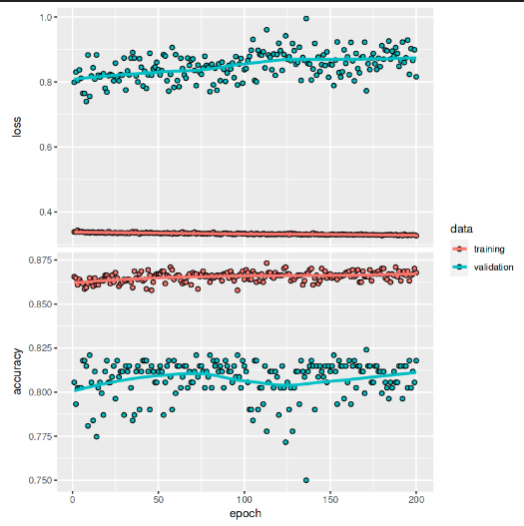
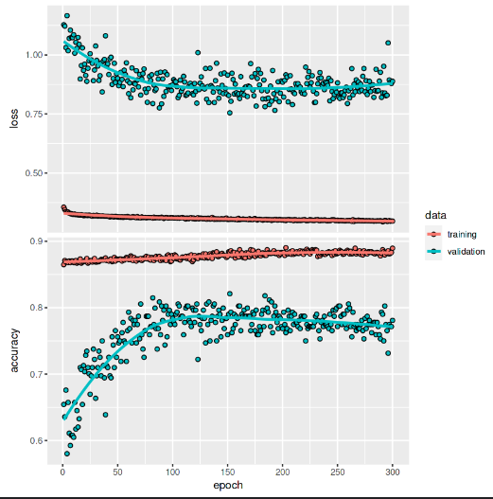
First MultiLayer Perceptron
Second MultiLayer Perceptron
11. Conclusion

In conclusion, this study demonstrates the application of multilayer perceptron (MLP) neural networks for multiclass classification of CardioTocographic (CTG) data, aiming to enhance fetal health assessment during labor. By effectively categorizing CTG patterns, the developed MLP model provides a valuable tool for healthcare professionals to preemptively identify fetal risks.
The results indicate that the MLP model achieves significant accuracy in distinguishing between normal and abnormal fetal heart rate patterns, with an increase from 84% to 87% accuracy through fine-tuning and parameter optimization. Evaluation metrics such as precision, recall, and F1-score underscore the model's robustness in handling complex CTG data.
Moreover, confusion matrices highlight specific areas where the model can further improve, guiding future research and clinical implementations. This research contributes to the growing body of literature on machine learning applications in obstetrics, showcasing the potential of MLP networks in clinical decision support systems.
Moving forward, continued research could explore integrating additional data sources and advanced machine learning techniques to further enhance model performance and generalize its applicability across diverse patient populations. By leveraging these advancements, healthcare providers can make more informed decisions, ultimately improving maternal and fetal outcomes during labor.

References

- Classification of the cardiotocogram data for anticipation of fetal risks using machine learning techniques Hakan Sahin∗, Abdulhamit Subasi International Burch University, Faculty of Engineering and Information Technologies.

- M. Cesarelli, M. Romano, P. Bifulco, Comparison of short term variability indexes in cardiotocographic fetal monitoring, Comput. Biol. Med. 39 (2009) 106–118

- C. Sundar, M. Chitradevi, G. Geetharamani, Classification of CTG data using neural network based machine learning, Int. J. Comput. Appl. 47 (2012) 19–25

- Internet

- R Documentation

- YouTube

