Roll No: 22F-BSAI-91

Name: Muhammad Shamas

AI-Powered Clinical Decision Support System for Patient Deterioration Prediction
Complete Project Report (Ready for Submission)

Abstract
Early detection of patient deterioration is critical in healthcare. This project developed an AI-powered Clinical Decision Support System (CDSS) for sepsis prediction using deep learning models including DNN, LSTM, GRU, Bi-LSTM, and BioClinicalBERT. The dataset contained 1,552,210 ICU records with severe class imbalance. Multiple models were evaluated using Accuracy, Precision, Recall, and F1-Score. Results showed that DNN with Adam optimizer achieved the highest recall (72%), while GRU achieved the highest accuracy (85%).

Introduction
Patient deterioration and sepsis are major causes of mortality in intensive care units. Early detection can improve outcomes and reduce mortality. This project investigates the effectiveness of deep learning techniques for predicting sepsis using ICU patient monitoring data.

Dataset Description
Dataset Size: 1,552,210 records
Target Variable: SepsisLabel
Features Used: Hour, HR, O2Sat, Temp, SBP, MAP, DBP, Resp, Age, Gender, Unit1, Unit2, HospAdmTime, ICULOS
Class Distribution:
No Sepsis: 1,524,294 (98.2%)
Sepsis: 27,916 (1.8%)

– Dataset Overview
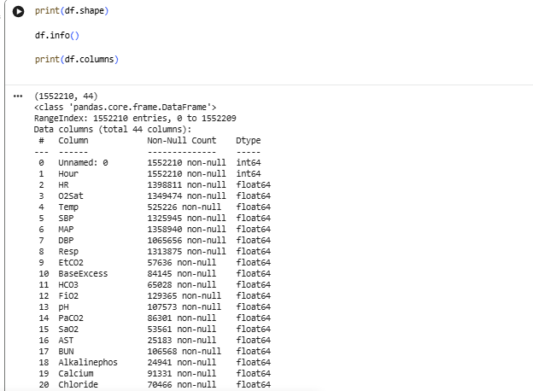

Data Preprocessing
Removed irrelevant columns, dropped features with >80% missing values, applied mean imputation, standardized features using StandardScaler, and handled class imbalance using class weights.

– Missing Values Analysis
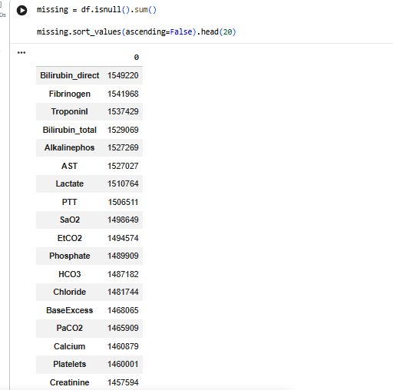

Deep Neural Network (Generation 1)
Architecture: Dense(128) -> BatchNorm -> Dropout -> Dense(64) -> BatchNorm -> Dropout -> Output.
Optimizers evaluated: Adam and SGD.

– Adam vs SGD Loss Curves
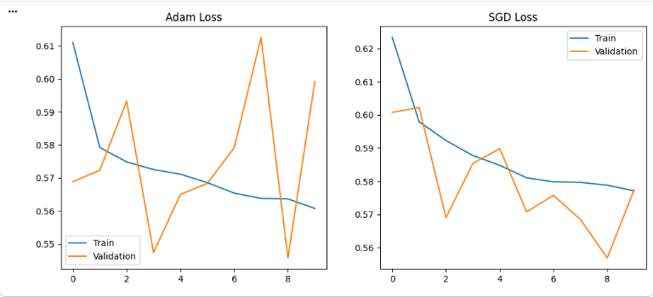

– DNN Confusion Matrix
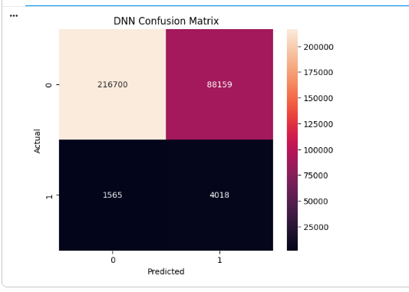

Recurrent Neural Networks (Generation 2)
LSTM, GRU and Bi-LSTM models were implemented to capture temporal relationships in patient data.

– LSTM Loss Curve
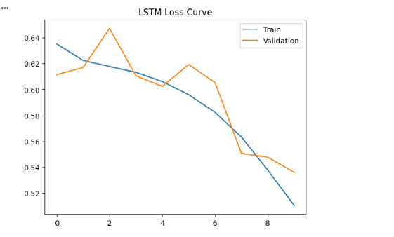

– GRU Loss Curve
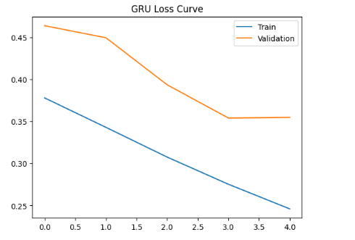

– Bi-LSTM Loss Curve
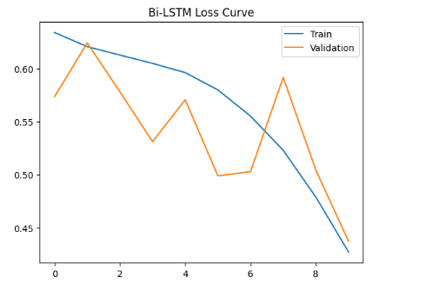

Transformer-Based Model (Generation 3)
BioClinicalBERT was demonstrated on clinical text examples. Since the dataset contained no clinical notes, full fine-tuning was not performed.

– BioClinicalBERT Output
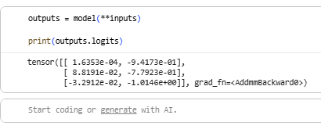

Experimental Results
DNN (Adam): Accuracy=0.71, Precision=0.04, Recall=0.72, F1=0.08
DNN (SGD): Accuracy=0.73, Precision=0.04, Recall=0.68, F1=0.08
LSTM: Accuracy=0.73, Precision=0.04, Recall=0.54, F1=0.07
GRU: Accuracy=0.85, Precision=0.05, Recall=0.39, F1=0.08
Bi-LSTM: Accuracy=0.80, Precision=0.04, Recall=0.46, F1=0.08

Comparison Table
Model | Accuracy | Precision | Recall | F1
DNN (Adam) | 0.71 | 0.04 | 0.72 | 0.08
DNN (SGD) | 0.73 | 0.04 | 0.68 | 0.08
LSTM | 0.73 | 0.04 | 0.54 | 0.07
GRU | 0.85 | 0.05 | 0.39 | 0.08
Bi-LSTM | 0.80 | 0.04 | 0.46 | 0.08

Discussion
Although GRU achieved the highest accuracy, DNN with Adam achieved the highest recall. In healthcare applications, recall is more important because missing a deteriorating patient can delay treatment and increase mortality risk.

Conclusion
The project successfully developed an AI-based system for patient deterioration prediction. DNN with Adam optimizer achieved the best recall and was the most clinically useful model. GRU achieved the highest accuracy. Future work includes integration of clinical notes and deployment in real-time healthcare systems.

References
PhysioNet Sepsis Dataset, TensorFlow, Scikit-Learn, Hugging Face Transformers, BioClinicalBERT.

