Serial reversal learning in nectar-feeding bats

# Introduction

*‘Take some more tea,’ the March Hare said to Alice, very earnestly.*

*‘I’ve had nothing yet,’ Alice replied in an offended tone, ‘so I can’t take more.’*

*‘You mean you can’t take LESS,’ said the Hatter: ‘it’s very easy to take MORE than nothing.’*

## Introductory statements

* Animal intelligence
* Discrimination
* We know that animals have the ability to discriminate and reverse that discrimination - cite the 1940s and 1950s
* A bridge to the study of reversal learning

### What is reversal learning

There are thrree versions of the reversal learning experiment that have been performed with different animal species. Plain old reversal learning. In the mid-session reversal learning task the animals face a two-alternative simultaneous forced choice and only one of the two stimuli will be paired with reward. After a certain number of trials a reversal of reward contingencies occurs: the stimulus that was previously associated with reward is no longer associated with reward, and *vice versa*. This task can be repeated over multiple sessions to see how the animals respond, and whether they develop a strategy. In the serial reversal learning task the animals experience a series of reversals of the reward contingencies. As the same stimuli are successively paired with a reward and then not paired with a reward, animals can develop strategies in response to this task as well.

**these animals can do basic reversal learning, these have been shown to do serial reveresal learning. Mention the bumbleebee tradeoff.**

**define error, performance, improvement here**

## Reversal learning: a conceptual history with some experimental history

It would seem, on the face of it, that the reversal learning task is a useful tool to compare the cognitive capacities of different species. The reversal learning task can be adapted to the behaviour and sensory physiology of many different species: olfactory stimuli; visual stimuli; auditory?; spatial orientation; tactile, etc (**insert references**). Regardless of the details of response behaviour, sensory stimulus and so on, performance on this task can be assessed with respect to the animal’s own performance: how many trials does it take to learn the reversal, relative to the number of trials to learn the original discrimination task? (**Zentall theoretical review**). Bitterman, for example, (**1965 and 1975 papers**) explicitly compared the performance of several different species (rats, pigeons, turtles, fish and monkeys) in the reversal learning task to try and answer the bigger question of whether the difference in intelligence between species is qualitative or quantitative one.

## Deconstructing this:

The concept of reversal learning as a comparative tool of animal intelligence has many assumptions built that have since been questioned and revised. **this is probably unnecessary as a bridge**

## What cognitive capacity is it measuring? Intelligence, rule-learning, cognitive flexbility

First-order learning can be seen to happen when an animal learns the stimulus-reward association and changes its behaviour accordingly: reversal learning is essentially a specific type of discrimination learning. This task, however, can also be used to explore the higher-order learning of rules or strategies. The optimal rule in a reversal learning task is ‘win-stay; lose-shift,’ which means in practice one ‘error’ per reversal. After learning the task, a perfectly rational animal will first exclusively choose the stimulus that is paired with reward. At the first choice of this stimulus that does not give a reward (the error), the animal will change its preference and exclusively choose the other stimulus which is now paired with a reward. Progressive ‘improvement’ in this task, where an animal makes fewer and fewer errors per reversal is indication that the animal is learning the rule of reversal, or ‘learning to learn’ (**Shettleworth book**).

* Learning to learn and the optimal strategy: the Rumbaugh primate literature
* Interpreting an animals’ ability to perform reversal learning as: cognitive flexibility, behavioural flexibility, learning set, attentional set formation.
* Cognitive flexibility reflects an individual’s ability to adaptively alter their behavioral strategy following a changing environment (Wasserman and Zentall, 2006) from the MaBouDi paper.
* Behavioural flexibility and the many ways that it has been used - look at the review
* Telling them apart and finding an explanation for the animals’ behaviour that takes into account their evolutionary history and foraging ecology

## does it even measure cognitive ability or is it just behavioural flexibility?

## anthropomorphism is baddy bad bad

## The difference between different sensory modalities even within animals and its significance

What is certainly true is that performance on the reversal learning task varies greatly, even between closely related species; or in the same speciies between slightly different versions of the task.

* the fish example from the zentall review
* all the rat examples

## Bringing this together to the bats

### Who are these little guys: their foraging ecology

Our research was done with Commissaris’s long-tongued bat, *Glossophaga commissarisi*, a Glossophagine bat species from Central and South America. Glossophagine bats have remarkably high metabolic rates for their body mass (C. C. Voigt and Winter (1999); Christian C. Voigt, Kelm, and Visser (2006)) because of the energetic demands of hovering flight (Y. Winter and Helversen (1998); O. v. Helversen and Reyer (1984)). While their diet can sometimes include fruits, insects, and plant-parts, their primary food source is flower nectar (**what’s a good citation for this?**). The sugars from the nectar completely fuel the bats’ high metabolism directly with very little conversion to or storage as fat tissue (Kelm et al. (2011); C. C. Voigt and Speakman (2007)). As flowers yield only small droplets of nectar for each visit made, (about 193 J of energy per visit: Christian C. Voigt, Kelm, and Visser (2006)), the bats need to make several hundred flower visits per night to satisfy their energetic requirements. Efficiency is therefore critical to the bats’ foraging behaviour.

The bats’ foraging ecology is shaped by the importance of flower-nectar as a resource. Plants the bats rely on for nectar in turn rely on them for the critical role of pollinators. The flowers have conspicuous olfactory, echo-acoustic and visual cues to attract and enable the bats to find the flowers (D. von Helversen and Helversen (1999); York Winter, Merten, and Kleindienst (2005)). Many bat-pollinated plants put out only a few flowers at a time that bloom for a long time (Kunz and Fenton (2005)). The nectar itself is a self-replenishing resource, meaning the same flower can be profitably exploited at multiple time-points. Thus, the bats rely primarily on their excellent spatial memory to relocate a profitable flower (Y. Winter (2005); Toelch et al. (2008)), and this memory can last upto a few weeks after the initial learning (Rose et al. (2016)). Estimating when to come back is another important aspect of the bats’ cognitive process. To be worth the energetic cost of the visit, the flower’s nectar levels need to be sufficiently replenished, which takes a certain amount of time. However, if a bat waits too long to return, competing conspecifics can deplete the refilled flower. Repeated visits to a flower therefore requires the bat to both remember its location and estimate its expected reward value. If a bat visits a flower and finds it full of nectar, the optimal strategy is to exploit it fully before a competitor can find it; leave the flower in search of others when it is empty; remember the location of the flower; and return to it when sufficient time has passed for it to refill, but not so long that a competitor can find it.

### A bridge: connect this with the theory about reversal learning and cognition.**

## animals with aspects of their ecology/behaviour similar to the bats

### Other nectar-feeders

**Insert linking sentence** Chittka (**Chittka 1998**) demonstrated that a bumblebee can perform serial spatial reversals when given 100 trials with each set of reward contigencies, with an error rate as low as 3% after eight reversals. When given a colour serial reversal, not only did bumblebees reverse their responses, but their performance improved greatly over the nine reversals. They did however show a slight increase in the number of errors in the final reversals, possibly due to proactive interference. Honeybees have been shown to reverse their responses on an olfactory serial reversal task, but instead of an improvement, showed a decrease in their discrimination behaviour, converging to at-chance performance. It is possible that the number of trials plays an important role in the bees’ learning of the reversals, as the honeybee experiment used only five trials per reversal, compared to 40 in the colour serial reversal task with the bumblebees.

### Animals with good spatial memory

**Insert linking sentence, tie it to sensory modality above** An environment that is spatially complex, or that requires facing many different types of stimuli, both from the environment itself and other conspecifics demands greater behavioural flexibility (**Jones and Robinson reference from the corvid paper**). Indeed, an environment that

## What we did with them and what did we think they would do

A reversal learning task requires an animal to respond to a change in the profitability of the options available to it, and remember all the rewarding options it has experienced in its environment: tasks that nectar-feeding bats perform many times in a typical foraging bout. We carried out a serial reversal learning task with wild *G. commissarisi* individuals. Over three nights the bats were given two potentially rewarding options to choose between: artificial, computer-controlled ‘flowers.’ Each bat was assigned two unique flowers to avoid inter-individual competition. Every instance when a bat approached a flower and attempted to collect a reward from it was termed a ‘visit.’ At the start of the night, only one of the options was rewarding and the other was not; no cue was provided to indicate which option was rewarding, but the two options were separated in space a distance sufficient for the bats to detect them as different locations. After the bats had made a certain number of visits to both options (rewarded or unrewarded), the reward contingencies reversed without any signal: the previously rewarding option was now unrewarding and the previously unrewarding option was rewarding. This reversal occurred five times a night on every night.

Our aims with this experiment were as follows. Firstly, we wanted to demonstrate that the bats were capable of reversal learning. We believed this to be extremely likely as the behavioural requirements of the task are typical features of the animals’ foraging ecology. Secondly, if the bats demonstrated the ability to respond to the reversals, we wanted to explore how this is reflected in their decision-making. In other words, what changes are seen in the relative number of visits made to the rewarding and the non-rewarding options? Thirdly, we wanted to see if the bats were capable of higher-order learning processes, or ‘learning to learn.’ Could the bats learn the ‘rule’ behind the change in their environment and use the optimal strategy of one error per reversal?

## Little results summary

We found that the bats show an extremely high overall preference for the rewarding option even as they experience multiple reversals of reward contingencies. With increasing experiences of reversals the bats switch their preference to the more rewarding option more and more rapidly after experiencing a reversal. They also show an overall increase in the percentage of visits they make to the rewarding option, with each successive night and with each successive reversal. And this is an effect that decreases with each successive reversal, possibly due to a ‘ceiling effect’: their preference too high for a further increase.

After the analyses described above were done and the data and results examined, we performed further analyses to explore the conclusions yielded by our confirmatory analyses. The difference between these results must be clearly noted. We reasoned that one important component affecting the bats’ increasing preference for the rewarding option was the difference between the first visits of a night, before any experience of a reversal, and all the subsequent visits after at least one reversal had occurred. Modeling the visits before and after the first reversal separately revealed that there is indeed a differential effect: bats make a larger proportion of their visits to the rewarding option before any experience of a reversal on a given night.

We sought to explore our conclusion that the increase in preference for the rewarding option experiences a ‘ceiling effect’ by examining the bats’ sampling visits. We defined these as visits to the non-rewarding option after the bats had experienced at least one reward at the rewarding option after a reversal. In other words, the bats now ‘knew’ which option was the rewarding one after the reversal, so any visit to the unrewarding option was no longer due to the prior association of this option with reward. We found that the number of sampling visits does not increase with successive reversals. In addition, the smaller increase in preference for the rewarding option with each reversal seen in the confirmatory analysis was not due to an increase in sampling visits, but explainable through the combination of a faster switch to the rewarding option and an extremely high proportion of visits to the rewarding option.

# Methods

## Study site and subjects

The experiment was done from the 28th of June to the 25th of July, 2017, at La Selva Biological Field Station, Province Heredia, Costa Rica. Male and female individuals of the species *Glossophaga commissarisi*, were captured from the wild for the experiment. The bats were attracted to a particular location in the forest using sugar-water (see **Reward** below) as bait and then caught in mist-nets. The bats were sexed and the selected individuals were were then taken to two flight-cages (4 x 6 m). The flight-cages had mesh walls and therefore the same climatic conditions as the surrounding environment. A group of four bats at a time were put into a flight cage. All the individuals in a group were the same sex. The bats were weighed and radio frequency identification (RFID) tags that were uniquely assigned to each bat were placed around their necks as collars. The bats were then released into the flight-cages so they could fly within them freely.

Before the start of the experiment the procedure was tested with four females and refinements were made to the procedure. The data from these individuals were not analyzed. 16 bats participated in the main experiment. At the end of the experiment, the RFID collars were removed and the bats were weighed to make sure they were still at a healthy weight. No blinding was done as all the data collection was completely automatized. Two of the bats did not drink a sufficient amount of sugar-water to meet minimum energy requirements and were released before the end of the experiment and not replaced. The data from these two individuals were not analyzed. Thus, 14 bats in total (seven males and seven females) completed the experiment and the data from these animals were analyzed.

Animal experimental procedures were reviewed and permission for animal experimentation and RFID-tagging was granted by Sistema Nacional de Areas de Conservación (SINAC) at the Ministerio de Ambiente y Energía (MINAE), Costa Rica.

## Experimental Setup

### Reward

The reward received by the bats during the experiment was also their main source of food. The reward was a 17% by weight solution of sugar dissolved in water (prepared fresh everyday), hereafter referred to as ‘nectar.’ The sugar consisted of a 1:1:1 mass-mixture of sucrose, fructose and dextrose. The nectar was thus similar in composition and concentration to the nectar produced by wild chiropterophilous plants (Baker, Baker, and Hodges 1998).

### Flower and pump setup

Each flight cage had a square plastic frame in the center (2x2x1.5m). Eight reward-dispensing devices - hereafter referred to as ‘flowers’ - were fixed in a radial pattern on this frame, two on each side of the square (see **Figure 1**) with a distance of 40 cm between adjacent flowers. This is a distance the bats can discriminate (Thiele and Winter 2005). Each flower had the following parts: an RFID reader mounted on a plastic cylinder around the head of the flower; an infra-red light-barrier beam; an electronic pinch valve through which a PVC tube was placed and fixed to the head of the flower

A stepper-motor pump was placed in the center of the plastic frame in each cage. The pumps contained a 25 mL Hamilton glass syringe (Sigma Aldrich). The precision of the two pumps differed slightly: the pump in Cage 1 delivered 2.11L per step of the stepper-motor, and the pump in Cage 2, 3.33 L per step. The glass syringe was connected to the tubing system of the flowers through five pinch valves. The pinch valves controlled the flow of liquid from the pump to the system and from a reservoir of liquid to the pump. The reservoir (500 mL thread bottle, Roth, Germany) was filled with fresh nectar everyday and connected to the syringe through the valves.

When a tagged bat approached a flower, the individual RFID number was read by the reader. If the bat then poked its nose into the flower and broke the light barrier, it triggered the release of a reward. The pinch valve opened and the pump moved the correct number of pre-programmed steps to dispense nectar to the head of the flower. The bat could easily hover in front of the flower and lick this up. Only when both events occurred, i.e., the RFID reader detected a bat and the light-barrier was broken, would a reward be triggered.

The flowers and the pump were connected to a Lenovo ThinkPad laptop computer, which ran the experimental programs and the programs used to clean and fill the systems: PhenoSoft Control 16, PhenoSoft GmBH, Berlin, Germany. The raw data were recorded to this computer as comma-separated values (CSV) files.

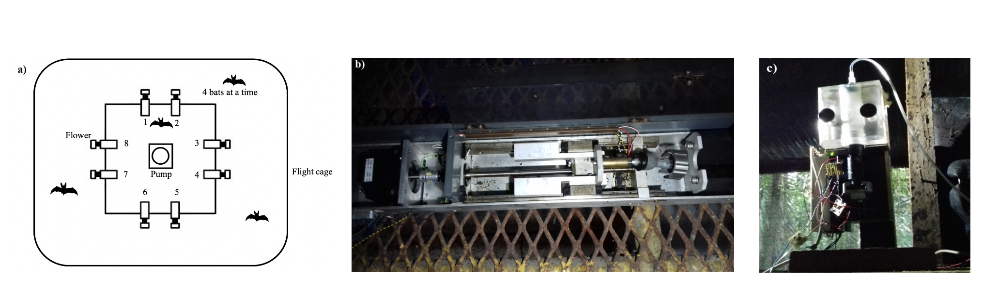

Figure 1: a) Schematic of the cage and flower set-up b) Horizontal pump c) Vertical pump

## Experimental procedure

Every day at around 10 h the old nectar was emptied from the system. The system was rinsed and filled with plain water until 15 h , when it was filled again with fresh nectar. Twice a week the system was filled with 70% ethanol for an hour to prevent microbial growth, then repeatedly rinsed with water.

Four bats were placed in a flight-cage in a group, and all the bats were the same sex. There were four such groups in total, and data were collected simultaneously from two groups, one in each flight-cage. Each bat was uniquely assigned two adjacent flowers on the same side of the square frame, out of the array of eight. These flowers were programmed to reward only one of the four bats in the cage. After the system was filled with fresh nectar at approximately 17 h, the program was left running for data-collection till the next morning. Thus, the bats could begin visiting the flowers to collect a reward whenever they chose, which was at approximately 18 h every night.

During the course of the night, when the syringe of the pump had been emptied, the pump re-filled automatically. This event happened only once every night. On the main experimental days this process took 4.5 minutes (SD = ±0.18) for the horizontal pump, and 2.43 minutes (SD = ±0.04) for the vertical pump. About 1 % (SD = ±0.74) of all visits made by the bats over all three experimental nights happened during the pump refill events, and the bats did not receive any reward on these visits, even if they were made to the rewarding flower.

Every night the bats were also given ad-libitum supplemental food: 3.5g of hummingbird food (NektarPlus, Nekton) in 100 mL of water and 3.5g of milk powder (Nido 1+, Nestle) in 100 mL of water. They were also given a small bowl of locally-sourced bee pollen.

## Experimental design

The experiment proceeded through the following stages.

### Training to use a flower

On the night the naive bats were captured and placed into the flight cages they could receive a reward from any of the flowers whenever they visited them throughout the night. To enable the bats to find the flowers a small cotton pad was placed on the flowers, soaked in di-methyl di-sulphide. This is a chemical attractant produced by many bat-pollinated flowers (O. von Helversen, Winkler, and Bestmann 2000). A small drop of honey was applied to the inside of the flowers to encourage the bats to place their heads inside, break the light-barrier and trigger a nectar reward. By the end of the night all the bats had found the flowers and learned to trigger rewards quickly.

### Training to use two specific flowers

After the bats had learned to trigger rewards, the next stage of training involved assigning the bats uniquely to two out of the eight flowers in the array. For an individual animal only the two flowers assigned it would be rewarding from this stage of training until the end of the experiment. Because the bats had already learned to trigger a reward at the flowers, the flowers were not provided with a cotton piece with the chemical attractant and honey was not applied to them. This stage was similar to the previous one, except the bats could only trigger a reward at their assigned flowers.

### Alternation

To ensure that the bats were familiar with both flowers assigned to them they went through one final stage of training: forced alternation between the two assigned flowers all night long.

### Main Experiment

In this serial reversal learning task the bats had to choose between a flower that gave 40 L of nectar and one that gave no reward at all. The location of the rewarding flower was not cued, but through the Alternation phase of training each bat knew the locations of both flowers that were potentially rewarding to it. After a bat had made 50 visits in total to the two flowers a reversal occurred: the previously rewarding flower became the non-rewarding flower and *vice versa*. Importantly, only visits to the two flowers assigned to a bat counted towards the visit tally, not visits to any of the other flowers which were unrewarding to that particular bat. The batch of 50 visits that occurred between two consecutive reversals (when the locations of the rewarding and unrewarding flowers remained stable) was termed a ‘reversal block,’ including the first 50 visits of a night when the bats had not experienced any reversal at all that night. This occurred at regular intervals of 50 visits until the bat either stopped making visits or reached a maximum of 300 visits in a night. After the bat had made 300 rewarded visits it could no longer receive a reward on that experimental night. There were five reversals per night. This stage of the experiment was repeated for three nights in a row. The same flower was the first to be rewarding at the start of every night. Thus, because there were five reversals every night (six blocks of 50 visits), if a bat completed the maximum of 300 visits on a night, the last flower to be rewarding that night was non-rewarding at the start of the next night.

## Statistical analysis

All the models were fit in a Bayesian framework using Hamiltonian Monte Carlo in the R package brms (Bürkner 2017), which is a front-end for rstan (Stan Development Team, 2020).

All the visits made by the bats during a night, up to a maximum of 300, were included in the analyses. There were three experimental nights, divided into six blocks of 50 visits each. At the end of the first five blocks a reversal occurred and the end of the last block was the end of data-collection for the night. Each block was further divided into five bins, each consisting of ten visits, in order to examine the bats’ behaviour within each block.

We defined a perseverative visit as a visit to the previously-rewarding option just after the occurrence of a reversal, until the first visit to the newly-rewarding option. By definition this could not happen in the first block of a night. A generalized linear mixed-model was used to investigate the effect of experimental night and reversal block on the number of perseverative visits. A negative-binomial likelihood function was used for this model. Experimental night, reversal block and their interaction were fixed effects and random slopes and intercepts were used to fit regression lines for each individual animal.

We also examined the proportion of visits made to the rewarding flower. This was defined as the ratio of the number of visits to the rewarding flower divided by the total number of visits in a bin. The total number of visits in a bin only included visits made to the two flowers assigned to a bat and any visit to a flower that was not assigned was not considered in the analysis. The model was fit using a binomial likelihood function, with experimental night, block, bin and their interactions as fixed effects; random slopes and intercepts were used to fit regression lines for the individuals.

After examining the above results, further analyses were done. It is important to note that these were *exploratory*, and the ideas were suggested to us by the results of the intended analyses described above.

A second model was fit to the proportion of visits to the rewarding flower to take into account the fact that the first night and the first block of each night were qualitatively different from the others. On the first night the animals had had no prior experience of any reversals, and during the first block of every night they had not experienced any reversals on that night, and this was reflected in the fit of the posterior predictions made from the first model. The second model of these data was identical to the first except for the addition of experimental night and block as factor variables, with the first night and the first block of every night as one level and the other nights and other blocks of each night as the other level. The two models were compared using leave-one-out cross-validation, implemented in brms using the package loo (Vehtari, Gelman, and Gabry 2017).

We reasoned that a comparison of the bats’ behaviour just before and after a reversal might reveal something of the learning mechanisms at work. If a higher proportion of visits to the rewarding flower just before a reversal is predictive of a higher proportion of visits to the rewarding flower just after, that might potentially indicate that the bats are learning the ‘rule’ behind the reversals. On the other hand, if there is no rule-learning, and the animals’ choice is driven by how much reinforcement was received at the two options, we would expect the opposite: the proportion of visits to the rewarding flower before the reversal is predictive of a *lower* proportion of visits to it just after as the animals take longer to ‘reverse’ their choices from a highly reinforced option. We took the proportion of visits to the rewarding option, averaged over the last three bins of a reversal block for each individual as the ‘asymptote’ of the bats’ choice behaviour. We fit a generalized linear-mixed model with the proportion of visits to the rewarding option the first bin just after a reversal as the response variable with the fixed effects asymptote, a continuous variable, and night, a factor variable. Random slopes and intercepts were used to fit regression lines for each individual animal.

Weakly informative priors were used. The random intercepts and slopes were given a Normal distribution with a mean of 0, and a standard deviation drawn from a Cauchy distribution with a mean of 0 and a standard deviation of 1. All the models were estimated using 4 chains with a thinning interval of 3, with 1200 warm-up samples and 1300 post-warm-up samples for the model with the first experimental night and block additionally treated differently; 2000 warm-up samples and 2000 post-warm-up samples for the model of the first bin of 10 visits after a reversal; and 1000 warm-up samples and 1000 post-warm-up samples for the others.

Visual inspection of the trace plots, the number of effective samples, the Gelman-Rubin convergence diagnostic () and the calculation of posterior predictions for the same clusters were all used to assess the fit of the models. In all of the models the was equal to 1 for all the chains.

The data from all 14 bats that participated in the three experimental nights were included in these models, even though some individuals did not complete all 300 visits on every single night.

All statistical analyses and creation of plots were done in R.

## Data availability

All data and analysis code are available online at …..

# Results

## Confirmatory Analyses

### Explanatory paragraph

**This paragraph is just for our guidance and will be removed later: it is an overall summary of the conclusions we draw from all of the analyses, i.e., the story we are building.**

**Confirmatory analyses**: As bats experience serial reversals they show a more rapid switch to the rewarding option after a reversal, and an overall increase in the proportion of visits made to the rewarding option. This overall increase was smaller with each successive reversal.

**Exploratory analyses**: The largest proportion of visits to the rewarding option was made every night before the bats had experienced any reversals. The higher the asymptote the longer the bats took to reverse, but this negative relationship varied by night and almost disappeared on the second night.

**In conclusion**: Experiencing serial reversal of reward, nectar-feeding bats learn that reversal can occur in their environment: we know this because they switch more rapidly; reach a higher proportion of visits to the rewarding option with a ‘ceiling effect’; and sample a little more once they have experienced a reversal on a day

### a) Bats made a very high proportion of their visits to the rewarding option after reversals

At the start of the first night, in the very first bin of ten visits when the bats did not yet have any information about the available options and had never experienced a reversal, the proportion of visits to the rewarding option averaged over the bats was close to chance: 54.5 %, 95% CIs [46.1, 62.3]. Within the next ten visits, however, this proportion increased to 92.1 %, 95% CIs [87.1, 96.4] and by the last bin of this first block was 99.3 %, 95 % CIs [97.9, 100]. Immediately after the first experience of a reversal, this proportion dropped down to 13.6%, 95% CIs [8.4, 19.5] in the first ten visits, but came back up to 96.4%, 95% CIs [92.9, 99.3] by the last bin of this block. This pattern of a decrease in the average proportion of visits to the rewarding option of all the bats immediately following a reversal, and then a rapid increase, was consistently true for all the reversals on the first night (**Figure 5**). Indeed, the proportion of visits to the rewarding option in the last 3 bins of a reversal block was 93 %, 95% CIs [91.8, 94.1] on the first night, even excluding the first block before any reversal experience. At the very start of the second and third nights, in the first bin of visits before any experience of a reversal *on that night*, the average proportion of visits to the rewarding option of all the bats was 69.8 %, 95% CIs [64.6, 74.7]. However the average proportion of visits to the rewarding option still showed the pattern of a decrease immediately after a reversal and then increase to a high proportion. On nights 2 and 3, after the bats had experienced the first reversal of the night, the average proportion of visits to the rewarding option in the last three bins of a reversal block was 94.8 %, 95% CIs [94, 95.5], comparable to the 93 %, 95% CIs [91.8, 94.1] on the first night.

### b) Bats switch to the rewarding option faster as they experience more reversals

A visit to a non-rewarding flower after a reversal, before the first experience of a reward at the newly-rewarding option was called a perseverative visit. Our analysis showed that both experimental night and block had a negative effect on the number of perseverative visits made by the bats. As the bats experience more reversals on more nights the number of perseverative visits decreased. The interaction of night and block, however, was positive: the decrease in the number of perseverative visits was smaller as the bats experienced more experimental nights (**Figure 3**).

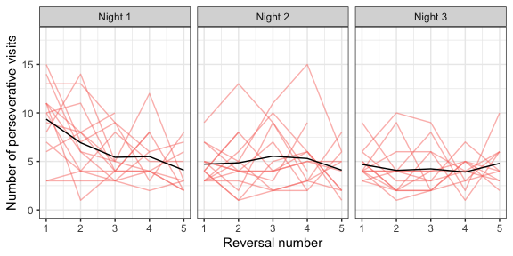

Figure 2: Number of perseverative visits made by the bats after each reversal across all three nights. A perseverative visit was defined as visit to the previously-rewarding option before the first visit to the newly-rewarding option after a reversal. By definition there were no perseverative visits in the first block of a night. The red lines are the perseverative visits made by the individual bats after each reversal of a night; the black lines are the number of perseverative visits averaged over the bats

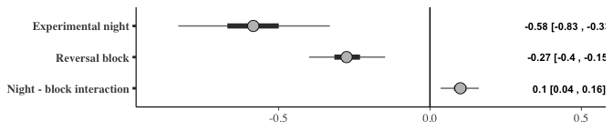

Figure 3: Forest plot of the estimates of the effect of night and block on perseverative visits; a negative effect indicates the perseverative visits decreased with successive nights and blocks. The circles represent the slope estimates, the thick horizontal lines represent the 50% credible intervals and the thin horizontal lines 95% credible intervals. The numbers are the slope estimates and the 95% credible intervals of each effect

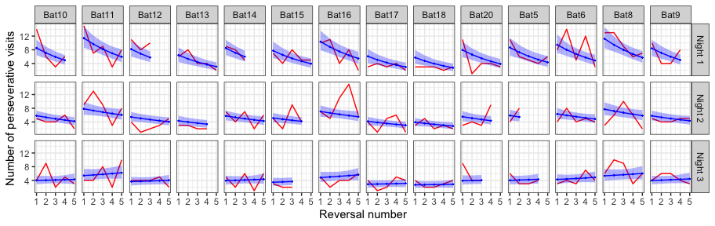

Figure 4: A comparison of the posterior predictions of the generalized linear mixed-effects model of perseverative visits and the empirical data from the bats. The red line indicates the number of perseverative visits per reversal made by the bats; the blue line indicates the corresponding posterior prediction of the model with the blue shading indicating 95% confidence intervals

### c) The bats make more visits to the rewarding option as they experience more reversals

The proportion of visits to the rewarding option was modeled as an effect of experimental night, block and bin. This analysis showed that night, block and bin all had a positive effect on the proportion of visits to the rewarding option: as the bats experience more reversals on more nights, and the more visits made since the occurrence of a reversal, the proportion of visits made to the rewarding option increased. Interestingly the slopes of the interactions of experimental night and block; block and bin within the block; and experimental night and bin within the block were all negative. That is, the increase in proportion of visits to the rewarding flower gets smaller as the bats experience more reversals on more nights. There is a smaller ‘improvement’ in performance, likely through a ‘ceiling effect,’ given how high the proportion of visits to the rewarding option was (**Figure 6**).

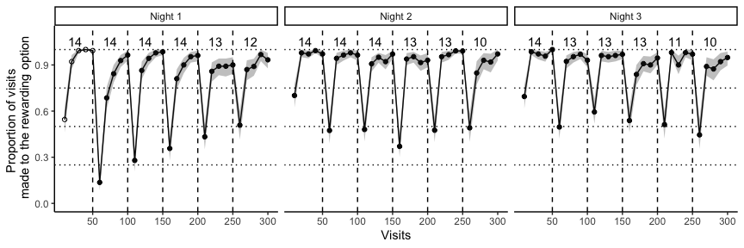

Figure 5: Average proportion of visits to the rewarding option in each bin of ten visits, averaged over all the individuals, across the three experimental nights. This bin average is indicated by white points in the first block on the first night before the bats experienced any reversals at all; the bin averages of all the other blocks are indicated by black points. The small numbers indicate the number of bats that participated in a particular reversal block, i.e., the sample size of a block. The solid black line connecting the points indicates the change in the average proportion of visits to the rewarding option with the shaded areas marking the 95% confidence intervals. The dashed vertical lines indicate the points when the reversals occurred

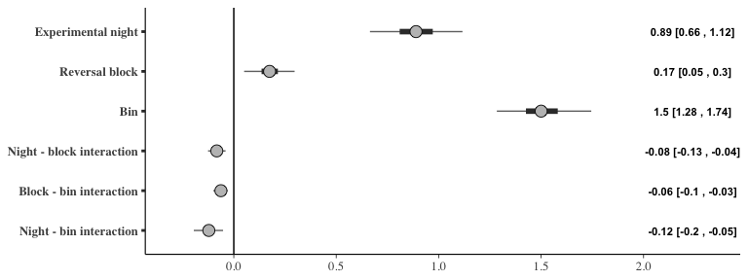

Figure 6: Forest plot of the estimates of the effect of night, block and bin on the proportion of visits to the rewarding option; a positive effect indicates the visits to the rewarding option increased with successive nights, blocks and bins (within each block). The circles represent the slope estimates, the thick horizontal lines represent the 50% credible intervals and the thin horizontal lines 95% credible intervals. The numbers are the slope estimates and the 95% credible intervals of each effect

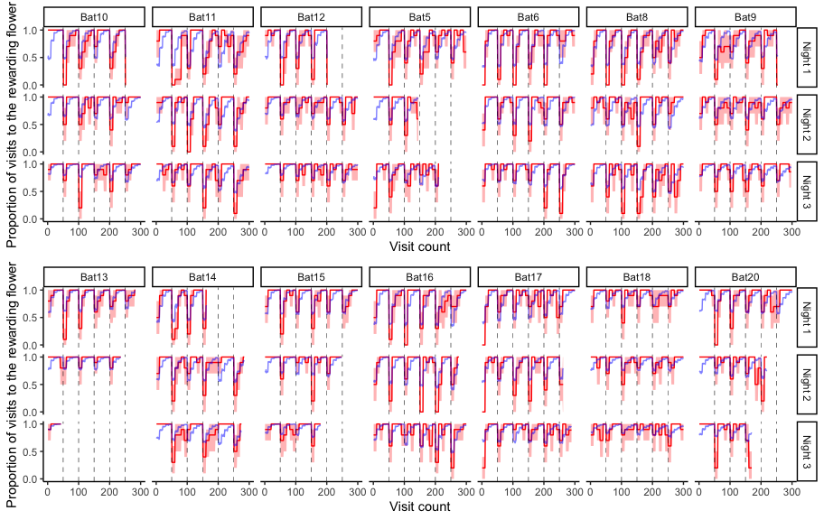

Figure 7: A comparison of the posterior predictions of the generalized linear mixed-effects model of the visits to the rewarding option and the empirical data from the bats. The red line indicates the average proportion of visits to the rewarding option per bin made by the individual bats, with the red shading indicating 95% confidence intervals; the blue line indicates the corresponding posterior prediction of the model

## Further exploratory analyses

### a) The effect of the first experimental night and the first block of each night

The first block of an experimental night was qualitatively different from the other blocks, as this was the only part of the night when the bats had not yet experienced a reversal. A similar argument can be made about the first experimental night: on this night the bats experience reversals for the first time. As it seemed the posterior predictions of our model with the effects of experimental night, block and bin did not completely capture the behaviour of the bats we did an exploratory analysis to specifically explore the effect of the first block and the first night.

The results of the model that accounts for the first night and block are presented in **Figure 8**. The main effects of night, block and bin, and their interactions were similar to the previous model. Additionally, the variable ‘block type,’ (i.e., whether a block was the first reversal block of the night or not), had a positive slope. The bats made more visits to the rewarding flower before they had experienced any reversal at all. While the ‘night type’ did not seem to affect the proportion of visits to the rewarding flower, block type and night type had an interaction effect with a positive coefficient: the first block of the first night, before any reversals had ever been experienced even once, had the highest proportion of visits to the rewarding flower compared to any other block on any other night.

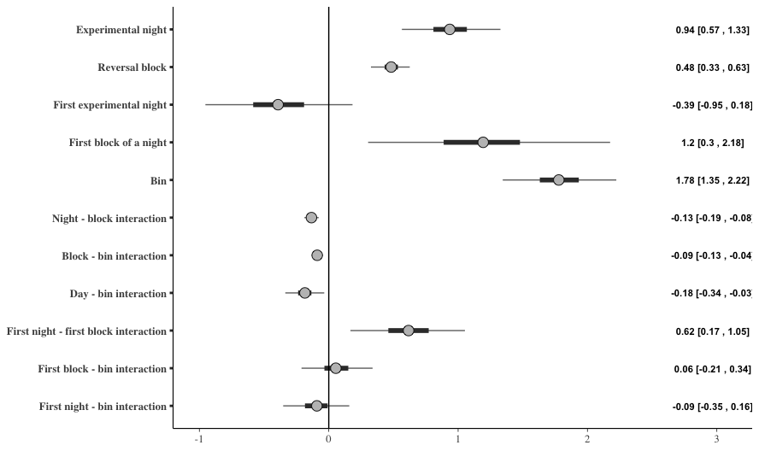

Figure 8: Forest plot of the estimates of the effect of night, block, and bin; and the differential effect of the first night and the first block (‘night-type’ and ‘block-type’) on the proportion of visits to the rewarding option; a positive effect indicates the visits to the rewarding option increased with successive nights, blocks and bins (within each block), or there were more visits to the rewarding option on the ‘block-type’ or ‘night-type’ indicated. The circles represent the slope estimates, the thick horizontal lines represent the 50% credible intervals and the thin horizontal lines 95% credible intervals

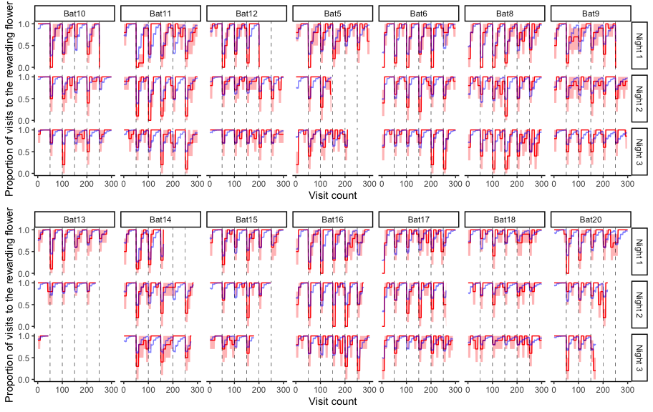

Figure 9: A comparison of the posterior predictions of the exploratory generalized linear mixed-effects model of the visits to the rewarding option and the empirical data from the bats, including the effect of ‘night-type’ and ‘block-type.’ The red line indicates the average proportion of visits to the rewarding option per bin made by the individual bats to show the change, with the red shading indicating 95% confidence intervals; the blue line indicates the corresponding posterior prediction of the model

We compared the predictive accuracy of the model that included night type and block type to the model that did not include these, using leave-one-out cross-validation. The LOO criterion was lower for the former than the latter, indicating better predictive accuracy (**Table 1**). Indeed, the posterior predictions of the model including night-type and block-type were a better fit for the first block of a night for many of the bats than those of the model that did not include them (**Figure 9**).

Table 1: Comparison of the two models of the proportion of visits to the rewarding option using leave-one-out cross-validation

| **Model** | **Difference in LOO estimates** | **Standard error** |
| --- | --- | --- |
| **Model accounting for the first night and first block separately** | 0.00 | 0.00 |
| **Night and block as continuous only** | -108.21 | 14.14 |

### b) The effect of asymptotic performance on the visits to the rewarding option just after a reversal

The proportion of visits to the rewarding flower just after a reversal made by the bats was compared to the asymptote just before. The asymptote, or asymptotic performance, was calculated as the average proportion of visits to the rewarding flower in the three bins before a reversal on the visits to the rewarding flower just after that reversal. The asymptotic performance before a reversal and the corresponding visits to the rewarding option just after that reversal are shown in the scatter-plot in **Figure 10**, with regression lines fit for each individual animal.

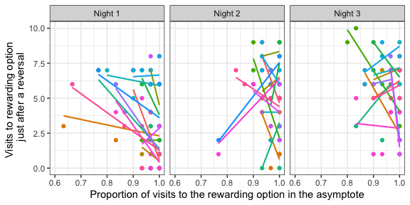

Figure 10: A comparison of the number of visits to the rewarding flower in the first bin of ten visits just after a reversal to the asymptotic proportion of visits to the rewarding flower just before that reversal. The asymptote was calculated as the proportion of visits to the rewarding flower averaged over the three bins of ten visits just before a reversal. Individual points are data from each individual bat for each one of the five reversals that occurred on a day. Colours indicate the individual bat. Regression lines are fit for each individual on each night

The analysis of the effect of the asymptotic performance on the visits to the rewarding option just after the reversal showed that the effect of the asymptote depended on the night. That is, there was a large interaction effect between the night and asymptote value. On the first night the slope of the effect of the asymptote and the visits to the rewarding option after the reversal was highly negative, indicating that the higher the asymptote value the lower the number of visits to the rewarding option just after a reversal. On the second night the slope was close to 0, though still negative, indicating a weaker relationship than on the first night. On the third night the slope highly negative again, similar to that on the first night (**Figure 11**).

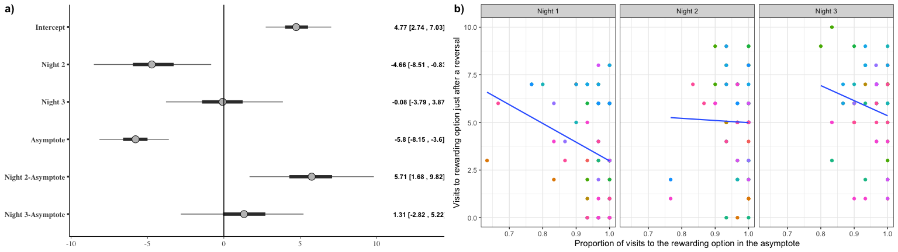

Figure 11: a) Forest plot of the coefficients of the effect of night and the value of the asymptote before a reversal on the number of visits to the rewarding option just after a reversal. The circles represent the intercept and slope estimates, the thick horizontal lines represent the 50% credible intervals and the thin horizontal lines 95% credible intervals. b) A comparison of the number of visits to the rewarding flower in the first bin of ten visits just after a reversal to the asymptotic proportion of visits to the rewarding flower just before that reversal. Individual points are data from each individual bat for each one of the five reversals that occurred on a day. Colours indicate the individual bat. Regression lines are fit for each night

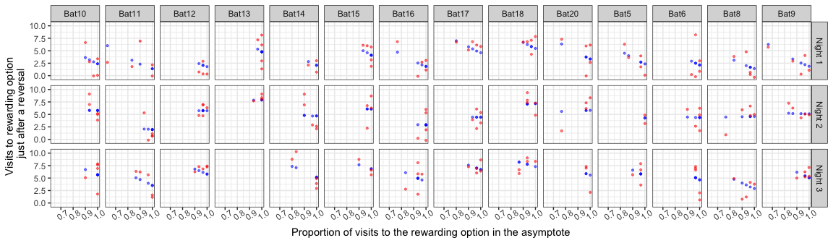

Figure 12: A comparison of the posterior predictions of the generalized linear mixed-effects model of the visits to the rewarding option after a reversal as an effect of night and asymptotic performance. Red points are the empirical values from the individual bats and the blue points indicate the corresponding posterior predictions of the model

# Discussion

## A brief recap of what the bats did

* Learned where the rewarding location was and made near exclusive visits to it until they experienced a reversal on a particular night.
* As they experienced reversals the bats learned to switch back more and more rapidly, topping out thanks to a ceiling effect
* **GUIDING LIGHT: In short, near-perfect performance achieved through decreasing the number of perseverative visits and increasing the overall proportion of visits to the rewarding option with just a little bit of sampling leftover**

## Rapid switching versus gradual switching

* Averaging data vs the individual data - talk about the model fits

## The role of unrewarded visits

* Mention this briefly if it impacts the interpretation of the data

## A task relevant to their foraging ecology

* Quick detection and response to a changing environment

## A comparison along relevant dimensions with the other animals that have done this task

* Corvids and their spatial abilities
* The other nectar-feeders
* Other mammals?
* Contrast with the spatial memory demands of passerines and chickadees - see discussion of the passerine paper

## What have we actually discovered about the animals’ abilities?

* Cognitive flexibility vs behavioural flexibility
* Exploration and exploitation
* They learn that a reversal is something that can happen in this world
* They learned this pretty quickly: something that works with their foraging ecology

# References

Baker, Herbert G., Irene Baker, and Scott A. Hodges. 1998. “Sugar Composition of Nectars and Fruits Consumed by Birds and Bats in the Tropics and Subtropics1.” *Biotropica* 30 (4): 559–86. https://doi.org/<https://doi.org/10.1111/j.1744-7429.1998.tb00097.x>.

Bürkner, Paul-Christian. 2017. “**Brms** : An *r* Package for Bayesian Multilevel Models Using *Stan*.” *Journal of Statistical Software* 80 (1). <https://doi.org/10.18637/jss.v080.i01>.

Helversen, Dagmar von, and Otto von Helversen. 1999. “Acoustic Guide in Bat-Pollinated Flower.” *Nature* 398 (6730): 759–60. <https://doi.org/10.1038/19648>.

Helversen, O. v., and H. -U. Reyer. 1984. “Nectar Intake and Energy Expenditure in a Flower Visiting Bat.” *Oecologia* 63 (2): 178–84. <https://doi.org/10.1007/BF00379875>.

Helversen, O. von, L. Winkler, and H. J. Bestmann. 2000. “Sulphur-Containing ‘Perfumes’ Attract Flower-Visiting Bats.” *Journal of Comparative Physiology A* 186 (2): 143–53. <https://doi.org/10.1007/s003590050014>.

Kelm, Detlev H., Ralph Simon, Doreen Kuhlow, Christian C. Voigt, and Michael Ristow. 2011. “High Activity Enables Life on a High-Sugar Diet: Blood Glucose Regulation in Nectar-Feeding Bats.” *Proceedings of the Royal Society B: Biological Sciences* 278 (1724): 3490–96. <https://doi.org/10.1098/rspb.2011.0465>.

Kunz, Thomas H., and M. Brock Fenton. 2005. *Bat Ecology*. University of Chicago Press.

Rose, Andreas, Miriam Kolar, Marco Tschapka, and Mirjam Knörnschild. 2016. “Learning Where to Feed: The Use of Social Information in Flower-Visiting Pallas’ Long-Tongued Bats (Glossophaga Soricina).” *Animal Cognition* 19 (2): 251–62. <https://doi.org/10.1007/s10071-015-0930-9>.

Thiele, Johannes, and York Winter. 2005. “Hierarchical Strategy for Relocating Food Targets in Flower Bats: Spatial Memory Versus Cue-Directed Search.” *Animal Behaviour* 69 (2): 315–27. <https://doi.org/10.1016/j.anbehav.2004.05.012>.

Toelch, Ulf, Kai Petra Stich, Clifton Lee Gass, and York Winter. 2008. “Effect of Local Spatial Cues in Small-Scale Orientation of Flower Bats.” *Animal Behaviour* 75 (3): 913–20. <https://doi.org/10.1016/j.anbehav.2007.07.011>.

Vehtari, Aki, Andrew Gelman, and Jonah Gabry. 2017. “Practical Bayesian Model Evaluation Using Leave-One-Out Cross-Validation and WAIC.” *Statistics and Computing* 27 (5): 1413–32. <https://doi.org/10.1007/s11222-016-9696-4>.

Voigt, C. C., and J. R. Speakman. 2007. “Nectar-Feeding Bats Fuel Their High Metabolism Directly with Exogenous Carbohydrates.” *Functional Ecology* 21 (5): 913–21. <https://doi.org/10.1111/j.1365-2435.2007.01321.x>.

Voigt, C. C., and Y. Winter. 1999. “Energetic Cost of Hovering Flight in Nectar-Feeding Bats (Phyllostomidae: Glossophaginae) and Its Scaling in Moths, Birds and Bats.” *Journal of Comparative Physiology B: Biochemical, Systemic, and Environmental Physiology* 169 (1): 38–48. <https://doi.org/10.1007/s003600050191>.

Voigt, Christian C., Detlev H. Kelm, and G. Henk Visser. 2006. “Field Metabolic Rates of Phytophagous Bats: Do Pollination Strategies of Plants Make Life of Nectar-Feeders Spin Faster?” *Journal of Comparative Physiology B* 176 (3): 213–22. <https://doi.org/10.1007/s00360-005-0042-y>.

Winter, Y. 2005. “Foraging in a Complex Naturalistic Environment: Capacity of Spatial Working Memory in Flower Bats.” *Journal of Experimental Biology* 208 (3): 539–48. <https://doi.org/10.1242/jeb.01416>.

Winter, Y., and O. von Helversen. 1998. “The Energy Cost of Flight: Do Small Bats Fly More Cheaply Than Birds?” *Journal of Comparative Physiology B* 168 (2): 105–11. <https://doi.org/10.1007/s003600050126>.

Winter, York, Sophie von Merten, and Hans-Ulrich Kleindienst. 2005. “Visual Landmark Orientation by Flying Bats at a Large-Scale Touch and Walk Screen for Bats, Birds and Rodents.” *Journal of Neuroscience Methods* 141 (2): 283–90. <https://doi.org/10.1016/j.jneumeth.2004.07.002>.