Serial reversal learning in nectar-feeding bats

*‘Take some more tea,’ the March Hare said to Alice, very earnestly.*

*‘I’ve had nothing yet,’ Alice replied in an offended tone, ‘so I can’t take more.’*

*‘You mean you can’t take LESS,’ said the Hatter: ‘it’s very easy to take MORE than nothing.’*

# Methods

## Study site and subjects

The experiment was done from the 28th of June to the 25th of July, 2017, at La Selva Biological Field Station, Province Heredia, Costa Rica. Male and female individuals of the species *Glossophaga commissarisi*, were captured from the wild for the experiment. The bats were attracted to a particular location in the forest using sugar-water (see **Reward** below) as bait and then caught in mist-nets. The bats were sexed and the selected individuals were were then taken to two flight-cages (4 x 6 m). The flight-cages had mesh walls and therefore the same climatic conditions as the surrounding environment. A group of four bats at a time were put into a flight cage. All the individuals in a group were the same sex. The bats were weighed and radio frequency identification (RFID) tags that were uniquely assigned to each bat were placed around their necks as collars. The bats were then released into the flight-cages so they could fly within them freely.

Before the start of the experiment the procedure was tested with four females and refinements were made to the procedure. The data from these individuals were not analyzed. 16 bats participated in the main experiment. At the end of the experiment, the RFID collars were removed and the bats were weighed to make sure they were still at a healthy weight. No blinding was done as all the data collection was completely automatized. Two of the bats did not drink a sufficient amount of sugar-water to meet minimum energy requirements and were released before the end of the experiment and not replaced. The data from these two individuals were not analyzed. Thus, 14 bats in total (seven males and seven females) completed the experiment and the data from these animals were analyzed.

Animal experimental procedures were reviewed and permission for animal experimentation and RFID-tagging was granted by Sistema Nacional de Areas de Conservación (SINAC) at the Ministerio de Ambiente y Energía (MINAE), Costa Rica.

## Experimental Setup

### Reward

The reward received by the bats during the experiment was also their main source of food. The reward was a 17% by weight solution of sugar dissolved in water (prepared fresh everyday), hereafter referred to as ‘nectar.’ The sugar consisted of a 1:1:1 mass-mixture of sucrose, fructose and dextrose. The nectar was thus similar in composition and concentration to the nectar produced by wild chiropterophilous plants (Baker, Baker, and Hodges 1998).

### Flower and pump setup

Each flight cage had a square plastic frame in the center (2x2x1.5m). Eight reward-dispensing devices - hereafter referred to as ‘flowers’ - were fixed in a radial pattern on this frame, two on each side of the square (see **Figure 1**) with a distance of 40 cm between adjacent flowers. This is a distance the bats can discriminate (Thiele and Winter 2005). Each flower had the following parts: an RFID reader mounted on a plastic cylinder around the head of the flower; an infra-red light-barrier beam; an electronic pinch valve through which a PVC tube was placed and fixed to the head of the flower

A stepper-motor pump was placed in the center of the plastic frame in each cage. The pumps contained a 25 mL Hamilton glass syringe (Sigma Aldrich). The precision of the two pumps differed slightly: the pump in Cage 1 delivered 2.11 L per step of the stepper-motor, and the pump in Cage 2, 3.33 L per step. The glass syringe was connected to the tubing system of the flowers through five pinch valves. The pinch valves controlled the flow of liquid from the pump to the system and from a reservoir of liquid to the pump. The reservoir (500 mL thread bottle, Roth, Germany) was filled with fresh nectar everyday and connected to the syringe through the valves.

When a tagged bat approached a flower, the individual RFID number was read by the reader. If the bat then poked its nose into the flower and broke the light barrier, it triggered the release of a reward. The pinch valve opened and the pump moved the correct number of pre-programmed steps to dispense nectar to the head of the flower. The bat could easily hover in front of the flower and lick up the nectar. Only when both events occurred, i.e., the RFID reader detected a bat and the light-barrier was broken, would a reward be triggered.

The flowers and the pump were connected to a Lenovo ThinkPad laptop computer, which ran the experimental programs and the programs used to clean and fill the systems: PhenoSoft Control 16, PhenoSoft GmBH, Berlin, Germany. The raw data were recorded to this computer as comma-separated values (CSV) files.

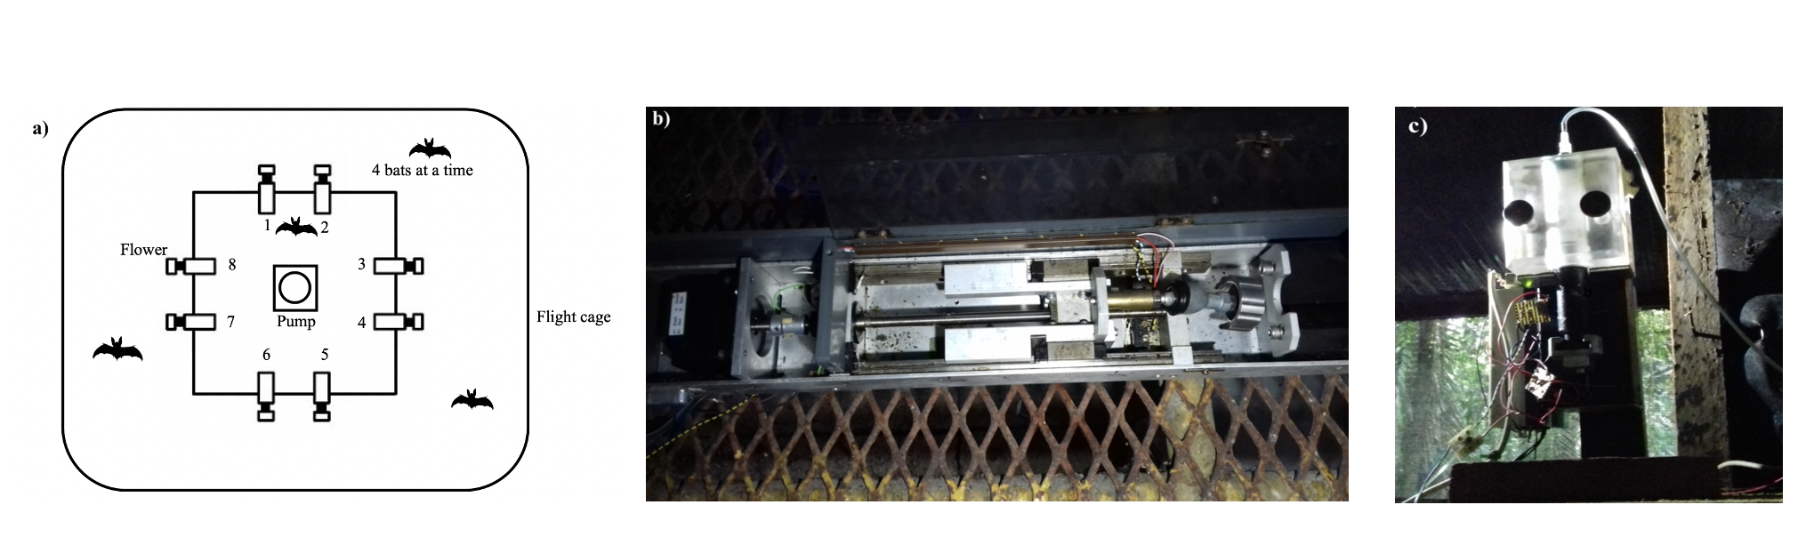

Figure 1: a) Schematic of the cage and flower set-up b) Horizontal pump c) Vertical pump

## Experimental procedure

Every day at around 10 h the old nectar was emptied from the system. The system was rinsed and filled with plain water until 15 h , when it was filled again with fresh nectar. Twice a week the system was filled with 70% ethanol for an hour to prevent microbial growth, then repeatedly rinsed with water.

Four bats were placed in a flight-cage in a group, and all the bats were the same sex. There were four such groups in total, and data were collected simultaneously from two groups, one in each flight-cage. Each bat was uniquely assigned two adjacent flowers on the same side of the square frame, out of the array of eight. These flowers were programmed to reward only one of the four bats in the cage. After the system was filled with fresh nectar at approximately 17 h, the program was left running for data-collection till the next morning. Thus, the bats could begin visiting the flowers to collect a reward whenever they chose, which was at approximately 18 h every night.

During the course of the night, when the syringe of the pump had been emptied, the pump re-filled automatically. This event happened only once every night. On the main experimental days this process took 4.5 minutes (SD = ±0.18) for the horizontal pump, and 2.43 minutes (SD = ±0.04) for the vertical pump. About 1 % (SD = ±0.74) of all visits made by the bats over all three experimental nights happened during the pump refill events, and the bats did not receive any reward on these visits, even if they were made to the rewarding flower.

Every night the bats were also given ad-libitum supplemental food: 3.5g of hummingbird food (NektarPlus, Nekton) in 100 mL of water and 3.5g of milk powder (Nido 1+, Nestle) in 100 mL of water. They were also given a small bowl of locally-sourced bee pollen.

## Experimental design

The experiment proceeded through the following stages.

### Training to use a flower

On the night the naive bats were captured and placed into the flight cages they could receive a reward from any of the flowers whenever they visited them throughout the night. To enable the bats to find the flowers a small cotton pad was placed on the flowers, soaked in di-methyl di-sulphide. This is a chemical attractant produced by many bat-pollinated flowers (O. von Helversen, Winkler, and Bestmann 2000). A small drop of honey was applied to the inside of the flowers to encourage the bats to place their heads inside, break the light-barrier and trigger a nectar reward. By the end of the night all the bats had found the flowers and learned to trigger rewards quickly.

### Training to use two specific flowers

After the bats had learned to trigger rewards, the next stage of training involved assigning the bats uniquely to two out of the eight flowers in the array. For an individual animal only the two flowers assigned it would be rewarding from this stage of training until the end of the experiment. Because the bats had already learned to trigger a reward at the flowers, the flowers were not provided with a cotton piece with the chemical attractant and honey was not applied to them. This stage was similar to the previous one, except the bats could only trigger a reward at their assigned flowers.

### Alternation

To ensure that the bats were familiar with both flowers assigned to them they went through one final stage of training: forced alternation between the two assigned flowers all night long.

### Main Experiment

In this serial reversal learning task the bats had to choose between a flower that gave 40 L of nectar and one that gave no reward at all. The location of the rewarding flower was not cued, but through the Alternation phase of training each bat knew the locations of both flowers that were potentially rewarding to it. After a bat had made 50 visits in total to the two flowers a reversal occurred: the previously rewarding flower became the non-rewarding flower and *vice versa*. Importantly, only visits to the two flowers assigned to a bat counted towards the visit tally, not visits to any of the other flowers which were unrewarding to that particular bat. The batch of 50 visits that occurred between two consecutive reversals (when the locations of the rewarding and unrewarding flowers remained stable) was termed a ‘reversal block,’ including the first 50 visits of a night when the bats had not experienced any reversal at all that night. This occurred at regular intervals of 50 visits until the bat either stopped making visits or reached a maximum of 300 visits in a night. After the bat had made 300 rewarded visits it could no longer receive a reward on that experimental night. There were five reversals per night. This stage of the experiment was repeated for three nights in a row. The same flower was the first to be rewarding at the start of every night. Thus, because there were five reversals every night (six blocks of 50 visits), if a bat completed the maximum of 300 visits on a night, the last flower to be rewarding that night was non-rewarding at the start of the next night.

## Statistical analysis

All the models were fit in a Bayesian framework using Hamiltonian Monte Carlo in the R package brms (Bürkner 2017), which is a front-end for rstan (Stan Development Team, 2020).

All the visits made by the bats during a night, up to a maximum of 300, were included in the analyses. There were three experimental nights, divided into six blocks of 50 visits each. At the end of the first five blocks a reversal occurred and the end of the last block was the end of data-collection for the night. Each block was further divided into five bins, each consisting of ten visits, in order to examine the bats’ behaviour within each block.

We defined a perseverative visit as a visit to the previously-rewarding option just after the occurrence of a reversal, until the first visit to the newly-rewarding option. By definition this could not happen in the first block of a night. A generalized linear mixed-model was used to investigate the effect of experimental night and reversal block on the number of perseverative visits. A negative-binomial likelihood function was used for this model. Experimental night, reversal block and their interaction were fixed effects and random slopes and intercepts were used to fit regression lines for each individual animal.

We also examined the proportion of visits made to the rewarding flower. This was defined as the ratio of the number of visits to the rewarding flower divided by the total number of visits in a bin. The total number of visits in a bin only included visits made to the two flowers assigned to a bat and any visit to a flower that was not assigned was not considered in the analysis. The model was fit using a binomial likelihood function, with experimental night, block, bin and their interactions as fixed effects; random slopes and intercepts were used to fit regression lines for the individuals.

After examining the above results, further analyses were done. It is important to note that these were *exploratory*, and the ideas were suggested to us by the results of the intended analyses described above.

A second model was fit to the proportion of visits to the rewarding flower to take into account the fact that the first night and the first block of each night were qualitatively different from the others. On the first night the animals had had no prior experience of any reversals, and during the first block of every night they had not experienced any reversals on that night, and this was reflected in the fit of the posterior predictions made from the first model. The second model of these data was identical to the first except for the addition of experimental night and block as factor variables, with the first night and the first block of every night as one level and the other nights and other blocks of each night as the other level. The two models were compared using leave-one-out cross-validation, implemented in brms using the package loo (Vehtari, Gelman, and Gabry 2017).

We reasoned that a comparison of the bats’ behaviour just before and after a reversal might reveal something of the learning mechanisms at work. If a higher proportion of visits to the rewarding flower just before a reversal is predictive of a higher proportion of visits to the rewarding flower just after, that might potentially indicate that the bats are learning the ‘rule’ behind the reversals. On the other hand, if there is no rule-learning, and the animals’ choice is driven by how much reinforcement was received at the two options, we would expect the opposite: the proportion of visits to the rewarding flower before the reversal is predictive of a *lower* proportion of visits to it just after as the animals take longer to ‘reverse’ their choices from a highly reinforced option. We took the proportion of visits to the rewarding option, averaged over the last three bins of a reversal block for each individual as the ‘asymptote’ of the bats’ choice behaviour. We fit a generalized linear-mixed model with the proportion of visits to the rewarding option the first bin just after a reversal as the response variable with the fixed effects asymptote, a continuous variable, and night, a factor variable. Random slopes and intercepts were used to fit regression lines for each individual animal.

Weakly informative priors were used. The random intercepts and slopes were given a Normal distribution with a mean of 0, and a standard deviation drawn from a Cauchy distribution with a mean of 0 and a standard deviation of 1. All the models were estimated using 4 chains with a thinning interval of 3, with 1200 warm-up samples and 1300 post-warm-up samples for the model with the first experimental night and block additionally treated differently; 2000 warm-up samples and 2000 post-warm-up samples for the model of the first bin of 10 visits after a reversal; and 1000 warm-up samples and 1000 post-warm-up samples for the others.

Visual inspection of the trace plots, the number of effective samples, the Gelman-Rubin convergence diagnostic () and the calculation of posterior predictions for the same clusters were all used to assess the fit of the models. In all of the models the was equal to 1 for all the chains.

The data from all 14 bats that participated in the three experimental nights were included in these models, even though some individuals did not complete all 300 visits on every single night.

All statistical analyses and creation of plots were done in R.

## Data availability

All data and analysis code are available online at …..

# Results

## Confirmatory Analyses

### Explanatory paragraph

**This paragraph is just for our guidance and will be removed later: it is an overall summary of the conclusions we draw from all of the analyses, i.e., the story we are building.**

**Confirmatory analyses**: As bats experience serial reversals they show a more rapid switch to the rewarding option after a reversal, and an overall increase in the proportion of visits made to the rewarding option. This overall increase was smaller with each successive reversal.

**Exploratory analyses**: The largest proportion of visits to the rewarding option was made every night before the bats had experienced any reversals. The higher the asymptote the longer the bats took to reverse, but this negative relationship varied by night and almost disappeared on the second night.

**In conclusion**: Experiencing serial reversal of reward, nectar-feeding bats learn that reversal can occur in their environment: we know this because they switch more rapidly; reach a higher proportion of visits to the rewarding option with a ‘ceiling effect’; and sample a little more once they have experienced a reversal on a day

### a) Bats made a very high proportion of their visits to the rewarding option after reversals

At the start of the first night, in the very first bin of ten visits when the bats did not yet have any information about the available options and had never experienced a reversal, the proportion of visits to the rewarding option averaged over the bats was close to chance: 54.5 %, 95% CIs [46.1, 62.3]. Within the next ten visits, however, this proportion increased to 92.1 %, 95% CIs [87.1, 96.4] and by the last bin of this first block was 99.3 %, 95 % CIs [97.9, 100]. Immediately after the first experience of a reversal, this proportion dropped down to 13.6%, 95% CIs [8.4, 19.5] in the first ten visits, but came back up to 96.4%, 95% CIs [92.9, 99.3] by the last bin of this block. This pattern of a decrease in the average proportion of visits to the rewarding option of all the bats immediately following a reversal, and then a rapid increase, was consistently true for all the reversals on the first night (**Figure 5**). Indeed, the proportion of visits to the rewarding option in the last 3 bins of a reversal block was 93 %, 95% CIs [91.8, 94.1] on the first night, even excluding the first block before any reversal experience. At the very start of the second and third nights, in the first bin of visits before any experience of a reversal *on that night*, the average proportion of visits to the rewarding option of all the bats was 69.8 %, 95% CIs [64.6, 74.7]. However the average proportion of visits to the rewarding option still showed the pattern of a decrease immediately after a reversal and then increase to a high proportion. On nights 2 and 3, after the bats had experienced the first reversal of the night, the average proportion of visits to the rewarding option in the last three bins of a reversal block was 94.8 %, 95% CIs [94, 95.5], comparable to the 93 %, 95% CIs [91.8, 94.1] on the first night.

### b) Bats switch to the rewarding option faster as they experience more reversals

A visit to a non-rewarding flower after a reversal, before the first experience of a reward at the newly-rewarding option was called a perseverative visit. Our analysis showed that both experimental night and block had a negative effect on the number of perseverative visits made by the bats. As the bats experience more reversals on more nights the number of perseverative visits decreased. The interaction of night and block, however, was positive: the decrease in the number of perseverative visits was smaller as the bats experienced more experimental nights (**Figure 3**).

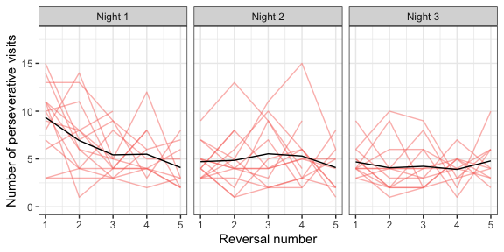

Figure 2: Number of perseverative visits made by the bats after each reversal across all three nights. A perseverative visit was defined as visit to the previously-rewarding option before the first visit to the newly-rewarding option after a reversal. By definition there were no perseverative visits in the first block of a night. The red lines are the perseverative visits made by the individual bats after each reversal of a night; the black lines are the number of perseverative visits averaged over the bats

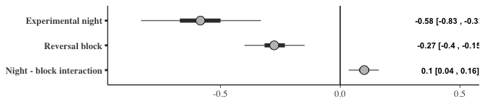

Figure 3: Forest plot of the estimates of the effect of night and block on perseverative visits; a negative effect indicates the perseverative visits decreased with successive nights and blocks. The circles represent the slope estimates, the thick horizontal lines represent the 50% credible intervals and the thin horizontal lines 95% credible intervals. The numbers are the slope estimates and the 95% credible intervals of each effect

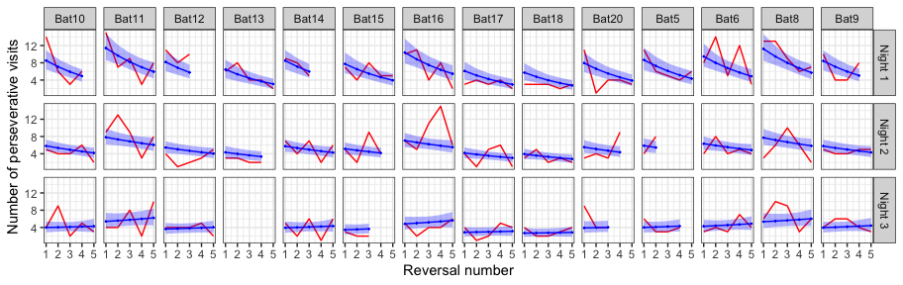

Figure 4: A comparison of the posterior predictions of the generalized linear mixed-effects model of perseverative visits and the empirical data from the bats. The red line indicates the number of perseverative visits per reversal made by the bats; the blue line indicates the corresponding posterior prediction of the model with the blue shading indicating 95% confidence intervals

### c) The bats make more visits to the rewarding option as they experience more reversals

The proportion of visits to the rewarding option was modeled as an effect of experimental night, block and bin. This analysis showed that night, block and bin all had a positive effect on the proportion of visits to the rewarding option: as the bats experience more reversals on more nights, and the more visits made since the occurrence of a reversal, the proportion of visits made to the rewarding option increased. Interestingly the slopes of the interactions of experimental night and block; block and bin within the block; and experimental night and bin within the block were all negative. That is, the increase in proportion of visits to the rewarding flower gets smaller as the bats experience more reversals on more nights. There is a smaller ‘improvement’ in performance, likely through a ‘ceiling effect,’ given how high the proportion of visits to the rewarding option was (**Figure 6**).

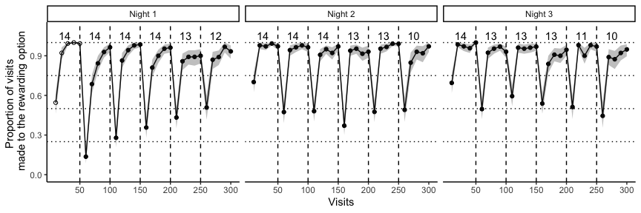

Figure 5: Average proportion of visits to the rewarding option in each bin of ten visits, averaged over all the individuals, across the three experimental nights. This bin average is indicated by white points in the first block on the first night before the bats experienced any reversals at all; the bin averages of all the other blocks are indicated by black points. The small numbers indicate the number of bats that participated in a particular reversal block, i.e., the sample size of a block. The solid black line connecting the points indicates the change in the average proportion of visits to the rewarding option with the shaded areas marking the 95% confidence intervals. The dashed vertical lines indicate the points when the reversals occurred

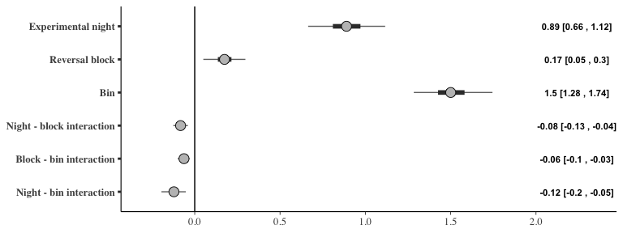

Figure 6: Forest plot of the estimates of the effect of night, block and bin on the proportion of visits to the rewarding option; a positive effect indicates the visits to the rewarding option increased with successive nights, blocks and bins (within each block). The circles represent the slope estimates, the thick horizontal lines represent the 50% credible intervals and the thin horizontal lines 95% credible intervals. The numbers are the slope estimates and the 95% credible intervals of each effect

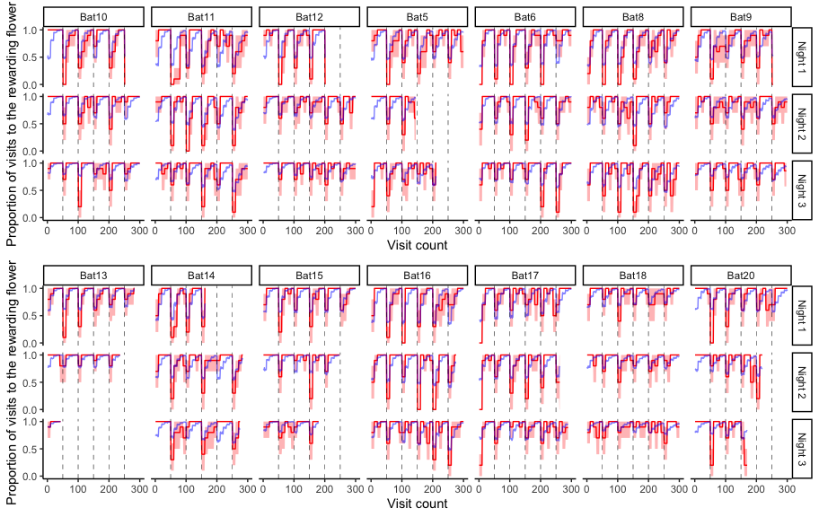

Figure 7: A comparison of the posterior predictions of the generalized linear mixed-effects model of the visits to the rewarding option and the empirical data from the bats. The red line indicates the average proportion of visits to the rewarding option per bin made by the individual bats, with the red shading indicating 95% confidence intervals; the blue line indicates the corresponding posterior prediction of the model

## Further exploratory analyses

### a) The effect of the first experimental night and the first block of each night

The first block of an experimental night was qualitatively different from the other blocks, as this was the only part of the night when the bats had not yet experienced a reversal. A similar argument can be made about the first experimental night: on this night the bats experience reversals for the first time. As it seemed the posterior predictions of our model with the effects of experimental night, block and bin did not completely capture the behaviour of the bats we did an exploratory analysis to specifically explore the effect of the first block and the first night.

The results of the model that accounts for the first night and block are presented in **Figure 8**. The main effects of night, block and bin, and their interactions were similar to the previous model. Additionally, the variable ‘block type,’ (i.e., whether a block was the first reversal block of the night or not), had a positive slope. The bats made more visits to the rewarding flower before they had experienced any reversal at all. While the ‘night type’ did not seem to affect the proportion of visits to the rewarding flower, block type and night type had an interaction effect with a positive coefficient: the first block of the first night, before any reversals had ever been experienced even once, had the highest proportion of visits to the rewarding flower compared to any other block on any other night.

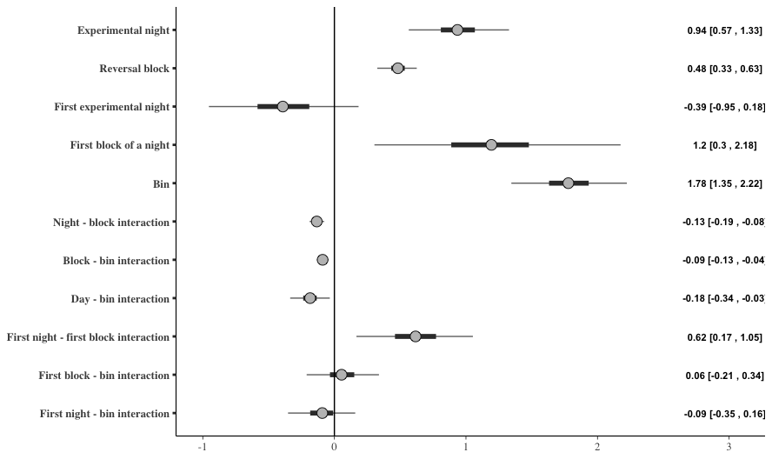

Figure 8: Forest plot of the estimates of the effect of night, block, and bin; and the differential effect of the first night and the first block (‘night-type’ and ‘block-type’) on the proportion of visits to the rewarding option; a positive effect indicates the visits to the rewarding option increased with successive nights, blocks and bins (within each block), or there were more visits to the rewarding option on the ‘block-type’ or ‘night-type’ indicated. The circles represent the slope estimates, the thick horizontal lines represent the 50% credible intervals and the thin horizontal lines 95% credible intervals

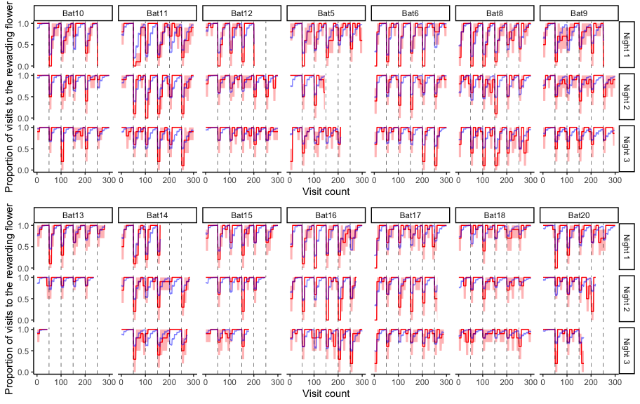

Figure 9: A comparison of the posterior predictions of the exploratory generalized linear mixed-effects model of the visits to the rewarding option and the empirical data from the bats, including the effect of ‘night-type’ and ‘block-type.’ The red line indicates the average proportion of visits to the rewarding option per bin made by the individual bats to show the change, with the red shading indicating 95% confidence intervals; the blue line indicates the corresponding posterior prediction of the model

We compared the predictive accuracy of the model that included night type and block type to the model that did not include these, using leave-one-out cross-validation. The LOO criterion was lower for the former than the latter, indicating better predictive accuracy (**Table 1**). Indeed, the posterior predictions of the model including night-type and block-type were a better fit for the first block of a night for many of the bats than those of the model that did not include them (**Figure 9**).

Table 1: Comparison of the two models of the proportion of visits to the rewarding option using leave-one-out cross-validation

| **Model** | **Difference in LOO estimates** | **Standard error** |
| --- | --- | --- |
| **Model accounting for the first night and first block separately** | 0.00 | 0.00 |
| **Night and block as continuous only** | -108.21 | 14.14 |

### b) The effect of asymptotic performance on the visits to the rewarding option just after a reversal

The proportion of visits to the rewarding flower just after a reversal made by the bats was compared to the asymptote just before. The asymptote, or asymptotic performance, was calculated as the average proportion of visits to the rewarding flower in the three bins before a reversal. The asymptotic performance before a reversal and the corresponding visits to the rewarding option just after that reversal are shown in the scatter-plot in **Figure 10**, with regression lines fit for each individual animal.

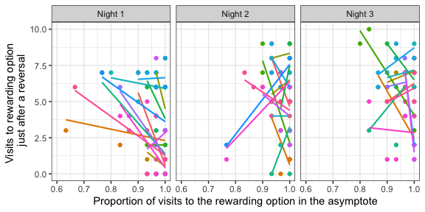

Figure 10: A comparison of the number of visits to the rewarding flower in the first bin of ten visits just after a reversal to the asymptotic proportion of visits to the rewarding flower just before that reversal. The asymptote was calculated as the proportion of visits to the rewarding flower averaged over the three bins of ten visits just before a reversal. Individual points are data from each individual bat for each one of the five reversals that occurred on a day. Colours indicate the individual bat. Regression lines are fit for each individual on each night

The analysis of the effect of the asymptotic performance on the visits to the rewarding option just after the reversal showed that the effect of the asymptote depended on the night. That is, there was a large interaction effect between the night and asymptote value. On the first night the slope of the effect of the asymptote was highly negative, indicating that the higher the asymptote value the lower the number of visits to the rewarding option just after a reversal. On the second night the slope was close to 0, though still negative, indicating a weaker relationship than on the first night. On the third night the slope highly negative again, similar to that on the first night (**Figure 11**).

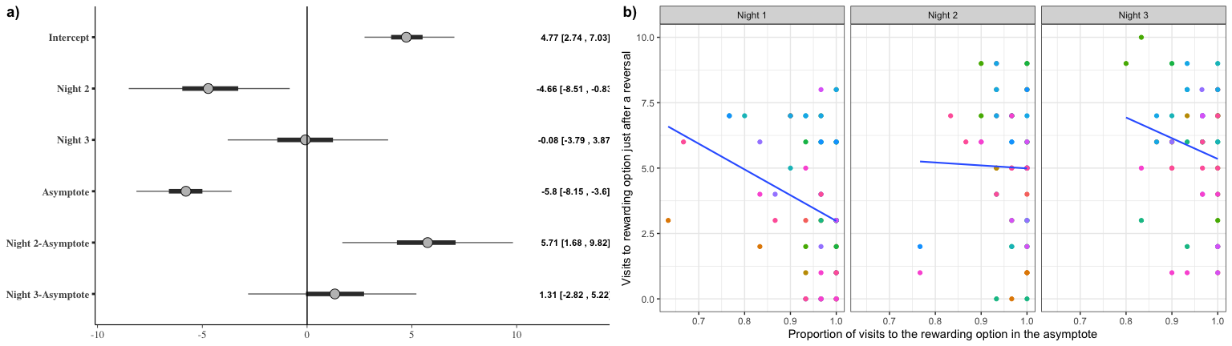

Figure 11: a) Forest plot of the coefficients of the effect of night and the value of the asymptote before a reversal on the number of visits to the rewarding option just after a reversal. The circles represent the intercept and slope estimates, the thick horizontal lines represent the 50% credible intervals and the thin horizontal lines 95% credible intervals. b) A comparison of the number of visits to the rewarding flower in the first bin of ten visits just after a reversal to the asymptotic proportion of visits to the rewarding flower just before that reversal. Individual points are data from each individual bat for each one of the five reversals that occurred on a day. Colours indicate the individual bat. Regression lines are fit for each night

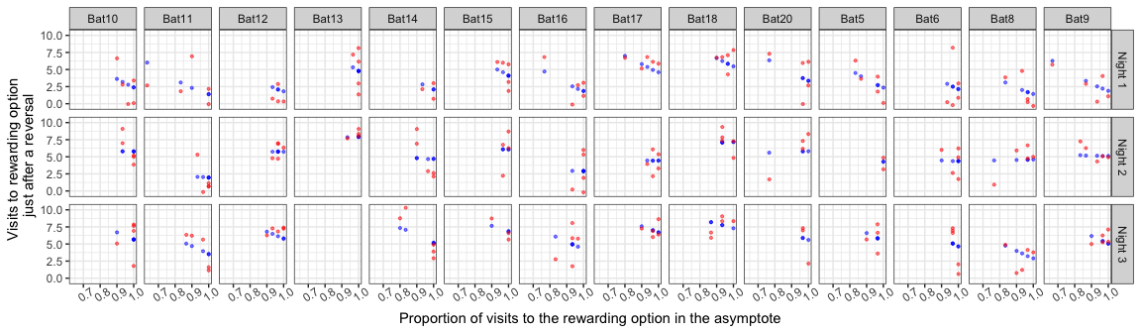

Figure 12: A comparison of the posterior predictions of the generalized linear mixed-effects model of the visits to the rewarding option after a reversal as an effect of night and asymptotic performance. Red points are the empirical values from the individual bats and the blue points indicate the corresponding posterior predictions of the model

# References

Baker, Herbert G., Irene Baker, and Scott A. Hodges. 1998. “Sugar Composition of Nectars and Fruits Consumed by Birds and Bats in the Tropics and Subtropics1.” *Biotropica* 30 (4): 559–86. https://doi.org/<https://doi.org/10.1111/j.1744-7429.1998.tb00097.x>.

Bürkner, Paul-Christian. 2017. “**Brms** : An *r* Package for Bayesian Multilevel Models Using *Stan*.” *Journal of Statistical Software* 80 (1). <https://doi.org/10.18637/jss.v080.i01>.

Helversen, Dagmar von, and Otto von Helversen. 1999. “Acoustic Guide in Bat-Pollinated Flower.” *Nature* 398 (6730): 759–60. <https://doi.org/10.1038/19648>.

Helversen, O. v., and H. -U. Reyer. 1984. “Nectar Intake and Energy Expenditure in a Flower Visiting Bat.” *Oecologia* 63 (2): 178–84. <https://doi.org/10.1007/BF00379875>.

Helversen, O. von, L. Winkler, and H. J. Bestmann. 2000. “Sulphur-Containing ‘Perfumes’ Attract Flower-Visiting Bats.” *Journal of Comparative Physiology A* 186 (2): 143–53. <https://doi.org/10.1007/s003590050014>.

Kelm, Detlev H., Ralph Simon, Doreen Kuhlow, Christian C. Voigt, and Michael Ristow. 2011. “High Activity Enables Life on a High-Sugar Diet: Blood Glucose Regulation in Nectar-Feeding Bats.” *Proceedings of the Royal Society B: Biological Sciences* 278 (1724): 3490–96. <https://doi.org/10.1098/rspb.2011.0465>.

Kunz, Thomas H., and M. Brock Fenton. 2005. *Bat Ecology*. University of Chicago Press.

Rose, Andreas, Miriam Kolar, Marco Tschapka, and Mirjam Knörnschild. 2016. “Learning Where to Feed: The Use of Social Information in Flower-Visiting Pallas’ Long-Tongued Bats (Glossophaga Soricina).” *Animal Cognition* 19 (2): 251–62. <https://doi.org/10.1007/s10071-015-0930-9>.

Thiele, Johannes, and York Winter. 2005. “Hierarchical Strategy for Relocating Food Targets in Flower Bats: Spatial Memory Versus Cue-Directed Search.” *Animal Behaviour* 69 (2): 315–27. <https://doi.org/10.1016/j.anbehav.2004.05.012>.

Toelch, Ulf, Kai Petra Stich, Clifton Lee Gass, and York Winter. 2008. “Effect of Local Spatial Cues in Small-Scale Orientation of Flower Bats.” *Animal Behaviour* 75 (3): 913–20. <https://doi.org/10.1016/j.anbehav.2007.07.011>.

Vehtari, Aki, Andrew Gelman, and Jonah Gabry. 2017. “Practical Bayesian Model Evaluation Using Leave-One-Out Cross-Validation and WAIC.” *Statistics and Computing* 27 (5): 1413–32. <https://doi.org/10.1007/s11222-016-9696-4>.

Voigt, C. C., and J. R. Speakman. 2007. “Nectar-Feeding Bats Fuel Their High Metabolism Directly with Exogenous Carbohydrates.” *Functional Ecology* 21 (5): 913–21. <https://doi.org/10.1111/j.1365-2435.2007.01321.x>.

Voigt, C. C., and Y. Winter. 1999. “Energetic Cost of Hovering Flight in Nectar-Feeding Bats (Phyllostomidae: Glossophaginae) and Its Scaling in Moths, Birds and Bats.” *Journal of Comparative Physiology B: Biochemical, Systemic, and Environmental Physiology* 169 (1): 38–48. <https://doi.org/10.1007/s003600050191>.

Voigt, Christian C., Detlev H. Kelm, and G. Henk Visser. 2006. “Field Metabolic Rates of Phytophagous Bats: Do Pollination Strategies of Plants Make Life of Nectar-Feeders Spin Faster?” *Journal of Comparative Physiology B* 176 (3): 213–22. <https://doi.org/10.1007/s00360-005-0042-y>.

Winter, Y. 2005. “Foraging in a Complex Naturalistic Environment: Capacity of Spatial Working Memory in Flower Bats.” *Journal of Experimental Biology* 208 (3): 539–48. <https://doi.org/10.1242/jeb.01416>.

Winter, Y., and O. von Helversen. 1998. “The Energy Cost of Flight: Do Small Bats Fly More Cheaply Than Birds?” *Journal of Comparative Physiology B* 168 (2): 105–11. <https://doi.org/10.1007/s003600050126>.

Winter, York, Sophie von Merten, and Hans-Ulrich Kleindienst. 2005. “Visual Landmark Orientation by Flying Bats at a Large-Scale Touch and Walk Screen for Bats, Birds and Rodents.” *Journal of Neuroscience Methods* 141 (2): 283–90. <https://doi.org/10.1016/j.jneumeth.2004.07.002>.