Enterprise Product Selection | EDA Team Review
US and Canada • Original vs. Proposed product lists • Enterprise hardware only • Internal discussion
I reviewed the original product lists and explored a revised set because the Canadian selection in particular appeared to have limited coverage. The new lists are only an exploratory reference, not a replacement for the existing eligibility screen. Our original rules remain a useful basis for selecting products with adequate historical data. After this screen, we could manually review a few additional products with shorter histories but meaningful recent activity, especially in CA.

1 | Scope and headline findings
All Enterprise means valid Enterprise-only transactions in Notebook, Workstation, Desktop and Visuals, separately for US and CA. The full-history monthly EDA covers April 2023–July 2026. Recent windows are kept distinct: 12 months for type-level revenue and ASP trends, and six months for current coverage. These comparisons are descriptive, not out-of-time model validation.
Metric | US original → proposed | CA original → proposed
Product groups | 65 → 62 | 24 → 38
Recent 6m revenue coverage | 38.97% → 47.81% | 21.17% → 36.85%
Recent 6m unit coverage | 35.92% → 44.48% | 16.74% → 32.97%
Full-history revenue coverage | Calculated by type below | 6.84% → 9.91%
Full-history unit coverage | Calculated by type below | 6.07% → 8.41%
Weekly reference rule pass | 63/65 → 48/62 (prior US run) | 13/24 → 11/38
The revised lists cover more recent Enterprise sales, but coverage improvement does not automatically mean every new product is baseline-ready. In particular, some shorter-history products have fewer supported weekly price-prediction samples.

2 | US: Full-history and current-market evidence
Full-history trends show whether the selected groups participate across earlier years; recent-window comparisons show whether they remain relevant now. The selected group may cover a larger share of recent sales while leaving earlier years poorly represented.
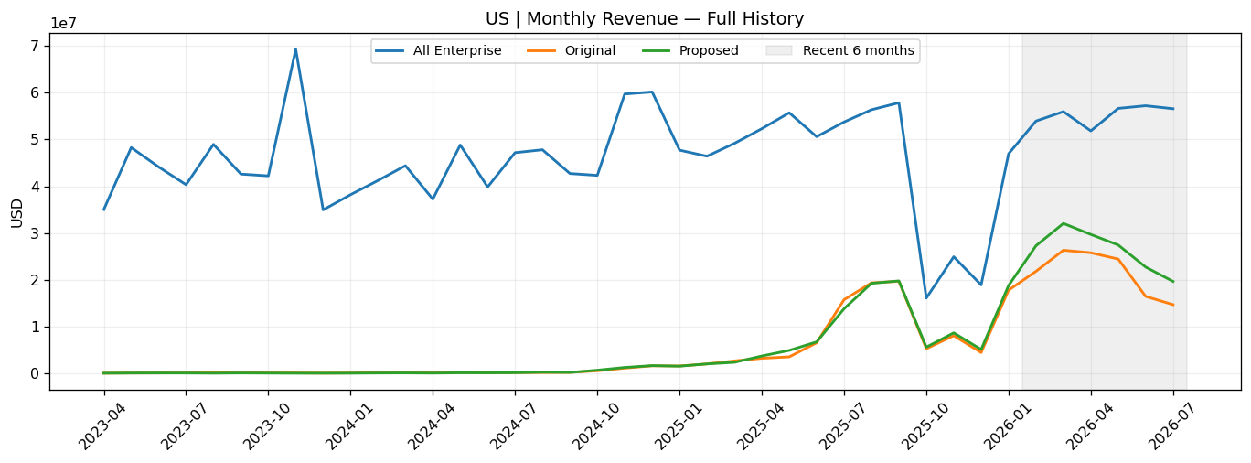
US: full-history monthly revenue (actual USD; All Enterprise, Original, Proposed).
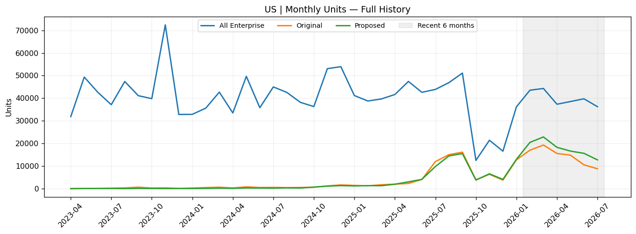
US: full-history monthly units (actual units).

Product-type coverage: full history versus the recent six months
Type | Full-history revenue | Recent 6m revenue | Recent 6m units
Notebook | 16.0% → 17.2% | 49.0% → 52.9% | 47.0% → 52.8%
Workstation | 9.0% → 13.1% | 27.8% → 48.4% | 34.2% → 54.3%
Desktop | 10.0% → 7.9% | 16.1% → 17.8% | 15.6% → 17.8%
Visuals | 13.2% → 8.1% | 14.2% → 17.0% | 9.9% → 19.6%
The table should be read by product type, not just in aggregate. Improvement in Notebook coverage may not imply equivalent representation of Desktop, Visuals or Workstation. Full-history shares are often far lower than recent shares, reflecting the newer or recently active composition of the selected cohorts.

3 | US: Product-type revenue and ASP trends
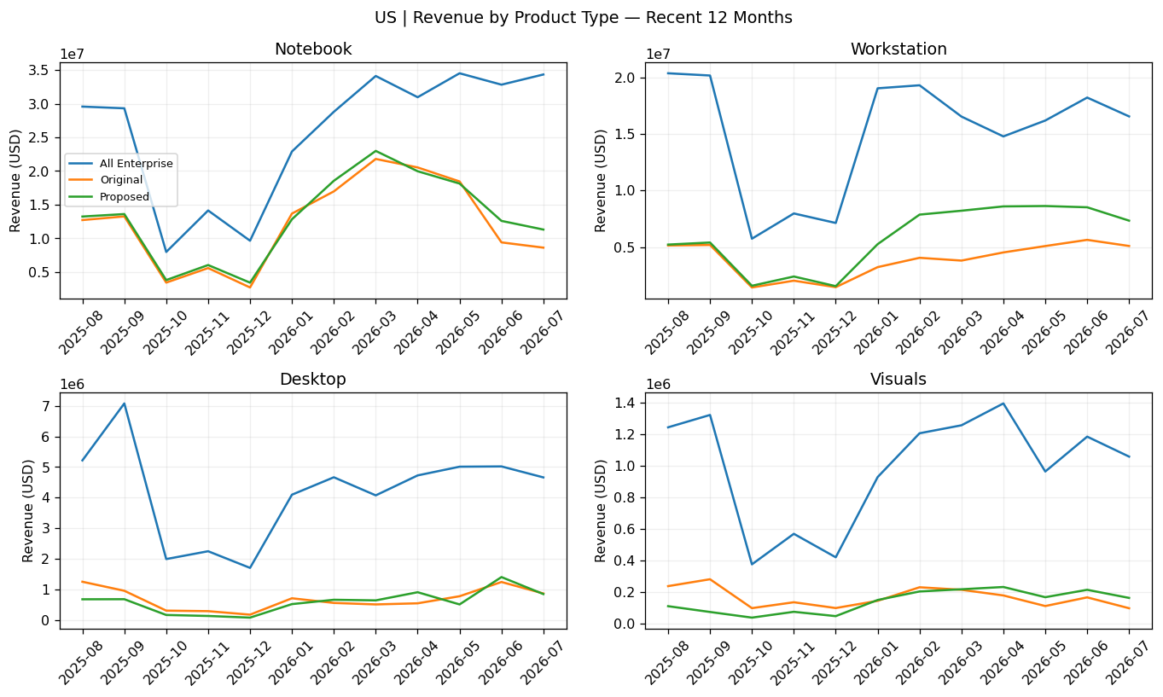
US: last 12 months, monthly revenue by product type.
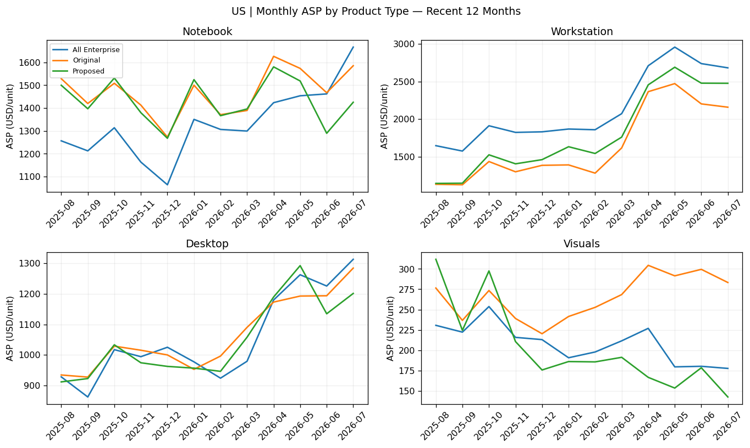
US: last 12 months, ASP = revenue / units by product type.

4 | US: Baseline readiness and implications
The previously computed US weekly audit found 63/65 original products passing, versus 48/62 proposed. The proposed median recent usable weeks increased from 19 to 21, while median historical usable weeks decreased from 17 to 14. The latest US notebook does not retain a readiness output, so these figures are from the preceding executed version and should be reconfirmed on the final extract.
A product passing a screening rule is not proof of forecast accuracy. For the core baseline, retain a clearly defined data-sufficient set; evaluate any manually included short-history products separately. CA may need a market-specific, less restrictive threshold, but only if the remaining ASP30/ASP90 features and future-seven-day observed labels support a meaningful evaluation.

2 | CA: Full-history and current-market evidence
Full-history trends show whether the selected groups participate across earlier years; recent-window comparisons show whether they remain relevant now. The selected group may cover a larger share of recent sales while leaving earlier years poorly represented.
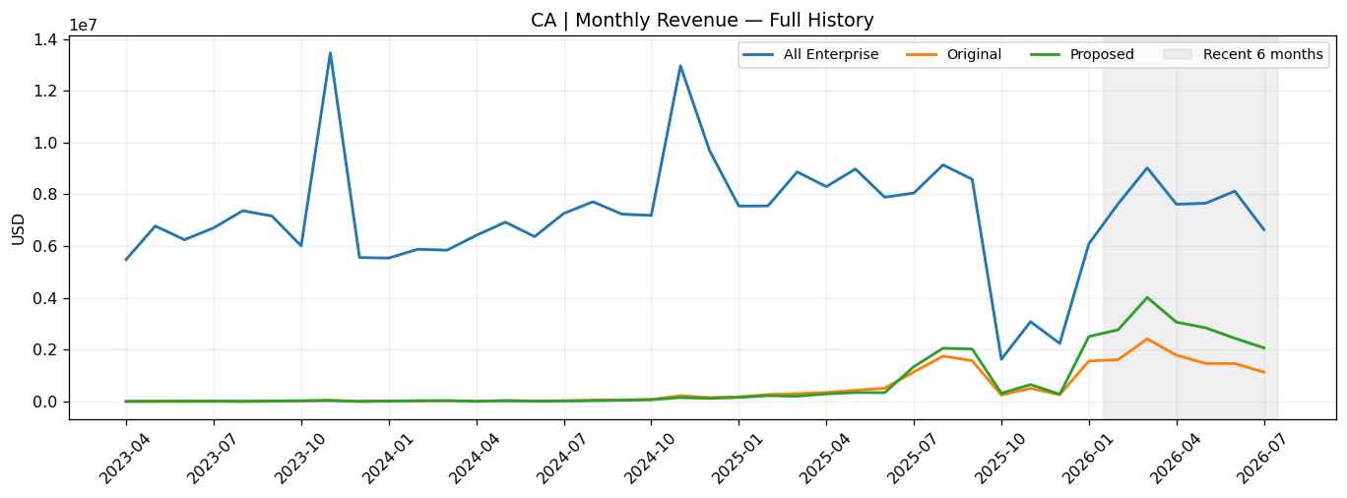
CA: full-history monthly revenue (actual USD; All Enterprise, Original, Proposed).
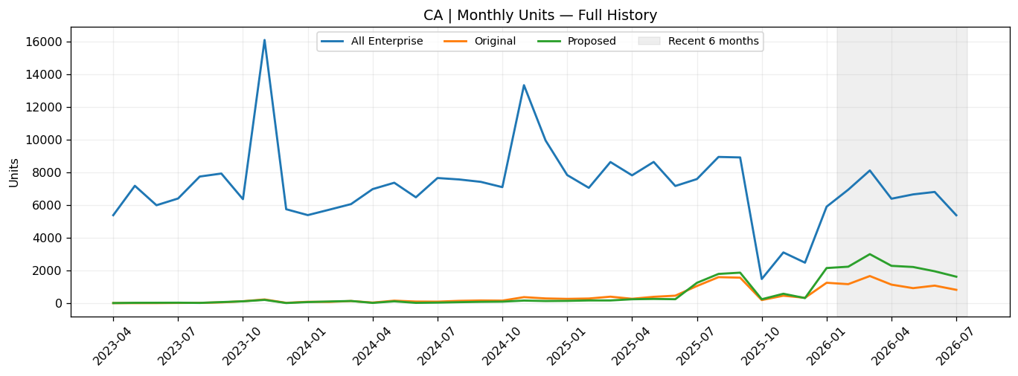
CA: full-history monthly units (actual units).

Product-type coverage: full history versus the recent six months
Type | Full-history revenue | Recent 6m revenue | Recent 6m units
Notebook | 9.3% → 12.8% | 29.5% → 45.8% | 24.4% → 44.9%
Workstation | 3.3% → 6.9% | 9.8% → 29.0% | 13.4% → 39.2%
Desktop | 3.3% → 5.2% | 3.9% → 12.3% | 4.1% → 11.4%
Visuals | 8.2% → 7.6% | 6.9% → 8.9% | 6.3% → 11.0%
The table should be read by product type, not just in aggregate. Improvement in Notebook coverage may not imply equivalent representation of Desktop, Visuals or Workstation. Full-history shares are often far lower than recent shares, reflecting the newer or recently active composition of the selected cohorts.

3 | CA: Product-type revenue and ASP trends
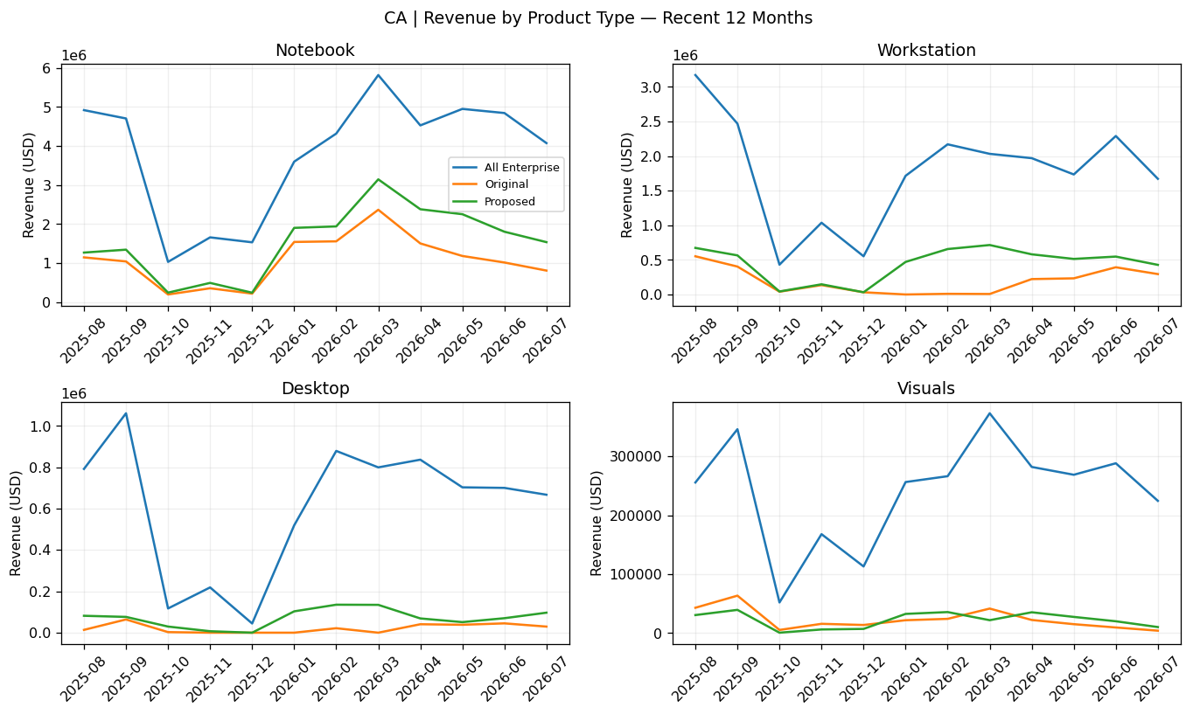
CA: last 12 months, monthly revenue by product type.


