EDA Assessment and Product Validation Findings

Our current recommendation
I suggest we keep the 65 US products as a provisional modeling population and review the 17 products with weak recent weekly support before finalizing the dashboard. The saved results show that the US weekly selection logic is consistent, and all candidate product types and families survive. They do not yet establish price representativeness or acceptable forecasting performance.
Your EDA gives us a useful foundation: it screens for both recent and historical activity, then checks whether US products have enough usable weekly observations. The validation adds evidence about which products remain, how their category mix changes, and how sensitive the final screen is to small changes.
Measure | US | Canada
Initial qualifying product groups | 76 | 24
Retained product groups | 65 | 24
Excluded after weekly support screen | 11 | Not applied
Recent selection window | March to August 2026 | March to August 2026
Historical window | September 2024 to February 2026 | September 2024 to February 2026

What has changed since the suggestions document
Type and family comparisons, US output consistency checks, and sensitivity to the final weekly minimums are now completed. The earlier suggestions document lists these as work to add. This review replaces those pending statuses with findings, while keeping price analysis, broader rule sensitivity and model evaluation as next steps.

1 How the EDA makes the selection
I would keep the current sequence, but label the stages clearly so we do not confuse a product having enough data with a product being representative or ready for pricing recommendations.
Stage | Current method | Why it matters
Define the product | Group by product name, family and type | This is the unit being selected; it may combine several product IDs.
Choose the periods | Six recent months plus three earlier six month periods | Separates current relevance from repeated historical support.
Initial US eligibility | More than 100 recent rows; at least 3 active recent months; more than 100 rows in at least 2 historical periods | Avoids relying on one large lifetime total.
Initial Canada eligibility | Same structure with more than 50 rows in the transaction gates | Uses a different activity threshold; its business rationale needs to be recorded.
US weekly support | At least 9 recent and 7 historical usable weeks | Checks whether aggregate activity produces enough supported forecast samples.
Final export | All retained groups and their matching transaction rows | The saved output is 65 US and 24 Canadian groups, not exactly 30.

Clarify the product and transaction definitions
The current three-field key can pool multiple product IDs. That can be reasonable for group-level recommendations, but a SKU decision needs an explicit mapping so different products are not treated as one.
The activity gates count rows, with duplicate rows preserved. We should confirm whether a row is an invoice line, order or distinct transaction before describing these counts as demand. An identical row may be a duplicate, but it should not be removed without checking its business meaning.

Keep the date rule explicit
The EDA uses ship date and falls back to order date. A fallback can move activity across windows, so the next extract should include a fallback count and agreed commercial date definition. The code chooses a common month before the latest observed month; this reduces partial-month exposure but does not prove the extract is complete.
Decision: keep eligibility, validation and any final dashboard ranking as separate outputs. TOP_N = 30 is unused, and the retained US table is sorted from lower recent support upward. Taking its first 30 rows would not select the strongest 30.

2 The saved US selection is internally consistent
The validation compares the 76-candidate table with the 65-retained table. The displayed basic checks pass: saved counts agree, group keys are unique, selected groups belong to the candidates, recent counts are within their 26-week denominator, percentages round correctly, and matching products have matching support counts.
Reapplying the final rule to the candidate table reproduces the same 65 retained groups. This supports the final weekly screen. It does not independently verify the underlying more-than-100-row gates or the weekly rolling calculations, because their transaction-level inputs are not saved here.
Reason for exclusion | Products | Meaning
Recent support only | 6 | Fewer than 9 recent usable weeks, despite passing historical support.
Historical support only | 4 | At least 9 recent weeks, but fewer than 7 historical weeks.
Both recent and historical | 1 | Fails both final support minimums.
Total excluded | 11 | 76 candidates minus 65 retained.

What this tells us about the selection
We retain 85.5% of the initial US candidates. The final screen removes genuinely different support patterns: some products have history but weak recent support, while others have recent activity without enough historical usable weeks. This is more informative than one overall transaction cutoff.
Please keep the reason for each removal in the selection report. A product that fails historical support may need a method for newer or less established products; a product that fails recent support may need a current-activity review. Neither reason proves the product is commercially unimportant.

What counts as a usable week
A usable checkpoint has at least 90 prior calendar days in the series, at least 5 rows in the previous 30 days, positive previous 90-day activity, and at least 2 rows in days t plus 1 through t plus 7. Features exclude the checkpoint day. The recent saved table checks 26 checkpoints per candidate.
Decision: describe this as a measure of supported historical samples. The historical usable-week denominator is not printed, so we should not compare a recent percentage with an invented historical percentage. The 18-month and 6-month counts also cover different lengths of time.
Evidence: uploaded validation notebook sections 2 and 3; EDA saved US candidate and retention outputs.

3 Product coverage is preserved within the US candidates
All four product types and all five candidate families remain in the retained set. The type mix changes only modestly: Notebook accounts for 35 of 65 selected groups, or 53.8%, versus 42 of 76 candidates, or 55.3%. A large Notebook share alone does not imply a problem when the candidate population already has that mix.
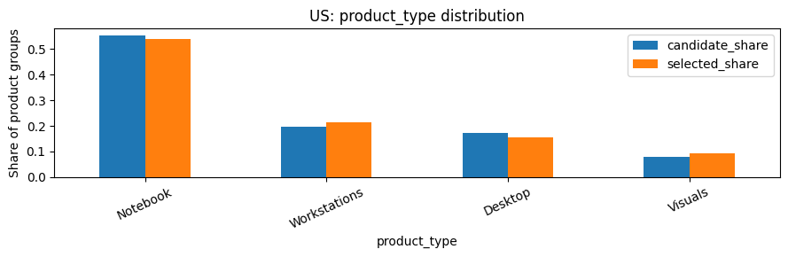
Figure 1 Product type shares in the 76 US candidates and 65 retained groups. Source: validation section 4.
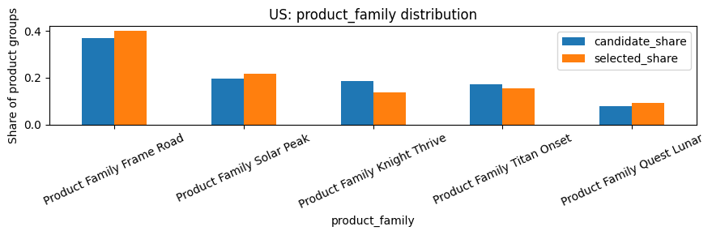
Figure 2 Product family shares using the same comparison population. Source: validation section 4.
The descriptive total variation distance is 0.0314 for type and 0.0630 for family, where zero means identical proportions. These are small differences for these features. The notebook uses 0.10 only as an exploratory guide; the team has not approved a formal acceptance threshold.
Decision: we can say type and family coverage are preserved relative to the 76 candidates. We should not extend that statement to the full Enterprise catalog, price bands, revenue or all engineered features. Those comparisons are not available in the saved outputs.

4 Coverage survives but some selections need review
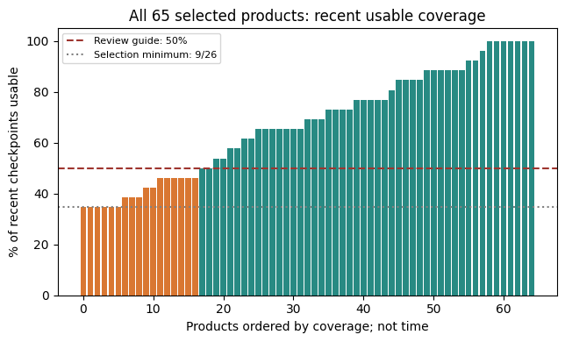
Figure 3 Recent weekly support for all 65 retained US groups. Orange products have fewer than half their checkpoints usable. Product order is not a time trend. Source: validation section 7A.
Seventeen products, or 26.2% of the retained set, have fewer than 13 of 26 recent checkpoints usable. Six sit exactly at the 9-week minimum, equivalent to 34.6% coverage. Two have only 8 historical usable weeks, one above the minimum. These flags overlap; they should not be added together.
The median retained product has 18 usable recent weeks, or 69.2% coverage, while 7 products have all 26. This range matters: a product can pass the rule and still provide a limited number of supported weekly observations.

Examples to discuss first
Product name | Recent weeks | Historical weeks | Review question
73QY858QLX SIGNAL ARC | 9 of 26 | 22 | Does the low recent support match the drop visible in its monthly chart?
CATALYST FRONTIER E8 JULIET D53 SUN 39RD | 9 of 26 | 49 | Is recent activity concentrated around a small number of large months?
A61L(P88238IC4)21MAWP OGEEJQU(CEQV N) | 10 of 26 | 76 | Why is recent support limited despite a long supported history?
LANTERN KN O70A RAY 1 W6556 63T 1J O15G | 10 of 26 | 8 | Is there enough history for the intended model?

Decision: keep these products in a review list rather than automatically deleting them. The 50% coverage guide is a review heuristic, not a new selection rule. The full list of 17 products appears in the appendix.

5 Monthly trends suggest different product behaviors
The original EDA charts provide useful context beyond a pass or fail flag. The four examples below are crops of the saved monthly plots, with their original axes and values preserved. Orange dashed lines mark March 2026. Each panel has its own vertical scale.
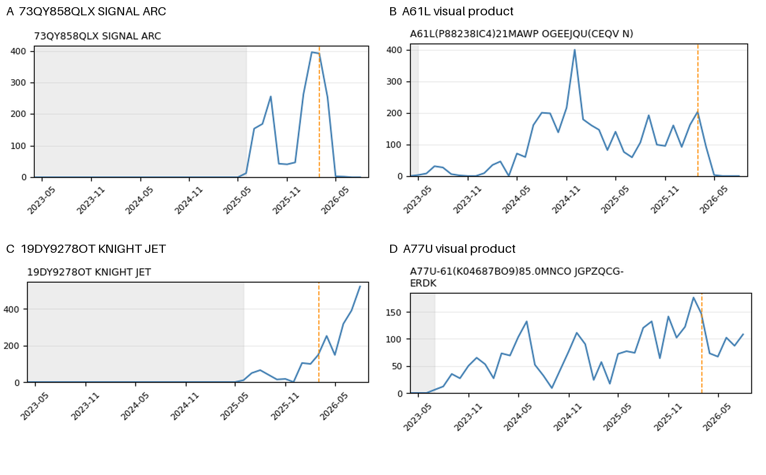
Figure 4 Selected monthly patterns from the saved EDA plots. A and B come from US plot page 1; C and D from US plot page 4. These are qualitative observations, not fitted trends.

What I would ask us to investigate
A 73QY858QLX SIGNAL ARC shows a large peak around the recent-window boundary followed by very low plotted activity. Its 9 usable recent weeks support a review of how concentrated its activity is. Please verify the monthly table and source dates before labeling it a declining product.
B The A61L visual product has substantial earlier activity and a marked reduction after the boundary in the saved chart. It still has 10 usable recent weeks and 76 historical weeks. A long history alone therefore does not guarantee strong current support.
C 19DY9278OT KNIGHT JET shows a visible rise in recent monthly row counts. D The A77U visual product shows activity across a longer period with fluctuations. Both have all 26 recent checkpoints usable. They illustrate that stronger weekly support can accompany different monthly patterns.
Decision: review spikes, gaps, late declines and recent growth separately. We cannot calculate monthly slopes, zero-month shares or inactivity gaps from chart images. Ask the EDA owner to export a small product-month table when possible; no full Enterprise extract is needed to share those aggregates.
Please also investigate any shared end-of-period fall across products before calling it a market trend. It could reflect extraction coverage, business timing or actual behavior. Gray shading before the first observed row does not prove the product had not launched.

6 Family retention and threshold sensitivity deserve attention
The screen preserves every family, but it removes some families more heavily. Knight Thrive retains 9 of 14 candidates, or 64.3%. Frame Road retains 26 of 28, or 92.9%; Quest Lunar retains all 6. That difference may be justified by support quality, but we should check whether commercially important products are being lost.
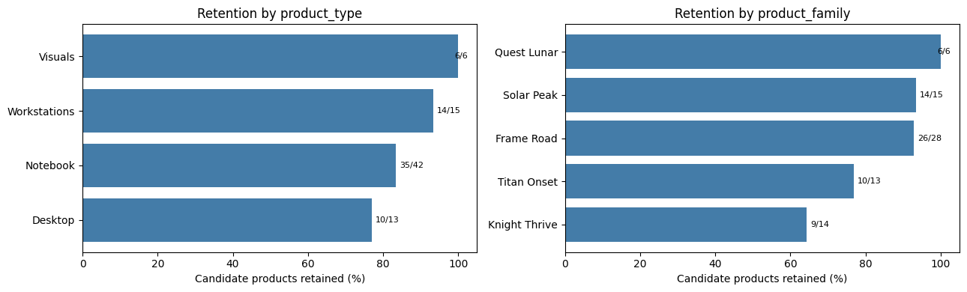
Figure 5 Retention by product type and family. Fractions show retained groups over candidate groups. Source: validation section 7A.
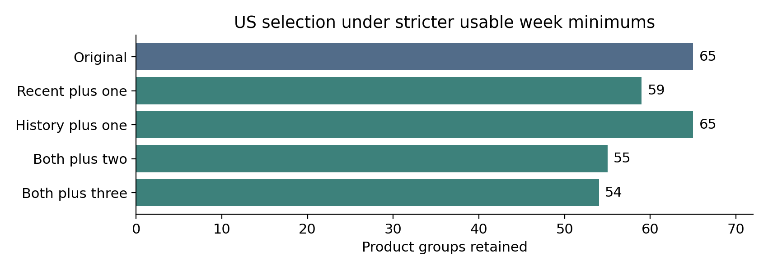
Figure 6 Retained counts under final weekly minimum changes. Recalculated directly from the saved candidate table; underlying transaction gates are unchanged.
Scenario | Recent minimum | History minimum | Retained | Original retained
Original | 9 | 7 | 65 | 100.0%
Recent plus one | 10 | 7 | 59 | 90.8%
History plus one | 9 | 8 | 65 | 100.0%
Both plus two | 11 | 9 | 55 | 84.6%
Both plus three | 12 | 10 | 54 | 83.1%

Decision: the result has reasonable local stability under these weekly changes, and type and family coverage survive the displayed scenarios. Six boundary products explain the loss when the recent minimum rises by one. The stricter scenarios are stress tests; they are not grounds to select a new threshold without checking forecast error and coverage.

7 What the Final Validation Rule now supports
The updated status is partial validation. We have completed useful checks, but each conclusion needs to stay tied to the features and population actually observed.
Requirement | Evidence now available | Remaining work
Cover types and families | All 4 US types and 5 candidate families retained | Confirm commercially important categories outside the initial candidate screen.
Cover price and activity levels | Recent and historical usable-week activity analyzed | Add price or ASP and transaction-volume tiers using eligible-population boundaries.
Similar distributions | US type and family share comparisons completed | Compare price, revenue, units, active months and relevant engineered features.
Stable under small changes | Final US usable-week minima tested; worst one-at-a-time retention is 90.8% | Test transaction gates, active-month rules and weekly sample definitions from numeric aggregates.
Acceptable performance outside the selected set | 11 initially eligible US groups are excluded by weekly support | No actual forecast metrics or approved tolerance are saved. This requirement remains untested.

Canada needs its own evidence
The EDA reports 24 Canadian qualifying groups and retains all 24. It applies the lower initial transaction gates but does not apply the same US usable-week filter. Please confirm whether Canada will use the same model and forecast horizon before deciding whether its support checks should match.
Because all printed Canadian candidates are retained, equality between selected and eligible distributions would follow by construction. It would not independently establish good selection. Numeric CA type, family, price and weekly-support tables are not saved in this validation notebook.

Which eligible population are we comparing against
For US, the 76 initial candidates are eligible before the final weekly screen; the 65 are retained after it. If the team defines eligibility as passing every support rule, the excluded 11 would not be eligible under that narrower definition. Please state the intended definition before using them as the outside-selected evaluation group.
Decision: retain the phrase “initial candidates” in current comparisons so the denominator is clear. Do not claim that all screenshot requirements have passed.

8 Resolve the weekly support decision before modeling
The future-seven-day condition needs a business decision. The code only calls a historical week usable when at least two transaction rows occur in the following seven days. That observation is unavailable at the forecast origin.

Choose the rule based on what we predict
If we predict demand or units for every week, zero and low-demand weeks are valid outcomes. Excluding them based on future activity can make model evaluation easier than real deployment. In that case, define eligibility using past information and include those outcomes in evaluation.
If we predict an average selling price for a future period, a period without sales may have no observed ASP. A minimum future-transaction rule can then define which historical labels are measurable. Even so, report how often a label is unavailable and limit performance claims to the supported periods. Do not describe the filter as information known in advance.

Keep the evaluation design separate from selection
Use the actual target, features and model intended for PriceWise. Train on earlier dates, test on later dates and keep any label windows out of the training period when they overlap the test boundary. If selection uses information from the test period, either freeze it at an earlier cutoff or describe the result as a retrospective diagnostic.
For the US, compare performance on retained products and an agreed outside-selected population, using the same dates and horizon. Include a simple baseline. Report both pooled errors and errors averaged across products so a few high-volume products do not dominate the result.
Metric | Plain meaning | Decision it helps
MAE | Average size of the forecast error in target units | Is the error small enough for the intended use?
WAPE | Total absolute error relative to total actual demand | How large is error relative to the evaluated volume? Undefined when total actual demand is zero.
Forecast bias | Whether predictions systematically run high or low | Could recommendations consistently overestimate or underestimate?
Supported period share | Fraction of periods with an evaluable target | Do reported errors apply to most weeks or a narrow subset?

Decision: agree on an acceptable error level with the model owner and stakeholder before declaring success. The EDA cannot establish model accuracy, price elasticity or the business impact of a price change.

Products to review first
All 17 below have fewer than half of the 26 recent checkpoints usable. “At minimum” means exactly 9 recent usable weeks; “Near history minimum” means 8 historical usable weeks. These are overlapping review flags, not failure labels. Names match the saved validation table.
Product name | Recent weeks | History weeks | Review flag
WHISKEY KN N31E SUN 1 E7528 60R E A01V | 9/26 | 9 | At recent minimum
HORIZON CA V87H RAY 3 H9562 92X H G15U | 9/26 | 17 | At recent minimum
78VCN39008 THRIVE RAY | 9/26 | 21 | At recent minimum
73QY858QLX SIGNAL ARC | 9/26 | 22 | At recent minimum
NOVEMBER JUNCTION N7 3-OI-4 V42 ARC 07RN | 9/26 | 23 | At recent minimum
CATALYST FRONTIER E8 JULIET D53 SUN 39RD | 9/26 | 49 | At recent minimum
LANTERN KN O70A RAY 1 W6556 63T 1J O15G | 10/26 | 8 | Near history minimum
CIVICCOHC 95 R6 WAY | 10/26 | 47 | Low recent coverage
A61L(P88238IC4)21MAWP OGEEJQU(CEQV N) | 10/26 | 76 | Low recent coverage
CYPRESS WH M10I SUN 4 N5072 36Q L V55I | 11/26 | 8 | Near history minimum
FRONTIER SOLSTICE F58H WAY 4 ARC SKY 30M | 11/26 | 13 | Low recent coverage
24UD7888QC HARBOR SKY | 12/26 | 11 | Low recent coverage
V94 WAY F3 | 12/26 | 21 | Low recent coverage
Z27 RAY J2 | 12/26 | 22 | Low recent coverage
H98D-98(F53088UJ0)05.7HLAL CDDRSEY-THXT | 12/26 | 24 | Low recent coverage
64TF79MLOF CANYON WAY | 12/26 | 27 | Low recent coverage
SOLSTICE FRONTIER P0 HARBOR K85 SKY 37KU | 12/26 | 49 | Low recent coverage

