**Neutrivin**

Neutrivin is an elegant platform to maintain constant vitamin levels in one’s diet. Depending on an individual’s dietary intake, it predicts which multivitamin is the most essential for them - prescribes them that medicine and keeps track of their food group levels throughout the prescription course.

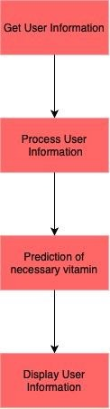

*A basic workflow of our application*

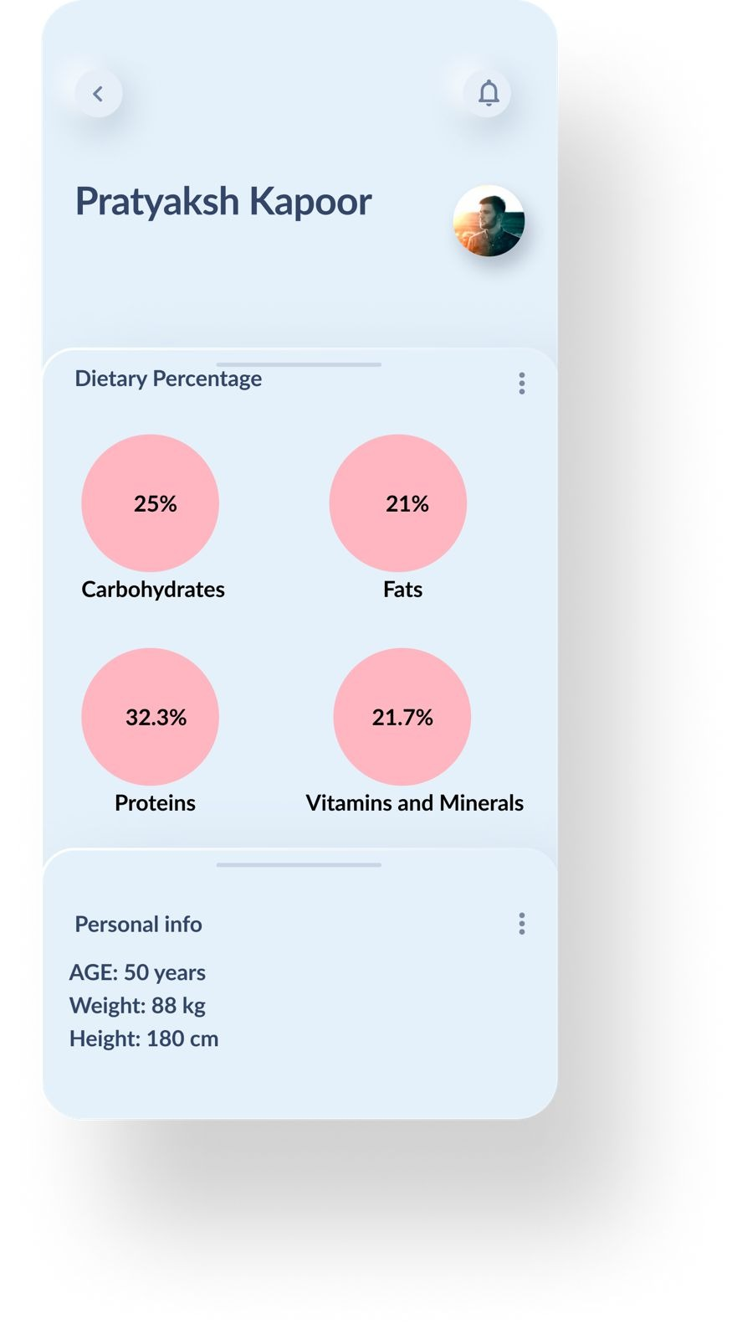 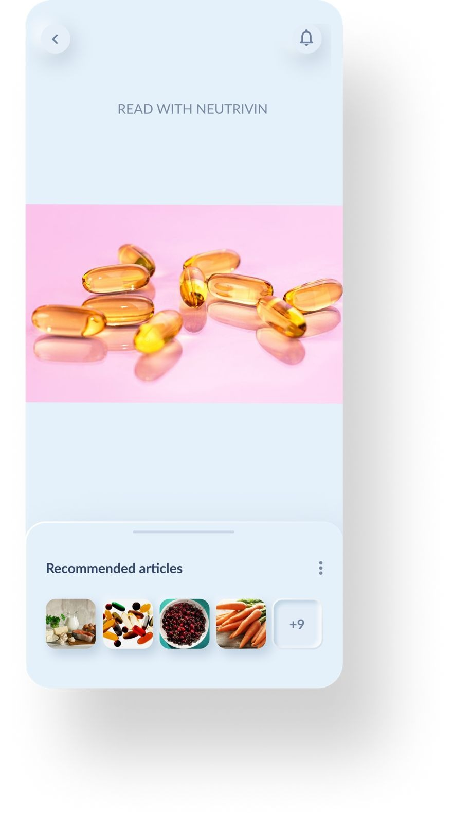

*A sample UI for the application*

