**What Is Amazon EC2?**

## Amazon Elastic Compute Cloud (Amazon EC2) provides scalable computing capacity in the Amazon Web Services (AWS) cloud. You can use Amazon EC2 to launch as many or as few virtual servers as you need Features of Amazon EC2

* Virtual computing environments, known as **instances**.
* Preconfigured templates for your instances, known as **Amazon Machine Images (AMIs)**, that package the bits you need for your server (including the operating system and additional software).
* Various configurations of CPU, memory, storage, and networking capacity for your instances, known as **instance types**
* Secure login information for your instances using **key pairs** (AWS stores the public key, and you store the private key in a secure place)
* Persistent storage volumes for your data using Amazon Elastic Block Store (Amazon EBS), known as **Amazon EBS volumes**
* Multiple physical locations for your resources, such as instances and Amazon EBS volumes, known as **regions** and **Availability Zones**
* A firewall that enables you to specify the protocols, ports, and source IP ranges that can reach your instances using **security groups**
* Static IPv4 addresses for dynamic cloud computing, known as **Elastic (Public) IP addresses**
* Virtual networks you can create that are logically isolated from the rest of the AWS cloud, and that you can optionally connect to your own network, known as **virtual private clouds (VPCs)**

# AMIs

An **Amazon Machine Image (AMI)** is a template that contains a software configuration (for example, an operating system, an application server, and applications).

From an AMI, you launch an *instance*, which is a copy of the AMI running as a virtual server in the cloud. You can launch multiple instances of an AMI, as shown in the following figure.

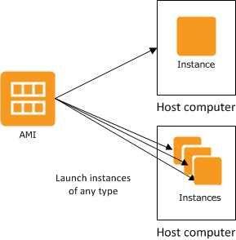

# Amazon EBS Snapshots

You can back up the data on your EBS volumes to Amazon S3 by taking point-in-time snapshots.

Snapshots are incremental backups. Active snapshots contain all the information needed to restore your data (from the time the snapshot was taken) to a new EBS volume.

## Instances Types

An instance type essentially determines the hardware of the host computer used for your instance.

Each instance type offers different compute and memory capabilities. Select an instance type based on the amount of memory and computing power that you need for the application or software that you plan to run on the instance.

You can launch different types of instances from a single AMI.

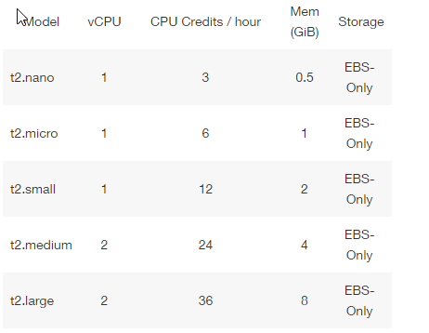

# Regions and Availability Zones

Amazon web services is hosted in multiple locations world-wide. These locations are composed of **regions** and **Availability Zones**.

Each **region**is a separate geographic area. Each region has multiple, isolated locations known as **Availability Zones**.

When you launch an instance, you can select an Availability Zone. If you distribute your instances across multiple Availability Zones and one instance fails, so that an instance in another Availability Zone can handle requests.

**To launch & connect to the EC2 instance please follow the below link**  
  
[***http://docs.aws.amazon.com/AWSEC2/latest/UserGuide/EC2_GetStarted.html***](http://docs.aws.amazon.com/AWSEC2/latest/UserGuide/EC2_GetStarted.html)

# Instance Purchasing Options

Amazon EC2 provides the following purchasing options to enable you to optimize your costs based on your needs:

* **On-Demand instances** — Pay, by the hour, for the instances that you launch.
* **Reserved Instances** — Purchase instances at a huge discount for a term from one to three years.  
    
  **RI Purchase term** options available: Full upfront, partial upfront, no upfront.

# Monitoring Amazon EC2

you can monitor CPU utilization, disk I/O, and network utilization for your Amazon EC2 instances. When performance falls outside your established baseline, you might need to reconfigure or optimize the instance to reduce CPU utilization, improve disk I/O, or reduce network traffic.

# Amazon EC2 Security Groups

A security group acts as a virtual firewall that controls the traffic for one or more instances. When you launch an instance, you associate one or more security groups with the instance. You add rules to each security group that allow traffic to or from its associated instances. You can modify the rules for a security group at any time; the new rules are automatically applied to all instances that are associated with the security group.

The rules of a security group control the inbound traffic that's allowed to reach the instances that are associated with the security group and the outbound traffic that's allowed to leave them.

By default, security groups allow all outbound traffic.

Security groups are stateful.

### **Subnet Security**

AWS provides two features that you can use to increase security in your VPC: **security groups** and **network ACLs**.

Security groups control inbound and outbound traffic for your **instances**, and network ACLs control inbound and outbound traffic for your **subnets**.

Security Group is stateful whereas Network ACL is stateless.

# Amazon EC2 and Amazon Virtual Private Cloud

Amazon Virtual Private Cloud (Amazon VPC) enables you to define a virtual network in your own logically isolated area within the AWS cloud, known as a virtual private cloud (VPC). You can launch your AWS resources, such as instances, into your VPC.

You can configure your VPC; you can select its IP address range, create subnets, and configure route tables, network gateways, and security settings.

# Amazon EC2 Instance IP Addressing

A **private IPv4 address** is an IP address that's not reachable over the Internet. You can use private IPv4 addresses for communication between instances in the same network

An instance launched in a VPC is given a primary private IP address in the IPv4 address range of the subnet.

If you don't specify a primary private IP address when you launch the instance, we select an available IP address in the subnet's IPv4 range for you.

A **public IP address** is an IPv4 address that's reachable from the Internet. You can use public addresses for communication between your instances and the Internet.  
 When you launch an instance into a VPC, your subnet has an attribute that determines whether instances launched into that subnet receive a public IP address from the public IPv4 address pool. By default, we assign a public IP address to instances launched in a default VPC, and we don't assign a public IP address to instances launched in a nondefault subnet.

# Elastic IP Addresses

An Elastic IP address is a static public IPv4 address designed for dynamic cloud computing.

++++++++++++++++++++++++++++++++++++++++++++++++++++++

Questions  
  
Q1: What is EC2, what is AMI, suppose if we want to create the replica of one server to different account & different AZ what is the procedure.  
  
Ans: EC2 is an Elastic Cloud Compute Service which enables us to create the virtual servers as per our requirements.   
AMI is Amazon Machine image, which is a template for instance that contains software configurations like OS & other packages. Also, it acts as a backup image for the instances to restore server later.

We can take a image (AMI) of the running server in one AWS account & share the permissions of the other AWS account with the image, so that replica can be created in another account using image.

Q2: How you will access the Ec2 instance if we lost the key pair.

Ans: We cannot access the instance if we lost a key pair, we can create a Image of the instance then create a replica of that server by creating a new key pair, then we can have access.

Q3: can we increase the size of primary disk of ec2. & how? process?

Ans: Yes, we can increase the size of primary volume of EC2.  
1) Stop the instance

2) Detach the volume

3) Take a snapshot of the volume

4) Create a new volume with bigger size required.

5) Attach new volume to the instance

6) Start the instance

Q4: what is EIP, what happen to EIP if we reboot the instance in vpc. & then ask in EC2-classic.

Elastic IP address is static public IP address that AWS provides which enable the instance to communicate publicly.   
If we reboot the instance in VPC elastic IP remains same but if we reboot in EC2-classic environment Elastic IP gets detached from instance.

Q5: can we attach more than one public ip to an instance.?  
Ans: Yes we can assign by assigning secondry private IP to the instance.

Q6: Suppose we started a test instance for 10 minutes, 30 minutes & 45 minutes durations of a .5$/hour cost of instance, what is the total running cost of the instance?  
Ans: It will charge for whole one hour.

Q7 : What is RI? what term plans AWS offers?  
Ans: Reserve Instances are purchased for minimum 1 yr or 3 yr durations to save up the cost.   
3 plans offers by AWS: full upfront, partial upfront, no upfront.

Q8: what is snapshots? how to configure snapshots?  
Snapshots are the backup of the EBS volumes data. We can have 3rd party software for the automated snapshots.  
  
++++++++++++++++++++++++++++++++++++++++++++++++++