Need to make again note for Prometheus

Prometheus architecture:

1. Prometheus server

* Retrieval -storage Http Server

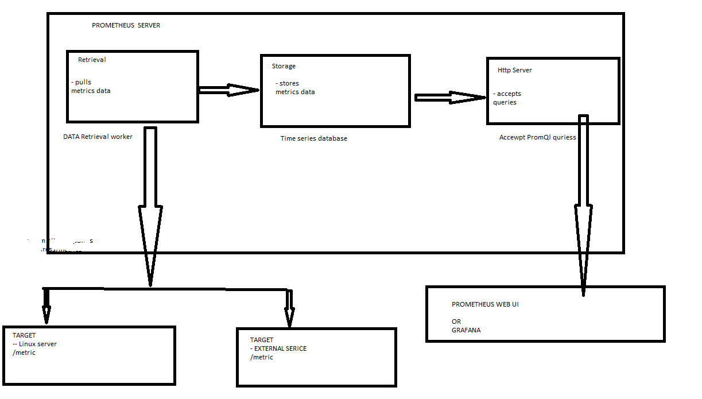

METRCIS TYPE:

1. How many times - > counter metrics - > it goes up only
2. What is the current value of now - > Gauge
3. How long or how big ? -- > Histogram

TARGET END POINTS AND EXPORTER

* > We can download a node exporter to use exporter in Prometheus

#Monitoring your our own application

* > How many request , how many exception , how many server resources are used
* We can use client librairies we can expose /metric endpoint

#PULL MECHANISM

Prometheus use pull mechanis : multiple Prometheus instances can pull metrics data

* Better detection/insight if service is up and running

Pushgateway :

Shortlived job like scheduler job that run to clean data from database can use pushgateway

#CONFIGURATION PROMETHEUS

Prometheus.yml file used to configure the Prometheus - > like which targets and what interval ?

#SERVCIE DISCOVERY mechanism

* It is used to find the target endpoints

#ALERT MANAGER

#PROMETHEUS DATA STORAGE

* Prometheus stores the data in local disk(HDD/SSD) in time series database .

#PROMQL LANGUAGE OR GRAFANA

#PROMETHEUS ADAPTOR

<https://github.com/kubernetes-sigs/prometheus-adapter/blob/master/docs/walkthrough.md>