Angular Version Used :8.x

TypeScript :3.x

Steps to Run the application:

1.Clone the Application from the Repository

2.Go inside the folder through the terminal

3.do npm install to get node module

4. do ng serve

Open browser and go to this url :localhost:4200

1.Home page :

When application loads the gitHub user list api is called and as a response 30 githubUser we get (Git HubUser allows only 30 itens at a time) and it is displayed on the first table.

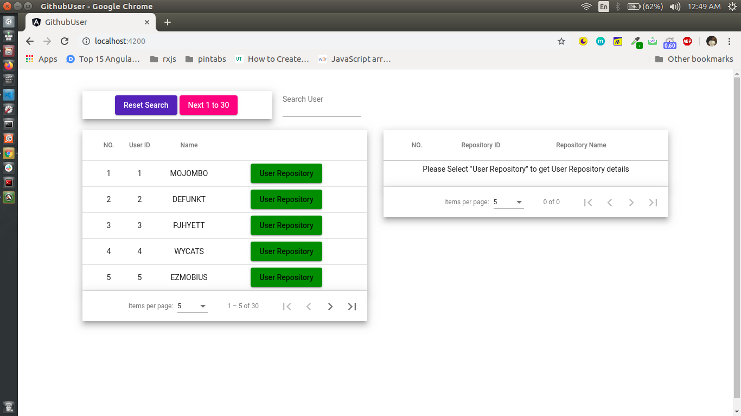

\* There are two buttons :

- Reset Search button :Which resets the data Table which contain the searched value .

-Next 1 to 30 button:This will call api to get next 30 gitHubusers.

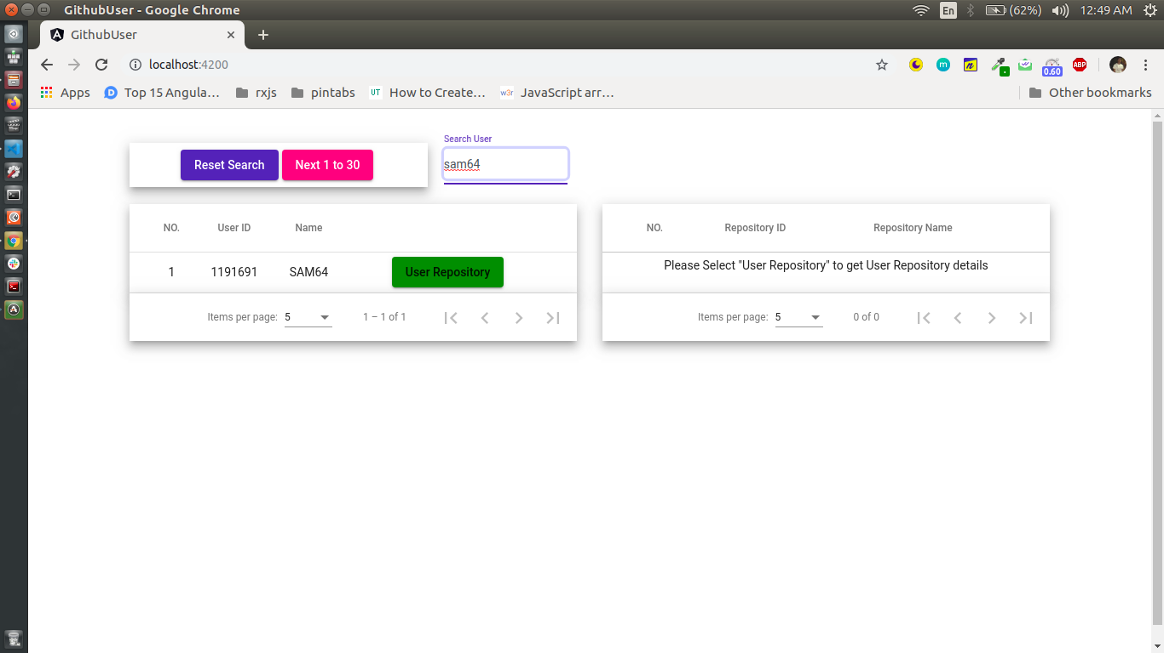\*Search Bar: which allows us to search the git User by his userName in gitHub.

\*User repository : When user clicks “User repository” then all the repositories which belong to that username is displayed in right side of the table.

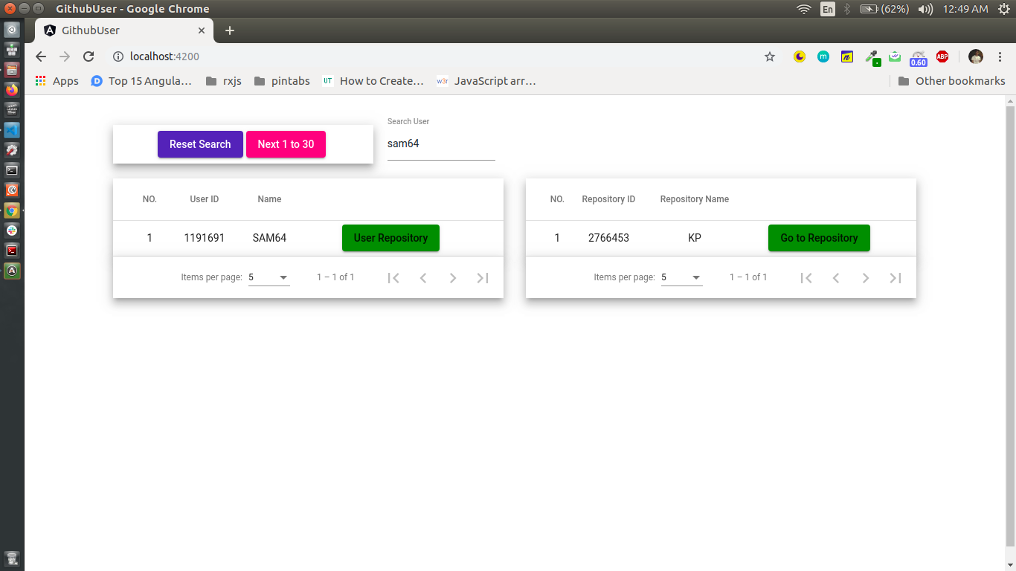

\* Go to repository : When we click this, it is redirect to the perticular repository in github.