Week 10, Day 4: ATPG - for stuck@fault
MCQ Quiz

1. Which of the following steps is typically performed first in the D algorithm for ATPG to generate test patterns for detecting stuck-at faults?
A) Fault Simulation
B) Pattern Generation
C) Fault Dropping
D) Fault activation
Answer: D) Fault activation
2. Which of the following steps is typically performed after fault activation in the D algorithm for ATPG to generate test patterns for detecting stuck-at faults?
A) Fault Simulation
B) Test Pattern Generation
C) Fault Propagation
D) Fault Justification
Answer: C) Fault Propagation
3. In the D algorithm for ATPG, line justification involves:
A) Activating a fault at the fault site.
B) Propagating the fault effect from the fault site to the output.
C) Setting the primary inputs to achieve the necessary values for fault sensitization and propagation.
D) Simulating the circuit to verify the presence of the fault.
Answer: C) Setting the primary inputs to achieve the necessary values for fault sensitization and propagation.
4. In the D algorithm for ATPG, line justification involves:
A) Activating a fault at the fault site.
B) Propagating the fault effect from the fault site to the output.
C) Setting the primary inputs to achieve the necessary values for fault sensitization and propagation.
D) Simulating the circuit to verify the presence of the fault.
Answer: C) Setting the primary inputs to achieve the necessary values for fault sensitization and propagation.
5. In an ATPG tool, when dealing with the propagation of a stuck-at-0 (s@0) fault at node 'b', which path is typically chosen for propagation according to line justification?
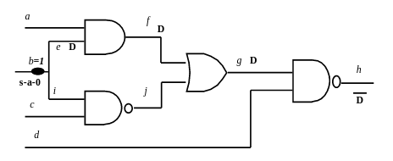

A) b-e-f-g-h
B) b-i-j-g-h
C) None of path exits for propagation of fault type S@0 at b
D) either b-e-f-g-h or b-i-j-g-h
Answer: B) b-i-j-g-h
6. Given a digital circuit with input nodes a, b, c, and d, and a stuck-at-0 (s@0) fault at node b, what are the test vector values for inputs a, b, c, and d as per the ATPG D-algorithm to detect this fault?

A) a=1, b=0, c=1, d=0
B) a=0, b=1, c=0, d=1
C) a=0, b=1, c=1, d=1
D) a=0, b=0, c=1, d=0
Answer: C) a=0, b=1, c=1, d=1

7. In an ATPG tool, if fault activation for a stuck-at-0 (s@0) fault at node 'b' fails to propagate through the path b→e→f→g→h, what is a likely reason for this failure according to line justification?

A) Node 'b' is not receiving the correct input values to activate the fault.
B) The fault at node 'b' is incorrectly set as a stuck-at-1 fault instead of a stuck-at-0 fault.
C) The circuit's clock is not synchronized properly for fault detection.
D) The path b→e→f→g→h has excessive delay that prevents fault propagation.
Answer: A) conflicting at j for various values of input ‘c’, the value of j should be 0.

8. In a digital circuit, if you need to propagate a stuck-at-0 (s@0) fault at a node 'X', which of the following sets of input values for A and B would be used to ensure that the fault at node 'X' is activated and propagated effectively?
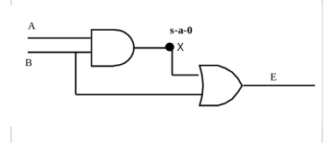
A) A=0, B=1
B) A=1, B=0
C) A=1, B=1
D) there is no other alternative path for fault propagation
Answer: B) A=1, B=0

9. What is the primary function of the build_model command in the ATPG modus tool?
A) It generates the test vectors required for fault detection.
B) It compiles the test results and generates a report.
C) It builds the logic model files from the input netlist and library cell descriptions.
D) It simulates the circuit behavior under various test conditions.
Answer: C) It builds the logic model files from the input netlist and library cell descriptions.
10. Which option of the build_model command is used to create black boxes for missing module definitions?
A) -allowmissingmodules
B) -use_black_boxes
C) -define_missing_modules
D) -add_black_boxes
Answer: A) -allowmissingmodules

