**Escrow Payment system Design a system for Escrow payment**

(What is escrow: https://www.investopedia.com/terms/e/escrow.asp)

1. We have three systems: sender system, escrow system and receiver system. Sender system transfers the fund from its own account in escrow system to receiver’s escrow account.

2. Sender then notifies receiver of the transaction

3. Receiver then checks with the escrow system for funds

4. Upon verification it marks the money transfer as complete

Interview Tasks:

1. Design entities and their interactions via flow diagram

2. Design REST APIs for system interactionscreate sender/receiver(Customer)

POST /v1/customer

{

"email": "email@email.com",

"first_name": "fname",

"last_name": "lname",

"address": "address",

"phone_number": "1111111"

}

get customer

GET /v1/customer/{customer_id}

create transaction

POST /v1/transaction

{

"receiver":"",

"amount":1000,

"date":""

}

Fetch Transaction

GET /v1/transaction/{transaction_id}

fetch all transactions

GET /v1/transactions/{customer_id}

complete transaction

PATCH /v1/transaction/{transaction_id}

{

"status":"Complete"

}

Cancel transaction

PATCH /v1/transaction/{transaction_id}

{

"status":"Cancel"

}

Notify customer

POST /v1/customer/{customer_id}/notify

{

"transaction_details":{},

}

Wallet

GET /v1/wallet/{customerId}

Wallet

customer_id , amot,transaction_id,date,status, credit/debit

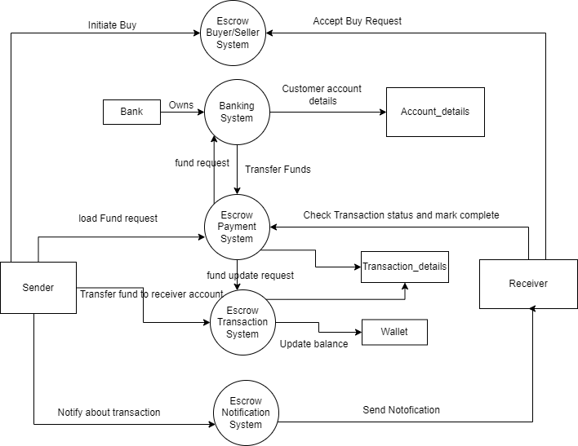

**Badminton Court booking**

system Design a badminton court booking system.

The system features are:

1. There are wooden as well as concrete courts in a sports complex.

2. Each booking slot has to be minimum 30 minutes and thereafter multiple of 30 min e.g. 30 min, 60 min, 90 min etc.

3. The sports complex timing is 6 AM to 9 PM

4. Each user gets a receipt of their court bookings for a given day.

For designing following are the considerations:

1. There can be many bookings at the same time

2. Concrete and wooden court have different pricing for 30 min slots

3. Group discount of 10% applies for more than 4 bookings at a time Expectations:

1. Design entities with proper details

2. Prepare rough flow diagram of booking and receipt printing

