Project 4 - Moodboard and Blockout

**Start Assignment**

**Due** 17 Sep by 23:59 **Points** 100 **Submitting** a file upload **File types** pdf

**PROJECT 4 - *Moodboard and Blackout***

### Contribution: 10%

**Due:** Sunday, September 17 by 11:59pm

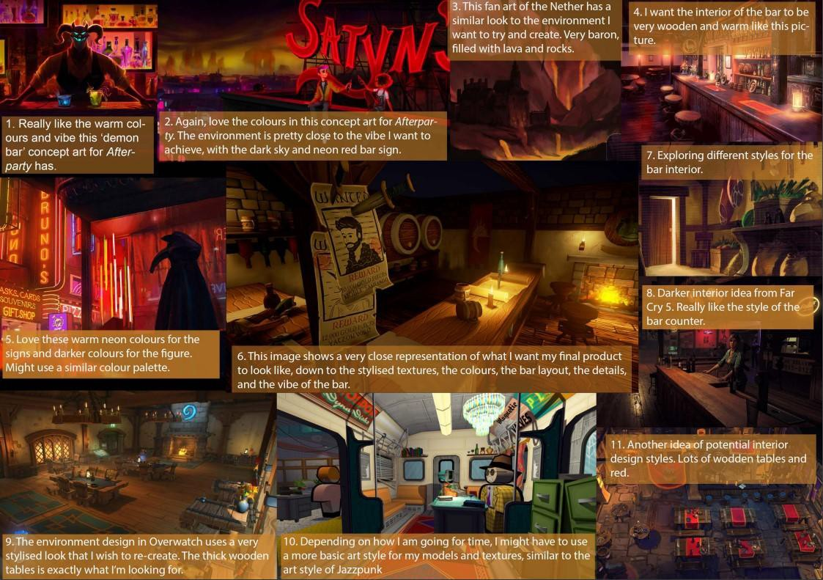

Image Source : GDS2 2021 Moodboard; Holly Wouters

At this point of the semester, students will undertake research and planning necessary to transform an empty scene into a fully realised, original environment. The aim of Project 4 is to create a moodboard in **PureRefE (http**[**s://www**](http://www.pureref.com/index.php))**.p**[**ureref.com/index.**](http://www.pureref.com/index.php))**ph**[**p)**](http://www.pureref.com/index.php))detailing key/important areas of the environment they will model in their chosen software and put together in Unity. Students will then begin the 3D process by creating a blackout of their scene to test their concept.

Tasks will include collecting references for a reference board, planning necessary asset production and producing a 3D blackout of their planned scene.

|  |
| --- |
| **Key Specifications:**  **Reference/Moodboard section** is a curated selection of sourced and annotated images that are meant to evoke the overall look and feel of your project and should convey the style, themes, atmosphere and any other visual information required by the environment.  **Minimum 10 Images**  **Maximum 30 Images**  **Created in PureRefE (http**[**s://www**](http://www.pureref.com/index.php))**.p**[**ureref.com/index**](http://www.pureref.com/index.php))**.p**[**hp)**](http://www.pureref.com/index.php))  **All images that get used in your Moodboard should credit the source and be annotated.** |

|  |
| --- |
| **Blockout/Greybox** is the process of making a rough draft of a level to get a sense of its scale, flow and gameplay before worrying about polished assets being implemented. Blackouts utilise simple primitives in place of more complex geometry, for example; a cube to represent a house.  **Created in 30 using the tools of your choice (Blender, Maya, Probuilder etc.) Imported into Unity for playtesting** |
| **This project considers the following:**  Unique and interesting concept  Documentation shows detailed research into settings, environment, and visuals. Good use of notes on visual components of the moodboard.  Document is formatted neatly and fits within the image limitations/specifications. Blackout showcases good consideration into scale and flow of level  Blackout shows intention and purpose with placement of elements Unity scene executes / is playable within editor |

**During the research phase,** students will build up visual references and inspirations into a reference moodboard. These visual references can be sourced from different media types (film, tv, animation, music, books and comics etc.) **Students will need** to pinpoint overall themes, ideas, and interactions they would like to include in the project and outline information relevant to their settings, narratives, environment, and visuals. During this time Students might produce their own visual media to add to their **PureRef E (http**[**s://www**](http://www.pureref.com/))**.p**[**ureref.com/**](http://www.pureref.com/))**)** canvas, such as sketches and thumbnails, in order to outline areas of their scene or individual assets key to the environment.

Students will consider how this environment may lend itself to unique or 'fun' interactions or moments once constructed in Unity.

Outside of class time, there is an expectation that students will research different methods and workflows to achieve the visual style they are planning for their project and 3D assets allowing them to scope their projects to their skillset appropriately.

**After completing the documentation,** students will tackle blocking out their environments within Unity by using the skills they've learned throughout the Art and Unity streams in order to playtest their level flow and composition. ***For this project the blackout is meant to be a rough pass of your scene and shouldn't contain polished art!***

**DELIVERABLES**

***MoodBoard***

**Due:** Sunday, September 17 by 11:59pm

A reference board is a curated selection of sourced images that are meant to evoke the overall look and feel of your project. This part of the document should be created in **PureRef** E **(http**[**s://www.**](http://www.pureref.com/))**p**[**ureref.com/**](http://www.pureref.com/))**)** and should convey the style, themes, atmosphere and any other visual information required by the environment.

### All images that get used in your reference board should credit the source and be annotated.

Credits can be either direct website links, or the artist/photographer/musician/creator's names. Always try to find the original creator, don't just say 'Pinterest' or 'Google images'. If the image/photo is your own, credit yourself for clarity.

Annotations/notes can be simple e.g. "This image shows the type of lighting I will attempt to capture in my scene." "These photos showcase eastern European architecture styles that will be prominent in the room I am designing". You can attach notes to collections of images, so if 3 or 4 images refer to the foliage type you would like to use in your scene, they can be clustered under the same annotation

e.g. "These native Australian plants are commonly found in rainforest climates and will be the inspiration for the foliage in my environment."

### Some suggestions of what to include:

|  |
| --- |
| Imagery that conveys the type of lighting the environment uses - harsh, soft/ morning, day, night/ interior, exterior/ artificial, natural etc. And the colours and atmosphere of the lighting in the space. |
| Location references, photographs or concept art of relevant spaces / buildings / flora *I* fauna / terrain etc. Cultural inspirations from around the world. |
| Inspirations; does a game, artist or piece of music inspire you? Share screenshots of the game/film/show, pieces of artwork from the artist who inspires you, or drop in the album cover or screenshot of the music video that you are referencing |
| Textures, Materials and surfaces that evoke something about the space you are trying to achieve. Are the materials worn and trashed, or is everything shiny and new? Is the space meant to have a luxurious feel? |
| Colours - what kind of palette are you using? Cold, warm, tropical? Is it the one palette that runs throughout - or do you utilise different colours in various zones to tell us something about the area or the emotion we are supposed to feel? |
| Style / Visual quality/ Aesthetic - Is this a toony or eel shaded experience, is it meant to evoke semi-realism? Are you trying to recreate the aesthetic of a game or tv show you love? What images best describe this look? |

**Some suggestions of what to consider while researching your ideas:**

|  |
| --- |
| Location setting. What time are we in? Is this a real-world location or a fantasy/sci-ti creation? Am I in space, the clouds, under the sea? E.g. a Luxury Getaway in the tropics will be very different to warming up by a cozy fireplace at a exclusive ski lodge! Perhaps it's a getaway set in the distant future - a Hotel on the Moon! |
| Who are the inhabitants who might dwell there? Are they human, creature or robots? Are their lives, hobbies and personalities conveyed through the environment design? If the location is abandoned - can we tell why? |
| Highlight what areas will be a focus for the audience/player. Do they have narrative significance? Are they just beautiful areas that draw you in? Are they part of a puzzle or do they hide a secret?  E.g. The scene of a crime, a locked room puzzle? |
| Small concepts and illustrations for key elements, details and assets. There should be substantial annotations throughout to explain everything! |

You might consider more, or other, relevant information for your project than what is listed here, e.g. what audio you might intend or soundtrack styles, if you are planning to add any. Considering your project from these angles will help you gather inspiration and may even inform gameplay or level layouts!

*One thing to consider; Characters/NPC models will not be allowed in the final Unity scene due to the amount of work and time they require. Think of conceptualising this information as setting up the world, and making sense of the details within it, without the expectation of adding characters/creatures in the final work.*

## *Blackout*

A blackout or grayboxing is a navigable sketch of a level that gives you an idea of the experience, the flow, and the scale of a level. The goal is to prototype, test, and adjust level foundations early in development. This way, you can test your ideas and determine which elements of your design work or are necessary. When building our blackouts we are experimenting. To verify the results of the experiment, you must test the prototype to help you imagine the player experience.

We often construct a blackout using primitive objects that are easy to iterate on and generally do not concern ourselves with good topology or modelling workflows.

By the end of the project student should have created a simple 3D prototype of their level by blocking out the environment and paying attention to scale/proportion, navigation through the level, flow and basic mechanics. The blackout can either created in 3D using the tools of your choice (Blender, Maya, etc.) or within the Unity editor using a tool such as Probuilder. The final blackout should be delivered as a playable Unity project.

**This project will form the basis of your final environment in Project 5.**

## *Submission Checklist*

For this project students should submit the relevant files in one .zip, via Canvas, clearly labelled with: Preferred Name

Student ID Project 4

For example: StephKelso-S3434380-Project4.pdf

**Note:** if the file is too large for Canvas submission, host it somewhere linkable online (i.e., your Google drive, Dropbox or One drive) and email Steph the link *before* the deadline.

**The final .zip folder should include:**

|  |
| --- |
| **Moodboard created in PureRef:E (http**[**s://www**](http://www.pureref.com/))**.p**[**ureref.com**](http://www.pureref.com/))**/)**    PureRef scene saved as a .pur file Minimum 10 Images  Maximum 30 Images  The ref board should support the blackout in conveying the style, themes, atmosphere and any other visual information required by the environment.  All images should reference their source and be fully annotated. |
| **Blackout:**  Created in 30 using the tools of your choice (Blender, Maya, etc.) or within the Unity editor (Probuilder or alternative)  Must be playable within Unity (e.g. has a controllable character/camera, has colliders on assets, etc.)  Does not need 'polished' gameplay or puzzles, but prototype / early pass implementation of these features will improve your mark:  E.g. Systems and mechanics such as Platforming/jumping, inventory/pick-up system, point-and-click, score-keeping/points system etc. as basic prototypes to test gameplay loops and experience.  E.g. Puzzles that have tasks and solutions, such as 'open the chest, get the code and unlock the door' a la 'Odd House')  Must be delivered as a Unity project with all files (Not a build!) |

**Give yourself enough time for the upload to complete before the deadline.**

# *RMIT Electronic Submission of work for assessment:*

I declare that in submitting all work for this assessment I have read, understood and agree to the content and expectations of the **assessment declaration (http**[**s://www.rmit.edu.au/students/student-**](http://www.rmit.edu.au/students/student-)

**essentials/assessment-and-exams/assessment/assessment-declaration)**

# *RMIT* Games *Late Assignment and Extension Policy:*

Students can seek an extension for circumstances outside of their control. Students can ask their tutor for the extension, but the course coordinator has final authority on granting extensions and the tutor may refer the matter to them.

If the reason for extension is accepted, **students can ask for a maximum of 7 days, up to 24 hours before the assignment due date.** This can be sought once per assignment without needing to apply for special consideration.

**If an extension is required within 24 hours before an assignment due date, OR after a due date, then special consideration must be applied for: http**[**s://www.rmit.edu.au/students/m**](http://www.rmit.edu.au/students/my-course/assessment-results/special-consideration)**y**[**-course/assessment-results/s**](http://www.rmit.edu.au/students/my-course/assessment-results/special-consideration)**p**[**ecial-consideration­**](http://www.rmit.edu.au/students/my-course/assessment-results/special-consideration) **extensions/special-consideration** E **(http**[**s://www.rmit.edu.au/students/m**](http://www.rmit.edu.au/students/my-course/assessment)**y**[**-course/assessment­**](http://www.rmit.edu.au/students/my-course/assessment) **results/special-consideration-extensions/special-consideration)**

If no special consideration is granted, the normal late penalties apply (see *below).* If special consideration is granted, a new due date will be negotiated without penalty. If this new deadline is missed, then late penalties (see *below)* apply as normal.

## *Assignment Submission Format:*

**If staff cannot open your files in the required format, or the format submitted is wrong,** such as a corrupt file being submitted, or entire project directories submitted instead of an executable file, the late penalty below applies until it is submitted in a working or correct format.

Students are responsible for downloading their submitted files after uploading to check that they work.

## *Late Penalties:*

### For assignments submitted late, with no extension (arranged up to 24 hours before the due date), or assignments submitted after an agreed extension date:

|  |
| --- |
| **For submitted files, documents or artefacts:**  Students will receive a **5% per day penalty** up to a **maximum of seven days** (35% of the total possible grade)  **After seven days, the grade will be an automatic fail and graded 0.** |
| **For presentations (not turning up to a presentation, not giving a presentation):**  Individual staff will determine whether a replacement video presentation is required, or a pdf of slides, or other submission in its place. |



|  |  |  |  |  |  |  |  |  |  |
| --- | --- | --- | --- | --- | --- | --- | --- | --- | --- |
| **Criteria** | **Ratings** | | | | | | | | |
| Moodboard (50%) | **High Distinction (80%-100%)** | **Distinction (70%-79%)** | | **Credit (60%-69%)** | | **Pass**  **(50%-59%)** | | **Fail (0%-49%)**  The moodboard | |
|  | The document  was concise and | The document was  full of relevant detail, | | The  document | | The document  was complete | | was incomplete  or did not | |
|  | full of relevant detail, met the  maximum image | but could have been more concise. Was  within the | | could have been more  concise and | | but could have  been more clear, concise | | provide any overview or  relevant insight | |
|  | count. The  student has | maximum/minimum  image count. The | | relevant. The  imagery gave | | and relevant.  Document met | | into the  concepts, | |
|  | managed to communicate  their idea clearly | imagery was relevant to the overall theme  and had appropriate | | an idea of the overall theme  and was | | the minimum  image count. The board | | themes or visuals of the  environment. | |
|  | through imagery and words. The  imagery was | annotations. The student credited all  images. The concept | | simply annotated.  Met the | | lacked diverse references.  Annotations | | Image limitations were  ignored and the | |
|  | relevant to the  overall theme | was unique and  interesting. | | minimum  image count. | | were basic. Not  all images were | | count was either  under or over. | |
|  | and annotated in depth. The  student credited |  | | There was an attempt to  properly | | credited. Few efforts were  made on the | | The board was incoherent and  lacked diverse | |
|  | all images. The  concept for the |  | | credit all  images. | | development of  this | | references or  annotations. | |
|  | project is creative, unique,  and has been |  | | Potential to push the  design | | environment. | | Majority of the images were  not credited. | |
| Blackout | **lill IQl nction (88 ):lnd**  'ffi B.SS1 ttb1e  WM11,R ffifi\y.  'o t has constructed a 3D scene within the  editor using polygon models, and paid close attention to scale/proportion of their structures and landmark objects, clear navigation through the level, and flow/movement. Student has expertly implemented a character controller, first pass lighting, and colliders on the environment to | | **Distinction** | | fLCCtlfflfitand **g ,i89f )** i n?Ji@  r fafcffiEe¾vithin wO?iit9 ffiLJdent  has constructed a 3D scene within the editor using polygon models, and emphasised clear navigation through the level. Student has partially implemented a character controller, first pass lighting, and colliders | | **Pass** | | **L itqtt%.Gf9'/J)**  **We3affi@1 -**  unplayable within Unity. Student has constructed a 3D scene using polygon models in Blender or Maya etc. but has not imported them into the engine.  Student has not implemented functions or tools in Unity to facilitate playtesting. |
| (50%) | **(70%-79%)** | | **(50%-59%)** | |
|  | Game is playable | | Game is | |
|  | within Unity. Student | | playable within | |
|  | has constructed a | | Unity. Student | |
|  | 3D scene within the | | has | |
|  | editor using polygon | | constructed a | |
|  | models, and | | 3D scene | |
|  | considered the | | within the | |
|  | scale/proportion of | | editor using | |
|  | their structures and | | polygon | |
|  | landmark objects, | | models. | |
|  | as well as | | Student has | |
|  | emphasised clear | | partially | |
|  | navigation through | | implemented | |
|  | the level. Student | | at minimum a | |
|  | has implemented a | | character | |
|  | character controller, | | controller and | |
|  | first pass lighting, | | colliders on | |
|  | and colliders on the | | the | |
|  | environment to | | environment | |
|  | facilitate playtesting. | | to facilitate | |
|  | Attempts at | | playtesting. | |

|  |  |  |  |  |  |
| --- | --- | --- | --- | --- | --- |
| **Criteria** | **Ratings** | | | | |
|  | facilitate playtesting. | implementing | on parts of the |  |  |
| Early pass/ | prototype gameplay | environment to |
| prototype gameplay | mechanics have | facilitate |
| mechanics and/or | been added to the | playtesting. |
|  | puzzles have been | scene, but do not |  |  |  |

added to the scene to test gameplay loops or experience.

fully test the gameplay loops or experience planned for the final assignment.