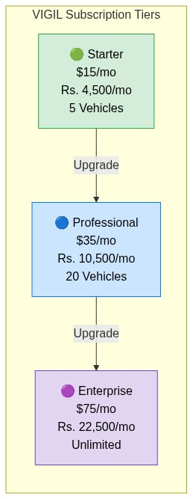
``

3. Technology Stack
``
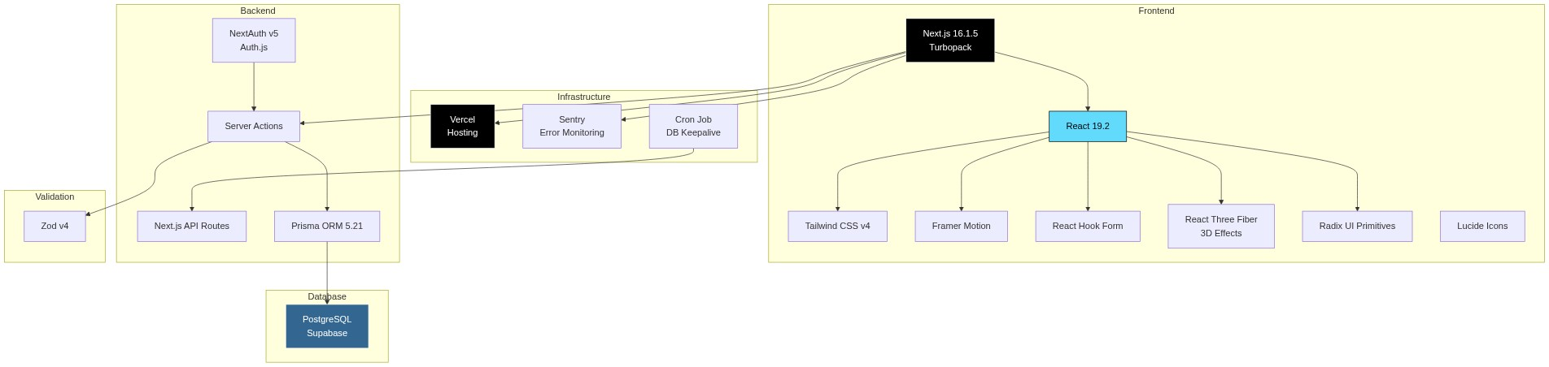
``
Layer | Technology | Version | Purpose
Runtime | Next.js (Turbopack) | 16.1.5 | Full-stack React framework
UI Library | React | 19.2.3 | Component rendering
Styling | Tailwind CSS | v4 | Utility-first CSS
Animations | Framer Motion | 12.36 | Page transitions, micro-animations
3D Effects | React Three Fiber | 8.15 | Aurora background effects
Forms | React Hook Form | 7.71 | Form state management
Validation | Zod | 4.3 | Schema validation (client + server)
Auth | NextAuth (Auth.js) | v5-beta | Session management, credentials provider
ORM | Prisma | 5.21 | Database queries, migrations
Database | PostgreSQL | — | Supabase-hosted
Hosting | Vercel | — | Serverless deployment
Monitoring | Sentry | 10.42 | Error tracking, performance
Printing | react-to-print | 3.2 | Browser print API
Icons | Lucide React | 0.563 | SVG icon library
Password | bcryptjs | 3.0 | Password hashing
Dates | date-fns | 4.1 | Date manipulation

4. System Architecture

High-Level Architecture
``
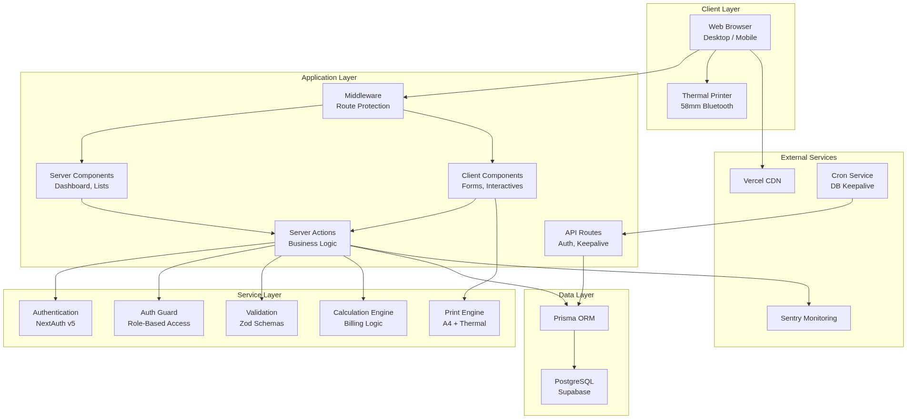
``

Request Flow
``
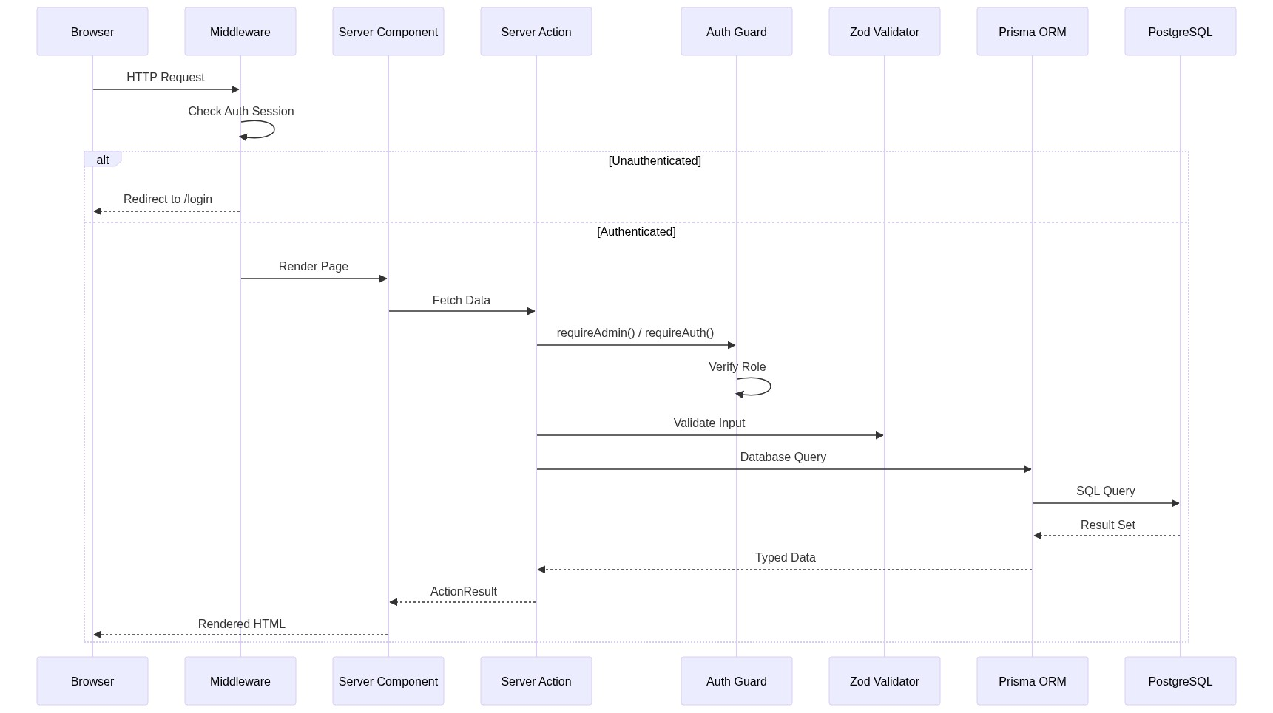
``

5. Entity Relationship Diagram
``
[Diagram could not be rendered]
erDiagram
USER {
string id PK
string name
string email UK
string password
string role "ADMIN | DRIVER"
datetime createdAt
datetime updatedAt
}
VEHICLE {
string id PK
string vehicleNo UK
string model
string category "CAR | VAN | SUV | BUS"
string status "ACTIVE | MAINTENANCE | RETIRED"
float ratePerDay "0 = Per-Km mode"
float kmPerDay
float excessKmRate
float extraHourRate
int seats
string acType
string features
string insuranceCoverage
float currentMileage
float oilChangeInterval
float lastOilChangeMileage
float filterChangeInterval
float lastFilterChangeMileage
float washInterval
float lastWashMileage
}
CUSTOMER {
string id PK
string name
string mobile
string email
string address
}
BUSINESS_PROFILE {
string id PK
string companyName
string address
string phone
string email
float usdRate
string logoUrl
string bankName
string bankBranch
string bankAccountNo
string bankAccountName
}
TOUR_SCHEDULE {
string id PK
string name UK
string description
int days
string vehicleCategory
string vehicleNo
float ratePerDay
float kmPerDay
float excessKmRate
float extraHourRate
float waitingCharge
float gatePass
boolean isActive
}
TOUR_SCHEDULE_DAY_ITEM {
string id PK
string tourScheduleId FK
int dayNumber
string title
string description
float distanceKm
float accommodation
float meals
float activities
float otherCosts
}
QUOTATION {
string id PK
int quotationNumber UK
string tourScheduleId FK
string customerName
string customerEmail
string vehicleNo
int numberOfPersons
float hireRatePerDay
float kmPerDay
float totalDistance
float transportCost
float accommodationTotal
float mealsTotal
float totalAmount
float markup
float discount
string status "DRAFT | SENT | ACCEPTED | EXPIRED"
string driverId FK
}
BOOKING {
string id PK
string vehicleNo
string customerName
datetime startDate
datetime endDate
string destination
string status "CONFIRMED | CANCELLED | COMPLETED"
float advanceAmount
string refundStatus "NULL | REFUNDED | FORFEITED"
string driverId FK
}
BILL {
string id PK
int billNumber UK
string vehicleNo
string customerName
string customerAddress
string route
float startMeter
float endMeter
float hireRate
float allowedKm
float packageCharge
float totalAmount
string currency "LKR | USD"
float exchangeRate
string paymentMethod "CASH | CREDIT"
float extraHours
float extraKm
float scheduledDays
string itinerary "JSON"
}
VEHICLE_EXPENSE {
string id PK
string vehicleNo
float amount
string category "REPAIR | FUEL | SERVICE | etc"
string description
datetime date
string bookingId
string driverId FK
}
TRIP_ACTIVITY {
string id PK
string bookingId FK
string driverId FK
string type "FUEL_FILL | STOP | BREAKDOWN | etc"
string note
string expenseId
datetime timestamp
}
PASSWORD_RESET_TOKEN {
string id PK
string email
string token UK
datetime expires
}
USER ||--o{ BOOKING : "drives"
USER ||--o{ QUOTATION : "assigned as driver"
USER ||--o{ VEHICLE_EXPENSE : "records"
USER ||--o{ TRIP_ACTIVITY : "logs"
BOOKING ||--o{ TRIP_ACTIVITY : "contains"
TOUR_SCHEDULE ||--o{ TOUR_SCHEDULE_DAY_ITEM : "has days"
TOUR_SCHEDULE ||--o{ QUOTATION : "used in"
``

6. Data Flow Diagrams

Level 0 — Context Diagram
``
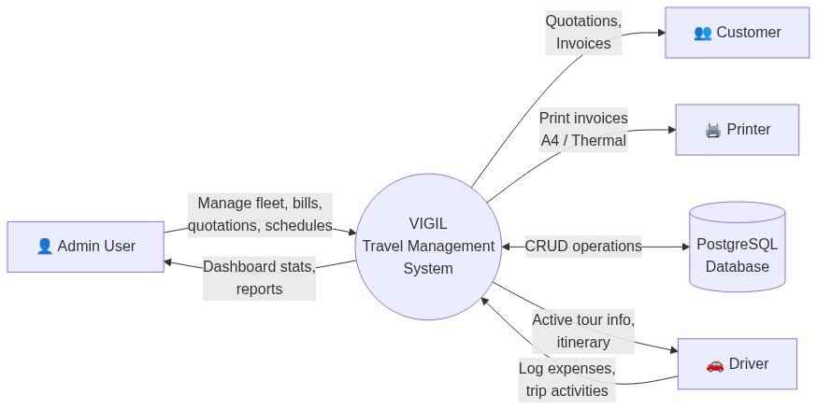
``

Level 1 — Major Processes
``
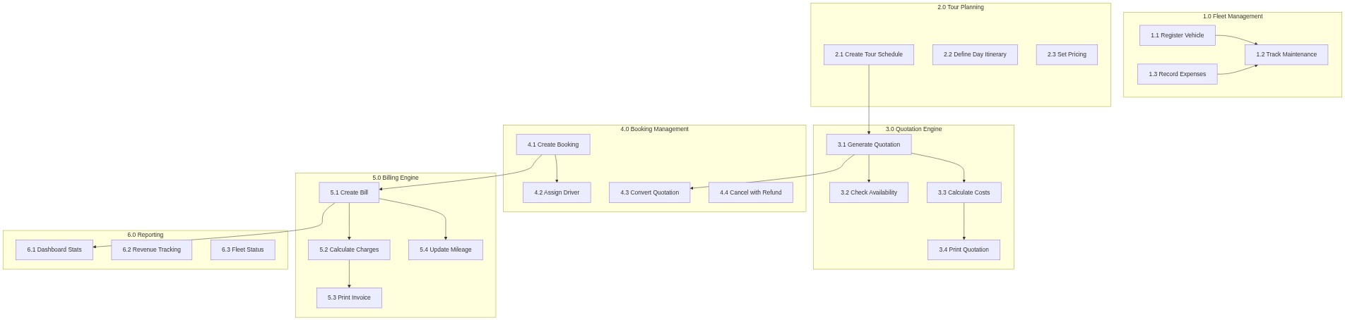
``

Level 2 — Billing Process Detail
``
[Diagram could not be rendered]
graph TB
START(("Start"))
SELECT_VEHICLE["Select Vehicle"]
CHECK_MODE{"Pricing Mode?"}
PKG["Per-Day Package Mode"]
KM["Per-Km Flat Rate Mode"]
ENTER_METERS["Enter Start/End Meter"]
CALC_DISTANCE["Calculate Distance<br/>endMeter - startMeter"]
CALC_PKG["Calculate:<br/>Package Charge +<br/>Excess Km × Rate +<br/>Extra Hours × Rate"]
CALC_KM["Calculate:<br/>Total Distance × Rate/km +<br/>Extra Hours × Rate"]
ADD_EXTRAS["Add Extra Charges:<br/>Waiting + Gate Pass +<br/>Accommodation + Meals +<br/>Activities + Other"]
DEDUCT["Deduct Advance Payment"]
TOTAL["Final Balance Due"]
PRINT["Print Invoice"]
UPDATE_MILEAGE["Update Vehicle<br/>Current Mileage"]
FINISH(("End"))
START --> SELECT_VEHICLE
SELECT_VEHICLE --> CHECK_MODE
CHECK_MODE -->|"ratePerDay > 0"| PKG
CHECK_MODE -->|"ratePerDay = 0"| KM
PKG --> ENTER_METERS
KM --> ENTER_METERS
ENTER_METERS --> CALC_DISTANCE
CALC_DISTANCE --> CALC_PKG
CALC_DISTANCE --> CALC_KM
CALC_PKG --> ADD_EXTRAS
CALC_KM --> ADD_EXTRAS
ADD_EXTRAS --> DEDUCT
DEDUCT --> TOTAL
TOTAL --> PRINT
TOTAL --> UPDATE_MILEAGE
PRINT --> FINISH
UPDATE_MILEAGE --> FINISH
``

7. Use Case Diagram
``
``

8. Class Diagram
``
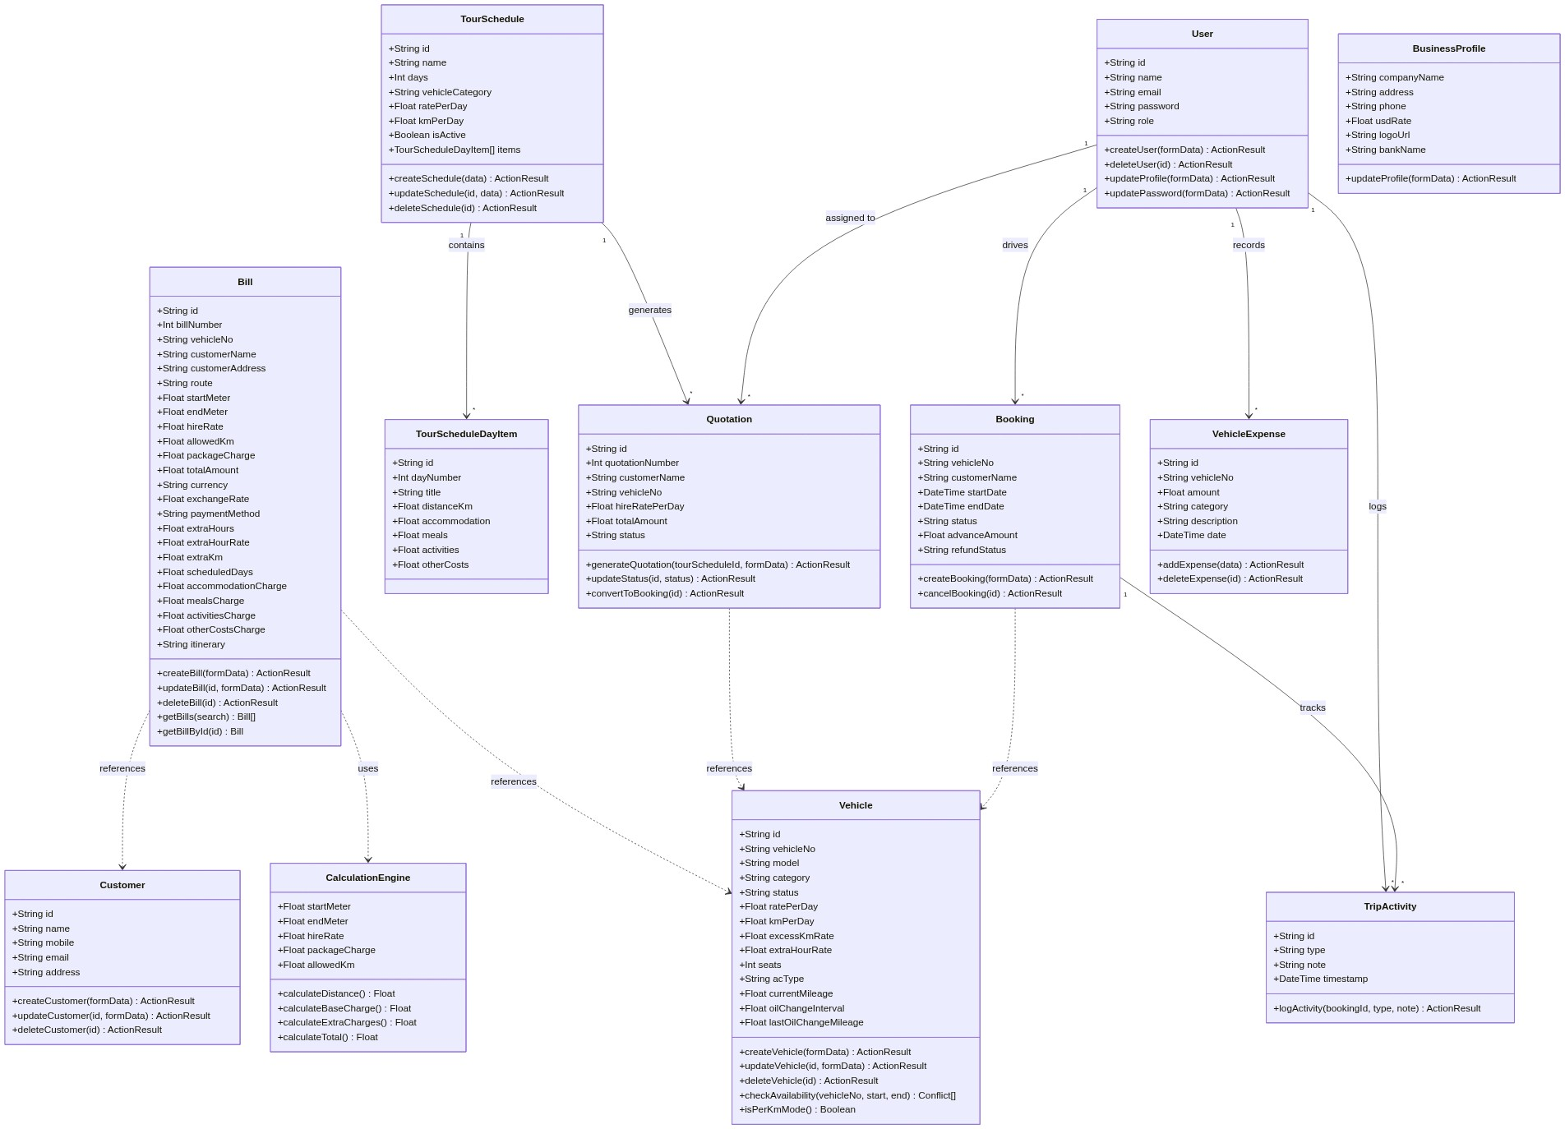
``

9. Sequence Diagrams

9.1 Quotation to Booking to Bill Flow
``
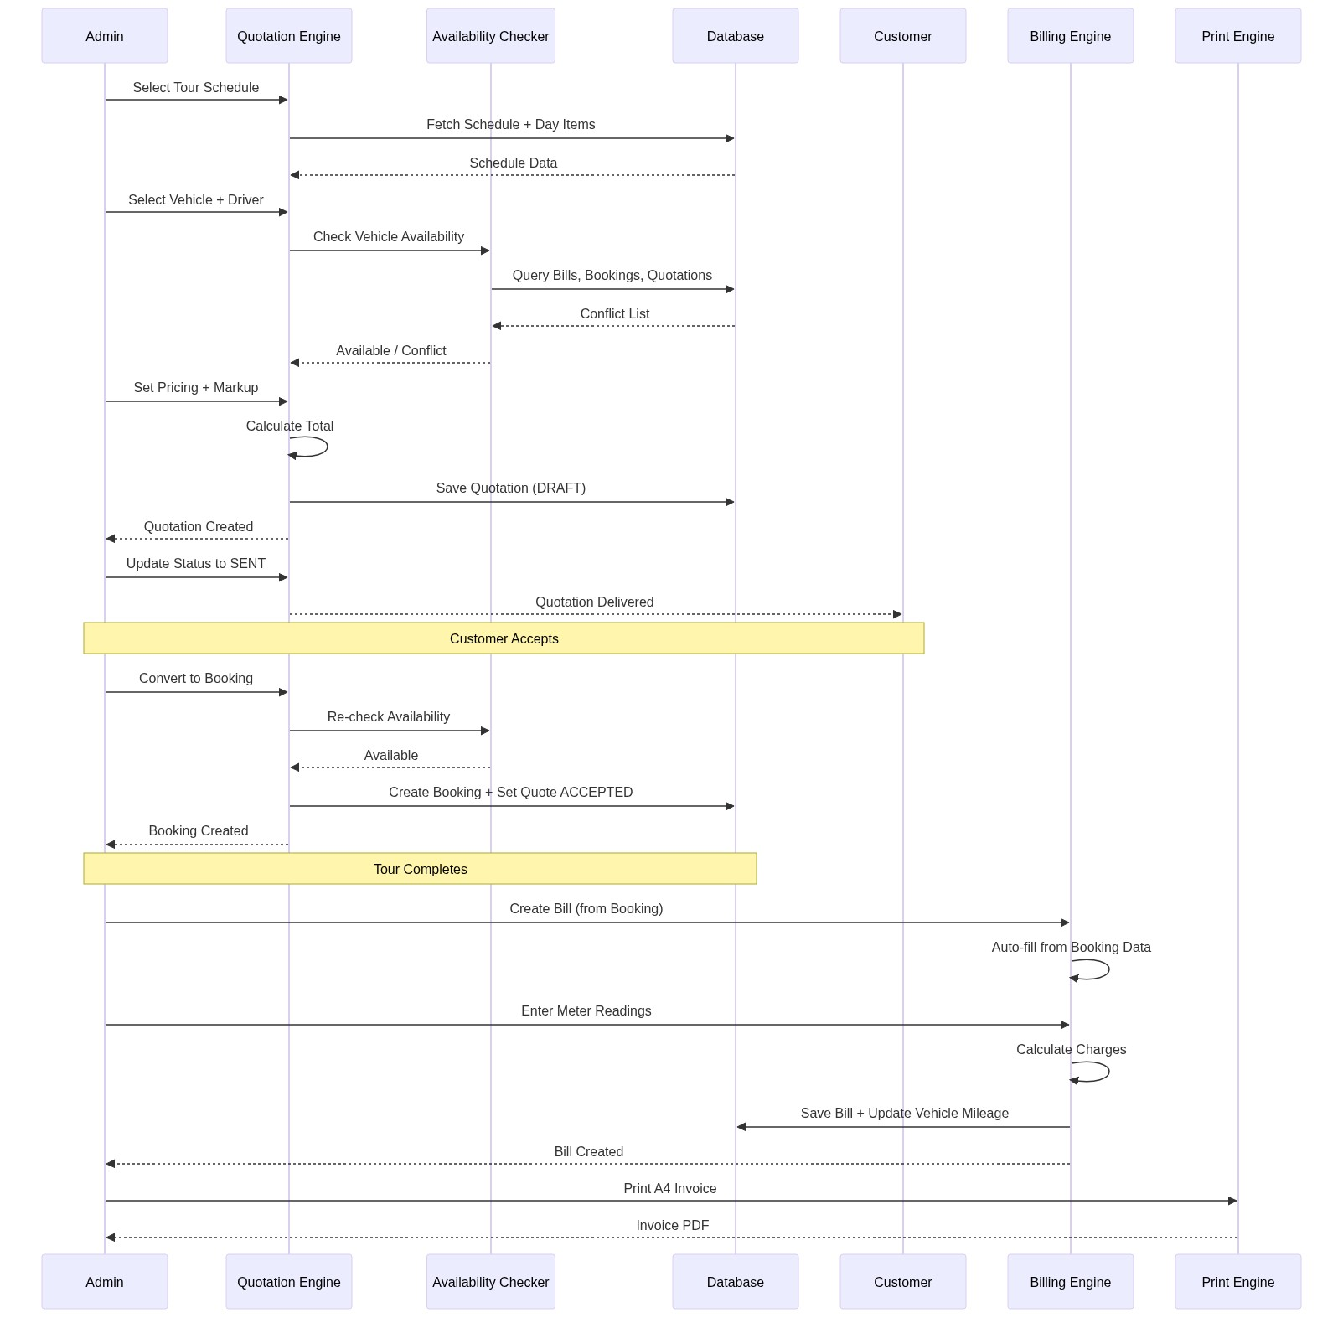
``

9.2 Bill Creation with Per-Km Pricing
``
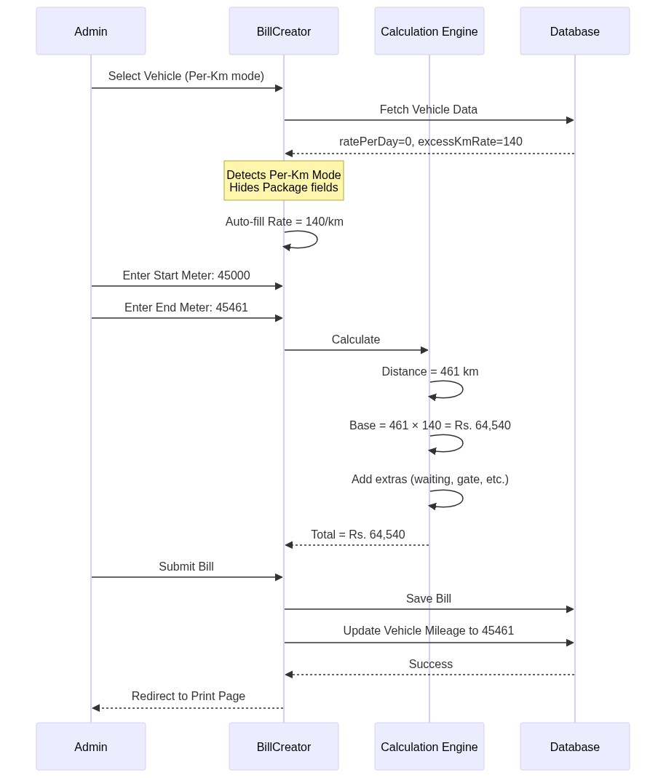
``

9.3 Driver Trip Activity Flow
``
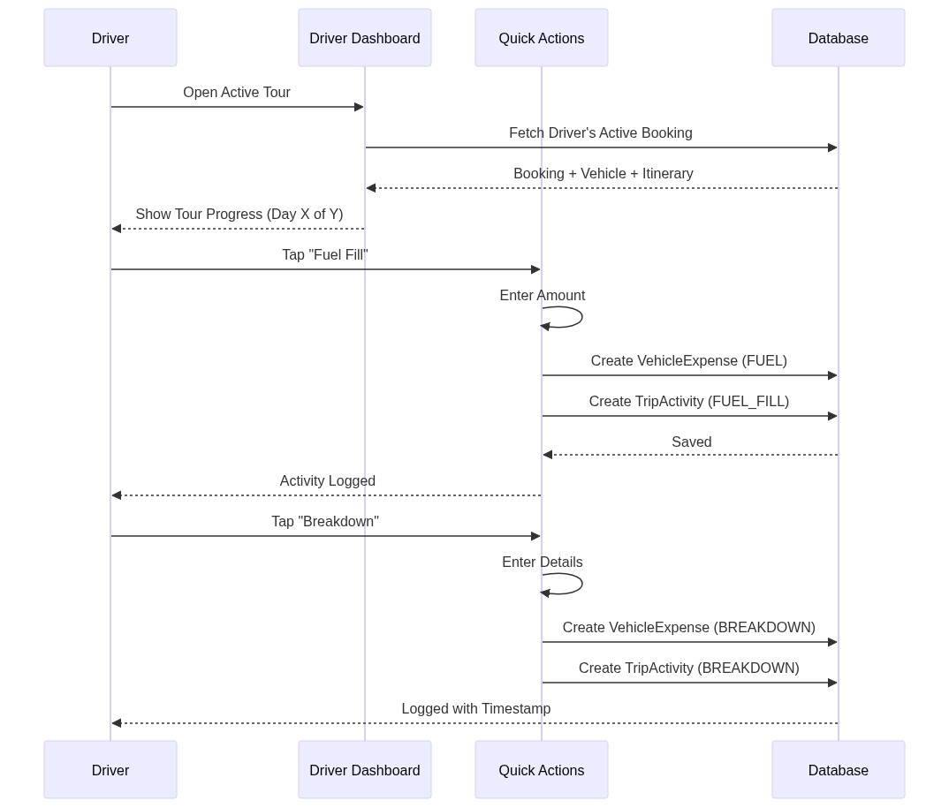
``

9.4 Authentication Flow
``
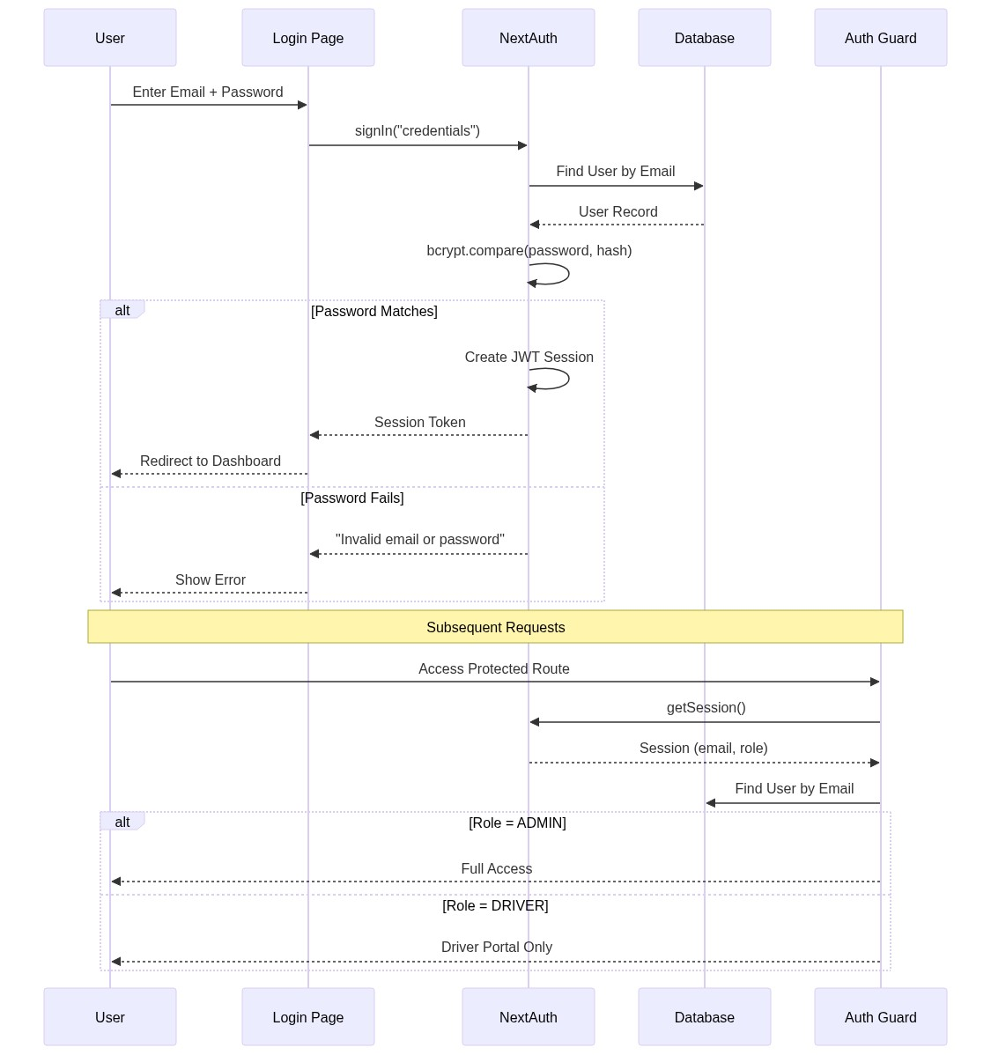
``

10. State Diagrams

10.1 Quotation Lifecycle
``
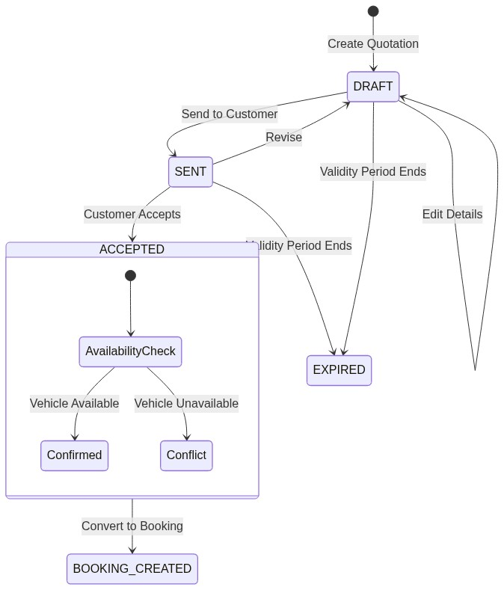
``

10.2 Booking Lifecycle
``
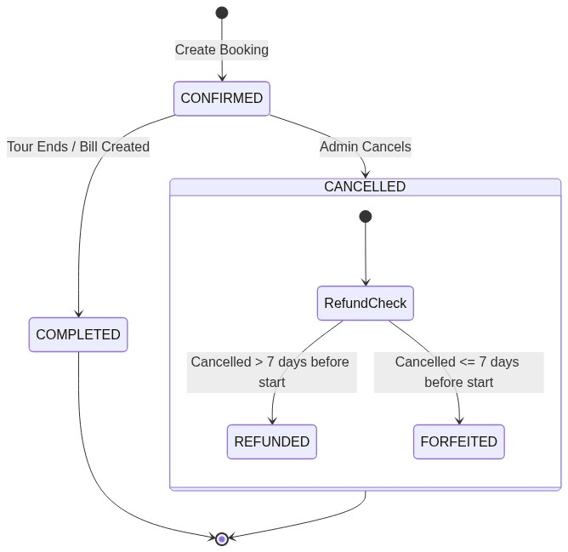
``

10.3 Vehicle Status
``
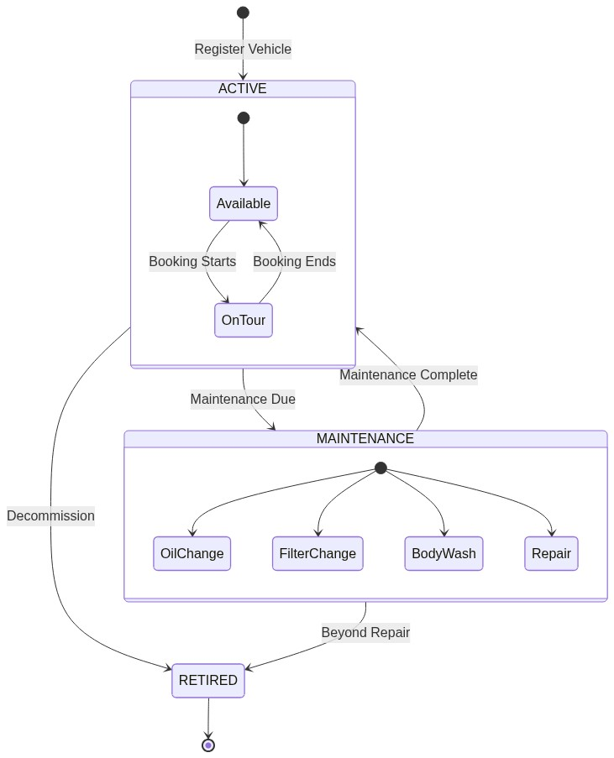
``

10.4 Bill Pricing Mode
``
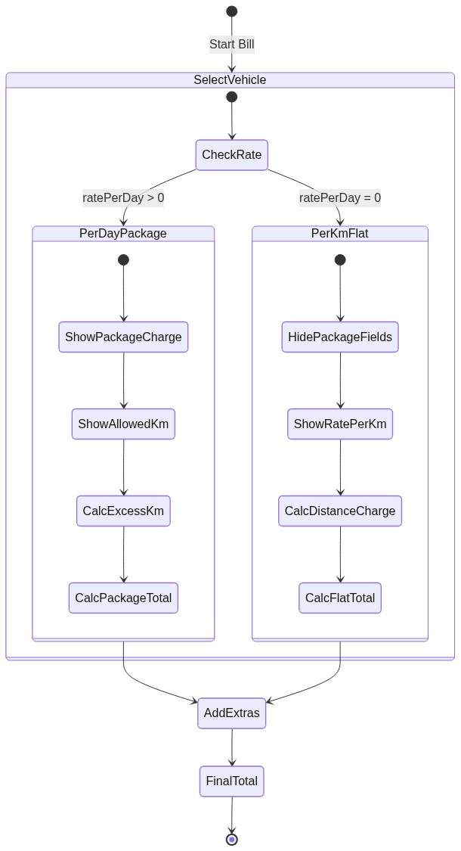
``

11. Component Architecture
``
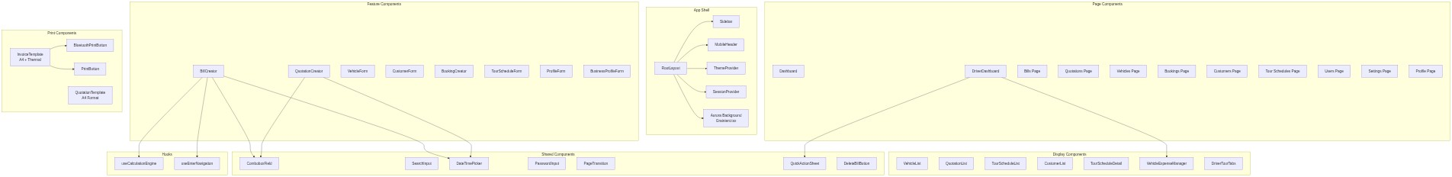
``

12. Database Schema

12.1 Complete Model Reference
[!IMPORTANT]11 database models stored in PostgreSQL via Prisma ORM. No Prisma enums are used — all enums are application-level strings validated by Zod schemas.

Bill Model
Field | Type | Default | Description
id | String | cuid() | Primary key
billNumber | Int | autoincrement | Unique sequential bill number
vehicleNo | String | — | Vehicle registration number
customerName | String | — | Customer full name
customerAddress | String? | — | Customer address
route | String | — | Tour route description
startMeter | Float | — | Odometer at trip start
endMeter | Float | — | Odometer at trip end
hireRate | Float | — | Rate per km (excess or flat)
allowedKm | Float | 0 | Included km in package
waitingCharge | Float | 0 | Waiting charges
gatePass | Float | 0 | Gate/toll fees
packageCharge | Float | 0 | Base package charge (0 for per-km)
advanceAmount | Float | 0 | Advance payment received
totalAmount | Float | — | Calculated total amount
currency | String | "LKR" | LKR or USD
exchangeRate | Float | 1.0 | USD to LKR rate
totalAmountLKR | Float | 0 | Amount in LKR
paymentMethod | String | "CASH" | CASH or CREDIT
startDate | DateTime | now() | Trip start date/time
endDate | DateTime | now() | Trip end date/time
extraHours | Float | 0 | Hours beyond scheduled
extraHourRate | Float | 0 | Charge per extra hour
extraKm | Float | 0 | Km beyond package allowance
scheduledDays | Float | 1 | Number of tour days
accommodationCharge | Float | 0 | Total accommodation cost
mealsCharge | Float | 0 | Total meals cost
activitiesCharge | Float | 0 | Total activities cost
otherCostsCharge | Float | 0 | Miscellaneous costs
itinerary | String? | — | JSON snapshot of day items

Vehicle Model
Field | Type | Default | Description
id | String | cuid() | Primary key
vehicleNo | String | — | Unique registration number
model | String? | — | Vehicle make/model
category | String | "CAR" | CAR, VAN, SUV, BUS, LORRY
status | String | "ACTIVE" | ACTIVE, MAINTENANCE, RETIRED
ratePerDay | Float | 0 | Daily hire rate (0 = Per-Km mode)
kmPerDay | Float | 0 | Included km per day in package
excessKmRate | Float | 0 | Rate per km (excess or flat)
extraHourRate | Float | 0 | Charge per extra hour
seats | Int? | — | Passenger capacity
acType | String? | — | AC type description
features | String? | — | Feature list (free text)
insuranceCoverage | String? | — | Insurance details
currentMileage | Float | 0 | Current odometer reading
oilChangeInterval | Float | 5000 | Km between oil changes
lastOilChangeMileage | Float | 0 | Mileage at last oil change
filterChangeInterval | Float | 10000 | Km between filter changes
lastFilterChangeMileage | Float | 0 | Mileage at last filter change
washInterval | Float | 1000 | Km between body washes
lastWashMileage | Float | 0 | Mileage at last wash

(Full schema for all 11 models documented in the ER Diagram section above)

13. Server Actions & API Reference

13.1 Bill Actions
Action | Auth | Parameters | Returns | Description
createBill | Admin | FormData | ActionResult<string> | Creates bill, calculates total, updates vehicle mileage, auto-closes booking
updateBill | Admin | id, FormData | ActionResult<string> | Updates bill and recalculates total
deleteBill | Admin | id | ActionResult<null> | Permanently deletes bill
getBills | Public | searchQuery? | Bill[] | Search by billNumber, vehicleNo, customerName, route
getBillById | Public | id | Bill | Fetch single bill

13.2 Vehicle Actions
Action | Auth | Parameters | Returns | Description
createVehicle | Admin | FormData | ActionResult<string> | Register new vehicle with maintenance tracking
updateVehicle | Admin | id, FormData | ActionResult<string> | Update vehicle details
deleteVehicle | Admin | id | ActionResult<null> | Delete (blocked if has expenses)
getVehicles | Public | searchQuery? | Vehicle[] | Search by vehicleNo, model
checkVehicleAvailability | Public | vehicleNo, start, end | Conflict[] | Check against Bills, Bookings, Quotations

13.3 Quotation Actions
Action | Auth | Parameters | Returns | Description
generateQuotation | Admin | tourScheduleId, FormData | ActionResult<string> | Auto-calculates totals from schedule
updateQuotation | Auth | id, tourScheduleId, FormData | ActionResult<string> | Update with availability check
updateQuotationStatus | Public | id, status | ActionResult<null> | Change DRAFT/SENT/ACCEPTED/EXPIRED
convertQuotationToBooking | Admin | quotationId | ActionResult<string> | Atomic conversion with availability check
deleteQuotation | Admin | id | ActionResult<null> | Permanently delete

13.4 Booking Actions
Action | Auth | Parameters | Returns | Description
createBooking | Auth | FormData | ActionResult<string> | Create with vehicle availability check
cancelBooking | Admin | id | ActionResult<null> | Cancel with refund policy (>7 days = REFUNDED, ≤7 = FORFEITED)
getBookings | Public | searchQuery? | Booking[] | Search by vehicleNo, customerName, destination

13.5 Tour Schedule Actions
Action | Auth | Parameters | Returns | Description
createTourSchedule | Admin | data | ActionResult<string> | Create schedule + day items in transaction
updateTourSchedule | Admin | id, data | ActionResult<string> | Update with delete/recreate of day items
deleteTourSchedule | Admin | id | ActionResult<null> | Soft delete (isActive = false)

13.6 Expense & Activity Actions
Action | Auth | Parameters | Returns | Description
addVehicleExpense | Auth | data | ActionResult<string> | Drivers need active booking for vehicle; auto-updates maintenance mileage
logTripActivity | Auth | bookingId, type, note? | ActionResult<string> | Driver must be assigned to booking
getDriverTourHistory | Auth | type | Booking[] | Upcoming or completed tours (max 20)

13.7 API Routes
Route | Method | Auth | Description
/api/auth/[...nextauth] | ALL | — | NextAuth authentication endpoints
/api/keepalive | GET | — | Lightweight DB ping to prevent Supabase pause

14. User Roles & Permissions
``
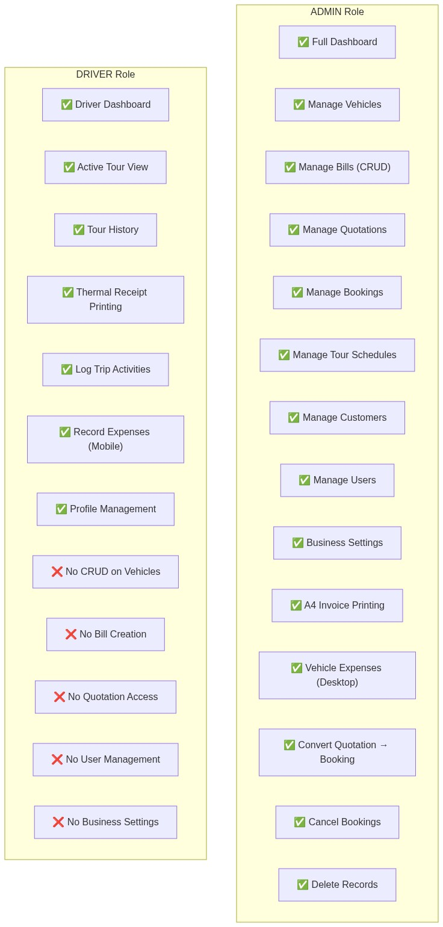
``

Permission Matrix
Feature | Admin | Driver
Login / Profile | ✅ | ✅
Dashboard (Full) | ✅ | ❌
Dashboard (Driver) | ❌ | ✅
Create/Edit/Delete Bills | ✅ | ❌
Print A4 Invoice | ✅ | ❌
Print Thermal Receipt | ✅ | ✅
Create/Edit Quotations | ✅ | ❌
Print Quotations | ✅ | ❌
Create/Cancel Bookings | ✅ | ❌
View Bookings | ✅ | ✅ (own)
Manage Vehicles | ✅ | ❌
Manage Tour Schedules | ✅ | ❌
Manage Customers | ✅ | ❌
Manage Users | ✅ | ❌
Business Settings | ✅ | ❌
Record Expenses | ✅ | ✅ (own vehicle)
Log Trip Activities | ✅ | ✅ (assigned tours)
View Tour History | ✅ | ✅ (own)
Bluetooth Printing | ✅ | ✅

15. Feature Documentation

15.1 Dual Pricing Modes
VIGIL supports two distinct vehicle pricing modes:
Per-Day Package Mode (ratePerDay > 0) - Vehicle has a daily hire rate (e.g., Rs. 15,000/day) - Includes a km allowance per day (e.g., 100 km/day) - Excess km charged at a separate rate - Suitable for tour packages with predictable daily pricing
Per-Km Flat Rate Mode (ratePerDay = 0) - Vehicle charges purely based on distance traveled - Rate per km applied to total trip distance - No package charge or km allowance - Suitable for airport transfers, point-to-point trips
``
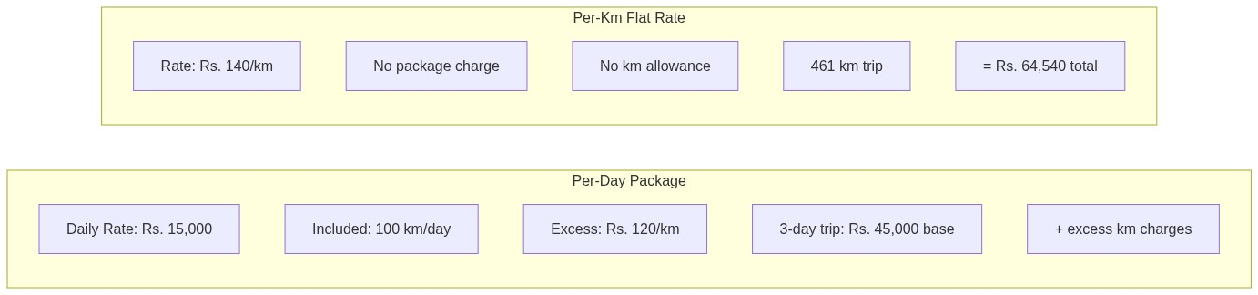
``

15.2 Calculation Engine
The billing calculation engine follows a 3-tier priority system:
Priority | Condition | Formula
1. Tour Distance Mode | totalTourDistance > 0 | extraKm × hireRate
2. Package Mode | allowedKm > 0 && packageCharge > 0 | excessKm × hireRate (excess only)
3. Flat Rate Mode | Default | totalDistance × hireRate

Extra Charges (added to all modes):waitingCharge + gatePass + packageCharge + (extraHours × extraHourRate) + accommodation + meals + activities + otherCosts

15.3 Vehicle Maintenance Tracking
``
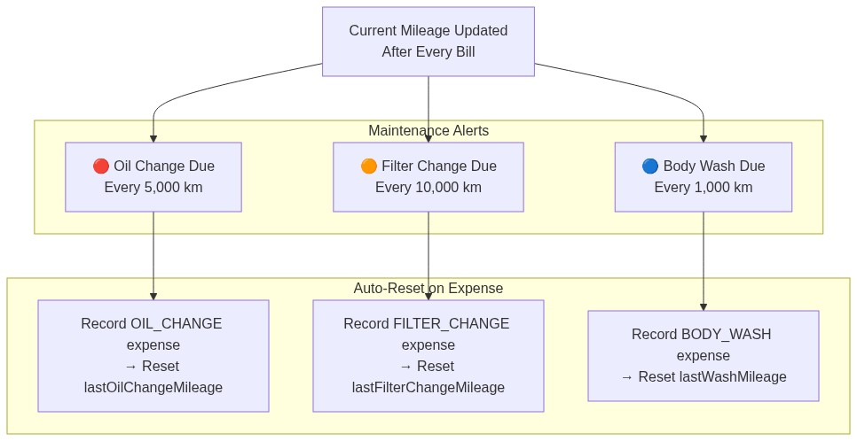
``

15.4 Availability Checking
The system performs real-time availability checking across three data sources:
``
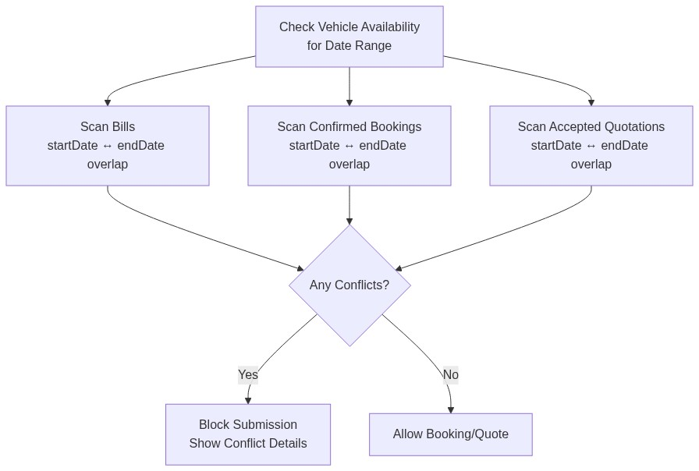
``

15.5 Print System
Format | Target User | Size | Features
A4 Portrait Invoice | Admin | 190mm × ~270mm | Company header, trip details, calculation table, signatures, "Powered by Bitgard" footer
58mm Thermal Receipt | Driver | 58mm width | Compact layout, large balance text, Bluetooth print support
A4 Quotation | Admin → Customer | 190mm × ~270mm | Vehicle specs panel, day-by-day itinerary table, cost summary, bank details, terms

15.6 Refund Policy
``
[Diagram could not be rendered]
graph LR
CANCEL["Cancel Booking"]
CHECK{"Days Until<br/>Start Date?"}
REFUND["✅ REFUNDED<br/>Full advance returned"]
FORFEIT["❌ FORFEITED<br/>Advance not returned"]
CANCEL --> CHECK
CHECK -->|"> 7 days"| REFUND
CHECK -->|"≤ 7 days"| FORFEIT
``

16. Deployment Architecture
``
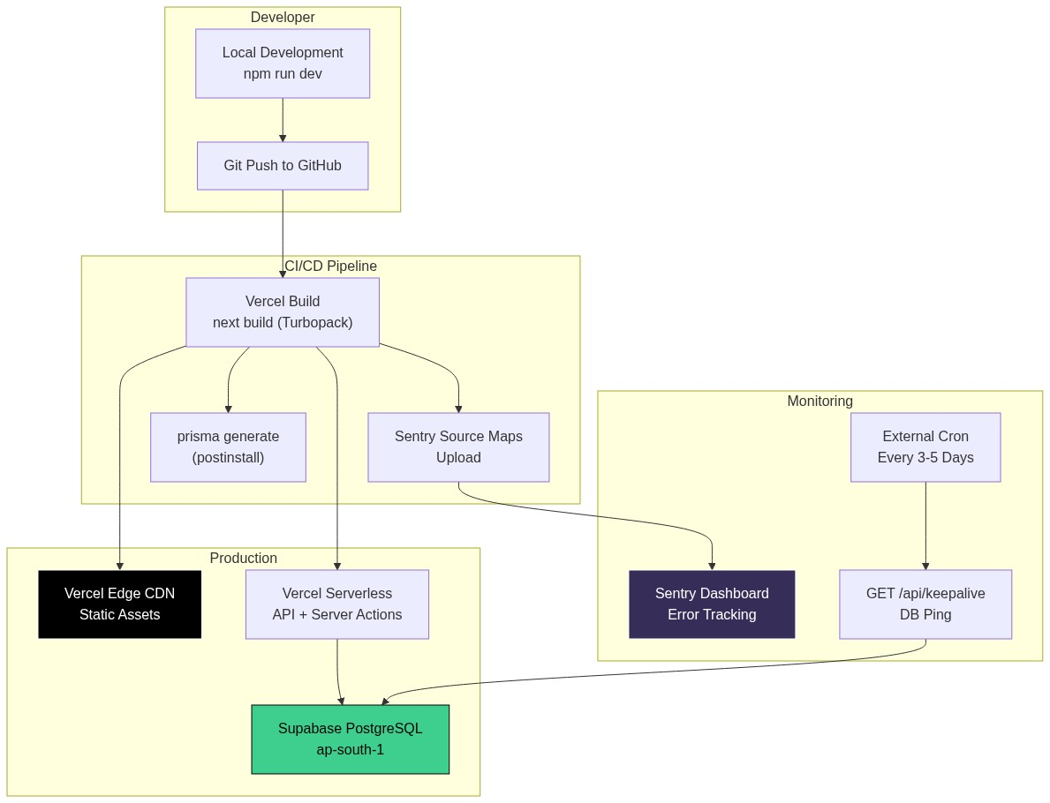
``

Environment Variables
Variable | Description
DATABASE_URL | PostgreSQL connection string (Supabase)
AUTH_SECRET | NextAuth JWT signing secret
NEXT_PUBLIC_APP_URL | Public application URL

Security Headers (Applied to All Routes)
Header | Value
X-Frame-Options | SAMEORIGIN
X-Content-Type-Options | nosniff
Referrer-Policy | origin-when-cross-origin
X-XSS-Protection | 1; mode=block
Permissions-Policy | camera=(), microphone=(), geolocation=()
Strict-Transport-Security | max-age=31536000; includeSubDomains

17. Security Features
``
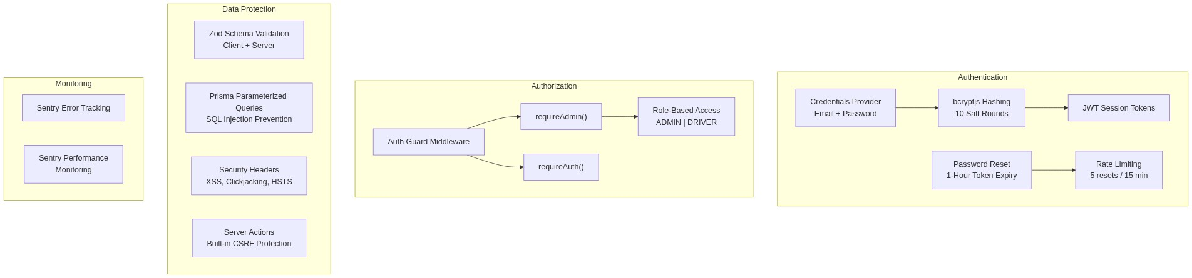
``

Security Checklist
Security Measure | Status | Implementation
Password Hashing | ✅ | bcryptjs with 10 rounds
JWT Sessions | ✅ | NextAuth v5
Role-Based Access | ✅ | Auth Guard pattern
Input Validation | ✅ | Zod v4 (dual client/server)
SQL Injection Prevention | ✅ | Prisma parameterized queries
XSS Protection | ✅ | Security headers + React escaping
CSRF Protection | ✅ | Next.js Server Actions
Clickjacking Prevention | ✅ | X-Frame-Options: SAMEORIGIN
HTTPS Enforcement | ✅ | HSTS header (1 year)
Rate Limiting | ✅ | Password reset endpoint
Error Monitoring | ✅ | Sentry integration
Permission Policy | ✅ | No camera/mic/geo access

18. Appendix

A. Expense Categories
Category | Icon | Color | Description
REPAIR | 🔧 | Red | General vehicle repairs
BREAKDOWN | ⚠️ | Orange | Roadside breakdowns
FUEL | ⛽ | Blue | Fuel fills
SERVICE | 🛠️ | Purple | Scheduled servicing
OIL_CHANGE | 💧 | Amber | Oil change (resets maintenance counter)
FILTER_CHANGE | 🔲 | Teal | Filter replacement (resets counter)
BODY_WASH | 🚿 | Cyan | Vehicle body wash (resets counter)
OTHER | 📋 | Gray | Miscellaneous expenses

B. Trip Activity Types
Type | Description
FUEL_FILL | Driver refueled the vehicle
FLAT_TIRE | Tire puncture/replacement
STOP | Unscheduled stop
HOTEL_CHECKIN | Hotel check-in for overnight stay
RESUME | Resumed journey after stop
BREAKDOWN | Vehicle breakdown event
NOTE | General driver note

C. Vehicle Categories
Category | Typical Use
CAR | Airport transfers, small tours (4 pax)
VAN | Group tours, family trips (14 pax)
SUV | Safari, luxury tours (7 pax)
BUS | Large group tours (40+ pax)
LORRY | Equipment transport

D. Payment Methods
Method | Description
CASH | Cash payment on completion
CREDIT | Credit/deferred payment

E. Currency Support
Currency | Code | Exchange Rate
Sri Lankan Rupee | LKR | 1.0 (base)
US Dollar | USD | Configurable (default: 300.0)

Document Version: 1.0
Generated: July 2026
System: VIGIL Smart Travel Management
Developer: Bitgard PVT LTD
Contact: +94 70 563 3969

This document is confidential and intended for internal use and prospective clients only. Subscription pricing is subject to change.]]>

