<![CDATA[# VIGIL — Smart Travel Management System ## Complete System Documentation v1.0
Product Name: VIGIL
Tagline: Smart Travel Management
Version: 1.0.0
Platform: Web (SaaS)
Developed by: Bitgard PVT LTD
Last Updated: July 2026

Table of Contents
- Executive Summary
- Subscription Plans & Pricing
- Technology Stack
- System Architecture
- Entity Relationship Diagram
- Data Flow Diagrams
- Use Case Diagram
- Class Diagram
- Sequence Diagrams
- State Diagrams
- Component Architecture
- Database Schema
- Server Actions & API Reference
- User Roles & Permissions
- Feature Documentation
- Deployment Architecture
- Security Features
- Appendix

1. Executive Summary
VIGIL is a cloud-based Smart Travel Management System designed for vehicle hire companies, tour operators, and fleet managers in Sri Lanka. It provides an end-to-end solution for managing the complete lifecycle of tour operations — from quotations and bookings through to billing and financial reporting.

Core Capabilities
Capability | Description
Fleet Management | Register vehicles with specs, pricing modes, and maintenance tracking
Tour Scheduling | Create multi-day tour itineraries with per-day cost breakdowns
Quotation Engine | Generate professional quotations with automatic cost calculations
Booking Management | Track reservations with driver assignment and availability checking
Billing Engine | Create bills with dual pricing modes (Per-Day Package / Per-Km Flat Rate)
Print System | A4 professional invoices (Admin) and 58mm thermal receipts (Driver)
Driver Portal | Mobile-first interface for drivers with tour tracking and expense logging
Dashboard & Analytics | Real-time revenue tracking, fleet utilization, and activity monitoring
Multi-Currency | LKR and USD support with configurable exchange rates

Target Market
- Vehicle hire companies (cars, vans, SUVs, buses)
- Tour operators and travel agencies
- Corporate fleet managers
- Airport transfer services

2. Subscription Plans & Pricing
[!NOTE] All prices are in USD. LKR equivalent shown at Rs. 300/USD. Annual plans include a 20% discount.

Plan Comparison
Feature | Starter | Professional | Enterprise
Monthly Price | $15/mo | $35/mo | $75/mo
Annual Price | $144/yr ($12/mo) | $336/yr ($28/mo) | $720/yr ($60/mo)
LKR Monthly | Rs. 4,500 | Rs. 10,500 | Rs. 22,500
LKR Annual | Rs. 43,200/yr | Rs. 100,800/yr | Rs. 216,000/yr
Vehicles | Up to 5 | Up to 20 | Unlimited
Admin Users | 1 | 3 | Unlimited
Driver Accounts | 2 | 10 | Unlimited
Bills per Month | 50 | 200 | Unlimited
Quotations per Month | 20 | 100 | Unlimited
Tour Schedules | 10 | 50 | Unlimited
Customer Records | 100 | 500 | Unlimited
Booking Management | ✅ | ✅ | ✅
Thermal Printing | ✅ | ✅ | ✅
A4 Invoice Printing | ✅ | ✅ | ✅
Bluetooth Printing | ❌ | ✅ | ✅
Driver Mobile Portal | ❌ | ✅ | ✅
Trip Activity Logging | ❌ | ✅ | ✅
Vehicle Expense Tracking | Basic | Full | Full
Maintenance Alerts | ❌ | ✅ | ✅
Dashboard Analytics | Basic | Advanced | Advanced
Multi-Currency (USD) | ❌ | ✅ | ✅
Custom Branding (Logo) | ❌ | ✅ | ✅
Bank Details on Quotes | ❌ | ✅ | ✅
Sentry Error Monitoring | ❌ | ❌ | ✅
Priority Support | Email | Email + Chat | Dedicated Account Manager
Data Retention | 1 Year | 3 Years | Unlimited
Free Trial | 14 Days | 14 Days | 30 Days

Pricing Diagram
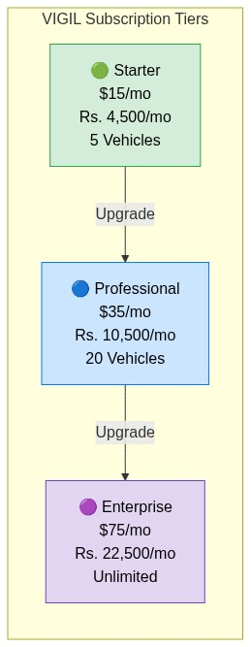
Diagram

3. Technology Stack
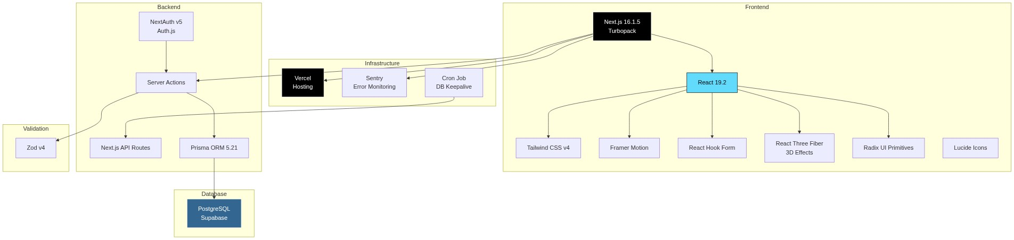
Diagram
Layer | Technology | Version | Purpose
Runtime | Next.js (Turbopack) | 16.1.5 | Full-stack React framework
UI Library | React | 19.2.3 | Component rendering
Styling | Tailwind CSS | v4 | Utility-first CSS
Animations | Framer Motion | 12.36 | Page transitions, micro-animations
3D Effects | React Three Fiber | 8.15 | Aurora background effects
Forms | React Hook Form | 7.71 | Form state management
Validation | Zod | 4.3 | Schema validation (client + server)
Auth | NextAuth (Auth.js) | v5-beta | Session management, credentials provider
ORM | Prisma | 5.21 | Database queries, migrations
Database | PostgreSQL | — | Supabase-hosted
Hosting | Vercel | — | Serverless deployment
Monitoring | Sentry | 10.42 | Error tracking, performance
Printing | react-to-print | 3.2 | Browser print API
Icons | Lucide React | 0.563 | SVG icon library
Password | bcryptjs | 3.0 | Password hashing
Dates | date-fns | 4.1 | Date manipulation

4. System Architecture

High-Level Architecture
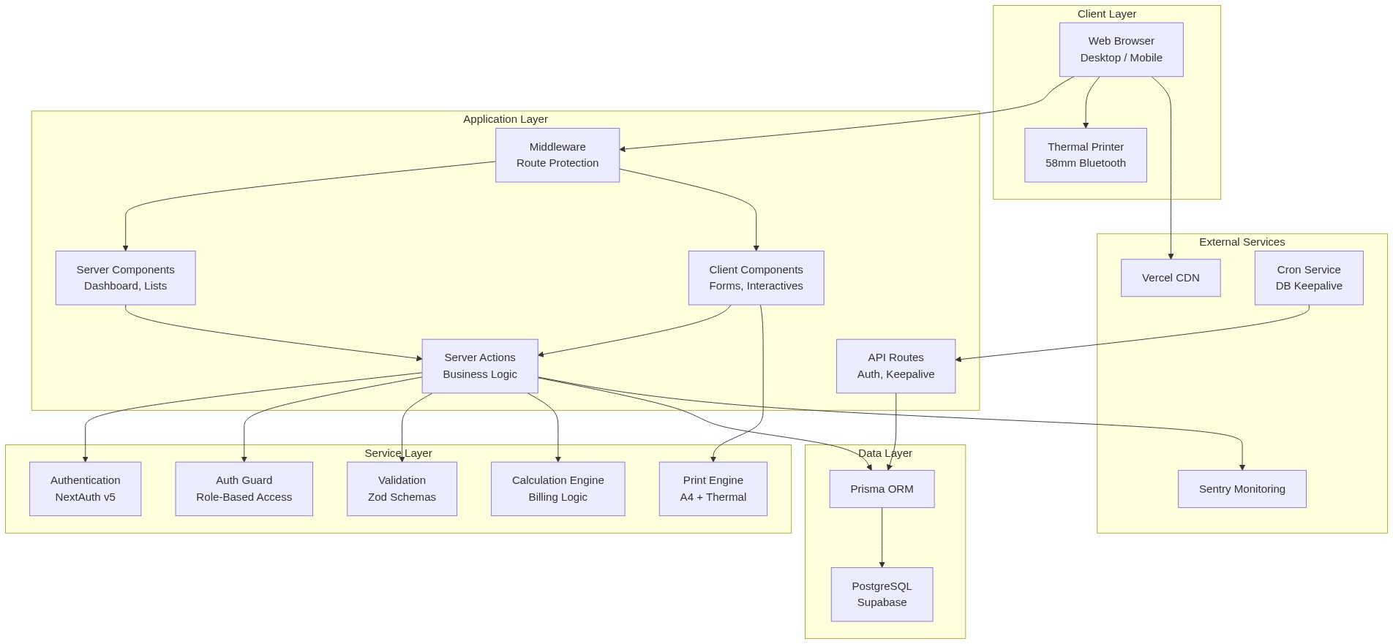
Diagram

Request Flow
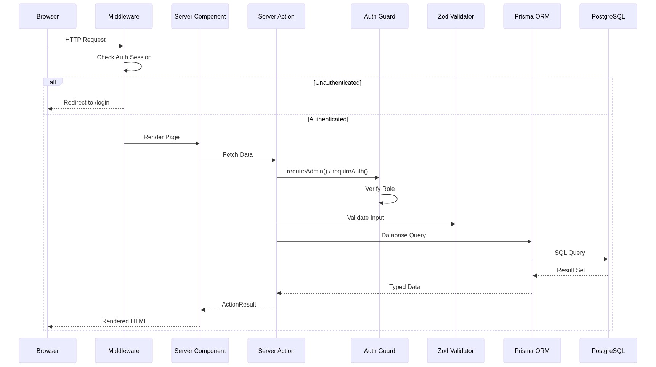
Diagram

5. Entity Relationship Diagram
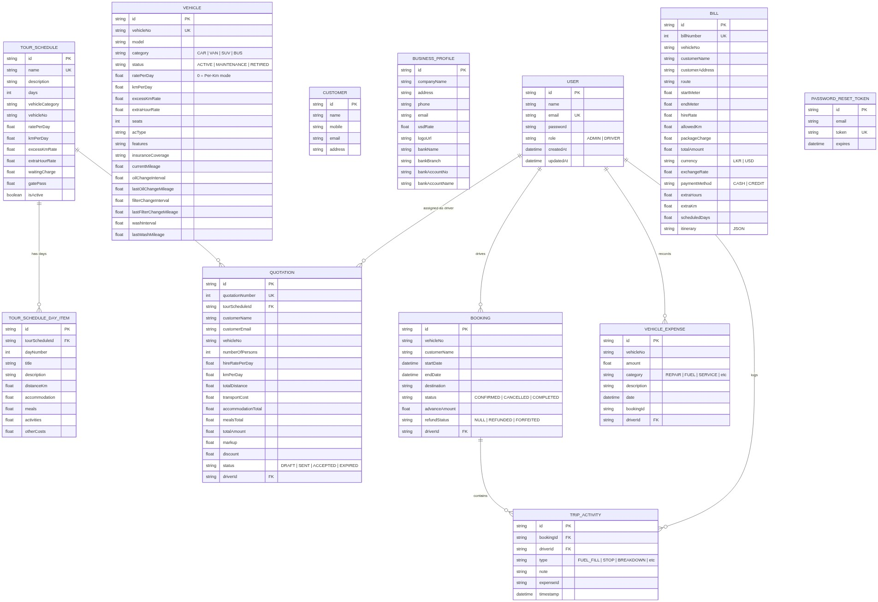
Diagram

6. Data Flow Diagrams

Level 0 — Context Diagram
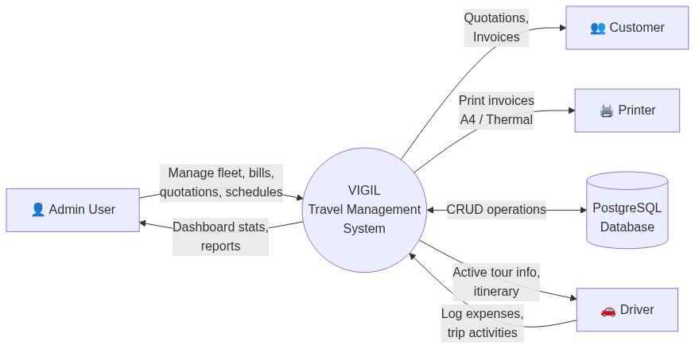
Diagram

Level 1 — Major Processes
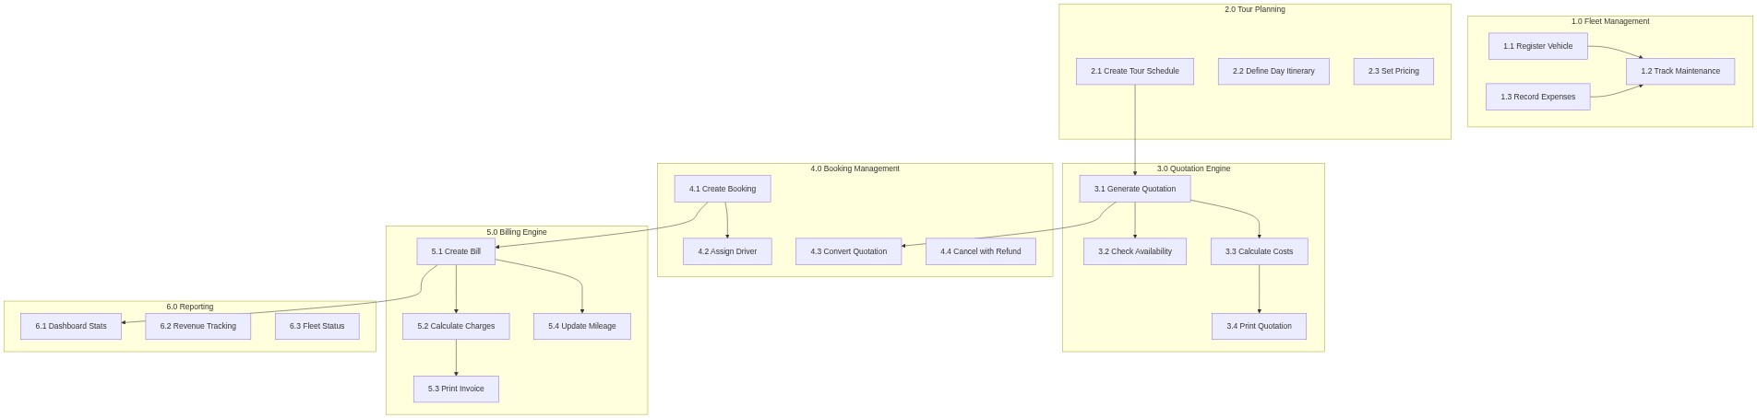
Diagram

Level 2 — Billing Process Detail
Diagram
Diagram

7. Use Case Diagram
Diagram

8. Class Diagram
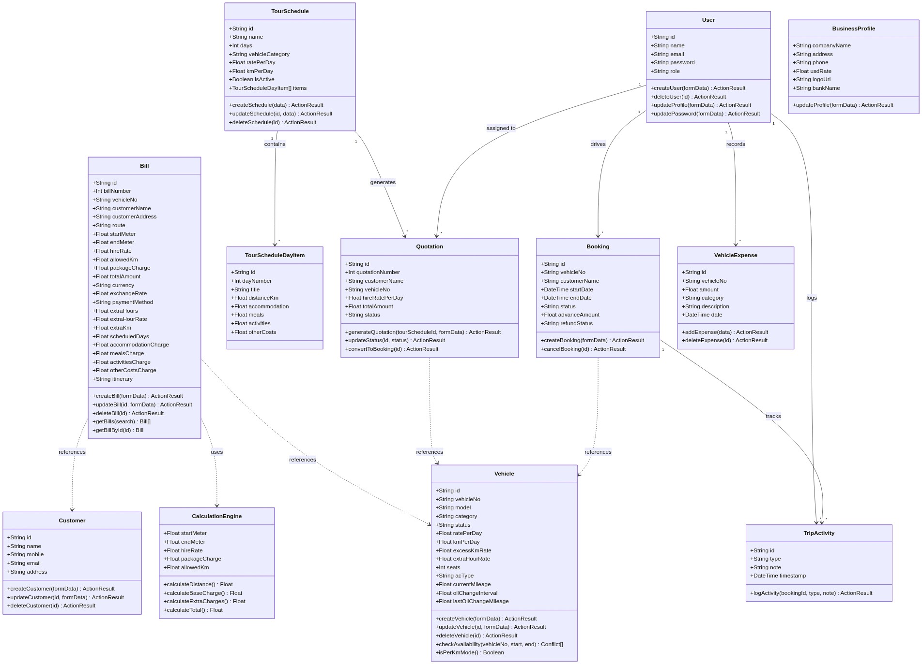
Diagram

9. Sequence Diagrams

9.1 Quotation to Booking to Bill Flow
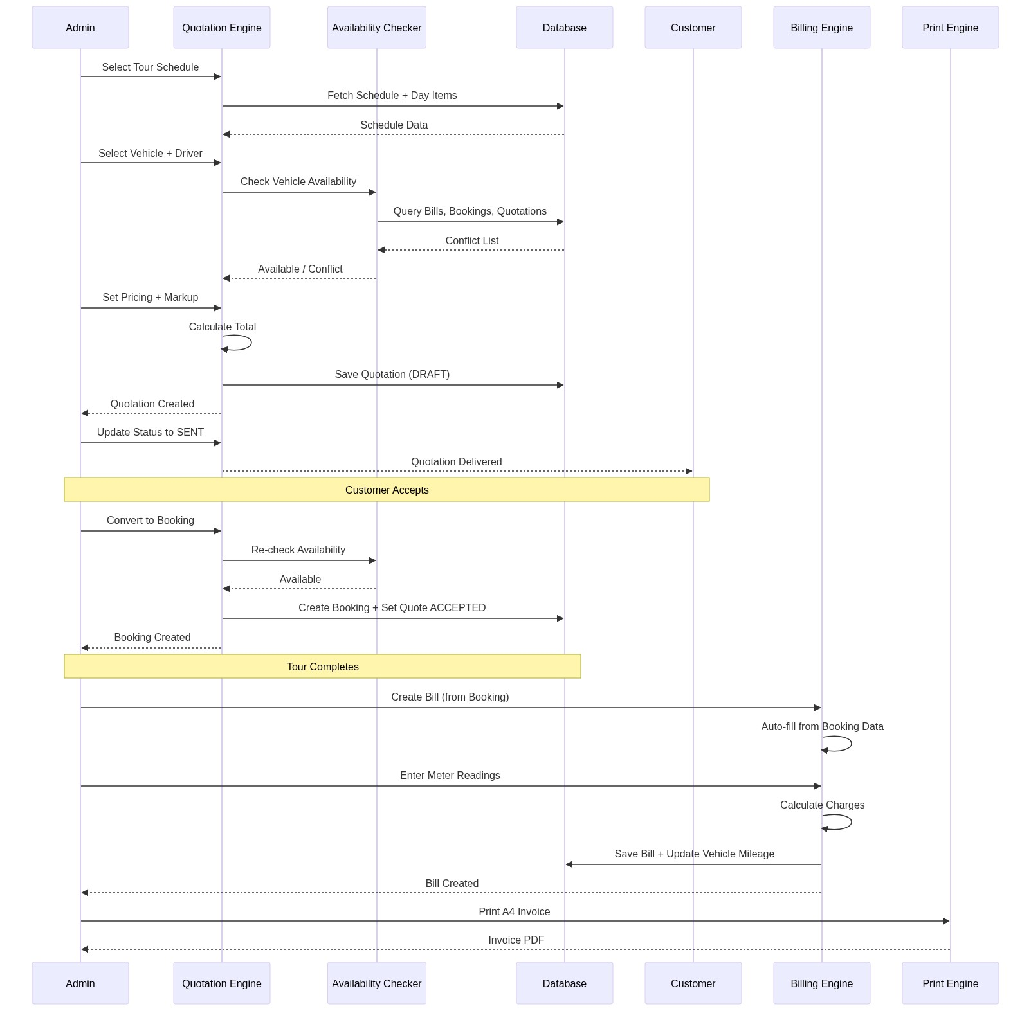
Diagram

9.2 Bill Creation with Per-Km Pricing
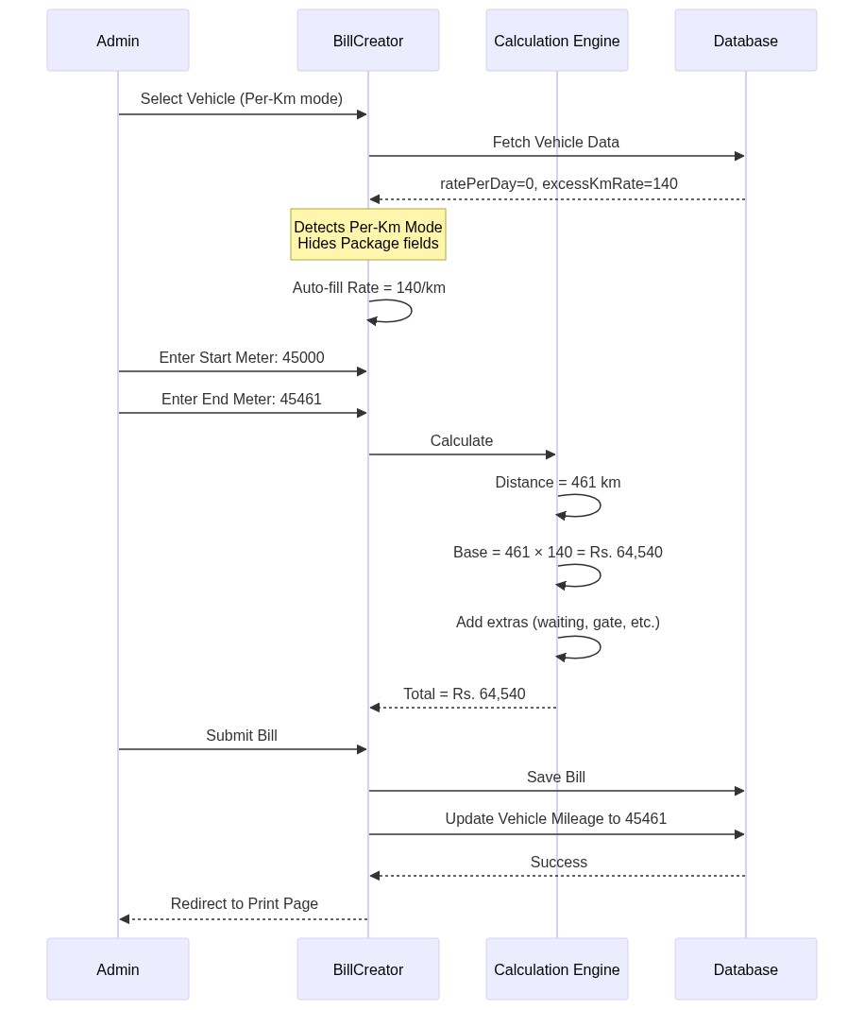
Diagram

9.3 Driver Trip Activity Flow
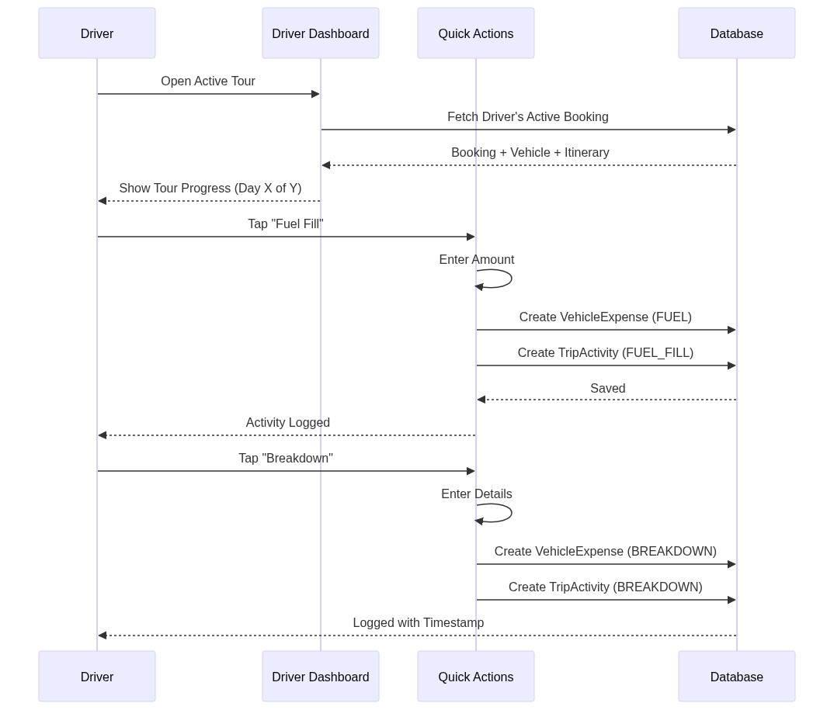
Diagram

9.4 Authentication Flow
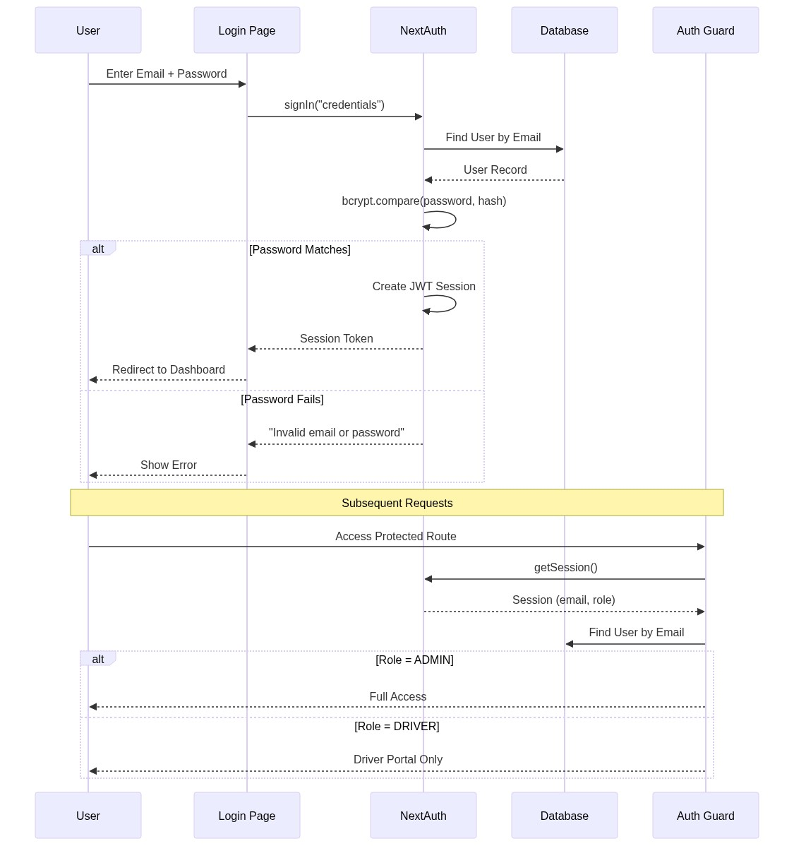
Diagram

10. State Diagrams

10.1 Quotation Lifecycle
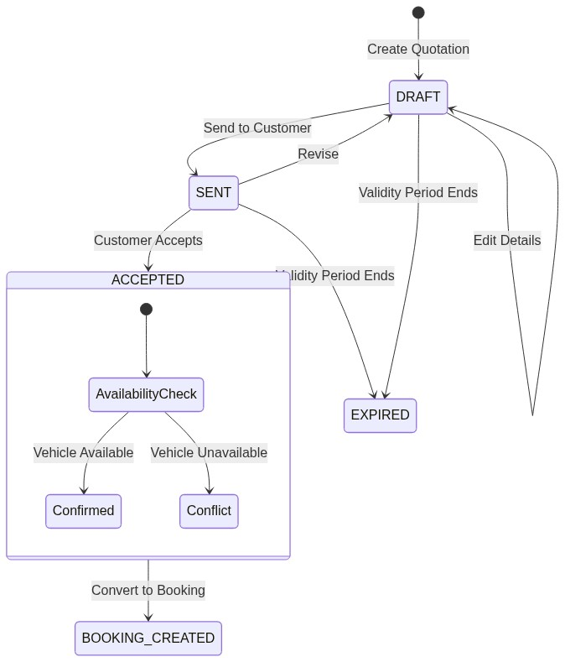
Diagram

10.2 Booking Lifecycle
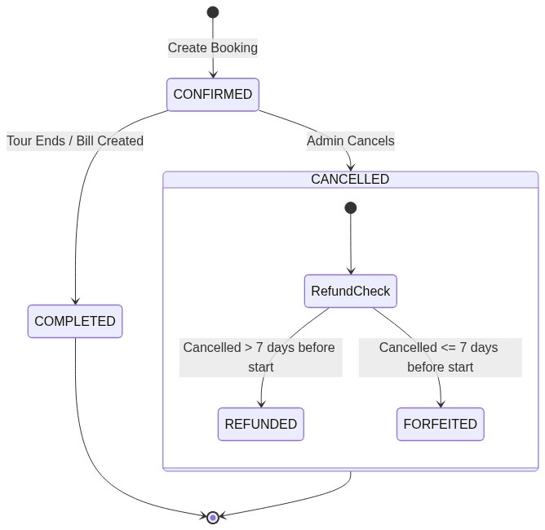
Diagram

10.3 Vehicle Status
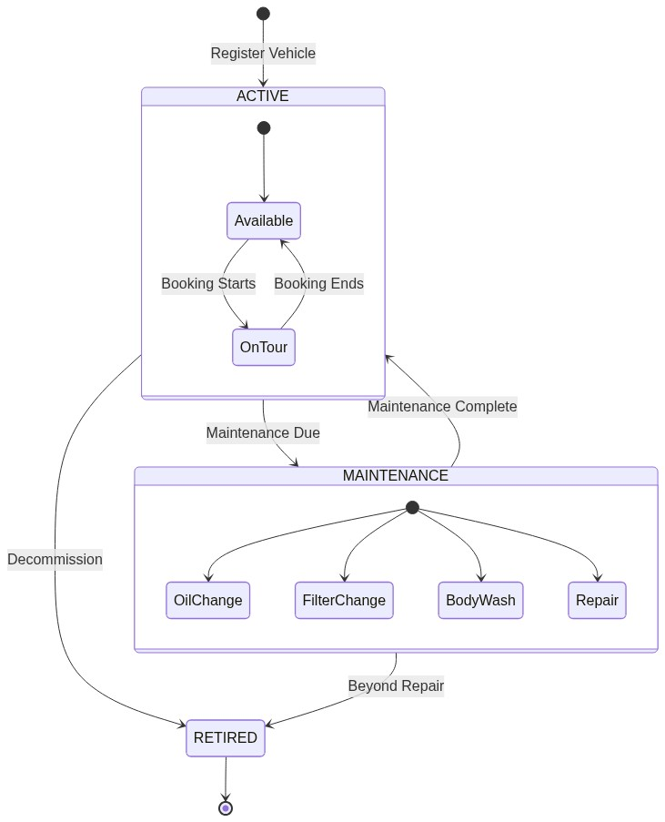
Diagram

10.4 Bill Pricing Mode
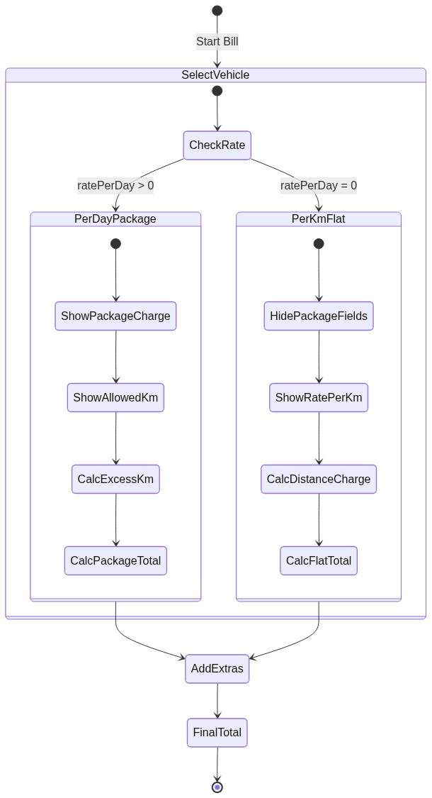
Diagram

11. Component Architecture
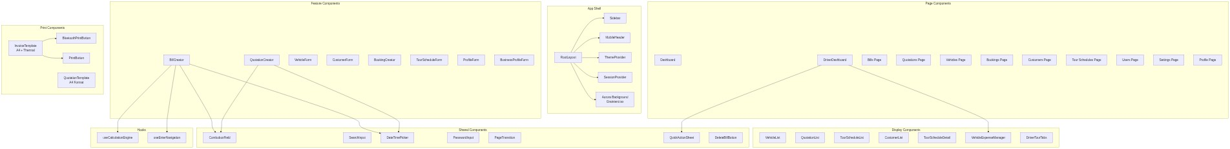
Diagram

12. Database Schema

12.1 Complete Model Reference
[!IMPORTANT] 11 database models stored in PostgreSQL via Prisma ORM. No Prisma enums are used — all enums are application-level strings validated by Zod schemas.

Bill Model
Field | Type | Default | Description
id | String | cuid() | Primary key
billNumber | Int | autoincrement | Unique sequential bill number
vehicleNo | String | — | Vehicle registration number
customerName | String | — | Customer full name
customerAddress | String? | — | Customer address
route | String | — | Tour route description
startMeter | Float | — | Odometer at trip start
endMeter | Float | — | Odometer at trip end
hireRate | Float | — | Rate per km (excess or flat)
allowedKm | Float | 0 | Included km in package
waitingCharge | Float | 0 | Waiting charges
gatePass | Float | 0 | Gate/toll fees
packageCharge | Float | 0 | Base package charge (0 for per-km)
advanceAmount | Float | 0 | Advance payment received
totalAmount | Float | — | Calculated total amount
currency | String | “LKR” | LKR or USD
exchangeRate | Float | 1.0 | USD to LKR rate
totalAmountLKR | Float | 0 | Amount in LKR
paymentMethod | String | “CASH” | CASH or CREDIT
startDate | DateTime | now() | Trip start date/time
endDate | DateTime | now() | Trip end date/time
extraHours | Float | 0 | Hours beyond scheduled
extraHourRate | Float | 0 | Charge per extra hour
extraKm | Float | 0 | Km beyond package allowance
scheduledDays | Float | 1 | Number of tour days
accommodationCharge | Float | 0 | Total accommodation cost
mealsCharge | Float | 0 | Total meals cost
activitiesCharge | Float | 0 | Total activities cost
otherCostsCharge | Float | 0 | Miscellaneous costs
itinerary | String? | — | JSON snapshot of day items

Vehicle Model
Field | Type | Default | Description
id | String | cuid() | Primary key
vehicleNo | String | — | Unique registration number
model | String? | — | Vehicle make/model
category | String | “CAR” | CAR, VAN, SUV, BUS, LORRY
status | String | “ACTIVE” | ACTIVE, MAINTENANCE, RETIRED
ratePerDay | Float | 0 | Daily hire rate (0 = Per-Km mode)
kmPerDay | Float | 0 | Included km per day in package
excessKmRate | Float | 0 | Rate per km (excess or flat)
extraHourRate | Float | 0 | Charge per extra hour
seats | Int? | — | Passenger capacity
acType | String? | — | AC type description
features | String? | — | Feature list (free text)
insuranceCoverage | String? | — | Insurance details
currentMileage | Float | 0 | Current odometer reading
oilChangeInterval | Float | 5000 | Km between oil changes
lastOilChangeMileage | Float | 0 | Mileage at last oil change
filterChangeInterval | Float | 10000 | Km between filter changes
lastFilterChangeMileage | Float | 0 | Mileage at last filter change
washInterval | Float | 1000 | Km between body washes
lastWashMileage | Float | 0 | Mileage at last wash
(Full schema for all 11 models documented in the ER Diagram section above)

13. Server Actions & API Reference

13.1 Bill Actions
Action | Auth | Parameters | Returns | Description
createBill | Admin | FormData | ActionResult<string> | Creates bill, calculates total, updates vehicle mileage, auto-closes booking
updateBill | Admin | id, FormData | ActionResult<string> | Updates bill and recalculates total
deleteBill | Admin | id | ActionResult<null> | Permanently deletes bill
getBills | Public | searchQuery? | Bill[] | Search by billNumber, vehicleNo, customerName, route
getBillById | Public | id | Bill | Fetch single bill

13.2 Vehicle Actions
Action | Auth | Parameters | Returns | Description
createVehicle | Admin | FormData | ActionResult<string> | Register new vehicle with maintenance tracking
updateVehicle | Admin | id, FormData | ActionResult<string> | Update vehicle details
deleteVehicle | Admin | id | ActionResult<null> | Delete (blocked if has expenses)
getVehicles | Public | searchQuery? | Vehicle[] | Search by vehicleNo, model
checkVehicleAvailability | Public | vehicleNo, start, end | Conflict[] | Check against Bills, Bookings, Quotations

13.3 Quotation Actions
Action | Auth | Parameters | Returns | Description
generateQuotation | Admin | tourScheduleId, FormData | ActionResult<string> | Auto-calculates totals from schedule
updateQuotation | Auth | id, tourScheduleId, FormData | ActionResult<string> | Update with availability check
updateQuotationStatus | Public | id, status | ActionResult<null> | Change DRAFT/SENT/ACCEPTED/EXPIRED
convertQuotationToBooking | Admin | quotationId | ActionResult<string> | Atomic conversion with availability check
deleteQuotation | Admin | id | ActionResult<null> | Permanently delete

13.4 Booking Actions
Action | Auth | Parameters | Returns | Description
createBooking | Auth | FormData | ActionResult<string> | Create with vehicle availability check
cancelBooking | Admin | id | ActionResult<null> | Cancel with refund policy (>7 days = REFUNDED, ≤7 = FORFEITED)
getBookings | Public | searchQuery? | Booking[] | Search by vehicleNo, customerName, destination

13.5 Tour Schedule Actions
Action | Auth | Parameters | Returns | Description
createTourSchedule | Admin | data | ActionResult<string> | Create schedule + day items in transaction
updateTourSchedule | Admin | id, data | ActionResult<string> | Update with delete/recreate of day items
deleteTourSchedule | Admin | id | ActionResult<null> | Soft delete (isActive = false)

13.6 Expense & Activity Actions
Action | Auth | Parameters | Returns | Description
addVehicleExpense | Auth | data | ActionResult<string> | Drivers need active booking for vehicle; auto-updates maintenance mileage
logTripActivity | Auth | bookingId, type, note? | ActionResult<string> | Driver must be assigned to booking
getDriverTourHistory | Auth | type | Booking[] | Upcoming or completed tours (max 20)

13.7 API Routes
Route | Method | Auth | Description
/api/auth/[...nextauth] | ALL | — | NextAuth authentication endpoints
/api/keepalive | GET | — | Lightweight DB ping to prevent Supabase pause

14. User Roles & Permissions
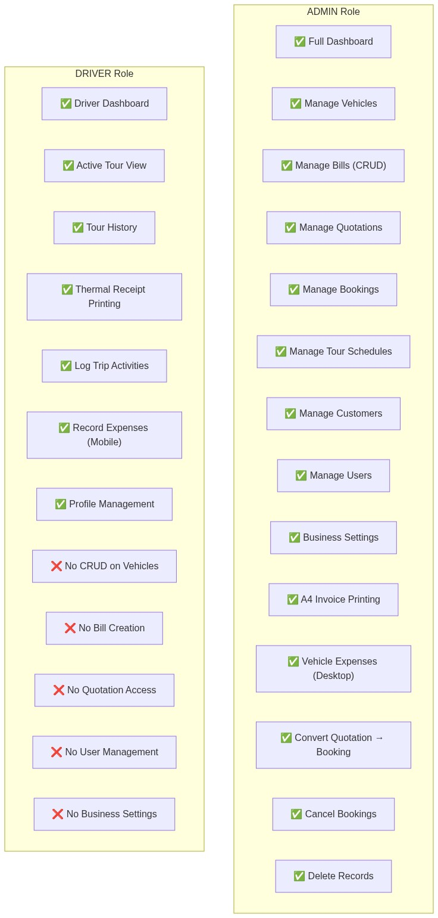
Diagram

Permission Matrix
Feature | Admin | Driver
Login / Profile | ✅ | ✅
Dashboard (Full) | ✅ | ❌
Dashboard (Driver) | ❌ | ✅
Create/Edit/Delete Bills | ✅ | ❌
Print A4 Invoice | ✅ | ❌
Print Thermal Receipt | ✅ | ✅
Create/Edit Quotations | ✅ | ❌
Print Quotations | ✅ | ❌
Create/Cancel Bookings | ✅ | ❌
View Bookings | ✅ | ✅ (own)
Manage Vehicles | ✅ | ❌
Manage Tour Schedules | ✅ | ❌
Manage Customers | ✅ | ❌
Manage Users | ✅ | ❌
Business Settings | ✅ | ❌
Record Expenses | ✅ | ✅ (own vehicle)
Log Trip Activities | ✅ | ✅ (assigned tours)
View Tour History | ✅ | ✅ (own)
Bluetooth Printing | ✅ | ✅

15. Feature Documentation

15.1 Dual Pricing Modes
VIGIL supports two distinct vehicle pricing modes:
Per-Day Package Mode (ratePerDay > 0) - Vehicle has a daily hire rate (e.g., Rs. 15,000/day) - Includes a km allowance per day (e.g., 100 km/day) - Excess km charged at a separate rate - Suitable for tour packages with predictable daily pricing
Per-Km Flat Rate Mode (ratePerDay = 0) - Vehicle charges purely based on distance traveled - Rate per km applied to total trip distance - No package charge or km allowance - Suitable for airport transfers, point-to-point trips
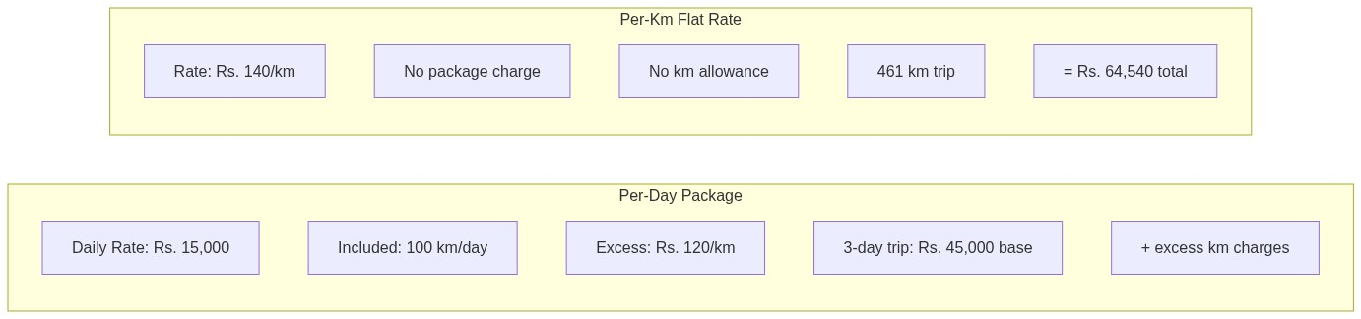
Diagram

15.2 Calculation Engine
The billing calculation engine follows a 3-tier priority system:
Priority | Condition | Formula
1. Tour Distance Mode | totalTourDistance > 0 | extraKm × hireRate
2. Package Mode | allowedKm > 0 && packageCharge > 0 | excessKm × hireRate (excess only)
3. Flat Rate Mode | Default | totalDistance × hireRate
Extra Charges (added to all modes): waitingCharge + gatePass + packageCharge + (extraHours × extraHourRate) + accommodation + meals + activities + otherCosts

15.3 Vehicle Maintenance Tracking
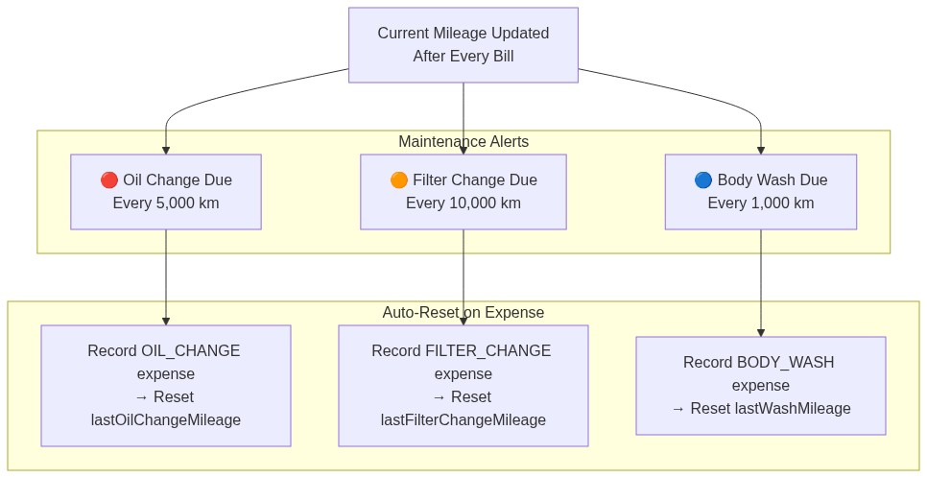
Diagram

15.4 Availability Checking
The system performs real-time availability checking across three data sources:
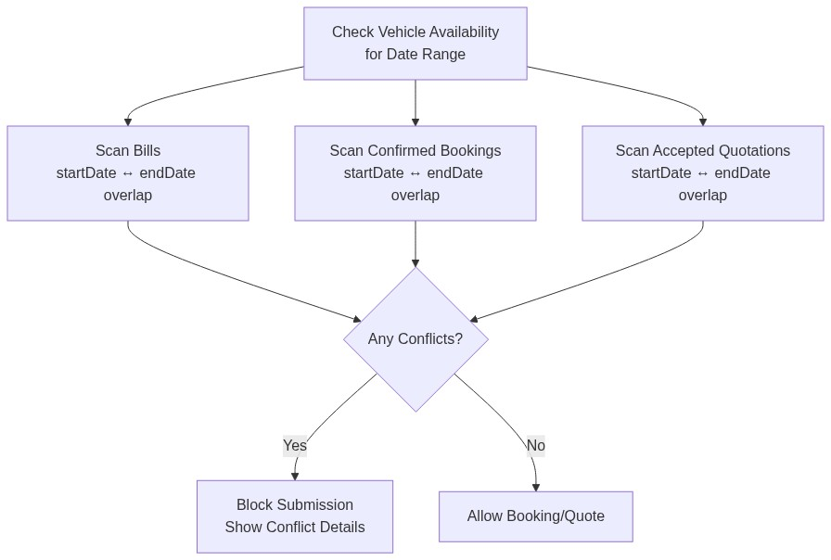
Diagram

15.5 Print System
Format | Target User | Size | Features
A4 Portrait Invoice | Admin | 190mm × ~270mm | Company header, trip details, calculation table, signatures, “Powered by Bitgard” footer
58mm Thermal Receipt | Driver | 58mm width | Compact layout, large balance text, Bluetooth print support
A4 Quotation | Admin → Customer | 190mm × ~270mm | Vehicle specs panel, day-by-day itinerary table, cost summary, bank details, terms

15.6 Refund Policy
Diagram
Diagram

16. Deployment Architecture
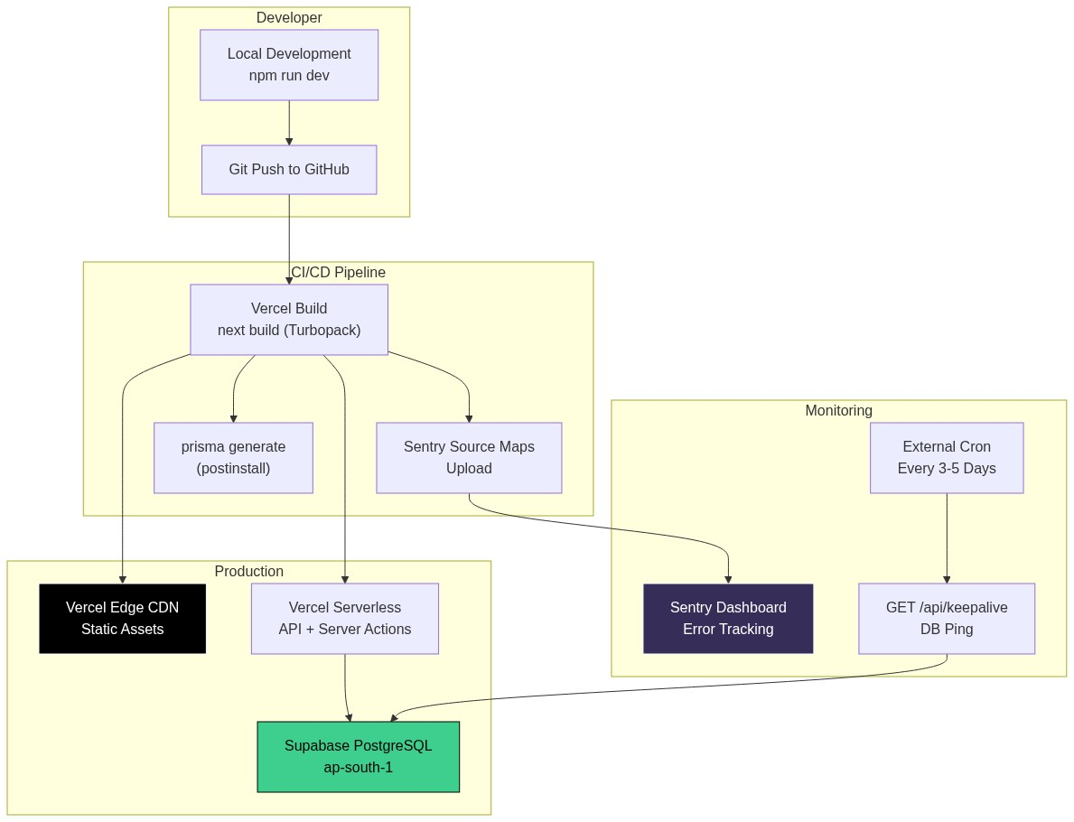
Diagram

Environment Variables
Variable | Description
DATABASE_URL | PostgreSQL connection string (Supabase)
AUTH_SECRET | NextAuth JWT signing secret
NEXT_PUBLIC_APP_URL | Public application URL

Security Headers (Applied to All Routes)
Header | Value
X-Frame-Options | SAMEORIGIN
X-Content-Type-Options | nosniff
Referrer-Policy | origin-when-cross-origin
X-XSS-Protection | 1; mode=block
Permissions-Policy | camera=(), microphone=(), geolocation=()
Strict-Transport-Security | max-age=31536000; includeSubDomains

17. Security Features
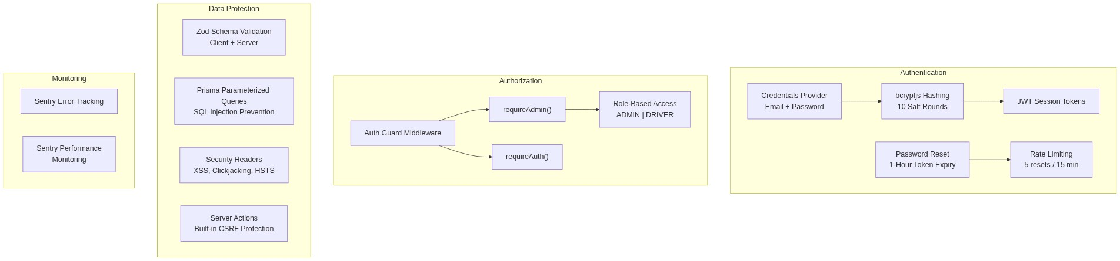
Diagram

Security Checklist
Security Measure | Status | Implementation
Password Hashing | ✅ | bcryptjs with 10 rounds
JWT Sessions | ✅ | NextAuth v5
Role-Based Access | ✅ | Auth Guard pattern
Input Validation | ✅ | Zod v4 (dual client/server)
SQL Injection Prevention | ✅ | Prisma parameterized queries
XSS Protection | ✅ | Security headers + React escaping
CSRF Protection | ✅ | Next.js Server Actions
Clickjacking Prevention | ✅ | X-Frame-Options: SAMEORIGIN
HTTPS Enforcement | ✅ | HSTS header (1 year)
Rate Limiting | ✅ | Password reset endpoint
Error Monitoring | ✅ | Sentry integration
Permission Policy | ✅ | No camera/mic/geo access

18. Appendix

A. Expense Categories
Category | Icon | Color | Description
REPAIR | 🔧 | Red | General vehicle repairs
BREAKDOWN | ⚠️ | Orange | Roadside breakdowns
FUEL | ⛽ | Blue | Fuel fills
SERVICE | 🛠️ | Purple | Scheduled servicing
OIL_CHANGE | 💧 | Amber | Oil change (resets maintenance counter)
FILTER_CHANGE | 🔲 | Teal | Filter replacement (resets counter)
BODY_WASH | 🚿 | Cyan | Vehicle body wash (resets counter)
OTHER | 📋 | Gray | Miscellaneous expenses

B. Trip Activity Types
Type | Description
FUEL_FILL | Driver refueled the vehicle
FLAT_TIRE | Tire puncture/replacement
STOP | Unscheduled stop
HOTEL_CHECKIN | Hotel check-in for overnight stay
RESUME | Resumed journey after stop
BREAKDOWN | Vehicle breakdown event
NOTE | General driver note

C. Vehicle Categories
Category | Typical Use
CAR | Airport transfers, small tours (4 pax)
VAN | Group tours, family trips (14 pax)
SUV | Safari, luxury tours (7 pax)
BUS | Large group tours (40+ pax)
LORRY | Equipment transport

D. Payment Methods
Method | Description
CASH | Cash payment on completion
CREDIT | Credit/deferred payment

E. Currency Support
Currency | Code | Exchange Rate
Sri Lankan Rupee | LKR | 1.0 (base)
US Dollar | USD | Configurable (default: 300.0)

Document Version: 1.0
Generated: July 2026
System: VIGIL Smart Travel Management
Developer: Bitgard PVT LTD
Contact: +94 70 563 3969

This document is confidential and intended for internal use and prospective clients only. Subscription pricing is subject to change. ]]>

