Project
Software Engineering



Department of Computer Science

BAHRIA UNIVERSITY ISLAMABAD

Name: Shameer Khan
Enrollment No. : 01-134242-115
Class : BSCS 4-B

Food Delivery with Health Intelligence

Problem Statement
Traditional food delivery applications mainly focus on fast ordering and delivery services without considering the health and nutritional needs of users. Many people struggle to maintain healthy eating habits because they do not receive clear nutrition information while ordering food online. Users with allergies, dietary restrictions, obesity concerns, or fitness goals often find it difficult to select meals that match their health requirements. Existing food delivery platforms usually prioritize convenience over health awareness, which may lead to unhealthy food choices and poor eating habits.
The proposed “Food Delivery with Health Intelligence” system aims to address this problem by integrating food delivery services with basic health and nutrition support features. The system will allow users to create health profiles, view nutritional information of meals, receive simple healthy meal recommendations, and track their food consumption history. By combining food ordering with health-related guidance, the system will help users make more informed and healthier food choices while maintaining the convenience of online food delivery.

Project Scope
The scope of the “Food Delivery with Health Intelligence” system is to provide a food delivery platform that combines traditional online food ordering with basic health and nutrition support features. The system is designed for users who want convenient food delivery services while also being aware of their nutritional intake and dietary preferences.
The system allows users to create accounts, manage health profiles, browse restaurants, view menu items with nutritional information, receive basic healthy meal recommendations, place orders, make payments, and track deliveries. Users can also view simple nutrition history and health-related food insights based on their orders.
Restaurants will be able to manage menus, update food and nutrition information, and handle customer orders. Administrators will manage users, restaurants, and overall system activities to ensure smooth platform operation.
The system focuses on improving food awareness and encouraging healthier meal choices while maintaining the convenience of online food delivery services.

Functional Requirements
- The system shall allow users to register an account.
- The system shall allow users to log in using email and password.
- The system shall allow users to update profile information.
- The system shall allow users to create and manage health profiles.
- The system shall calculate BMI using user health data.
- The system shall display calorie and nutrition information for meals.
- The system shall provide healthy meal recommendations.
- The system shall display allergy and sugar warnings.
- The system shall store user nutrition history.
- The system shall allow users to browse restaurants and menus.
- The system shall allow users to add items to the cart.
- The system shall allow users to place food orders.
- The system shall allow users to track order status.
- The system shall allow users to make online payments.
- The system shall generate payment confirmations.
- The system shall allow restaurants to add and manage menu items.
- The system shall allow restaurants to update nutrition information.
- The system shall allow restaurants to view customer orders.
- The system shall allow restaurants to update order status.
- The system shall allow administrators to manage users and restaurants.
- The system shall allow administrators to monitor reports and system activities.

Non-Functional Requirements
- The system should respond to user requests within 2 seconds.
- The system should support multiple users simultaneously.
- Only authorized users should access admin functions.
- The system should provide a user-friendly interface.
- The application should be easy to navigate.
- The system should operate with minimal downtime.
- The system should maintain accurate order and payment records.
- The system should be scalable for increasing users and restaurants.
- The system should be available 24/7.
- The system should be modular and easy to maintain.
- The application should support both mobile and web platforms.

Use Case Diagram

Customer
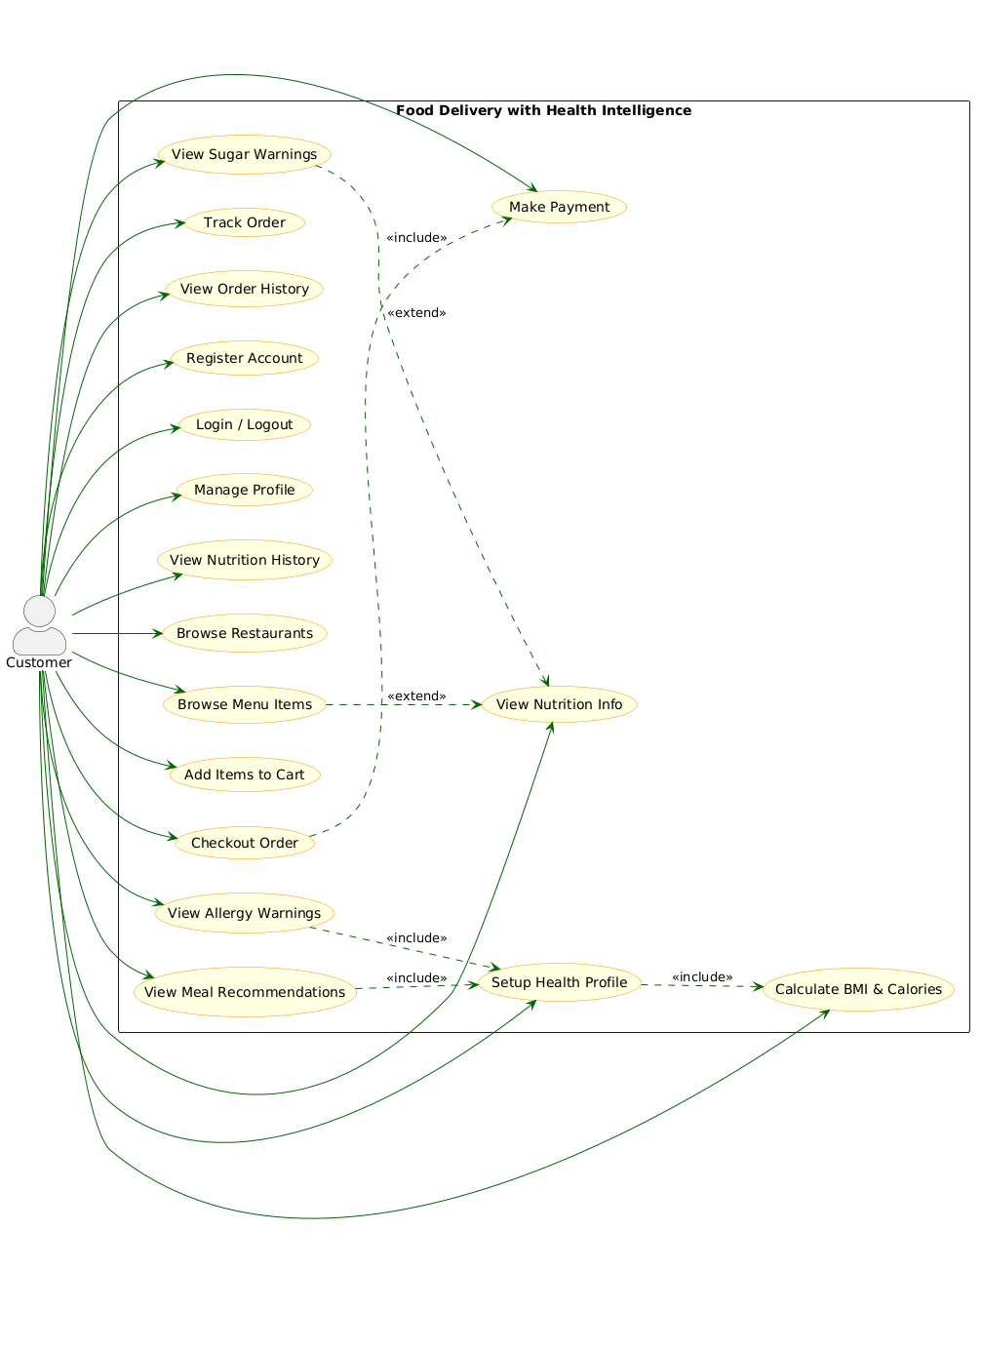

Restaurant
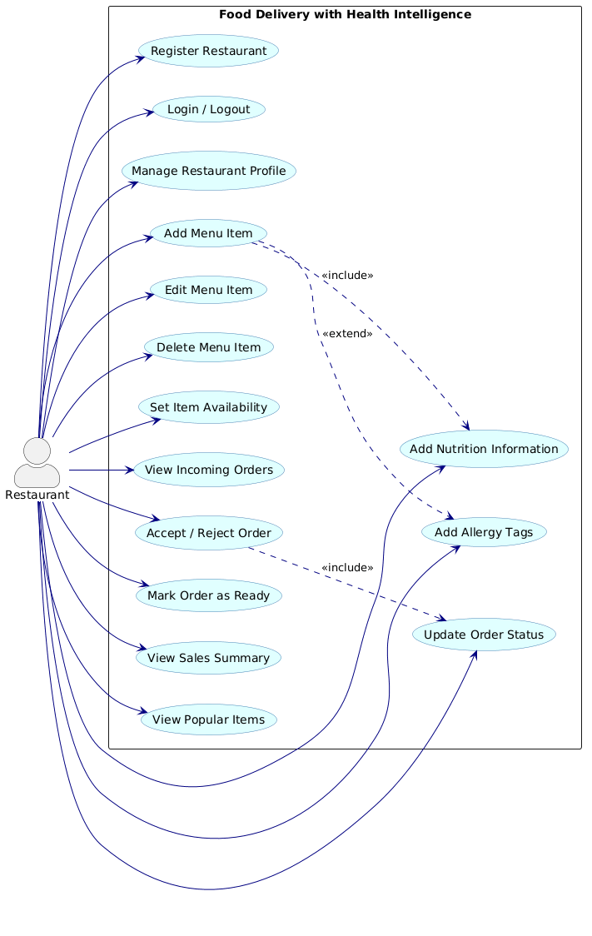

Admin
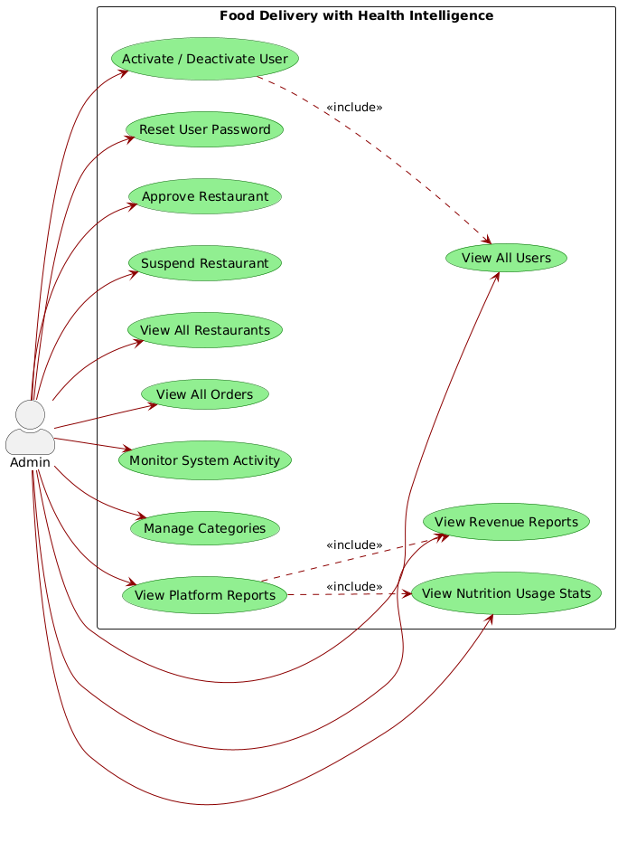

Use Case Description table

Use Case 1: Register Account
Field | Details
Actor | Customer
Description | A new user creates a personal account to access the platform's features.
Precondition | The user has not previously registered with the provided email address.
Main Flow | 1. User opens the application and selects the Register option.  2. User enters required details: Name, Email, Password, and Phone Number.  3. System validates the input for correct formatting and uniqueness.  4. System creates the account and sends a confirmation email/SMS.  5. User is redirected to the login screen.
Alternate Flow | Email Exists: If the email is already in the database, the system displays an error and prompts the user to log in or use a different email.
Postcondition | A new account is stored in the database; the user is eligible to log in.

Use Case 2: Place Order
Field | Details
Actor | Customer
Description | The customer selects food items and finalizes the purchase process.
Precondition | Customer is logged in and has items added to the virtual shopping cart.
Main Flow | 1. Customer reviews the items in the cart.  2. Customer enters or selects a delivery address.  3. Customer selects a payment method.  4. Customer confirms the order.  5. System transmits the order details to the restaurant.  6. System generates a unique Order ID and confirmation message.
Alternate Flow | Payment Failed: If the transaction is declined, the system notifies the user and keeps the order in the cart for a retry.
Postcondition | An order record is created with a status of "Pending."

Use Case 3: View Meal Recommendations
Field | Details
Actor | Customer
Description | The system suggests meals that align with the user's health goals.
Precondition | The customer has completed their Health Profile (UC-02).
Main Flow | 1. Customer navigates to the Recommendations tab.  2. System retrieves the user's health profile and calorie targets.  3. System filters the available menu to find items matching the calorie/dietary criteria.  4. System displays the suggestions with a detailed nutritional summary.
Alternate Flow | Missing Profile: If no profile is found, the system prompts the user to "Setup Health Profile" first.
Postcondition | The customer views a curated list of healthy food options.

Use Case 4: Update Order Status
Field | Details
Actor | Restaurant
Description | The restaurant updates progress of live order to keep the customer informed.
Precondition | An order has been placed and accepted by the restaurant.
Main Flow | 1. Restaurant opens the Active Orders list.  2. Staff selects a specific order.  3. Staff updates the status (e.g., Preparing, Ready, or Out for Delivery).  4. System sends a push notification/update to the customer.
Alternate Flow | N/A
Postcondition | The order status is updated in the database; the customer is notified in real-time.

Use Case 5: Approve Restaurant
Field | Details
Actor | Admin
Description | The system administrator reviews new restaurant applications for quality and legitimacy.
Precondition | A restaurant has submitted a registration application.
Main Flow | 1. Admin accesses the Pending Registrations dashboard.  2. Admin reviews the restaurant's documentation and details.  3. Admin selects "Approve" or "Reject."  4. System sends a status notification to the restaurant owner.
Alternate Flow | Clarification Needed: Admin puts the application on "Hold" and requests further information from the restaurant.
Postcondition | The restaurant's status is updated to "Active" or "Rejected" in the system.

Context Diagram
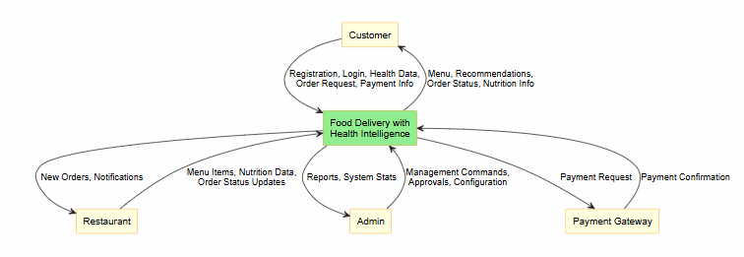

Level 0 DFD
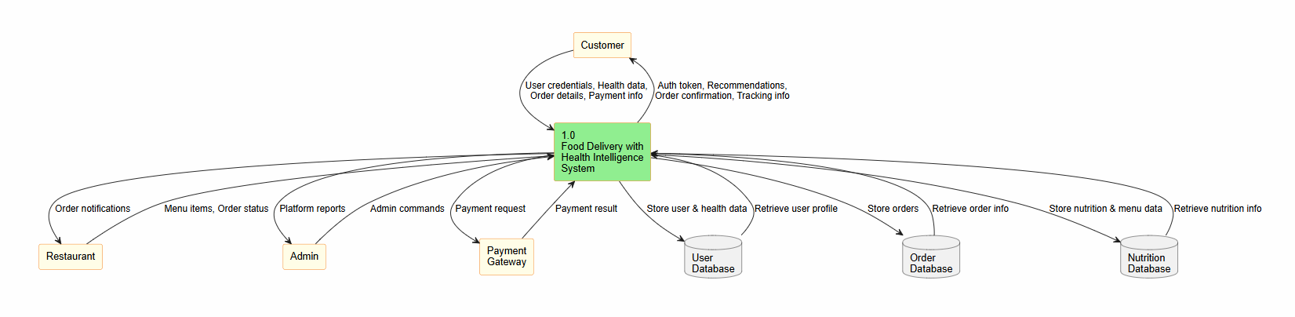

Level 1 DFD
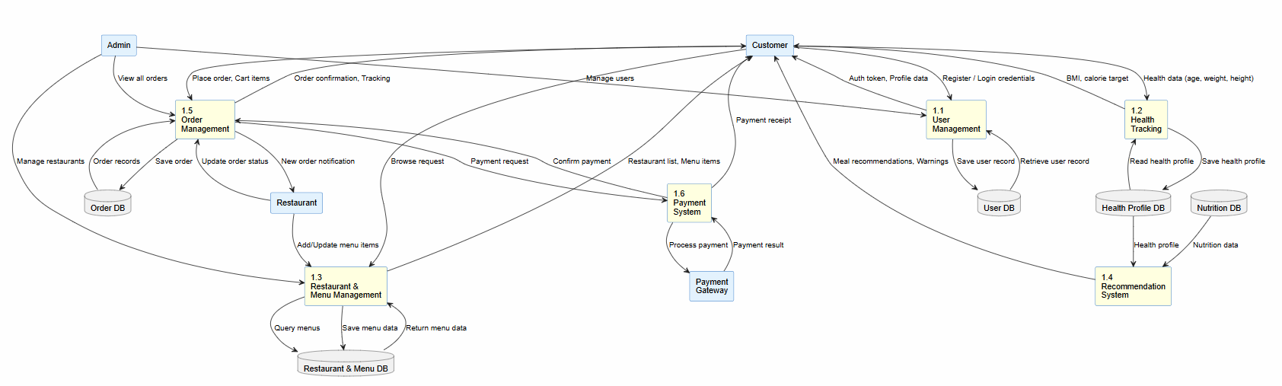

Class Diagram
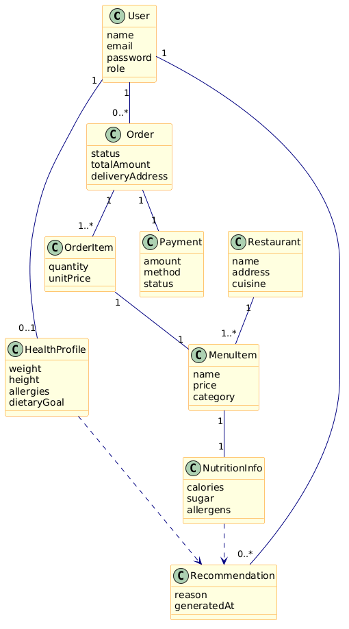

Sequence Diagram(Place Order)
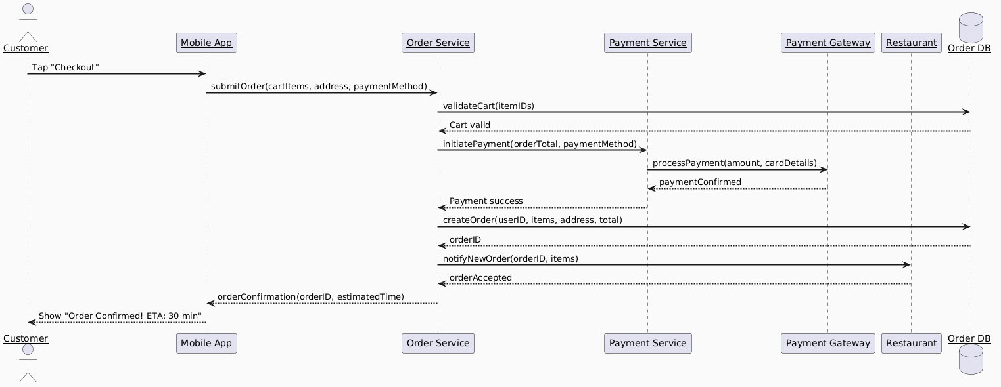

State Diagram(Order Lifecycle)
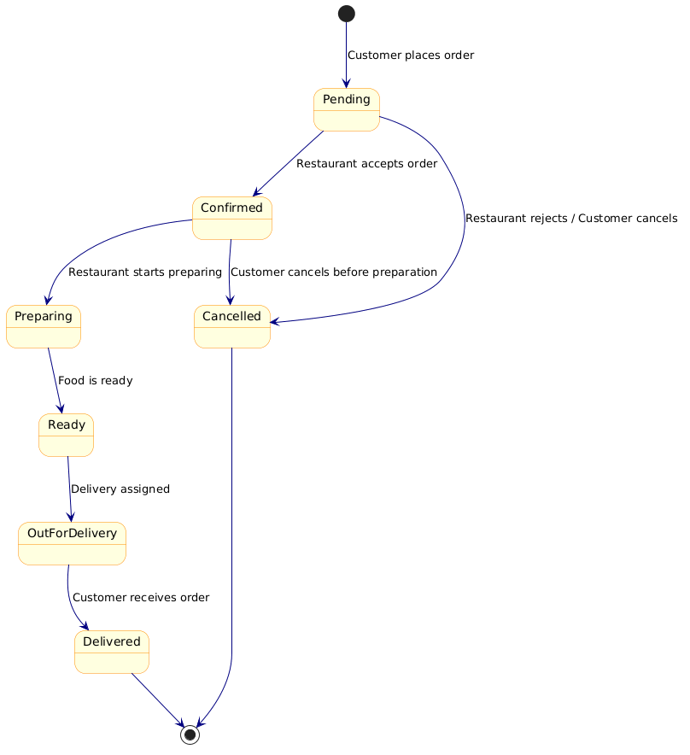

Activity Diagram(Ordering Process)
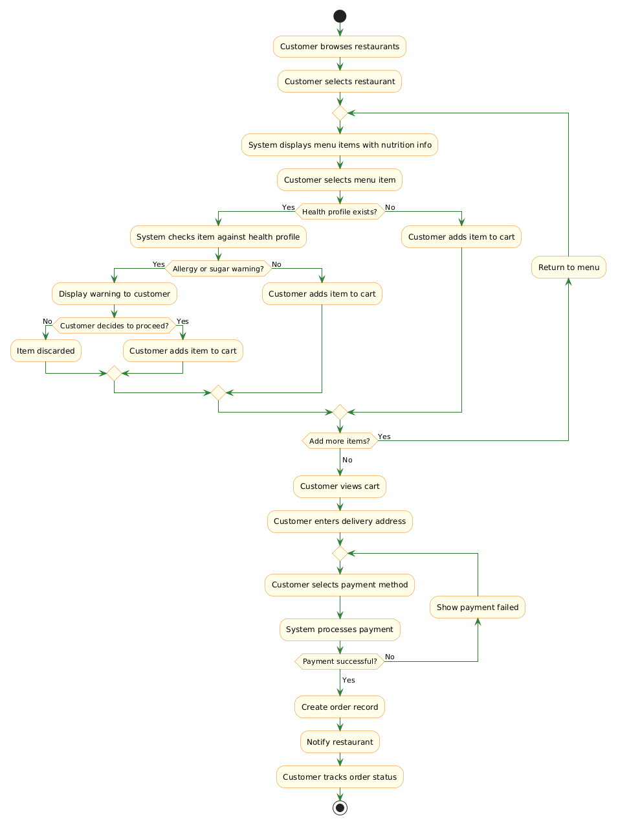

UML diagrams refined
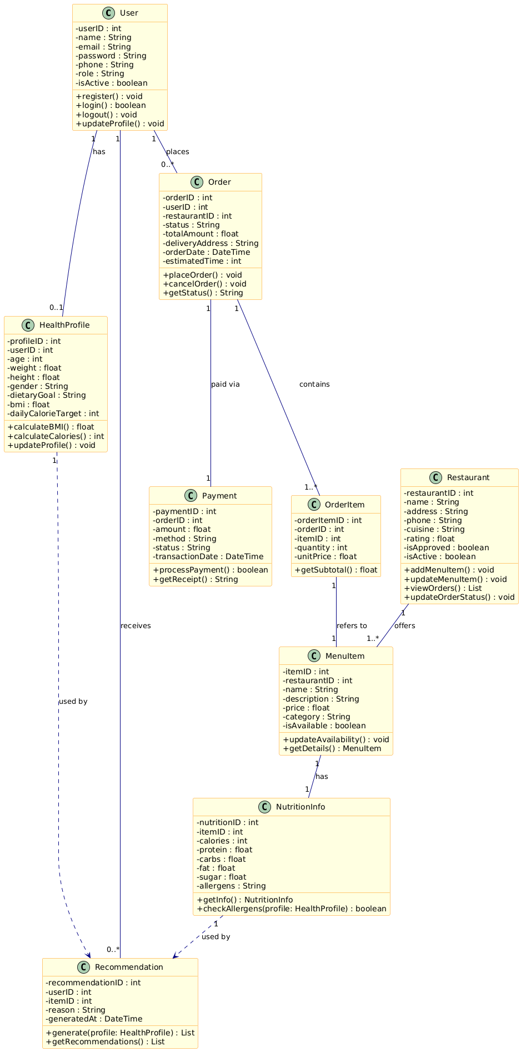

Architecture
Food Delivery with Health Intelligence follows a Layered Architecture design to ensure proper separation of responsibilities, maintainability, and scalability. In this architecture, the system is divided into multiple layers where each layer performs a specific set of tasks and communicates only with adjacent layers.
The Presentation Layer is responsible for user interaction and includes the mobile application and admin dashboard through which users, restaurants, and administrators access system features. The Business Logic Layer processes the core functionalities of the system such as authentication, order management, payment handling, and health recommendation processing. The Data Layer manages the storage and retrieval of information including user data, nutrition details, orders, and payment records using databases.
Additionally, the system may interact with external services such as payment gateways and map APIs for payment processing and delivery-related functionalities. The layered architecture improves modularity, simplifies maintenance, and allows future enhancements without significantly affecting the entire system.
