Comparison with OKTA ASA & CyberArk  This is a datasheet that provides comparison of AuthNull with OKTA Advanced Server Access & CyberArk |  |  |  |  |  | - Passwordless Privileged Access Management  

  Passwordless PAM  AuthNull replaces traditional PAM with a Passwordless solution.  AuthNull enables access to server infrastructure without passwords, or SSH Keys.  Passwordless Authentication  AuthNull enables passwordless authentication by supporting LDAP 1FA or 2FA, Posix account logins with 1FA or 2FA, additionally through protocols such as SSH, VNC, RDP, Telnet and more.  All credentials are stored as a decentralized identity credentials eliminating the need for a vault.  What is the best way to reduce the most critical attack surface of credentials? By removing it of course! |  |  | How does AuthNull compare with OKTA?  The biggest credential breach during the pandemic was shared credentials. OKTA does not fully eliminate a central attack surface and still relies on a Certificate authority.  While this can be claimed as “passwordless”, and “ephermeral”.. the fact is that this requires users to be logged in and allowing their workstations to trust their CA.  This makes the OKTA certificate authority a biggest attack surface. Removing the CA is the best way to secure a system and that is what AuthNull has done,  AuthNull enables organizations to truly deploy Zero trust, passwordless security to access critical infrastructure.  .   |  |  | How does AuthNull compare with CyberAark?  CyberArk is most well known of PAM solutions. CyberArk is a traditional PAM system with high friction and takes weeks, if not months to rollout.  While CyberArk offers full versatility in terms of features, it is operationally intensive.  Organizations that are just getting started with PAM and are used to the current generation SAAS platforms may find CyberArk overwhelming, bloated and hard to use.  What customers say about CyberArk –  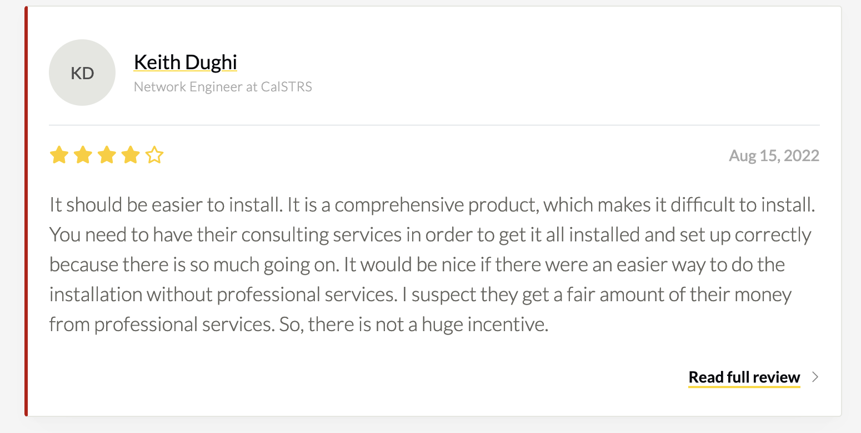  AuthNull enables organizations to truly deploy Zero trust, passwordless security to access critical infrastructureIs Zero Trust the answer?  - As the increased remote workforce strained traditional IT perimeter defenses  - And recent attacks exposed further weaknesses, one potential architecture framework emerged: Zero Trust. This is the only model that organizations trust today to protect their IT assets.  Comparison  Please see the following page to see the detailed comparison between OKTA and AuthNull  Contact Us  AuthNull  16668 Winchester Club Dr. Meadow Vista CA 95722

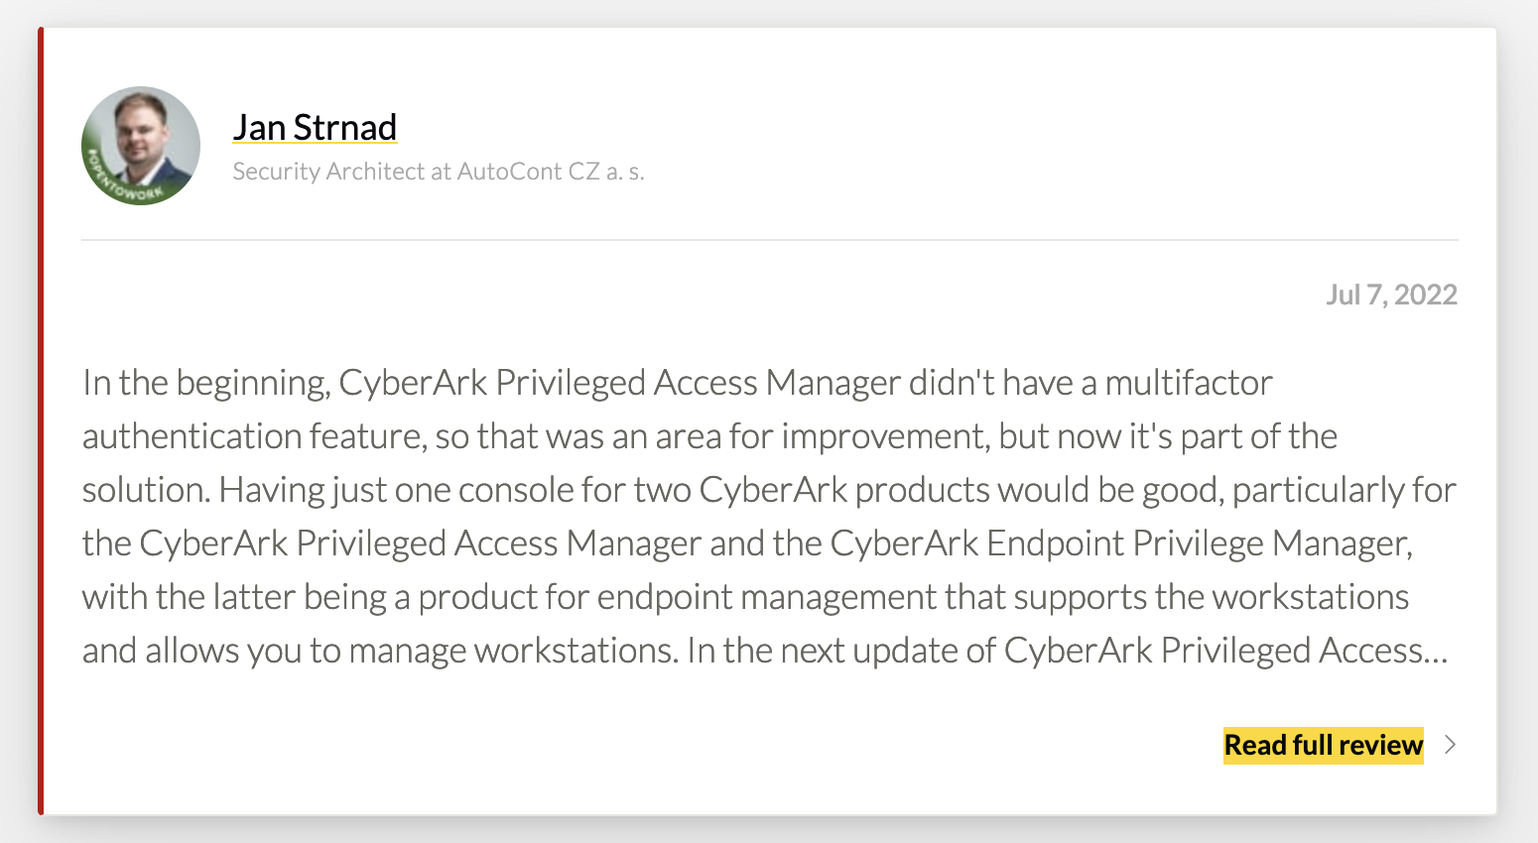  It is very clear that existing CyberArk customers consider it as a very bloated and a cumbersome solution to implement. The fact that CyberArk has a professional services arm and encourages customers to leverage it to implement the solution adds fuel to the fire of the belief that it is intentionally more complicated than it needs to be, and incurs in signficant IT spend to implement.  How is AuthNull Different?  AuthNull is built from ground up to be simple AuthNull has the right combination of features that really matter, removing all the bloat that is not needed.  AuthNull uses passwordless and comes with a wallet app that enables passwordless Authentication. This app also eliminates a centralized vault as Authnull provides the same functionality through decentralized credentials and the wallet app These decentralized credentials are stored in the users wallet as opposed to a central vault eliminating a major attack vector. |  |  | AuthNull PAM  AuthNull is a next-gen PAM platform  AuthNull is a drop-in replacement for legacy PAM solutions while providing simplified passwordless authentication to acccess server infrastructure  Session Management and Recording  Get full video and text recording of your sessions.  Learn more  Credential Authentication - 1FA or 2FA  AuthNull provides 1FA, 2FA credential authentication for local and LDAP users respectively.  Learn more  Endpoint Management  AuthNull's endpoint agent supports endpoint management - user synchronization, user and group discovery and synchronization, services installation, authentication configuration and more.  Learn more  Tamper evident credentials.  AuthNull provides tamper evident identities and credential transactions using decentralized identity and optional blockchain based immutable addresses.  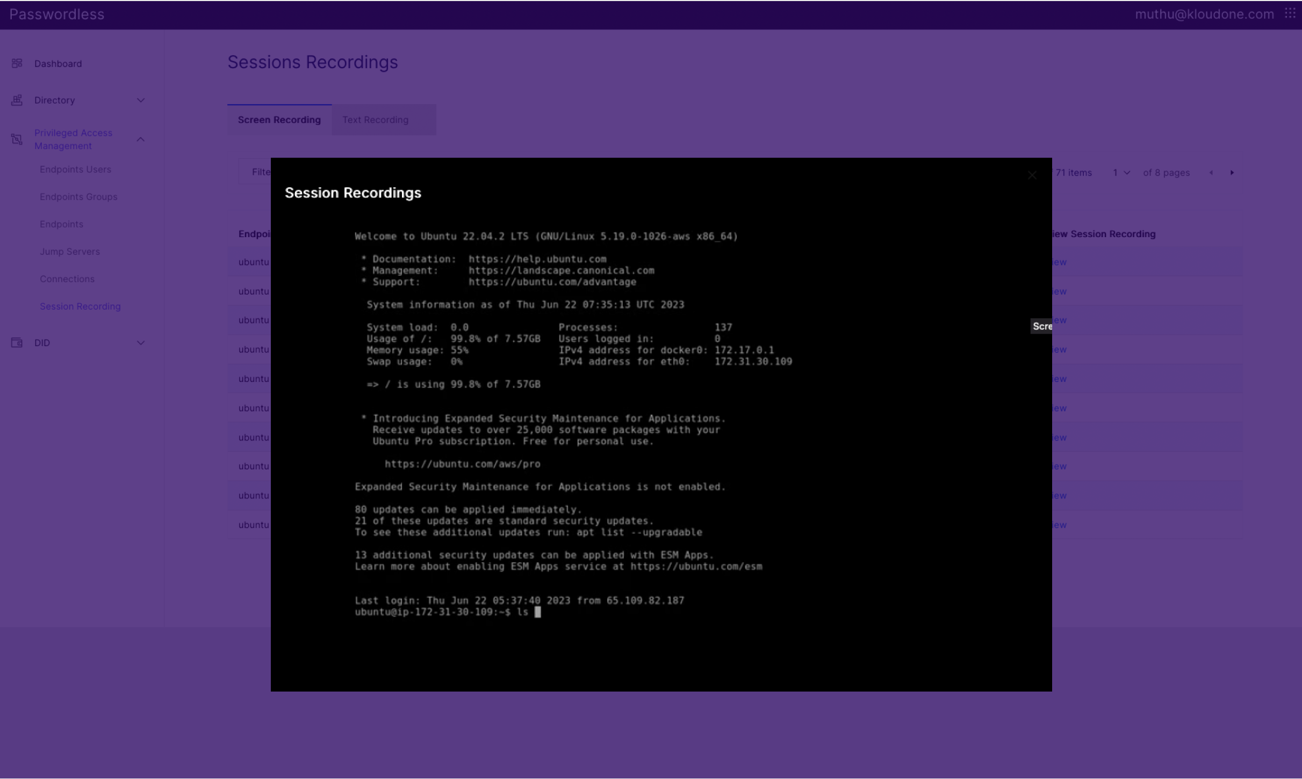 |  |  | Features include.  Session Video Recording  All sessions going through the web console are automatically and fully recorded.  Text Recording  All sessions regardless of direct SSH connections, or going through a web console are fully recorded using a text recording feature.  Authentication logs  Authentication logs from each server is automatically available on the SIEM solution of your choice, or on a ELK console on AuthNull.  Passwordless 1FA  Passwordless access for local privileged accounts. No SSH Keys, Passwords - rotation and distribution needed. All sessions are validated with two roots of trust, require decentralized credentials stored on Wallet protected by users' bioetrics.  LDAP Account authentication with Passwordless as 2nd Factor  LDAP accounts can be logged in with Passwordless 2nd Factor, with JIT SSH Keys generated during user checkout.  Local privileged accounts - JIT privileged escalation  Local privileged users can be checked out with escalated privileges Just In Time (JIT) with automated expirty of credentials.

Feature | OKTA Advanced Server Access | AuthNull | Cyberark
Login client | Custom, SSH client | VNC, SSH, RDP – no custom clients | VNC, SSH, RDP – no custom clients
Passwordless approach | Centralized, ephemeral CA | Decentralized credentials and identity | Centralized + Ephemeral CA
Existing passwords and SSH keys supported | No | Supported for legacy reasons | Supported
Windows support | Yes | Yes (upcoming) | Yes
Linux Support | Yes | Yes | Yes
Blockchain based tamper evident credentials | No | Yes | Yes
Blockchain hash logging | No | Yes | No
Authenticator | OKTA Authenticator App | AuthNull Authenticator /Wallet App | CyberArk authenticator app
FaceID to protect credentials | Yes | Yes | Yes
SSO console depends on passwords | Yes, OKTA SSO | Yes, OKTA SSO | Yes, OKTA SSO
End user console | Yes | Yes | Yes
Extensive logging | Yes | Yes | Yes
Built in runtime guardrails | No | Yes | No
No | No | No | No
Self rotating credentials | No | Yes | No
Agent for PAM | Yes | Yes | Yes
AD authentication | No | Yes | Yes
Passwordless SSH Login | Yes | Yes | Yes

