###### Department of Information Technology



University of Gujrat

***Event Organizer Management system***

**Submitted By:**

|  |  |
| --- | --- |
| **M. Shameer Azhar** | **20011556-026** |
| **Irfan Munawar** | **20011556-113** |
| **Hamza Shabbir** | **20011556-150** |
| **M. Wasil Butt** | **20011556-144** |
| **Amber Mustafa Ch.** | **20011556-145** |
| **Afreen Tariq** | **20011556-120** |
| **Ch. Taimoor Nasir** | **20011556-155** |

**Supervised By:**

**Mr. Awais Akram**

**DECLARATION**

I certify that project title ___ “**Event Organizer Management System” ___** is under my supervision with students of ___**IT - 20 – C___**, Faculty of Computing & Information Technology, University of Gujrat, Pakistan, worked under my supervision.

**__________________________________**

Mr. Awais Akram

Department of Information Technology

Faculty of Computing & Information Technology

University of Gujrat, Punjab, Pakistan.

Email: Awais.Akram@uog.edu.pk

Dated: 29 - 12 - 2022

Table of Contents

Final Year Project Proposal 4

1.1 Introduction 4

1.2. Project Title: 4

1.3. Project Overview statement: 4

1.4. Project Goals & Objectives: 6

1.5. High-level system components: 6

1.6. List of optional functional units: 7

1.7. Exclusions: 7

1.8. Application Architecture: 7

1.9. Hardware and Software Specification: 8

1.10. Tools and technologies used with reasoning: 9

1.11. Modules…………………………………………………………………………...9

# 

# 

+

# Final Year Project Proposal

## Introduction

This is digital era, and everything is getting digital so its hour of need to digitalize the system. We are making “**event organizer management system**” the purpose, role of which is to store the record of customer and service providing organization (self) in efficient, accurate and reliable manner not only this but making sure the delivery of fast and reliable quality services. This management system will help the organization to keep track of the record of customer (customer history) in an efficient manner. **No need for bulky paperwork because** we have got the most efficient system. While searching it is very difficult and tiresome to search page by page to know details of customer but with the management system software everything from searching to addition of services to bill total everything is just one touch far. This will revolutionize the whole system and people will benefit in a number of ways.

1. Project Title
2. Project Overview Statement
3. Project Goals
4. Project Objectives
5. High Level System Components
   1. Component No.1
   2. Component No.2
   3. Component No.3
   4. Component No.4
      1. ………..
6. List of Optional Functional Units
7. Exclusions
8. Application Architecture

## 1.2. Project Title:

**"Event Central: Your One - Stop Shop for Event Management"**

**"Efficient Event: Streamline Your Event Planning with Our Management System"**

## 1.3. Project Overview statement:

The Event Organizer Management System is a tool designed to help plan and execute successful events. It is a comprehensive platform that allows users to manage all aspects of event planning, including registration, ticketing and scheduling.

The system provides a range of features to help event organizers streamline their workflows and improve efficiency. These features include:

* A customizable event calendar that allows users to schedule and manage events, appointments, and services.
* A comprehensive contact database for storing and managing information about attendees, vendors, and partners.
* A ticketing system for selling tickets and managing registration once all details are taken.
* Tools for including venue management and transportation scheduling.
* The Event Organizer Management System is designed to be user-friendly and intuitive, making it easy for event organizers to plan and execute events of all sizes. It is also highly scalable, able to handle events ranging from small, local gatherings to large, international conferences.

Overall, the Event Organizer Management System is a powerful and flexible tool that helps event organizers save time and effort while delivering successful and well-organized events.

Project Overview Statement Template

|  |
| --- |
| Project Title:  Event Organizer Management System |
| Project Manager: Mr. Awais Akram |
| Project Members:   |  |  |  |  | | --- | --- | --- | --- | | Name | Registration # | Email Address | Signature | | M. Shameer Azhar | 20011556 - 026 | [20011556-026@uog.edu.pk](mailto:20011556-026@uog.edu.pk) | Shameer | | Irfan Munawar | 200115556-113 | [20011556-113@uog.edu.pk](mailto:20011556-113@uog.edu.pk) | Irfan | | Hamza Shabbir | 200115556-150 | [20011556-150@uog.edu.pk](mailto:20011556-150@uog.edu.pk) | Hamza | | M. Wasil Butt | 200115556-144 | [20011556-144@uog.edu.pk](mailto:20011556-144@uog.edu.pk) | Wasil | | Afreen Tariq | 200115556-120 | [20011556-120@uog.edu.pk](mailto:20011556-120@uog.edu.pk) | Afreen | | Amber Mustafa Ch. | 200115556-145 | [20011556-145@uog.edu.pk](mailto:20011556-145@uog.edu.pk) | Amber | | Ch. Taimoor Nasir | 200115556-155 | [20011556-155@uog.edu.pk](mailto:20011556-155@uog.edu.pk) | Turri | |
| Project Goal: The goal is to streamline the event planning processes in an efficient and user-friendly manner. It will make billing, adding services and editing them a lot easier, more reliable and paper free. |
| Objectives:   |  |  | | --- | --- | | Sr.# |  | | 1 | This tool gives them with services to select making the Event planning efficient. | | 2 | It will register events, add services (catering, lights, food etc), make receipts. | | 3 | Organization can evaluate their progress effectively. | | 4 | It will make record keeping easier | | 5 | To provide user-friendly system to cope in better event organization. | | 6 | It will help in reducing paper waste. | |
| Project Success criteria:  It will revolutionize the whole system. The attendees and event managers will feel efficiency and accuracy in their work. We can see high adoption to this tool.   1. The project would be completed in defined time and budget. 2. Project team and consumer satisfactions will meet. 3. The system should be dependable and consistently deliver expected results. |
| Assumptions:  The organizer and attendee have the necessary resources (pc & internet) and enough knowledge to use the system (it will be user-friendly normal mobile user can use it).  Risks:  System down and poor internet connection are possible risks.  Obstacles:  Organizer or attendee may not have enough knowledge to use the tool.  Security and privacy may prove to be an obstacle. |
| Organization Address (if any): This is a developmental project for academic purposes, so it is going to be operated at “**University of Gujrat**”. |
| Type of project: 📺Research  **📺Development** |
| Target End users: |
| Development Technology: **📺Object Oriented** 📺Structured |
| Platform: 📺Web based 📺Distributed  **📺Desktop based** 📺Setup Configurations  📺Other_____________________ |
| Approved By: Mr. Awais Akram |
| Date: 29 – 12 – 2022 |

## 1.4. Project Goals & Objectives:

**Project Goals:**

Streamline event planning and management: The system should provide event organizers with all the tools and features they need to efficiently plan and manage their events, including registration, services selection, event type selection and billing etc.

* Enhance the attendee experience: The system should make it easy for attendees to access event information, register for events, and interact with organizers.
* Improve data tracking and analysis: The system should provide organizers with detailed reporting and analytics capabilities, allowing them to track key metrics related to their events and make informed decisions about future events.
* Save time and reduce workload: By automating many of the tasks involved in event planning and management, the system should help organizers save time and reduce their workload.

**Project Objectives:**

The objectives of the Event Organizer Management System may include:

* Provide event organizers with a comprehensive and user-friendly platform for managing all aspects of their events.
* Streamline the event planning process, allowing organizers to focus on creating a successful and memorable experience for attendees.
* Provide robust reporting and analytics capabilities, enabling organizers to track and analyze key metrics related to their events.
* Help organizers deliver exceptional events that exceed the expectations of attendees and stakeholders.
* Save time and reduce workload for organizers by automating tasks and streamlining processes.

## 1.5. High-level system components:

The system firstly system will make user to login after it gets event type (conference, wedding, tour, party etc) afterwards will allow user to enter services they want to add depending on event type (lighting, buses for tour, sound system and promotion) will also ask for sponsors if any and venue will be added and all necessary info related to customer (name, ph. no., id, email etc) will be taken and in the end bill receipt is generated and stored in database and shared with admin as well.

## 1.6. List of optional functional units:

**Performance: (throughput & response time)**

The tool will work (run/execute) efficiently and will not be out of service for more than 30 minutes. The throughput of the system will be **500 kilobytes**. For better performance a system must have 4 GB of ram with core i3 3rd gen 2 GHz processor and maximum 2 GB of storage is required for proper functioning of this system.

**Ease of Learning & Use:**

The system is very user-friendly, the average mobile and pc user can use this system very easily. The UI is very humane, and one gets used to it quickly.

**Budget & Cost Saving:**

We are extremely in cost saving mode as this is a semester project, so no cost is required if any expense comes our university is going to deal with it.

**Timetables and Deadlines:**

After mid-term we will give 2 hours every 3 days of week to this project. Insha’Allah the project will be fully completed and tested under different circumstances before evaluation.

**Documentation:**

Documentation of project is a very important part, so we are getting it done along with code part. It helps a lot in evaluation and testing the system afterwards if any error occurs.

**Quality management & Security:**

The quality of the system is managed accordingly with advancement updates must be made to the system. The privacy of customers (attendees) must be considered. Any misuse should not be made with user data. Their private information must stay anonymous. All privacy policies and laws must be followed.

**Assumptions and Issues lists:**

The issues can be project may take more time to complete. The user may lack enough knowledge to use the system. Any failure in system may cause tool to stop working properly.

## 1.7. Exclusion:

1. The privacy of every customer must be respected.
2. The billing information (the services with which customer is entertained) must stay private.
3. All community guidelines and legislation must be followed throughout the system.
4. Taxes are applied as per government policies.
5. Cost of any service added later will be added separately to bill receipt.

## 1.8. Application Architecture:

It is a 2- tier architecture comprising of client and server end direct communication is made. Request of resources from client to database and in response to request the transfer of services from database to client. The behavior mentioned can be seen in the data flow diagram given below.

***1.8.1 DATA FLOW DIAGRAM:***

# 

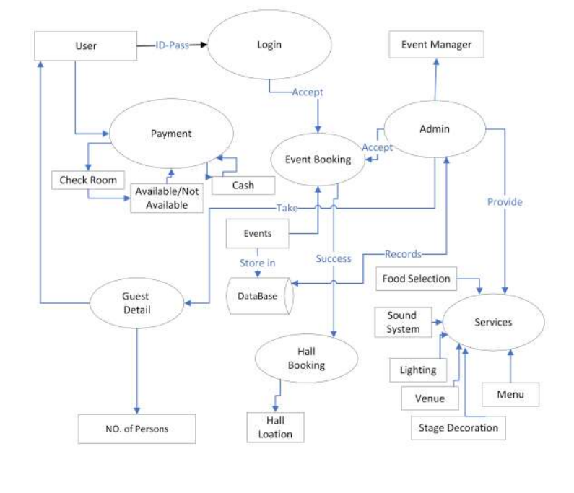

## 1.9. Hardware and Software Specification:

**Hardware Specification: (maximum)**

**Processor:** Core i3 and Gen 2 GHz.

**RAM:** gigabytes

**Storage:** maximum 2 gigabytes

**GPU:** not required

**NIC:** required

**Software Specifications:**

**Operating System:** Windows XP

All necessary software to run the tool/ management system

## 1.10. Tools and technologies used with reasoning:

We are using **Microsoft visual studio** in that we are using **.Net framework** & **windows presentation foundation.**

**C#:**

* We are using it as back-end for the functionality.
* It will add functionality to the system

**XAML: (using WPF)**

* We are using it for front-end production.
* For making UI of the management system.
* We are developing this tool on windows 11.
* Targeted platform is windows XP and later.
* Budget is managed by university.

**1.11 Modules:**

1. **Welcome window:**

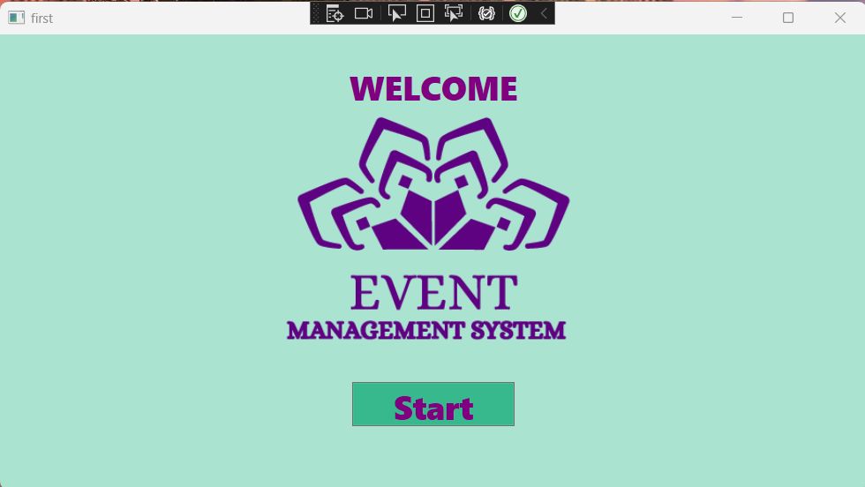

1. **Controls window**

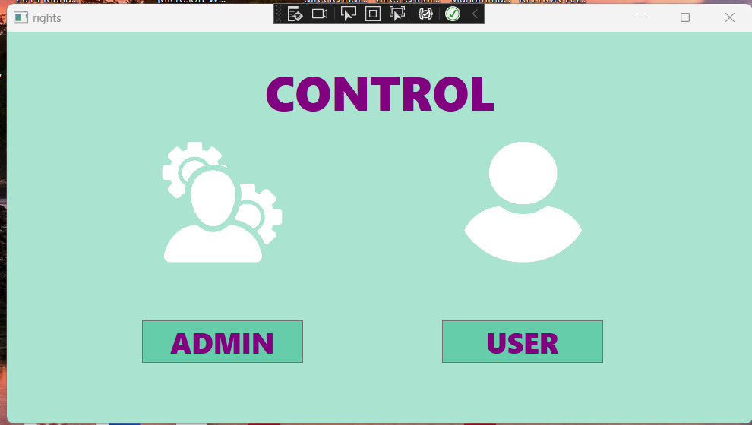

1. **User window:**

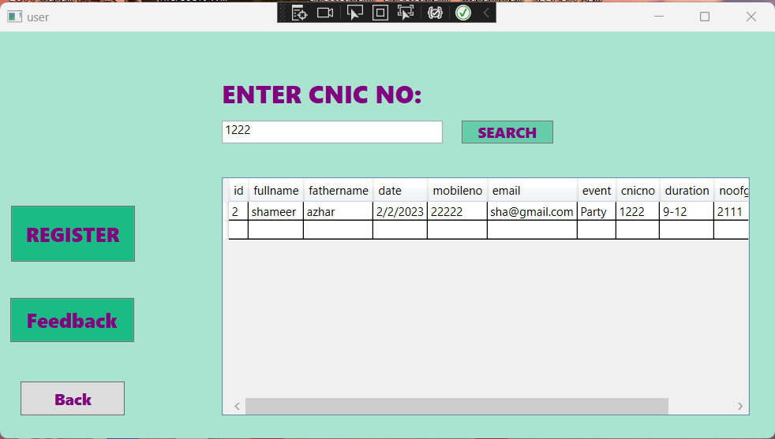

1. **Registration – user window**

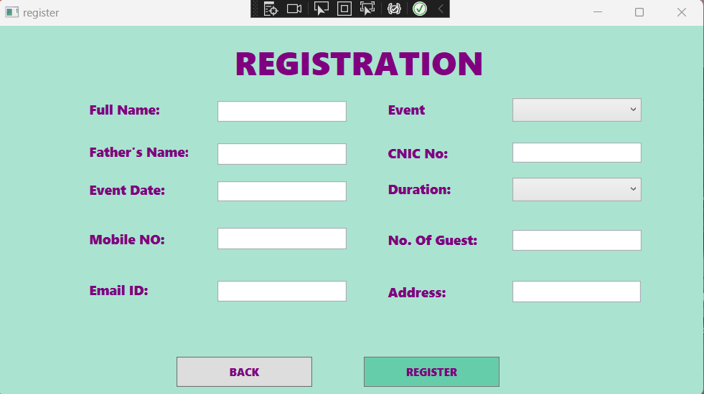

1. **Question – feedback – user window:**

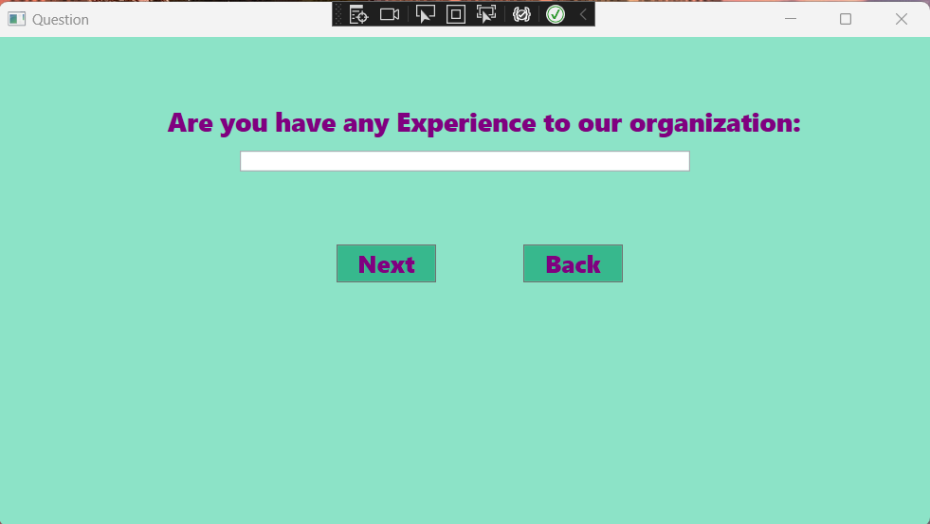

1. **Feedback window:**

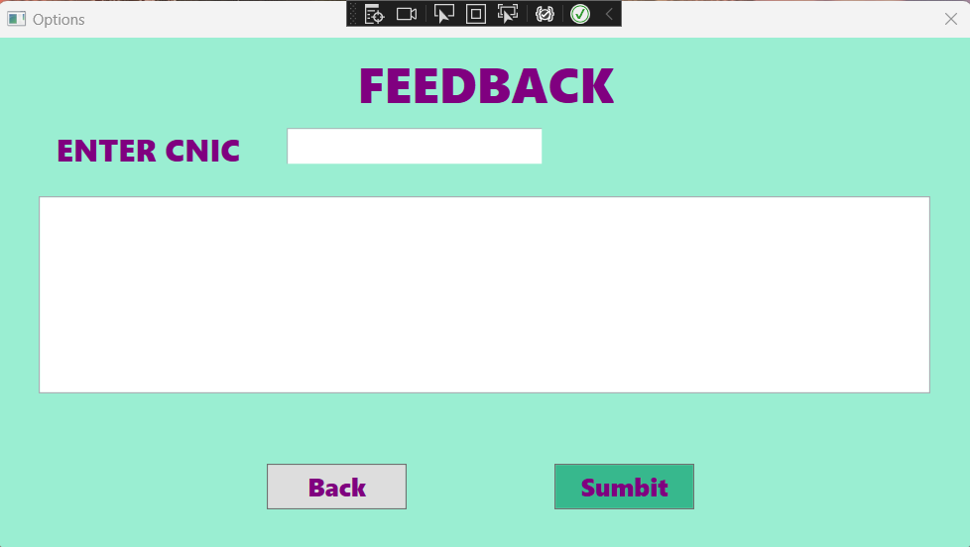

1. **Admin control – login window:**

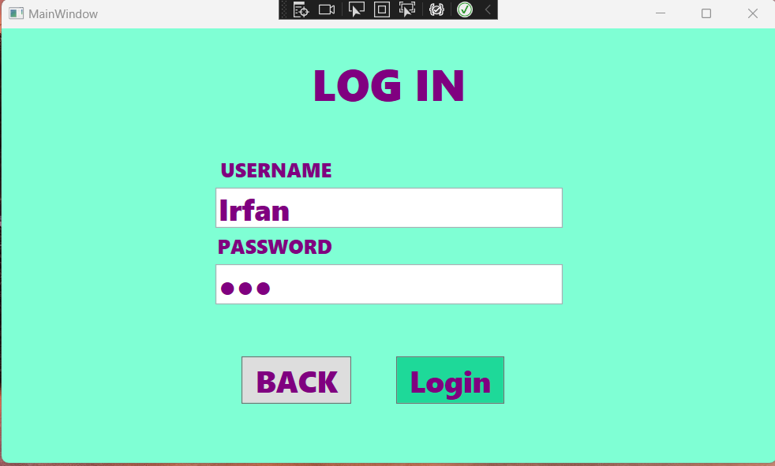

1. **Home – Admin controls:**

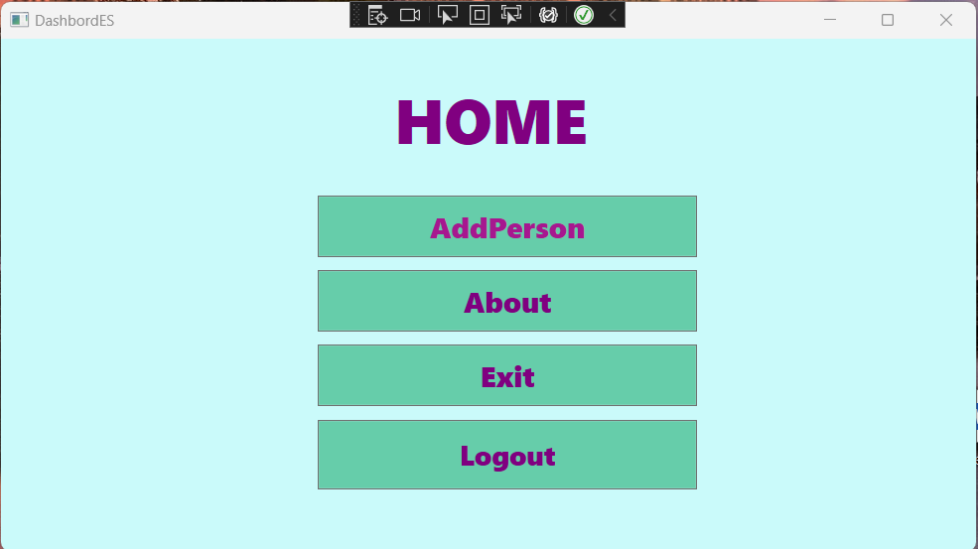

1. **About Us:**

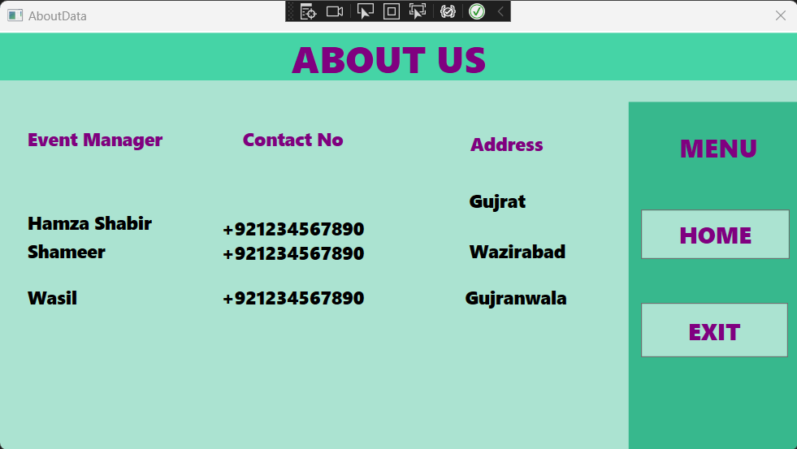

1. **Data picker – admin control:**

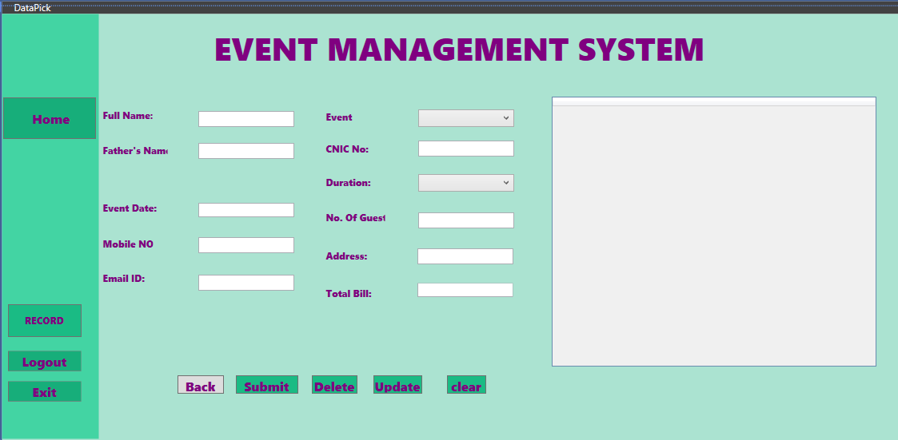

1. **Feedback record - admin:**

