**Actors Table Structure:**

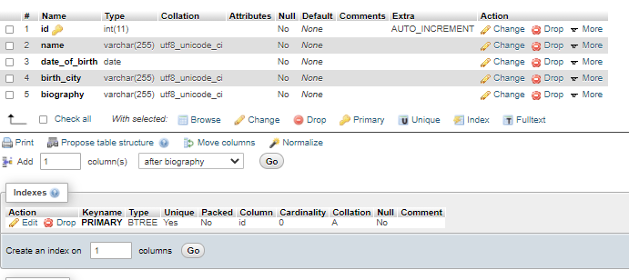

**Actors Table data:**

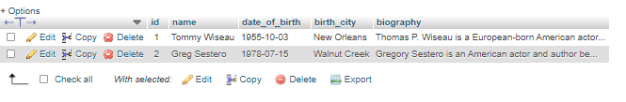

**Blogs Table Structure:**

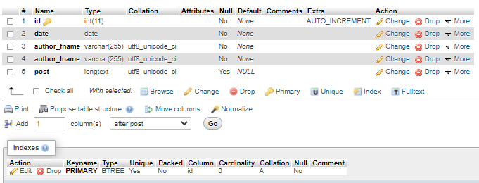

**Blog Table data:**



**Current_bets Table Structure:**

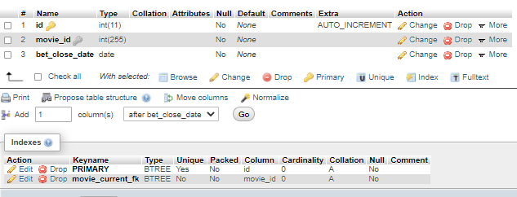

**Current_bets Table data:**

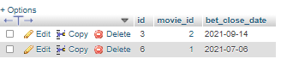

**Director Table Structure:**

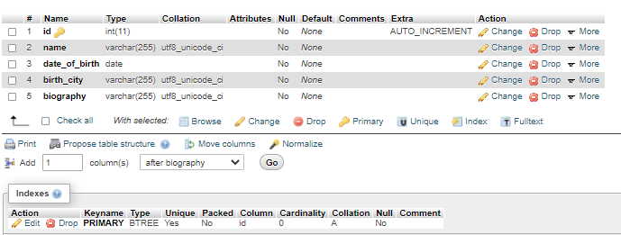

**Director Table data:**

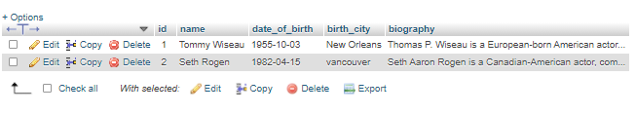

**Donation Table Structure:**

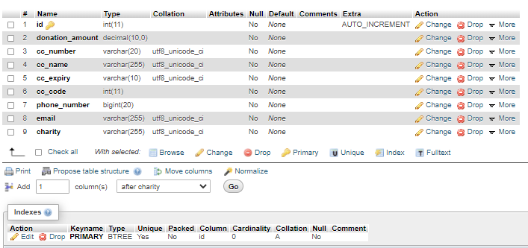

**Donation Table data:**



**FAQs Table Structure:**

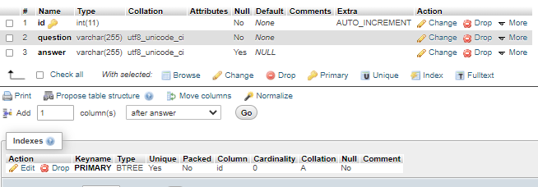

**FAQs Table data:**

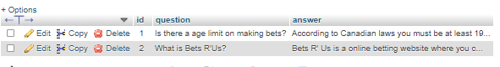

**Feedback Table Structure:**

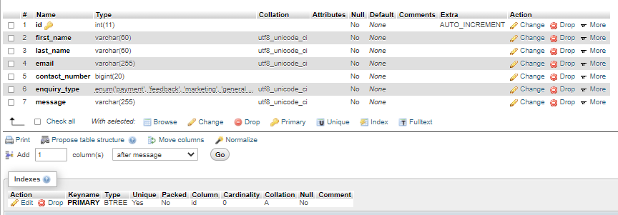

**Feedback Table data:**

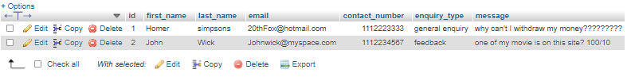

**Movie and actor many to many relationship Table Structure:**

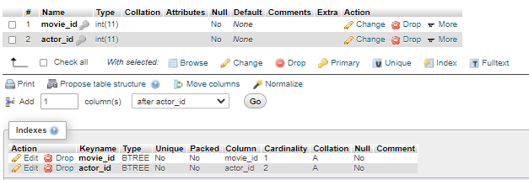

**Movie and actor many to many relationship Table data:**

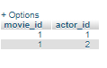

**Movie and director many to many relationship table Structure:**

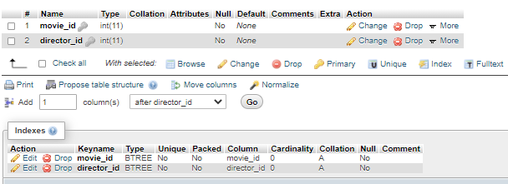

**Movie and director many to many relationship table data:**

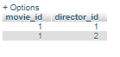

**Movie Table Structure:**

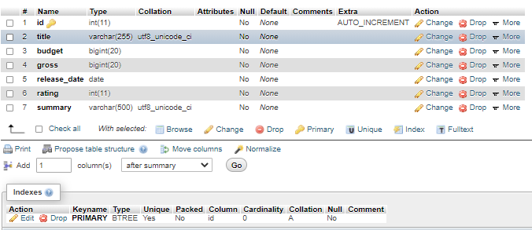

**Movie Table data:**

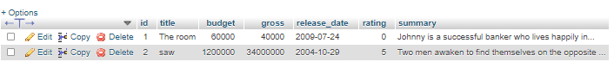

**Place_bets Table Structure:**

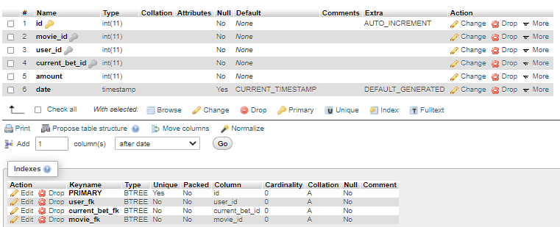

**Place_bets Table data:**

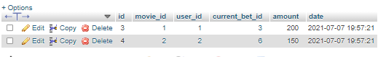

**Rules Table Structure:**

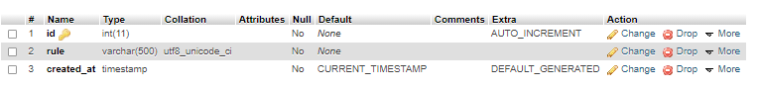

**Rules Table data:**

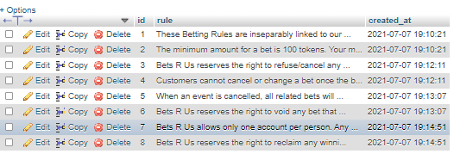

**Wallet Table Structure:**

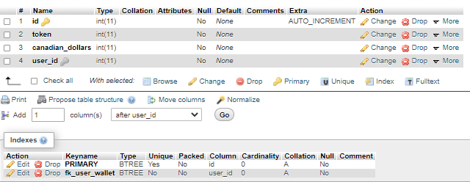

**Wallet Table data:**

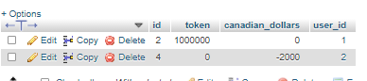

**Users Table Structure:**

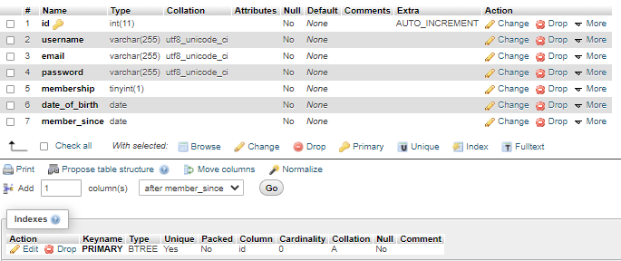

**Users Table data:**

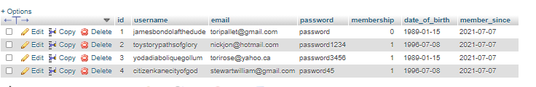

**Your_bets Table Structure:**

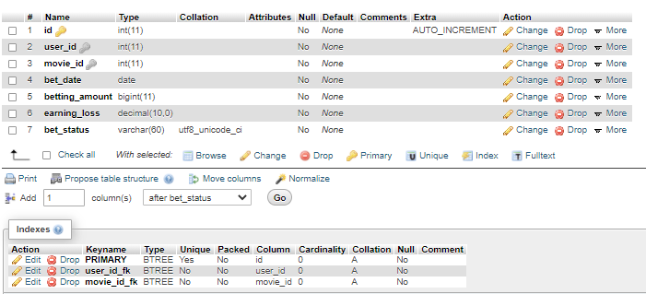

**Your_bets Table data:**

