## Feb 28, 2024 | [Night Owlers Status Update](https://www.google.com/calendar/event?eid=NmM3dDM1OG1tZ2VpNzQzbnRkbzl0Y2YxZ24gc2hhbWlpdmFuQG0)

Attendees: Angru, Jutipong, Theebika, Ivan

Meeting time: 6:00 PM - 6:40 PM

Location: Zoom

# Agenda

## Status update

### Team Updates

* **Ivan:**
  + Provided an overview of Next.js functionalities, focusing on the export and import process to facilitate the reuse of components across the project.
  + Discussed the advantages of using Tailwind CSS for rapid UI development and how it accelerates the styling process.
  + Showcased the current progress of his work, highlighting the implementation of Next.js and Tailwind CSS in the project.
* **Angru:**
  + Established a set of variables for use within the MongoDB database, aiming to streamline data management and operations.
  + Demonstrated his methodology in integrating MongoDB into the project, focusing on schema design and data manipulation.
* **Theebika:**
  + Completed the prototype for the car-detail page, which aims to provide detailed information about cars to the users.
  + Completed on working on wireframe design
* **Jutipong:**
  + Announced the completion of his wireframe design, providing a visual layout for the project's interface.
  + Raised an issue regarding difficulties with implementing modification features within the wireframe.

### **Key Questions Addressed**

* **Defining the Main Page:**
  + Clarified that the main page of the project is identified by the page.tsx file in the Next.js framework.
* **Admin Reservation Page Wireframe:**
  + Described the layout and functionality expected on the admin side for the reservation page, including a dashboard with navigation and a detailed list of reservations.
* **Admin Perspective on Reservation Form:**
  + Outlined the design considerations for the reservation form from an admin perspective, emphasizing intuitiveness and comprehensive detail capturing.
* **Creation of Card Components:**
  + Confirmed that card components are to be developed as .tsx files, integrating seamlessly within the Next.js environment.
* **Reservations and References:**
  + Discussed the necessity to establish a clear referencing system for reservations, particularly for car reservations, to streamline the booking and management process.

### **Challenges Identified**

* **React Components:**
  + Identified challenges with React component implementation, marking it as the primary obstacle currently facing the team.
  + Resolved the issues by each member sharing their screen

### **Action Items**

* **All Members:**
  + Collaborate on resolving the React components issue
  + Ivan and Jutipong to refine the implementation of modification features within the wireframe.
  + Angru to continue optimizing the database schema based on project requirements and feedback.
  + Theebika to integrate the car-detail page prototype into the project, ensuring functional and design coherence.

### **Closing Notes**

* The meeting discussed of the effective tool utilization (Next.js, Tailwind CSS, MongoDB) for project efficiency.
* Addressing the React components challenge is prioritized to maintain project momentum.
* The team is committed to collaborative problem-solving to overcome current obstacles and ensure project success.

Data example:

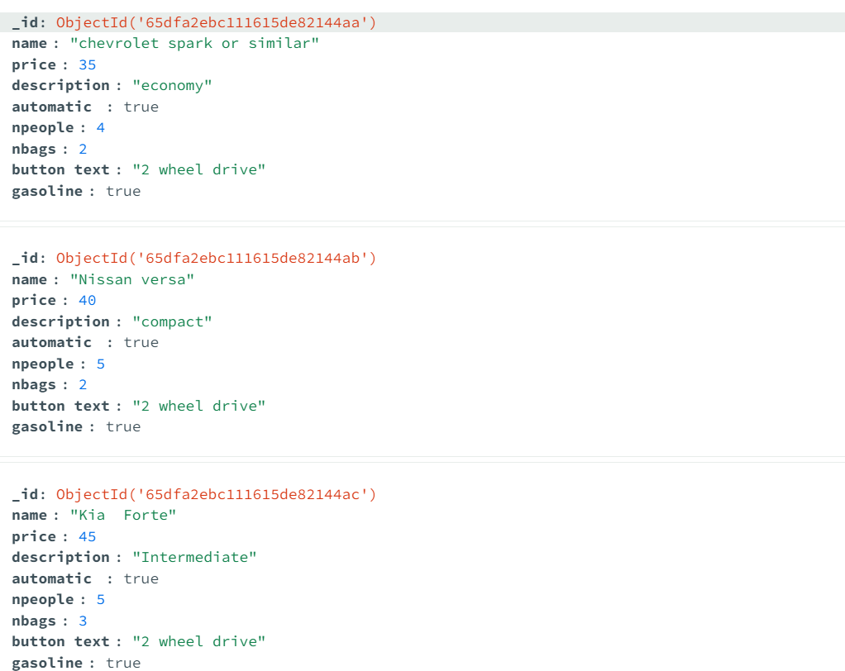

What was suggested: Can remove button text