B.Tech. BCSE497J - Project-I

EXPLAINABLE AND DRIFT-AWARE FRAUD DETECTION FOR DIGITAL PAYMENTS: A PRODUCTION-GRADE MLOPS PIPELINE

Submitted in partial fulfillment of the requirements for the degree of

Bachelor of Technology

in

Computer Science and Engineering

by

23BCE0608 | SHAMIK SENGUPTA
23BCE0622 | YASHASWINI KANAUJIA

Under the Supervision of
Dr. Sharmila C
Assistant Professor Sr. Grade 1
School of Computer Science and Engineering (SCOPE)



October 2026

DECLARATION

We hereby declare that the project entitled Explainable and Drift-Aware Fraud Detection for Digital Payments: A Production-Grade MLOps Pipeline submitted by us, for the award of the degree of Bachelor of Technology in Computer Science and Engineering to VIT is a record of bonafide work carried out by us under the supervision of Dr. Sharmila C.
We further declare that the work reported in this project has not been submitted and will not be submitted, either in part or in full, for the award of any other degree or diploma in this institute or any other institute or university.

Place : Vellore Date :
Signature of the Candidates

CERTIFICATE

This is to certify that the project entitled Explainable and Drift-Aware Fraud Detection for Digital Payments: A Production-Grade MLOps Pipeline submitted by Shamik Sengupta (23BCE0608) and Yashaswini Kanaujia (23BCE0622), School of Computer Science and Engineering, VIT, for the award of the degree of Bachelor of Technology in Computer Science and Engineering, is a record of bonafide work carried out by them under my supervision during Fall Semester 2026-2027, as per the VIT code of academic and research ethics.

The contents of this report have not been submitted and will not be submitted either in part or in full, for the award of any other degree or diploma in this institute or any other institute or university. The project fulfills the requirements and regulations of the University and in my opinion meets the necessary standards for submission.

Place : Vellore
Date :

Signature of the Guide

Examiner(s)

Dr. Boominathan P
B.Tech. Computer Science and Engineering
ACKNOWLEDGEMENTS

We are deeply grateful to the management of Vellore Institute of Technology (VIT) for providing us with the opportunity and resources to undertake this project. Their commitment to fostering a conducive learning environment has been instrumental in our academic journey. The support and infrastructure provided by VIT have enabled us to explore and develop our ideas to their fullest potential.

Our sincere thanks to Dr. Jaisankar N, the Dean of the School of Computer Science and Engineering (SCOPE), for his unwavering support and encouragement. His leadership and vision have greatly inspired us to strive for excellence. The Dean's dedication to academic excellence and innovation has been a constant source of motivation for us. We appreciate his efforts in creating an environment that nurtures creativity and critical thinking.

We express our profound appreciation to Dr. Boominathan P, the Head of the Department, B.Tech. Computer Science and Engineering, for his insightful guidance and continuous support. His expertise and advice have been crucial in shaping the direction of our project. The Head of Department's commitment to fostering a collaborative and supportive atmosphere has greatly enhanced our learning experience. His constructive feedback and encouragement have been invaluable in overcoming challenges and achieving our project goals.

We are immensely thankful to our project guide, Dr. Sharmila C, for her dedicated mentorship and invaluable feedback. Her patience, knowledge, and encouragement have been pivotal in the successful completion of this project. Our supervisor's willingness to share her expertise and provide thoughtful guidance has been instrumental in refining our ideas and methodologies. Her support has not only contributed to the success of this project but has also enriched our overall academic experience.

Thank you all for your contributions and support.

Shamik Sengupta
Yashaswini Kanaujia

TABLE OF CONTENTS

Sl.No | Contents | Page No.
 | Abstract | xi
1. | INTRODUCTION | 1
 | 1.1 Background | 1
 | 1.2 Motivations | 1
 | 1.3 Scope of the Project | 2
2. | PROJECT DESCRIPTION AND GOALS | 3
 | 2.1 Literature Review | 3
 | 2.2 Research Gap | 4
 | 2.3 Objectives | 5
 | 2.4 Problem Statement | 5
 | 2.5 Project Plan | 5
3. | TECHNICAL SPECIFICATION | 7
 | 3.1 Requirements | 7
 | 3.1.1 Functional Requirements | 7
 | 3.1.2 Non-Functional Requirements | 7
 | 3.2 Feasibility Study | 8
 | 3.2.1 Technical Feasibility | 8
 | 3.2.2 Economic Feasibility | 8
 | 3.2.3 Social Feasibility | 8
 | 3.3 System Specification | 8
 | 3.3.1 Hardware Specification | 8
 | 3.3.2 Software Specification | 9
4. | DESIGN APPROACH AND DETAILS | 10
 | 4.1 System Architecture | 10
 | 4.2 Design | 10
 | 4.2.1 Data Flow Diagram | 10
 | 4.2.2 Use Case Diagram | 11
 | 4.2.3 Class Diagram | 12
 | 4.2.4 Sequence Diagram | 13
5. | METHODOLOGY AND TESTING | 15
 | 5.1 Module Description | 15
 | 5.1.1 Data Versioning and Splitting | 15
 | 5.1.2 Preprocessing Pipeline | 15
 | 5.1.3 Model Training and Hyperparameter Tuning | 15
 | 5.1.4 Serving API | 16
 | 5.1.5 Explainability Module | 16
 | 5.1.6 Drift Monitoring Module | 17
 | 5.1.7 Containerisation, CI/CD and Deployment | 17
 | 5.1.8 UPI Extension (Simulated Dataset) | 18
 | 5.2 Testing | 19
6. | PROJECT DEMONSTRATION | 22
 | 6.1 Scoring a Fraudulent Transaction | 22
 | 6.2 Scoring a Legitimate Transaction and Invalid Input | 22
 | 6.3 Batch Prediction | 22
 | 6.4 Drift Detection and Alerting | 23
 | 6.5 UPI Demonstration | 23
7. | RESULT AND DISCUSSION | 25
 | 7.1 Hyperparameter Search | 25
 | 7.2 Holdout Performance | 25
 | 7.3 Effect of the Decision Threshold | 27
 | 7.4 Explainability Results | 28
 | 7.5 Drift Detection Results | 28
 | 7.6 Latency | 29
 | 7.7 Cost Analysis | 30
 | 7.8 UPI Extension Results | 30
 | 7.9 Discussion and Limitations | 31
8. | CONCLUSION | 33
 | 8.1 Conclusion | 33
 | 8.2 Future Work | 33
9. | REFERENCES | 34
 | APPENDIX A – SAMPLE CODE | 36

List of Figures

Figure No. | Title | Page No.
2.1 | Project timeline (July to October 2026) | 6
4.1 | System architecture | 10
4.2 | Level-1 data flow diagram | 11
4.3 | Use case diagram | 12
4.4 | Class diagram | 13
4.5 | Sequence diagram for a prediction request | 14
7.1 | Cross-validated PR-AUC of the 20 Hyperopt trials | 25
7.2 | Confusion matrix on the holdout set | 26
7.3 | (a) Precision-recall curve and (b) ROC curve on the holdout set | 27
7.4 | Global feature importance (mean absolute SHAP value) | 28
7.5 | Per-feature drift scores for a normal and a shifted window of 300 transactions | 29
7.6 | Per-feature drift scores for a normal-month and a festive-season window of 500 UPI payments | 31

List of Tables

Table No. | Title | Page No.
2.1 | Summary of related work | 3
3.1 | Hardware specification | 8
3.2 | Software specification | 9
5.1 | REST endpoints | 16
5.2 | Test cases | 20
7.1 | Best hyperparameters found by Hyperopt | 25
7.2 | Holdout metrics of the selected model (threshold 0.5) | 26
7.3 | Comparison with baseline models (holdout) | 27
7.4 | Precision and recall at different thresholds (holdout, 98 frauds) | 28
7.5 | Drift check summary | 29
7.6 | Measured latency | 30
7.7 | UPI holdout results (days 60–89, threshold 0.5) | 30
7.8 | UPI drift check summary | 31

List of Abbreviations

API Application Programming Interface
AUC Area Under the Curve
CI/CD Continuous Integration / Continuous Deployment
CPU Central Processing Unit
CSV Comma-Separated Values
CV Cross-Validation
DFD Data Flow Diagram
DVC Data Version Control
FN False Negative
FP False Positive
GHCR GitHub Container Registry
HTTP Hypertext Transfer Protocol
IQR Interquartile Range
JSON JavaScript Object Notation
ML Machine Learning
MLOps Machine Learning Operations
NPCI National Payments Corporation of India
P2M Person to Merchant
P2P Person to Person
PCA Principal Component Analysis
PR-AUC Area Under the Precision-Recall Curve
RAM Random Access Memory
REST Representational State Transfer
ROC Receiver Operating Characteristic
SHAP SHapley Additive exPlanations
TN True Negative
TP True Positive
TPE Tree-structured Parzen Estimator
TSDB Time Series Database
UI User Interface
ULB Université Libre de Bruxelles
UPI Unified Payments Interface
VPA Virtual Payment Address
XAI Explainable Artificial Intelligence
XGBoost eXtreme Gradient Boosting

Symbols and Notations

y True class label (1 = fraud, 0 = legitimate)
p̂ Predicted probability of fraud
τ Decision threshold on p̂ (default 0.5)
φ₀ SHAP base value (expected model margin, log-odds)
φⱼ SHAP contribution of feature j (log-odds)
w₊ scale_pos_weight, ratio of negatives to positives
W₁ Wasserstein-1 distance used as drift score
s Drift share, fraction of monitored features flagged
N_w Drift window size (inputs per evaluation)

ABSTRACT

Card fraud is a very small percentage of the transactions, but every missed fraud costs the bank and the cardholder real money. Creating a classifier that performs well on a notebook is not enough. The model also needs to be served reliably, its decisions need to be explainable to the analyst who reads the flagged payment, and someone needs to detect when incoming transactions deviate from the data it's trained on. This project is the complete pipeline for the public ULB credit card dataset, with 284,807 credit card transactions from Europe, only 492 (0.17%) of which are fraudulent.
We built on the same MLOps template, which was already written for loan approval use case, and restructured it for the fraud detection one. DVC versioning and splitting the data once in code with an 80/20 holdout, while maintaining the same amount of fraud cases in each part. A scikit-learn pipeline (mean imputation, robust scaling of Time and Amount) is used to train an XGBoost classifier using cost sensitive weighting (scale_pos_weight of ~577). Hyperparameters are tuned with Hyperopt's TPE search over 20 trials, where every trial is scored by mean PR-AUC across five stratified folds, and all runs, parameters and model artifacts are tracked in MLflow. We selected PR-AUC to use because accuracy has no meaning here: If a model predicts "legitimate" for all its predictions, then it is already 99.83% accurate.
On the untouched holdout of 56,962 transactions the selected model reaches a PR-AUC of 0.869 and a ROC-AUC of 0.981. With the default threshold at 0.5 it is able to detect 82 of the 98 frauds (recall 0.837) and trigger 13 false alarms (precision 0.863).
A FastAPI app with strict pydantic input validation is used to serve the model. For each fraud transaction, the 5 highest SHAP contributions are returned, exactly as calculated using TreeSHAP. Inference inputs are buffered and each 500 requests are compared to the training distribution by an isolated Evidently worker. The drift share and per-feature scores are exported as Prometheus gauges, alert rules fire when at least 30% of the monitored features have drifted for ten minutes, and a provisioned Grafana dashboard will be used to visualize the drift trend. In a controlled test with 300-transaction windows, normal test traffic showed drift in 2 of 29 features, while deliberately shifted traffic showed drift in 18 of 29 and put both alert rules into the pending state. All of this is deployed with just a single docker compose command. A 22-test regression suite is used to run before building and pushing image via a GitHub Actions workflow, and kubernetes manifests are provided for deployment.
We then tested whether the pipeline carries over to Indian digital payments. With the same structure, we ran it on a simulated UPI stream of 330,687 payments over 180 days (1,200 of them fraud), described by 14 named features such as device novelty, payee VPA age and transaction velocity. Trained on days 0 to 59 and tested on the unseen days 60 to 89, the UPI model reached a PR-AUC of 0.908 and caught 119 of 135 frauds (precision 0.826). Its explanations name concrete causes, such as a new device at 4 a.m. paying 12 times the usual amount. When a simulated festive season changed spending habits and brought in a new scam pattern, the drift monitor flagged 8 of 14 features, against 0 of 14 in a normal month.
Keywords: credit card fraud, imbalanced classification, XGBoost, SHAP, concept drift, MLOps, MLflow, FastAPI, Prometheus, UPI, digital payments

CHAPTER 1

INTRODUCTION

1.1 Background

Payment in India and across the world has experienced a rapid growth of digital payments in recent ten years, with card not present transactions becoming a common occurrence. As they have grown, so has fraud. The typical fraud transaction is a legitimate one by all surface appearances: it's a typical amount, a typical merchant category, a typical time of day. The signal lies in small irregularities; it's a combination of things a rule written by hand won't pick up. That's why most issuers are now behind each transaction they are willing to approve with a machine learning model, which scores the request and approves it within milliseconds.

In this project, the well-known credit card fraud dataset released by the Machine Learning Group of ULB in collaboration with Worldline [1] is used. It includes transactions by European cardholders for two days in September 2013. Twenty-eight out of the 30 input features (V1-V28) are principal components of the original variables used to protect customer privacy. The elapsed seconds since the first transaction (Time) and the amount (Amount) are stored in raw form. The Class column, which is labeled as fraud, is “1”. The unbalanced nature of the data is what makes it so unique; 492 frauds in 284,807 transactions, or 0.173%.

It is a solved narrow sense problem to train a good model on this data. Gradient-boosted trees such as XGBoost [2] are a strong default, and many notebooks reach high scores. The difficult part, and the one that this project is going to concentrate on, is everything outside of the model. In real ML systems, the model code is a small box in the middle of a large system of data pipelines, configuration, serving and monitoring, and the vast majority of the lifetime costs of the system lie in the surrounding system, Sculley et al. [6] demonstrated. This surrounding system is the domain of MLOps, which is a set of practices that attempts to make it reproducible, testable and observable [7].

1.2 Motivations

This project was brought to us because of three practical issues. First one was the typical approach taken to assessing fraud models in a course or online tutorial. Accuracy is still commonly reported, although it carries very little information at a 0.17% positive rate, and sometimes resampling, like SMOTE [12] is performed prior to the train/test split, thus introducing information into the test set. We desired an evaluation we could justify: a single stratified holdout which is never interacted with during tuning, cross-validation within the training split just, and PR-AUC as the single metric, which Saito and Rehmsmeier [9] suggest for imbalanced problems.

The second gap was explainability. If a fraud analyst is alerted, they should have an understanding of why the model has flagged the payment prior to blocking the card or calling the customer. It is expected of regulators more and more. Just a probability isn't enough to solve that problem. Per transaction analysis of the features that push the score up or down, for tree models it can be computed exactly and quickly [4] and these are SHAP values [3].

Monitoring was the third gap. Fraud patterns evolve as fraudsters evolve and input distribution changes with the seasons and the introduction of new merchants or new payment channels. This is referred to as concept drift by Gama et al. [8]. The model deployed will go bad without anyone realizing it, if the model is never tested against its training distribution. Labels for fraud also come late (usually several weeks after the chargeback), therefore the first signal that is actually available in production is a change in the inputs. We wanted the system to monitor that automatically.

1.3 Scope of the Project
The project is based on one public data set and one model throughout its entire life cycle. It includes data versioning, reproducible splitting, preprocessing, model training with hyperparameter search, experiment tracking, a REST API for single and batch scoring, per-prediction explanations, input drift detection (metrics and alerts), containerisation, a CI pipeline and Kubernetes manifests. It is structured as a series of phases based on the original template: Phase 2: Fraud Detection instead of loan problem, Rebuild training and testing logic; Phase 3a: Add SHAP explanations; Phase 3b: Add drift monitoring; Phase 3c: Package with docker compose, Prometheus, Grafana and DVC.
A final phase extends the pipeline to a second dataset: a simulated stream of UPI payments with named features. The same code serves it as a separate service, selected with one setting (DATASET=upi), so the two datasets can be compared side by side.
A few elements are left intentionally out. We do not retrain automatically when a drift is detected since a safe retraining loop requires retraining to be performed on a dataset that includes delayed ground-truth labels, a champion/challenger comparison and a rollback path, none of which can be simulated honestly on a static two-day dataset. We also do not use Alertmanager as an alert receiver, rather we specify alert rules and evaluate them; connecting them to a notification channel is left for future work. Lastly, the features are anonymised PCA components, so we cannot create new behavioural attributes, such as the velocity with which they spend per card.
CHAPTER 2

PROJECT DESCRIPTION AND GOALS

2.1 Literature Review
The work that is relevant to this project can be grouped into three categories: models for Fraud Detection, Explainability for Tree Ensembles, and the Engineering aspects of deploying and monitoring ML systems.
In the modeling, Bhattacharyya et al. [15] compared the performance of logistic regression, support vector machines and random forests using real card data and concluded that the random forests performed best, and that the results are very sensitive to the sampling of the minority class. Undersampling has been investigated by Dal Pozzolo et al. [1] on the same ULB data and it was demonstrated that it changes the posterior probabilities, which means that the scores have to be recalibrated before they can be used as probabilities. In subsequent research [10] the same authors proposed that realistic evaluation should consider that labels are not immediately available and that an investigator can only investigate a small number of alerts per day, hence their emphasis on precision for the top alerts rather than on accuracy overall. For this problem, Chawla et al. [12] proposed an oversampling method known as SMOTE; however, synthetic oversampling needs to be performed within each training fold to prevent leakage. Scale_pos_weight parameter of XGBoost [2] was described by Chen and Guestrin, which provides a simple cost-sensitive alternative to resampling.
For hyperparameter search, Bergstra et al. [5] proposed a model of good and bad regions of the search space, namely the Hyperopt and Tree-structured Parzen Estimator, which typically requires much fewer trials than grid search. Saito and Rehmsmeier [9] found that on imbalanced data, ROC curves can be very optimistic, since the false positive rate is calculated over a large number of negative examples, and that the precision-recall curve is more representative of the minority class.
For explainability, Lundberg and Lee [3] combined multiple methods into a single framework based on Shapley values in game theory and introduced SHAP. Lundberg et al. [4] then came up with TreeSHAP that computes exact SHAP in polynomial time for tree ensembles, rather than taking a sampling approximation like KernelSHAP.
In the engineering perspective, Sculley et al. [6] talked about how there is hidden technical debt in ML systems, and Breck et al. [13] introduced a rubric of tests for data, model, infrastructure and monitoring. Zaharia et al. [11] proposed MLflow to manage experiments and model packaging. Kreuzberger et al. [7] conducted a survey of MLOps and found the essential elements to be versioning, CI/CD, model registry, serving and monitoring. Paleyes et al. [16] gathered deployment case studies and identified the following as the most common problems: monitoring and model updating. Rabanser et al. [14] tested various approaches to detecting dataset shift and discovered that simple univariate two-sample tests per feature performed surprisingly well. Table 2.1: Papers that influenced our design.

Table 2.1 Summary of related work
Ref. | Work | Key idea | Relevance / gap
[1] | Dal Pozzolo et al., 2015 | Undersampling and probability calibration on the ULB dataset | Resampling changes probabilities; we use class weighting instead
[10] | Dal Pozzolo et al., 2018 | Realistic fraud setting with delayed labels and alert budgets | Motivates input-drift monitoring since labels arrive late
[2] | Chen and Guestrin, 2016 | Scalable gradient boosting (XGBoost) | Base classifier; scale_pos_weight for imbalance
[5] | Bergstra et al., 2013 | TPE search in Hyperopt | Tuning method used with stratified CV
[9] | Saito and Rehmsmeier, 2015 | PR curve vs ROC curve on imbalanced data | PR-AUC chosen as model-selection metric
[3], [4] | Lundberg et al., 2017, 2020 | SHAP and exact TreeSHAP | Per-transaction explanations in the API
[6], [13] | Sculley et al., 2015; Breck et al., 2017 | Technical debt and ML test rubric | Single source of truth for features; test gates in CI
[14] | Rabanser et al., 2019 | Comparison of dataset-shift detectors | Per-feature statistical drift with a share threshold

2.2 Research Gap
The majority of the published fraud detection literature focuses on offline metrics on a test set. Explainability and drift detection are typically treated as distinct topics and when they are shown, it's usually in a notebook, not in a running service. The initial template we started with had the serving and packaging parts, but the test was hard-coded and failed when the best MLflow run changed, the model was reloaded from MLflow on each request, the serving part pointed to an S3 bucket and tracking server that were no longer in existence, and there was no explanation or monitoring whatsoever.
There is also a practical integration problem which is not often discussed. Popular drift libraries bring in their own web frameworks and dependencies. In our case, Evidently 0.7.x requires a package named multipart, whereas FastAPI 0.103 requires another package called python-multipart, that has the same import name. The two cannot be loaded in one interpreter. The upgrade of the serving stack to make it coexist would have required unpinning of FastAPI and Starlette. Adding monitoring without destabilising the serving path is just the sort of thing that can get you from a demo to a deployable system.
For Indian digital payments the gap is wider. UPI carries most retail digital payments in India, yet neither NPCI nor the banks publish transaction-level fraud data, only aggregate figures. There is therefore no public dataset on which an explainable, drift-aware pipeline with readable features can be tested.

2.3 Objectives
- To create a leak-free training pipeline using a single stratified holdout, stratified cross-validation within the training split and PR-AUC as selection metric on the ULB dataset.
- Tune an XGBoost classifier using Hyperopt and store all trials, parameters, metrics and the final model in MLflow for easy reproducibility.
- To provide the best model via a validated REST API that offers single, form-style and batch CSV predictions.
- To provide a top five contributing features explanation for each fraud flagged prediction, with minimal impact to legitimate traffic latency.
- Expose input drift as Prometheus metrics and trigger alerts if detected automatically against the training distribution without touching the drift library code.
- To wrap up the entire system in Docker, docker compose and Kubernetes manifests, and have a CI process that prevents publishing of images when tests fail.
- To apply the same pipeline to a simulated UPI payment stream with named features, and show that its explanations and drift reports become directly readable.

2.4 Problem Statement
The system is supposed to predict whether a given stream of card transactions is fraudulent or not, given the time of the transaction, the amount of funds involved, and 28 anonymised PCA components describing the transaction. It needs to provide an explanation of the features that led to the identification of a transaction as fraudulent for each transaction it identifies as fraudulent. It should also detect when distribution of incoming transactions deviates from the training distribution and indicate that to those who are operating it. Everything has to be reproducible from versioned data and code, automatically tested and deployable as containers. With less than 2 positives per thousand examples, the model is evaluated based on PR-AUC (precision recall of the fraud class) and not accuracy. The same requirements hold for the UPI extension, where each payment is described by 14 named features instead of PCA components.
2.5 Project Plan
The work was split into phases, each of which left the system in a working, tested state before the next one started. Fig. 2.1 shows the timeline we followed. The first two weeks were dedicated to learning the baseline template and the data set itself. Then came training and tracking, followed by testing and CI, so that each future change would be automatically verified. Explainability (Phase 3a) and drift monitoring (Phase 3b) were added on top of the stable serving path, with the services being packed up in Phase 3c. Training pipeline and Docker + CI were led by Shamik Sengupta, while explainability and drift monitoring and observability were led by Yashaswini Kanaujia, with both of us sharing testing and documentation.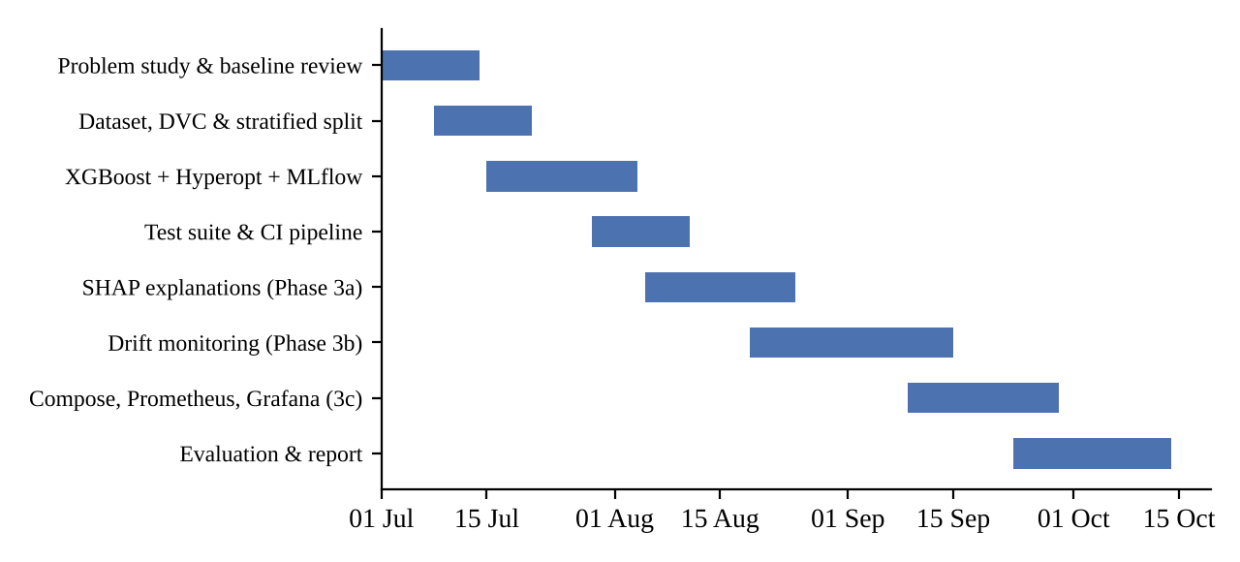
Fig. 2.1 Project timeline (July to October 2026)
CHAPTER 3

TECHNICAL SPECIFICATION

3.1 Requirements

3.1.1 Functional Requirements
- FR1: The system shall accept a single transaction (Time, V1 to V28, Amount) as JSON and return a label (Fraud or Legitimate) and the fraud probability.
- FR2: For a transaction labelled Fraud, the response shall include the base value and the five features with the largest absolute SHAP contribution, each with its raw value, SHAP value and direction.
- FR3: The system shall reject requests with missing or non-numeric fields with HTTP 422 before they reach the model.
- FR4: The system shall accept a CSV file for batch scoring, append a Prediction column, return the file and archive a copy by date.
- FR5: The training pipeline shall tune the model, log all trials and the final model to MLflow, and the API shall always serve the run with the highest holdout PR-AUC.
- FR6: The system shall buffer inference inputs and recompute drift against the training reference every N_w inputs, and also on demand through an endpoint.
- FR7: Drift results shall be exposed as Prometheus metrics and evaluated by alert rules; a Grafana dashboard shall display them.
- FR8: The same service shall run on the UPI dataset when started with DATASET=upi, and shall check every categorical field against its list of allowed values.

3.1.2 Non-Functional Requirements
- Performance: The process of generating a single prediction score should be finished well below 100 ms in end-to-end performance on a commodity device.
- Reliability: A failure of the drift calculation must in no way cause a delay in the processing of a prediction request.
- Reproducibility: The data is pinned via DVC hash value, the split procedure and all the searches are fixed using the seeding value (random_state = 42), while the version of the underlying libraries are pinned in requirements.txt (prometheus-fastapi-instrumentator is not yet pinned).
- Maintainability: The list of features, preprocessing and split procedures each resides at only one location in the codebase.
- Portability: The application performs identically whether it's running on the local computer, inside docker compose or on Kubernetes cluster.
- Testability: All the unit test cases must be executable offline, without access to either raw data or MLflow server.

3.2 Feasibility Study

3.2.1 Technical Feasibility
All components are mature open-source tools with good documentation. The dataset is small enough (about 150 MB) to train on a laptop: the full search of 20 trials with five folds each, plus the final refit, took about 6.4 minutes on our machine according to the MLflow run timestamps. TreeSHAP on a 300-tree model of depth 5 explains a single row in roughly 12 ms. The only real technical risk was the dependency conflict between Evidently and FastAPI described in Section 2.2, which we resolved by running the drift computation in a separate worker process.

3.2.2 Economic Feasibility
Every tool in the stack (Python, scikit-learn, XGBoost, SHAP, MLflow, Hyperopt, FastAPI, Evidently, Prometheus, Grafana, Docker, DVC and GitHub Actions on public repositories) is free to use, so there is no licensing cost. Training runs on a CPU and does not need a GPU. The trained model is 515 KB, and the serving container can run on a small instance. For a bank, even a handful of extra frauds caught per day would outweigh the cost of hosting such a service.

3.2.3 Social Feasibility
Fraud detection protects cardholders from financial loss and reduces the stress of disputed transactions. Explanations make it easier for an analyst to justify a decision to a customer and reduce the chance of blocking a genuine card for reasons nobody can explain. The dataset has been anonymized using PCA so no personal details are visible in this study. In a real-world deployment, fairness across customer groups would still need to be considered. However this isn't possible, with this dataset because we don't have information.

3.3 System Specification

3.3.1 Hardware Specification
Table 3.1 Hardware specification
Component | Minimum | Used for development
Processor | 4-core x86-64 CPU | HP Victus laptop, multi-core x86-64 CPU
Memory | 8 GB RAM | 16 GB RAM
Storage | 5 GB free (dataset, venv, images) | SSD
GPU | Not required | Not used
Network | Needed only for pip, Docker images and CI | Broadband

3.3.2 Software Specification
Table 3.2 Software specification
Category | Tool / library | Version
Language | Python | 3.11 (local venv), 3.10 (Docker image)
ML | scikit-learn, XGBoost, NumPy, pandas | 1.2.2, 2.0.3, 1.24.3, 1.5.3
Tuning / tracking | Hyperopt, MLflow | 0.2.7, 2.13.2
Explainability | SHAP (TreeExplainer) | 0.44.1
Serving | FastAPI, pydantic, Uvicorn | 0.103.0, 2.4.2, 0.23.2
Drift | Evidently (isolated worker) | 0.7.21
Observability | prometheus-fastapi-instrumentator, Prometheus, Grafana | latest, 2.53.0, 11.1.0
Versioning / CI | Git, DVC, GitHub Actions | DVC 3.51.2
Deployment | Docker, docker compose, Kubernetes (Docker Desktop) | -
Testing / IDE | pytest, VS Code | 7.4.2
Operating system | Windows 11 (development), Linux containers | -

CHAPTER 4

DESIGN APPROACH AND DETAILS

4.1 System Architecture
Fig. 4.1 presents the architectural diagram as a whole. There are four tiers in total. Offline tier works on the developer machine where the DVC-tracked dataset is split, model tuning and training happen, and MLflow run is logged, while the same deterministic split is used for creating the drift reference file. CI tier works on GitHub and runs test suite for every push; only after it succeeds does it build and publish Docker image to the GitHub Container registry. Serving tier is represented by the FastAPI application that loads the best MLflow run, holds the model and its SHAP explainer in memory, and saves input for every inference in a rolling buffer. The observability tier consists of Prometheus that polls the /metrics endpoint every 15 sec and evaluates alert rules and Grafana that reads data from Prometheus.

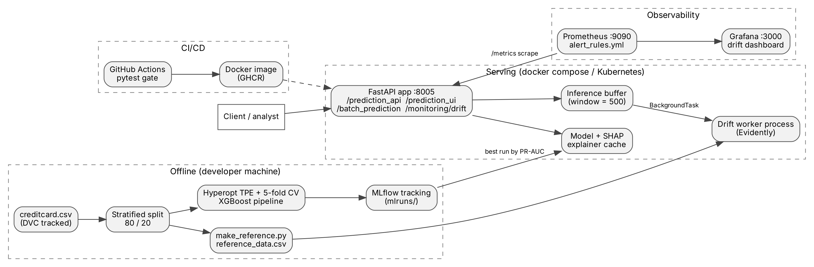
Fig. 4.1 System architecture
Two design choices need an explanation. First the model is not reloaded every time a request comes in. The API finds the run ID keeps it cached for 60 seconds and updates it in the background. It also keeps the model. Explainer cached using that ID. So they are only rebuilt when a better run is found. Second the drift calculation never happens inside the API process. The API just adds rows to a buffer. When the buffer is full it starts a FastAPI BackgroundTask. This task runs drift_worker.py as a Python process. The worker uses Evidently compares the buffer with the reference data writes a JSON summary and then quits. The API then reads that summary. Updates the gauges. This keeps the multipart packages in separate interpreters and keeps the drift work away from the request latency path.
For the UPI extension the same image runs as a second container (app-upi, port 8006) with DATASET=upi. Both containers export the same metric names, and Prometheus scrapes them as two separate jobs.

4.2 Design

4.2.1 Data Flow Diagram
Fig. 4.2 is a level-1 data flow diagram. A transaction enters process 1.0, where it is validated against the typed schema. Invalid input goes straight back to the client with a 422 response. Valid input goes to process 2.0, which loads the model artifact from the MLflow store (D1) and scores it. Only fraud-flagged transactions continue to process 3.0 for explanation. In parallel, the raw input is written to the inference buffer (D2). Process 4.0 reads the buffer and the reference data (D3) and writes drift gauges into Prometheus (D4), from where the analyst sees alerts and the dashboard. Process 5.0 is the offline training flow that reads the raw dataset (D5) and writes parameters, metrics and the model into D1.
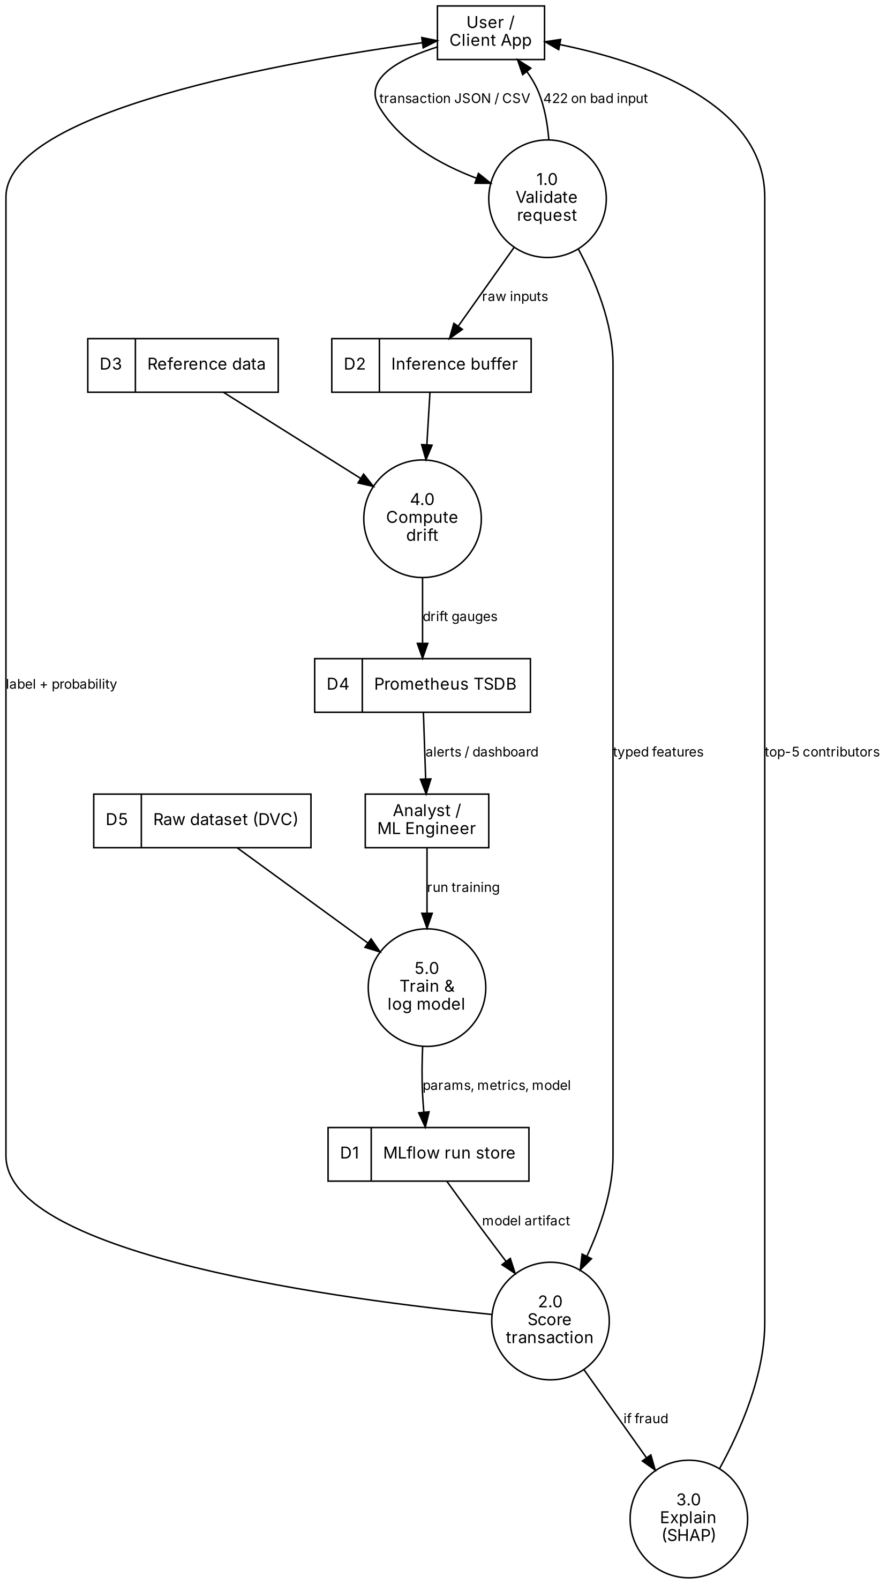
Fig. 4.2 Level-1 data flow diagram

4.2.2 Use Case Diagram
There are three kinds of users (Fig. 4.3). A client system or bank analyst scores transactions, reads the explanation and uploads batch files. The ML engineer trains and tunes models, compares runs in MLflow, builds and deploys the image and can trigger a drift check manually. An operations or on-call person watches the dashboard and responds to drift alerts.
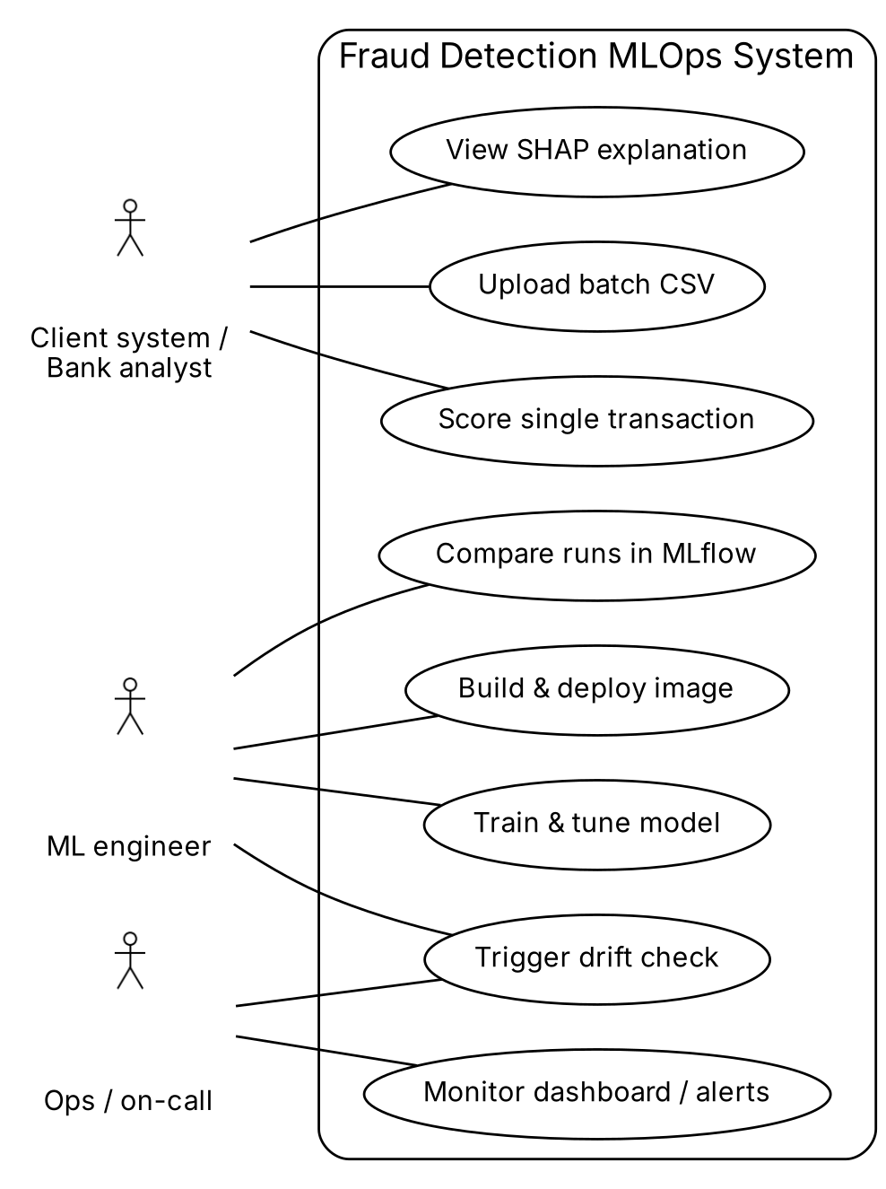
Fig. 4.3 Use case diagram

4.2.3 Class Diagram
The codebase is mostly functional, but the main types and modules are shown in Fig. 4.4. The two custom transformers inherit from scikit-learn's BaseEstimator and TransformerMixin so that they can be fitted inside a Pipeline and cross-validated without leakage. The request and response models are pydantic classes. TransactionFeatures is generated from the feature list with create_model, so the schema cannot drift away from config.FEATURES. PredictionResponse nests an optional PredictionExplanation, which holds a list of FeatureContribution objects. The predict and drift modules hold module-level state (the model cache and the rolling buffer).
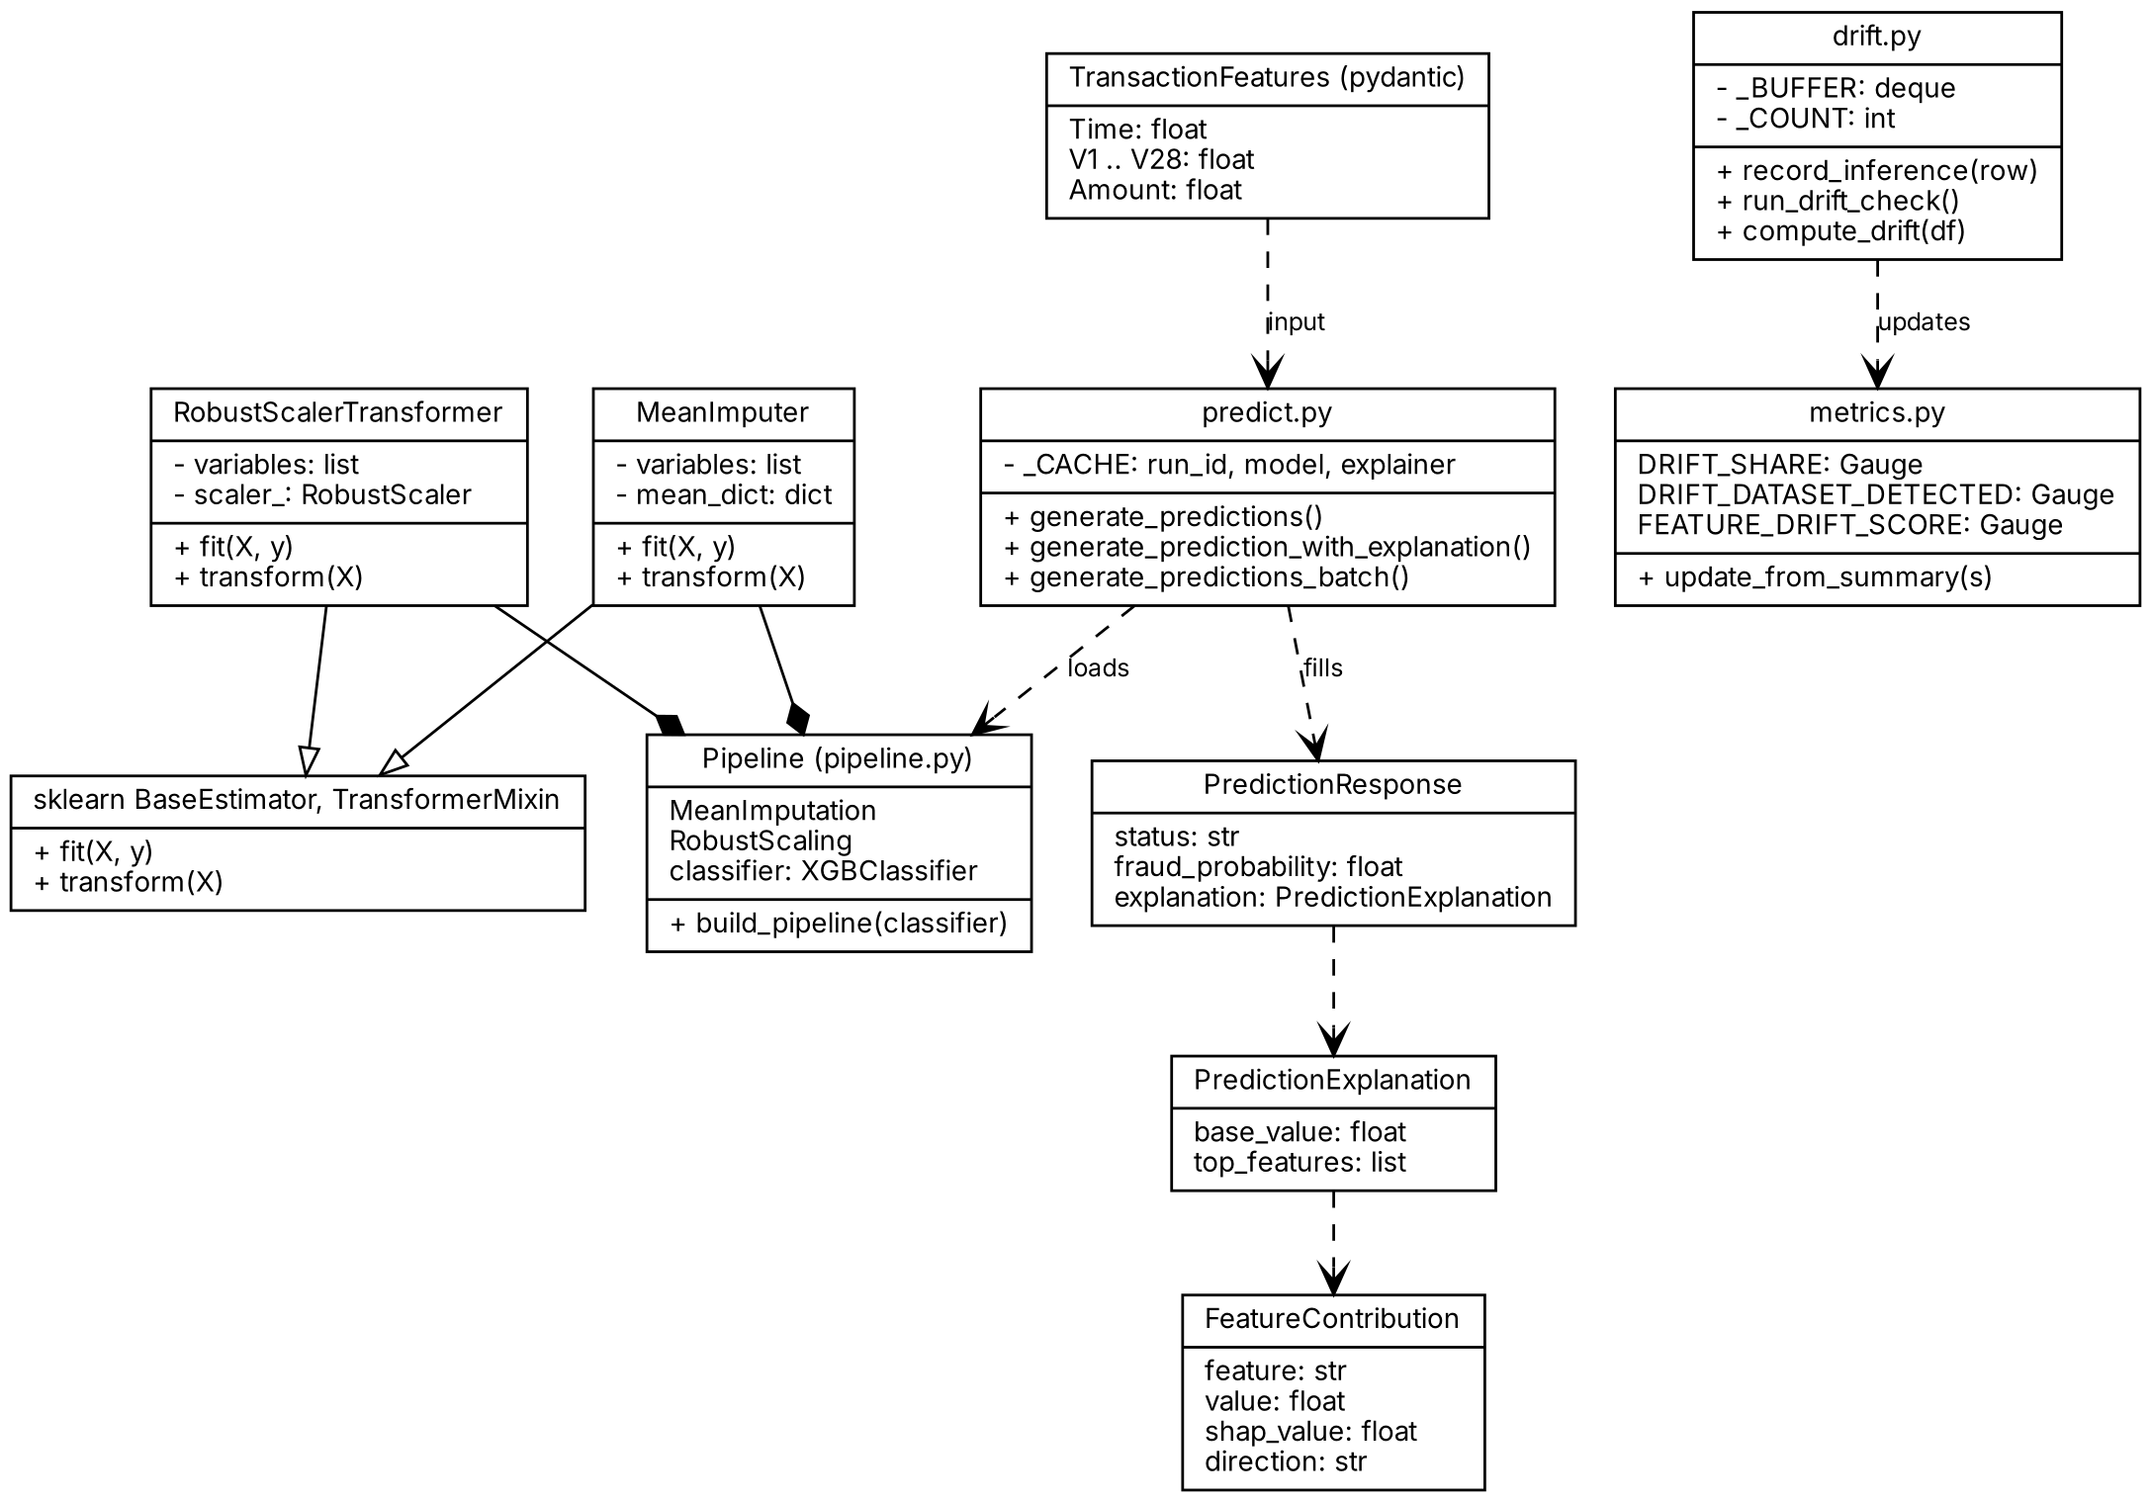
Fig. 4.4 Class diagram

4.2.4 Sequence Diagram
Fig. 4.5 traces one request to /prediction_api. After validation, main.py calls predict.py, which asks MLflow for the best run ID and loads the model only on a cache miss. The probability and label are computed, and SHAP is run only if the label is fraud. The input is then recorded in the drift buffer, and the response is returned to the client. If that request completed a window, a background task runs the drift check after the response has already been sent, so the client never waits for it.
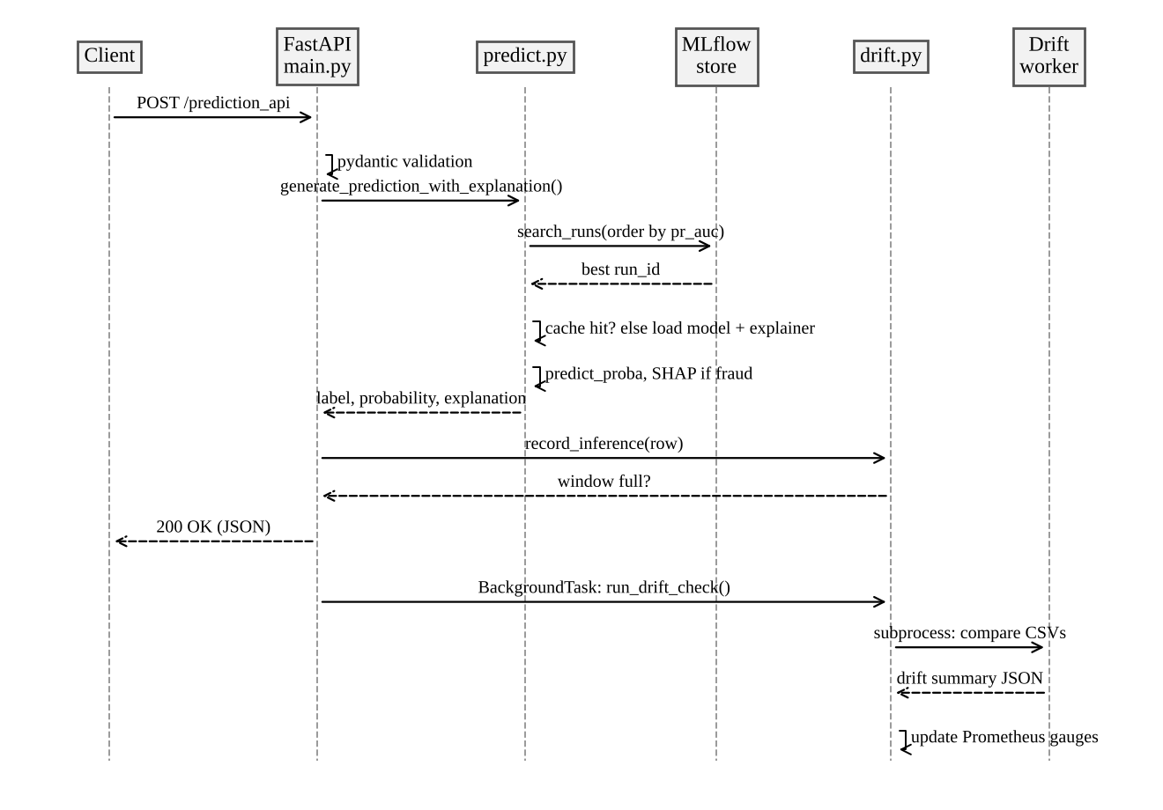
Fig. 4.5 Sequence diagram for a prediction request
CHAPTER 5

METHODOLOGY AND TESTING

5.1 Module Description

5.1.1 Data Versioning and Splitting
It is not possible to store the raw file creditcard.csv in Git because it is too large. It is stored with DVC instead: The repository only stores creditcard.csv.dvc, which contains the file's MD5 hash (e90efcb8...) and size, and the actual file is stored in a DVC remote. The hash pins the exact file; with a shared remote, dvc pull would fetch the same bytes. We had to add a commit of pinning pathspec to 0.11.2 to requirements-dev.txt as newer versions of pathspec removed a private symbol that DVC 3.51 imports.
The split is done in code by stratified_split() in processing/data_handling.py, which is the only place a train/test split is made. It splits the data using train_test_split with test_size = 0.2, random_state = 42 and stratify = y. This results in 227,845 training rows, 394 frauds, and 56,962 test rows, 98 frauds, keeping the 0.17% fraud rate in both halves. The holdout is used only once, at the end of tuning. All the cross validation takes place within the training split.
5.1.2 Preprocessing Pipeline
V1 to V28 are already PCA outputs they are. Roughly scaled so they are passed through without any changes. Time and Amount are data and they are heavily skewed. Amount in particular has outliers. We scale these two columns using a RobustScaler this method uses the median and the interquartile range so a few large transactions do not take over the scaling the way they would with min-max or standard scaling. A MeanImputer runs first as a safety net. The dataset has no missing values. A batch CSV uploaded later might. Both transformers are defined in processing/preprocessing.py. They are put together by build_pipeline(), in pipeline.py this is the single definition used by training, testing and serving. Because they are trained inside the Pipeline cross_val_score refits them on each training fold. They never look at the rows they are tested on.

5.1.3 Model Training and Hyperparameter Tuning
The classifier is XGBoost's XGBClassifier. Instead of resampling, class imbalance is handled with scale_pos_weight, set to the ratio of legitimate to fraudulent transactions in the training split (227,451 / 394, which is about 577). This tells the booster to weight each fraud as heavily as about 577 legitimate transactions in the loss. The evaluation metric is set to aucpr.
Hyperopt's TPE algorithm searches nine hyperparameters: max_depth (3 to 9), learning_rate (0.01 to 0.3), n_estimators (100 to 450 in steps of 50), subsample and colsample_bytree (0.5 to 1.0), gamma (0 to 5), reg_alpha and reg_lambda (0 to 1) and max_delta_step (0 to 10). The last one is recommended for logistic objectives on very imbalanced data because it limits how large each update can be. For every trial, the objective function builds a fresh pipeline, runs 5-fold StratifiedKFold cross-validation on the training split with average_precision as the score, logs the parameters and the mean and standard deviation of the fold scores to a nested MLflow run, and returns the negative mean PR-AUC for Hyperopt to minimise. After 20 trials, the best configuration is refitted on the whole training split and evaluated once on the holdout. The parent MLflow run stores the best parameters, the holdout PR-AUC, ROC-AUC, precision, recall and F1, and the fitted pipeline as an MLflow sklearn model.
def objective(params):
clf = make_classifier(params)
classification_pipeline = pipe.build_pipeline(clf)
skf = StratifiedKFold(n_splits=config.CV_FOLDS, shuffle=True,
random_state=config.RANDOM_STATE)
scores = cross_val_score(classification_pipeline, X_train, y_train,
cv=skf, scoring='average_precision', n_jobs=1)
with mlflow.start_run(nested=True):
mlflow.log_params({...})
mlflow.log_metric('cv_pr_auc_mean', float(scores.mean()))
return {'loss': -float(scores.mean()), 'status': STATUS_OK}

5.1.4 Serving API
main.py exposes the endpoints listed in Table 5.1. The request body for the prediction endpoints is TransactionFeatures, in which all 30 fields are required floats. This typed boundary replaced the baseline's untyped string fields: anything malformed is rejected by FastAPI with a 422 response that names the offending field, before any model code runs. The service always uses the MLflow run with the highest holdout PR-AUC, found with mlflow.search_runs ordered by metrics.pr_auc. CORS is enabled and prometheus-fastapi-instrumentator adds request count and latency histograms on /metrics. Batch outputs are archived under batch_predictions/<date>/<file>_<timestamp>.csv; the timestamp uses hyphens instead of colons because colons are not allowed in Windows file names, which we found out the hard way.
Table 5.1 REST endpoints
Method | Endpoint | Purpose
GET | / | Health / welcome message
POST | /prediction_api | Label, fraud probability and SHAP explanation (if fraud)
POST | /prediction_ui | Label only, for simple form-based clients
POST | /batch_prediction | Upload CSV, returns CSV with a Prediction column
POST | /monitoring/drift | Run a drift check now on the buffered inputs
GET | /monitoring/drift | Return the last drift summary
GET | /metrics | Prometheus metrics (HTTP and drift gauges)
GET | /docs | Interactive Swagger documentation

5.1.5 Explainability Module
explain.py wraps SHAP's TreeExplainer around the XGBoost step of the pipeline (model.named_steps['classifier']). We chose TreeExplainer over KernelExplainer because XGBoost is a tree ensemble, and TreeSHAP gives exact Shapley values in polynomial time, whereas KernelExplainer approximates them by perturbing a background sample and is orders of magnitude slower. Since the explainer sees only the classifier, each row is first passed through model[:-1], the preprocessing steps, so that the explainer works in the same feature space as the model. The two transformers retain the column names of the DataFrame, which is why the explanation continues to refer to Time, V1 to V28 and Amount.
The SHAP values are given in log-odds (margin) units, not in terms of probability. The base value combined with the sum of all 30 SHAP values gives the model's raw margin for that row. We include the five features that have the largest absolute contribution, listing them in order, together with the original value that the client provided and a direction field (either increases_fraud_risk or decreases_fraud_risk). The units are specified in the pydantic field descriptions, where they therefore appear directly in the Swagger documentation. Explanations are only attached to transactions that have been flagged for fraud (since EXPLAIN_ONLY_FLAGGED is set to True), which means that the additional cost rises in proportion to the 0.17% flag rate rather than with the total amount of traffic. Various versions of SHAP return the values as a list, a 3-D array or a 2-D array; the helper function _positive_class_shap() converts all three of these formats into a standard form, and a unit test confirms the shape of the result that we actually obtain.
5.1.6 Drift Monitoring Module
The monitoring package is split into four files to ensure the serving process never imports Evidently. metrics.py defines the Prometheus gauges and imports only prometheus_client; it is imported at application start-up to ensure the drift series appear in /metrics from the first scrape. drift.py maintains a thread-safe deque of the most recent N_w inputs (N_w = 500 by default, configurable via the DRIFT_WINDOW environment variable). record_inference() filters to monitored features and returns True every N_w inputs, causing main.py to schedule a background check. drift_worker.py is a standalone script that runs in its own interpreter. Before importing Evidently it preloads the standalone multipart.py module directly into sys.modules to ensure litestar finds the package it expects. It then runs Evidently's DataDriftPreset over the shared columns and compacts the result into a JSON summary. Finally, make_reference.py re-regenerates the reference by re-running the same seeded split and sampling 20,000 rows of X_train.
Twenty-nine features are monitored: V1 to V28 and Amount. Time is excluded deliberately. It measures seconds since the first transaction in the dataset, meaning any live data will always fall outside the training range and exhibit permanent drift that means nothing. For numerical columns Evidently uses a normed Wasserstein distance with threshold 0.1. The drift share s is the fraction of the 29 features above this threshold, dataset drift is declared when s ≥ 0.3. Five gauges are exported for the dataset overall (detected flag, share, drifted column count, window size, last run timestamp) and one labelled gauge with the score of each feature. Every feature is set on every run, so a feature that stops drifting falls back on the dashboard rather than retaining an old high value. Two alert rules in alert_rules.yml use these gauges, FraudInputDatasetDrift and FraudInputDriftShareHigh, each held for 10 minutes to ensure a single noisy window cannot trigger them. FraudInputDatasetDrift fires on the dataset flag (s ≥ 0.3), FraudInputDriftShareHigh uses a strict s > 0.3, so they differ only when s is exactly 0.3.
5.1.7 Containerisation, CI/CD and Deployment
The Dockerfile starts from python:3.10-slim-bookworm, installs the pinned requirements, copies the code, and finally runs pytest as part of the build, so that an image cannot be built from code with failing tests. The docker-compose.yml launches three services: the app on port 8005, Prometheus 2.53.0 on port 9090 with the scrape config and alert rules mounted as read only, and Grafana 11.1.0 on port 3000 with the datasource and dashboard provisioned from files. The mlruns directory and the reference file are bind-mounted into the app container. We encountered two Docker gotchas here. When the reference file was missing, Docker silently created a directory with that name, and nesting a file mount in a directory mount caused Docker to write an empty placeholder back into the repository. The compose file now mounts each target as a separate leaf path, with comments saying so.
The GitHub Actions workflow in .github/workflows/main.yml has two jobs. The first, test, installs the requirements on Python 3.10 and runs pytest on every push and pull request to main. The second, build-and-push, depends on the first and only runs on pushes: it logs in to GHCR using the workflow token, and pushes the image tagged both latest and with the commit SHA. For Kubernetes, the deployment.yml runs one replica of the image with the mlruns folder mounted from the host, and the service.yml exposes it through a LoadBalancer on port 80. The manifests are written for the Kubernetes cluster that ships with Docker Desktop.
5.1.8 UPI Extension (Simulated Dataset)
No public transaction-level UPI fraud dataset exists, because NPCI and the banks publish only aggregate statistics. We therefore wrote a seeded simulator (prediction_model/upi/simulate.py) that generates six months of UPI-style payments: 330,687 transactions from 30,000 simulated users, of which 1,200 are fraud. Every rule and rate in it is a visible parameter, and the same seed always gives the same stream. The data is simulated and is not calibrated to real NPCI statistics.
Each payment has 14 named model inputs: amount, hour, day of week, transaction type (P2P or P2M), merchant category, UPI app, device type, payer bank, state, whether the device and the payee are new to the account, the age of the payee’s VPA in days, the payer’s number of transactions in the last 24 hours, and the amount relative to the payer’s usual amount. A timestamp is kept for the split but is not a model input.
The stream has two regimes. In days 0 to 89 the fraud rate is about 0.28% and all fraud is account takeover: a fraudster on a new device, often at night, sends large P2P transfers in quick succession. From day 90 a festive-sale season begins. Traffic rises by 35%, the merchant mix moves towards e-commerce and travel, baskets grow, more payments happen in the evening, more payees are new sellers, and a cashback campaign moves some users to other UPI apps. The fraud rate rises to about 0.42%, and around 70% of fraud becomes social engineering, where the victim approves a modest daytime payment from their own phone to a VPA created a few days earlier.
The UPI model keeps the ULB structure: mean imputation, then a one-hot encoder over a fixed list of categories, then XGBoost with scale_pos_weight set to the class ratio of the training rows. Since the 20-trial search on ULB gave no measurable gain (Section 7.2), the UPI model uses one fixed configuration (depth 5, 300 trees, learning rate 0.1). The split is by time, not at random: the model is trained on days 0 to 59 (93,520 payments, 260 frauds) and evaluated once on the unseen days 60 to 89, because a payment model is always used on transactions that come after its training data.
Serving, explanation and monitoring reuse the ULB code. The request schema checks each categorical field against its allowed values and rejects anything else with HTTP 422. One-hot encoding splits a category into several columns, so explain.py adds their SHAP values back into one contribution per original feature; the analyst sees “merchant_category = gaming” rather than a list of dummy columns. All 14 inputs are monitored for drift against a 20,000-row sample of the training days, with the same thresholds as ULB.
5.2 Testing
The test suite was designed according to the recommendation by Breck et al. [13] on testing data and model behaviour, not just code paths. The previous version of the test suite had only one test that checked some hard-coded prediction, which failed every time the best MLflow run was changed, rendering it useless. It was replaced with 22 tests in three files that do not require a database or MLflow server with raw data, only synthetic data where it is needed. This allowed for their execution in CI and the Docker build process. The list of these tests is given in Table 5.2. The whole test suite runs in about 15 seconds.
Table 5.2 Test cases
No. | Test | What it checks | Result
1 | test_schema_accepts_valid_row | A complete row of 30 floats is accepted | Pass
2 | test_schema_rejects_missing_field | Dropping Amount raises ValidationError | Pass
3 | test_schema_rejects_wrong_type | Amount = "not_a_number" is rejected | Pass
4 | test_feature_contract | 30 features, Time first, Amount last, schema fields = config.FEATURES | Pass
5 | test_split_preserves_class_ratio | Fraud rate in train and test within 0.3% of the full rate | Pass
6 | test_split_is_deterministic | Two splits give identical indices | Pass
7 | test_explain_row_shape_and_ranking | Top-N length, sorted by |SHAP|, correct keys and direction | Pass
8 | test_explain_row_respects_top_n | top_n = 3 returns exactly three features | Pass
9 | test_record_inference_fires_every_window | With window 5, fires at the 5th and 10th input | Pass
10 | test_record_inference_keeps_only_monitored_features | Time is dropped from the buffer | Pass
11 | test_summarize_extracts_count_share_and_scores | Parser reads count, share and per-feature scores | Pass
12 | test_summarize_no_drift_below_threshold | No dataset drift when all scores are low | Pass
13 | test_summarize_fills_missing_features_with_zero | Missing features reported as 0.0 | Pass
14 | test_update_from_summary_sets_gauges | Gauge values readable from the Prometheus registry | Pass
15 | test_worker_end_to_end_detects_broad_shift | Real worker process flags drift when 15 of 29 columns shift | Pass (Docker/CI, Python 3.10)
16 | test_best_run_id_is_cached_and_refreshed_in_background | Best run looked up once, served from cache, refreshed in background after expiry | Pass
17 | test_simulator_schema_order_and_drift | Simulated UPI stream has the expected columns, time order and festive-season change | Pass
18 | test_simulator_is_deterministic | The same seed gives the same stream | Pass
19 | test_upi_schema_validates_categories | An unknown category (e.g. "casino") is rejected | Pass
20 | test_one_hot_uses_fixed_categories | Encoded columns come from the fixed category list | Pass
21 | test_explanations_are_per_input_feature_and_additive | One-hot SHAP values summed per feature; additivity holds | Pass
22 | test_time_split_keeps_holdout_after_training | Holdout days come strictly after training days | Pass

Beyond the automated tests, we tested the running service by hand. We sent valid fraud and legitimate transactions from the test split, sent a request with a string in the Amount field to confirm the 422 response, uploaded a 200-row CSV to the batch endpoint, and pushed normal and deliberately shifted traffic through the API to check that the drift gauges and alerts responded. These results are presented in Chapters 6 and 7.
CHAPTER 6

PROJECT DEMONSTRATION
This chapter walks through the running system. The stack is started with two preparation commands followed by docker compose up:
# 1. write reference_data.csv
python -m prediction_model.monitoring.make_reference
# 2. make the mlruns paths portable between host and container
python -m prediction_model.fix_mlruns_paths
# 3. app :8005, Prometheus :9090, Grafana :3000
docker compose up --build

6.1 Scoring a Fraudulent Transaction
We took a transaction from the test split that is labelled as fraud and posted it to /prediction_api. The model returned a fraud probability of 0.99997 and attached its explanation. The trimmed response is shown below. V14, V10 and V12 had strongly negative values and were the three strongest reasons for the fraud label, while V8 and V2 pulled the score slightly back towards legitimate.
POST /prediction_api
{
"status": "Fraud",
"fraud_probability": 0.9999656677246094,
"explanation": {
"base_value": 8.5388,
"top_features": [
{"feature": "V14", "value": -6.174, "shap_value": 3.117,
"direction": "increases_fraud_risk"},
{"feature": "V10", "value": -4.881, "shap_value": 1.746,
"direction": "increases_fraud_risk"},
{"feature": "V12", "value": -4.686, "shap_value": 1.234,
"direction": "increases_fraud_risk"},
{"feature": "V8", "value": 1.167, "shap_value": -0.922,
"direction": "decreases_fraud_risk"},
{"feature": "V2", "value": 2.463, "shap_value": -0.687,
"direction": "decreases_fraud_risk"}
]
}
}

6.2 Scoring a Legitimate Transaction and Invalid Input
A legitimate transaction from the test split returned status Legitimate with a probability of 2.47 x 10⁻⁶ and explanation set to null, since no explanation is computed for non-flagged traffic. When we changed Amount to the string "abc" , the request never reached the model. FastAPI returned HTTP 422 with the following body:
{"detail": [{"type": "float_parsing",
"loc": ["body", "Amount"],
"msg": "Input should be a valid number, unable to parse
string as a number",
"input": "abc"}]}

6.3 Batch Prediction
We uploaded the first 200 rows of the test split as sample_batch.csv to /batch_prediction. The service returned the same file with a Prediction column (fraud or legit) appended, as a CSV download, and wrote a copy to batch_predictions/2026-10-14/. Extra columns such as the ground-truth Class column are ignored, because the input is sliced to config.FEATURES before prediction. These first 200 rows contain no fraud, so the web console uses a different 200-row sample (185 legitimate and 15 fraud), in which the model caught 14 of the 15 frauds with no false alarms.

6.4 Drift Detection and Alerting
To demonstrate monitoring, we ran the API with DRIFT_WINDOW = 300 and sent 300 real test transactions. The drift check flagged only 2 of 29 features (s = 0.069), so no dataset drift was reported. We then sent 300 more test transactions after modifying them to imitate a change in customer behaviour: Amount was multiplied by 3 with 50 added, and twelve PCA components (V1 to V7, V9 to V12 and V14) were shifted by 1.5. This time 18 of 29 features were flagged (s = 0.621), dataset_drift_detected became 1, and the /metrics endpoint exposed the new values:
fraud_input_drift_dataset_detected 1.0
fraud_input_drift_share 0.6206896551724138
fraud_input_drifted_columns_count 18.0
fraud_input_drift_window_size 300.0
fraud_input_feature_drift_score{feature="V7"} 1.3053805446288955
Prometheus picked up the gauge on its next scrape, and both alert rules moved into the pending state. They would move to firing if the condition was met for the configured 10 min. The Grafana dashboard which is set up using grafana_dashboard.json contains four panels. These include the drift share over time plot with the 0.3 threshold, a stat panel for the dataset drift flag, a stat panel for the drifted columns and window size, and a time series of the per-feature drift scores..

6.5 UPI Demonstration
The UPI service runs beside the ULB service, is started by the same docker compose command and listens on port 8006. We repeated the demonstration with payments taken from the simulated stream.
An account-takeover payment was flagged as fraud with a probability above 0.9999. Its five largest contributions were is_new_device = 1 (+4.63), amount_to_user_avg = 12.29 (+3.92), hour = 4 (+2.09), txns_last_24h = 8 (+1.50) and txn_type = P2P (+1.09). Unlike the ULB explanation, each item is something an analyst can check with the customer: a new phone, a 4 a.m. transfer, twelve times the usual amount and eight payments in a day.
A grocery payment of ₹198.76 at 10 a.m., from a known device to a known payee, was scored as legitimate with no explanation attached. Changing merchant_category to “casino”, which is not an allowed value, returned HTTP 422 naming that field and listing the allowed categories.
A festive-season scam was scored as legitimate, with a fraud probability below 0.01: an ₹82 payment made in the afternoon from the victim’s own phone to an e-commerce “seller” whose VPA was three days old. The model was trained before this type of fraud existed, which is exactly the case drift monitoring is meant to catch. A batch of 300 held-out payments from days 60 to 89, 30 of them fraud, returned 27 of the 30 frauds with no false alarms.
Finally, we sent 500 payments from the normal months (days 60 to 89) and ran a drift check: none of the 14 features drifted. A second window of 500 payments from the festive season (days 120 to 179) flagged 8 of 14 features (s = 0.571), set the dataset drift flag and moved the UPI alert rules into the pending state. Nothing in this window was shifted by hand; the change comes from the simulated festive season itself.
CHAPTER 7

RESULT AND DISCUSSION

7.1 Hyperparameter Search
Fig. 7.1 shows the mean cross-validated PR-AUC of the 20 Hyperopt trials, sorted from worst to best. Scores ranged from 0.773 to 0.854 with a mean of 0.836. Most trials were packed between 0.84 and 0.85, so a wide range of settings performs about equally well. Default XGBoost, with no tuning at all, reaches the same cross-validated score (0.854), so the eight-point spread reflects a few poor settings rather than a gain from tuning. The best configuration is listed in Table 7.1. It is a fairly shallow model (depth 5) with 300 trees, a moderate learning rate and quite strong row subsampling (0.64), which helps with variance given that there are only 394 frauds to learn from.
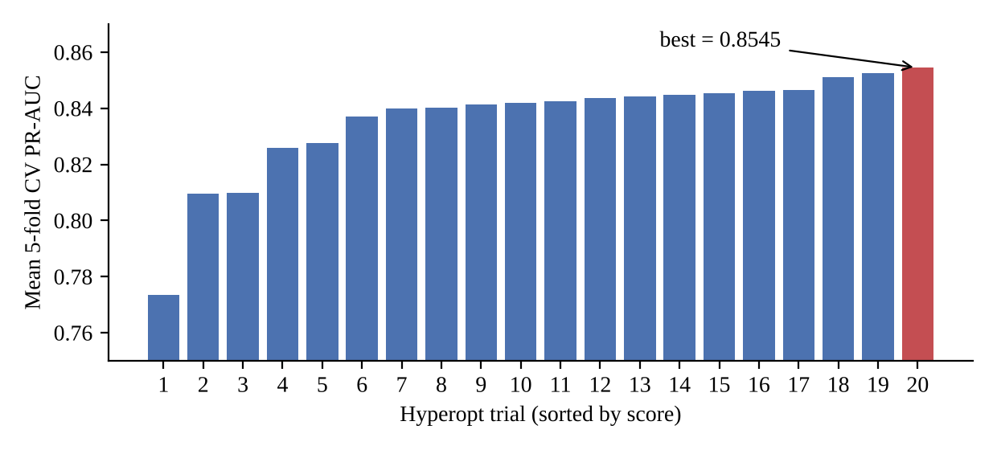
Fig. 7.1 Cross-validated PR-AUC of the 20 Hyperopt trials
Table 7.1 Best hyperparameters found by Hyperopt
Parameter | Value | Parameter | Value
max_depth | 5 | gamma | 3.164
n_estimators | 300 | reg_alpha | 0.033
learning_rate | 0.093 | reg_lambda | 0.860
subsample | 0.636 | max_delta_step | 0
colsample_bytree | 0.829 | scale_pos_weight | 577.3

7.2 Holdout Performance
Table 7.2 gives the results of the refitted model on the 56,962-row holdout. These are the values logged to MLflow, and we reproduced them exactly by reloading the model and re-running the split. The holdout PR-AUC (0.869) is slightly higher than the best cross-validated score (0.854). The difference is within the fold-to-fold variation and is expected, since the final model is trained on all of the training data instead of four-fifths of it.
Table 7.2 Holdout metrics of the selected model (threshold 0.5)
Metric | Value
PR-AUC (average precision) | 0.8693
ROC-AUC | 0.9809
Precision (fraud) | 0.8632
Recall (fraud) | 0.8367
F1-score (fraud) | 0.8497
Accuracy | 0.9995
Accuracy of always predicting legitimate | 0.9983

The last two rows show why we do not report accuracy as a result. Our model's accuracy is 99.95%, but a model that never predicts fraud already gets 99.83%. The confusion matrix in Fig. 7.2 is more informative: of the 98 frauds in the holdout, 82 were caught and 16 were missed, while 13 of the 56,864 legitimate transactions were wrongly flagged. In practical terms an analyst would need to review 95 alerts to find 82 frauds, which is a manageable workload.
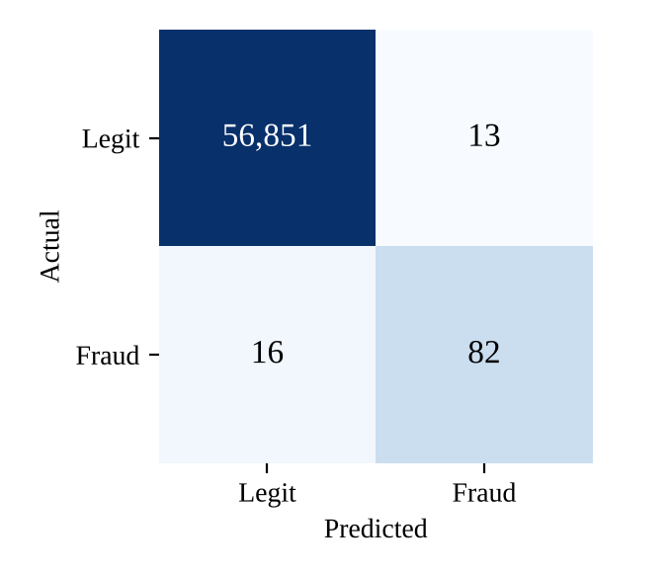
Fig. 7.2 Confusion matrix on the holdout set
Fig. 7.3 shows the precision-recall and ROC curves. The dashed line in the PR plot is the precision of a random classifier, which equals the fraud rate (0.0017). The ROC curve rises almost vertically and its AUC is 0.981, but this mostly reflects how easy it is to keep the false positive rate low when there are 56,864 negatives. The PR curve is more honest : precision is above 0.8 up to a recall of around 0.8 and then falls quickly, because the last 15 to 20 percent of frauds look very similar to legitimate transactions.
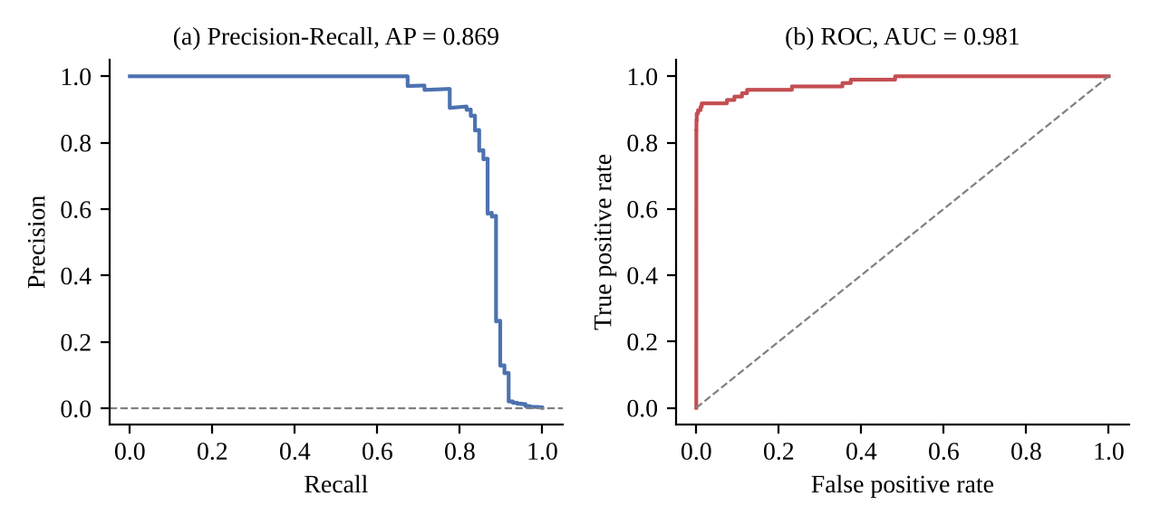
Fig. 7.3 (a) Precision-recall curve and (b) ROC curve on the holdout set
To assess whether the model is beating simpler alternatives, we trained four baselines on the same split (Table 7.3): logistic regression with balanced class weights, a 200-tree random forest with balanced weights, and XGBoost with default settings, with and without the class weight. The 95% confidence intervals for PR-AUC come from 1,000 bootstrap resamples of the holdout.
Table 7.3 Comparison with baseline models (holdout, 56,962 transactions, 98 frauds)
Model | PR-AUC [95% CI] | ROC-AUC | Precision | Recall | TP | FP
Logistic regression (balanced) | 0.719 [0.63, 0.81] | 0.972 | 0.061 | 0.918 | 90 | 1385
Random forest (balanced) | 0.858 [0.78, 0.93] | 0.947 | 0.961 | 0.745 | 73 | 3
XGBoost (default) | 0.878 [0.81, 0.94] | 0.974 | 0.919 | 0.806 | 79 | 7
XGBoost (default + class weight) | 0.880 [0.81, 0.94] | 0.968 | 0.882 | 0.837 | 82 | 11
XGBoost (tuned, ours) | 0.869 [0.80, 0.93] | 0.981 | 0.863 | 0.837 | 82 | 13
The three XGBoost models form the best group. Logistic regression has a high ROC-AUC (0.972) but a precision of only 0.061 at the default threshold, with 1,385 false alarms, and the random forest is the most precise model but misses 25 of the 98 frauds. Hyperparameter tuning did not provide a significant gain: the paired bootstrap difference in PR-AUC between the tuned model and default XGBoost with the class weight is -0.011 (95% CI [-0.028, 0.004]). The main gains are achieved from selecting XGBoost and incorporating the class weight rather than the search.

7.3 Effect of the Decision Threshold
The API defaults to the threshold of 0.5. Since the output of the model is probability, the bank could consider adjusting the threshold according to the size of the review team. Table 7.4 shows how the change would affect the holdout set. Decreasing the threshold to 0.1 will allow detecting three more frauds but more than triple the false alarms. Meanwhile, increasing the threshold to 0.9 will reduce the false alarms to 8 but fail to detect two frauds. The F1-score does not change significantly between 0.3 and 0.9, so choosing one of them as optimal is a matter of business requirements and the relative cost of false alarms and missed frauds.
Table 7.4 Precision and recall at different thresholds (holdout, 98 frauds)
Threshold τ | TP | FP | FN | Precision | Recall | F1
0.1 | 85 | 46 | 13 | 0.649 | 0.867 | 0.742
0.2 | 84 | 25 | 14 | 0.771 | 0.857 | 0.812
0.3 | 83 | 18 | 15 | 0.822 | 0.847 | 0.834
0.5 | 82 | 13 | 16 | 0.863 | 0.837 | 0.850
0.7 | 82 | 11 | 16 | 0.882 | 0.837 | 0.859
0.9 | 80 | 8 | 18 | 0.909 | 0.816 | 0.860

7.4 Explainability Results
To see which features the model relies on overall, we averaged the absolute SHAP values over a random sample of 5,000 holdout rows (Fig. 7.4). V4 and V14 stand out clearly, followed by V12 and V10. This matches what is commonly reported for this dataset and matches the explanation shown in Section 6.1, where V14, V10 and V12 were the top three reasons for the fraud label. Amount and Time contribute relatively little. This is useful when reading the drift results: drift in V4, V14, V12 or V10 matters much more than drift in a low-importance feature, and the alert description in alert_rules.yml points the on-call person to these features first.
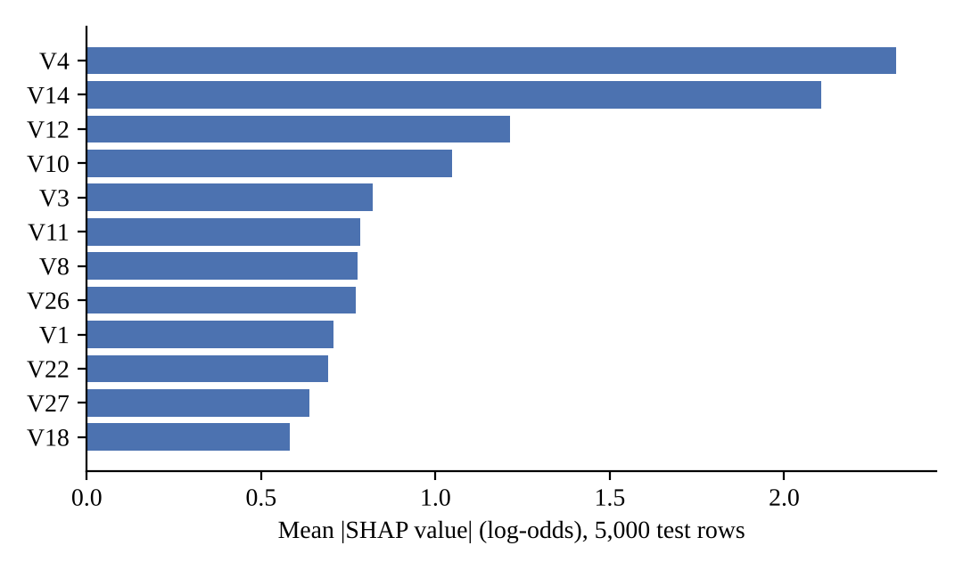
Fig. 7.4 Global feature importance (mean absolute SHAP value)

7.5 Drift Detection Results
Fig. 7.5 compares the per-feature drift scores of the two windows from Section 6.4. In the normal window every feature stayed close to or below the 0.1 threshold; V20 and V21 were just above it (0.104 and 0.101), which is the kind of noise expected from a 300-row sample, and the drift share of 0.069 stayed far below the 0.3 alert level. In the shifted window, the thirteen modified features (twelve PCA components and Amount) all fell between 0.78 and 1.63, and the five unmodified features (V15, V21, V22, V25 and V28) also crossed 0.1 by a tiny margin, making for 18 drifted features altogether. The detector thus distinguishes the two cases clearly. The 10-minute hold on the alert rules provides a second layer of defense against a single noisy window. We repeated the test using the default 500-transaction window: normal traffic falsely flagged 1 of 29 features (s = 0.034) and shifted traffic 15 of 29 (s = 0.517), so the result is still valid at the window size used in deployment (Table 7.5).
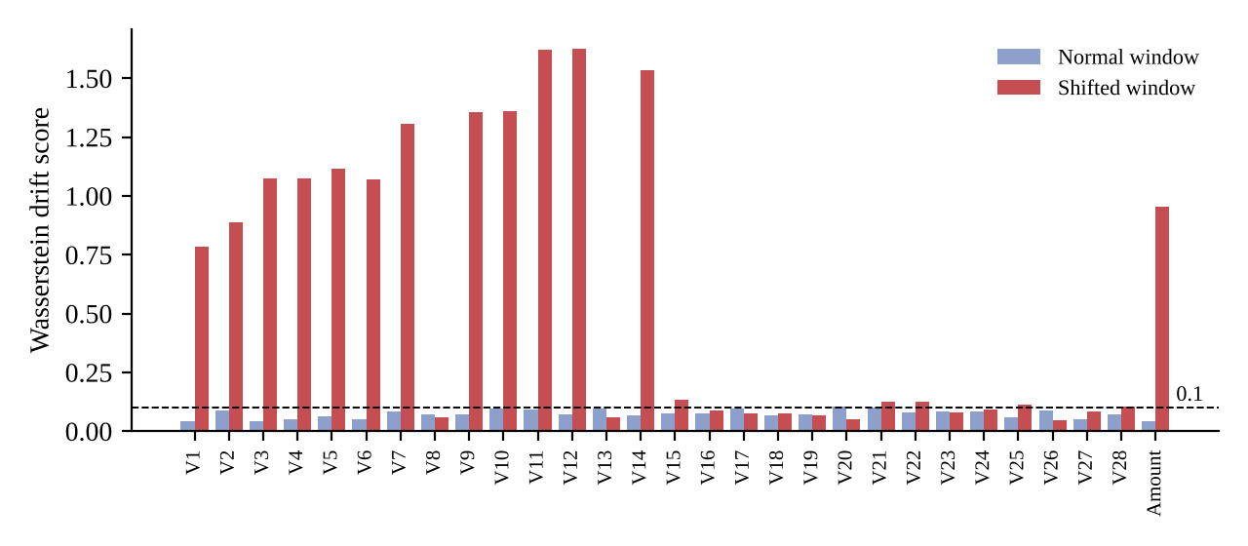
Fig. 7.5 Per-feature drift scores for a normal and a shifted window of 300 transactions
Table 7.5 Drift check summary
Window | Rows | Drifted features | Drift share s | Dataset drift
Normal test traffic | 300 | 2 / 29 | 0.069 | No
Shifted traffic | 300 | 18 / 29 | 0.621 | Yes (alert pending)
Normal test traffic | 500 | 1 / 29 | 0.034 | No
Shifted traffic | 500 | 15 / 29 | 0.517 | Yes

7.6 Latency
We measured latency in a Linux test environment (Python 3.10) with the pinned library versions. Table 7.6 shows the results. Scoring the entire holdout of 56,962 rows in one batch took 0.22 seconds. A single in-process prediction took a median of 8.4 ms, and the SHAP explanation added about 12.5 ms, but only for flagged transactions. Over HTTP, through FastAPI with validation and drift buffering, the median end-to-end time for /prediction_api was 27.5 ms and the 95th percentile was 39.4 ms over 300 requests. This is well within the 100 ms target in Section 3.1.2. The drift computation itself takes a few seconds, mostly to start the worker process and import Evidently, but it runs in the background after the response is sent, so it does not appear in these numbers.
Table 7.6 Measured latency
Operation | Median | 95th percentile
Model predict_proba, single row (in process) | 8.4 ms | 10.8 ms
TreeSHAP explanation, single row | 12.5 ms | -
/prediction_api end to end over HTTP | 27.5 ms | 39.4 ms
Batch scoring of 56,962 rows | 0.22 s | -

7.7 Cost Analysis
The software cost of the project is zero since all components are open source and GitHub actions are free for public repositories. Compute cost is also low: the entire tuning and training run (100 cross-validation fits, plus the final refit) took 385 seconds on a laptop CPU, the model file is 515 KB, and the serving container consumes well under one CPU core at the latencies measured above. In a production deployment, the largest costs would be a small virtual machine or Kubernetes node to host the API and the monitoring stack, and storage for MLflow artifacts and Prometheus data.
A more meaningful cost for this problem is the cost of errors. At the default threshold the model produced 16 false negatives and 13 false positives on the holdout. A false negative means the fraud goes through, and the money is lost, whereas a false positive costs an analyst a few minutes and may annoy a customer. Since missed frauds are usually much more expensive than reviews, a bank with sufficient reviewers may prefer to accept up to 18–25 false alarms (twice as many as 13) to catch an additional fraud out of 98. The system makes this trade-off easy to enact since the probability is already returned by the API.

7.8 UPI Extension Results
Table 7.7 gives the UPI model’s results on the unseen days 60 to 89 (47,108 payments, 135 frauds). Its PR-AUC of 0.908 is close to the ULB result of 0.869. This was intended: the simulated fraud patterns overlap with normal behaviour, since a near-perfect score would only show that the task had been made too easy. The result shows that the pipeline works on a new schema with categorical features; it is not a claim about real UPI fraud rates, for which the credit card results remain our benchmark.
Table 7.7 UPI holdout results (days 60–89, threshold 0.5)
Metric | Value
PR-AUC (average precision) | 0.908
Precision (fraud) | 0.826
Recall (fraud) | 0.881
F1-score (fraud) | 0.853
Frauds caught / missed | 119 / 16
False alarms | 25
Fig. 7.6 compares the per-feature drift scores of the two UPI windows from Section 6.5, and Table 7.8 summarises them. The festive window drifted most in amount_to_user_avg (0.38), hour (0.26), amount (0.22), payee_vpa_age_days (0.18) and merchant_category (0.17). Because the features have names, the drift report itself says what changed: larger payments relative to each payer’s habits, more evening payments, younger payee accounts and a different merchant mix. These are the same signals that carry the new scam pattern.
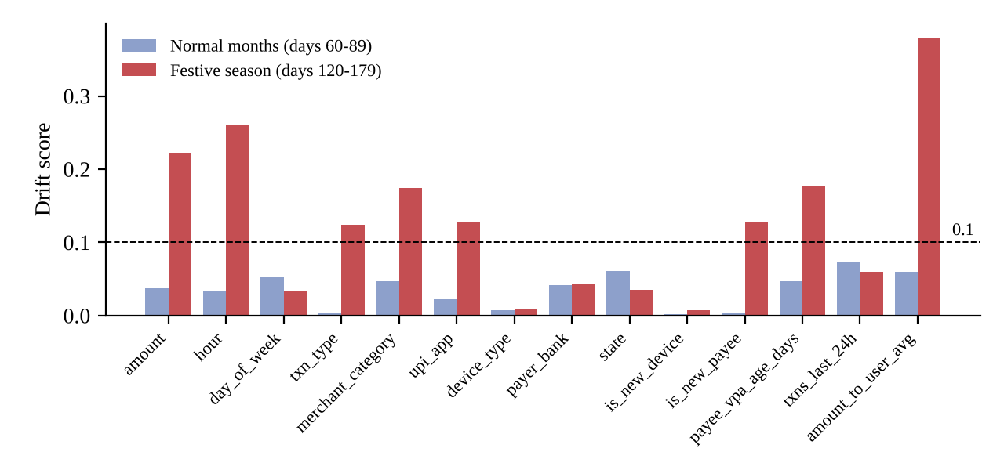
Fig. 7.6 Per-feature drift scores for a normal-month and a festive-season window of 500 UPI payments
Table 7.8 UPI drift check summary
Window | Rows | Drifted features | Drift share s | Dataset drift
Normal months (days 60–89) | 500 | 0 / 14 | 0.000 | No
Festive season (days 120–179) | 500 | 8 / 14 | 0.571 | Yes (alert pending)
Scored on the festive months (days 90 to 179), the model’s recall fell to about 26%. It still caught about 83% of account takeovers (206 of 247) but only 6 of 558 social-engineering scams. The drift alert therefore arrives at the point where the model has started to miss a new type of fraud, which is the signal a team would use to collect fresh labels and retrain.

7.9 Discussion and Limitations
There are several caveats worth noting. Since the dataset only covers two days, the analysis cannot detect any seasonal or annual drift; that is why we demonstrated the drift detector on an artificial change rather than real drift. The PCA features have lost any intuitive meaning behind them, so while saying that 'V14 was very negative' is accurate, it is not an immediately understandable signal to a business user. A production-grade implementation on a bank's internal system would operate on named features and produce more actionable explanations, such as 'the number of international transfers was much lower this week'. Input drift is only a precursor to performance drift: changes to the inputs do not necessarily affect the model performance, and performance can degrade even when there is no input drift. Measuring actual performance requires proper delayed labels, which the current dataset does not have.
The UPI extension addresses the readability problem with named features, but its data is simulated. Its results show how the pipeline behaves on readable features and a realistic seasonal change, not how well it would detect real UPI fraud.
There are also two engineering improvements left to implement. The API originally retrieved the best run from MLflow on every single request, which on the Docker bind mount took around 4 seconds to complete since MLflow's file store has to read through all runs' metadata. The current fix retrieves the best run ID once every 60 seconds and then keeps it in a cache that is refreshed in a background thread, bringing the response time down to ~50 ms. Pinning a specific version of the registered model would eliminate the need for the lookup completely. The drift buffer is kept in memory, meaning it is reinitialized every time the container restarts and is not shared between replicas if the API is scaled out.
CHAPTER 8

CONCLUSION

8.1 Conclusion
We developed a MLOps pipeline for credit card fraud detection, including versioned data and monitored containers. The resulting model — an XGBoost classifier, tuned with Hyperopt on stratified cross-validated PR-AUC — has a holdout PR-AUC of 0.869 and detects 82 of 98 frauds with just 13 false positives among nearly 57,000 transactions. All training runs are logged to MLflow, and the best run’s API is served automatically, with every fraud prediction explained by an exact TreeSHAP value at ~12 ms latency per example. Input drifts are detected every 500 requests by an Evidently worker in an isolated process, exposed via Prometheus metrics, alert rules, and a Grafana dashboard. In our tests, the detector distinguished normal and drifted data — 2 of 29 features drifted in the former, 18 of 29 in the latter — while the service was guarded by a 22-test suite run in CI and during the Docker build. The service can be run locally and deployed to Kubernetes with a single command.
Running the same pipeline on a simulated UPI stream showed the other half of the picture. With named features, the explanation of a flagged payment reads as a list of facts an analyst can check, and the drift report names what changed when the festive season arrived (8 of 14 features drifted, against 0 of 14 in a normal month). The model also missed the new scam type it had never seen, which is why monitoring, and later retraining on fresh labels, matter.
The most valuable lessons learned were not related to the model, but rather to the operationalization stack. A versioning conflict between dependencies caused the drift worker to be run in a separate process. The Docker mount caused by the Evidently agent to write placeholder files back into the repository. And the baseline test that sometimes passed and sometimes failed, depending on which run of MLflow happened to be best, would have been a showstopper in production. Debugging these issues taught us more about MLOps than the model tuning did.

8.2 Future Work
- Close the loop from drift to retraining, with delayed labels, a champion/challenger comparison on recent data and an automatic rollback.
- Register models in the MLflow Model Registry and serve a pinned version or stage instead of searching runs at request time.
- Route the alerts through Alertmanager to email or Slack, and add performance monitoring once labels become available.
- Move the drift buffer to a shared store such as Redis so that drift is computed across all replicas.
- Add explanations for batch predictions, and test calibrated probabilities and cost-based threshold selection.
- Evaluate the pipeline on a dataset with named features and a longer time span to study natural drift.
CHAPTER 9

REFERENCES
- Dal Pozzolo, A., Caelen, O., Johnson, R.A. and Bontempi, G., 2015. Calibrating probability with undersampling for unbalanced classification. In 2015 IEEE Symposium Series on Computational Intelligence, pp.159-166. IEEE.
- Chen, T. and Guestrin, C., 2016. XGBoost: A scalable tree boosting system. In Proceedings of the 22nd ACM SIGKDD International Conference on Knowledge Discovery and Data Mining, pp.785-794.
- Lundberg, S.M. and Lee, S.I., 2017. A unified approach to interpreting model predictions. Advances in Neural Information Processing Systems, 30, pp.4765-4774.
- Lundberg, S.M., Erion, G., Chen, H., DeGrave, A., Prutkin, J.M., Nair, B., Katz, R., Himmelfarb, J., Bansal, N. and Lee, S.I., 2020. From local explanations to global understanding with explainable AI for trees. Nature Machine Intelligence, 2(1), pp.56-67.
- Bergstra, J., Yamins, D. and Cox, D., 2013. Making a science of model search: Hyperparameter optimization in hundreds of dimensions for vision architectures. In International Conference on Machine Learning, pp.115-123. PMLR.
- Sculley, D., Holt, G., Golovin, D., Davydov, E., Phillips, T., Ebner, D., Chaudhary, V., Young, M., Crespo, J.F. and Dennison, D., 2015. Hidden technical debt in machine learning systems. Advances in Neural Information Processing Systems, 28, pp.2503-2511.
- Kreuzberger, D., Kühl, N. and Hirschl, S., 2023. Machine learning operations (MLOps): Overview, definition, and architecture. IEEE Access, 11, pp.31866-31879.
- Gama, J., Žliobaitė, I., Bifet, A., Pechenizkiy, M. and Bouchachia, A., 2014. A survey on concept drift adaptation. ACM Computing Surveys, 46(4), pp.1-37.
- Saito, T. and Rehmsmeier, M., 2015. The precision-recall plot is more informative than the ROC plot when evaluating binary classifiers on imbalanced datasets. PLoS ONE, 10(3), e0118432.
- Dal Pozzolo, A., Boracchi, G., Caelen, O., Alippi, C. and Bontempi, G., 2018. Credit card fraud detection: A realistic modeling and a novel learning strategy. IEEE Transactions on Neural Networks and Learning Systems, 29(8), pp.3784-3797.
- Zaharia, M., Chen, A., Davidson, A., Ghodsi, A., Hong, S.A., Konwinski, A., Murching, S., Nykodym, T., Ogilvie, P., Parkhe, M. and Xie, F., 2018. Accelerating the machine learning lifecycle with MLflow. IEEE Data Engineering Bulletin, 41(4), pp.39-45.
- Chawla, N.V., Bowyer, K.W., Hall, L.O. and Kegelmeyer, W.P., 2002. SMOTE: Synthetic minority over-sampling technique. Journal of Artificial Intelligence Research, 16, pp.321-357.
- Breck, E., Cai, S., Nielsen, E., Salib, M. and Sculley, D., 2017. The ML test score: A rubric for ML production readiness and technical debt reduction. In 2017 IEEE International Conference on Big Data, pp.1123-1132. IEEE.
- Rabanser, S., Günnemann, S. and Lipton, Z., 2019. Failing loudly: An empirical study of methods for detecting dataset shift. Advances in Neural Information Processing Systems, 32.
- Bhattacharyya, S., Jha, S., Tharakunnel, K. and Westland, J.C., 2011. Data mining for credit card fraud: A comparative study. Decision Support Systems, 50(3), pp.602-613.
- Paleyes, A., Urma, R.G. and Lawrence, N.D., 2022. Challenges in deploying machine learning: A survey of case studies. ACM Computing Surveys, 55(6), pp.1-29.

APPENDIX A – SAMPLE CODE
A.1 Preprocessing transformers (prediction_model/processing/preprocessing.py)
from sklearn.base import BaseEstimator,TransformerMixin
from sklearn.preprocessing import RobustScaler
from prediction_model.config import config
import numpy as np
class MeanImputer(BaseEstimator,TransformerMixin):
def __init__(self,variables=None):
self.variables = variables
def fit(self,X,y=None):
self.mean_dict = {}
for col in self.variables:
self.mean_dict[col] = X[col].mean()
return self
def transform(self,X):
X = X.copy()
for col in self.variables:
X[col] = X[col].fillna(self.mean_dict[col])
return X
class RobustScalerTransformer(BaseEstimator,TransformerMixin):
def __init__(self,variables=None):
self.variables = variables
def fit(self,X,y=None):
self.scaler_ = RobustScaler()
self.scaler_.fit(X[self.variables])
return self
def transform(self,X):
X = X.copy()
X[self.variables] = self.scaler_.transform(X[self.variables])
return X
A.2 Single pipeline definition (prediction_model/pipeline.py)
def build_pipeline(classifier=None):
steps = [
('MeanImputation', pp.MeanImputer(variables=config.FEATURES)),
('RobustScaling', pp.RobustScalerTransformer(variables=config.ROBUST_SCALE_FEATURES)),
]
if classifier is not None:
steps.append(('classifier', classifier))
return Pipeline(steps)
A.3 Training and tuning entry point (prediction_model/training_pipeline.py)
if __name__ == '__main__':
mlflow.set_experiment(config.EXPERIMENT_NAME)
with mlflow.start_run(run_name='fraud_xgb_hyperopt'):
trials = Trials()
best = fmin(fn=objective, space=search_space, algo=tpe.suggest,
max_evals=config.MAX_EVALS, trials=trials)
best_params = space_eval(search_space, best)
print("Best hyperparameters:", best_params)
# Refit the best config on the full training split and evaluate ONCE on the
# untouched holdout. Preprocessing is fit inside the pipeline on X_train only,
# so no information from X_test leaks into scaling/imputation.
final_pipeline = pipe.build_pipeline(make_classifier(best_params))
final_pipeline.fit(X_train, y_train)
proba = final_pipeline.predict_proba(X_test)[:, 1]
preds = (proba >= 0.5).astype(int)
metrics = {
'pr_auc': average_precision_score(y_test, proba), # primary / model-selection metric
'roc_auc': roc_auc_score(y_test, proba),
'precision': precision_score(y_test, preds, zero_division=0),
'recall': recall_score(y_test, preds, zero_division=0),
'f1': f1_score(y_test, preds, zero_division=0),
}
print("Holdout metrics:", {k: round(v, 4) for k, v in metrics.items()})
mlflow.log_params(best_params)
mlflow.log_metrics(metrics)
mlflow.sklearn.log_model(final_pipeline, config.MODEL_NAME.lstrip('/'))
A.4 Cached model loading and explained prediction (prediction_model/predict.py)
_RUN_ID_CACHE = {"run_id": None, "resolved_at": 0.0, "refresh": None}
_RUN_ID_LOCK = threading.Lock()
def _query_best_run_id():
experiment = mlflow.get_experiment_by_name(config.EXPERIMENT_NAME)
runs_df = mlflow.search_runs(experiment_ids=experiment.experiment_id,
order_by=['metrics.pr_auc DESC'])
return runs_df.iloc[0]['run_id']
def _refresh_run_id():
try:
run_id = _query_best_run_id()
with _RUN_ID_LOCK:
_RUN_ID_CACHE.update(run_id=run_id, resolved_at=time.monotonic())
except Exception: # noqa: BLE001 - keep serving the cached run; retry after the next TTL
with _RUN_ID_LOCK:
_RUN_ID_CACHE["resolved_at"] = time.monotonic()
finally:
with _RUN_ID_LOCK:
_RUN_ID_CACHE["refresh"] = None
def _resolve_best_run_id():
if _RUN_ID_CACHE["run_id"] is None:
run_id = _query_best_run_id()
with _RUN_ID_LOCK:
_RUN_ID_CACHE.update(run_id=run_id, resolved_at=time.monotonic())
return run_id
with _RUN_ID_LOCK:
expired = time.monotonic() - _RUN_ID_CACHE["resolved_at"] >= config.RUN_ID_CACHE_SECONDS
if expired and _RUN_ID_CACHE["refresh"] is None:
_RUN_ID_CACHE["refresh"] = threading.Thread(target=_refresh_run_id, daemon=True)
_RUN_ID_CACHE["refresh"].start()
return _RUN_ID_CACHE["run_id"]
def _get_model_and_explainer():
run_id = _resolve_best_run_id()
if run_id != _CACHE["run_id"] or _CACHE["model"] is None:
model = mlflow.sklearn.load_model('runs:/' + run_id + config.MODEL_NAME)
_CACHE.update(run_id=run_id, model=model, explainer=explain.build_explainer(model))
return _CACHE["model"], _CACHE["explainer"]
def generate_prediction_with_explanation(data_input):
data = pd.DataFrame(data_input)[config.FEATURES]
model, explainer = _get_model_and_explainer()
fraud_probability = float(model.predict_proba(data)[:, 1][0])
prediction = 'fraud' if model.predict(data)[0] == 1 else 'legit'
explanation = None
if prediction == 'fraud' or not config.EXPLAIN_ONLY_FLAGGED:
explanation = explain.explain_row(model, explainer, data, config.SHAP_TOP_N)
return {"prediction": prediction,
"fraud_probability": fraud_probability,
"explanation": explanation}
A.5 Local SHAP explanation (prediction_model/explain.py)
def explain_row(model, explainer, X_row, top_n):
X_transformed = model[:-1].transform(X_row)
shap_row = _positive_class_shap(explainer.shap_values(X_transformed))[0]
raw = X_row.iloc[0]
contributions = [
{
'feature': feature,
'value': float(raw[feature]), # raw submitted value (human-readable)
'shap_value': float(shap_row[i]), # contribution in log-odds/margin space
'direction': 'increases_fraud_risk' if shap_row[i] > 0 else 'decreases_fraud_risk',
}
for i, feature in enumerate(X_transformed.columns)
]
contributions.sort(key=lambda c: abs(c['shap_value']), reverse=True)
return {
'base_value': _base_value(explainer.expected_value),
'top_features': contributions[:top_n],
}
A.6 Drift buffer and worker invocation (prediction_model/monitoring/drift.py)
def record_inference(row):
global _COUNT
monitored = {f: row[f] for f in config.DRIFT_FEATURES if f in row}
with _LOCK:
_BUFFER.append(monitored)
_COUNT += 1
should_fire = (len(_BUFFER) >= config.DRIFT_WINDOW
and _COUNT % config.DRIFT_WINDOW == 0)
return should_fire
def _snapshot_current():
with _LOCK:
if not _BUFFER:
return None
return pd.DataFrame(list(_BUFFER))
def _require_reference():
if not os.path.exists(config.DRIFT_REFERENCE_FILE):
raise FileNotFoundError(
f"Drift reference not found at {config.DRIFT_REFERENCE_FILE}. "
f"Generate it with: python -m prediction_model.monitoring.make_reference")
def compute_drift(current_df):
_require_reference()
with tempfile.TemporaryDirectory() as tmp:
current_csv = os.path.join(tmp, "current.csv")
out_json = os.path.join(tmp, "drift.json")
current_df.to_csv(current_csv, index=False)
proc = subprocess.run(
[sys.executable, _WORKER,
"--current", current_csv,
"--reference", config.DRIFT_REFERENCE_FILE,
"--out", out_json,
"--alert-share", str(config.DRIFT_ALERT_SHARE)],
capture_output=True, text=True,
)
if proc.returncode != 0 or not os.path.exists(out_json):
raise RuntimeError(
f"drift worker failed (rc={proc.returncode}): {proc.stderr[-800:]}")
with open(out_json, encoding="utf-8") as fh:
return json.load(fh)
A.7 Prediction endpoint (main.py)
def _record_and_maybe_check(data, background_tasks):
if not config.DRIFT_ENABLED:
return
if drift.record_inference(data):
background_tasks.add_task(drift.safe_run_drift_check)
@app.post("/prediction_api", response_model=PredictionResponse)
def predict(transaction: TransactionFeatures, background_tasks: BackgroundTasks):
data = transaction.model_dump()
result = generate_prediction_with_explanation([data])
_record_and_maybe_check(data, background_tasks)
return {
"status": _label(result["prediction"]),
"fraud_probability": result["fraud_probability"],
"explanation": result["explanation"], # None unless fraud-flagged
}

