data1.csv are compiled using [**JPL Small-Body Database Search Engine**](https://ssd.jpl.nasa.gov/sbdb_query.cgi#x)with the following constraints:

1. Object type: Asteroids;
2. Orbit classes: Apollo, Amor, Mars-crossing, Inner Main-belt, Main-belt, Outer Main-belt
3. Spectrum types: S,C,X

The list comprises of **731** asteroids satisfying the requirements.

The database data1 has the following output fields SPK-ID, a (au), e, i (deg), node (deg), peri (deg), M (deg), epoch (TBD), diameter (km), spect. type (SMASSII),

Where a – semi-major axis, e – eccentricity, i – inclination given wrt to ecliptic plane, node – longitude of ascending node, peri – argument of perihelion, M – mean anomaly.

data1.csv are compiled using [**JPL Small-Body Database Search Engine**](https://ssd.jpl.nasa.gov/sbdb_query.cgi#x)with the following constraints:

1. Object type: Asteroids;
2. Orbit classes: Apollo, Amor
3. Spectrum types: S,C,X

The list comprises of **133** asteroids satisfying the requirements.

The database data1 has the following output fields SPK-ID, a (au), e, i (deg), node (deg), peri (deg), M (deg), epoch (TBD), diameter (km), spect. type (SMASSII),

Where a – semi-major axis, e – eccentricity, i – inclination given wrt to ecliptic plane, node – longitude of ascending node, peri – argument of perihelion, M – mean anomaly.

Data_metallic_asteroids  
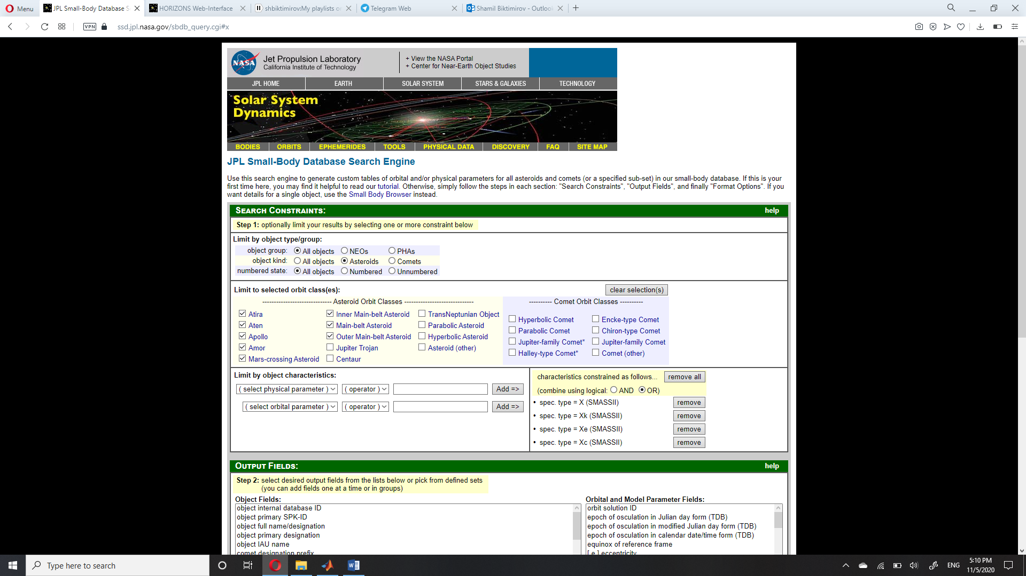

249 asteroids satisfying reqs on sp type and diameters