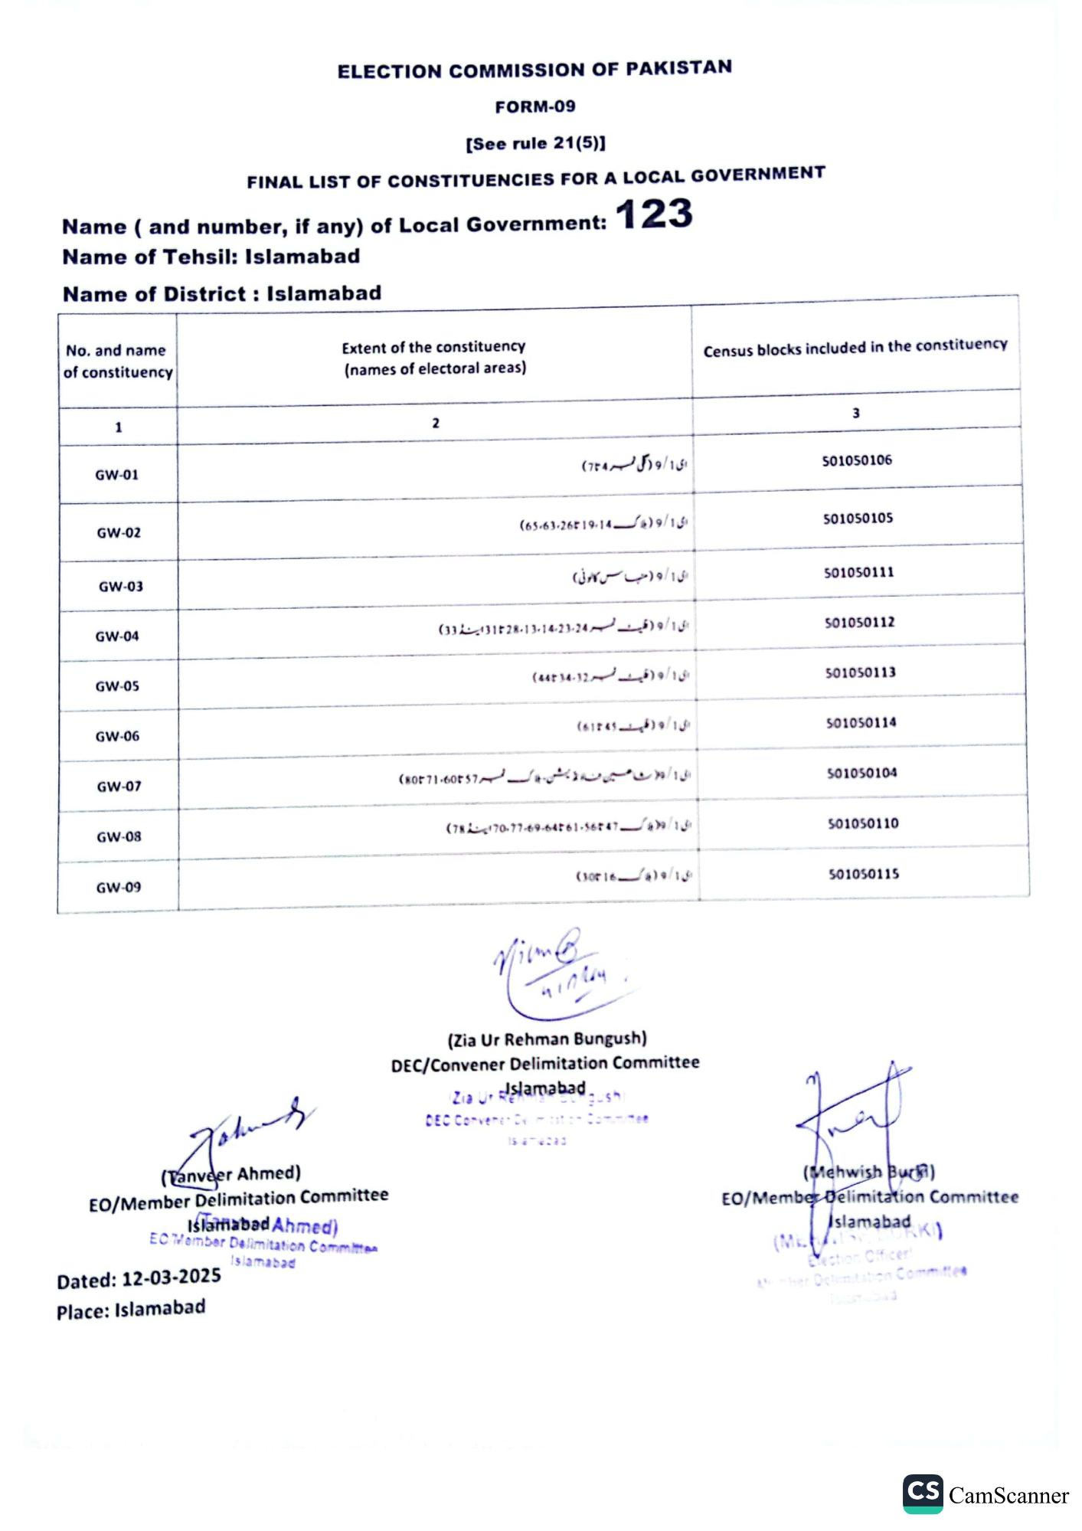
ELECTION COMMISSION OF PAKISTAN
FORM-09
[See rule 21(5)]
FINAL LIST OF CONSTITUENCIES FOR A LOCAL GOVERNMENT
Name (and number, if any) of Local Government: 123
Name of Tehsil: Islamabad
Name of District: Islamabad
No. and name of constituency
Extent of the constituency (names of electoral areas)
Census blocks included in the constituency
1
GW-01
GW-02
GW-03
GW-04
GW-05
2
ای ۱ / و (گلی نمبر (74)
(65-63-26719-149/16
ی ۱ / و ( حبس کالونی)
(3331828-13-14-23-24) 9/1
(44234-3259/1§
3
501050106
501050105
501050111
501050112
501050113
GW-06
(61845)9/1
501050114
GW-07
(80871-600 57LA/13
501050104
GW-08
GW-09
Johans
(Tanveer Ahmed)
EO/Member Delimitation Committee
Islamabad Ahmed)
EC Member Delimitation Committen
Dated: 12-03-2025
Islamabad
Place: Islamabad
(78170-77-69-64261-56247/49/13
501050110
(30r16)9/18
501050115
Vium B
पातविय
(Zia Ur Rehman Bungush)
DEC/Convener Delimitation Committee
Zia Ur Islamabadsh
DEC Convener Dv
(Mehwish Buck)
EO/Member Delimitation Committee
Islamabad
Election Officer!
Amber Octimitation Committe
CS CamScanner

