Sri Lanka Institute of Information Technology



**Enterprise Standards and Best Practices for IT Infrastructure**

**4th Year 2nd Semester**

**vMotion**

Name: **S.U.K. Hingalagoda**

Registration No: **IT 13 0568 58**

**What is vMotion?**

The technology vMotion allows the user to move virtual servers and desktops from one physical server to another without having to shut down the virtual desktop or server. All of this is done in real time without the user of the virtual machine even knowing they have been moved. vMotion is the first step among many VMware software solutions that are incorporated to make sure that downtime is kept to a minimum, which include Fault Tolerance, High Availability, and Digital Resource Scheduler.

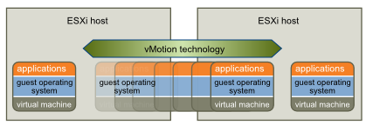

**Requirements for vMotion**

* Both the source ESX host and the destination ESX host must be able to access the same shared storage on which the VM is located; the shared storage can be either FC, iSCSI, or NFS. VMotion will also work with Raw Device Mappings (RDMs) as long as they are configured to work in virtual compatibility mode.
* ESX hosts must have a Gigabit Ethernet network adapter or higher to be configured on the VMkernel vSwitch used by VMotion; slower NICs will work, but they are not recommended. For best results, and because VMotion traffic is sent as clear text, it is best to have an isolated network for VMotion traffic.
* ESX hosts must have processors that are able to execute each other's instructions. Processor clock speeds, cache sizes, and number of cores can differ among ESX hosts, but they must have the same processor vendor class (Intel or AMD) and compatible feature sets. It is possible to override these restrictions for CPUs from the same vendor, but doing so can cause a VM to crash because it must access a CPU feature or instruction that the new ESX host does not support.

Additional requirements for VMotion to function properly

* vSwitch network labels (port groups) must match exactly (including case) on each ESX host.
* A VM cannot be using CPU affinity, which pins a VM to run on a specific processor(s) on an ESX host.
* A VM cannot be connected to an internal-only (no NICs assigned to it) vSwitch.
* Using jumbo frames is recommended for best performance.
* The source and destination hosts must be licensed for VMotion.
* A VM cannot have its virtual CD-ROM and floppy drives mapped to either a host device or a local datastore ISO file.

**Benefits of vMotion**

* **Automatically optimize and allocate entire pools of resources**

By having all your server and/or desktops virtualized you can move VM’s from one physical host to another, which is done rapidly over a high speed network connection, the original host and destination host stay in sync until the transfer it complete leaving the user unaware of the move. This allows network administrators to easily select resource pools to assign to the different VMs

* **Minimizes scheduled Downtime**

90% of downtime is scheduled, before vMotion administrators had to do server maintenance late at night in order to avoid disrupting users. Having all the servers as virtual machines, you only have to move the VM to another physical host, creating zero downtime for the users and allowing administrators to perform maintenance at any time. With DRS (Digital Resource Manager), all you have to do is put a server in maintanence mode and vMotion will automatically move all VM's to another server

* **Move VM’s from failing or underperforming priorities**

If there looks like a server is about to fail or is reaching its capacity, administrators can manually move VMs to another physical host, this allows your data center to be more dynamic in nature. Instead of having to upgrade hardware, you can move VM to another host to allow each VM to be more flexible in nature. If 2 VM's are putting a physical host to capacity then you could move one to another server that isn't being used as much.

* **Storage vMotion**

While technically its own separate feature, it works similar to vMotion, except it deals completely with data. As a VM starts to reach its data capacity, the LUN can easily be moved to a larger storage center. This is done without disruption to the users or having to manually reassigning more space to the VM.

**Steps to configure vMotion on VMware ESXi**

* Click on **Configuration** tab and then select **Network Adapters**. The new connection will be visible. (Here the new network card is vmnic9 as appeared.)

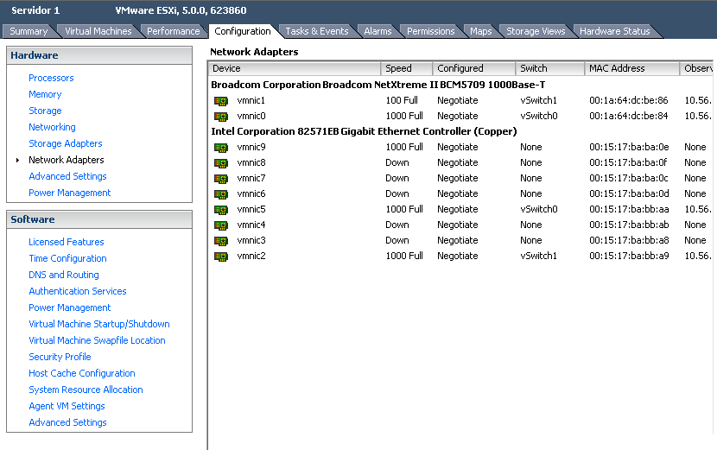

* Select **Networking** under **Configuration** tab. Then click on **Add** **Networking** to create the Switch.

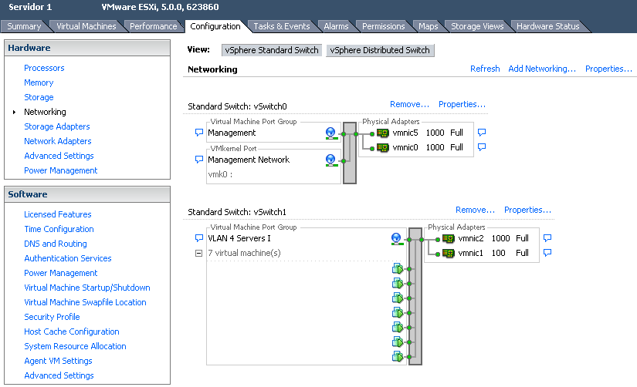

* In **Add Networking** window click on **VMkernel** and click **Next.**

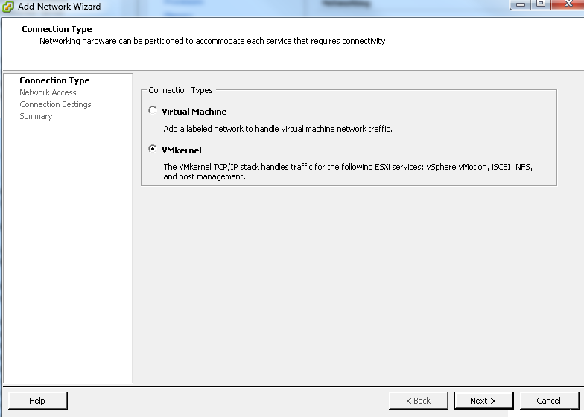

* Make a new network card or cards that have connected from one serer to another and click on **Next**. (Here it’s vmnic9)

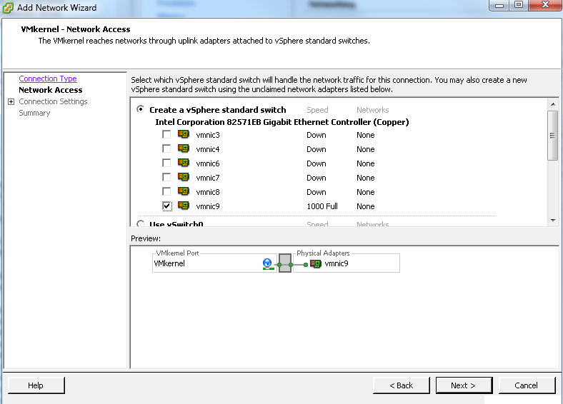

* Give a **Network Label** name and click on **Next**.

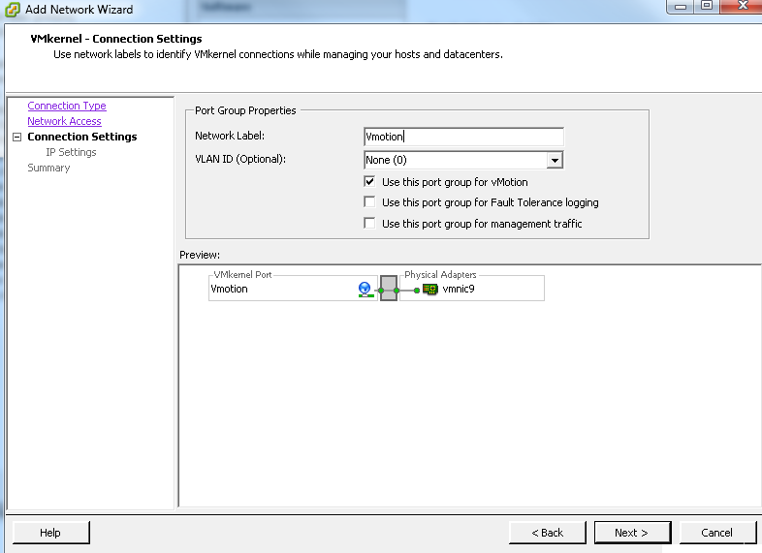

* Provide appropriate IP settings as required and click on **Next**.

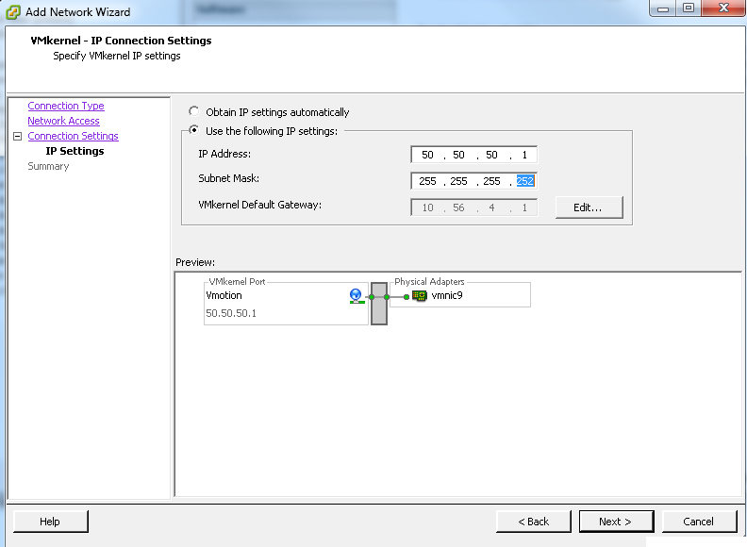

* Click on **Finish.**

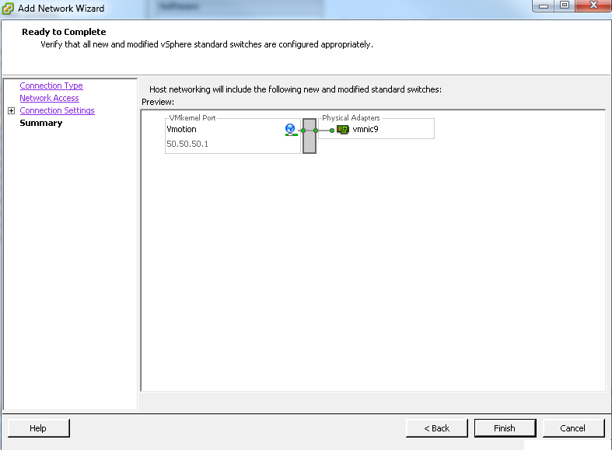

* Details about newly created virtual switch with vmotion will be appeared in the window.

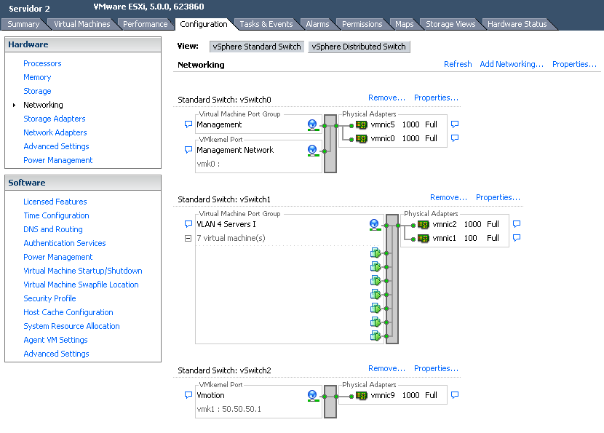

* Continue the same steps with the other serer involved.
* Click on **Configuration** tab on the new server and then select **Network Adapters**.

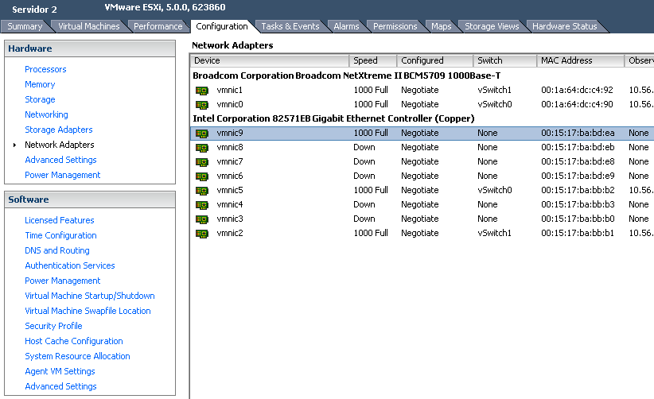

* Select **Networking** under **Configuration** tab. Then click on **Add** **Networking** to create the Switch.

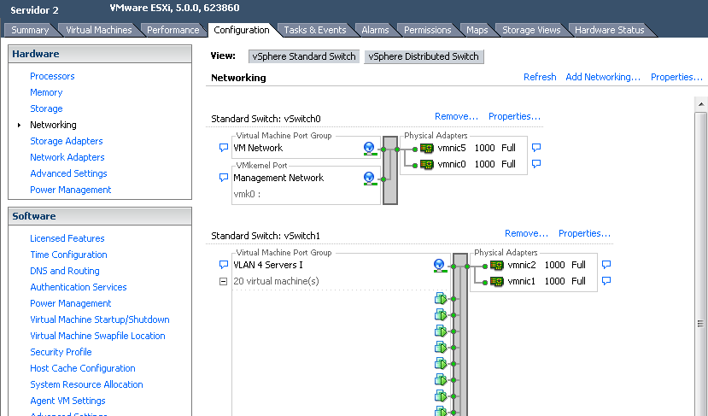

* In **Add Networking** window click on **VMkernel** and click **Next.**

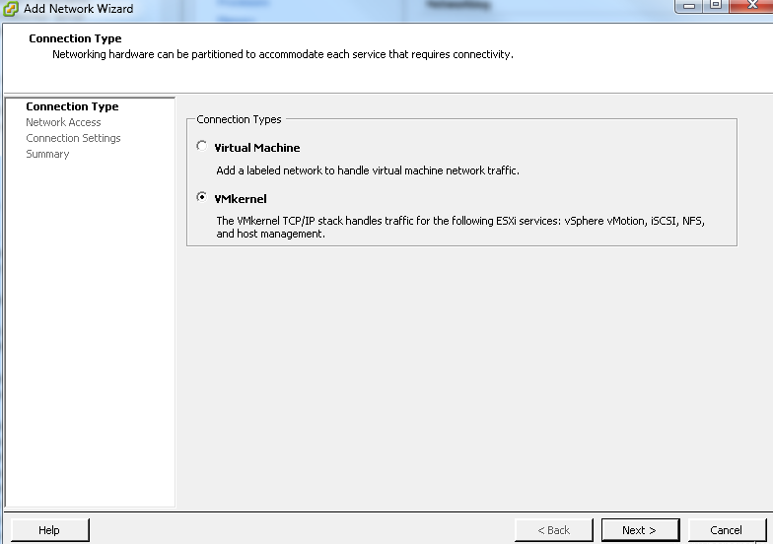

* Make a new network card or cards that have connected from one serer to another and click on **Next**. (Here it’s vmnic9)

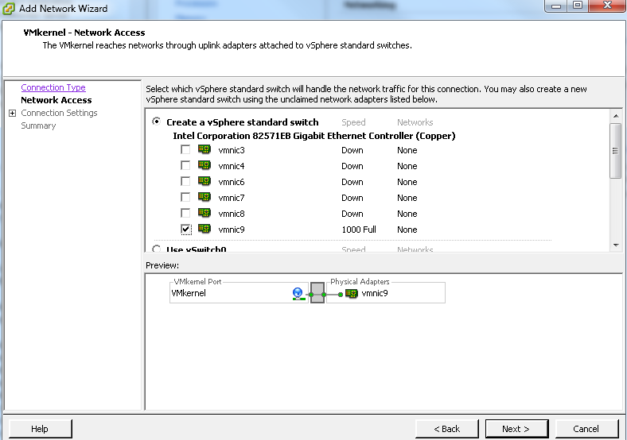

* Give a **Network Label** name and click on **Next**.

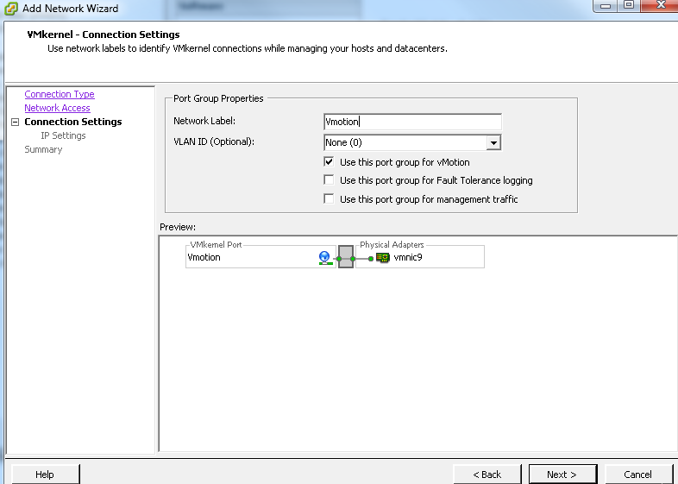

* Provide appropriate IP settings as required and click on **Next**. (Here the IP address must be different from the server that has been configured earlier).

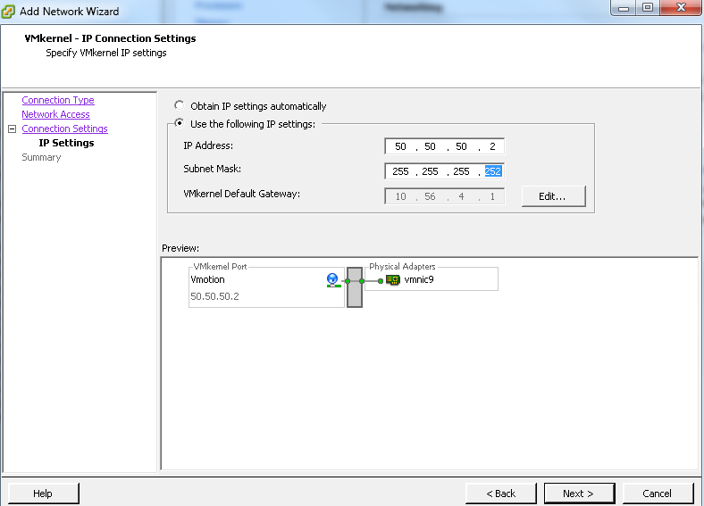

* Click on **Finish.**

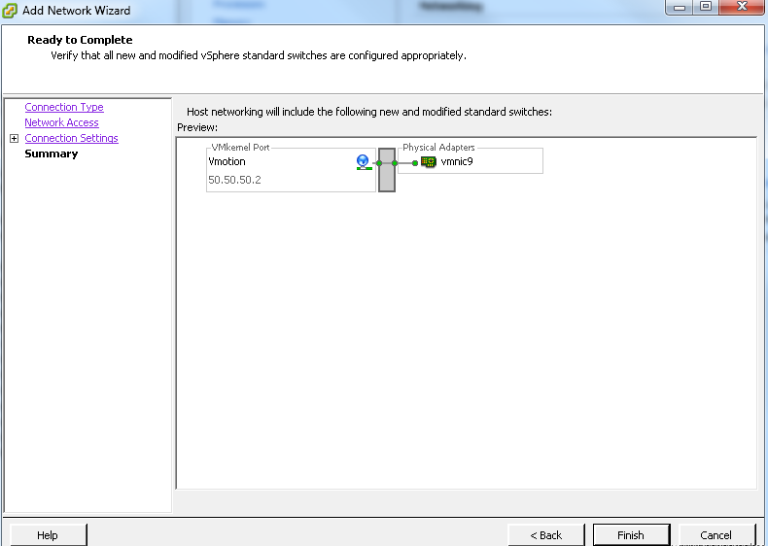

* To ensure that the entire system is working properly migrate a VM from one ESXi to the other using vMotion functionality that have been configured.
* Click on the right mouse button on a virtual machine. Then click on **Migrate**.

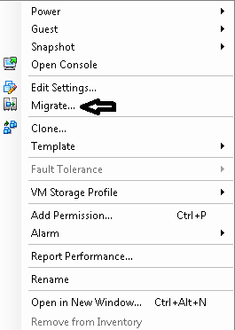

* Select **Migration Type** and click on **Next.**

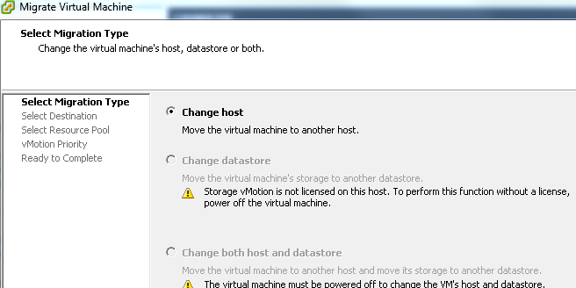

* Select the target server (destination) where we will move the virtual machine and click on **Next.**

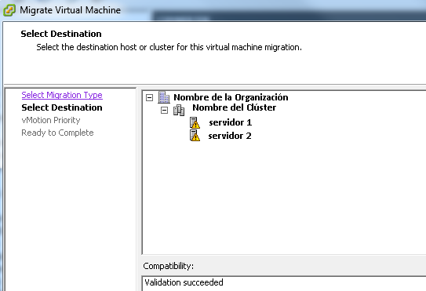

* Select the **vMotion Priority** and click on **Next.**

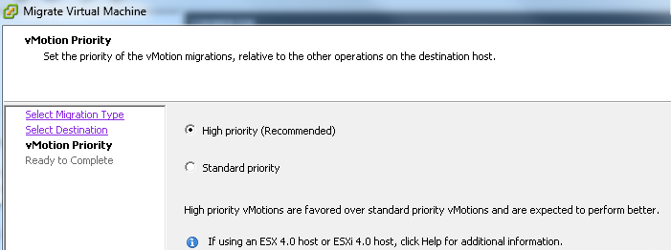

* Click on **Finish** to start the migration.

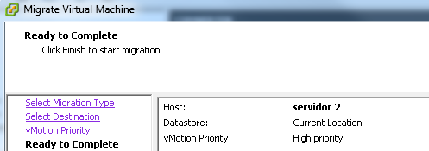

* **Status** of the system migration will be shown.

21.png