**Project Report**

**On**

**“Point Of Sale System”**

**Submitted By**

**Shamim Raj**

ID: 220322004

**Md Imran Mia**

ID:220322047

**Sushanta Sarkar**

ID:220322025

**Naimul Islam**

ID:220322001

**Babu Bepary**

ID:190122078

**Mehedi Hasan Easha**

ID:220322028

**Supervised by**

Md. Tahfimuzzaman

Lecturer

Department of Computer Science and Engineering

**A project submitted in partial fulfillment of the requirement for the degree of Bachelor of Science in Computer Science and Engineering**

**Department of Computer Science and Engineering**

**European University of Bangladesh**

|  |  |  |
| --- | --- | --- |
|  |  |  |
|  |  |  |
|  |  |  |
|  |  |  |
|  |  |  |
|  |  |  |
|  |  |  |
|  |  |  |
|  |  |  |
|  |  |  |

DASHBOARD

We have a gorgeous looking dashboard for our customer from where they get Revenue, Sale Return, Purchase Return and Profit information of today / last 7 days / current month / current year at a glance by one click.

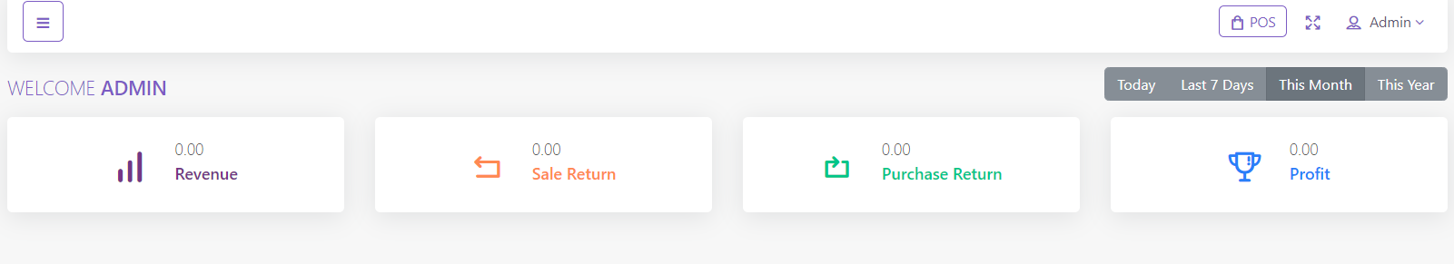

### PRODUCT

## **Category**

You can add, edit and delete product category. You can also import category from CSV file and export table data to PDF, Excel, CSV. Also you can print data from table.

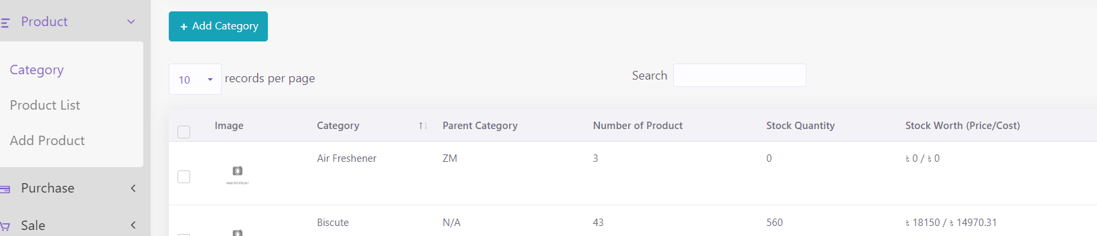

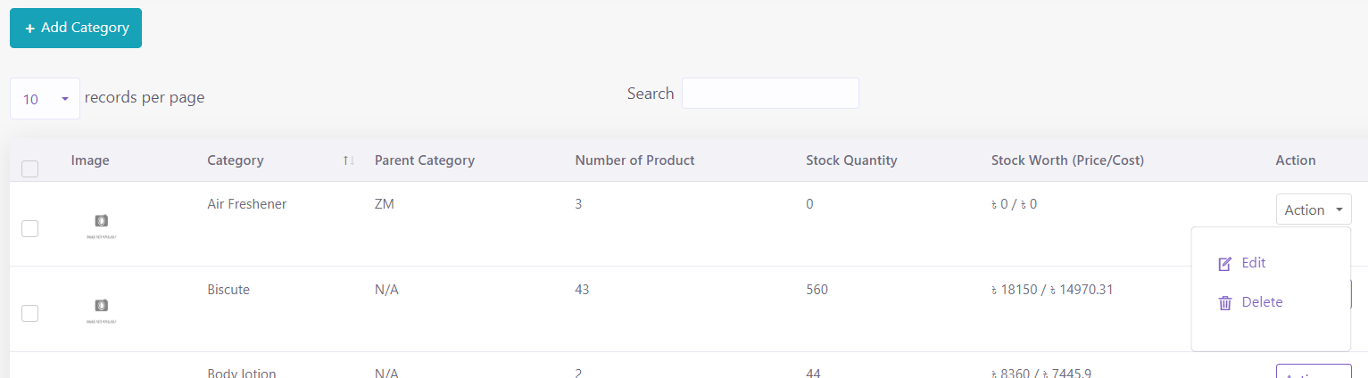

## **Product**

In product section you will just add general information of a product. **To add stock you have to purchase that product.** You can create three types of product in SaleProPOS.

* Standard
* Digital
* Combo (Combination of standard product. Like mango juice is a combo product as it is consist of mango and sugar ).
* Service

You can add, edit and delete product. You can import product from CSV. **You must follow the instruction to import data from CSV**. To get better understanding you can download the sample file.

You can sort table data according to column

And you can search, export and print data from table that we discussed earlier in greater detail.

### ADDING STOCK

In **Product** section you just added general information of product. So where the stock comes from? To add stock you have to purchase that product for specific warehouse. This software is pretty smart that it will automatically update the stock quantity and you don't have to worry about it.

### PURCHASE

## **Add Purchase**

You can create purchase in Purchase module. **By creating purchase the stock quantity of product will be increased.** .There are three purchase status: Recieved, Partial, Pending, Orderd. You can add product to order table by typing or scanning barcode of product

### PURCHASE

## **Add Purchase**

You can create purchase in Purchase module. **By creating purchase the stock quantity of product will be increased.** .There are three purchase status: Recieved, Partial, Pending, Orderd. You can add product to order table by typing or scanning barcode of product

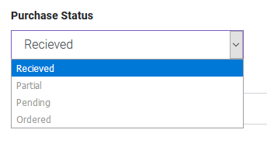   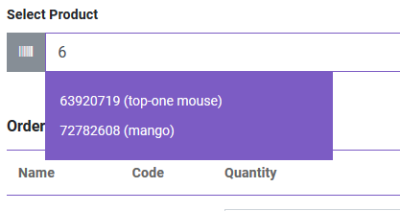

You can also edit product info from order table.

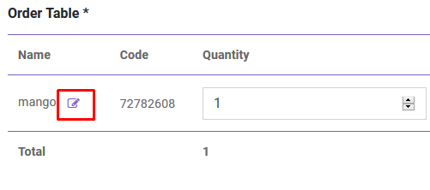

After creating purchase you will be redirected to purchase index page. You will get summary of purchase from table. To get details you just have to click in the table row.

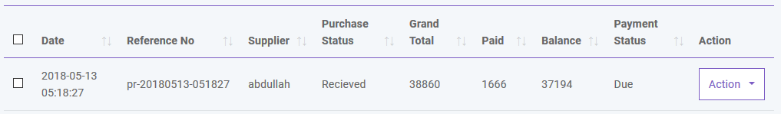

## **Payment**

You can make payment from Purchase table. You can make payment with Cash, Gift Card, Cheque, Credit card and Deposit.

## **Payment**

You can make payment from Purchase table. You can make payment with Cash, Gift Card, Cheque, Credit card and Deposit.

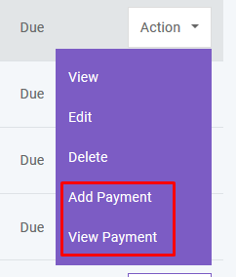   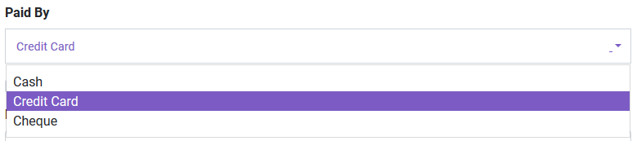

And you can search, export and print data from table that we discussed in [Product](https://salepropos.com/demo/public/read_me/#product) section.

### SALE

## **POS**

You can create sale from POS. Customer, Warehouse and Biller (representative of your company) will be automatically selected according to POS Settings under [Settings](https://salepropos.com/demo/public/read_me/#setting) module. Touch screen keybord is activated in POS module. You can add product to order table by typing or scanning barcode of product. Featured Product will be displayed in the right side. You can also add product by clicking product image. You can edit product info from order table.

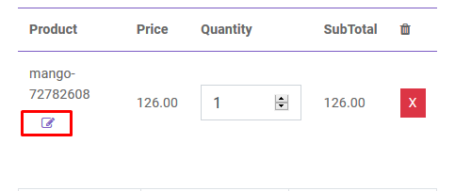

To add order discount, order tax and shipping cost you just have to click the button that are shown below. To finalize the sale you have to click the **Payment** button.

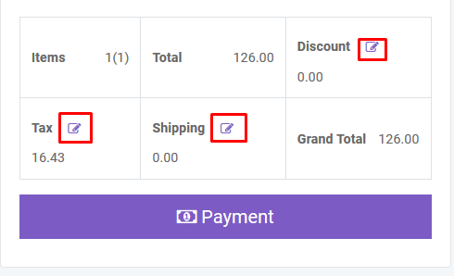

After creating sale you will be redirected to sale index page. A confirmation mail will be sent automatically to customer's email with sale details. You will get summary of sale from table. To get details you just have to click in the table row.

## **Payment**

You can make payment from Sale table. You can make payment with Cash, Cheque, Credit Card, Gift Card, Deposit and Paypal. A confirmation mail will be sent automatically to customer's email with payment details.

   

And you can search, export and print data from table that we discussed in [Product](https://salepropos.com/demo/public/read_me/#product) section.

## **Delivery**

You can add delivery for your sold products. A confirmation mail will be sent automatically to customer's email with delivery details.

### PEOPLE

## **Add User**

You can create, edit and delete user account. By creating user account password will be sent to the user's email that is given. Again you can active or inactive a user.

There is also be a register option to create user account. But his/her ID will not be activated untill admin will approve it.

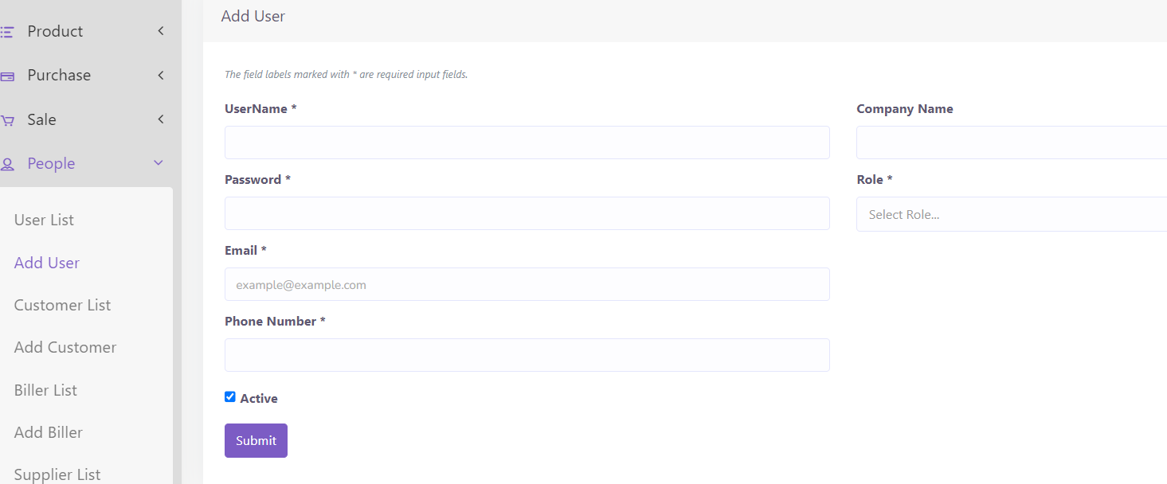

## **Add Customer**

You can create, edit and delete customer. After creating customer a confirmation email will automatically send to customer. You can add money to customer's database just like a bank account. You can also import customer with CSV file. **You must follow the instruction to import data from CSV.**

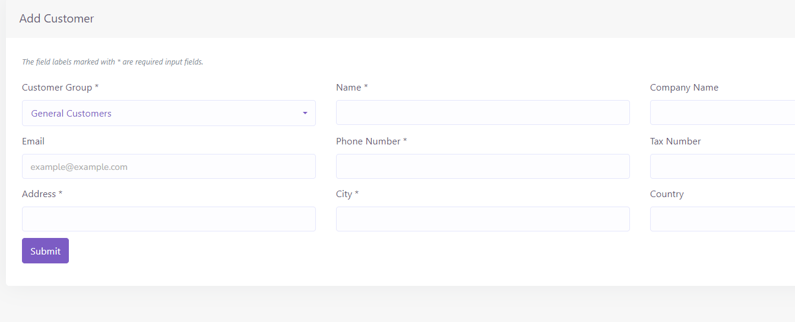

## **Add Biller**

Biller is the representative of your company. You may have multiple company and you want to manage all your inventory from a single platform. So this is a solution for enterprise. You can create, edit and delete biller. After creating biller a confirmation email will automatically send to biller. You can also import biller with CSV file. **You must follow the instruction to import data from CSV.**

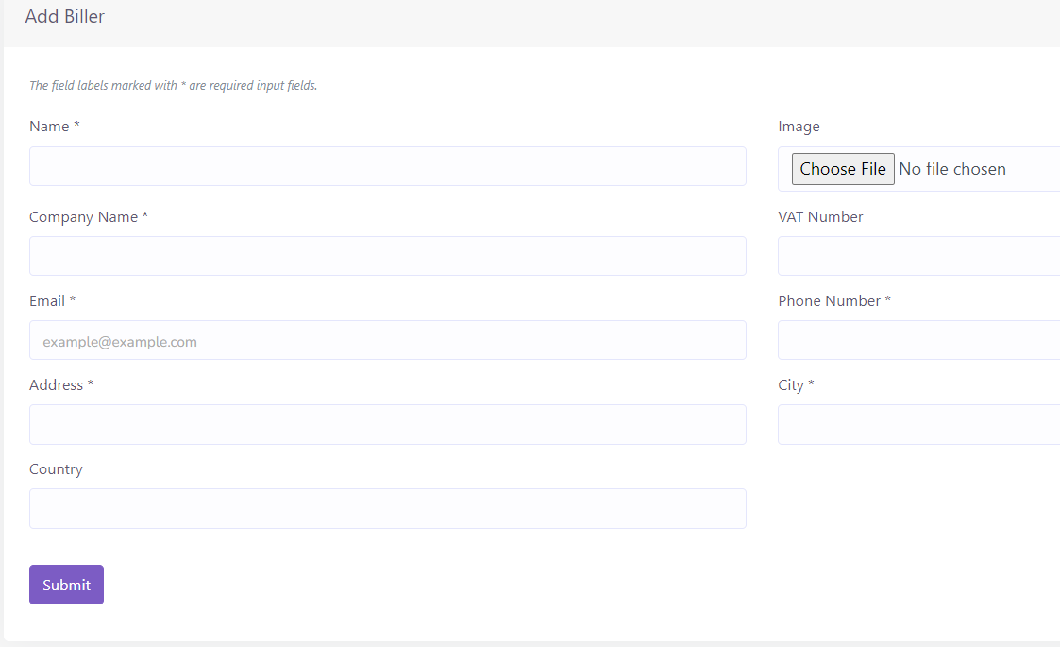

## **Add Supplier**

Supplier is the people from whom you purchase products. You can create, edit and delete supplier. After creating supplier a confirmation email will automatically send to supplier. You can also import supplier with CSV file. **You must follow the instruction to import data from CSV.**

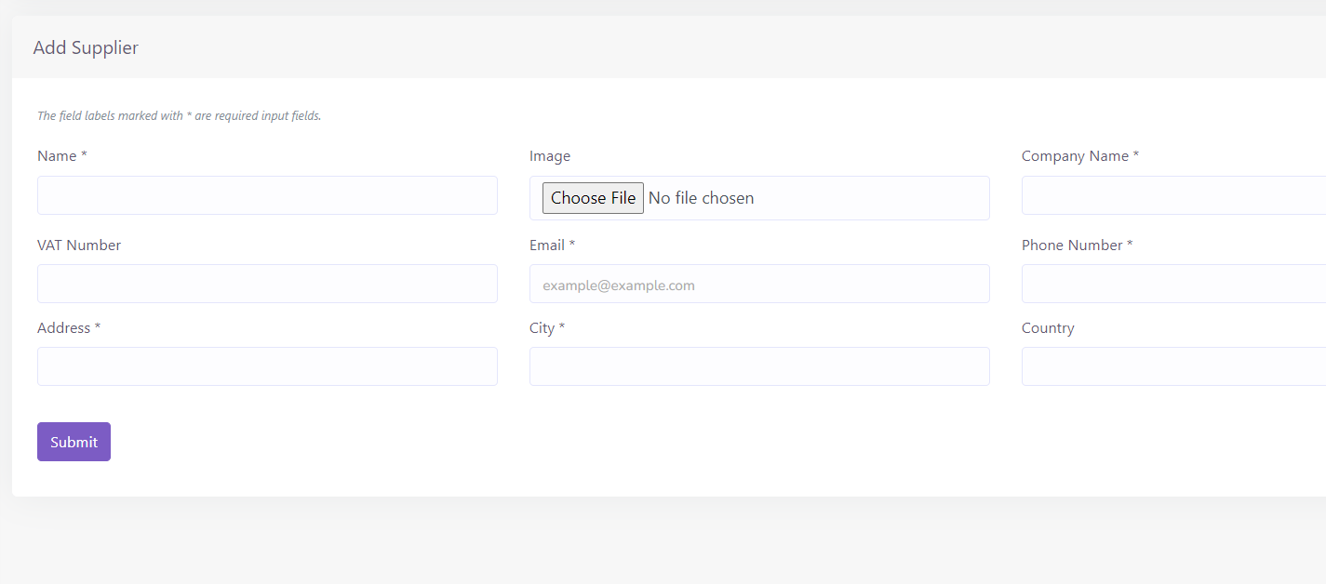

And you can search, export and print data from table that we discussed in [Product](https://salepropos.com/demo/public/read_me/#product) section.