InvestorHub: A Web-Based Investor and Business Matching Platform with Verified Onboarding, Real-Time Communication and Online Payment Settlement
[Student Name]
ID# [Student ID]

A Practicum in the Partial Fulfillment of the Requirements
for the Award of Bachelor of Computer Science and Engineering (BCSE)

Department of Computer Science and Engineering
IUBAT School of Computer Science and Engineering
IUBAT—International University of Business Agriculture and Technology

Spring 2026

InvestorHub: A Web-Based Investor and Business Matching Platform with Verified Onboarding, Real-Time Communication and Online Payment Settlement

[Student Name]

A Practicum in the Partial Fulfillment of the Requirements for the Award of Bachelor of Computer Science and Engineering (BCSE)
The practicum has been examined and approved,

_____________________________
Prof. Dr. Utpal Kanti Das
Dean and Chair

_____________________________
Shahinur Alam
Co-supervisor, Coordinator and Assistant Professor

_____________________________
[Supervisor Name]
[Designation], Department of Computer Science and Engineering

Department of Computer Science and Engineering
IUBAT School of Computer Science and Engineering
IUBAT—International University of Business Agriculture and Technology
Spring 2026

Letter of Transmittal
23 May 2026
The Chair
Practicum Defense Committee
Department of Computer Science and Engineering
IUBAT School of Computer Science and Engineering
IUBAT—International University of Business Agriculture and Technology
4 Embankment Drive Road, Sector 10, Uttara Model Town
Dhaka 1230, Bangladesh.
Subject: Letter of Transmittal.
Dear Sir,
It is my pleasure to submit the practicum report titled "InvestorHub: A Web-Based Investor and Business Matching Platform with Verified Onboarding, Real-Time Communication and Online Payment Settlement", which I prepared as part of the requirement of the CSC 490 Practicum for the Bachelor of Computer Science and Engineering programme. The practicum was carried out at [Organization Name] over a period of twelve weeks, during which I worked in the product team and developed the platform described in this report.
The report presents the background of the study, the requirement engineering and analysis of the system, its design, the project management and planning activity, the testing that was carried out, and the ethical considerations of the work. I have tried to follow the prescribed format and to present the work honestly, including its limitations. I would be grateful if you would kindly accept this report and give me the opportunity to defend it before the committee.
Yours sincerely,
_____________
[Student Name]
[Student ID]

Organization’s Certificate

Place your organization’s certificate scanned copy here.

Student’s Declaration
I hereby declare that this practicum report titled "InvestorHub: A Web-Based Investor and Business Matching Platform with Verified Onboarding, Real-Time Communication and Online Payment Settlement" is the result of my own work carried out at [Organization Name] under the supervision of [Supervisor Name]. The analysis, design, implementation and testing described in this report were performed by me. All external sources of information that I have used are acknowledged in the reference list, and no part of this report has been copied from any other report or submitted previously for the award of any other degree or diploma.

_____________
[Student Name]
[Student ID]

Supervisor’s Certification
This is to certify that the practicum report titled "InvestorHub: A Web-Based Investor and Business Matching Platform with Verified Onboarding, Real-Time Communication and Online Payment Settlement" has been prepared by [Student Name], bearing ID [Student ID], under my supervision as a partial fulfilment of the requirement for the award of the degree of Bachelor of Computer Science and Engineering. The work is original and, to the best of my knowledge, has not been submitted elsewhere for any other degree. I recommend the report for submission to the practicum defense committee.

_______________________________
[Supervisor Name]
[Designation], Department of Computer Science and Engineering
Department of Computer Science and Engineering
IUBAT School of Computer Science and Engineering
IUBAT—International University of Business Agriculture and Technology

Abstract
Small and medium enterprises in Bangladesh consistently report access to finance as their strongest constraint, while individual investors lack a verified pipeline of opportunities; today the two sides meet mainly through personal contacts and social media groups where identity is unverified, discovery is unstructured and no record of an agreement survives. This practicum designed and developed InvestorHub, a moderated web platform that connects verified investors with verified business owners and supports the whole engagement cycle. An applicant registers in one of the two roles, pays a one-time registration entry fee through a payment gateway, submits a national identity document and is activated by an administrator; listings are published only after administrative approval; a match request is permitted only between opposite roles and, once accepted, opens a real-time chat channel; and an investor funds a business listing through the SSLCommerz gateway, where every transaction is re-validated with the gateway before it is recorded, a platform commission is deducted and an invoice is generated. The system was implemented with Node.js, Express and MongoDB on the server, React on the client and Socket.IO for real-time messaging, following an incremental process model over four increments. It was modelled using use case, activity, swimlane, sequence, data flow, entity relationship and class diagrams, estimated at 281 adjusted function points, and verified through twenty-four executed test cases covering authentication, access control, listing moderation, matching, real-time messaging, payment settlement and abuse control, all of which passed. The delivered platform demonstrates that verified onboarding, moderated content, controlled communication and gateway-validated settlement can be combined into one system that is affordable to operate; its present limitations are manual identity verification, the absence of an escrow facility and the absence of algorithmic matching, each of which is addressed in the future plan.

Acknowledgments
First of all, I express my gratitude to Almighty Allah for giving me the strength and patience to complete this practicum. I am deeply grateful to my supervisor, [Supervisor Name], [Designation], Department of Computer Science and Engineering, IUBAT, for the guidance and the detailed feedback given in every weekly meeting, which shaped both the system and this report. I am thankful to Prof. Dr. Utpal Kanti Das, Dean and Chair, and to Shahinur Alam, Coordinator, for organising the practicum programme and for their continuous support. I sincerely thank [Organization Supervisor Name] of [Organization Name] for accepting me into the product team, for explaining the requirements of the platform and for reviewing each increment. I am also grateful to the teachers of the department whose courses prepared me for this work, and to my fellow students for their advice during the development. Finally, I thank my parents and my family for their encouragement and support throughout my studies.

Table of Contents
Letter of Transmittal iii
Organization’s Certificate iv
Student’s Declaration v
Supervisor’s Certification vi
Abstract vii
Acknowledgments viii
List of Figures xii
List of Tables xiii
Chapter 1. Introduction 1
1.1 Background of the Study 2
1.2 Methodology 2
1.2.1 Primary Sources 2
1.2.2 Secondary Sources 2
1.3 Objectives 2
1.3.1 Broad Objective 3
1.3.2 Specific Objectives 3
1.4 Process Model 3
1.5 Feasibility Study 3
1.5.1 Technical Feasibility 3
1.5.2 Economic Feasibility 3
1.5.3 Operational Feasibility 3
1.6 Structure of the Report 3
Chapter 2. Organizational Overview 4
2.1 Organization Vision 5
2.2 Organization Mission 5
2.3 Organization Services 5
2.4 Organizational Structure 5
2.5 Working Position in the Organization 5
2.6 Address of the Organization 5
Chapter 3. Methods 6
3.1 Headings 7
3.2 Section Title 7
3.3 PB-Head Style 7
3.4 PC-Head Style and Accompanying Paragraph 8
3.4.1 Body Text with PC-Head 8
3.5 Numbered List Style 8
3.6 Bulleted List Style 9
3.7 Figures 9
3.7.1 Figure Style 10
3.7.2 Figure Description Style 10
3.8 Tables 10
3.8.1 Table Title Style 11
3.8.2 Table Cell Style 11
3.8.3 Table Description Style 11
3.9 Referencing 11
3.9.1 Referencing in text 12
3.9.2 The Reference List 13
Chapter 4. Conclusion 22
References 24

List of Figures
Figure 2.1 Organizational Structure 5
Figure 3.1 Figure Title. 9
Figure 3.2 Figure Title2. 10

List of Tables
Table 3.1 Table Title. 11
Table 3.2 In-text Citation Style. 12
Table 3.3 IEEE Referencing Style quick guide 14

Chapter 1.

Introduction

Small and medium businesses in Bangladesh often have a workable plan but no dependable way to reach an investor, while individual investors have capital but no verified pipeline of opportunities. The two sides usually meet through personal contacts, scattered Facebook groups or informal brokers, so the search is slow and neither side can check the other in advance. InvestorHub was built during this practicum to close that gap: it is a web platform where a verified investor and a verified business owner can publish what they are looking for, request a match, negotiate over real-time chat, and settle the agreed amount through an online payment gateway, with an administrator moderating every account and every listing.
This chapter explains why the work was undertaken, how the information was collected, what the system was expected to achieve, which process model guided the development, whether the project was feasible, and how the remaining chapters of this report are organised.

1.1 Background of the Study
Access to finance is repeatedly identified as the strongest barrier to growth for cottage, micro, small and medium enterprises in Bangladesh. A business owner who cannot satisfy the collateral requirements of a bank is left with informal lenders or with personal savings, both of which limit how fast the business can grow. At the same time, a growing number of professionals and expatriates are willing to place a modest amount of capital in a local venture, but they have no organised way of discovering such ventures or of checking whether the person behind a proposal is real.
The existing alternatives solve only part of the problem. Social media groups create visibility but no verification, no record of who agreed to what, and no protection for the money that changes hands. General classified sites list opportunities but treat an investment proposal like any other advertisement. International equity crowdfunding platforms are not adapted to the local payment ecosystem and are largely inaccessible to a small business in a district town.
The practicum therefore focused on a single, well-defined problem: build a moderated marketplace in which identity is verified before an account becomes active, listings are approved before they become public, communication is restricted to genuinely matched parties, and money moves through a recognised payment gateway that leaves an auditable record. The study is limited to the design and implementation of this platform; it does not attempt to evaluate the financial performance of the investments made through it.

1.2 Methodology
Two categories of data sources were used to understand the problem, to derive the requirements and to prepare this report. Primary sources produced the requirements and the acceptance criteria, while secondary sources supplied the technical and methodological background.

1.2.1 Primary Sources
The primary sources used during the practicum are given below:
- Weekly requirement and review meetings with the organization supervisor, in which each increment was demonstrated and the next set of tasks was agreed.
- Informal interviews with two small business owners and one private investor, which produced the verification, moderation and negotiation requirements.
- Direct observation of how the same users currently arrange funding through social media groups and personal contacts.
- Hands-on testing of the developed increments, in which every route and every user journey was exercised and the defects were recorded and fixed.
- The official SSLCommerz sandbox account, used to observe the real behaviour of a hosted checkout, its callbacks and its validation API.

1.2.2 Secondary Sources
The secondary sources consulted during the practicum are given below:
- Official documentation of the technologies used: Node.js, Express, MongoDB, Mongoose, React, Socket.IO and the SSLCommerz integration guide.
- Software engineering textbooks and course material for the process model, function point estimation, risk management and software testing techniques applied in Chapters 5, 6 and 8.
- Published articles and reports on access to finance for small and medium enterprises in Bangladesh, used to justify the problem statement.
- The department practicum guidelines and report template, which defined the structure of this document.

1.3 Objectives
The objectives of the developed system are divided into a broad objective, which states the overall purpose of the work, and a set of specific objectives, which are measurable and were each verified before the practicum ended.

1.3.1 Broad Objective
The broad objective of this practicum is to design and develop a secure, moderated web platform that connects verified investors with verified business owners in Bangladesh, and that supports the complete engagement cycle from discovery and matching through negotiation to an online payment settlement with a permanent transaction record.

1.3.2 Specific Objectives
- To build a role-based authentication system in which every account is verified by an identity document and activated by an administrator before it can use the platform.
- To provide a listing module where an investor or a business owner can publish, search, filter and manage proposals, with administrative approval before a listing becomes public.
- To implement a matching workflow that allows a request only between opposite roles and that opens a real-time chat channel once the request is accepted.
- To integrate the SSLCommerz payment gateway for the registration entry fee and for investments, with server-side validation, a platform commission and a downloadable invoice.
- To provide an administrative dashboard for user moderation, listing approval, report handling, payment monitoring and platform analytics.

1.4 Process Model
The incremental process model was followed during the practicum. The complete platform was divided into four increments, and each increment repeated the five framework activities of communication, planning, modeling, construction and deployment. Every increment ended with a working release that was demonstrated to the supervisor, and the feedback collected in that demonstration shaped the next increment. Figure 1.1 shows how the model was applied.
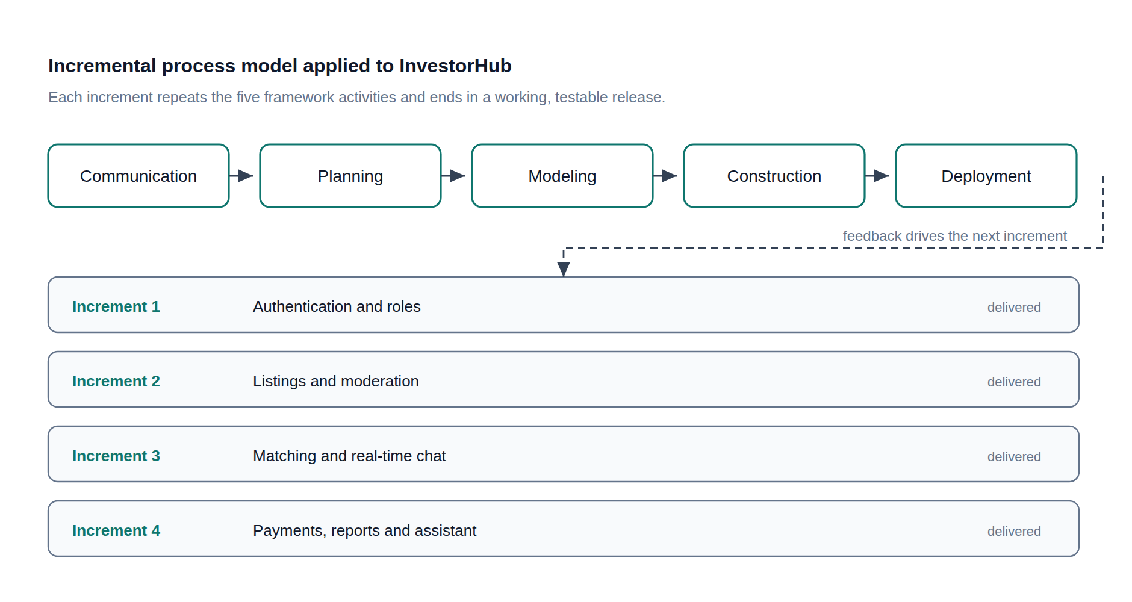
Figure 1.1 Incremental process model followed in this practicum.
Figure 1.1 shows the five framework activities repeating over four increments, each of which delivered a working and testable part of InvestorHub.
The incremental model was chosen for the following reasons:
- The core requirements were clear from the first week, but the details of moderation, matching and payment settlement were expected to change as the supervisor reviewed each demonstration.
- A single developer had to deliver the work within a twelve-week practicum, so a model that produces a usable release early and adds capability afterwards reduces the risk of ending with nothing deliverable.
- The payment module depended on an external gateway whose behaviour could only be learned by experiment, so it had to be isolated in its own increment rather than planned in full at the start.
- The waterfall model was rejected because it assumes stable and complete requirements, and a fully agile method with a daily customer presence was not possible in an academic placement with weekly supervision.

1.5 Feasibility Study
Before construction began, the project was examined from three angles to confirm that it could actually be delivered with the available skills, budget and working environment.

1.5.1 Technical Feasibility
The platform is built entirely on free and mature open-source technology. The server uses Node.js with the Express framework, the database is MongoDB accessed through Mongoose, the client is a React single-page application built with Vite and styled with Tailwind CSS, and real-time messaging uses Socket.IO. All of these run on ordinary hardware and are supported by extensive documentation, and the same JavaScript language is used on both sides, which suits a single developer. The one external dependency, the SSLCommerz payment gateway, publishes a sandbox environment that allowed the whole payment cycle to be developed and tested without handling real money. The project is therefore technically feasible.

1.5.2 Economic Feasibility
The development cost was limited to the developer's time, because every framework and library used in the project is free of licence cost. The database runs on a free managed cluster during development, the payment gateway charges only a per-transaction fee on live traffic, and hosting a system of this size costs a small monthly amount. On the revenue side the platform earns a one-time registration entry fee from every member and a ten percent commission on every completed investment, so the running cost is recovered from a modest number of successful transactions. A detailed cost breakdown is presented in Chapter 6. The project is therefore economically feasible.

1.5.3 Operational Feasibility
The platform is used through a normal web browser and needs no installation, which matters for users who work mainly from a mobile phone. The interface follows patterns that users already know from social media and e-commerce sites: a feed of listings, a search box with filters, a chat window and a notification area. The administrator needs no technical background, since moderation is performed through buttons on the dashboard rather than through the database. Payment is made through the familiar SSLCommerz page, which already supports the cards and mobile financial services used in Bangladesh. The project is therefore operationally feasible.

1.6 Structure of the Report
The report is organised into ten chapters. Chapter 1 introduces the problem, the objectives, the process model and the feasibility of the work. Chapter 2 describes the organization in which the practicum was carried out. Chapter 3 presents requirement engineering, including the user, system, functional and non-functional requirements and the use case diagram. Chapter 4 covers the analysis of the system through activity diagrams, swimlane diagrams and the class diagram. Chapter 5 records the project management activity, in particular risk identification, analysis, planning and the RMMM plan. Chapter 6 presents project planning, function point estimation, the schedule and the cost accounts. Chapter 7 explains the design of the interface, the data flow and the database. Chapter 8 reports the quality management process and the executed test cases. Chapter 9 discusses the ethical and sustainability considerations of the work. Chapter 10 concludes the report with the benefits, the limitations, the value of the practicum and the future plan, and is followed by the references and the plagiarism report.

Chapter 2.

Organization Overview

The practicum was carried out at [Organization Name], a software development company based in Dhaka, Bangladesh. The company builds web and mobile applications for local clients and maintains an internal product team, and it accepts a small number of practicum students each semester into that team. The author was attached to the product team for twelve weeks and was assigned the InvestorHub platform described in this report, working alongside the organization supervisor who reviewed each increment.
[Replace this paragraph with two or three sentences about the organization: the year it was established, the size of the team, the market it serves and the kind of projects it delivers. The information can be taken from the company profile or from the placement letter.]

2.1 Organization Vision
[Write the vision statement of the organization here, as it appears in the company profile.]

2.2 Organization Mission
[Write the mission statement of the organization here, as it appears in the company profile.]

2.3 Organization Services
The organization provides the following services:
- [Service 1, for example custom web application development.]
- [Service 2, for example mobile application development.]
- [Service 3, for example UI/UX design and product consultancy.]
- [Service 4, for example software maintenance and technical support.]

2.4 Organizational Structure
The organogram of the organization is shown in Figure 2.1. It shows the reporting line that the author followed during the practicum, from the practicum student to the organization supervisor and then to the head of the product team.
[Insert the organogram image of the organization in place of this paragraph.]
Figure 2.1 Organizational structure of the organization.
Figure 2.1 shows the organizational hierarchy and the position of the practicum student inside it.

2.5 Working Position in the Organization
The author worked as a practicum student in the position of [Junior Software Developer / Web Developer Intern] within the product team. The responsibilities were to analyse the requirements of the assigned platform, to design and implement both the server-side and the client-side modules, to test each increment, and to present the completed increment in the weekly review meeting.

2.6 Address of the Organization
[Organization Name]
[House and road number, area]
[City, postal code, Bangladesh]
Telephone: [number] Email: [address] Website: [address]

Chapter 3.

Requirement Engineering

Requirement engineering established what InvestorHub had to do before any code was written, and the requirements were revisited at the start of every increment. This chapter records the analysis activity, the four categories of requirements that were derived from it, and the use case model of the resulting system.

3.1 Requirement Analysis
Requirement analysis started from the way the two user groups work today. Business owners described a process in which they post an appeal for investment in a social media group, receive a number of replies that cannot be verified, and lose several weeks before discovering that a contact is not serious. Investors described the mirror image of the same problem: proposals arrive without documents, without any proof of identity and without any record of what was agreed.
Three problems were extracted from these observations. First, identity is unverified, so neither side can trust the other. Second, discovery is unstructured, so a proposal reaches whoever happens to see the post rather than the people who are actually interested in that sector or amount. Third, there is no record: conversations are scattered and payments are made outside any system that could prove what happened.
Each problem was mapped to a design decision that the platform had to satisfy. Unverified identity produced the requirement for a national identity document upload and an administrative activation step. Unstructured discovery produced the requirement for typed, categorised listings with search and filtering and for administrative approval before publication. The absence of a record produced the requirement for a stored match state, a persistent chat history and a gateway-verified payment with an invoice. These decisions are traceable to the functional requirements listed in Section 3.2.3.

3.2 Requirement Engineering
The elicited requirements were separated into user requirements, system requirements, functional requirements and non-functional requirements so that each could be verified independently.

3.2.1 User Requirements
The platform serves four types of user, whose requirements are stated below.
- A guest must be able to browse and search the approved listings, open a listing to read its detail, register an account and contact the platform, all without signing in.
- An investor must be able to publish an investment offer, discover business listings, request a match with a business owner, chat with an accepted match, invest in a business listing through the gateway, and download the invoice for a completed investment.
- A business owner must be able to publish a funding request, respond to incoming match requests, chat with the matched investor, and follow the status of the funding received.
- An administrator must be able to review and activate registered accounts, approve or reject listings, act on reports submitted by members, monitor payments and entry fees, answer contact messages, and view platform analytics.

3.2.2 System Requirements
The hardware and software needed to develop, host and use the platform are listed in Table 3.1.
Table 3.1 System requirements of the platform.
Category | Requirement
Development machine | Any computer with a dual-core processor, 8 GB RAM and 20 GB free storage
Server runtime | Node.js 18 or later with the npm package manager
Database | MongoDB 6.0 or later, local instance or a managed Atlas cluster
Server framework | Express 4 with Mongoose, JSON Web Token, bcrypt, Multer and PDFKit
Client | React 19 built with Vite, styled with Tailwind CSS, state managed by Redux Toolkit
Real-time channel | Socket.IO on both server and client over WebSocket
Payment gateway | SSLCommerz merchant account, sandbox for testing and live for production
End-user device | Any desktop or mobile device with a modern browser and an internet connection
Hosting | A Node.js host for the API, a static host for the client build, and HTTPS on both
Table 3.1 lists the hardware and software environment required to build, deploy and use InvestorHub.

3.2.3 Functional Requirements
The functional requirements state what the system must do. Each requirement in Table 3.2 was implemented and verified by at least one test case in Chapter 8.
Table 3.2 Functional requirements of InvestorHub.
ID | Requirement | Priority
FR-01 | The system shall register a user as an investor or a business owner and create the account in the pending state. | High
FR-02 | The system shall collect a one-time registration entry fee through the payment gateway before the account can proceed. | High
FR-03 | The system shall require an identity document image and store it for administrative verification. | High
FR-04 | The system shall allow an administrator to activate, reject, suspend, block or delete an account, and shall record the reason for a rejection. | High
FR-05 | The system shall authenticate a user with an email and password and shall issue a signed token for subsequent requests. | High
FR-06 | The system shall allow an active member to create, edit and delete a listing, with an optional image attachment. | High
FR-07 | The system shall hold every new listing in the pending state until an administrator approves or rejects it. | High
FR-08 | The system shall let any visitor browse approved listings and search or filter them by keyword, type, category and budget range. | High
FR-09 | The system shall allow a member to send a match request only to a member of the opposite role, and shall prevent duplicate requests. | High
FR-10 | The system shall allow the receiver to accept or reject a match request and the sender to withdraw a pending request. | High
FR-11 | The system shall provide real-time chat between an investor and a business owner, with message persistence, typing indication and seen status. | High
FR-12 | The system shall allow an investor to invest in an active business listing through the payment gateway. | High
FR-13 | The system shall validate every payment with the gateway validation service before it is marked completed, and shall accept the notification only once. | High
FR-14 | The system shall deduct a platform commission from a completed investment and record the net amount payable to the business owner. | Medium
FR-15 | The system shall generate a downloadable PDF invoice for every completed investment. | Medium
FR-16 | The system shall mark a listing as completed once the total completed investment reaches its funding goal. | Medium
FR-17 | The system shall allow a member to report a listing or a user and to follow the status of that report. | Medium
FR-18 | The system shall allow a signed-in member to submit, edit and delete one platform review with a star rating. | Low
FR-19 | The system shall provide an assistant on the home page that answers questions about the platform. | Low
FR-20 | The system shall present platform analytics to the administrator, including user, listing, match, payment and revenue totals. | Medium
Table 3.2 lists the twenty functional requirements of the platform with their implementation priority.

3.2.4 Non-Functional Requirements
The non-functional requirements state the quality attributes the system must exhibit. They are listed in Table 3.3 together with the mechanism that satisfies each one.
Table 3.3 Non-functional requirements of InvestorHub.
ID | Attribute | Requirement and how it is met
NFR-01 | Security | Passwords are stored as bcrypt hashes and are never returned by the API; every protected route requires a signed JSON Web Token; roles and account status are checked on the server for every request.
NFR-02 | Payment integrity | No payment is trusted from a redirect alone. Every transaction is re-validated against the gateway validation service and the settlement routine is idempotent, so a repeated notification cannot credit a payment twice.
NFR-03 | Privacy | The identity document is visible only to the account owner and to an administrator, and no contact detail is exposed before a match is accepted.
NFR-04 | Performance | Listing queries are paginated and indexed, and the chat uses a persistent WebSocket rather than repeated polling, so a message is delivered without a page refresh.
NFR-05 | Availability and abuse control | A global rate limiter protects the API and a stricter limiter protects the assistant endpoint, so a single client cannot exhaust the service.
NFR-06 | Usability | The interface is responsive from a small phone to a desktop, every destructive action asks for confirmation, and every rejected action returns a readable reason.
NFR-07 | Maintainability | The server is organised as one router per domain module and the client as one page component per route, so a change stays inside the module it belongs to.
NFR-08 | Reliability | Validation errors, authorisation failures and gateway failures are handled centrally and reported to the user without exposing internal details.
Table 3.3 lists the quality attributes of the system and the mechanism that satisfies each of them.

3.3 Use Case Diagram of the System
The use case model records who may start each service of the platform. Four human actors were identified: the guest, the abstract registered user with its investor and business owner specialisations, and the administrator. The payment gateway participates as an external secondary actor because the platform hands control to it and then receives its result.

3.3.1 Use Case Diagram
Figure 3.1 shows the complete use case diagram. Association lines connect an actor to the use cases it starts, the hollow triangle shows that an investor and a business owner inherit every member use case, and the dashed arrows carry the include and extend stereotypes.
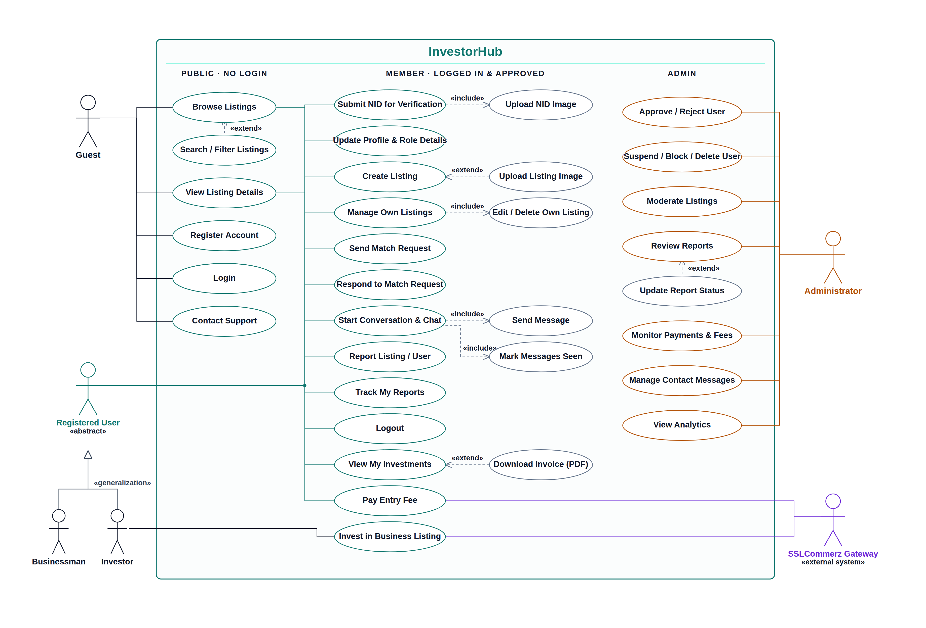
Figure 3.1 Use case diagram of InvestorHub.
Figure 3.1 shows the system boundary, the public, member and administrative use cases, the actor associations, the generalization of the two member roles and the include and extend relationships between use cases.
The main use cases of the system are summarised in Table 3.4, which states the actor that starts each one and the condition that must hold before it can run.
Table 3.4 Description of the main use cases.
Use case | Primary actor | Pre-condition | Outcome
Register account | Guest | Email not already used | Account created in the pending state
Pay entry fee | Registered user | Signed in, fee not yet paid | Account marked as fee paid
Submit identity document | Registered user | Entry fee paid | Document stored for review
Approve account | Administrator | Account pending with document | Account becomes active
Create listing | Investor, Business owner | Account active | Listing stored as pending
Moderate listing | Administrator | Listing pending | Listing approved or rejected with reason
Browse and search listings | Guest, Member | None | Matching approved listings are returned
Send match request | Investor, Business owner | Target has the opposite role | Request stored as pending
Respond to match request | Investor, Business owner | Request addressed to the user | Request accepted or rejected
Chat with match | Investor, Business owner | Both parties are of opposite roles | Messages exchanged and stored
Invest in a listing | Investor | Listing active and not owned by the investor | Payment settled and match finalized
Download invoice | Investor, Business owner | Investment completed | PDF invoice produced
Report a listing or user | Member | Target is not the user | Report queued for the administrator
Review the platform | Member | Signed in | Review stored or updated
View analytics | Administrator | Signed in as administrator | Platform totals displayed
Table 3.4 describes the primary actor, the pre-condition and the outcome of each principal use case.

Chapter 4.

Analysis

Analysis turns the requirements of Chapter 3 into models of behaviour and structure. This chapter presents the analysis pattern chosen for the platform, the activity diagrams that describe the control flow of the main functions, the swimlane diagram that assigns each step to a responsible party, and the class diagram that fixes the structure of the data.

4.1 Software Analysis Pattern
InvestorHub follows a layered client-server analysis pattern. The client layer is a single-page React application that holds no business rule of its own: it renders state and issues requests. The service layer is an Express application divided into one router per domain concern, namely authentication, users, listings, matches, conversations, payments, reports, reviews, the assistant and administration. Cross-cutting concerns such as token verification, role checking, account status checking, input validation and error handling are implemented as middleware so that they are applied uniformly instead of being repeated in every route. The data layer is a set of Mongoose models that own the schema, the validation rules and the indexes.
Two additional patterns were applied inside this structure. The state pattern governs the lifecycle of the central entities: an account moves through pending, active, suspended, blocked or rejected; a listing through pending, active, rejected or completed; a match through pending, accepted, rejected or finalized; and an investment through pending, completed, failed or cancelled. Every transition is performed on the server, so a client can never place an entity in a state that the rules do not allow. The observer pattern governs the real-time layer: a client subscribes to a conversation room and the server publishes new messages, typing indications and seen receipts to the subscribers of that room.

4.2 Activity Diagram
The activity diagrams describe the order in which the actions of the platform are performed, the decisions that branch the flow and the activities that may run concurrently. Two diagrams are presented: one for the member and one for the administrator.

4.2.1 Activity Diagram for the Member
Figure 4.1 shows the member flow. A new user branches to registration and an existing user to authentication, and both flows merge into the validity decision, which loops back to the login activity when the credentials are wrong. The next decision separates an account that is not yet active, which can only reach the approval page, from an active account, which passes a fork into five concurrent activity chains: browsing listings, creating a listing, requesting a match, maintaining the profile and handling incoming matches. Chat is entered only when the match is accepted; otherwise the flow bypasses it. All chains synchronise at the join bar before logout.
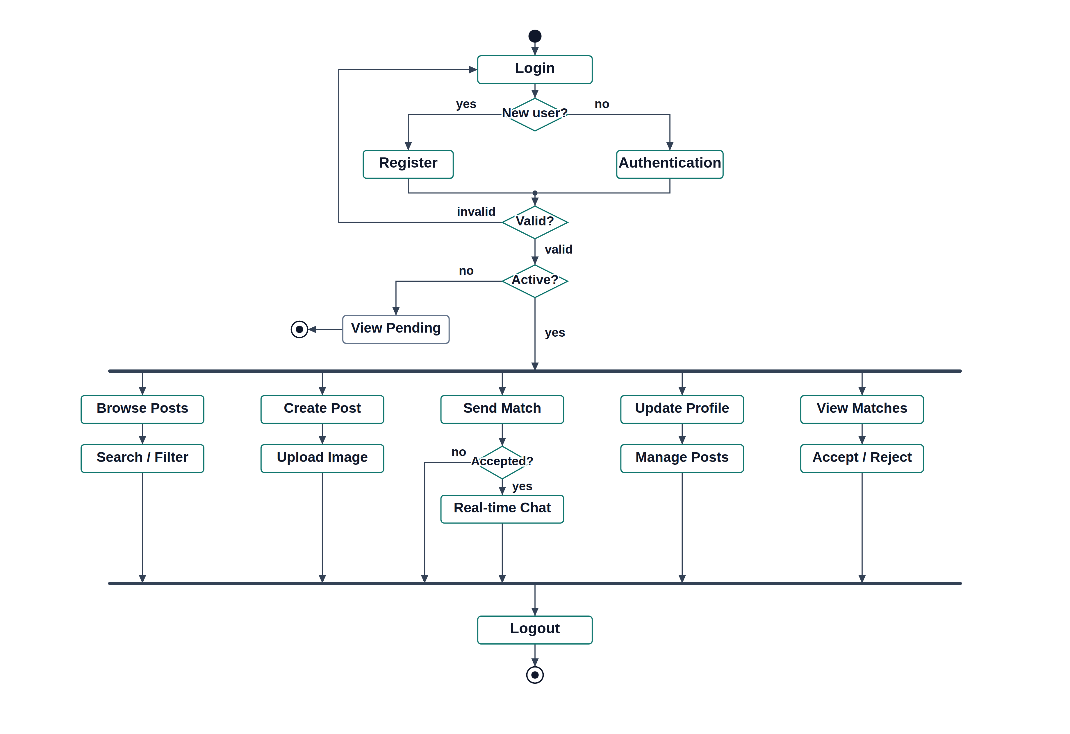
Figure 4.1 Activity diagram for the member (investor or business owner).
Figure 4.1 shows the registration and authentication branches, the account status decision, the fork into concurrent member activities and the join that precedes logout.

4.2.2 Activity Diagram for the Administrator
Figure 4.2 shows the administrator flow. After a successful sign-in the administrator reaches the dashboard, where a fork opens four concurrent moderation chains: account approval and status change, account deletion, report review with the optional status update, and analytics. Every chain synchronises at the join bar before logout.
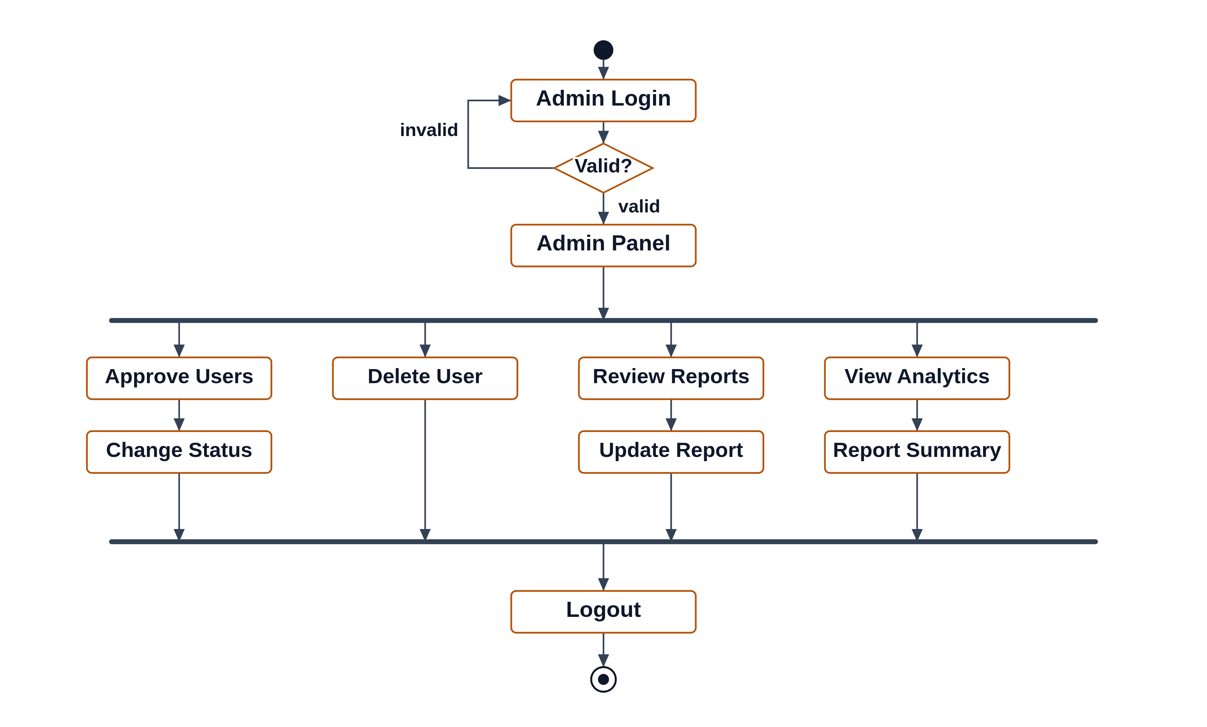
Figure 4.2 Activity diagram for the administrator.
Figure 4.2 shows the administrative sign-in with its validation loop and the four concurrent moderation activities that join before logout.

4.3 Swim-lane Diagram
The swimlane diagram in Figure 4.3 repeats the main workflow of the platform but assigns every action to the party that performs it. The member lane holds the actions taken by the investor or the business owner, the system lane holds the automatic processing performed by the server, and the administrator lane holds the moderation decisions. The diagram makes the hand-off points explicit: registration is a member action that produces a system record, approval is an administrative action that returns control to the member, and each later step alternates between the member and the system until the payment is settled.
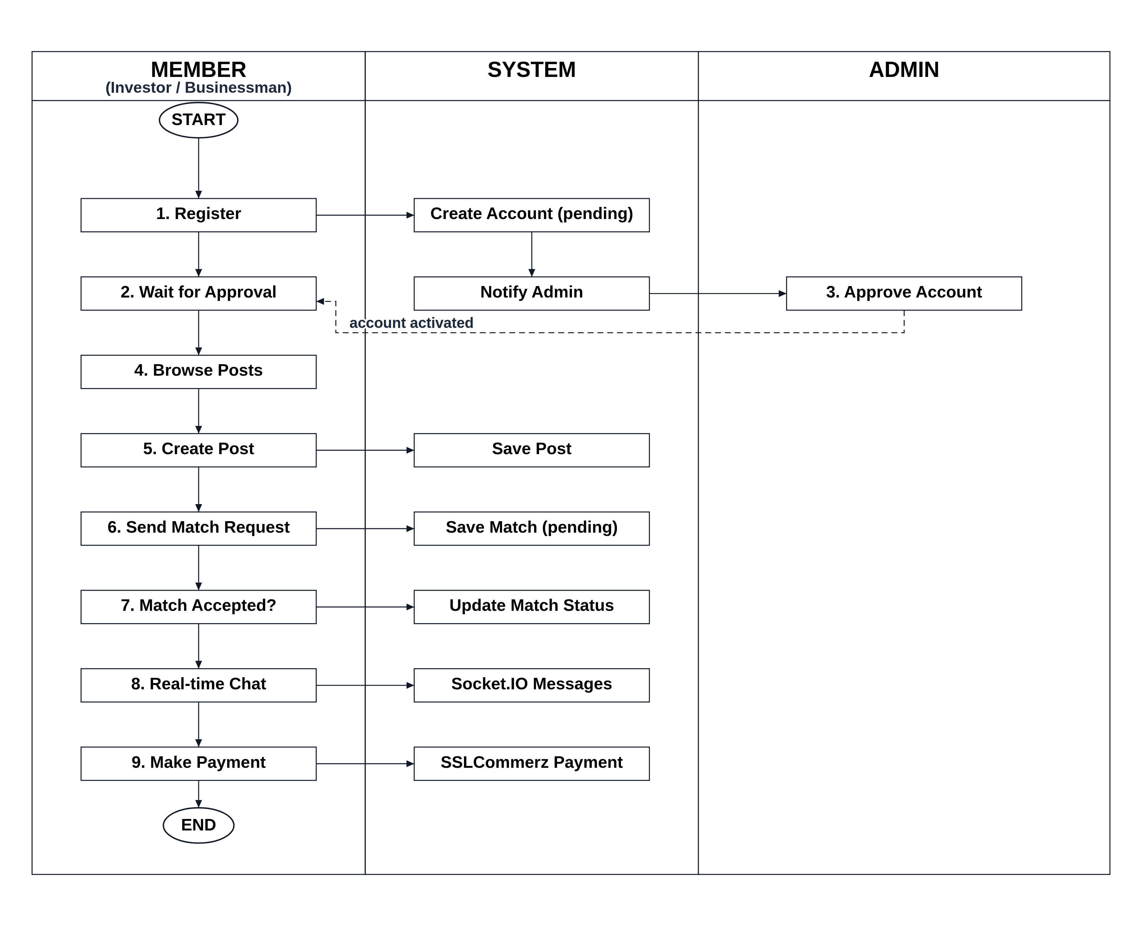
Figure 4.3 Swimlane diagram of the member, system and administrator workflow.
Figure 4.3 assigns every step of the main workflow to the member, the system or the administrator, and shows the hand-off points between the three lanes.

4.4 Sequence Diagram
The sequence diagram in Figure 4.4 shows the ordered exchange of messages for the registration, approval and payment flows, including the calls that leave the platform for the payment gateway and the callback that returns. It complements the activity diagrams by showing the time ordering between the browser, the server, the database and the external gateway.
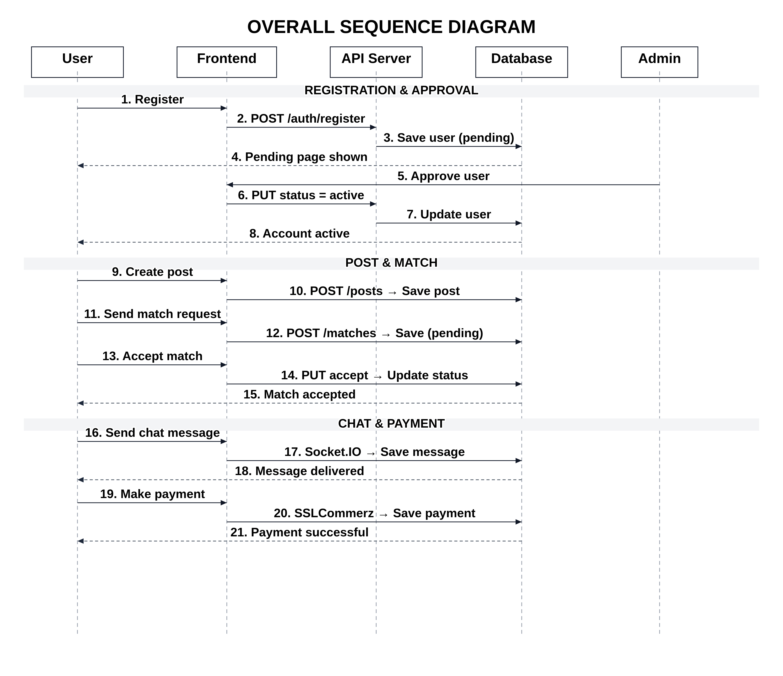
Figure 4.4 Sequence diagram of the principal system interactions.
Figure 4.4 shows the ordered messages exchanged between the client, the server, the database and the external payment gateway during registration, approval and payment.

4.5 Class Diagram
The class diagram in Figure 4.5 fixes the structure of the data that the platform stores. The User class is central: it holds the identity, the role and the account status, and it owns the two behaviours that are implemented as instance methods, namely password comparison and token generation. An account of the investor role may own one investor profile and an account of the business role one business profile, which keeps the role-specific attributes out of the shared user record. A user writes many listings, participates in many matches and conversations, sends many messages, makes many payments and may write at most one platform review. A match optionally refers to the listing it was raised against, and an investment refers to the investor, the business owner and the listing being funded. The contact message class stands alone because a contact enquiry may be submitted without an account.
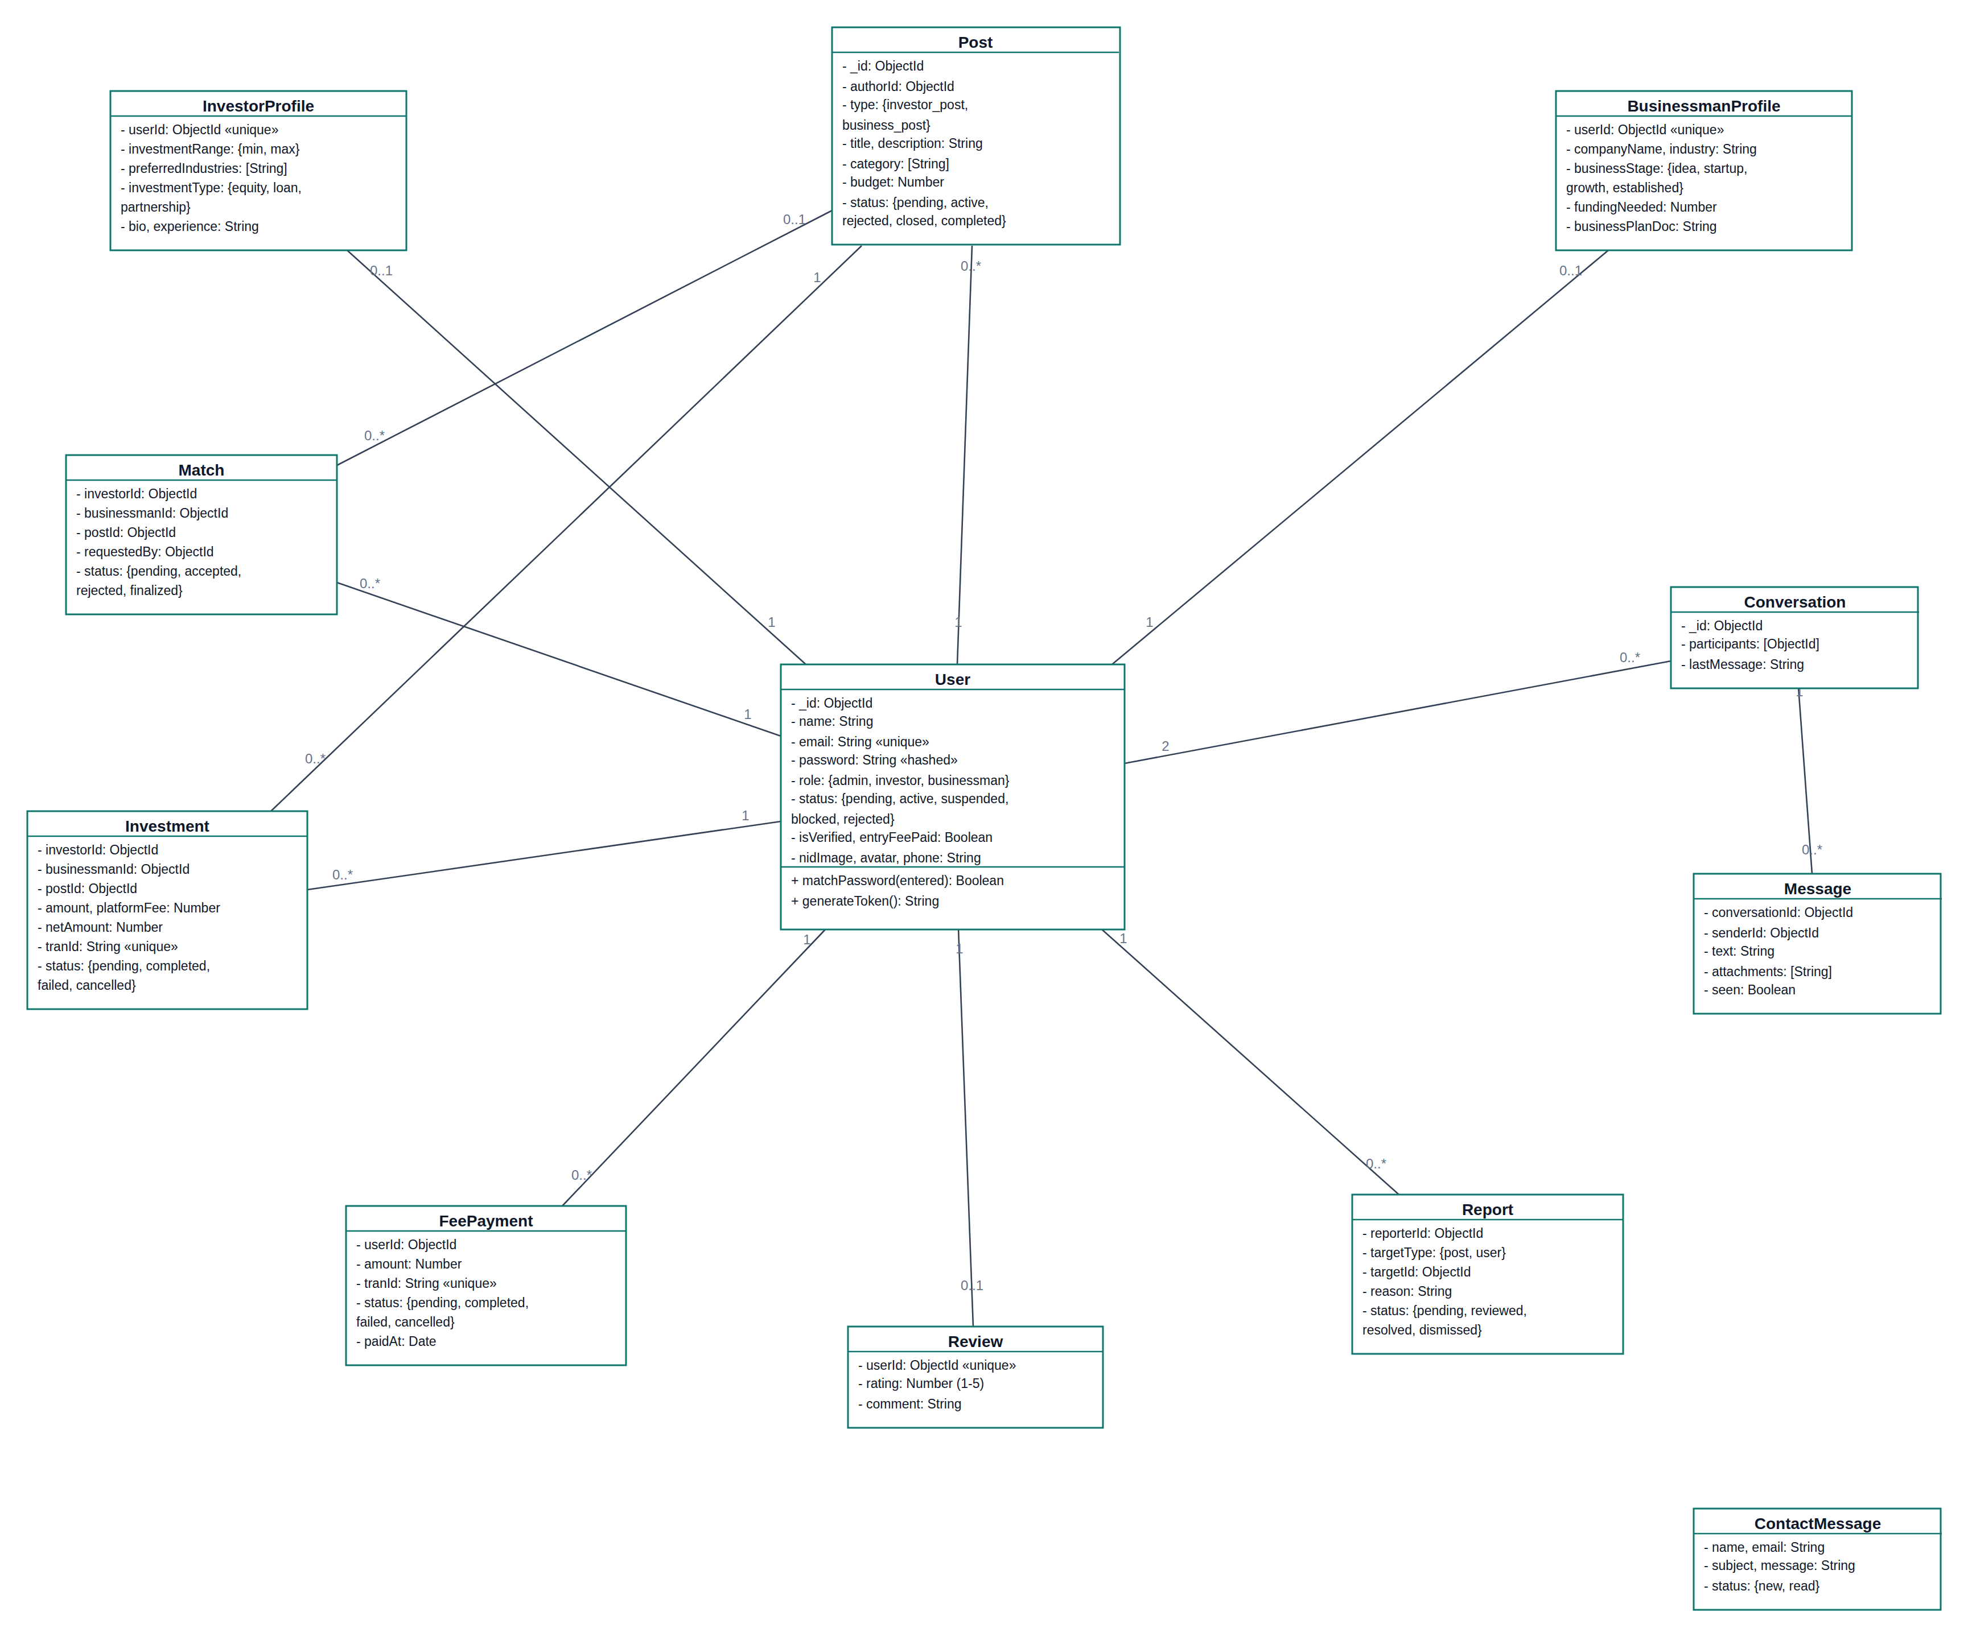
Figure 4.5 Class diagram of InvestorHub.
Figure 4.5 shows the twelve persistent classes of the system with their attributes, the two methods of the User class and the multiplicity of every association.

Chapter 5.

Project Management

A project that depends on an external payment gateway, on the moderation behaviour of a human administrator and on a single developer working to a fixed twelve-week deadline carries real risk. Risk management was therefore treated as a continuous activity rather than a document written once. Risks were identified at the start of every increment, analysed for probability and impact, given a planned response, and tracked through the RMMM plan presented at the end of this chapter.

5.1 Risk Identification Table
Eleven risks were identified across four categories. Project risks threaten the schedule, technical risks threaten the product, business risks threaten the value of the delivered system, and external risks arise outside the project boundary. Table 5.1 lists them.
Table 5.1 Risk identification.
ID | Risk | Category
R-01 | Requirements change after an increment has been demonstrated | Project
R-02 | A single developer is unavailable through illness or examinations | Project
R-03 | The twelve-week schedule is too short for the full feature set | Project
R-04 | The payment gateway sandbox behaves differently from the live environment | Technical
R-05 | A payment callback is replayed or forged, crediting an investment twice | Technical
R-06 | Credentials or the identity document are exposed by a weak access rule | Technical
R-07 | Real-time chat delivers a message to the wrong user after a re-login | Technical
R-08 | The database schema changes late and breaks existing documents | Technical
R-09 | Users do not trust an online platform with an identity document or a payment | Business
R-10 | An external service, such as the gateway or the assistant model, is withdrawn or changed | External
R-11 | Hosting or network failure makes the platform unreachable during the defense | External
Table 5.1 lists the risks identified during the practicum with the category of each risk.

5.2 Risk Analysis Table
Each identified risk was rated for the probability of occurrence and for the impact it would have if it occurred. Probability is expressed as a percentage and impact on a four-point scale where catastrophic denotes a risk that would prevent delivery, critical a risk that would remove a core feature, marginal a risk that would reduce quality, and negligible a risk that would cause only inconvenience. Table 5.2 records the analysis.
Table 5.2 Risk analysis.
ID | Risk | Probability | Impact | Exposure
R-01 | Requirements change after a demonstration | 70% | Marginal | Medium
R-02 | Developer unavailable | 30% | Critical | Medium
R-03 | Schedule too short for the full scope | 50% | Critical | High
R-04 | Sandbox differs from live gateway | 40% | Critical | High
R-05 | Replayed or forged payment callback | 25% | Catastrophic | High
R-06 | Credential or document exposure | 20% | Catastrophic | High
R-07 | Message delivered to the wrong user | 35% | Critical | Medium
R-08 | Late schema change breaks documents | 40% | Marginal | Medium
R-09 | Users distrust the platform | 50% | Marginal | Medium
R-10 | External service changed or withdrawn | 30% | Critical | Medium
R-11 | Hosting or network failure | 20% | Marginal | Low
Table 5.2 states the probability, the impact and the resulting exposure of every identified risk.

5.3 Risk Planning Table
A response was planned for every risk before construction started. Table 5.3 records the strategy and the concrete action taken in the project.
Table 5.3 Risk planning.
ID | Strategy | Planned action
R-01 | Accept and absorb | Use the incremental model, demonstrate weekly and keep the next increment small enough to absorb a change.
R-02 | Mitigate | Commit working code to the remote repository daily so that no work exists only on one machine, and keep a written task list that another developer could continue.
R-03 | Mitigate | Rank every requirement as high, medium or low priority and schedule the high priority features into the first two increments.
R-04 | Mitigate | Read the gateway documentation before coding, keep every environment-specific value in configuration rather than in code, and test the complete cycle in the sandbox.
R-05 | Avoid | Never trust a redirect payload. Re-validate every transaction with the gateway validation service and make the settlement routine idempotent.
R-06 | Avoid | Hash passwords, exclude the password field from every query result, verify the token and the role on the server for every protected route, and restrict the identity document to the owner and the administrator.
R-07 | Mitigate | Bind the socket identity at the handshake from the token and discard a socket opened with a previous token.
R-08 | Mitigate | Define the schema with explicit types, defaults and enumerations, and add an index before the collection grows.
R-09 | Mitigate | Make moderation visible: show the account status, the approval state of a listing and the verification badge, and route every payment through a recognised gateway.
R-10 | Mitigate | Isolate every external call behind a single server module and keep the endpoint and the model name in configuration so that they can be changed without touching the application.
R-11 | Mitigate | Deploy early, keep a local runnable copy of the system and a recorded demonstration as a fallback for the defense.
Table 5.3 records the response strategy and the concrete planned action for every risk.

5.4 The RMMM Plan
The risk mitigation, monitoring and management plan states, for the risks with the highest exposure, how the risk was reduced before it occurred, what signal was watched during the project, and what would be done if the risk materialised. Table 5.4 presents the plan for the five high exposure risks.
Table 5.4 RMMM plan for the high exposure risks.
Risk | Mitigation | Monitoring | Management
R-03 Schedule too short | Prioritise requirements and build the core first; keep optional features for the last increment. | Compare the completed tasks against the schedule chart at every weekly review. | Move low priority features, such as the assistant and the review page, into the future plan and deliver the core complete.
R-04 Gateway difference | Keep store credentials, callback URLs and the live flag in configuration; test the full cycle in the sandbox. | Inspect the gateway response of every test payment and log the failure reason returned by the gateway. | Switch the affected value in configuration and repeat the sandbox cycle; the application code does not change.
R-05 Replayed payment callback | Validate every transaction against the gateway validation service, compare the amount and the transaction identifier, and make settlement idempotent. | Check that the transaction identifier is unique in the database and that a repeated notification leaves the record unchanged. | Mark the transaction as failed, keep the listing unfunded and investigate the transaction identifier in the gateway panel.
R-06 Credential or document exposure | Hash passwords, exclude them from query results, verify token, role and account status on the server, and restrict document access. | Re-test the protected routes without a token and with a token of the wrong role after every increment. | Revoke the signing secret, force re-authentication and correct the failing access rule before the next release.
R-07 Wrong recipient in chat | Derive the socket identity from the token at handshake time and reject a reused socket. | Test a re-login as a different user in the same browser and confirm that the previous identity is gone. | Disconnect the stale socket, clear the client cache and re-establish the connection with the current token.
Table 5.4 gives the mitigation, monitoring and management actions for the risks with the highest exposure.

Chapter 6.

Project Planning

Project planning estimated the size of the system, converted that size into an expected effort and schedule, and recorded the cost of the resources consumed. The function point method was used for the estimate because the platform is a data-intensive, transaction-processing application whose size is better described by the functions it exposes than by the number of lines of code.

6.1 System Project Estimation
Estimation followed four steps. First, the transaction functions and the data functions of the system were counted from the requirement specification. Second, each function was rated as simple, average or complex. Third, the counts were multiplied by the standard weights to obtain the unadjusted function point total. Fourth, the fourteen general system characteristics were rated to produce the value adjustment factor, which was applied to obtain the adjusted function point count.

6.2 Function-Oriented Metrics
The function types used in the count are the external input, which is a process that enters data into the system; the external output, which is a process that sends derived data out of the system; the external inquiry, which retrieves data without derivation; the internal logical file, which is a group of data maintained inside the system; and the external interface file, which is a group of data referenced but maintained elsewhere. Table 6.1 gives the standard weights used.
Table 6.1 Function point complexity weights.
Function type | Simple | Average | Complex
External input (EI) | 3 | 4 | 6
External output (EO) | 4 | 5 | 7
External inquiry (EQ) | 3 | 4 | 6
Internal logical file (ILF) | 7 | 10 | 15
External interface file (EIF) | 5 | 7 | 10
Table 6.1 gives the standard weight of each function type at each complexity level.

6.3 Identifying Complexity
The functions of InvestorHub were extracted from the functional requirements of Section 3.2.3 and from the implemented routes, and each was rated for complexity according to the number of data elements and file types it references.

6.3.1 Identifying Complexity of Transaction Function
Table 6.2 lists the transaction functions of the system with the assigned complexity.
Table 6.2 Complexity of the transaction functions.
Transaction function | Type | Complexity
Register account | EI | Average
Sign in | EI | Simple
Submit identity document | EI | Simple
Create or edit listing | EI | Complex
Delete listing | EI | Simple
Send match request | EI | Average
Respond to or withdraw a match request | EI | Average
Send chat message | EI | Average
Initiate entry fee payment | EI | Average
Initiate investment payment | EI | Complex
Submit report | EI | Simple
Submit or edit review | EI | Simple
Submit contact message | EI | Simple
Moderate account status | EI | Average
Moderate listing status | EI | Average
Update report status | EI | Simple
Browse and filter listings | EQ | Complex
View listing detail | EQ | Average
View own listings | EQ | Simple
View matches | EQ | Average
View conversation history | EQ | Average
View own investments | EQ | Average
View own reports | EQ | Simple
View platform reviews | EQ | Simple
Administrative user list | EQ | Average
Administrative payment list | EQ | Average
Generate PDF invoice | EO | Complex
Platform analytics | EO | Complex
Rating summary of reviews | EO | Simple
Assistant answer | EO | Average
Table 6.2 lists every transaction function of the system with its type and assigned complexity.

6.3.2 Identifying Complexity of Data Function
Table 6.3 lists the data functions. The twelve collections maintained by the platform are internal logical files, while the payment gateway and the assistant model are external interface files because their data is referenced by the system but maintained outside it.
Table 6.3 Complexity of the data functions.
Data function | Type | Complexity
User | ILF | Complex
Investor profile | ILF | Average
Business profile | ILF | Average
Post (listing) | ILF | Complex
Match | ILF | Average
Conversation | ILF | Simple
Message | ILF | Average
Investment | ILF | Complex
Fee payment | ILF | Average
Report | ILF | Average
Review | ILF | Simple
Contact message | ILF | Simple
Payment gateway transaction data | EIF | Average
Assistant model service | EIF | Simple
Table 6.3 lists the data functions maintained inside the system and those referenced from outside it.

6.3.3 Unadjusted Function Point Contribution (Transaction Function)
Table 6.4 multiplies the transaction function counts by the corresponding weights. The transaction functions contribute 138 unadjusted function points.
Table 6.4 Unadjusted function point contribution of the transaction functions.
Type | Simple (n x w) | Average (n x w) | Complex (n x w) | Subtotal
External input (EI) | 6 x 3 = 18 | 7 x 4 = 28 | 2 x 6 = 12 | 58
External inquiry (EQ) | 3 x 3 = 9 | 6 x 4 = 24 | 1 x 6 = 6 | 39
External output (EO) | 1 x 4 = 4 | 1 x 5 = 5 | 2 x 7 = 14 | 23
Total | 31 | 57 | 32 | 120
Table 6.4 computes the unadjusted function point contribution of the thirty transaction functions.

6.3.4 Unadjusted Function Point Contribution (Data Function)
Table 6.5 multiplies the data function counts by the corresponding weights. The data functions contribute 124 unadjusted function points, so the total unadjusted function point count of the system is 120 + 124 = 244.
Table 6.5 Unadjusted function point contribution of the data functions.
Type | Simple (n x w) | Average (n x w) | Complex (n x w) | Subtotal
Internal logical file (ILF) | 3 x 7 = 21 | 6 x 10 = 60 | 3 x 15 = 45 | 126
External interface file (EIF) | 1 x 5 = 5 | 1 x 7 = 7 | 0 x 10 = 0 | 12
Total | 26 | 67 | 45 | 138
Table 6.5 computes the unadjusted function point contribution of the fourteen data functions.

6.3.5 Performance and Environmental Impact
The fourteen general system characteristics were each rated from zero, meaning no influence, to five, meaning strong influence throughout. Table 6.6 records the ratings and their sum, which is the total degree of influence.
Table 6.6 General system characteristics and degree of influence.
No. | General system characteristic | Rating
1 | Data communication | 5
2 | Distributed data processing | 3
3 | Performance | 4
4 | Heavily used configuration | 2
5 | Transaction rate | 4
6 | Online data entry | 5
7 | End user efficiency | 4
8 | Online update | 4
9 | Complex processing | 3
10 | Reusability | 3
11 | Installation ease | 3
12 | Operational ease | 4
13 | Multiple sites | 2
14 | Facilitate change | 4
 | Total degree of influence (TDI) | 50
Table 6.6 records the rating of each general system characteristic and the resulting total degree of influence.

6.3.6 Counting Adjusted Function Point
The value adjustment factor is obtained as VAF = 0.65 + (0.01 x TDI) = 0.65 + (0.01 x 50) = 1.15. The adjusted function point count is therefore AFP = UFP x VAF = 244 x 1.15 = 280.6, which is taken as 281 function points.
Using an average productivity of eight function points per person-month for a single developer working in a familiar language on a system of this size, the estimated effort is approximately 281 / 8 = 35 person-months for a full commercial delivery. The practicum delivered the platform in twelve weeks because the scope was limited to a working single-tenant system without the documentation, multi-environment operations and support obligations that a commercial delivery carries, and because a large part of the infrastructure was supplied by mature open-source frameworks. Table 6.7 summarises the estimate.
Table 6.7 Summary of the function point estimate.
Item | Value
Transaction function contribution | 120 FP
Data function contribution | 138 FP
Unadjusted function points (UFP) | 244 FP
Total degree of influence (TDI) | 50
Value adjustment factor (VAF) | 1.15
Adjusted function points (AFP) | 281 FP
Assumed productivity | 8 FP per person-month
Estimated effort for a commercial delivery | 35 person-months
Actual practicum effort | 12 weeks, one developer
Table 6.7 summarises the inputs and the result of the function point estimation.

6.4 Project Schedule Chart
The twelve weeks of the practicum were divided into ten scheduled tasks. Tasks that depend on each other were placed in sequence, while tasks that could progress together, such as interface work and server work inside the same module, were overlapped. Figure 6.1 shows the schedule.
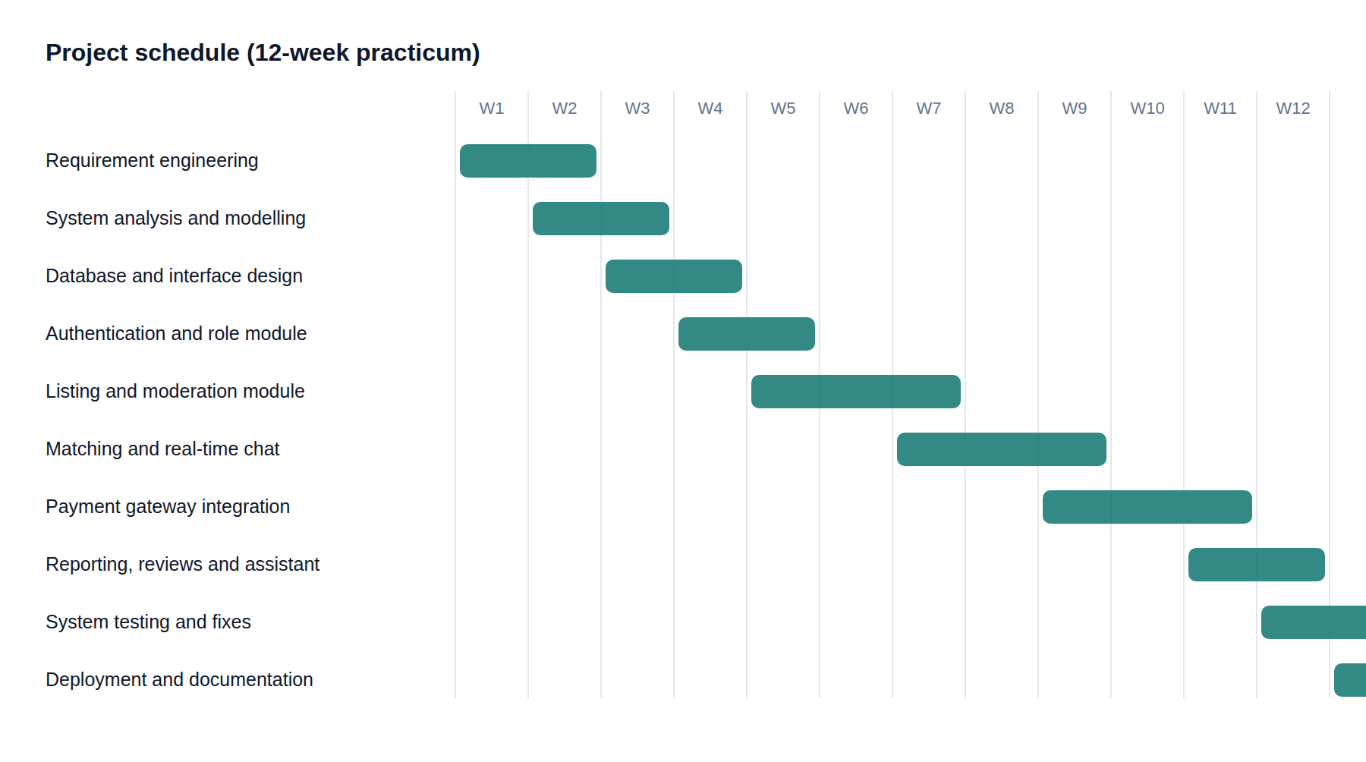
Figure 6.1 Project schedule chart of the practicum.
Figure 6.1 shows the ten scheduled tasks of the project across the twelve weeks of the practicum, with the overlap between dependent and parallel activities.

6.5 Accounts Table
The cost of the project is recorded in four accounts: personnel, hardware, software and other operating costs. The figures are stated in Bangladeshi Taka and cover the twelve-week practicum period.

6.5.1 Personnel Cost
Personnel cost is the notional cost of the development effort. It was not paid by the organization during the practicum, but it is recorded here so that the true cost of the system is visible.
Table 6.8 Personnel cost.
Role | Rate | Duration | Cost (BDT)
Junior software developer (author) | 25,000 per month | 3 months | 75,000
Organization supervisor review time | 1,500 per session | 12 sessions | 18,000
Total personnel cost |  |  | 93,000
Table 6.8 records the notional personnel cost of the practicum project.

6.5.2 Expected Hardware Cost
Table 6.9 records the hardware used, apportioned over the practicum period.
Table 6.9 Expected hardware cost.
Item | Quantity | Cost (BDT)
Development laptop (already owned, depreciation for 3 months) | 1 | 6,000
Internet connection | 3 months | 3,600
Electricity and workspace | 3 months | 3,000
Total hardware cost |  | 12,600
Table 6.9 records the hardware and infrastructure cost apportioned to the project.

6.5.3 Expected Software Cost
Every framework and library used in the project is open source, so the software cost is limited to the hosted services consumed during development.
Table 6.10 Expected software cost.
Item | Licence | Cost (BDT)
Node.js, Express, MongoDB, React, Tailwind CSS, Socket.IO | Open source | 0
MongoDB Atlas shared cluster | Free tier | 0
SSLCommerz sandbox account | Free for testing | 0
Assistant model API usage during development | Pay as you go | 600
Application hosting for three months | Entry plan | 3,000
Domain name for one year | Commercial | 1,200
Total software cost |  | 4,800
Table 6.10 records the licence and service cost of the software used in the project.

6.5.4 Expected Other Cost
Table 6.11 records the remaining operating costs of the project.
Table 6.11 Expected other cost.
Item | Cost (BDT)
Transport for placement and review meetings | 3,000
Printing and binding of the report | 1,500
Stationery and miscellaneous | 700
Total other cost | 5,200
Table 6.11 records the remaining operating costs of the project.
The total project cost is therefore 93,000 + 12,600 + 4,800 + 5,200 = 115,600 BDT, of which only 22,600 BDT is a direct cash outlay because the personnel cost was contributed as practicum effort.

Chapter 7.

Designing

Design converts the analysis models of Chapter 4 into the concrete artefacts that were implemented: the screens the user works with, the flow of data between the processes of the system, and the structure of the stored data. This chapter presents the interface design, the data flow diagrams at three levels and the database design including normalization, the entity relationship model and the table structures.

7.1 Interface Design
The interface was designed around three principles. First, a visitor should be able to judge the platform before signing up, so browsing and searching listings are public. Second, a member should never be surprised by a rule, so the account status, the approval state of a listing and the outcome of a match request are always visible. Third, the same layout must work on a mobile phone, because most users in the target market browse on a phone. The screens below were captured from the running system.

7.1.1 Public Interface
Figure 7.1 shows the landing page, which states what the platform does, offers a search box over the live listings and displays the platform totals. The assistant launcher sits at the bottom right of the page.
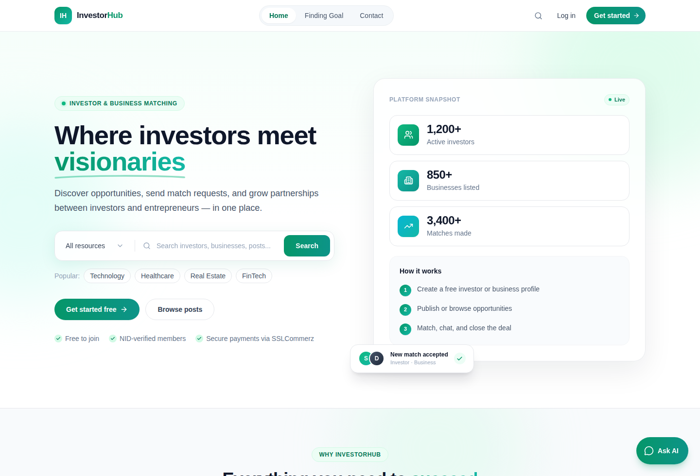
Figure 7.1 Landing page of InvestorHub.
Figure 7.1 shows the public landing page with the headline search, the platform snapshot and the assistant launcher.
Figure 7.2 shows the listing page, where a visitor can search by keyword and narrow the result by listing type, category and budget range.
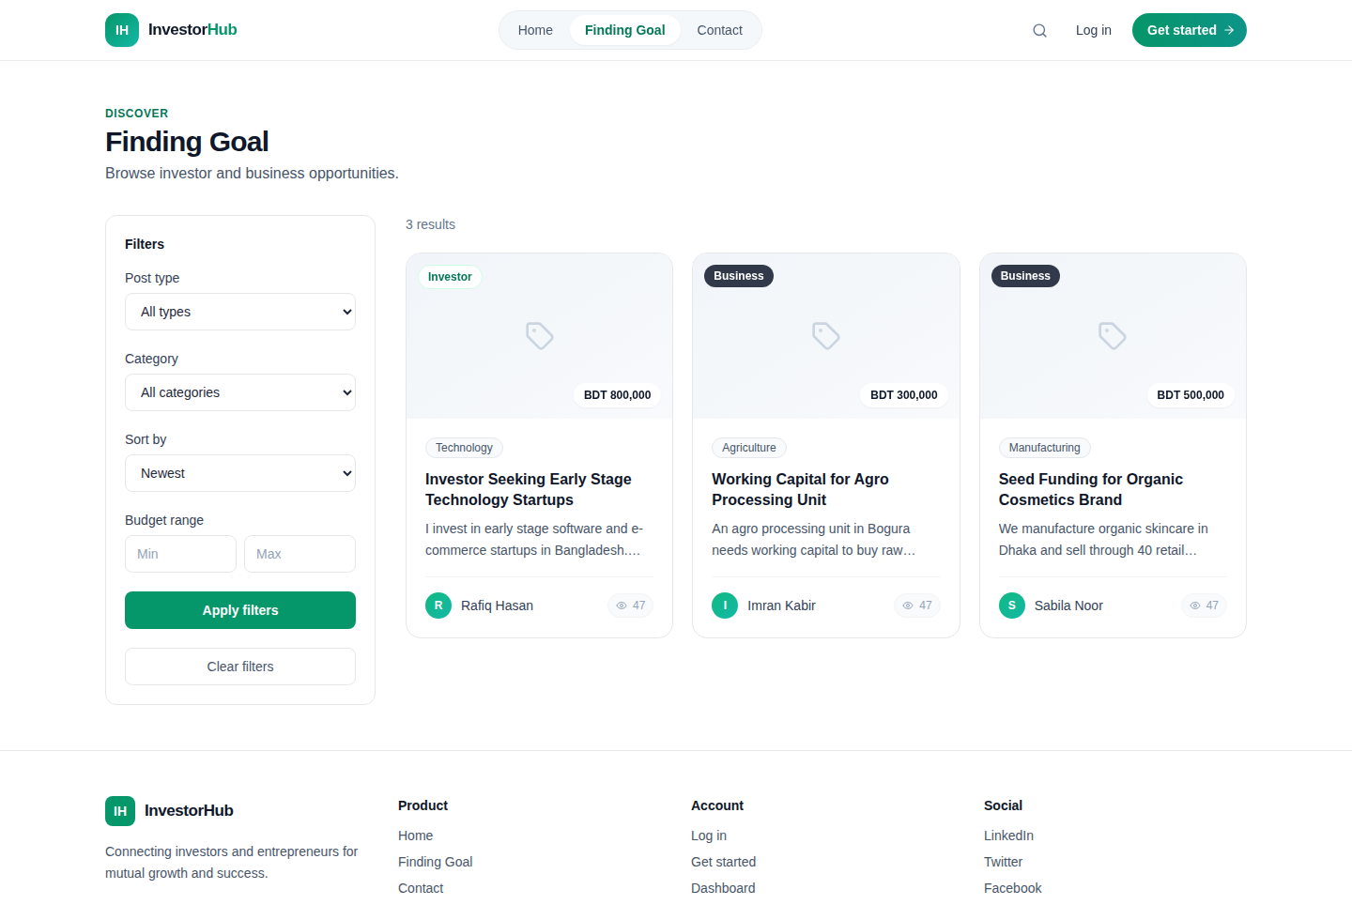
Figure 7.2 Public listing page with search and filters.
Figure 7.2 shows the approved listings together with the keyword search and the type, category and budget filters.
Figure 7.3 shows the registration form, in which the applicant chooses the investor or the business role. Figure 7.4 shows the public contact form.
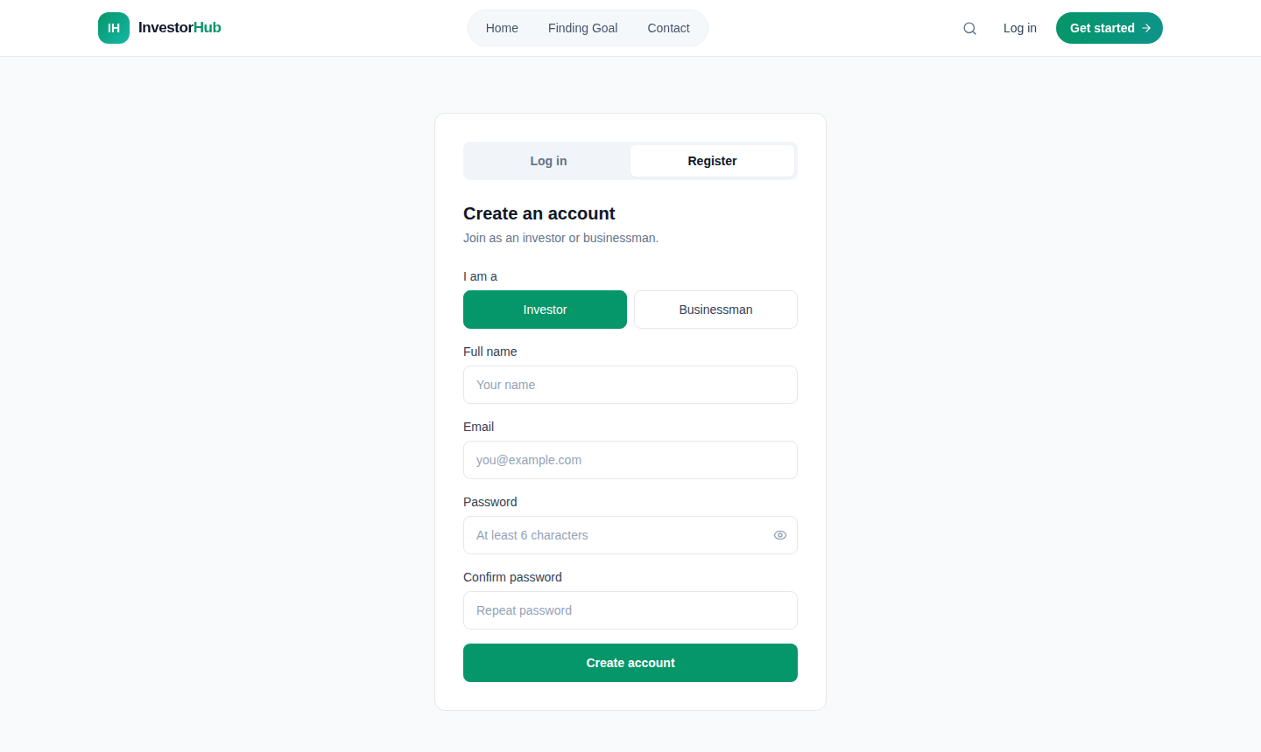
Figure 7.3 Registration form with role selection.
Figure 7.3 shows the registration form where an applicant supplies the name, email and password and selects the investor or business role.
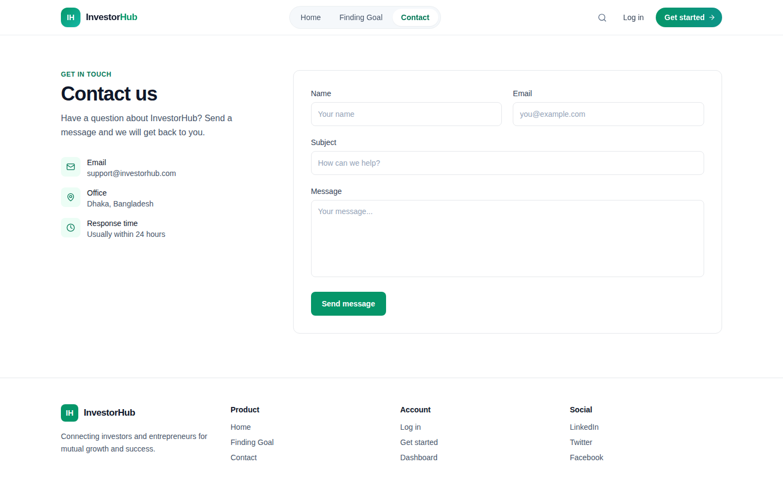
Figure 7.4 Public contact form.
Figure 7.4 shows the contact form that any visitor may use to reach the platform administrators.

7.1.2 Member Interface
Figure 7.5 shows the member dashboard, which summarises the member's listings, matches, messages and investments in one view and gives access to every member function from the sidebar.
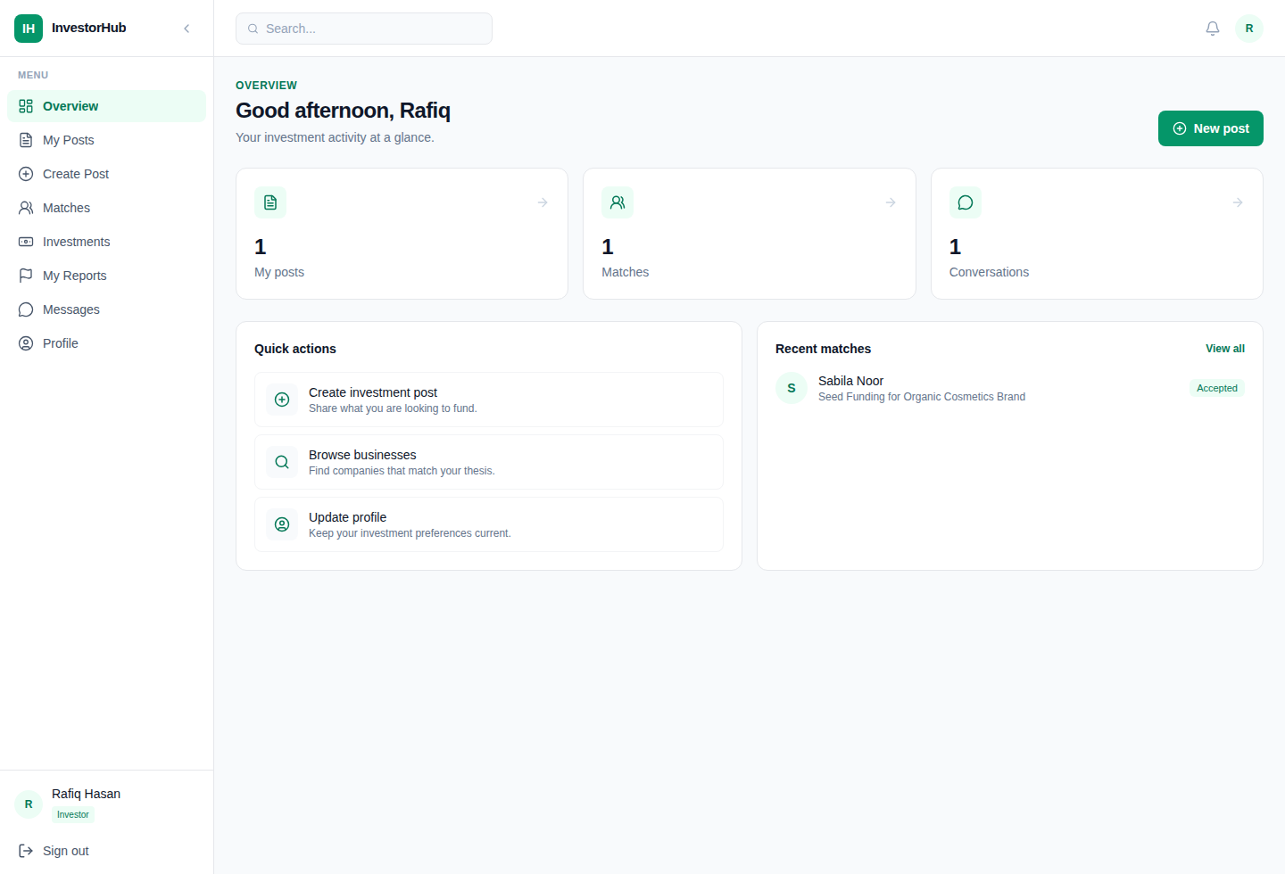
Figure 7.5 Member dashboard.
Figure 7.5 shows the overview page of a member with the counters for listings, matches and messages and the navigation sidebar.
Figure 7.6 shows the listing creation form and Figure 7.7 the list of the member's own listings with the approval state of each one.
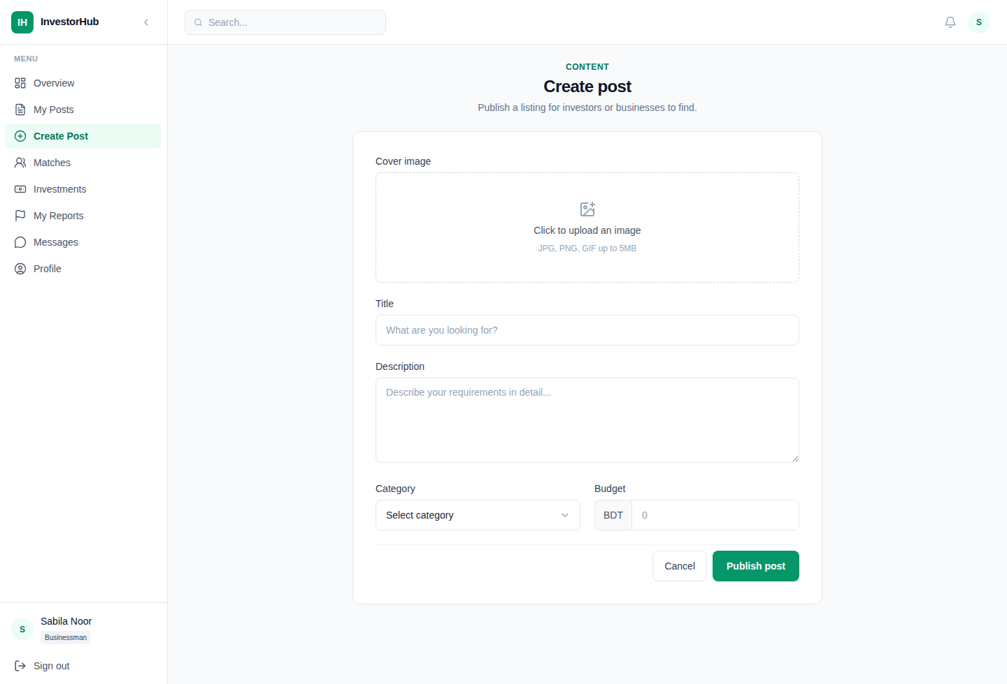
Figure 7.6 Listing creation form.
Figure 7.6 shows the form used to publish a listing, including the title, description, category, budget and image fields.
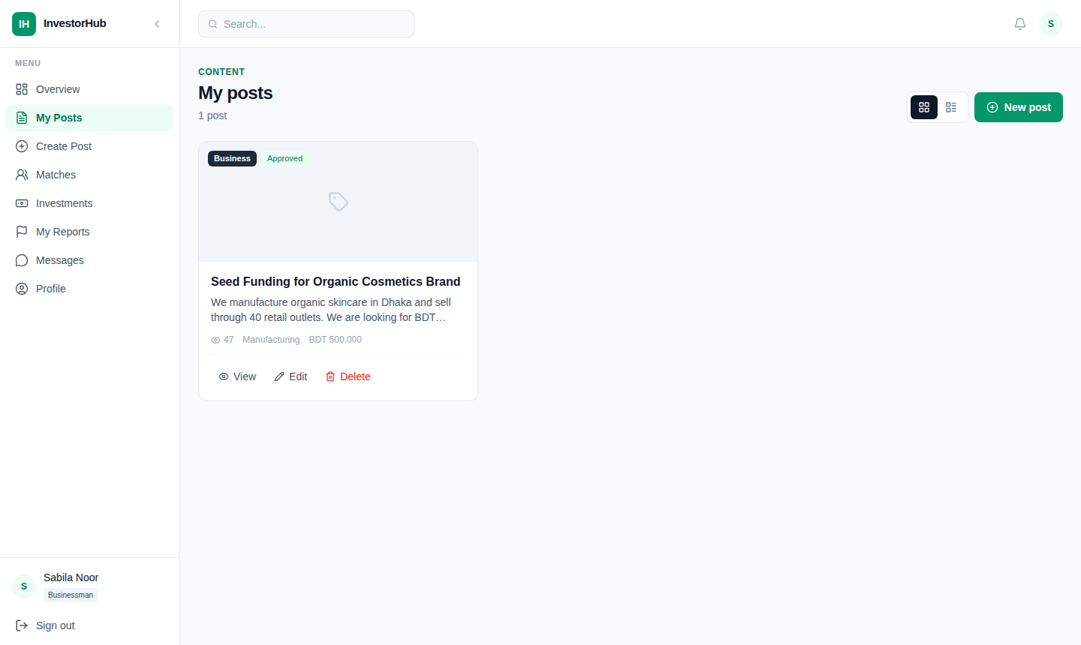
Figure 7.7 Member listing management page.
Figure 7.7 shows the member's own listings with the pending, approved or rejected state of each listing.
Figure 7.8 shows the matches page, where an incoming request can be accepted or declined and the listing title links to the listing it was raised against. Figure 7.9 shows the real-time chat between a matched investor and business owner.
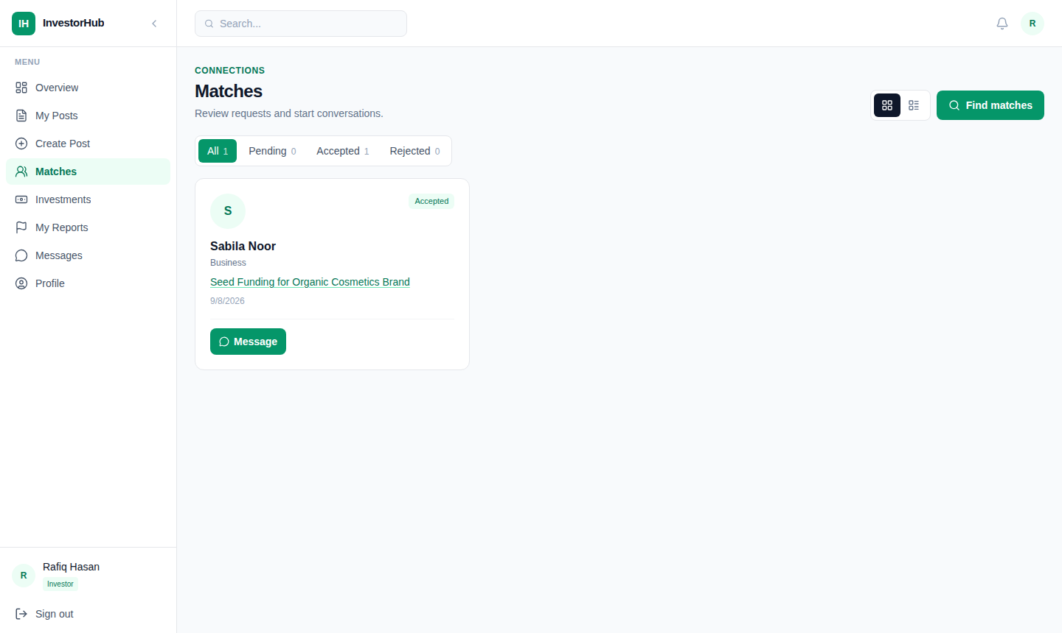
Figure 7.8 Match management page.
Figure 7.8 shows the incoming and outgoing match requests with their state and the accept and decline actions.
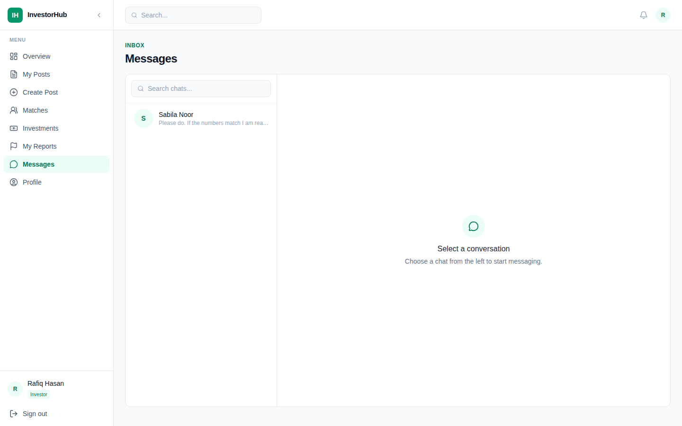
Figure 7.9 Real-time chat between a matched investor and business owner.
Figure 7.9 shows the conversation list, the message thread and the message composer of the real-time chat module.
Figure 7.10 shows the investment record of an investor, including the platform commission and the link to the invoice, and Figure 7.11 shows the platform review page.
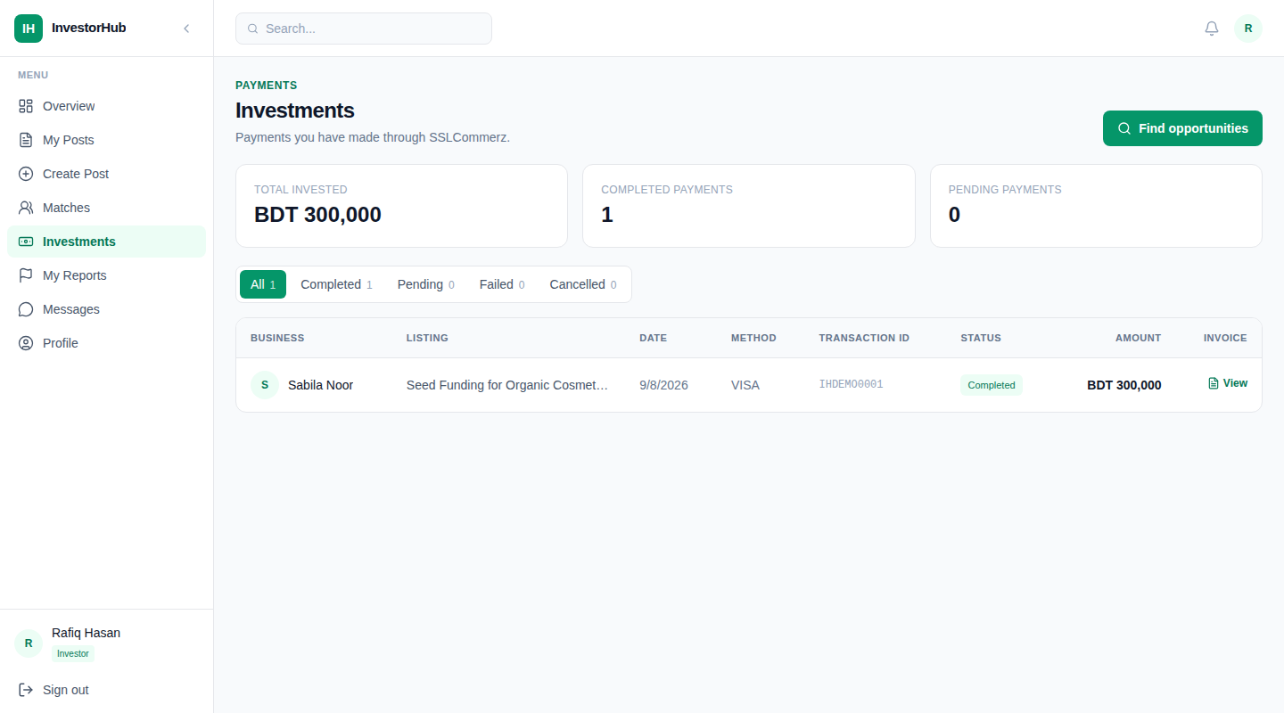
Figure 7.10 Investment records of a member.
Figure 7.10 shows a completed investment with the amount, the platform commission, the net amount and the invoice link.
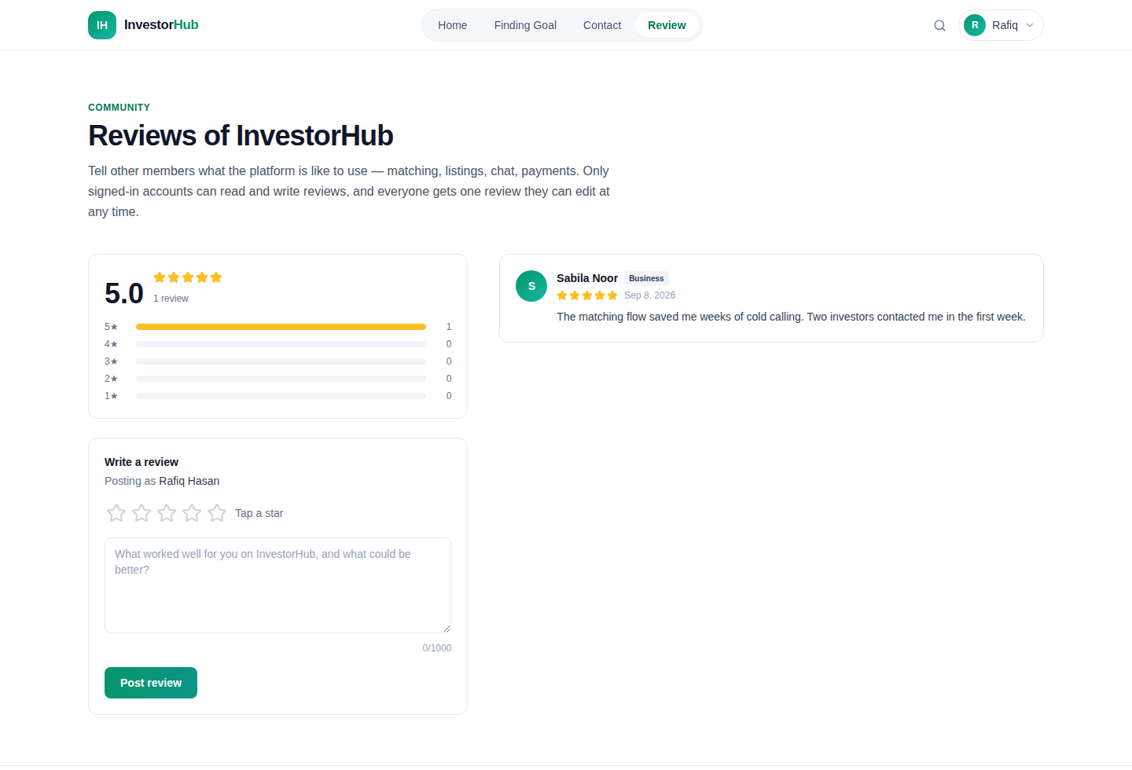
Figure 7.11 Platform review page.
Figure 7.11 shows the rating summary, the review form of the signed-in member and the reviews written by other members.

7.1.3 Administrative Interface
Figure 7.12 shows the analytics page, which is the entry point of the administrative dashboard. It reports the totals for users, listings, payments and platform revenue, and the health rates for activation, approval, match acceptance and payment success.
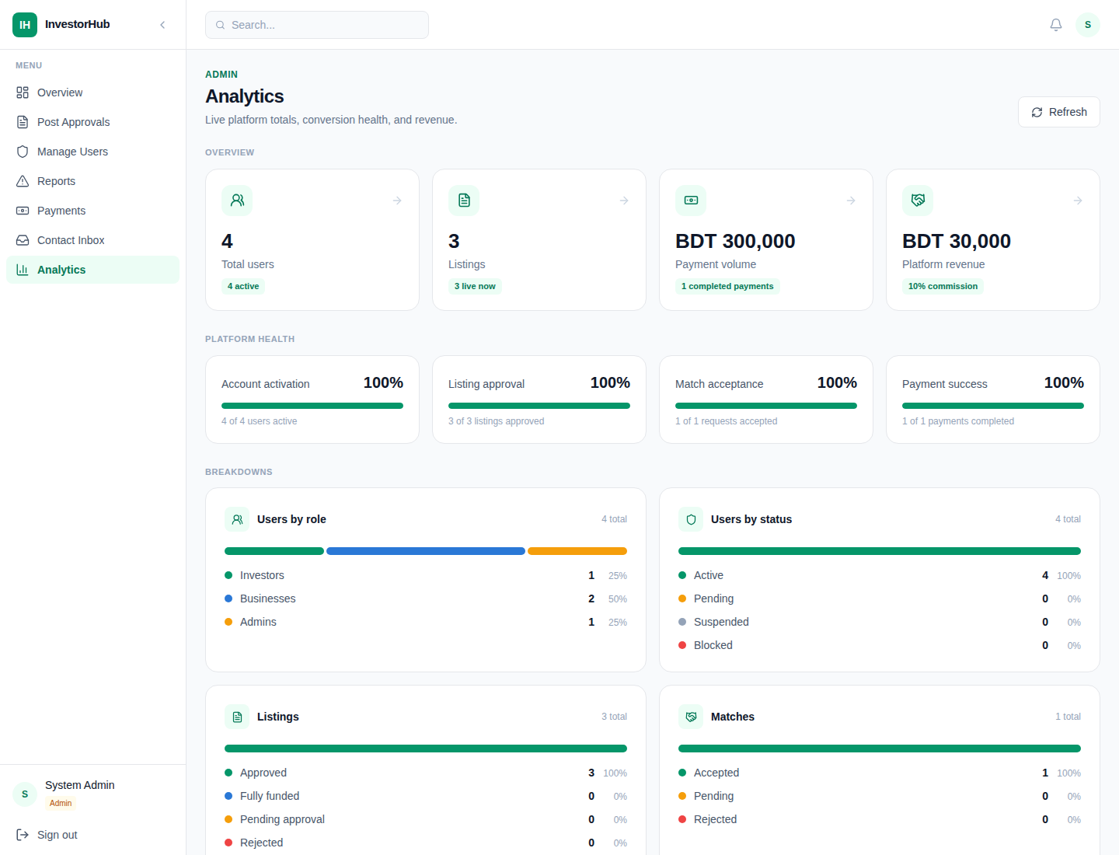
Figure 7.12 Administrative analytics dashboard.
Figure 7.12 shows the platform totals, the health rates and the breakdowns by role, status, listing state and match state.
Figure 7.13 shows account moderation, Figure 7.14 listing approval and Figure 7.15 the report queue through which the administrator acts on member complaints.
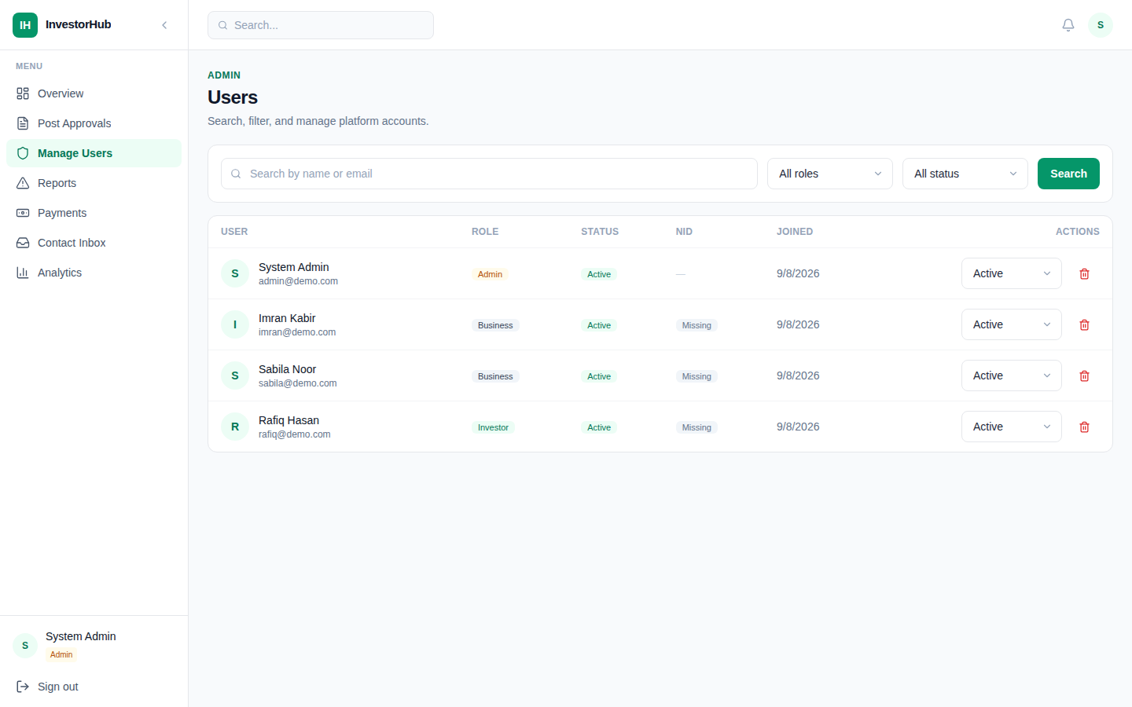
Figure 7.13 Account moderation page.
Figure 7.13 shows the registered accounts with their role and status and the actions available to the administrator.
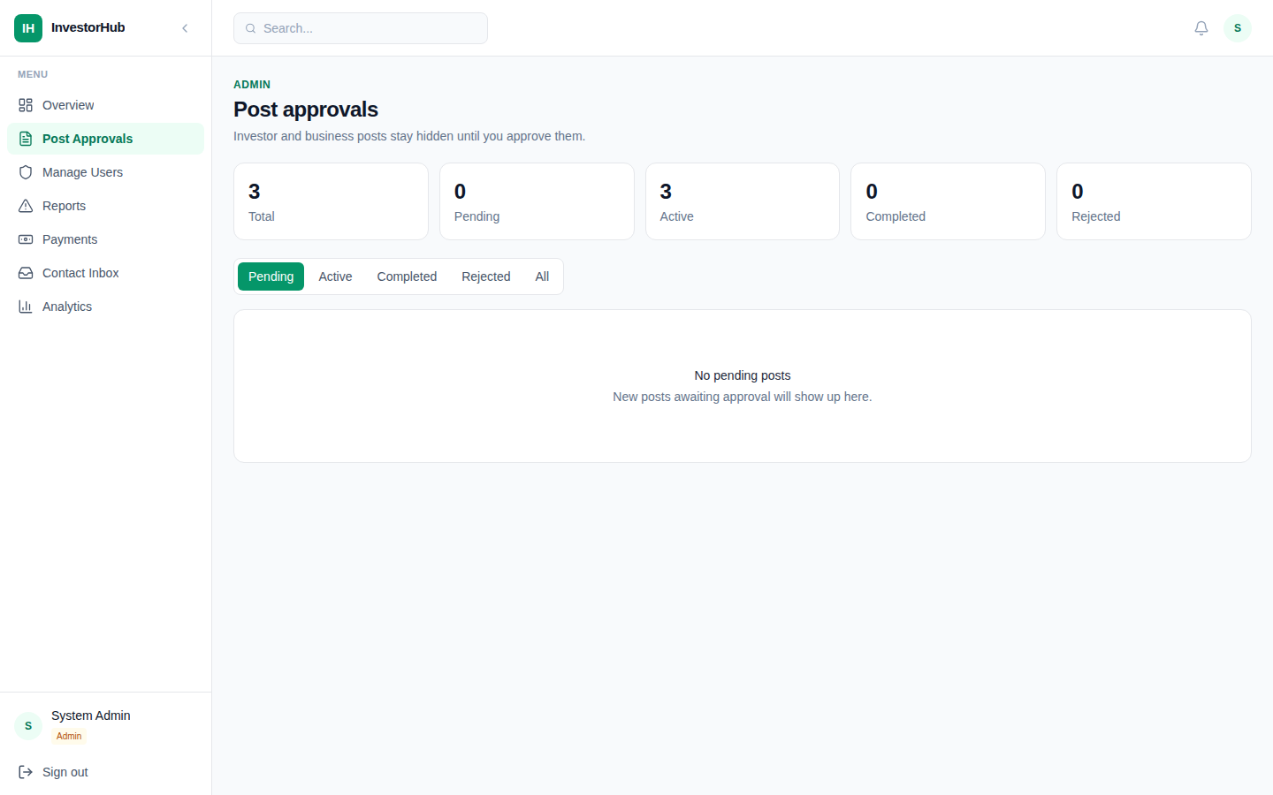
Figure 7.14 Listing approval page.
Figure 7.14 shows the listings awaiting moderation together with the approve, reject and delete actions.
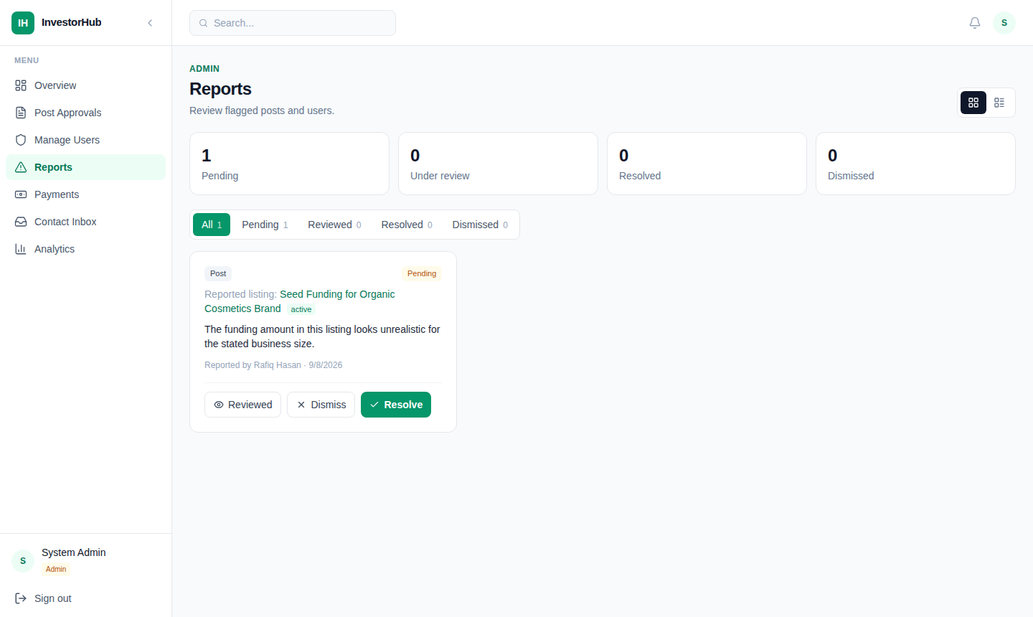
Figure 7.15 Report handling page.
Figure 7.15 shows the reports submitted by members with the reported target, the reason and the status update control.

7.2 Data Flow Diagram
The data flow diagrams describe the system as a set of processes that transform data, the external entities that supply or receive it, and the data stores that hold it. Three levels are presented: the context diagram, the decomposition into five processes, and the decomposition of each process.

7.2.1 Level 0 Context Diagram
Figure 7.16 shows the whole platform as a single process surrounded by its external entities: the guest, the investor, the business owner, the administrator and the payment gateway.
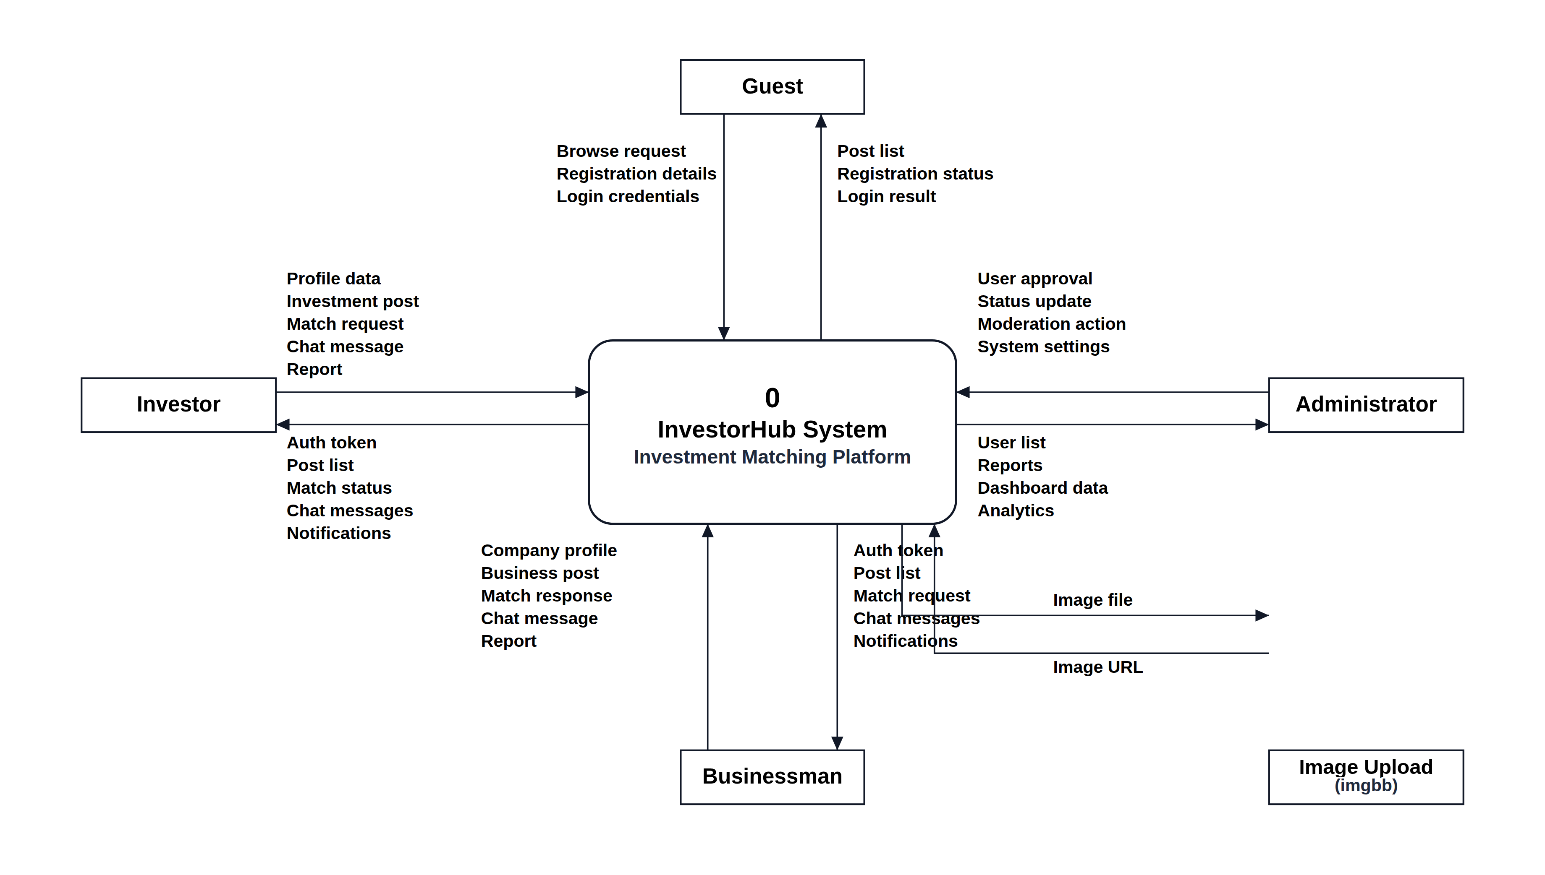
Figure 7.16 Level 0 context diagram of InvestorHub.
Figure 7.16 shows the platform as a single process with the data that flows between it and each external entity.

7.2.2 Level 1 Decomposition
Figure 7.17 decomposes the platform into five processes: authentication, listing management, match management, the chat service and the administration module, together with the six data stores they read and write.
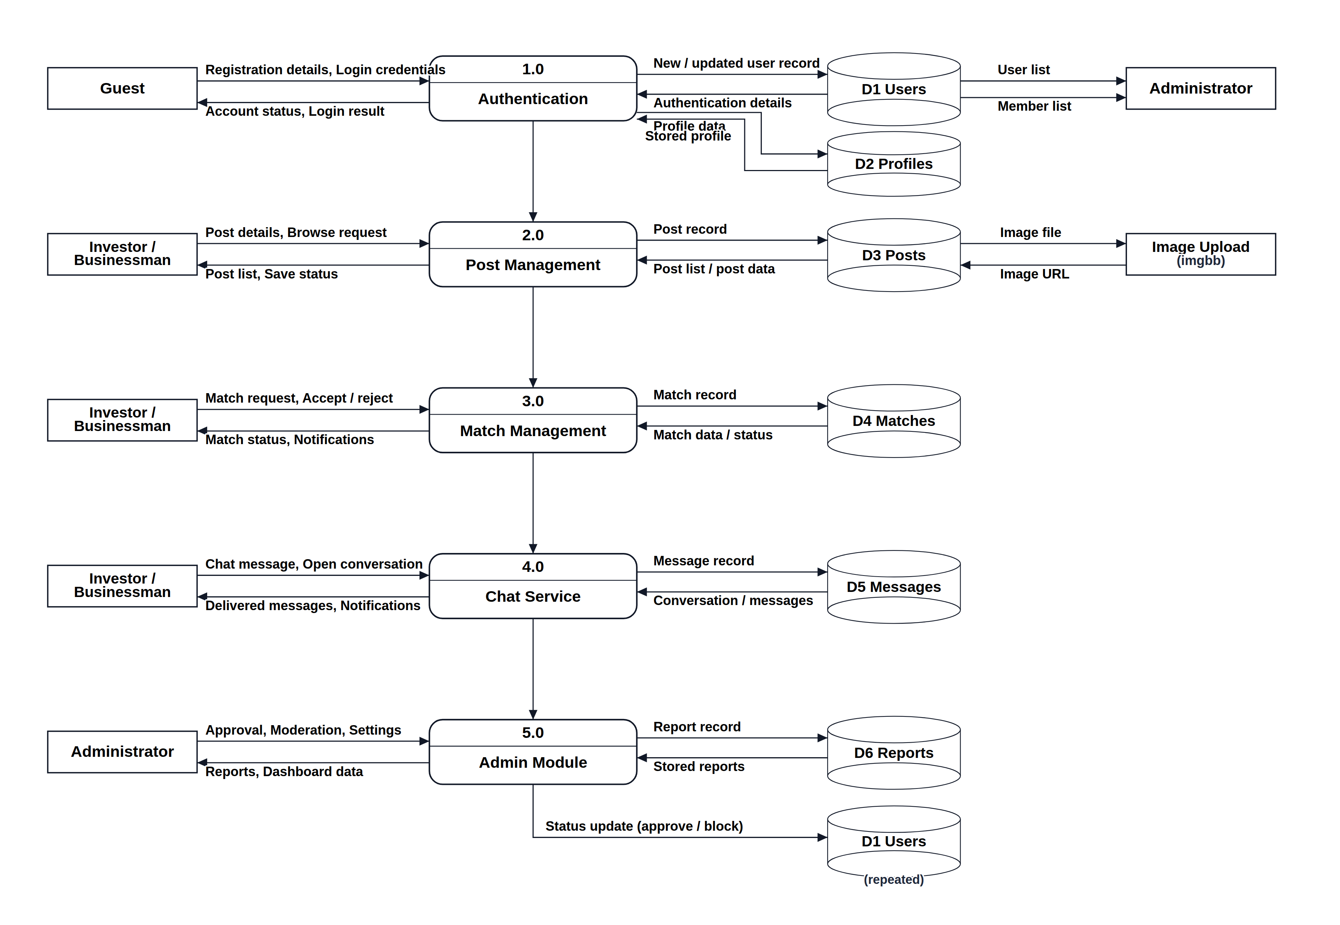
Figure 7.17 Level 1 data flow diagram.
Figure 7.17 decomposes the system into its five processes and shows the data stores that each process reads and writes.

7.2.3 Level 2 Decomposition of the Processes
Figures 7.18 to 7.22 decompose each level 1 process into its constituent sub-processes.
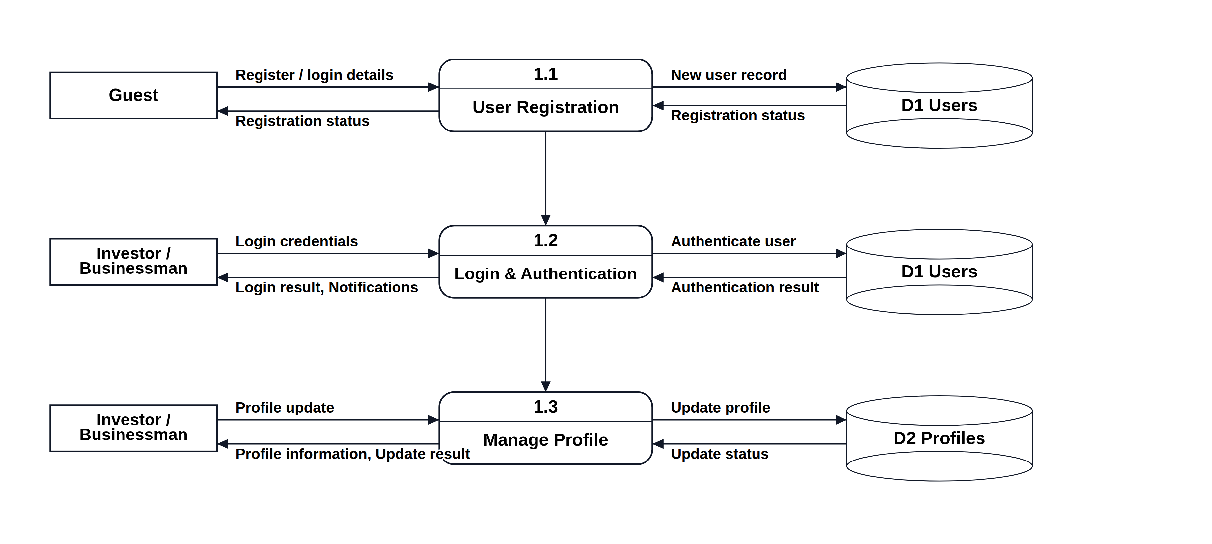
Figure 7.18 Level 2 data flow diagram of the authentication process.
Figure 7.18 decomposes the authentication process into registration, credential verification, identity verification and account activation.
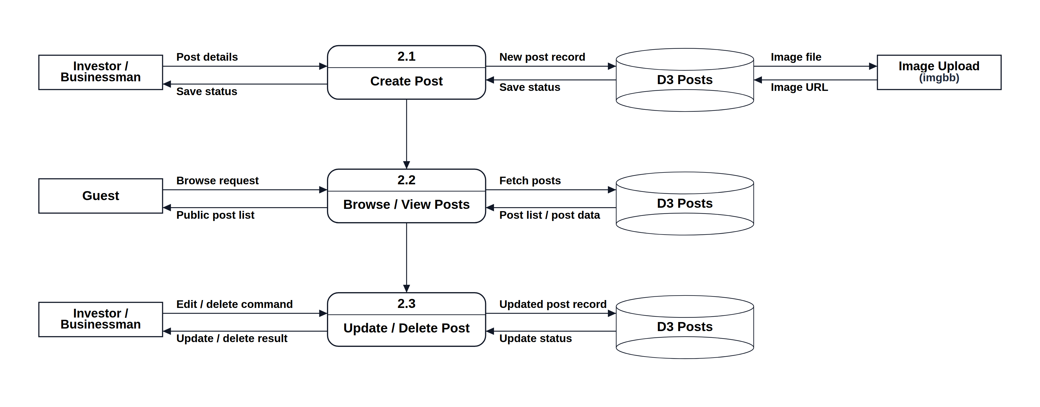
Figure 7.19 Level 2 data flow diagram of the listing management process.
Figure 7.19 decomposes listing management into creation, moderation, publication and search.
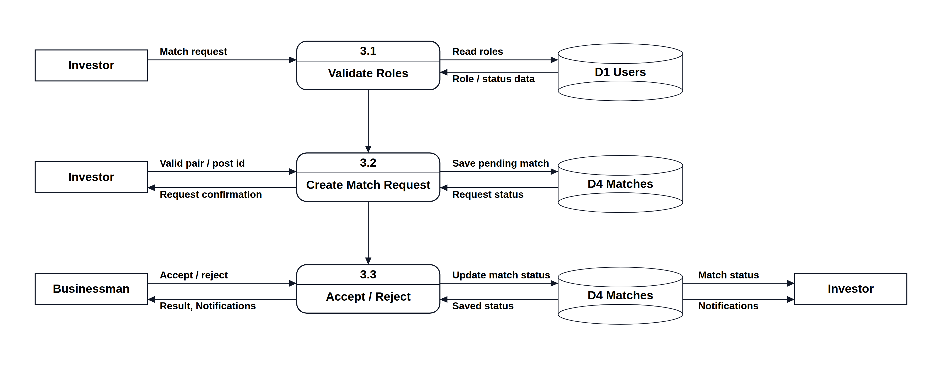
Figure 7.20 Level 2 data flow diagram of the match management process.
Figure 7.20 decomposes match management into request creation, validation, response handling and state update.
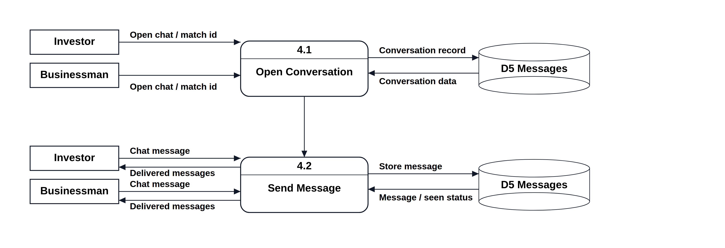
Figure 7.21 Level 2 data flow diagram of the chat service.
Figure 7.21 decomposes the chat service into conversation creation, message delivery and seen tracking.
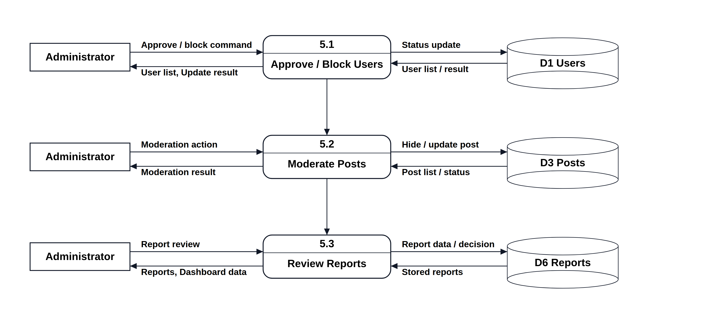
Figure 7.22 Level 2 data flow diagram of the administration module.
Figure 7.22 decomposes administration into account moderation, listing moderation, report handling and analytics.

7.3 Database Design
The platform stores its data in MongoDB, a document database. Although a document database does not enforce a fixed schema, every collection in InvestorHub is defined by a Mongoose schema that fixes the field names, the data types, the permitted values of every enumerated field and the indexes, so the stored data is as disciplined as it would be in a relational database.

7.3.1 Normalization of Data Fields
The collections were normalised to third normal form before they were implemented, and the normalisation was carried out in the following steps.
First normal form. The initial design kept the investor and the business details inside the user document, and kept the participants of a conversation as a single text field. Repeating and multi-valued groups were removed: the participants of a conversation became an array of user references, the categories of a listing became an array of category values, and each attachment became a separate element rather than a delimited string. Every field now holds one atomic value or an explicit list of atomic values.
Second normal form. Attributes that depended on only part of a composite key were separated. The investor-specific attributes, namely the investment range, the preferred industries and the investment type, were moved out of the user collection into an investor profile collection keyed by the user reference, and the business-specific attributes, namely the company name, the industry, the business stage and the funding needed, were moved into a business profile collection. A user document now holds only the attributes that every account has, irrespective of role.
Third normal form. Transitive dependencies were removed. The payment details of an investment, such as the transaction identifier, the validation identifier, the bank transaction identifier and the payment method, depend on the transaction and not on the investor, so they live in the investment collection rather than in the user collection. The commission and the net amount are stored with the investment because they are properties of that transaction, not of the listing. The registration fee is kept in a separate fee payment collection because it belongs to the account rather than to any investment. The result is that every non-key attribute depends on the key of its own collection and on nothing else.
Two deliberate departures from strict normalisation were made for performance. The author role is duplicated on a listing so that the listing type can be filtered without reading the user document, and the last message text is duplicated on a conversation so that the conversation list can be rendered without reading the message collection. Both values are written by the server at the same time as the source value, so they cannot drift.

7.3.2 Entity Relationship Model
Figure 7.23 presents the entity relationship model in Chen notation. Rectangles are entities, diamonds are relationships, and the triangle marks the inheritance of the investor, business owner and administrator roles from the user entity. The dashed rectangle is the logical junction that resolves the many-to-many relationship between a user and a conversation.
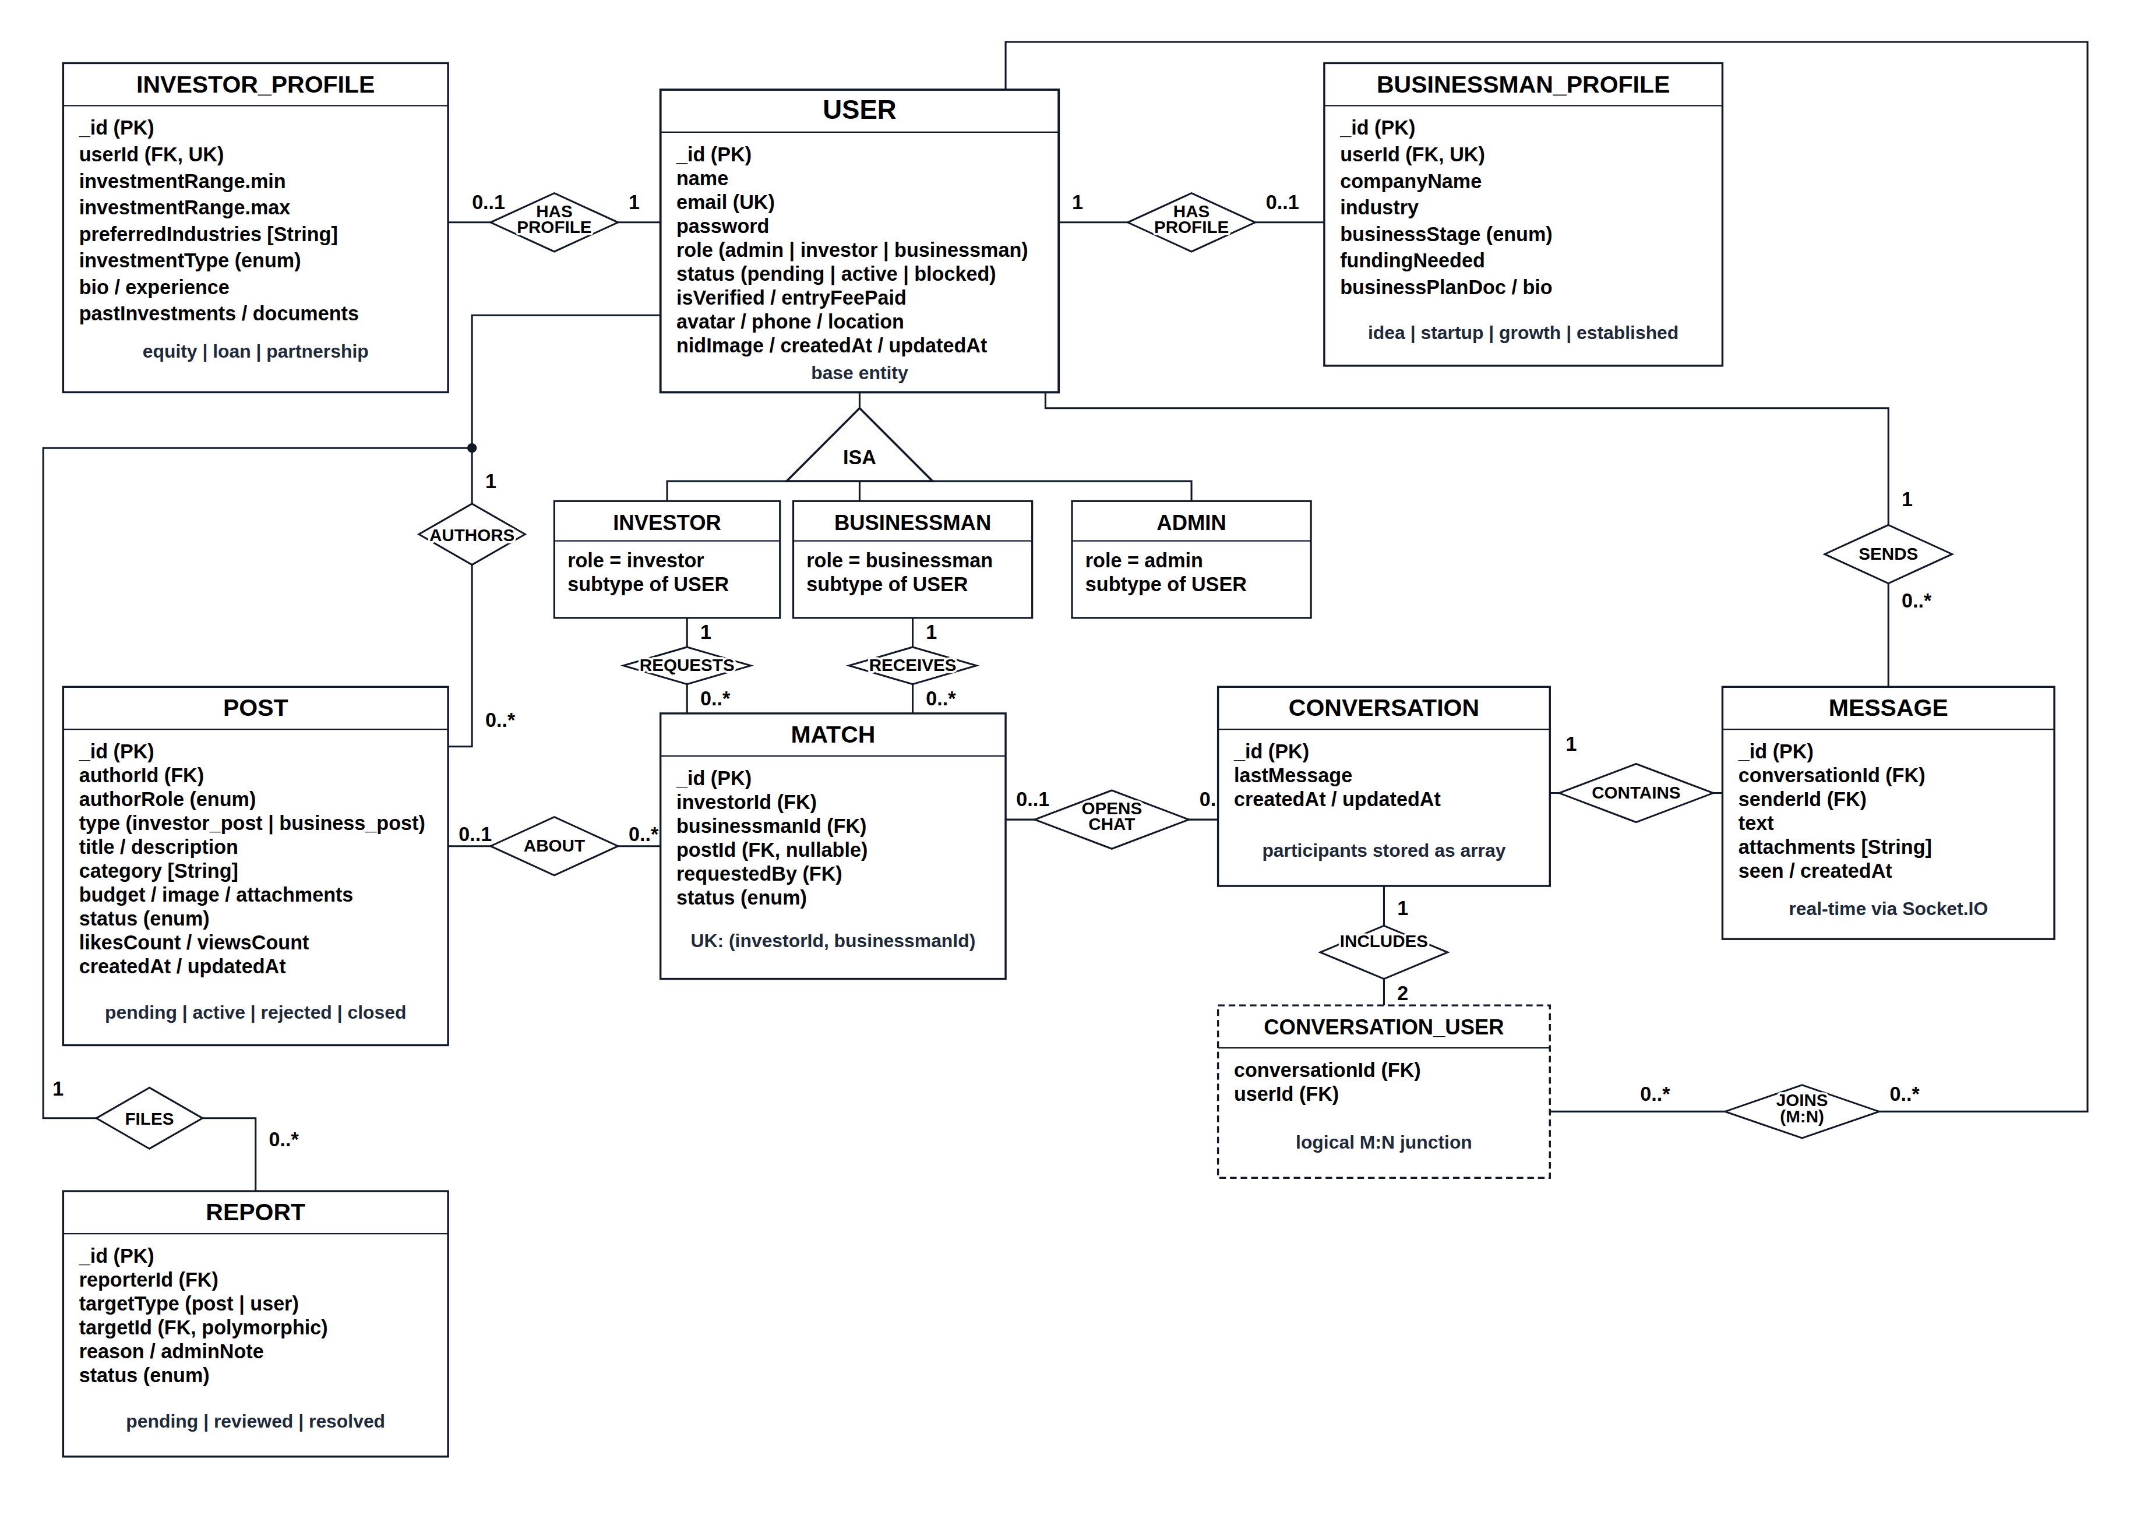
Figure 7.23 Entity relationship diagram of InvestorHub.
Figure 7.23 shows the entities, their attributes, the relationships between them with the cardinality of each side, and the role inheritance of the user entity.

7.3.3 Database Table Structure
Tables 7.1 to 7.6 give the structure of the principal collections. The remaining collections, namely the two profile collections, the fee payment, the report, the review and the contact message, follow the same pattern and are shown in the class diagram of Figure 4.5.
Table 7.1 Structure of the users collection.
Field | Type | Constraint | Description
_id | ObjectId | Primary key | Identifier generated by the database
name | String | Required, max 100 | Full name of the account holder
email | String | Required, unique | Login identifier, stored in lower case
password | String | Required, min 6, hidden | Bcrypt hash, never returned by the API
role | String | Enum, required | admin, investor or businessman
status | String | Enum, default pending | pending, active, suspended, blocked or rejected
rejectionReason | String | Max 1000 | Reason shown to the user when rejected
isVerified | Boolean | Default false | Identity verification flag
entryFeePaid | Boolean | Default false | Set when the registration fee is settled
nidImage | String | Optional | URL of the stored identity document
avatar, phone, location | String | Optional | Profile picture and contact details
createdAt, updatedAt | Date | Automatic | Record timestamps
Table 7.1 gives the field structure of the users collection.
Table 7.2 Structure of the posts collection.
Field | Type | Constraint | Description
_id | ObjectId | Primary key | Listing identifier
authorId | ObjectId | Foreign key to users | Owner of the listing
authorRole | String | Enum | Role of the author at the time of writing
type | String | Enum, required | investor_post or business_post
title | String | Required, max 200 | Title of the listing
description | String | Required, max 5000 | Full description of the proposal
category | [String] | Optional | One or more category labels
budget | Number | Default 0 | Amount offered or requested
image, attachments | String, [String] | Optional | Cover image and supporting files
status | String | Enum, default pending | pending, active, rejected, closed or completed
likesCount, viewsCount | Number | Default 0 | Engagement counters
createdAt, updatedAt | Date | Automatic | Record timestamps
Table 7.2 gives the field structure of the posts collection that stores every listing.
Table 7.3 Structure of the matches collection.
Field | Type | Constraint | Description
_id | ObjectId | Primary key | Match identifier
investorId | ObjectId | Foreign key to users | Investor side of the pair
businessmanId | ObjectId | Foreign key to users | Business side of the pair
postId | ObjectId | Foreign key, nullable | Listing the request was raised against
requestedBy | ObjectId | Foreign key to users | Party that initiated the request
status | String | Enum, default pending | pending, accepted, rejected or finalized
(investorId, businessmanId) | Index | Unique | Prevents a duplicate pair
createdAt, updatedAt | Date | Automatic | Record timestamps
Table 7.3 gives the field structure of the matches collection, including the unique pair index.
Table 7.4 Structure of the conversations and messages collections.
Collection | Field | Type | Description
conversations | _id | ObjectId | Conversation identifier
conversations | participants | [ObjectId] | The two users of the conversation
conversations | lastMessage | String | Preview text for the conversation list
messages | conversationId | ObjectId | Conversation the message belongs to
messages | senderId | ObjectId | Author of the message
messages | text | String | Message body, maximum 5000 characters
messages | attachments | [String] | Optional attachment URLs
messages | seen | Boolean | Set when the recipient opens the conversation
Table 7.4 gives the field structure of the two collections that store the real-time conversation.
Table 7.5 Structure of the investments collection.
Field | Type | Constraint | Description
_id | ObjectId | Primary key | Investment identifier
investorId | ObjectId | Foreign key to users | Investor making the payment
businessmanId | ObjectId | Foreign key to users | Recipient of the net amount
postId | ObjectId | Foreign key to posts | Listing being funded
amount | Number | Required, min 10 | Gross amount paid by the investor
platformFee | Number | Default 0 | Commission retained by the platform
netAmount | Number | Default 0 | Amount payable to the business owner
tranId | String | Required, unique | Transaction identifier sent to the gateway
valId | String | Optional | Validation identifier returned by the gateway
status | String | Enum, default pending | pending, completed, failed or cancelled
paymentMethod, bankTranId | String | Optional | Instrument and bank reference
paidAt | Date | Nullable | Time at which the payment was settled
Table 7.5 gives the field structure of the investments collection.
Table 7.6 Indexes defined on the collections.
Collection | Index | Purpose
users | email (unique) | Prevents duplicate accounts and speeds up sign-in
posts | status, type, category, createdAt | Supports the public listing filters and sorting
matches | investorId + businessmanId (unique) | Prevents a duplicate match pair
conversations | participants | Finds the conversation of a pair of users
messages | conversationId + createdAt | Loads a message thread in order
investments | investorId, businessmanId, tranId (unique) | Supports the investment lists and guards the transaction identifier
reviews | userId (unique), createdAt | Enforces one review per account
Table 7.6 lists the indexes created on the collections and the reason each one exists.

Chapter 8.

System Quality and Testing

Quality was treated as an activity that runs alongside construction rather than a phase that follows it. This chapter describes the quality management process that was applied during the practicum and presents the test cases that were executed against the finished system.

8.1 System Quality Management
The quality objective of the project was that every requirement of Section 3.2.3 should be demonstrable on the running system, that no protected resource should be reachable without the correct role and account status, and that no payment should be recorded as completed without confirmation from the gateway.

8.1.1 Software Quality Management Process
The process had five recurring elements, applied in every increment.
Quality planning. At the start of each increment the acceptance criteria of the new features were written down together with the requirement identifiers they satisfy, so that the definition of done was fixed before coding started.
Quality assurance through standards. Coding standards were applied uniformly: one router per domain module on the server, one page component per route on the client, validation declared at the route boundary with a validation library rather than written by hand, and all error handling routed through a single middleware. A static analysis tool was run over the client code before every commit.
Quality control through review and testing. Every increment was demonstrated to the organization supervisor, whose comments were recorded and fixed in the following week. Unit level checks were performed on the server modules, integration testing was performed on each route with a REST client, and system testing exercised the complete user journeys described in Section 8.2.
Defect management. Each defect found in a review or a test was recorded with its symptom, its cause and its fix. Three defects are worth recording because they changed the design: sessions were being lost on page reload because the client redirected before the token check completed, which was fixed by an explicit authentication-checked state; a chat socket opened with a previous token continued to send messages under the old identity, which was fixed by binding the identity at the handshake and discarding a stale socket; and the first assistant model that was selected required about thirty-five seconds to answer, which was fixed by measuring the latency of the available models and selecting a faster one.
Quality improvement. The measurements taken at the end of the practicum were that all twenty functional requirements are demonstrable, that every protected route rejects an unauthenticated or wrongly-roled request, and that the assistant answers in approximately one second instead of thirty-five.

8.2 Software Test Cases
Twenty-four test cases were executed against the finished system. They cover authentication and access control, listing management, matching, chat, payment, moderation and the supporting modules. Every case states the input, the expected result and the actual result. All twenty-four passed.
Table 8.1 Executed test cases and their results.
ID | Test case | Input | Expected result | Actual | Status
TC-01 | Register with a valid input | Name, unused email, password of six characters, role | Account created with status pending | As expected | Pass
TC-02 | Register with an existing email | An email already registered | Rejected with a duplicate account message | As expected | Pass
TC-03 | Register with a short password | Password of four characters | Rejected with a validation message | As expected | Pass
TC-04 | Sign in with correct credentials | Registered email and password | Token issued and dashboard opened | As expected | Pass
TC-05 | Sign in with a wrong password | Registered email, wrong password | Rejected without disclosing which field is wrong | As expected | Pass
TC-06 | Sign in with a blocked account | Account whose status is blocked | Rejected with an account suspended message | As expected | Pass
TC-07 | Reach the dashboard without a token | Direct URL with no session | Redirected to the sign-in page | As expected | Pass
TC-08 | Reach an administrative page as a member | Member token, administrative URL | Access denied and redirected | As expected | Pass
TC-09 | Use the dashboard with a pending account | Account not yet activated | Redirected to the approval page | As expected | Pass
TC-10 | Create a listing | Title, description, category and budget | Listing stored with status pending | As expected | Pass
TC-11 | Create a listing without a title | Empty title field | Rejected with a validation message | As expected | Pass
TC-12 | Public visibility of a pending listing | Browse as a guest | The pending listing is not listed | As expected | Pass
TC-13 | Approve a listing | Administrator approves the pending listing | Listing becomes active and appears publicly | As expected | Pass
TC-14 | Reject a listing without a reason | Administrator rejects with an empty reason | Rejected, a reason is required | As expected | Pass
TC-15 | Search and filter listings | Keyword, type and budget range | Only the matching approved listings are returned | As expected | Pass
TC-16 | Match request to the same role | Business owner requests a business owner | Rejected, the target must be of the opposite role | As expected | Pass
TC-17 | Duplicate match request | A second request to the same party | Rejected, a request is already pending | As expected | Pass
TC-18 | Accept a match request | Receiver accepts the pending request | Match becomes accepted and chat becomes available | As expected | Pass
TC-19 | Real-time message delivery | Message sent from the investor window | Message appears in the business window without a refresh | As expected | Pass
TC-20 | Invest in one's own listing | Author attempts to invest in the listing | Rejected, self investment is not allowed | As expected | Pass
TC-21 | Complete an investment in the sandbox | Valid amount and successful sandbox payment | Investment completed, commission deducted, match finalized | As expected | Pass
TC-22 | Repeat a payment notification | The same notification delivered twice | The second notification changes nothing | As expected | Pass
TC-23 | Review the platform twice | A second review from the same account | The existing review is updated, not duplicated | As expected | Pass
TC-24 | Use the assistant without signing in | Question asked from the home page | Answered within the rate limit and refused beyond it | As expected | Pass
Table 8.1 records the twenty-four test cases executed against the finished system and their results.
In addition to the functional test cases, the responsive layout was checked at a width of 390 pixels for a mobile phone and 1440 pixels for a desktop, and the protected routes were re-tested after every increment to confirm that a new feature had not weakened an existing access rule.

Chapter 9.

Ethical Consideration

InvestorHub handles three categories of sensitive material: the identity documents of its members, the private negotiation between two parties, and money moving from an investor to a business owner. Each of these carries an obligation, and the obligations were considered during design rather than after deployment. This chapter records the ethical considerations that shaped the system and the way the work contributes to economic and social sustainability.

9.1 Ethical Considerations in the Software Development Process

9.1.1 Data Privacy and Security
The platform collects more personal data than an ordinary website, because verification requires a national identity document. Four decisions follow from this. Passwords are stored only as bcrypt hashes and the password field is excluded from every query result, so a database dump does not expose a single usable credential. The identity document is visible only to the account owner and to an administrator, and it is never attached to a public listing. Contact details are not shown before a match is accepted, so a member cannot harvest phone numbers by browsing. Payment card data never reaches the platform at all: the investor is redirected to the gateway, enters the instrument there, and the platform receives only a transaction identifier and a validation result. Data is also limited to what the service needs; no location tracking, no advertising identifier and no third party analytics script is embedded in the client.

9.1.2 Intellectual Property
Two kinds of intellectual property are involved. The first is the property of others: every framework and library used in the project is open source and was used in accordance with its licence, no code was copied from a tutorial or a repository without understanding and adapting it, and the payment gateway was integrated through its published interface. The second is the property of the users: a business listing may describe a plan that the owner does not want copied, so the platform advises members to publish only the level of detail needed to attract interest and to exchange a full business plan privately after a match is accepted. The reporting mechanism gives a member a route to complain if another member copies a listing.

9.1.3 User Impact
The platform sits between people and their money, so a design mistake has a financial consequence rather than merely an inconvenient one. Three safeguards address this. Moderation means that an account and a listing are checked by a person before either becomes visible, which reduces the number of fraudulent proposals that reach investors. The record of the negotiation, the accepted match and the settled payment gives both parties evidence of what was agreed. The assistant on the home page is explicitly instructed not to give financial advice, not to promise returns and not to invent account details, and the interface states that its answers can be wrong and that important matters should be confirmed with support.

9.1.4 Bias and Fairness
A matching platform can quietly disadvantage a group of users if its ranking favours one kind of listing. InvestorHub therefore ranks listings by recency, budget or view count, all of which are objective and visible to the user, and it does not apply a hidden score that would favour a particular sector or a particular region. Every approved listing is reachable through search on equal terms. Moderation is a second source of possible bias, so a rejection must carry a written reason that is shown to the affected user, which makes an arbitrary decision visible and contestable. The platform is open to any adult with a valid national identity document, and the interface language and the fee level were kept simple and low so that a small district business is not excluded.

9.1.5 Responsibility to Stakeholders
The stakeholders of the platform are the investors, the business owners, the host organization and the regulator. Investors are owed accurate listing information and a payment path that cannot lose their money silently, which is why every payment is validated with the gateway and recorded with an invoice. Business owners are owed a fair commission that is disclosed before they accept an investment, which is why the fee and the net amount are displayed in the investment form, in the invoice and in the investment record. The host organization is owed a maintainable system, which is why the code is organised by module and the configuration is externalised. The regulator is owed an audit trail, which is why every transaction is stored with its gateway identifiers, its status and its settlement time.

9.1.6 Professional Responsibility
The work followed the principles that a computing professional is expected to observe. Nothing in this report claims a capability that the system does not have: the limitations are stated openly in Chapter 10. Defects found during testing were fixed or recorded rather than hidden. Security was treated as a requirement and not as an optional extra, and no credential or secret was committed to the source repository. Where an external service was used, its terms were respected and its key was kept on the server so that it could not be extracted from the client. The report itself was written by the author, and every external source used is acknowledged in the reference list.

9.2 Sustainability in the Software Development Process

9.2.1 Economic Sustainability
The platform is economically sustainable in two senses. As a product, it earns from a one-time registration entry fee and a percentage commission on completed investments, so its income grows with the value it actually delivers rather than with advertising volume, and the cost analysis in Chapter 6 shows that the running cost is recovered from a modest number of successful transactions. As a piece of software, it is inexpensive to keep alive: the entire stack is open source, the database and the hosting have free or low-cost entry tiers, and no proprietary licence has to be renewed. In the wider economy the platform lowers the transaction cost of finding capital, which helps small enterprises that cannot satisfy bank collateral requirements to grow and to employ more people.

9.2.2 Social Sustainability
Socially, the platform widens access to a resource that is currently distributed through personal networks. A business owner in a district town with no acquaintance among investors can present a proposal on the same page as a business in the capital. Verification and moderation build the trust that such a marketplace needs in order to work at all, and the reporting mechanism gives members a way to remove bad actors. Because the platform is a responsive web application rather than a native app, it works on the low-cost phones that most of the target users own, and no download is required. The digital record of agreements also reduces the disputes that arise from purely verbal arrangements, which protects the weaker party in a negotiation.

Chapter 10.

Conclusion

This final chapter summarises what was built during the practicum, states the benefits the system offers and the limitations it still has, reflects on the value of the placement, and sets out the plan for continuing the work.

10.1 Brief Overview of the Project
InvestorHub is a web platform that connects verified investors with verified business owners in Bangladesh. An applicant registers as an investor or as a business owner, pays a one-time registration entry fee through the payment gateway, submits a national identity document, and waits for an administrator to activate the account. An active member publishes a listing, which becomes public only after administrative approval, and browses or searches the listings of the opposite role. A match request may be sent only to a member of the opposite role; when the receiver accepts it, a real-time chat channel opens between the two parties. An investor then funds a business listing through the SSLCommerz gateway, where every transaction is re-validated with the gateway before it is recorded as completed, a platform commission is deducted, the match is finalized and a PDF invoice is produced. Members may report a listing or a user and follow the outcome, and may leave one review of the platform. The administrator moderates accounts, listings and reports, monitors payments and reads the analytics dashboard. The system was implemented with Node.js, Express and MongoDB on the server, React on the client, and Socket.IO for the real-time channel.

10.2 Proposed System Benefits
The delivered system offers the following benefits over the present practice:
- Verified participation. An account becomes usable only after an identity document has been submitted and an administrator has activated it, which removes the anonymous proposals that make social media groups unreliable.
- Structured discovery. Listings are typed, categorised and searchable by keyword, sector and budget range, so an investor reaches the relevant proposals instead of scrolling through unrelated posts.
- Controlled communication. A conversation can be opened only between an investor and a business owner, which prevents the unsolicited messages that discourage participation.
- Verified settlement. Every payment is confirmed with the gateway before it is recorded, the settlement is idempotent, and both parties receive an invoice, so there is a permanent record of what was paid.
- Transparent commission. The platform fee and the net amount are shown in the investment form, the invoice and the investment record, so the business owner knows the net proceeds in advance.
- Operational visibility. The analytics dashboard gives the administrator live totals for users, listings, matches, payments and revenue, which supports decisions about the platform.

10.3 Limitations of the Project
The following limitations are acknowledged:
- Identity verification is manual. The administrator compares the submitted document by eye; there is no automated check against a national database, so verification depends on administrative diligence.
- The platform records the investment but does not administer the agreement. Equity transfer, repayment schedules and legal documentation happen outside the system.
- Funds are settled directly and the platform holds no escrow, so it cannot reverse a payment if a party fails to honour the agreement after the money has moved.
- Matching is manual rather than algorithmic. A user must find a counterpart through search; the system does not yet recommend listings based on the stated preferences.
- The interface is available in English only, which limits access for users who are more comfortable in Bangla.
- The system has been tested by the developer and the supervisor with sandbox payments. It has not yet been exposed to a large number of concurrent real users, so its behaviour under load is estimated rather than measured.

10.4 Practicum and Its Value
The practicum turned a set of course topics into a single working system, and the value of the placement lay mostly in the parts that a course exercise does not contain. Working to a weekly review taught the discipline of delivering something demonstrable every week and of accepting that a requirement can change after it has been implemented. Integrating a payment gateway taught that an external system is not a library: its documentation must be read carefully, its behaviour must be verified by experiment, and its responses must never be trusted without independent validation. Building the real-time layer taught how an identity established at connection time can leak into a later session if it is not bound correctly, a defect that only appears when the same browser is used by two accounts.
The placement also improved the non-technical side of the work. Writing this report required the system to be modelled rather than merely coded, and producing the entity relationship, use case, activity, swimlane, data flow and class diagrams exposed inconsistencies that were then corrected in the implementation. Explaining a design decision to a supervisor who did not write the code taught the difference between describing what a function does and justifying why it exists. These are the abilities the practicum was intended to develop, and they transfer directly to professional work.

10.5 Future Plan
The following extensions are planned for the platform:
- An escrow facility that holds the invested amount until both parties confirm the agreed milestone, which would remove the largest remaining risk for investors.
- A recommendation engine that ranks listings against the stated investment range, preferred sectors and past activity of a member, replacing manual search with proactive matching.
- Automated identity verification against a national identity service, so activation no longer depends entirely on manual inspection.
- A Bangla interface alongside English, and a progressive web application build so that the platform can be installed and used on a low-cost phone with an unreliable connection.
- Email and push notification for match requests, messages and moderation decisions, so a user does not need to keep the site open to learn of an update.
- A structured document exchange for business plans and financial statements, with access granted only after a match is accepted.
- A load and security assessment before the platform is opened to the public, including a penetration test of the authentication and payment paths.

References
[1] R. S. Pressman and B. R. Maxim, Software Engineering: A Practitioner's Approach, 9th ed. New York, NY, USA: McGraw-Hill Education, 2020.
[2] I. Sommerville, Software Engineering, 10th ed. Harlow, England: Pearson Education, 2016.
[3] A. Silberschatz, H. F. Korth, and S. Sudarshan, Database System Concepts, 7th ed. New York, NY, USA: McGraw-Hill Education, 2020.
[4] OpenJS Foundation, "Node.js documentation." [Online]. Available: https://nodejs.org/docs. [Accessed: Sep. 2026].
[5] OpenJS Foundation, "Express 4.x API reference." [Online]. Available: https://expressjs.com/en/4x/api.html. [Accessed: Sep. 2026].
[6] MongoDB Inc., "MongoDB manual." [Online]. Available: https://www.mongodb.com/docs/manual. [Accessed: Sep. 2026].
[7] Automattic, "Mongoose documentation." [Online]. Available: https://mongoosejs.com/docs. [Accessed: Sep. 2026].
[8] Meta Open Source, "React documentation." [Online]. Available: https://react.dev. [Accessed: Sep. 2026].
[9] Socket.IO, "Socket.IO documentation." [Online]. Available: https://socket.io/docs/v4. [Accessed: Sep. 2026].
[10] SSLCommerz, "Developer integration guide." [Online]. Available: https://developer.sslcommerz.com. [Accessed: Sep. 2026].
[11] M. Jones, J. Bradley, and N. Sakimura, "JSON Web Token (JWT)," IETF RFC 7519, May 2015. [Online]. Available: https://www.rfc-editor.org/rfc/rfc7519.
[12] N. Provos and D. Mazieres, "A future-adaptable password scheme," in Proc. USENIX Annual Technical Conference, Monterey, CA, USA, 1999, pp. 81-91.
[13] International Function Point Users Group, Function Point Counting Practices Manual, Release 4.3.1. Princeton Junction, NJ, USA: IFPUG, 2010.
[14] OWASP Foundation, "OWASP Top 10: The ten most critical web application security risks." [Online]. Available: https://owasp.org/www-project-top-ten. [Accessed: Sep. 2026].
[15] Bangladesh Bank, "SME and special programmes department: Annual report on SME financing." [Online]. Available: https://www.bb.org.bd. [Accessed: Sep. 2026].
[16] SME Foundation, "SME sector in Bangladesh: Access to finance." [Online]. Available: https://www.smef.gov.bd. [Accessed: Sep. 2026].
[17] Practicum Instructions, Guidelines and Report Structure, Department of Computer Science and Engineering, IUBAT-International University of Business Agriculture and Technology, Dhaka, Bangladesh, Spring 2026.
[18] Practicum Report Template, Department of Computer Science and Engineering, IUBAT-International University of Business Agriculture and Technology, Dhaka, Bangladesh, Spring 2026.

Plagiarism Report
The similarity report generated for this practicum report is attached below. The department requires the similarity index to remain below the prescribed limit.
[Attach the plagiarism report of this document here.]

