1. Write an SQL query where employee details will be shown according to order of their first name.

SELECT * FROM EMPLOYEES

Order by first_name;

1. Write an SQL query to fetch “first_name” from the employee table in upper case.

SELECT upper(first_name)

FROM EMPLOYEES

Order by first_name;

1. Write an SQL query to show the details of employees who join in feb-2008.

SELECT * FROM EMPLOYEES

where hire_date between '1-Feb-2008' and '28-Feb-2008';

1. Write an SQL query to show even rows only.

select * from employees

where MOD(employee_id,2)=0;

1. SELECT * FROM EMPLOYEES

where hire_date between '1-Feb-2008' and '28-Feb-2008';

1. select first_name, add_months(sysdate,5), next_day(sysdate,'wed'), last_day(sysdate)

from employees;

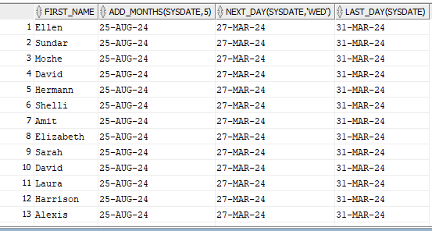

1. select employee_id,sysdate, (sysdate-5) "before 5 months"

from employees

where department_id = 90;

(5 days minus korse)

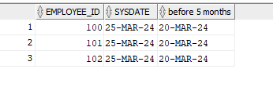

1. select employee_id, hire_date,sysdate,

Add_months(sysdate,-5) review,

last_day(hire_date)

from employees

where months_between(sysdate, hire_date)<200;

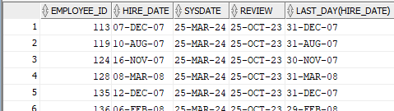

1. Display year in which more than 10 employees joined.

select to_char(hire_date,'YYYY'), count(first_name)

from employees

group by to_char(hire_date,'YYYY')

having count(first_name)>10;

1. Display departments where more than 5 employees get commission.

select department_id, count(commission_pct)

from employees

group by department_id

having count(commission_pct)>5;

1. Display job id of employees whose average salary is greater than 10000.

Select job_id, round(avg(salary))

from employees

group by job_id

having round(avg(salary))>10000;