REPORT

Project Title – Marketing Funnel Analysis (Task 3)

Project Overview –
Marketing campaigns aim to convert potential customers into actual customers through a series of stages known as a marketing funnel. In this task, we analyze a bank marketing campaign dataset to understand how customers move from initial contact to final subscription. The analysis helps in evaluating campaign effectiveness and identifying stages where customer drop-off occurs.

Business and Problem Statement: Student Satisfaction Analysis -
Context & Problem: Banks and financial institutions conduct large-scale marketing campaigns by contacting customers through calls and messages. Although a large number of customers are contacted, only a small percentage end up subscribing to the product. The challenge is to understand where and why customers drop out of the funnel. Without structured funnel analysis, marketing teams cannot accurately evaluate campaign efficiency or optimize targeting strategies.

Objective & Outcome: The objective of this task is to apply data analytics using Python to build a marketing funnel and calculate conversion rates at each stage. By identifying visitor-to-lead and lead-to-customer conversions, the project aims to provide actionable insights that help improve customer targeting, campaign messaging, and overall conversion rates. The expected outcome is a clear visualization of funnel performance and data-driven recommendations for improving future campaigns.

Tools and Libraries –
Tool | Purpose
Google Colab | Online coding environment
Pandas | Data loading and manipulation
Matplotlib | Data Visualization
NumPy | Numerical computations

Data Cleaning and Loading –
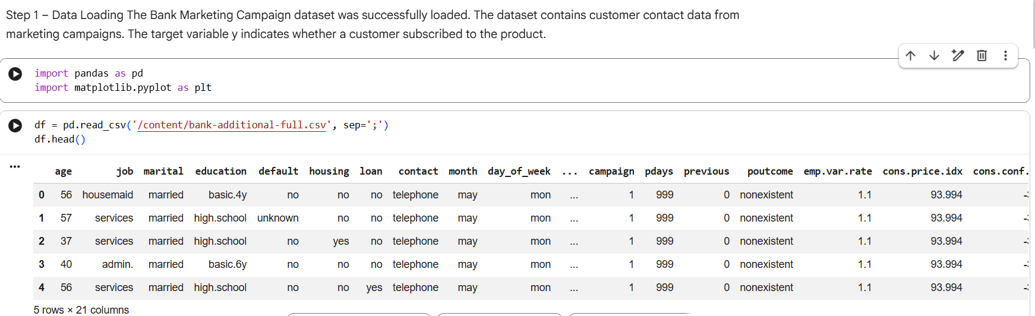

Funnel Definition
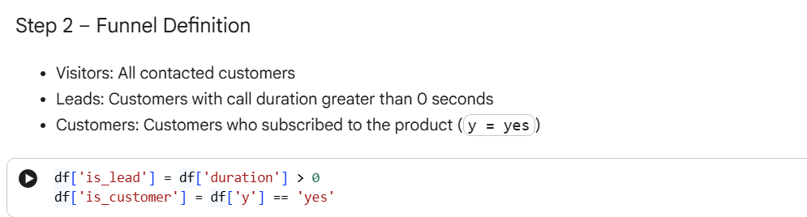

Funnel Counts
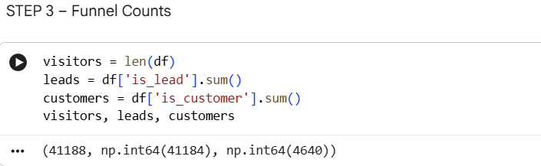
- Conversion Metrics
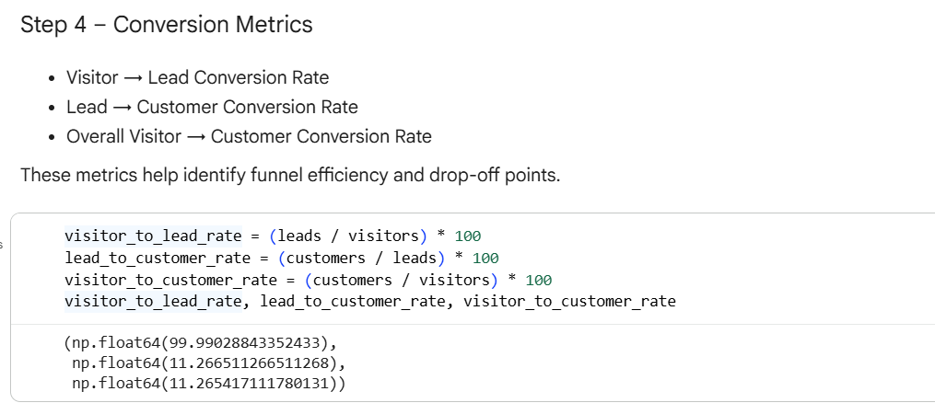

Funnel Visualization
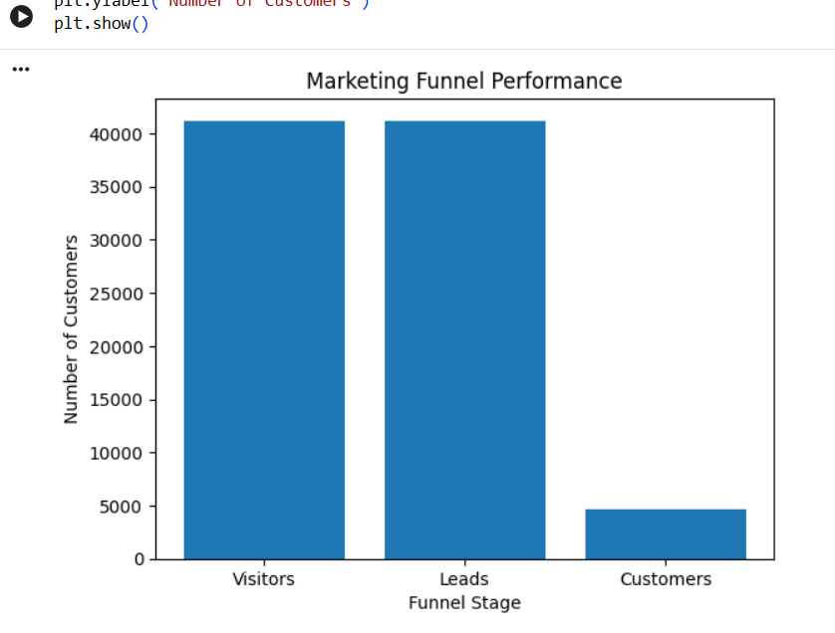

Drop-off Analysis
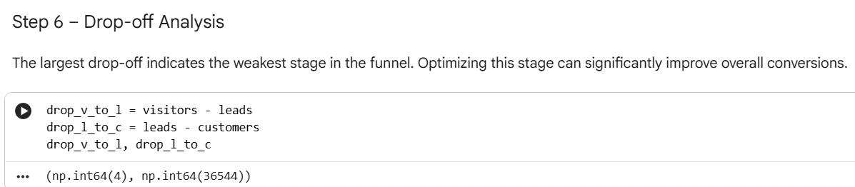

Channel Performance
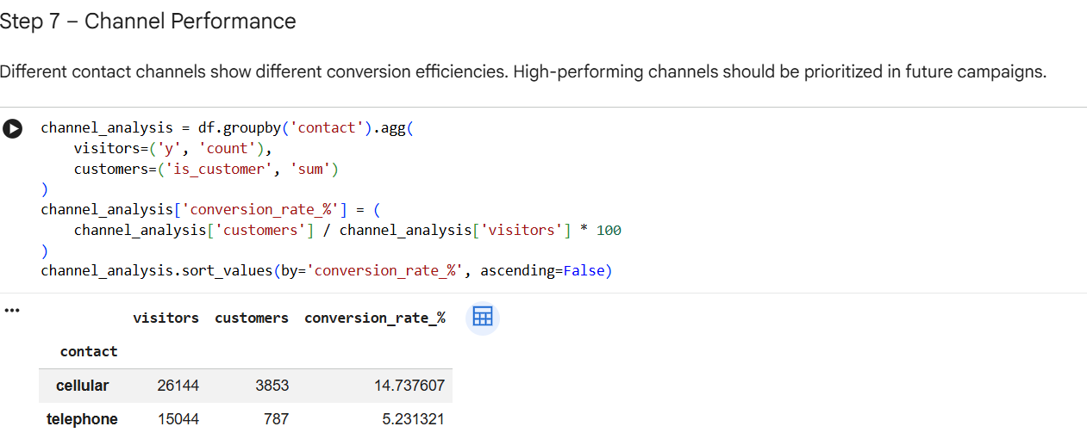
- Time-based Performance
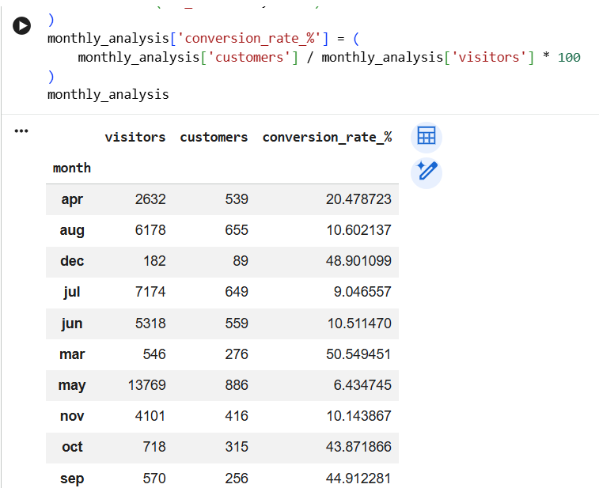

Key Insights & Recommendations
- Significant drop-off occurs between Visitors and Leads
→ Improve targeting and campaign messaging.
- Certain contact channels outperform others
→ Allocate more budget to high-converting channels.
- Lead to Customer conversion can be improved
→ Optimize follow-up timing and personalize communication.
- Conversion rates vary by month
→ Focus campaigns during high-performing periods.
- Colablink: https://colab.research.google.com/drive/1XrpXjnxnlh3bSrmNOzi4Pp-WlRzBfmWv?usp=sharing

