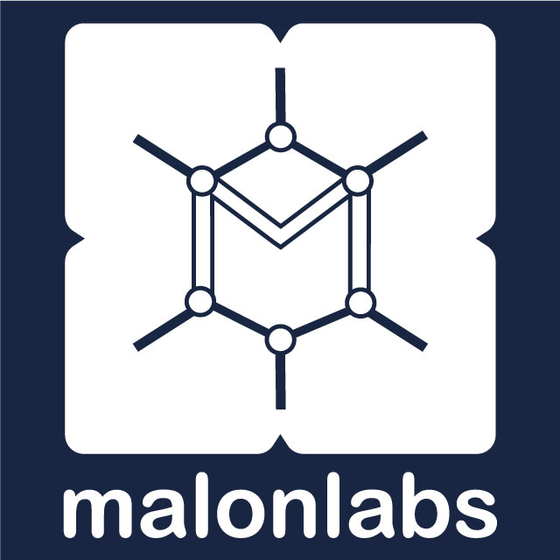

AI Readiness Assessment

Malon Labs Consulting

This assessment helps us understand your organization's current technology landscape, pain points, and readiness for AI adoption. Your answers will be used to create a customized AI opportunity report and implementation roadmap.

Company Name
Industry / Sector
Number of Employees
Contact Person & Role
Email / Phone
Date
Completed By

Section 1: Company & Technology Overview
1. What are your company's core products or services?

2. What technology tools and systems does your organization currently use? (Select all that apply)
☐ Microsoft Office / Microsoft 365
☐ Google Workspace (Gmail, Docs, Sheets)
☐ Accounting software (QuickBooks, Tally, Sage, etc.)
☐ CRM / Customer management system
☐ ERP / Enterprise resource planning
☐ Custom-built internal software
☐ WhatsApp Business
☐ Social media management tools
☐ Other: ___________________________
3. How would you rate your organization's overall technology maturity?
1 — Not at all 2 — Minimal 3 — Moderate 4 — Good 5 — Excellent
Your rating: _____
4. How reliable is your internet connectivity?
☐ Consistently fast and reliable
☐ Generally good with occasional outages
☐ Unreliable — frequent disruptions
☐ We rely primarily on mobile data

Section 2: Pain Points & Workflows
5. What are the top 3 tasks or processes that consume the most staff time in your organization?

6. Which of these pain points does your team experience regularly? (Select all that apply)
☐ Manual, repetitive data entry
☐ Slow report generation or document creation
☐ Difficulty finding information across systems
☐ Inconsistent customer response times
☐ Scheduling and coordination challenges
☐ Inventory or supply chain tracking issues
☐ High volume of routine customer inquiries
☐ Staff spending time on tasks below their skill level
☐ Other: ___________________________
7. Estimate the hours per week your team spends on manual, repetitive tasks that could potentially be automated.
☐ Less than 5 hours
☐ 5–15 hours
☐ 15–30 hours
☐ 30–50 hours
☐ More than 50 hours
8. Which departments would benefit most from improved efficiency? (Rank top 3)

Section 3: AI Awareness & Team Readiness
9. How familiar is your leadership team with AI and automation tools?
1 — Not at all 2 — Minimal 3 — Moderate 4 — Good 5 — Excellent
Your rating: _____
10. Does anyone in your organization currently use AI tools (ChatGPT, Copilot, Gemini, etc.) in their work?
☐ Yes — widely used across the organization
☐ Yes — a few individuals use them informally
☐ No — but there is interest
☐ No — and there is skepticism or resistance
11. How open is your team to adopting new technology tools?
1 — Not at all 2 — Minimal 3 — Moderate 4 — Good 5 — Excellent
Your rating: _____
12. Do you have an internal IT team or dedicated technical staff?
☐ Yes — dedicated IT department
☐ Yes — 1-2 technical staff
☐ No — we outsource IT support
☐ No — no dedicated IT capacity
13. What concerns, if any, does your organization have about adopting AI? (Select all that apply)
☐ Cost / return on investment unclear
☐ Data privacy and security risks
☐ Staff resistance to change
☐ Lack of technical knowledge
☐ Internet reliability
☐ Not sure which tools are trustworthy
☐ Fear of job displacement among staff
☐ Regulatory or compliance concerns
☐ None — we are ready to explore

Section 4: Goals & Priorities
14. What is the primary business outcome you hope AI can help achieve?
☐ Reduce operational costs
☐ Save staff time on repetitive tasks
☐ Improve customer service and response time
☐ Generate better reports and insights
☐ Increase revenue or sales
☐ Improve internal communication
☐ Gain competitive advantage in our market
☐ Other: ___________________________
15. If we could solve ONE problem with AI in the next 30 days, what would it be?

16. Are there specific AI tools or capabilities you have heard about and want to explore?

Section 5: Budget & Timeline
17. What is your approximate budget range for AI consulting and implementation?
☐ Under TZS 2,000,000 (Exploring options)
☐ TZS 2,000,000 – 5,000,000 (Jumpstart engagement)
☐ TZS 5,000,000 – 25,000,000 (Full implementation)
☐ TZS 25,000,000+ (Enterprise transformation)
☐ Not yet determined — need guidance
18. How soon would you like to begin an AI implementation project?
☐ Immediately — within the next 2 weeks
☐ Short-term — within 1-2 months
☐ Medium-term — within 3-6 months
☐ We are in the research phase
19. Would your organization be interested in ongoing AI advisory and support after the initial engagement?
☐ Yes ☐ No ☐ Not sure
20. Is there anything else you would like us to know about your organization, challenges, or goals?

Thank you for completing this assessment.

A Malon Labs consultant will review your responses and prepare a customized AI Opportunity Report within 5 business days.

Contact us: info@malonlabs.com | +255 766 629 933 | malonlabs.com

